**Project Report: Steganography Tool**

# 1. Introduction

The Steganography Tool is a desktop application that allows users to securely hide secret messages inside images and later extract them. It leverages Least Significant Bit (LSB) steganography to encode textual data into image pixels, making the hidden information invisible to the human eye.

# 2. Objectives

- Provide a simple, GUI-based tool for message hiding and extraction.  
- Implement a dark-themed interface for better usability.  
- Enable secure communication without altering image quality significantly.  
- Provide a refresh function for resetting the application state.

# 3. Features

- Message Hiding: Hide secret text inside .png or .bmp images.  
- Message Extraction: Retrieve hidden text directly from steganographic images.  
- Graphical User Interface (GUI): Built with tkinter.  
- Dark Theme: A hacker-style UI with green text on a dark background.  
- Refresh Button: Clears current selections and resets the interface.  
- Error Handling: Alerts if an image or message is missing.

# 4. System Requirements

Programming Language: Python 3.8+  
Libraries:  
- pillow (for image processing)  
- tkinter (for GUI)  
- tkinterdnd2 (optional for drag-and-drop support)  
  
Dependencies are listed in requirements.txt.

# 5. Implementation

Encoding (stego.py):  
- Converts text into binary.  
- Embeds binary data in the least significant bits (LSBs) of RGB pixels.  
- Uses a special EOF marker (1111111111111110) to denote message end.  
  
Decoding (stego.py):  
- Reads pixel LSBs to extract binary data.  
- Reconstructs hidden text until EOF marker is detected.  
  
GUI (gui.py):  
- Upload image → Enter text → Save stego image.  
- Extract hidden message → Display in popup.  
- Refresh → Clears all selections.

# 6. Screenshots

Main Interface:

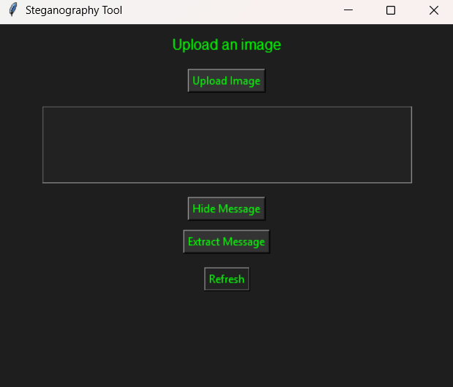

Message Hiding:

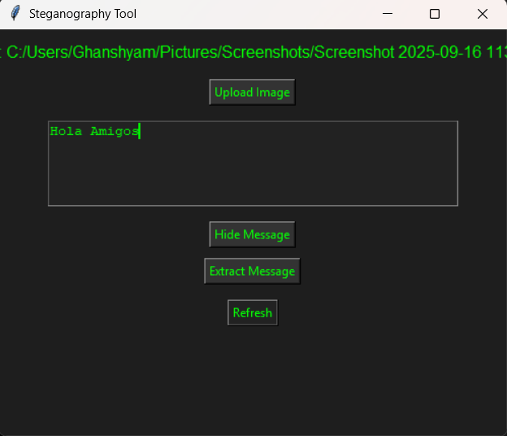

Message Extraction:

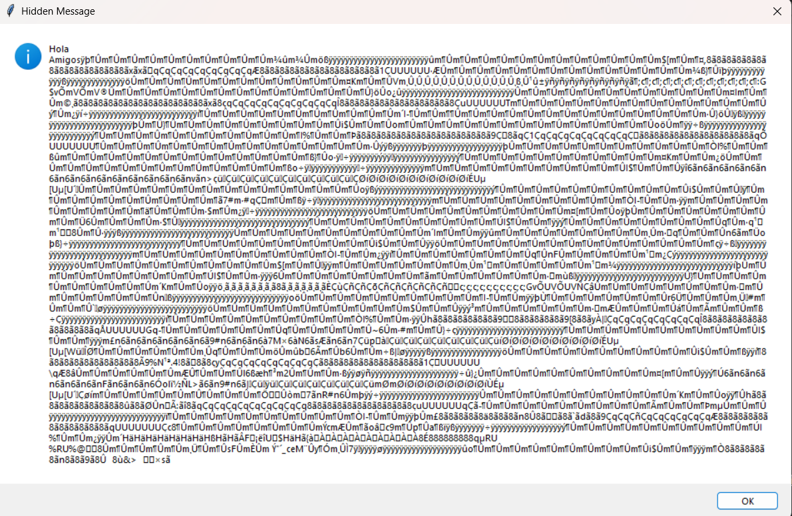

# 7. Usage

1. Upload an image.  
2. Enter a secret message.  
3. Click Hide Message → Save the new image.  
4. To retrieve, load the stego image and click Extract Message.  
5. Use Refresh to reset the application.

# 8. Limitations

- Only supports text messages, not full files.  
- Large messages may distort image slightly.  
- Currently works with .png and .bmp formats.