VISVESVARAYA TECHNOLOGICAL UNIVERSITY
“JnanaSangama”, Belgaum -590014, Karnataka.

LAB REPORT
on
Object Oriented Java Programming (23CS3PCOOJ)
Submitted by
Suryansh Singh (1BF24CS309)
in partial fulfillment for the award of the degree of
BACHELOR OF ENGINEERING
in

B.M.S. COLLEGE OF ENGINEERING
(Autonomous Institution under VTU)
BENGALURU-560019
Aug-2025 to Jan-2026

B.M.S. College of Engineering,
Bull Temple Road, Bangalore 560019
(Affiliated To Visvesvaraya Technological University, Belgaum)
Department of Computer Science and Engineering

CERTIFICATE
This is to certify that the Lab work entitled “Object Oriented Java Programming (23CS3PCOOJ)” carried out by Suryansh Singh (1BF24CS309), who is bonafide student of B.M.S. College of Engineering. It is in partial fulfilment for the award of Bachelor of Engineering in Computer Science and Engineering of the Visvesvaraya Technological University, Belgaum. The Lab report has been approved as it satisfies the academic requirements in respect of an Object-Oriented Java Programming (23CS3PCOOJ) work prescribed for the said degree.

Dr. Seema Patil  Associate Professor  Department of CSE, BMSCE | Dr. Kavitha Sooda  Professor & HOD  Department of CSE, BMSCE

Index
Sl.  No. | Date | Experiment Title | Page No.
1 | 23/09/25 | Implementing Quadratic Equation | 4-5
2 | 14/10/25 | SGPA Calculation | 6-8
3 | 14/10/25 | Book Search(toString) | 9-10
4 | 04/11/25 | Implementing Abstract Class in Shapes | 11-12
5 | 04/11/25 | Bank Program | 13-17
6 | 11/11/25 | Implementing Package | 18-20
7 | 25/11/25 | Handling Exception on Age | 21-22
8 | 09/12/25 | Using Threads | 23-24

Github Link:suryansh-singh-3008/OOJ: Record of lab programs done java lab

Program 1
Implement Quadratic Equations
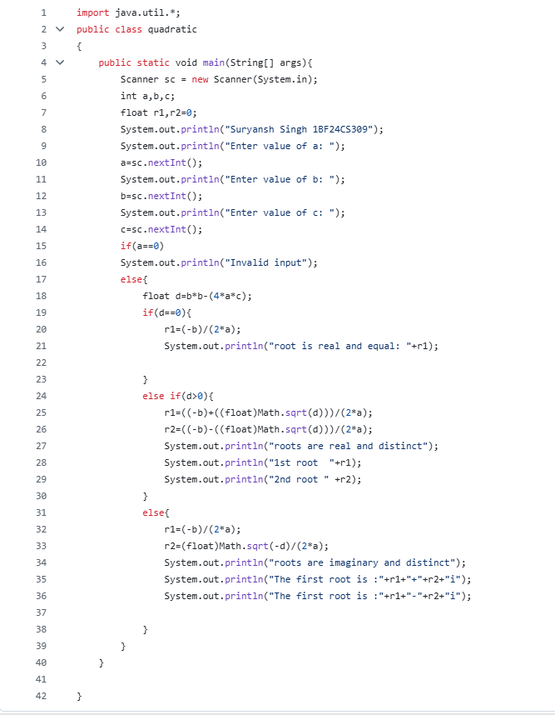

Output:

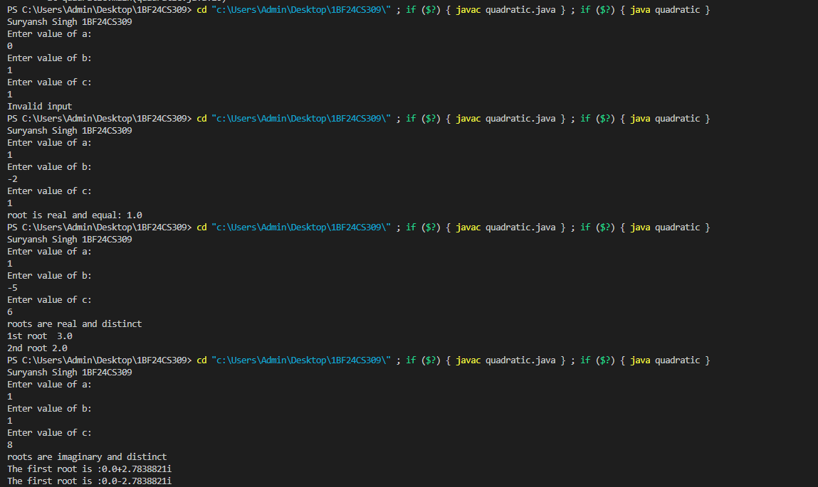

Program 2
SGPA Calculations

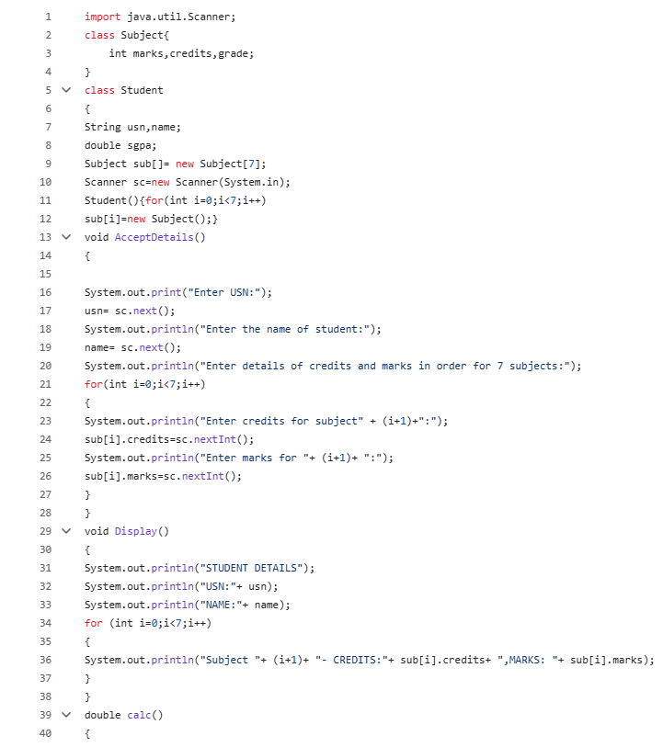

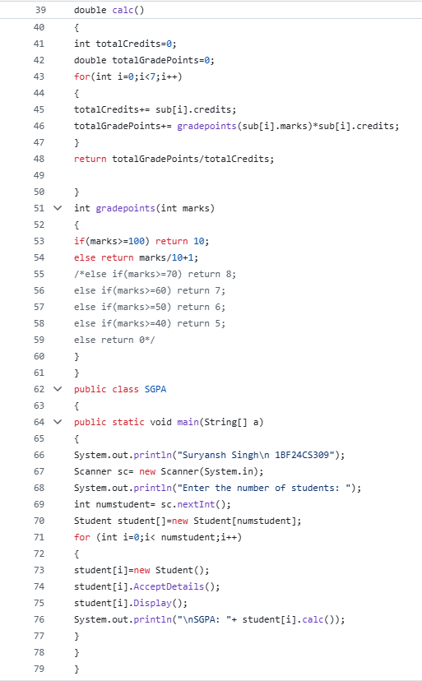

Output:
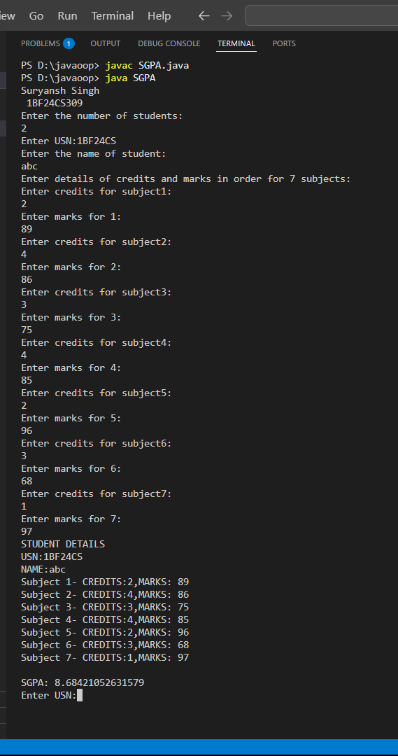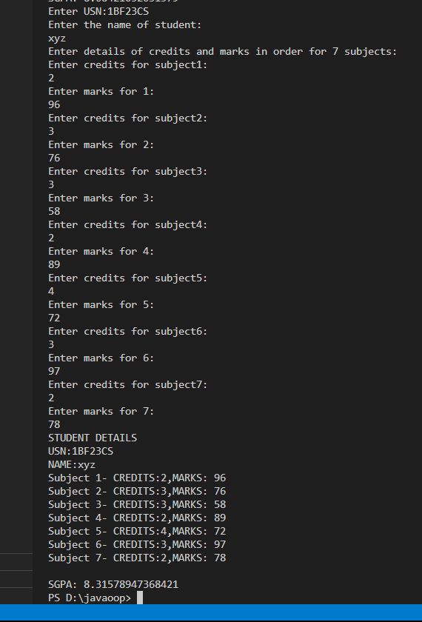

Program 3:
Book searching
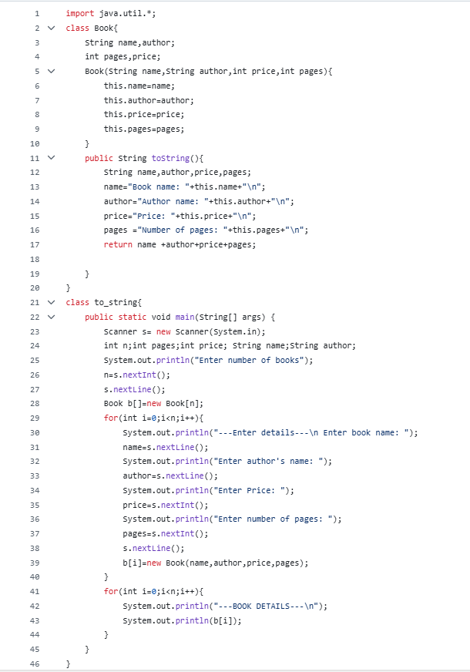

Output:
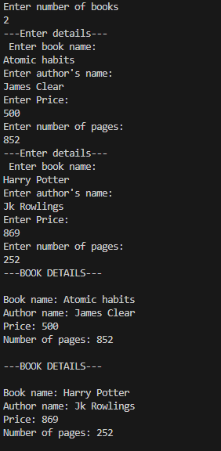

Program 4:
Implementing Abstract Class in Figures

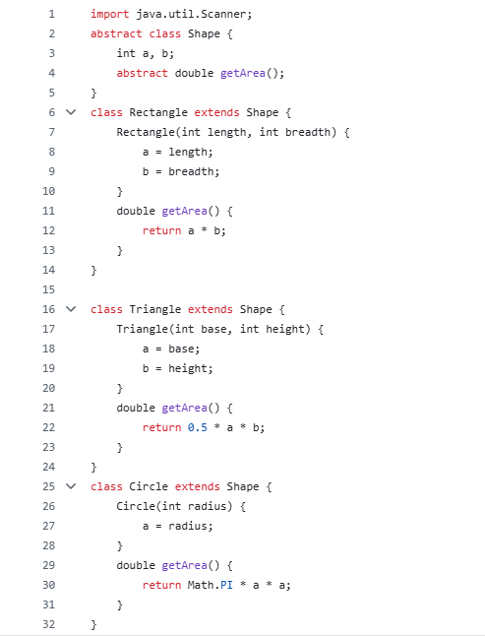
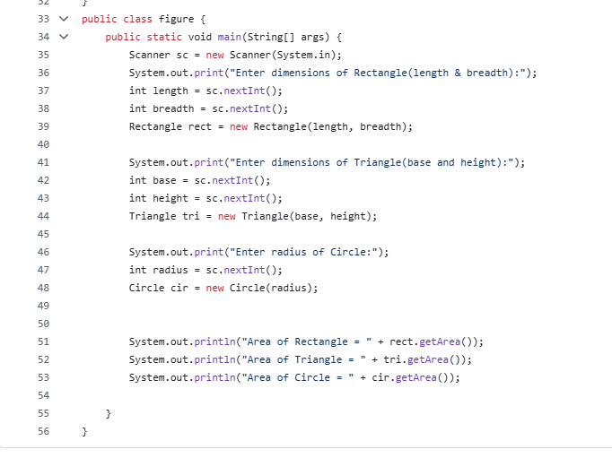Output:
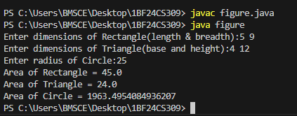

Program 5:
Bank Program

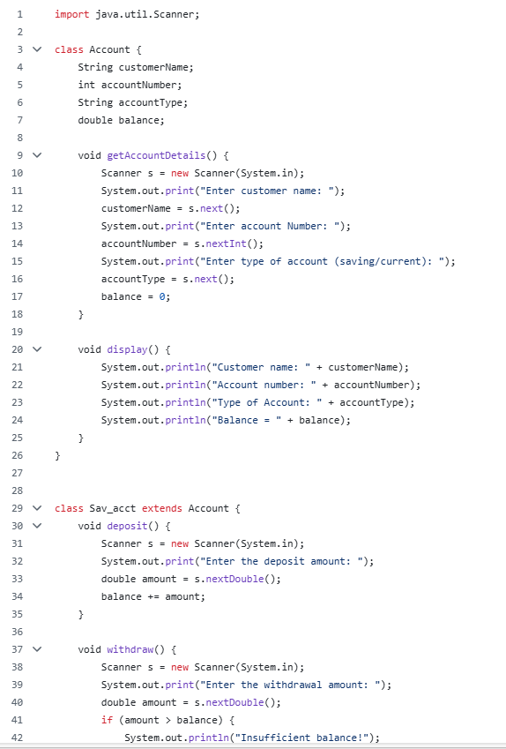
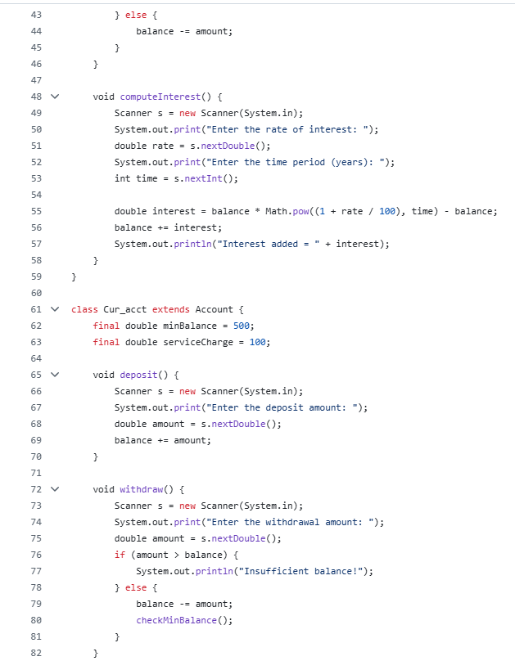
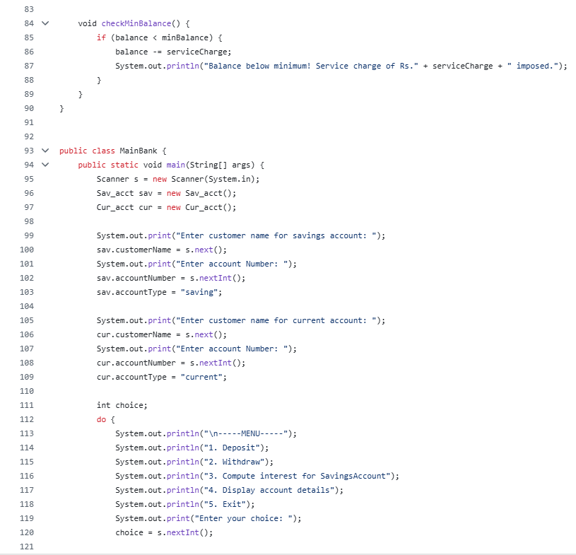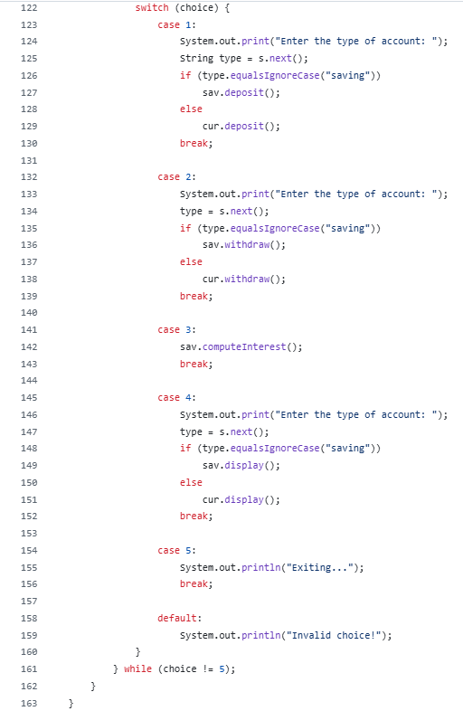

Output:

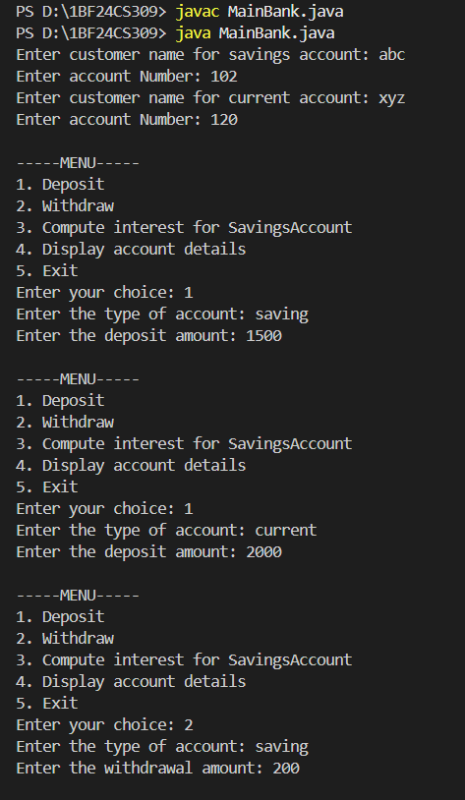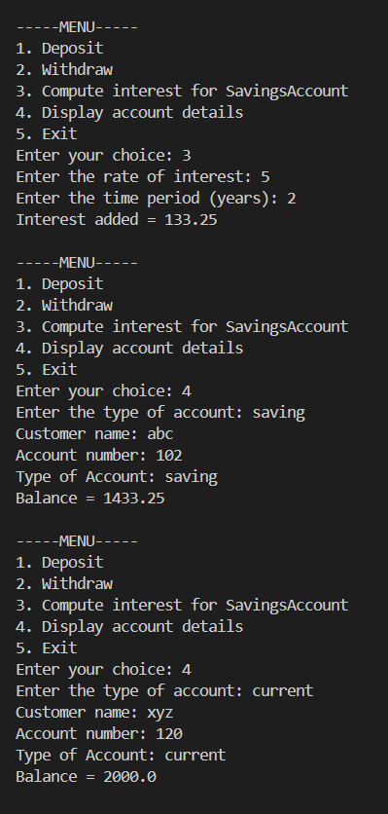

Program 6:
Implementing Package

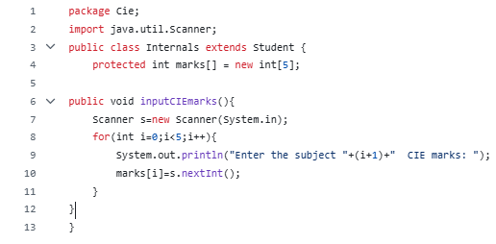
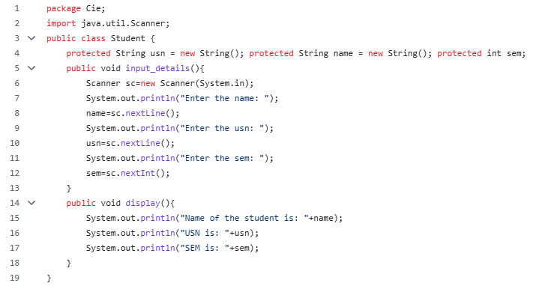

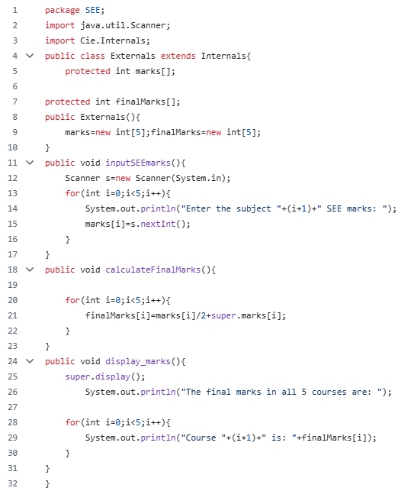
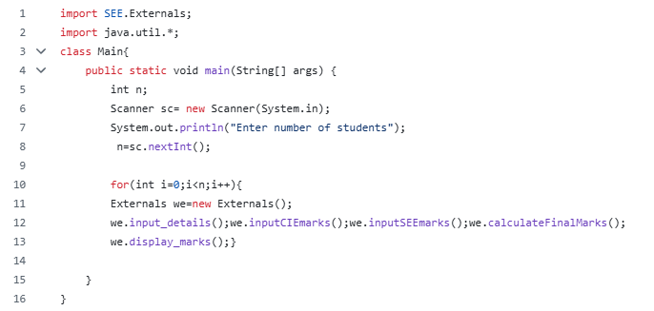

Output:

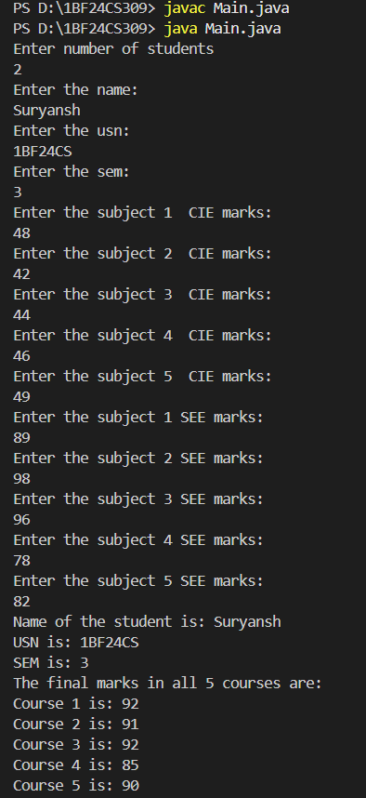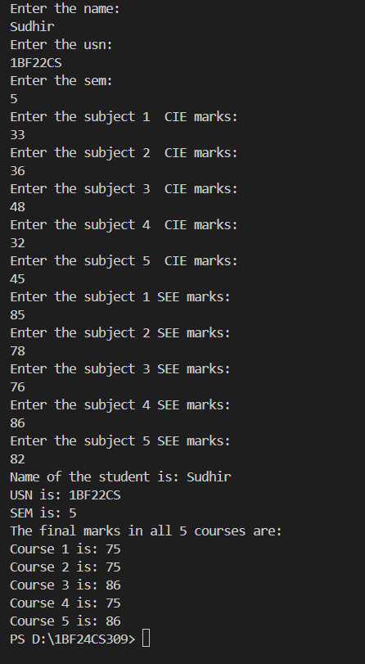

Program 7:
Handling age Exception

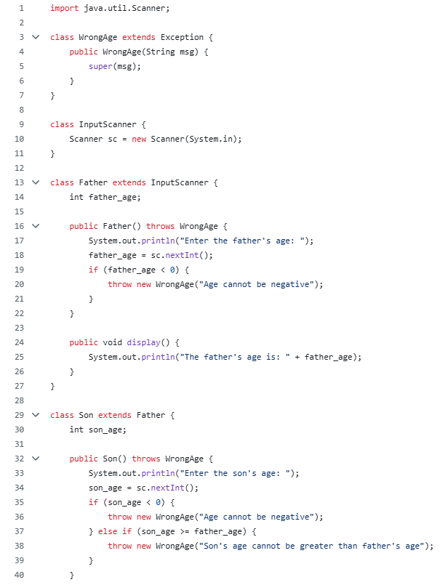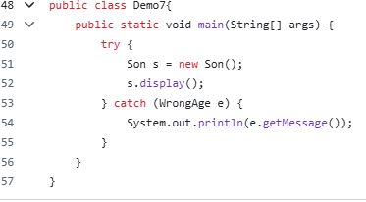
Output:

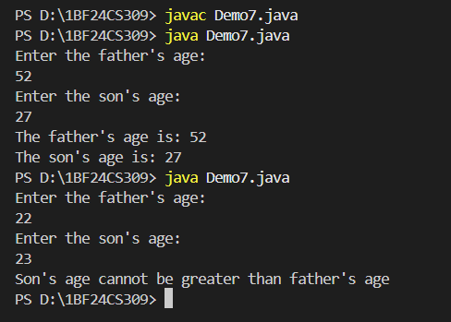

Program 8:
Using Threads
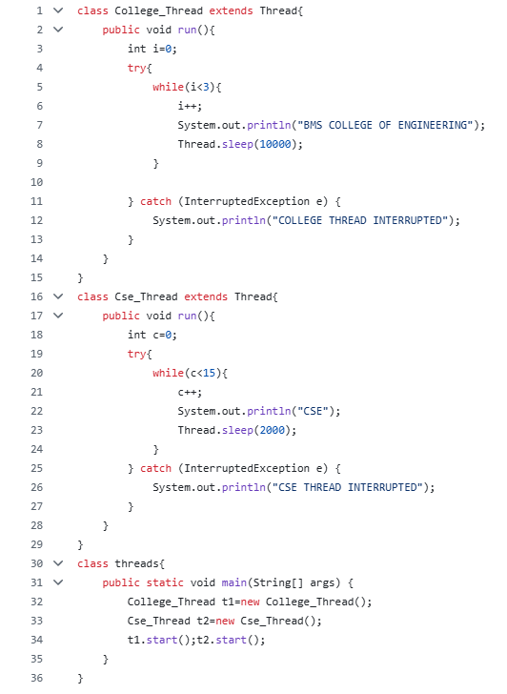

Output:

