## VISVESVARAYA TECHNOLOGICAL UNIVERSITY



#### BELAGAVI, KARNATAKA

**INTERNSHIP TRAINING REPORT**

**ON**

# “ARTIFICIAL INTELLIGECE AND MACHINE LEARNING”

***A report submitted in the partial fulfillment of the requirements for the award of the degree of***

***Bachelor of Engineering In***

***Information Science & Engineering***

***Submitted by***

## SURYANSH KUMAR SRIVASTAVA 1SG20IS100

**DEPARTMENT OF INFORMATION SCIENCE & ENGINEERING**

## SAPTHAGIRI COLLEGE OF ENGINEERING

**Bengaluru-57**

### 2023-24

**SRI SRINIVASA EDUCATIONAL AND CHARITABLE TRUST®**

**SAPTHAGIRI COLLEGE OF ENGINEERING**

**(Affiliated to Visvesvaraya Technological University, Belagavi and Approved by AICTE, NewDelhi) (Accredited by NAAC with “A” grade)(NBA Accredited-CSE, ECE, EEE, ISE, ME)**

**(An ISO9001:2015 & ISO14001:2015 Certified)**



### Department of Information Science & Engineering

Certificate

Certified that the Internship work entitled **ARTIFICIAL INTELLIGENCE AND MACHINE LEARNING** carried out by **Suryansh Kumar Srivastava (1SG20IS100)** bonafide student of 8th semester, Department of **Information Science & Engineering**, Sapthagiri College of Engineering, Bengaluru in partial fulfillment of the award of **Bachelor of Engineering** in **Information Science & Engineering** of the **Visvesvaraya Technological University,** Belagavi during the year 2023-24. It is certified that all corrections/suggestions indicated for Internal Assessment have been incorporated in the Report deposited in the departmental library. The Internship report has been approved as it satisfies the academic requirements in respect of Internship work prescribed for the said Degree.

**Prof. Gayathri R Signature of the Guide**

**Dr. H R Ranganatha Signature of the HOD**

**Dr. H Ramakrishna Signature of the Principal**

**Name of the Examiners Signature with date 1.**

**2.**

#### ABSTRACT

This machine learning training provides a comprehensive overview of the principles and practices of machine learning, a rapidly growing field that has transformed the way we approach problem-solving in various industries. Through a combination of theoretical lectures and hands-on exercises, participants will learn how to build intelligent systems that can analyze, learn, and make predictions based on data. The training covers a wide range of topics, including supervised and unsupervised learning, neural networks, deep learning, feature engineering, model evaluation, hyperparameter tuning, and model deployment. Participants will also learn about the ethical considerations involved in machine learning, including issues like bias, fairness, and privacy. By the end of this training, I have gained a strong foundation in machine learning, as well as practical experience working with popular tools and frameworks such as Python, scikit-learn, and TensorFlow.

**ACKNOWLEDGEMENT**

Any achievement doesn’t depend solely on the individual efforts but on the guidance, encouragement and co-operation of intellectuals, elders and friends. A number of personalities have helped us. I would like to take this opportunity to thank them all.

I would like to express our heart-felt gratitude to **Dr. H Ramakrishna**, Principal, Sapthagiri College of Engineering, Bengaluru, for his help and inspiration during the tenure of the course.

It is great privilege to extend my deep sense of gratitude to **Dr. H R Ranganatha**, Head of the Department, Information Science and Engineering, Sapthagiri College of Engineering, Bengaluru, who patronized throughout my career, for his constant support and encouragement and for the facilities provided to carry out this work successfully.

I also extend my thanks to **Prof. Ambika S,** Internship Coordinator, Dept. of ISE, S.C.E., Bengaluru for their kind cooperation.

With profound sense of gratitude, I acknowledge the guidance and support extended by **Prof. Gayathri R**, Assistant Professor, Department of Information Science & Engineering, S.C.E., Bengaluru. Her incessant encouragement and valuable technical support have been of immense help in realizing this internship. Her guidance gave us the environment to enhance our knowledge, skills and to reach the pinnacle with sheer determination, dedication, and hard work.

I also extend my sense of gratitude and sincere thanks to all faculty members and non- teaching staff members of Information Science and Engineering, Sapthagiri College of Engineering, Bengaluru for their views and encouraging ideas.

**SURYANSH KUMAR SRIVASTAVA (1SG20IS100)**

**TABLE OF CONTENTS**

|  |  |  |  |  |
| --- | --- | --- | --- | --- |
| 1 |  |  | **INTRODUCTION** | **1** |
|  | 1.1 |  | Introduction about the Company | 1 |
|  |  | 1.1.1 | Vision | 1 |
|  |  | 1.1.2 | Mission | 2 |
|  |  | 1.1.3 | Values | 2 |
|  |  | 1.1.4 | Quality Policy | 2 |
|  |  | 1.1.5 | Development Sectors | 3 |
|  | 1.2 |  | Company Products and Services Offered | 3 |
|  |  | 1.2.1 | Products | 3 |
|  | 1.3 |  | Overview of the Organization | 4 |
|  |  | 1.3.1 | Services | 4 |
| 2 |  |  | **TASK PERFORMED** | **6** |
|  | 2.1 |  | Learning Experience | 6 |
|  | 2.2 |  | Knowledge Acquired | 6 |
|  | 2.3 |  | Skills Learned | 6 |
|  | 2.4 |  | The Most Challenging Task Performed | 14 |
|  | 2.5 |  | Problem Statement | 15 |
| 3 |  |  | **REFLECTION** | **16** |
|  | 3.1 |  | Prediction of Migraine Classification using K-Nearest Neighbors | 16 |
|  | 3.2 |  | Classification of Ambassador Car and SUV Car | 21 |
| 4 |  |  | **CONCLUSION** | **24** |
| 5 |  |  | **REFERENCES** | **25** |

iii

**LIST OF FIGURES**

|  |  |  |
| --- | --- | --- |
| **Figure No.** | **Figure Name** | **Page No.** |
| 1.1 | Company Logo | 1 |
| 2.1 | Machine Learning Infrastructure | 8 |
| 2.2 | Flow Model of Algorithms of Supervised Learning | 9 |
| 2.3 | Flow Model of Algorithms of Unsupervised | 9 |
|  | Learning |  |
| 2.4 | Flow Model of Algorithms of Reinforcement Learning | 10 |
| 2.5 | Types of Machine Learning Algorithms | 10 |
| 2.6 | Linear Regression | 11 |
| 2.7 | Linear Regression v/s Logistic Regression | 12 |
| 2.8 | Plot of ideal SVM Algorithm | 13 |
| 2.9 | Ideal diagram of a Decision Tree | 14 |
| 3.1 | Dataset | 16 |
| 3.2 | Code Snippet | 18 |
| 3.3 | Confusion Matrix | 18 |
| 3.4 | Home Page Snapshot | 19 |
| 3.5 | Result Snapshot | 20 |
| 3.6 | Code Snippet of Training | 21 |
| 3.7 | Training the Data | 22 |

iv

**Chapter 1**

**INTRODUCTION**

* 1. **Introduction About the Company**

It is pleasure in introducing “Karunadu Technologies Private Limited” as a leading IT software solutions and services industry focusing on quality standards and customer values. It is also a leading Skills and Talent Development company that is building a manpower pool for global industry requirements.



**Fig 1.1: Company Logo**

The company offers broad range of customized software applications powered by concrete technology and industry expertise. It also offers end to end embedded solutions and services. They deal with broad range of product development along with customized features ensuring at most customer satisfaction and also empower individual with knowledge, skills and competencies that assist them to escalate as integrated individuals with a sense of commitment and dedication.

#### 1.1.1 Vision

To Empower Unskilled Individual with knowledge, skills and technical competencies in the field of Information Technology and Embedded engineering which assist them to escalate as integrated individuals contributing to company’s and Nation’s growth.

#### Mission

* + - * Provide cost effective and reliable solutions to customers across various latest technologies.
      * Offer scalable end-to-end application development and management solutions .
      * Provide cost effective highly scalable products for varied verticals.
      * Focus on creating sustainable value growth through innovative solutions and unique partnerships.
      * Create, design and deliver business solutions with high value and innovation by leveraging technology expertise and innovative business models to address long-term business objectives.
      * Keep our products and services updated with the latest innovations in the respective requirement and technology.

#### Values

* To develop software and Embedded solutions and services focusing on quality standards and customer values.
* Offer end to end embedded solutions which ensure the best customer satisfaction.
* To build Skilled and Talented manpower pool for global industry requirements.
* To develop software and embedded products which are globally recognized.
* To become a global leader in Offering Scalable and cost-effective Software solutions and services across various domains like E-commerce, Banking, Finance, Healthcare and more.
* To generate employment for skilled and highly talented youth of our Country INDIA.

#### Quality Policy

To win consumers confidence and loyalty, a company needs to consistently deliver branded products and items of excellent quality. Karunadu Technologies understand the different needs of the consumers and customers and strive to develop and deliver superior brands to ensure that they are the preferred choice. And by applying consistently high standards, they are able to do things right first time, cut waste, reduce costs and drive profitability.

They have strict mandated quality standards in place, and regular audits. Self- evaluations are used to assess compliance. By adhering to these standards, their business produces items that are great in quality, safe, and compliant with all applicable industry and governmental regulations in the places where they operate. They actively engage with their consumers and customers, translating and incorporating their needs and requirements into their products and services.

#### 1.1.5 Development Sectors

Karunadu Technologies is now establishing connections with academic institutions to provide students with the internships and skill-development programs they need to be prepared for the workforce. They have collaborated with educational institutions in and near Karnataka. The main services offered in the Edtech domains include internships, workshops, pre-placement training, industry-focused lab sets, and hands-on skill development using the most recent technology.

They offer services in a variety of industries, such as healthcare, medical equipment, data analysis and visualization, education, vehicle and driving safety solutions, consumer insights, and smart home appliances. They also extend their services in the areas that include creating mobile applications, developing and hosting websites, using automated transcription, and etc.

### Company Products and Services Offered

#### Products

* **KECMS – Karunadu Enterprise Content Management System**

Karunadu Enterprise Content Management System is a one stop solution for all our enterprise content management System relating to digital asset management, document imaging, workflow systems and records management systems. Increasing digitalization has led to an exponential growth in business content and managing this sea of unstructured data is tedious work.

* **KEMS – Karunadu Education Management System**

Manage diversified data relating to education management on cloud. Educational data including students and staff is gathered over years which contain information from admission/appointment until leaving the Education. Statistical reports for the College/school can be generated along with admission Tracking and result analysis to keep track of progressive improvements of both student and staff.

* **KASS – Karunadu Advanced Security System**

A Complete one stop embedded solution for large apartments. Security system which monitors door breakage, window breakage, gas leakage, motion detection and various other features which can be operated and maintained by centralized monitored system. This Embedded solution enhances the security measures of apartment/building and enhances the security of individuals may be from unintended intervention or from unauthorized access.

### Overview of the Organization

**“**Karunadu Technologies Private Limited” is a leading IT software solutions and services industry focusing on quality standards and customer values. It is also a leading Skills and Talent Development company that is building a manpower pool for global industry requirements.

The company offers broad range of customized software applications powered by concrete technology and industry expertise. It also offers end to end embedded solutions and services. They deal with broad range of product development along with customized features ensuring at most customer satisfaction and also empower individual with knowledge, skills and competencies that assist them to escalate as integrated individuals with a sense of commitment and dedication.

#### 1.3.1 Services

* **IT Solutions and Services**

Karunadu Technologies is a Bangalore based IT Training and Software Development center with an exclusive expertise in the area of IT Services and Solutions. Karunadu Technologies Pvt. Ltd. is also expertise in Web Designing and Consulting Services.

* **Embedded Design and Development**

Karunadu Technologies Pvt. Ltd. has expertise in Design and development of embedded products and offers solutions and services in field of Electronics.

* **Academic Projects**

Karunadu Technologies Pvt. Ltd. helps students in their academics by imparting industrial experience into projects to strive excellence of students. Karunadu Technologies Pvt. Ltd. encourages students to implement their own ideas to projects keeping in mind "A small seed sown upfront will be nourished to become a large tree one day”, thereby focusing the future entrepreneurs. They have a wide range of IEEE projects for B.E, MTech, MCA, BCA, DIPLOMA students for all branches in each and every domain.

* **Embedded Design and Development**

Karunadu Technologies Pvt. Ltd. has expertise in Design and development of embedded products and offers solutions and services in field of Electronics.

* **Academic Projects**

Karunadu Technologies Pvt. Ltd. helps students in their academics by imparting industrial experience into projects to strive excellence of students. Karunadu Technologies Pvt. Ltd. encourages students to implement their own ideas to projects keeping in mind "A small seed sown upfront will be nourished to become a large tree one day”, thereby focusing the future entrepreneurs. They have a wide range of IEEE projects for B.E, MTech, MCA, BCA, DIPLOMA students for all branches in each and every domain.

* **Implant Training**

Karunadu Technologies Pvt. Ltd. provides Implant training for students according to the interest of students keeping in mind the current technology and academic benefit one obtains after completing the training. Students will be nourished and will be trained throughout with practical experience. Students will be exposed to industrial standards which boost their carrier. Students will become Acquaint to various structural partitions such as labs, workshops, assembly units, stores, and administrative unit and machinery units. They help students to understand their functions, applications and maintenance. Students will be trained from initial stage that is from collection of Project Requirements, Project Planning, Designing, implementation, testing, deployment and maintenance there by helping to understand the business model of the industry. Entire project life cycle will be demonstrated with hands on experience. Students will also be trained about management skills and team building activities.

* **Software Courses**

Karunadu Technologies Pvt. Ltd. provides courses for students according to the interest of students keeping in mind the current technology and assist them for their further Employment. Company provides various courses such as C, C++, VB, DBMS, Dot Net, Core Java and J2EE along with live project. These courses serve as the foundation for students to develop proficiency in software development, covering fundamental programming principles, database management, web development frameworks, and enterprise-level application architecture. Emphasizing practical learning, the company offers opportunities for students to engage in live projects, enabling them to apply theoretical knowledge to real-world scenarios. Through hands-on experience and expert guidance, students not only acquire technical skills but also gain valuable insights into industry best practices.

## CHAPTER 2

# TASKS PERFORMED

### Learning Experience

The value that I have gained is to always work hard even if the task is small and it seems unimportant. It helped me to build a good work idea, and the effort could be seen. My co-workers had a lot of experience I have talked to them and asked for some advice they have for me. I could learn a lot and get more ideas. I think this internship is extremely cherished by me. The internship enhanced my skill and ability to work in a team.

It also means that we have learned many things. My strength in the internship is that I am a good team builder. As a member of the team, I am responsible in group discussions and giving my own opinions. If there was anything that I am not able to understand I would ask, besides I am a cooperative person.

### Knowledge Acquired

The knowledge I have gained in our training is about Artificial Intelligence and Machine Learning. I have learnt many things about the science of collecting, analyzing and preprocessing raw data to train my machine learning model effectively. Machine learning models can process vast amounts of data quickly and accurately, making it possible to analyze and understand complex data sets that would be impossible for humans to process on their own. Machine learning models can make accurate predictions and forecasts based on historical data, allowing businesses to make informed decisions and plan for the future.

It has been a great technical learning experience as it is thought to me a lot about various machine learning algorithms and appropriate use of it really improved my technical knowledge and skills.

### Skills Learned

I have learned to work well in a team. Another side that I learned throughout my internship is to never be afraid to ask doubts. By asking questions I got answers. I learnt to read the use cases and understand the need and analyze the problem and find a solution to it. I had worked on projects in groups and group discussion helped me a lot in finding the solution because teamwork helps to get more ideas. Internships give students the hands-on experience they need.

#### Python

Python is a multiparadigm, general-purpose, interpreted, high-level programming language. Python allows programmers to use different programming styles to create simple or complex programs, get quicker results and write code almost as if speaking in a human language.

#### NumPy

NumPy is basic package for scientific computing. It is the python language implementation which includes powerful N-dimensional array structure, sophisticated functions, Tools that can be integrated into C/C++ and Fortran code, Linear algebra, Fourier transform and Random number features. Besides its obvious scientific uses, NumPy can also be used as an efficient multidimensional container of generic data.

#### Pandas

Pandas Data Frame is two-dimensional size-mutable, potentially heterogeneous tabular data structure with labelled axes (rows and columns). A Data frame is a two-dimensional data structure, i.e., data is aligned in a tabular fashion in rows and columns. Pandas Data Frame consists of three principal components, the data, rows, and columns.

#### Matplotlib

Matplotlib is a very popular Python library for data visualization. Like Pandas, it is not directly related to Machine Learning. It particularly comes in handy when a programmer wants to visualize the patterns in the data. It is a 2D plotting library used for creating 2D graphs and plots. A module named pyplot makes it easy for programmers for plotting as it provides features to control line styles, font properties, formatting axes, etc. It provides various kinds of graphs and plots for data visualization, viz., histogram, error charts, bar charts, etc.

#### Machine Learning

Machine learning (ML) is a type of artificial intelligence (AI) that allows software applications to become more accurate at predicting outcomes without being explicitly programmed to do so. Machine learning algorithms use historical data as input to predict new output values. The Fig 2.1 shows the machine learning workflow: data is collected, processed, used to train a model, deployed, and then monitored for continued accuracy.

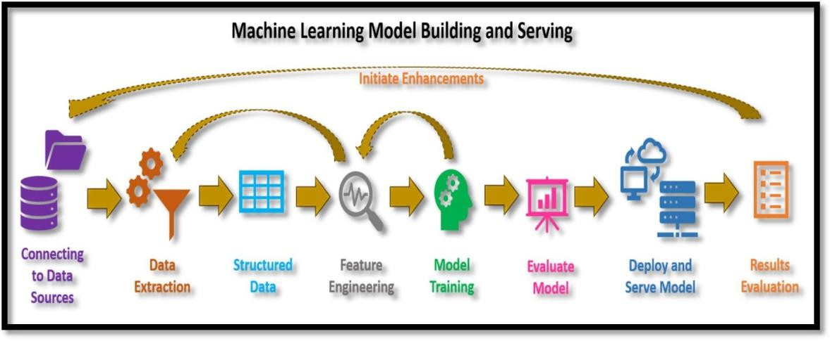

#### Fig 2.1: Machine Learning Infrastructure

* + 1. **Types of Machine Learning**
       - **Supervised learning**

Supervised learning is a type of machine learning method in which we provide sample labelled data to the machine learning system in order to train it, and on that basis, it predicts the output. The system creates a model using labelled data to understand the datasets and learn about each data, once the training and processing are done then we test the model by providing a sample data to check whether it is predicting the exact output or not.

The goal of supervised learning is to map input data with the output data. The supervised learning is based on supervision, and it is the same as when a student learns things in the supervision of the teacher. The example of supervised learning is **spam filtering**. The Fig 2.2 outlines the two main categories of supervised learning algorithms: regression and classification. Regression algorithms, like linear regression or random forest, excel at predicting continuous values, such as weather patterns or stock prices. Classification algorithms, on the other hand, focus on predicting categorical outputs, like image recognition (identifying objects in a picture) or spam filtering (separating legitimate emails from unwanted messages). Examples of classification algorithms include logistic regression and decision trees. The diagram also acknowledges convolutional neural networks (CNNs) in the lower right corner, which are powerful tools that can be applied to both regression and classification tasks.

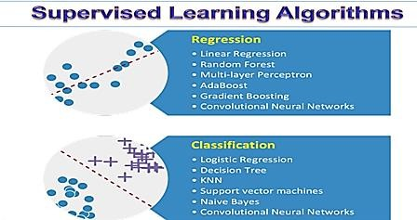

**Fig 2.2: Flow Model of Algorithms of Supervised Learning**

#### Unsupervised Learning

Unsupervised learning is the training of machine using information that is neither classified nor labelled and allowing the algorithm to act on that information without guidance. Here the task of machine is to group unsorted information according to similarities, patterns and differences without any prior training of data. Unlike supervised learning, no teacher is provided that means no training will be given to the machine. Therefore, machine is restricted to find the hidden structure in unlabeled data by our-self. For instance, suppose it is given an image having both dogs and cats which have not seen ever. Thus, machine has no any idea about the features of dogs and cat so we can’t categorize it in dogs and cats. But it can categorize them according to their similarities, patterns and differences as shown in Fig 2.3.

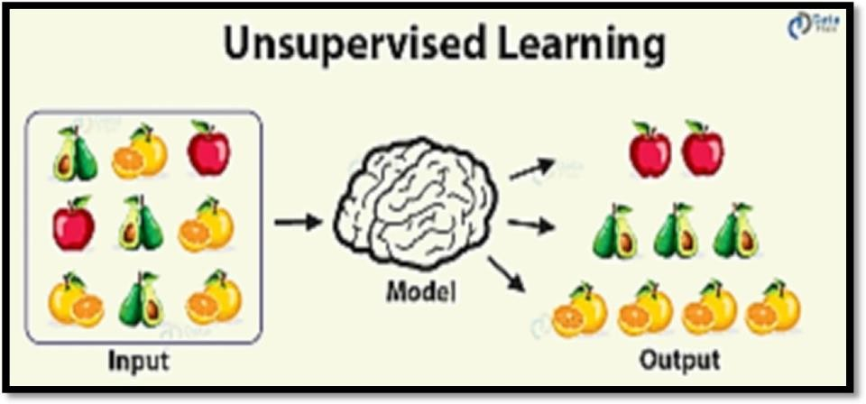

**Fig 2.3: Flow Model of Algorithms of Unsupervised Learning**

#### Reinforcement Learning

Fig 2.4 depicts flow model of algorithms of Reinforcement learning. It is an area of Machine Learning. It is about taking suitable action to maximize reward in a particular situation. It is employed by various software and machines to find the best possible behavior or path it should take in a specific situation. Reinforcement learning differs from the supervised learning in a way that in supervised learning the training data has the answer key with it so the model is trained with the correct answer itself whereas in reinforcement learning, there is no answer but the reinforcement agent decides what to do to perform the given task. In the absence of training dataset, it is bound to learn from its experience.

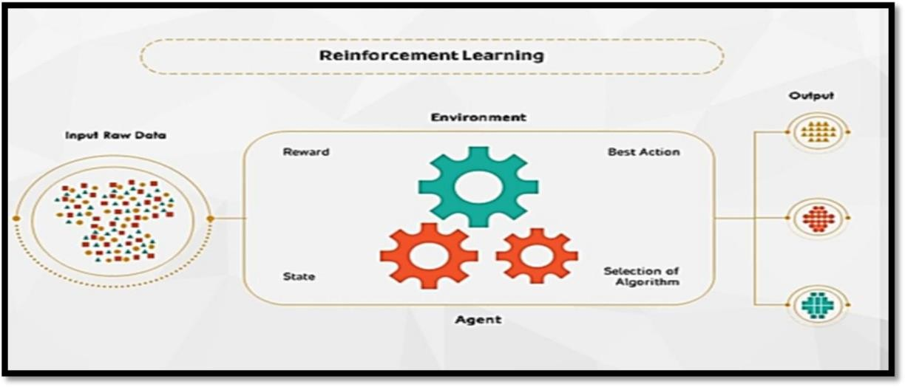

**Fig 2.4: Flow Model of Algorithms of Reinforcement Learning**

#### Machine Learning Algorithms

Machine learning is an application of artificial intelligence (AI) that provides systems the ability to automatically learn and improve from experience without being explicitly programmed. Machine learning focuses on the development of computer programs that can access data and use it learn for themselves as shown in Fig 2.5.

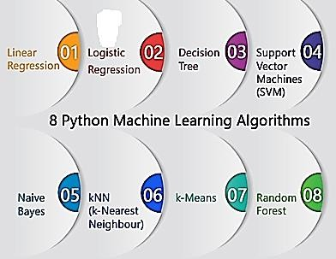

**Fig 2.5: Types of Machine Learning Algorithms**

#### Linear Regression

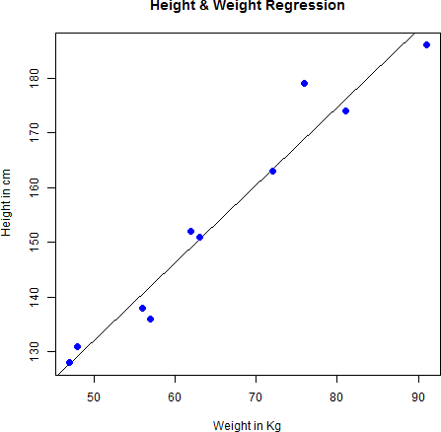It is one of the most widely known modeling technique. Linear regression is usually among the first few topics which people pick while learning predictive modelling. In this technique, the dependent variable is continuous, independent variable(s) can be continuous or discrete, and nature of regression line is linear. Linear Regression establishes a relationship between dependent variable (Y) and one or more independent variables(X) using a best fit straight line (also known as regression line) as shown in Fig 2.6.It is represented by an equation Y=a+b*X + e, where a is intercept, b is slope of the line and e is error term. This equation can be used to predict the value of target variable based on given predictor variable.

**Fig 2.6: Linear Regression**

#### Multiple Linear Regression

In many cases, there may be possibilities of dealing with more than one predictor variable for finding out the value of the response variable. Therefore, the simple linear models cannot be utilized as there is a need for undertaking multiple linear regression for analyzing the predictor variables. The difference between simple linear regression and multiple linear regression is that, multiple linear regression has more than 1 independent variables, whereas simple linear regression has only 1 independent variable. Using the two explanatory variables, we can delineate the equation of multiple linear regression as follows:

𝑦𝑖 = 𝑏0 + 𝑏1𝑥1 + 𝑏𝑥2 + 𝑒𝑖

#### Logistic Regression

Logistic regression is a statistical model that in its basic form uses a logistic function to model a binary dependent variable, although many more complex extensions exist. In regression analysis, logistic regression is estimating the parameters of a logistic model (a form of binary regression). The Fig 2.7 is a comparison of logistic regression and linear regression. Mathematically, a binary logistic model has a dependent variable with two possible values, such as pass/fail which is represented by an indicator variable, where the two values are labelled "0" and "1". In the logistic model, the log-odds (the logarithm of the odds) for the value labelled "1" is a linear combination of one or more independent variables ("predictors"); the independent variables can each be a binary variable (two classes, coded by an indicator variable) or a continuous variable (any real value). The corresponding probability of the value labelled "1" can vary between 0 (certainly the value "0") and 1 (certainly the value "1"), hence the labelling, the function that converts log-odds to probability is the logistic function, hence the name. The unit of measurement for the log-odds scale is called a logit, from logistic unit, hence the alternative names. Analogous models with a different sigmoid function instead of the logistic function can also be used, such as the profit model; the defining characteristic of the logistic model is that increasing one of the independent variables multiplicatively scales the odds of the given outcome at a constant rate, with each independent variable having its own parameter; for a binary dependent variable this generalizes the odds ratio.

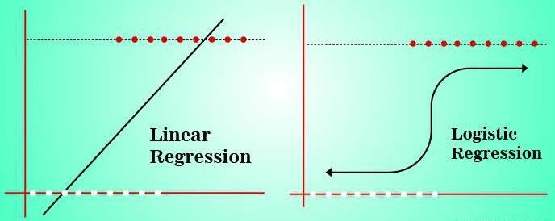

**Fig 2.7: Linear Regression v/s Logistic Regression**

#### K Nearest Neighbor (KNN)

K nearest neighbors or KNN Algorithm is a simple algorithm which uses the entire dataset in its training phase. Whenever a prediction is required for an unseen data instance, it searches through the entire training dataset for k-most similar instances and the data with the most similar instance is finally returned as the prediction. KNN is often used in search applications where you are looking for similar items, like find items similar to this one.

#### Support Vector Machine (SVM)

“Support Vector Machine” (SVM) is a supervised machine learning algorithm that can be used for both classification and regression challenges. Fig 2.8 represents the plot of ideal SVM algorithm. However, it is mostly used in classification problems. In the SVM algorithm, we plot each data item as a point in n- dimensional space (where n is a number of features you have) with the value of each feature being the value of a particular coordinate.

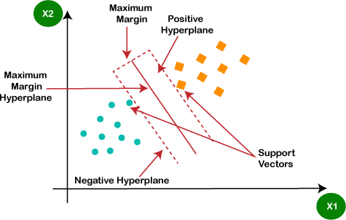

#### Decision Tree

**Fig 2.8: Plot of ideal SVM Algorithm**

Decision Tree is a **supervised learning technique** that can be used for both classification and Regression problems, but mostly it is preferred for solving Classification problems. It is a tree-structured classifier, where **internal nodes represent the features of a dataset, branches represent the decision rules** and **each leaf node represents the outcome.** It is a graphical representation for getting all the possible solutions to a problem/decision on based on given conditions as shown in Fig 2.9.

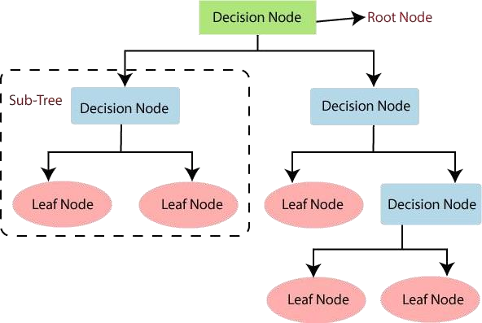

**Fig 2.9: Ideal diagram of a Decision Tree**

### The Most Challenging Task Performed

During my tenure in artificial intelligence and machine learning, honing resilience and patience was paramount, especially when confronted with complex tasks. Among these challenges, **refining prediction models for migraine** classification using the K-Nearest Neighbors (KNN) algorithm stood out as particularly demanding. This endeavor necessitated a deep understanding of the intricate nuances within migraine data and the precise calibration of KNN parameters to achieve optimal classification accuracy. Similarly, **distinguishing between SUVs and Ambassador cars** presented its own unique set of obstacles, including variations in size, shape, and design elements. Overcoming these challenges demanded a resilient mindset, coupled with a patient approach to fine-tune algorithms and navigate through diverse datasets effectively. Balancing the intricacies of both projects demanded a comprehensive understanding of machine learning algorithms, data preprocessing techniques, and model evaluation methods. Overall, overcoming these challenges required perseverance, critical thinking, and continuous experimentation to deliver effective solutions in both projects.

### Problem Statement

**Migraine Prediction using K Nearest Neighbors:**

* Training the Model based on the data collected and processed.
* Develop a machine learning model utilizing K Nearest Neighbors to classify migraine based on their characteristics.
* Address challenges such as class imbalance, noisy data, and parameter optimization to build an accurate and robust classification system. Ultimately, the goal is to aid in drug discovery and development processes by automating the classification of compounds into relevant categories.

**Ambassador Car and SUV Car Classification in Images:**

* Create an artificial intelligence system capable of accurately distinguishing between images of Ambassador and SUV car.
* The project involves training to recognize key visual features that differentiate between the two types of cars.
* These algorithms analyze various features of the vehicles, such as engine power, size, shape, and historical data, to categorize them accurately. For instance, SUVs typically have higher ground clearance and larger cargo space compared to sedans like the Ambassador.
* By training AI models on labeled datasets, we can develop robust classification systems that automatically distinguish between these two types of vehicles with high accuracy, aiding in inventory management, market analysis, and customer recommendation systems for automotive companies.

## CHAPTER 3

**REFLECTIONS**

#### Prediction of Migraine Classification using K Nearest Neighbors

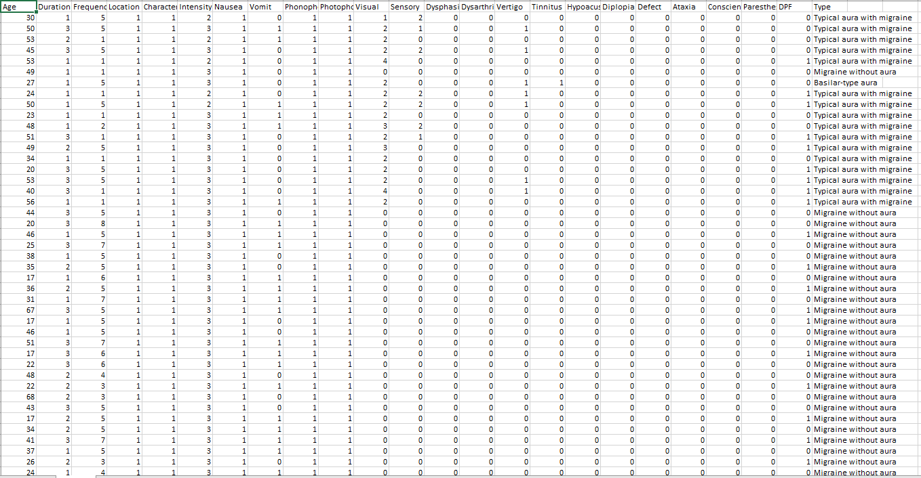

**Fig 3.1: Dataset**

Fig 3.1 table containing data about patient details. The table includes the following columns:

* Age: This appears to be the age of the person who experienced the migraine.
* Duration: This is the duration of the migraine in hours.
* Frequency: This is the frequency of the migraine, indicated by a number but it doesn't specify the time unit (e.g., days, weeks, months).
* Location: This is the location of the pain in the head. It appears to be coded, with "1" indicating left.
* Intensity: This is the intensity of the pain on a scale of 0 to 4, with 0 being no pain and 4 being the worst pain imaginable.
* Nausea: This is a binary field indicating whether or not the person experienced nausea (1 for yes, 0 for no).
* Vomit: This is a binary field indicating whether or not the person vomited (1 for yes, 0 for no).
* Phonophobia: This is a binary field indicating whether or not the person experienced phonophobia (sensitivity to sound) (1 for yes, 0 for no).
* Photophobia: This is a binary field indicating whether or not the person experienced photophobia (sensitivity to light) (1 for yes, 0 for no).
* Visual: This appears to be a code for visual symptoms. It isn't possible to tell from the data what the codes mean.
* Sensory: This appears to be a code for sensory symptoms. It isn't possible to tell from the data what the codes mean.
* Dysphasia: This is a binary field indicating whether or not the person experienced dysphasia (difficulty speaking) (1 for yes, 0 for no).
* Dysarthria: This is a binary field indicating whether or not the person experienced dysarthria (difficulty slurring words) (1 for yes, 0 for no).
* Vertigo: This is a binary field indicating whether or not the person experienced vertigo (dizziness) (1 for yes, 0 for no).
* Tinnitus: This is a binary field indicating whether or not the person experienced tinnitus (ringing in the ears) (1 for yes, 0 for no).
* Hypoacusis: This is a binary field indicating whether or not the person experienced hypoacusis (hearing loss) (1 for yes, 0 for no).

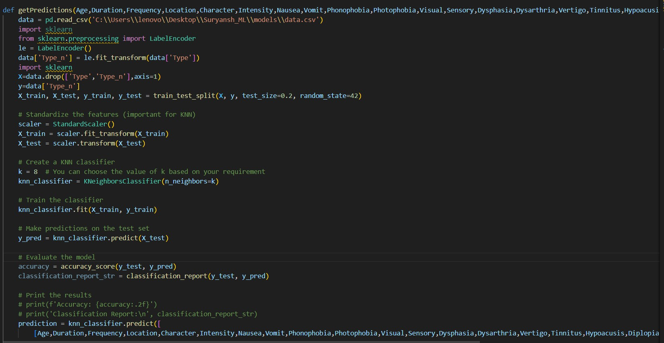

**Fig 3.2: Code Snippet**

Fig 3.2 represents the code snippet seems to be training a K-Nearest Neighbors (KNN) classification model to predict patient migraines. In this case, the model is likely trying to predict the types of migraines from the training data.

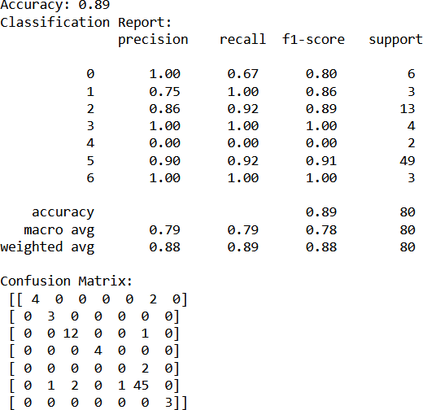

**Fig 3.3: Confusion Matrix**

The confusion matrix is a table that shows the number of correct and incorrect predictions made by the model. In this case, the model is trying to predict the type of migraine . The Fig.3.3 sent is showing the results of a machine learning classification task. The table shows the accuracy, precision, recall, F1-score, and support for each class, as well as the confusion matrix.

* Accuracy: 0.89
* Precision: This is a measure of how many times a model correctly predicted a positive case. A high precision means that most of the positive predictions were correct.
* Recall: This is a measure of how many times the model correctly identified all positive cases. A high recall means that the model didn't miss many positive cases.
* F1-Score: This is a harmonic mean of precision and recall. A high F1-score means that the model balanced both precision and recall well.
* Support: This is the number of data points for each class.

The confusion matrix shows that the model is more accurate at predicting type of migraines. It is important to consider the trade-off between precision and recall when evaluating a classification model. A high precision means that the model is good at not making false positive predictions, but a low recall means that the model is missing some of the true positive cases.

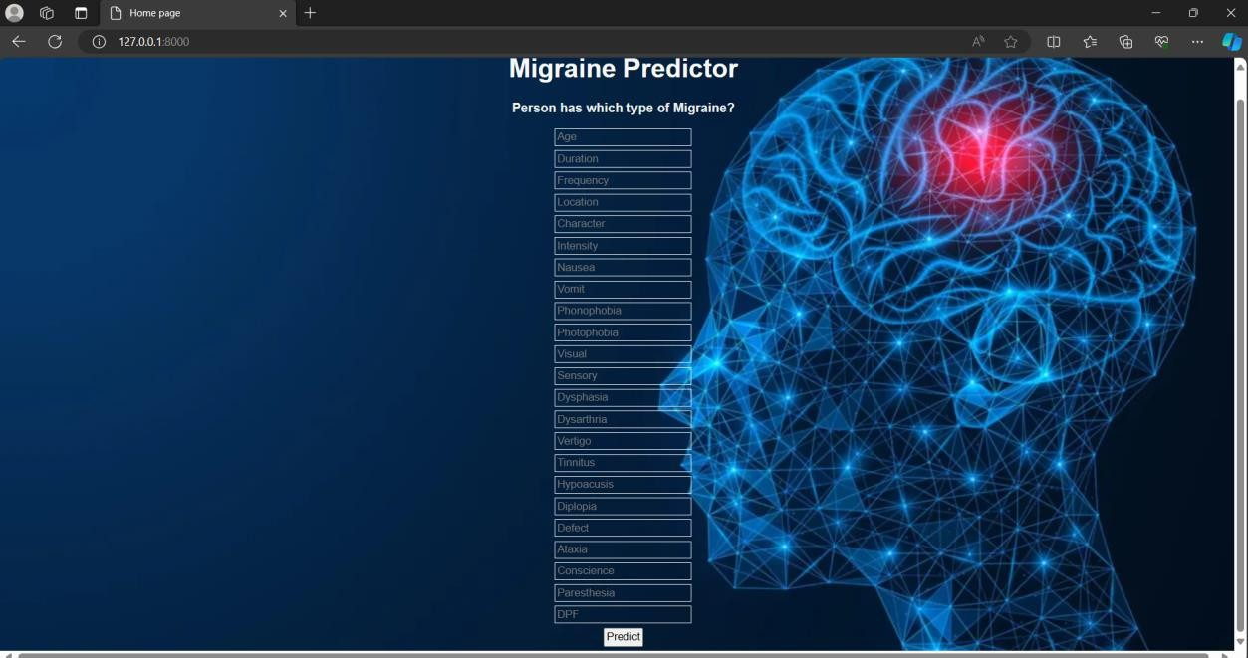

**Fig 3.4: Home Page Snapshot**

The dataset used in this project consists of many variables: Age, Duration, Frequency, Location, Intensity, Nausea, Vomit, Phonophobia, Photophobia, Visual, Sensory, Dysphasia, Dysarthria, Vertigo, Tinnitus, Hypoacusis, Diplopia, Defect, Ataxia, Consciousness, Paresthesia, DPF, Type inputs given as shown in Fig 3.4.

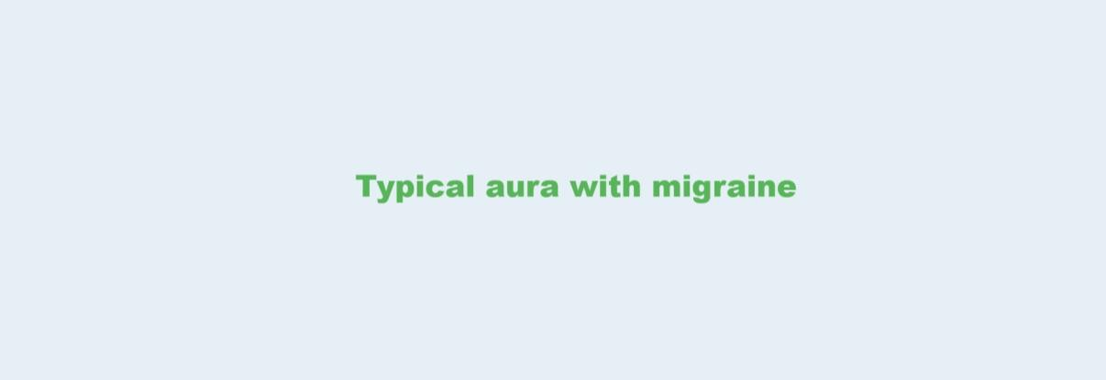

**Fig 3.5: Result Snapshot**

Based on the input parameters provided in the Fig 3.4 we developed a model that has the capacity of predicting fracture by making use of the information provided in data.csv Dataset as shown in Fig 3.5.

By analyzing information within the data.csv dataset, we developed a migraines prediction model. This model, built upon the input parameters outlined in Fig 3.4, has the capability to forecast potential migraines. This development holds significant promise for preventative measures, allowing for early intervention and improved patient outcomes. Leveraging the input parameters defined in Fig 3.4, a fracture prediction model was constructed that analyzes data from the data.csv dataset to forecast potential migraines.

* 1. **Classification of Ambassador Car and SUV Car**

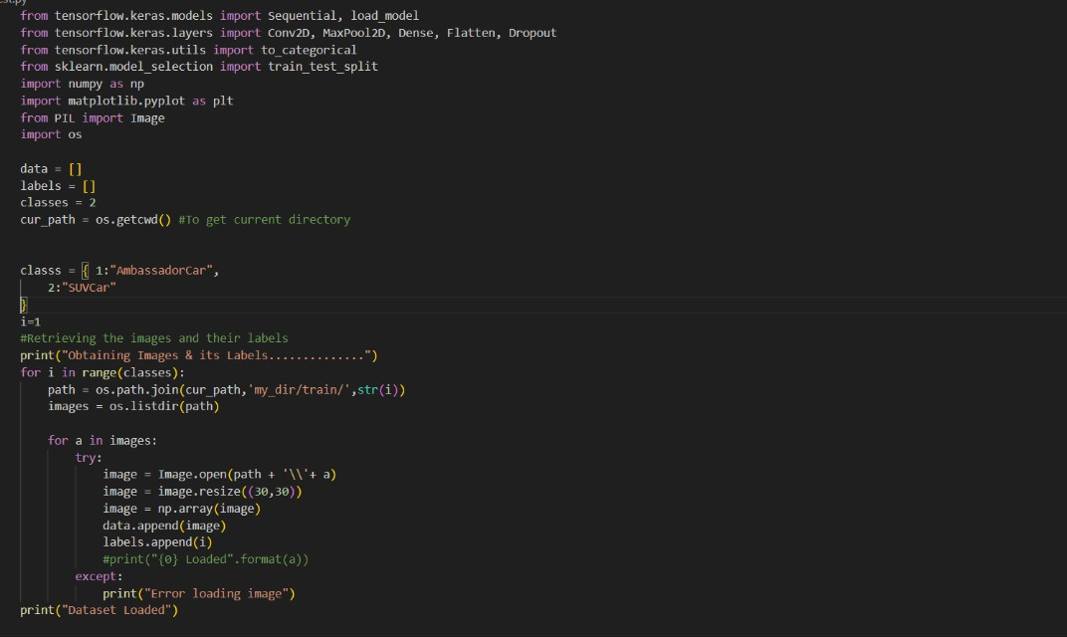

**Fig 3.6: Code Snippet of Training**

By feeding it a massive dataset of labelled images containing both Ambassadors and SUVs, the system can learn to distinguish between them based on key visual features. These features include the overall size and shape of the car, with SUVs being generally larger and boxier than the classic Ambassador. But the most telling difference comes from ground clearance. SUVs sit significantly higher off the ground compared to sedans like the Ambassador. The AI system analyzes these features and others, like grille design and roofline, to learn the patterns that differentiate the two car types.

Once trained, the magic happens. The AI can then analyze completely new, unseen images and categorize them as either Ambassador or SUV with impressive accuracy. This translates to real-world benefits, particularly for businesses managing car inventory. Imagine a dealership or rental company no longer needing to manually sort through photos – the AI can do it automatically, saving time and resources. By adding new features and training data, the AI's capabilities can keep expanding, making car image organization a breeze.

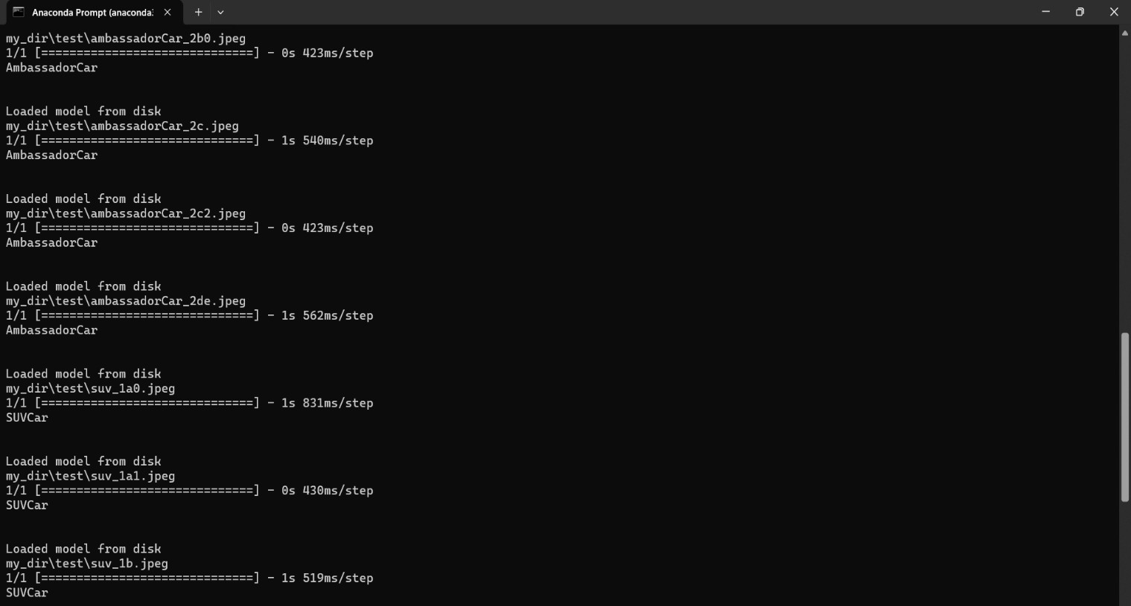

**Fig 3.7: Training the Data**

The Fig. 3.7 is a screenshot of a command line window, likely showing the output of running the Python training code. An epoch refers to one complete pass through the entire training dataset. Here's an explanation of some of the elements seen in each line:

* **Epoch [number]**: This specifies the current epoch number (e.g., Epoch 81).
* **Os/Bs [time]**: This indicates the operating system (Os) or batch size (Bs) followed by the time taken per step in the epoch.
* **loss**: This refers to the loss function, a measure of how well the model's predictions deviate from the ground truth. Lower loss indicates better performance.
* **accuracy**: This represents the model's accuracy, the proportion of correct predictions made on a set of data.
* **val loss/val_accuracy**: These indicate the loss and accuracy on the validation set, a portion of the data used to monitor the model's generalization ability during training.

The values you see here suggest that the model is performing well with a very low loss value and high accuracy on both the training and validation sets. As the epochs progress, the loss decreases and the accuracy increases, signifying that the model is learning to classify air cooler images accurately.

By above all the Reflections.

**1. K Nearest Neighbors (KNN) for Classification:**

The project applies KNN, a machine learning algorithm, to classify data points based on their similarity to labeled data points.

**2. Challenges in Machine Learning Projects:**

The project highlights common challenges faced in machine learning projects, including:

Class Imbalance: When data for one class is significantly less than others.

Noisy Data: Data containing errors or inconsistencies.

Parameter Optimization: Tuning the parameters of a model to achieve the best performance.

**3. Machine Learning in Drug Discovery:**

The project showcases how machine learning can be used to automate the classification of compounds in drug discovery, potentially speeding up the process.

**4. Machine Learning in Image Recognition:**

The project demonstrates how machine learning can be used to train AI models to distinguish between different objects in images, such as car types.

**5. Applications of Machine Learning:**

The project showcases how machine learning can be applied in various industries, including:

Pharmaceuticals: Drug discovery and development.

Automotive: Inventory management, market analysis, and customer recommendations.

## CHAPTER 4

# CONCLUSION

In conclusion, the training on artificial intelligence and machine learning has provided me with a comprehensive understanding of how to prepare data, build models and evaluate their performance through hands-on exercises and projects. I have learned the basics of supervised and unsupervised learning and explored various algorithms such as decision tree, random forest and neural networks.

It is important to remember that artificial intelligence and machine learning is a constantly evolving field and there is always more to learn. However, by understanding the fundamental concepts and techniques covered in the training, we will be well-equipped to tackle a wide range of machine learning problems. Furthermore, we have a solid foundation on which we can continue to build our knowledge and skills in artificial intelligence and machine learning.

## CHAPTER 5

# REFERENCES

**BOOKS**

[1] "The Hundred-Page Machine Learning Book" by Andriy Burkov.

[2] "Hands-On Machine Learning with Scikit-Learn and TensorFlow" by Aurélien Géron.

[3] "Deep Learning" by Ian Goodfellow, Yoshua Bengio, and Aaron Courville.

[4] "Python Machine Learning" by Sebastian Raschka and Vahid Mirjalili.

**WEBSITES**

* https://[www.tensorflow.org/learn](http://www.tensorflow.org/learn)
* https://[www.kaggle.com/learn/machine-learning](http://www.kaggle.com/learn/machine-learning)
* https://machinelearningmastery.com/