Week 3 Task: Advanced Data Analysis
and Visualization in Logistics
Exploratory Data Analysis using Python

1. Executive Summary
This project analyzes 600 simulated shipment records using Python, Pandas, NumPy and Matplotlib. It explores delivery time, shipment volume, distance, transport cost, delays, transport modes and regions. The mean delivery time is 10.41 days and the median is 10.01 days. Mean transport cost is 545.01 hypothetical units, while distance and cost have a correlation of 0.64. These results demonstrate an EDA workflow and are not real-world logistics benchmarks.

2. Objectives
- Define a hypothetical logistics dataset and describe its variables.
- Calculate central tendency, distributions and correlations.
- Create charts for trends, comparisons and relationships.
- Interpret patterns to identify potential cost drivers and bottlenecks.
- Document reusable Python code, recommendations and limitations.

3. Dataset and Simulation
The dataset is synthetically generated with a fixed random seed for reproducibility. Each row represents one shipment. Delivery time is influenced in the simulation by distance, mode, region, carrier and random variation. Cost is generated from distance, volume, transport-mode assumptions and random variation. A few missing cost and distance values are added to demonstrate quality checks. No real company data is used.
Variable | Type | Description
shipment_id | ID | Unique shipment
region | Category | North, South, East, West, Central
carrier | Category | Carrier A, B or C
transport_mode | Category | Road, Rail or Air
shipment_volume_units | Integer | Units in shipment
distance_km | Numeric | Route distance
delivery_time_days | Numeric | Simulated delivery duration
transport_cost | Numeric | Hypothetical cost units
delay_days | Numeric | Delay relative to simulated baseline
on_time_delivery | Boolean | Simulated on-time status

4. Methodology
- Generate 600 reproducible records and export a CSV snapshot.
- Inspect row/column counts, data types, missing values and sample records.
- Use describe(), mean() and median() for descriptive statistics.
- Use a histogram to assess delivery-time distribution.
- Use bar charts to compare costs by mode and delays by region.
- Use a scatter plot and correlation matrix to explore numeric relationships.
- Interpret patterns cautiously; correlation does not prove causation.

5. EDA Results and Visualizations
Missingness: 5 transport-cost values and 3 distance values are missing. Pandas summary functions skip missing values by default. For operational use, investigate why data is missing and avoid filling values without a defensible rule.
Descriptive statistics for numeric variables:
Metric | Count | Mean | Std dev | Median | Maximum
shipment_volume_units | 600 | 17.20 | 9.75 | 17.00 | 34.00
distance_km | 597 | 560.38 | 250.08 | 563.40 | 1253.20
delivery_time_days | 600 | 10.41 | 5.79 | 10.01 | 25.67
transport_cost | 595 | 545.01 | 174.40 | 524.99 | 1073.72
delay_days | 600 | 4.75 | 4.23 | 5.03 | 15.59

5.1 Delivery-time distribution
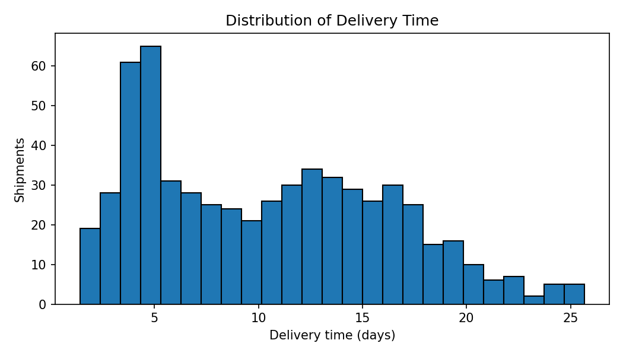
The histogram shows the spread of delivery durations. Mean delivery time is 10.41 days and median is 10.01 days. Comparing them helps identify whether longer deliveries pull the mean upward. Histograms suit continuous variables because they show concentration, spread and skew.

5.2 Average transport cost by mode
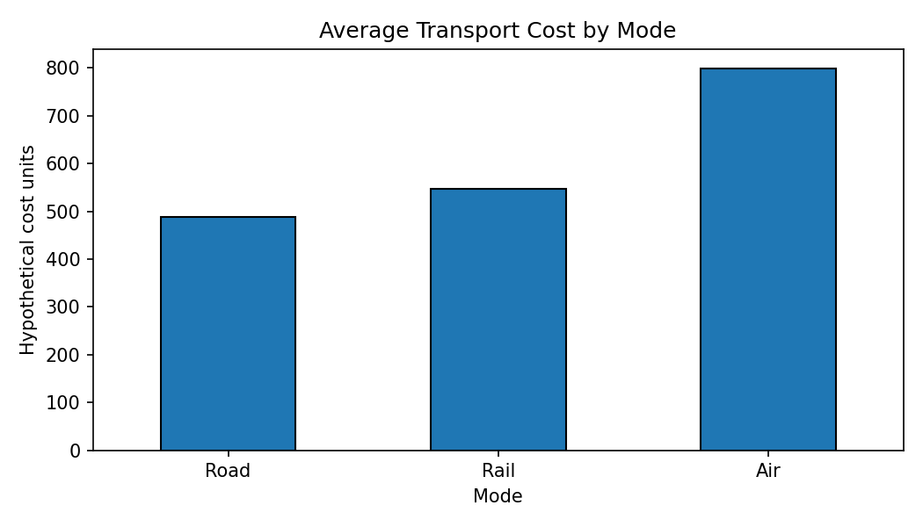
The bar chart compares average simulated costs for Road, Rail and Air. Air has a deliberately higher cost premium in this simulation. In a real decision, cost must be balanced against speed, capacity, reliability and service needs. Bars are useful for comparing category-level averages.

5.3 Distance versus transport cost
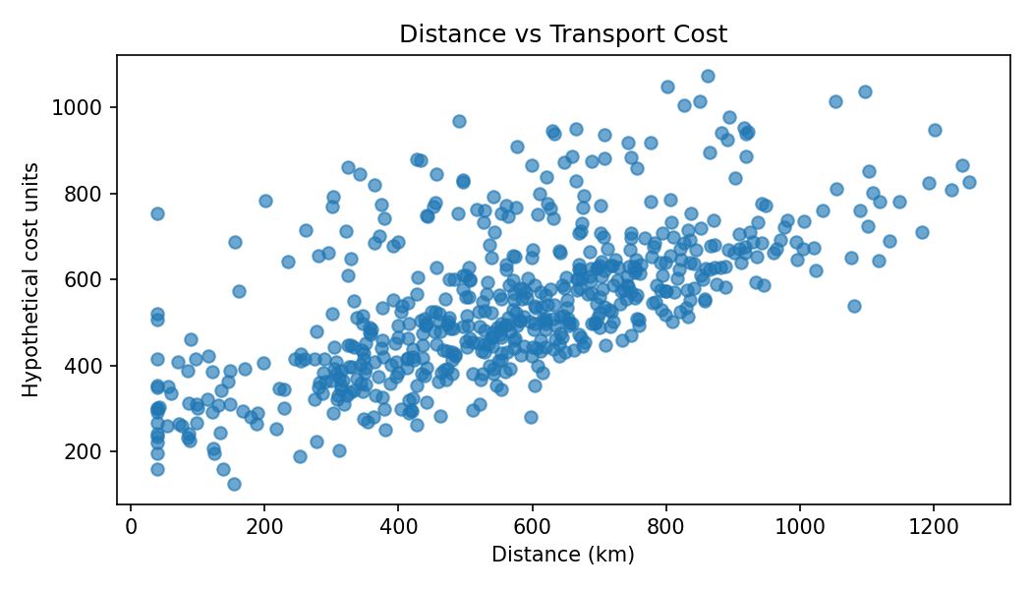
The scatter plot explores whether longer routes cost more. The correlation is 0.64, indicating a positive association in this simulated dataset. The spread also reflects volume, mode and random cost effects. Scatter plots reveal direction, clusters and unusual observations.

5.4 Average delay by region
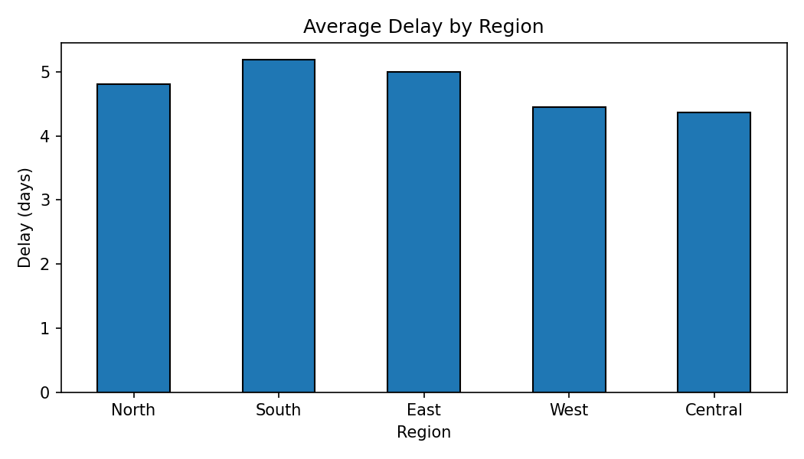
Regional average delays help identify where further investigation may be useful. Since region effects were included in the simulation, differences are expected. A region's average does not prove causation; compare sample sizes, distances, mode and carrier mix.

5.5 Correlation matrix
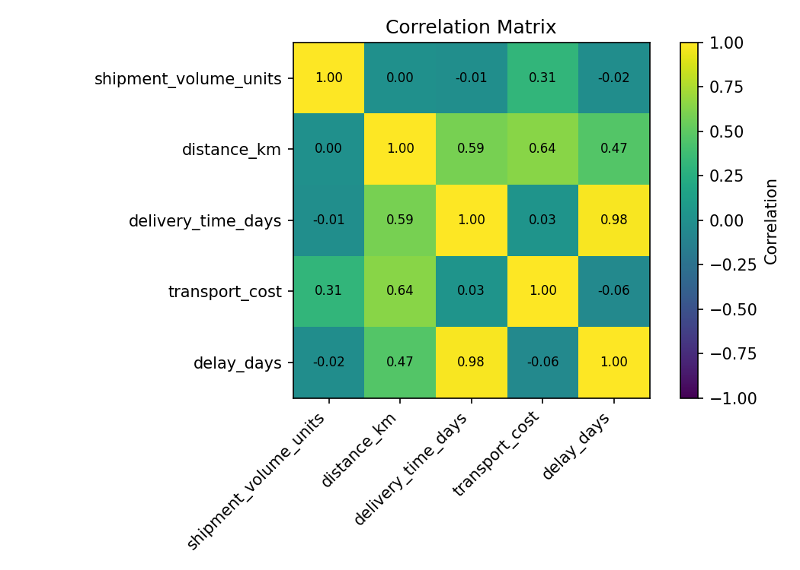
The heatmap summarizes linear associations. Values near +1 indicate positive association, near -1 negative association, and near 0 weak linear association. Correlation is not causation and may miss nonlinear relationships. A heatmap helps scan several numeric relationships at once.

6. Analytical Insights
- Typical delivery duration: mean 10.41 days and median 10.01 days; review the histogram for unusually long cases.
- Distance and cost are positively associated (correlation 0.64), but transport mode and shipment volume are also plausible cost drivers.
- Mode averages can guide further comparison, but a low-cost mode may not meet a required delivery window.
- Regional average delay differences are useful screening signals, not proof that geography itself causes delays.
- Missing data (5 costs and 3 distances) can affect averages, correlations and comparisons.

7. Recommendations
- Investigate delayed or extreme shipments by carrier, mode, distance and region; distinguish real disruptions from data errors.
- Track cost per kilometre and cost per unit, not only total cost, for fairer comparisons.
- Compare carriers within similar distance and mode groups before ranking performance.
- Add data-quality checks for unique shipment IDs, valid ranges, required fields and consistent units.
- Monitor average and median delivery time, on-time rate, delay, cost per shipment, cost per kilometre and volume.
- Validate any conclusions on real authorized operational data before making business decisions.

8. Python Code Excerpt
import pandas as pd
import matplotlib.pyplot as plt
df = pd.read_csv("hypothetical_logistics_dataset.csv")
print(df.isna().sum())
print(df[["delivery_time_days", "transport_cost"]].describe())
print(df.groupby("transport_mode")["transport_cost"].mean())
print(df[["distance_km", "transport_cost", "delivery_time_days"]].corr())
plt.hist(df["delivery_time_days"].dropna(), bins=25, edgecolor="black")
plt.xlabel("Delivery time (days)")
plt.ylabel("Number of shipments")
plt.title("Distribution of Delivery Time")
plt.tight_layout()
plt.show()
plt.scatter(df["distance_km"], df["transport_cost"], alpha=0.65)
plt.xlabel("Distance (km)")
plt.ylabel("Transport cost")
plt.tight_layout()
plt.show()
The full script week3_logistics_eda.py generates the dataset and all five visualizations. It uses a fixed random seed so results are reproducible.

9. Limitations
The dataset is hypothetical and its patterns are influenced by the simulation rules. It must not be treated as evidence of actual carrier performance, regional delays or market prices. Before real business use, replace it with an authorized dataset, validate field definitions and units, document the source, and repeat the analysis.

10. Conclusion
This project demonstrates how descriptive statistics and visualization turn shipment records into interpretable performance indicators. Histograms describe distributions, bar charts compare groups, scatter plots explore relationships, and correlation heatmaps summarize numeric associations. Sound logistics analysis combines these patterns with data-quality checks, domain context and cautious interpretation.

References
- Pandas: https://pandas.pydata.org/docs/
- Matplotlib: https://matplotlib.org/stable/
- NumPy: https://numpy.org/doc/

