Predictive Modeling and Optimization
in Logistics Systems
Python-based forecasting, model evaluation, and operational recommendations
Project report | Educational simulation | October 2026

1. Executive Summary
This project builds a supervised regression workflow to forecast shipment delivery duration. A hypothetical dataset of 1,000 shipments includes distance, weight, transport mode, region, weather, traffic, and priority. Linear Regression is used as a baseline and Random Forest as an ensemble alternative. On the held-out test set, Linear Regression performed best by RMSE, achieving MAE 1.03 days, RMSE 1.26 days, and R-squared 0.801. The report translates predictions into recommendations for exception handling, capacity planning, shipment consolidation, and constrained mode selection. The dataset is synthetic, so metrics are illustrative, not industry benchmarks.

2. Problem Definition
The logistics problem is to estimate how many days a shipment will take to arrive, using information available at dispatch or early in transit. Forecasts can help planners identify potentially late shipments, communicate expected arrival times, and allocate capacity. This is a regression problem because the target, delivery_days, is numeric.

3. Dataset and Features
The CSV contains 1,000 simulated shipments and 10 columns. The target is delivery_days. Predictors are distance_km, weight_kg, transport_mode, region, weather_condition, traffic_level, and priority. transport_cost is retained for descriptive analysis but excluded from the prediction features to avoid depending on a field that may not be available when the forecast is made.
Feature | Type | Meaning
distance_km | Numeric | Distance travelled/planned in kilometres
weight_kg | Numeric | Shipment weight
transport_mode | Category | Road, Rail, Air
region | Category | Operating region
weather_condition | Category | Clear, Rain, Severe
traffic_level | Category | Low, Medium, High
priority | Category | Standard or Express
transport_cost | Numeric | Simulated transport cost; excluded from predictors
delivery_days | Target | Simulated delivery duration
Some feature values are intentionally missing. Numeric fields are imputed with the median; categorical fields use the most frequent category. Imputation and one-hot encoding are kept inside a scikit-learn pipeline so preprocessing is learned from training data rather than the test set.

4. Exploratory Data Analysis
Mean delivery time is 7.87 days and median is 7.89 days. The correlation between distance and delivery duration is 0.63, showing a positive association in the simulated data. These summaries provide context but do not prove causation.
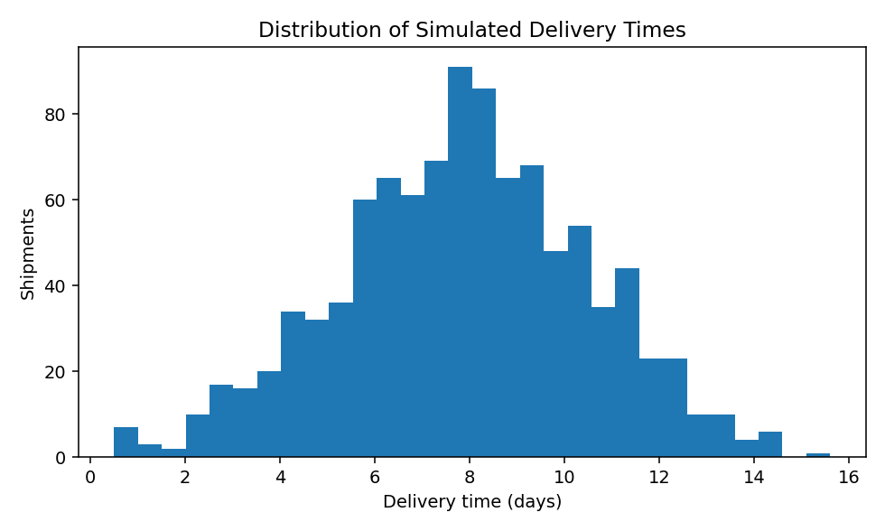
Figure 1. Distribution of delivery duration.
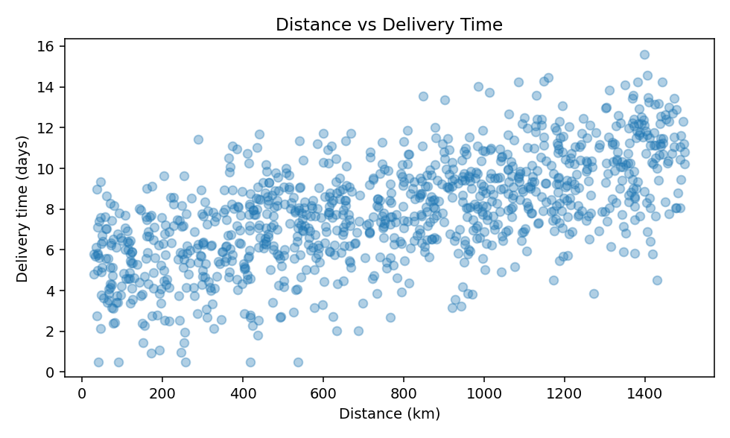
Figure 2. Distance and delivery time; a positive pattern is visible.

5. Model Selection
Linear Regression is a fast, interpretable baseline that estimates a linear relationship between encoded features and delivery time. Random Forest combines multiple decision trees and can capture nonlinear effects and interactions among distance, weather, mode, traffic, and priority. Both models use the same train/test split to make the comparison fair.

6. Data Preparation, Training, and Testing
The dataset is split into 80% training and 20% test rows using a fixed random seed. Numeric values are median-imputed, categories are mode-imputed and one-hot encoded. The test set is reserved for final evaluation.
X_train, X_test, y_train, y_test = train_test_split(
X, y, test_size=0.20, random_state=21
)
pipeline = Pipeline([
("preprocess", preprocessor),
("model", RandomForestRegressor(
n_estimators=160, max_depth=12,
min_samples_leaf=3, random_state=21
))
])
pipeline.fit(X_train, y_train)
pred = pipeline.predict(X_test)
mae = mean_absolute_error(y_test, pred)
rmse = np.sqrt(mean_squared_error(y_test, pred))
r2 = r2_score(y_test, pred)

7. Evaluation Metrics and Results
Model | MAE (days) | RMSE (days) | R²
Linear Regression | 1.025 | 1.259 | 0.801
Random Forest | 1.123 | 1.378 | 0.761
Linear Regression had the lowest test RMSE in this simulation. MAE represents average absolute prediction error in days; RMSE penalizes larger errors more heavily; R-squared summarizes the fraction of target variation explained by the model. Five-fold cross-validation MAE for the Random Forest pipeline was 1.09 ± 0.06 days. Cross-validation provides a stability check, while the separate test set provides a final estimate.
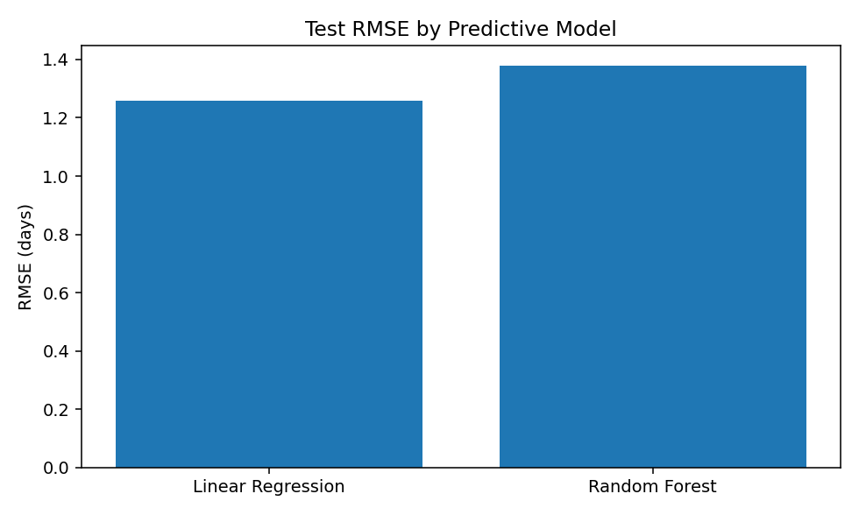
Figure 3. Test-set RMSE comparison; lower is better.
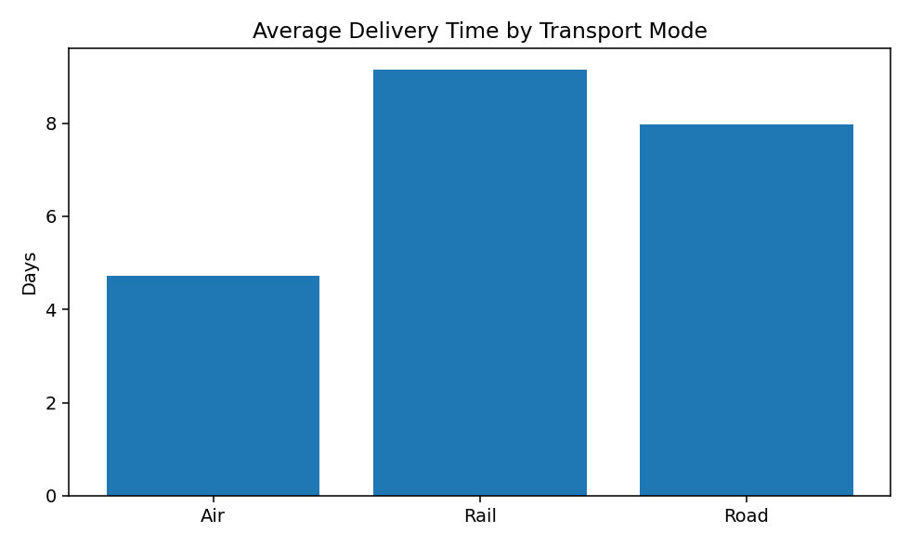
Figure 4. Average simulated delivery duration by mode; descriptive differences depend on synthetic assumptions.

8. Cross-Validation and Hyperparameter Tuning
Five-fold cross-validation is applied to the training data. The current Random Forest uses 160 trees, maximum depth 12, and minimum leaf size 3. A next iteration can use GridSearchCV or RandomizedSearchCV to compare n_estimators, max_depth, min_samples_leaf, and max_features while optimizing negative MAE. Tune only on training data, then evaluate the selected model once on the test set. For real operational forecasting, time-based validation is often preferable because seasonality and changing conditions can make random splits optimistic.
param_grid = {
"model__n_estimators": [100, 160, 300],
"model__max_depth": [8, 12, None],
"model__min_samples_leaf": [2, 3, 5]
}
# GridSearchCV(pipeline, param_grid,
# scoring="neg_mean_absolute_error", cv=5)
# Fit only on training data; test the selected model once.

9. Optimization Recommendations
- Risk-based exception handling: Flag shipments whose predicted arrival exceeds a service-level target. Ask planners to review the riskiest shipments first instead of treating every order equally.
- Transport-mode trade-offs: Compare feasible road, rail, and air options using predicted arrival time, cost, capacity, reliability, and emissions. Do not select the fastest mode automatically; respect cost and service constraints.
- Shipment consolidation: Group compatible standard-priority shipments when delivery windows and handling constraints allow, while protecting express commitments.
- Regional capacity planning: Aggregate shipment volume and predicted delay risk by region and date to plan vehicles, staff, and carrier capacity before peaks.
- Route and dispatch planning: Combine predictions with current traffic, route constraints, vehicle capacity, driver hours, and delivery windows. Test route alternatives before deployment.
- Monitoring and governance: Track MAE, RMSE, on-time delivery, late-delivery rate, and cost per shipment. Review data drift and keep a human override for unusual cases.

10. Implementation Roadmap
- Establish a baseline using historical delivery and cost records, with agreed definitions of lateness and service levels.
- Run predictions in shadow mode and compare estimates with actual arrival times.
- Build an operations view that highlights high-risk shipments and feasible alternatives.
- Pilot one operational change at a time and compare cost, on-time delivery, and utilization against a baseline.
- Monitor data quality and model drift; retrain only after validation and review.

11. Limitations
The dataset is simulated, so the model scores do not establish real-world accuracy or savings. The dataset omits factors such as depot dwell time, carrier reliability, holidays, customs, driver hours, and real-time traffic. Random splits can overstate future performance where time trends exist. No cost savings are claimed because no real-world controlled trial was conducted. Real deployment requires historical data, time-aware validation, privacy safeguards, operational constraints, and monitoring.

12. Conclusion
This project demonstrates an end-to-end predictive workflow: define a target, inspect and prepare data, train a baseline and ensemble model, evaluate with regression metrics, validate using cross-validation, and translate predictions into operational actions. Forecasts become useful when they support measurable decisions such as early exception handling, capacity planning, consolidation, and constrained transport-mode selection.

Appendix: Reproducibility
Files included are the dataset CSV, Python script, README, this report, and charts. Install dependencies using: pip install pandas numpy matplotlib scikit-learn python-docx. Run: python logistics_predictive_model.py.

