YUVAINTERN DATA SCIENCE INTERNSHIP
WEEK 6 | INTEGRATIVE CAPSTONE PROJECT
End-to-End Customer Analytics
and Repeat-Purchase Prediction
Integrating Data Cleaning, EDA, RFM Clustering, Classical Machine Learning and Deep Learning
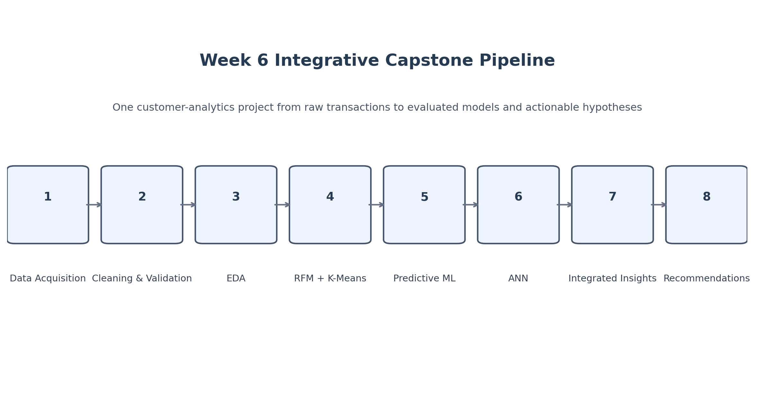
Integrated capstone workflow.

Prepared for internship evaluation

1. Executive Summary
This Week 6 capstone consolidates the analytical work completed throughout the internship into one coherent customer-analytics project. The same public Online Retail transaction dataset is taken from raw form through data-quality assessment and cleaning, exploratory analysis, RFM-based customer segmentation, repeat-purchase prediction with classical machine learning, and deep-learning classification with a TensorFlow/Keras Artificial Neural Network.
The capstone uses two complementary analytical perspectives. First, unsupervised learning answers the descriptive question of how customers differ in recency, frequency and monetary value. Second, supervised learning answers the predictive question of whether a customer will make another purchase during a future period. The predictive setup uses a chronological cutoff so that future transactions define the target without becoming model inputs.
Final capstone snapshot
392,692 cleaned transactions | 4,338 customers | 2 customer clusters | 0.4328 silhouette score | 3 predictive models | ANN ROC-AUC 0.7401 | Cluster repeat rates: 28.73% and 96.41%

What the capstone demonstrates
- A complete start-to-finish Python Data Science workflow rather than an isolated algorithm exercise.
- Consistent reuse of validated preprocessing and feature engineering across the internship tasks.
- Both descriptive and predictive analytics: RFM/K-Means for segmentation and classification models for future behavior.
- Critical evaluation of results using multiple metrics and an explicit discussion of limitations and business implications.
- Integration of analytical outputs into a final customer-level interpretation and set of testable recommendations.

2. Problem Statement and Capstone Objectives
Online retail transaction data contains detailed information about purchases, but raw transactions do not directly answer strategic customer questions. The capstone therefore frames the project around customer understanding and repeat-purchase behavior: identify meaningful customer patterns, predict future repeat purchase from historical behavior, compare modeling approaches, and translate the results into practical analytical recommendations.
Objective | How the capstone addresses it
Acquire public data | Load and inspect the Online Retail transaction dataset.
Preprocess data | Remove duplicates, missing customer/product information, cancellations and invalid transactions.
Explore data | Analyze transaction value, time, countries, products, customer frequency and numerical relationships.
Unsupervised learning | Use RFM features and K-Means to identify customer segments.
Supervised learning | Predict repeat purchase using Logistic Regression and Random Forest.
Deep learning | Extend the same prediction problem with a compact TensorFlow/Keras ANN.
Evaluate models | Use Accuracy, Precision, Recall, F1-score and ROC-AUC plus silhouette score for clustering.
Integrate insights | Relate customer segments to observed repeat-purchase rates and model findings.
Recommend next steps | Identify retention, experimentation and feature/model improvement opportunities.

3. End-to-End Methodology
Figure 1. End-to-end capstone workflow integrating descriptive, unsupervised, supervised and deep-learning stages.

3.1 Pipeline logic
Stage | Purpose | Primary output
1. Data acquisition | Load the public transaction dataset. | Raw DataFrame
2. Data cleaning | Improve validity and consistency. | 392,692 cleaned transactions
3. Feature engineering | Create transaction amount and time fields. | 13-column analytical dataset
4. EDA | Understand time, customer, country and product patterns. | Visual and statistical findings
5. RFM + K-Means | Describe customer segments. | 2 customer clusters
6. Predictive ML | Estimate repeat-purchase behavior. | Logistic Regression + Random Forest
7. Deep learning | Benchmark a nonlinear ANN. | TensorFlow/Keras ANN
8. Integration | Combine segments and predictive behavior. | Customer-level capstone insights
9. Recommendations | Translate evidence into next actions. | Testable business recommendations
Design principle
The capstone treats prediction as decision support. Model outputs describe observed relationships in the dataset; they do not by themselves establish causation or prove that a marketing intervention will increase purchasing.

4. Data Acquisition and Data Cleaning

4.1 Dataset overview
Metric | Value
Original rows | 541,909
Original columns | 8
Missing Description values | 1,454
Missing CustomerID values | 135,080
Duplicate rows detected | 5,268
Quantity <= 0 | 10,624
UnitPrice <= 0 | 2,517
Cancellation invoices | 9,288
Date range | 2010-12-01 08:26 to 2011-12-09 12:50
The raw data showed several predictable transaction-data quality issues: missing customer identifiers, missing product descriptions, duplicated records, cancellation invoices, non-positive quantities and non-positive prices. These were addressed before any customer-level analysis or model training.

4.2 Cleaning rules
- Remove duplicate transaction rows.
- Drop records with missing Description.
- Drop records with missing CustomerID.
- Remove invoices beginning with the cancellation marker C.
- Keep only Quantity > 0 and UnitPrice > 0.
- Convert CustomerID to integer.
- Create TotalAmount = Quantity x UnitPrice.
Cleaning result
Final cleaned dataset: 392,692 rows and 9 columns before time-feature extraction. Rows removed: 149,217. Retention: 72.46%.

4.3 Validation
Validation check | Result
Missing values after cleaning | 0 across all analytical columns
Duplicate rows after cleaning | 0
Minimum Quantity | 1
Minimum UnitPrice | 0.001
Cancellation invoices remaining | 0
Final analytical rows after time features | 392,692
Final columns | 13

5. Exploratory Data Analysis
The EDA stage is intentionally focused on findings that help explain the later customer-level modeling. Transaction amount is used as the principal monetary measure. The analysis also examines customer activity, geographic concentration, product demand and numerical relationships.

5.1 Overall scale
EDA metric | Value
Total transaction amount | £8,887,208.89
Total quantity sold | 5,152,002
Unique customers | 4,338
Unique invoices | 18,532
Unique products | 3,665
Unique countries | 37
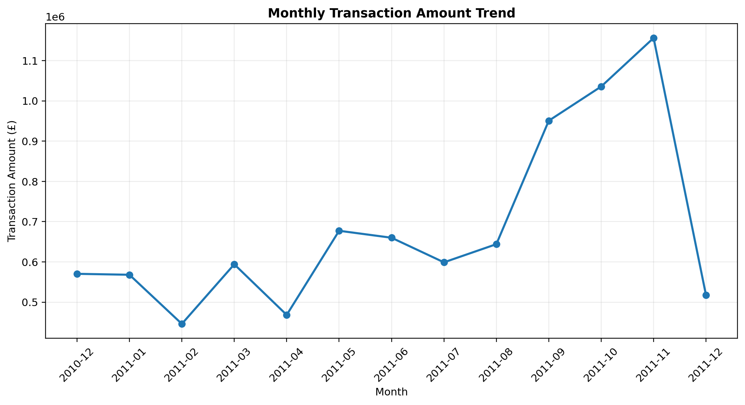
Figure 2. Monthly transaction amount trend; December 2011 is a partial month because the dataset ends on 9 December 2011.

Transaction activity varies across the observed months. November 2011 records the highest monthly transaction amount at £1,156,205.61. The final December value should not be compared with a full month because the source data ends on 9 December.
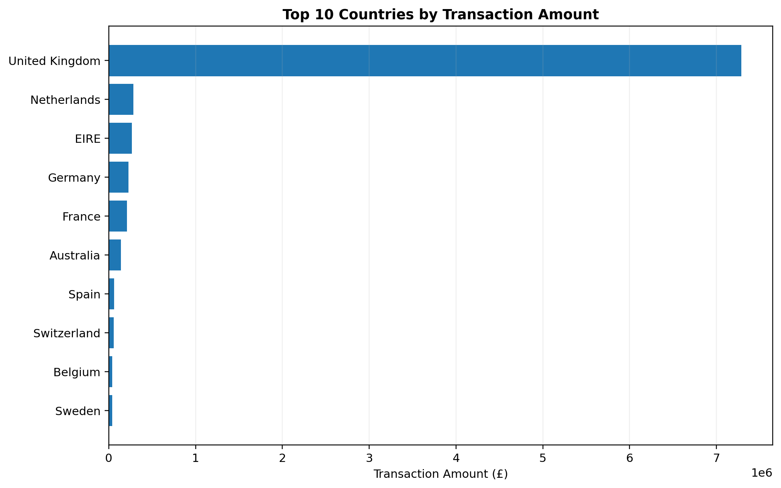
Figure 3. Geographic concentration of transaction amount.

The United Kingdom accounts for the largest share of transaction amount, at approximately £7.29 million. This concentration is an important contextual characteristic of the dataset and should be considered when generalizing findings to other markets.
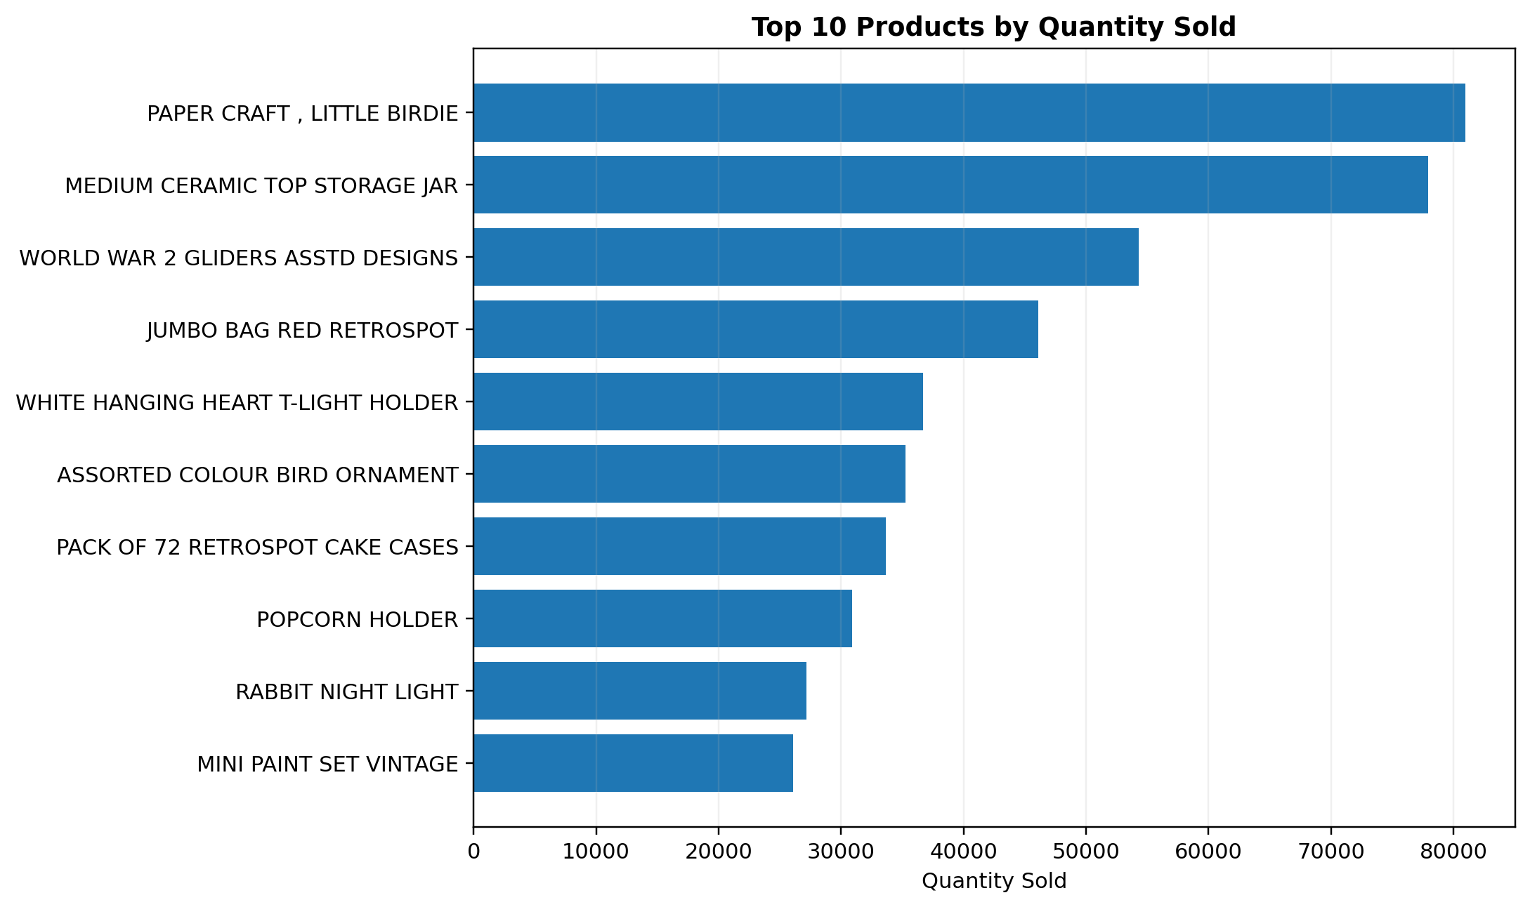
Figure 4. Highest-volume products by total quantity.

PAPER CRAFT , LITTLE BIRDIE has the highest recorded quantity at 80,995 units, while several other high-volume items also contribute substantial demand. Quantity rankings and monetary rankings are not identical, emphasizing that volume and customer value capture different dimensions of the transaction data.
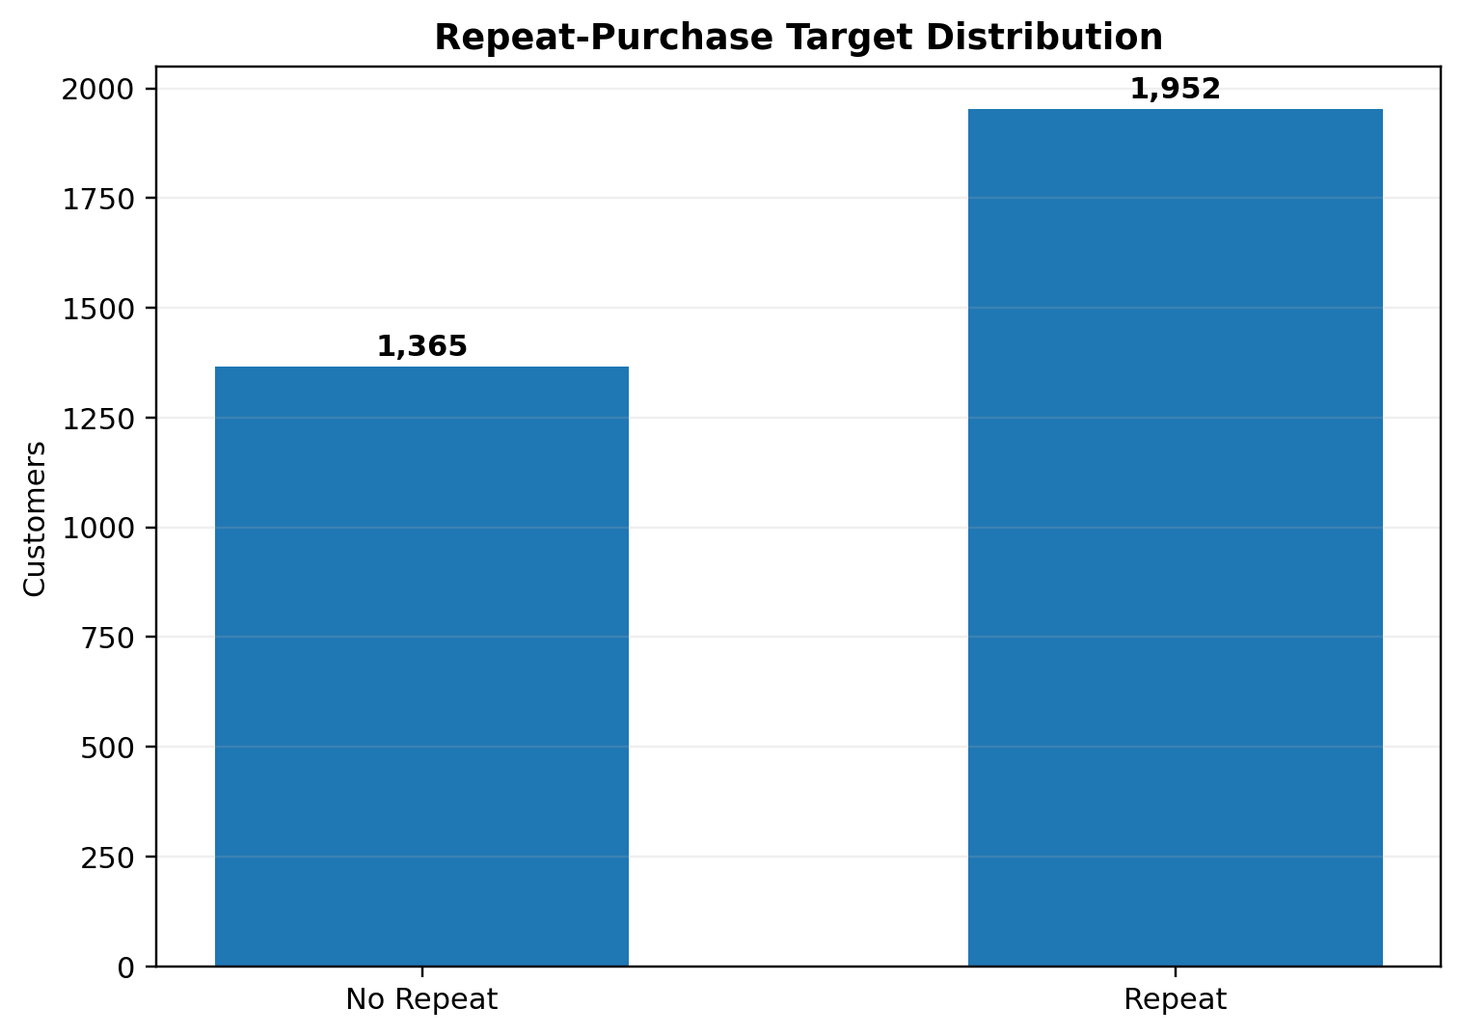
Figure 5. Repeat-purchase target distribution used in predictive modeling.

The predictive target contains 1,952 repeat purchasers (58.85%) and 1,365 non-repeat customers (41.15%). This is not perfectly balanced, which is one reason the project evaluates precision, recall, F1-score and ROC-AUC in addition to accuracy.

6. Unsupervised Learning: RFM Analysis and K-Means
RFM analysis converts transaction histories into customer-level behavior. Recency measures days since the latest observed purchase, Frequency counts unique invoices, and Monetary sums transaction amount. These features are log-transformed and standardized before K-Means clustering.

6.1 Cluster-selection evidence
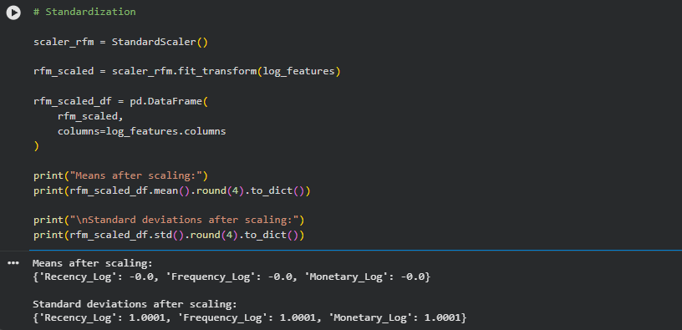
Figure 1. Standardization of the log-transformed RFM features before clustering.

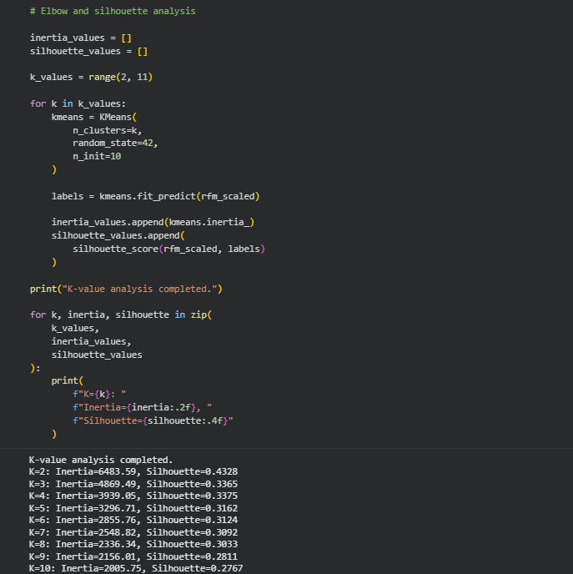
Figure 2. Inertia and silhouette scores for K values from 2 to 10.

Figure 6. Representative analytical visualization; the model-selection evidence above is used to select the final K value.

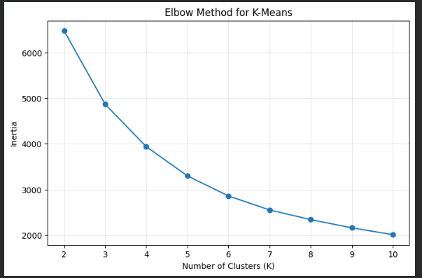
Figure 3. Elbow-method plot for K-Means cluster selection.

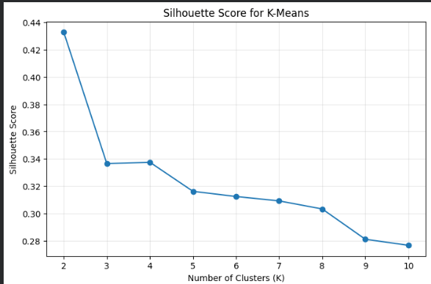
Figure 4. Silhouette-score plot for K-Means cluster selection.

Cluster-selection decision
K = 2 was selected because it produced the highest silhouette score in the tested range (0.4328). The elbow curve declines progressively rather than showing one overwhelmingly dominant elbow, so silhouette provided useful complementary evidence.

6.2 Cluster profiles
Cluster | Customers | Customer % | Avg Recency | Avg Frequency | Avg Monetary
0 | 2,672 | 61.60% | 134.09 days | 1.67 invoices | £495.59
1 | 1,666 | 38.40% | 25.89 days | 8.44 invoices | £4,539.60
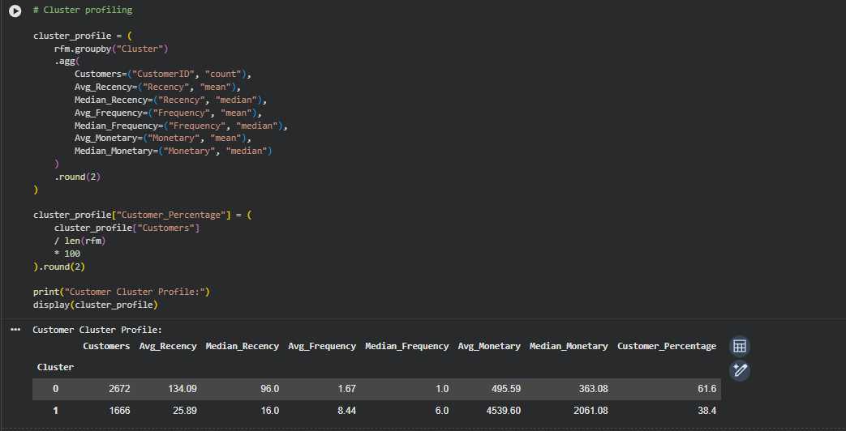
Figure 5. Final customer cluster profile table produced from the K-Means model.

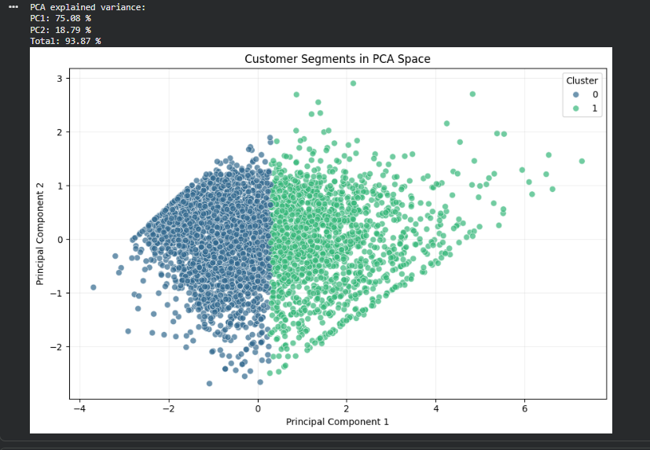
Figure 6. PCA projection of the two customer segments and explained-variance output.

Cluster 0 represents a larger group with much higher average recency and lower purchasing frequency and monetary value. Cluster 1 represents a smaller but much more active group with recent purchasing, higher frequency and much higher monetary value. These labels are analytical descriptions rather than claims about customer intent.
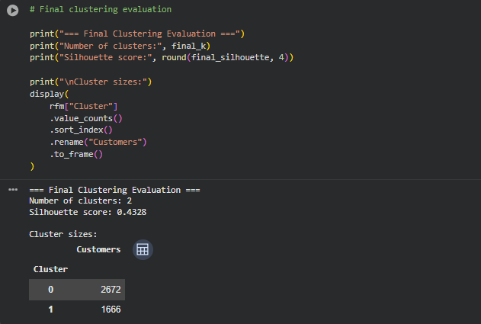
Figure 15. Final clustering evaluation: K = 2 and silhouette score = 0.4328.

7. Supervised Learning: Repeat-Purchase Prediction

7.1 Leakage-controlled temporal design
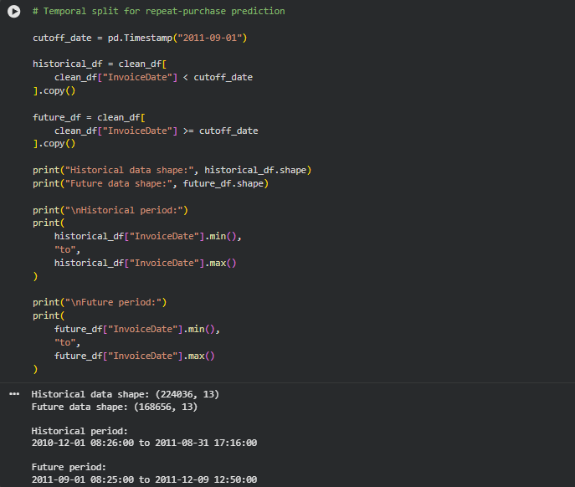
Figure 7. Chronological historical/future split used to define the repeat-purchase prediction problem.

A cutoff date of 1 September 2011 separates model inputs from the future target period. Historical transactions before the cutoff produce the customer features; transactions on or after the cutoff are used only to determine whether the customer purchased again. This mirrors the logic used in Tasks 4 and 5 and protects the predictive evaluation from direct future-information leakage.

7.2 Customer-level features
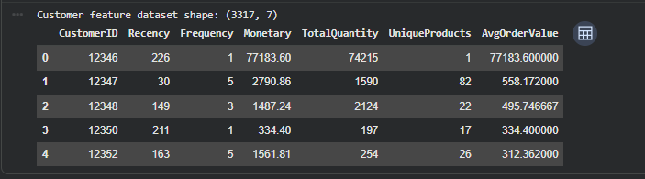
Figure 8. Historical customer feature table containing the six predictive features.

Feature | Definition
Recency | Days since latest historical purchase
Frequency | Unique historical invoice count
Monetary | Total historical transaction amount
TotalQuantity | Total units purchased historically
UniqueProducts | Distinct stock codes purchased
AvgOrderValue | Monetary / Frequency

7.3 Classical model results
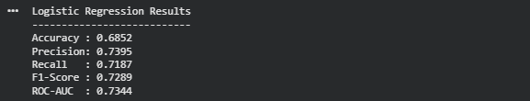
Figure 9. Logistic Regression test-set results.

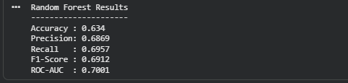
Figure 10. Random Forest test-set results.

Model | Accuracy | Precision | Recall | F1-Score | ROC-AUC
Logistic Regression | 68.52% | 73.95% | 71.87% | 72.89% | 73.44%
Random Forest | 63.86% | 69.31% | 69.31% | 69.31% | 70.01%

7.4 Feature importance
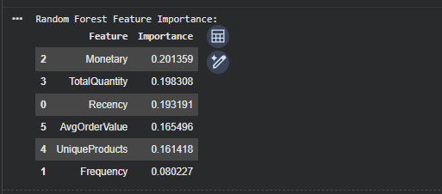
Figure 11. Random Forest feature-importance table.

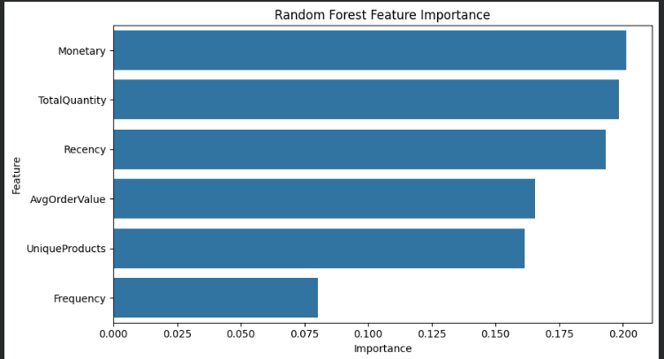
Figure 12. Random Forest feature-importance visualization.

Monetary, TotalQuantity and Recency are the largest contributors in the recorded Random Forest importance values, followed by AvgOrderValue and UniqueProducts. Frequency has the smallest recorded importance of the six features in this model. Feature importance is model-specific and should not be interpreted as causal impact.

8. Deep Learning: Artificial Neural Network
The deep-learning component extends the same repeat-purchase problem with a compact TensorFlow/Keras ANN. The architecture is deliberately moderate because the final customer-level modeling table contains only 3,317 customers and six engineered features.
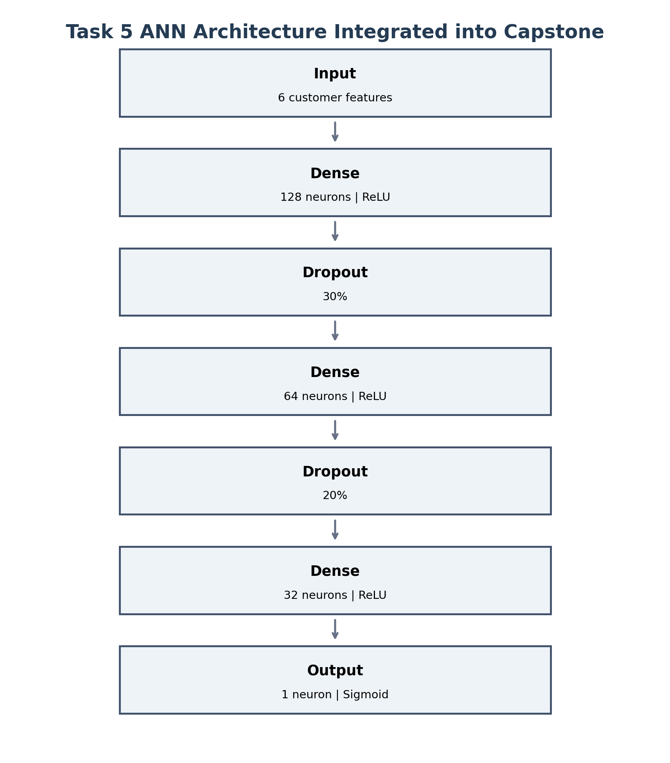
Figure 7. ANN architecture used in Week 5 and integrated into the Week 6 capstone.

Layer | Configuration | Parameters
Input | 6 features | -
Dense 1 | 128 neurons, ReLU | 896
Dropout 1 | 30% | 0
Dense 2 | 64 neurons, ReLU | 8,256
Dropout 2 | 20% | 0
Dense 3 | 32 neurons, ReLU | 2,080
Output | 1 neuron, Sigmoid | 33
Total | 11,265 trainable parameters | 11,265
Training used Adam optimization, binary cross-entropy, a batch size of 32 and a maximum of 100 epochs. Early stopping monitored validation loss with patience 10 and restored the best weights. The model trained for 23 epochs, with the best validation-loss epoch at 13 and best validation loss 0.59217.
Final ANN test performance
Accuracy 68.22% | Precision 73.94% | Recall 71.10% | F1-score 72.49% | ROC-AUC 74.02%.

9. Unified Model Evaluation
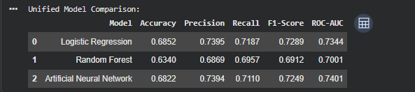
Figure 13. Unified predictive-model comparison table.

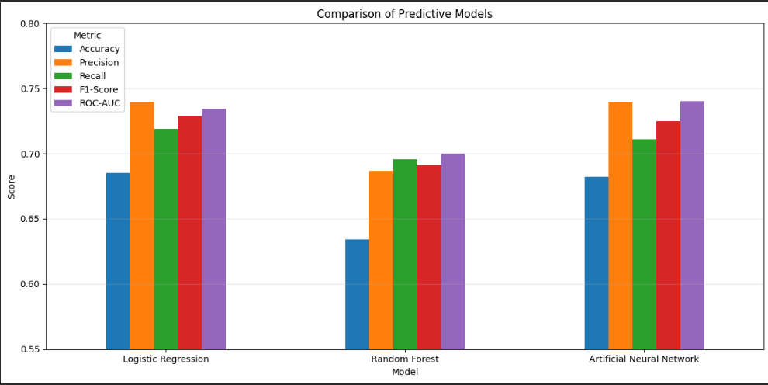
Figure 14. Unified predictive-model comparison chart.

Model | Accuracy | Precision | Recall | F1 | ROC-AUC | Analytical reading
Logistic Regression | 68.52% | 73.95% | 71.87% | 72.89% | 73.44% | Strong simple baseline; slightly higher accuracy/F1 than ANN.
Random Forest | 63.86% | 69.31% | 69.31% | 69.31% | 70.01% | Lower recorded test performance in this feature setup.
ANN | 68.22% | 73.94% | 71.10% | 72.49% | 74.02% | Highest recorded ROC-AUC; performance remains close to Logistic Regression.
The comparison shows why the capstone should not reduce model evaluation to a single score. Logistic Regression has the highest recorded accuracy and F1-score, while the ANN has the highest recorded ROC-AUC. The differences are relatively small, suggesting that the six engineered customer features already provide substantial predictive signal and that added model complexity does not automatically yield a large improvement.

10. Integrated Customer Analysis
The distinctive new contribution of the capstone is the explicit combination of customer segmentation and future repeat-purchase behavior. The RFM/K-Means segmentation provides a descriptive customer profile, while the repeat-purchase target provides an observed future outcome over the chosen horizon.
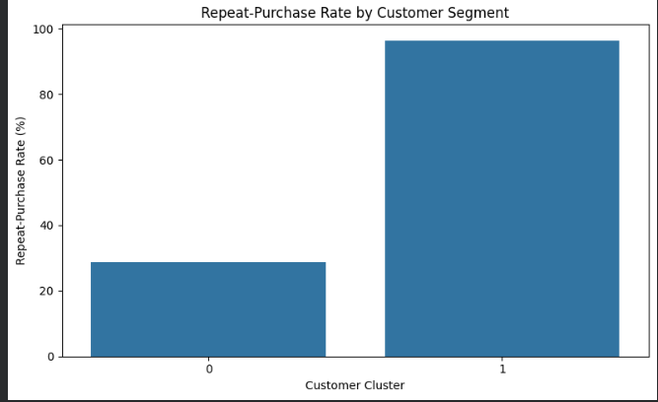
Figure 16. Repeat-purchase rate by customer segment.

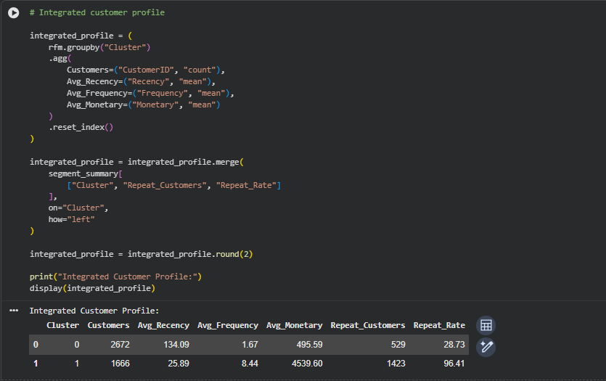
Figure 17. Integrated customer profile combining RFM characteristics with repeat-purchase outcomes.

Cluster | Customers | Avg Recency | Avg Frequency | Avg Monetary | Repeat Customers | Repeat Rate
0 | 2,672 | 134.09 | 1.67 | £495.59 | 529 | 28.73%
1 | 1,666 | 25.89 | 8.44 | £4,539.60 | 1,423 | 96.41%
The observed repeat-purchase rate differs substantially between the two segments. Cluster 1 combines recent activity, higher purchase frequency and higher monetary value with a 96.41% observed repeat rate over the future period. Cluster 0 has lower engagement metrics and a 28.73% observed repeat rate. This association is analytically useful, but it should not be interpreted as evidence that any single RFM variable causes repeat purchase.
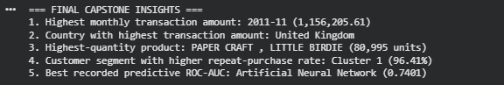
Figure 18. Programmatically generated final capstone insights from the integrated analysis.

11. Insights and Recommendations

11.1 Key insights
- The cleaned dataset retains 392,692 valid transactions from 541,909 raw rows after systematic quality controls.
- Transaction activity is concentrated in a relatively small number of countries, with the United Kingdom accounting for the largest transaction amount.
- Customer behavior is highly heterogeneous, supporting the use of customer-level aggregation rather than transaction-level averages alone.
- Two RFM segments provide a compact descriptive view of customer engagement and value, with a strong difference in observed repeat-purchase rates.
- The predictive models achieve moderate performance, indicating useful signal but considerable room for improvement.
- The ANN does not dominate every metric; this is an important finding because it shows that deep learning complexity should be justified by measurable benefit rather than assumed superiority.

11.2 Recommendations
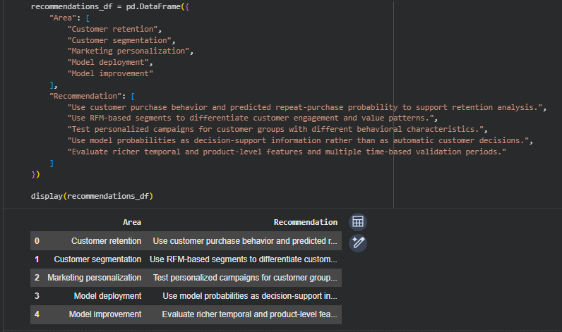
Figure 19. Structured recommendation table generated from the capstone analysis.

Area | Recommended analytical action
Retention | Use customer behavior and predicted probability to prioritize retention analysis.
Segmentation | Combine RFM segments with predictive behavior for differentiated customer monitoring.
Marketing | Run controlled experiments on personalized offers or reminders rather than assuming model predictions imply treatment effectiveness.
Model deployment | Use model probabilities as decision-support inputs with monitoring, not as irreversible customer decisions.
Model improvement | Add richer temporal and product-level features and evaluate several chronological validation windows.
Business caution
Prediction and causation are different tasks. A high repeat-purchase probability identifies customers who resemble historically repeating customers; it does not prove that an intervention will cause a purchase. A/B testing or other causal evaluation is required for that question.

12. Challenges, Successes and Reflection

12.1 Challenges encountered
Challenge | How it was handled
Missing and incomplete records | Removed missing product descriptions and customer IDs where customer-level analysis required reliable identifiers.
Duplicates | Duplicate transaction rows were removed and the cleaned dataset revalidated.
Cancellations / invalid values | Cancellation invoices and non-positive quantities/prices were excluded from the analytical transaction set.
Skewed customer features | log1p transformation reduced the influence of extreme customer values before clustering/modeling.
Leakage risk | Historical/future temporal split prevented future transactions from being used as predictive inputs.
Overfitting risk | ANN used dropout, validation monitoring and early stopping.
Model complexity | Classical models were retained as baselines so the ANN could be evaluated honestly.

12.2 What worked well
- The same dataset and validated preprocessing logic were carried through the entire internship, creating a coherent analytical narrative.
- RFM segmentation and repeat-purchase prediction answered complementary descriptive and predictive questions.
- Multiple evaluation metrics exposed nuanced differences between models.
- The capstone added a new integration layer by relating cluster membership to future repeat-purchase behavior.
- The project separates measured findings from business hypotheses and avoids unsupported causal claims.

12.3 Learning outcomes
- Designed an end-to-end Data Science workflow using Python.
- Applied Pandas-based data quality and feature-engineering techniques to a real transaction dataset.
- Performed practical EDA and communicated patterns through charts and tables.
- Implemented RFM analysis and K-Means clustering with model-selection evidence.
- Built and evaluated classical classification models and a TensorFlow/Keras ANN.
- Learned how data leakage, skewness, model complexity and validation affect the credibility of results.
- Translated technical outputs into customer-analytics recommendations and limitations.

13. Further Analysis and Future Work
- Use rolling or repeated chronological validation to test whether the predictive signal remains stable over time.
- Evaluate alternative prediction horizons so the operational meaning of repeat purchase can be compared across time windows.
- Tune classification thresholds based on the relative cost of false positives and false negatives.
- Engineer purchase-interval, trend and recent-vs-historical behavior features.
- Add product-category and basket-level features while preserving leakage controls.
- Investigate probability calibration and explainability methods such as SHAP or permutation importance.
- Evaluate simpler models against more complex models under a common computational and deployment constraint.

14. Conclusion
The Week 6 capstone successfully integrates the major Data Science capabilities developed during the internship into one coherent project. Beginning with 541,909 raw transactions, the pipeline creates 392,692 validated analytical transactions, explores customer and transaction behavior, forms two RFM-based customer segments, and predicts repeat purchase using Logistic Regression, Random Forest and a TensorFlow/Keras ANN.
The combined results show meaningful structure in customer behavior without implying perfect predictability. The two customer segments differ strongly in engagement and observed repeat-purchase rates, while the predictive models achieve ROC-AUC values around 0.70-0.74. The ANN records the highest ROC-AUC of 0.7401, while Logistic Regression records slightly higher accuracy and F1-score. The evidence therefore supports a nuanced conclusion: useful predictive signal exists, but additional data and feature engineering are needed for materially stronger predictive performance.
Final takeaway
The capstone demonstrates the complete Data Science lifecycle: define the problem, acquire and clean data, explore it, model it from multiple perspectives, evaluate results critically, integrate findings and communicate practical next steps.

Appendix A. Execution Evidence Screenshots
The following screenshots were supplied with the capstone notebook execution. They are retained here as evidence of the clustering, supervised-learning and integrated-analysis stages. Each figure is captioned and placed at readable size. The main body of the report interprets the corresponding results.
Figure 1. Standardization of log-transformed RFM features.

Figure 2. Inertia and silhouette scores across K values.

Figure 3. Elbow-method plot.

Figure 4. Silhouette-score plot.

Figure 5. K-Means cluster profile.

Figure 6. PCA visualization of customer segments.

Figure 7. Historical/future temporal split.

Figure 8. Customer-level predictive feature table.

Figure 9. Logistic Regression results.

Figure 10. Random Forest results.

Figure 11. Random Forest feature-importance table.

Figure 12. Random Forest feature-importance chart.

Figure 13. Unified model comparison table.

Figure 14. Unified model comparison chart.

Figure 15. Final clustering evaluation.

Figure 16. Repeat-purchase rate by customer segment.

Figure 17. Integrated customer profile.

Figure 18. Final capstone insights.

Figure 19. Recommendations table.

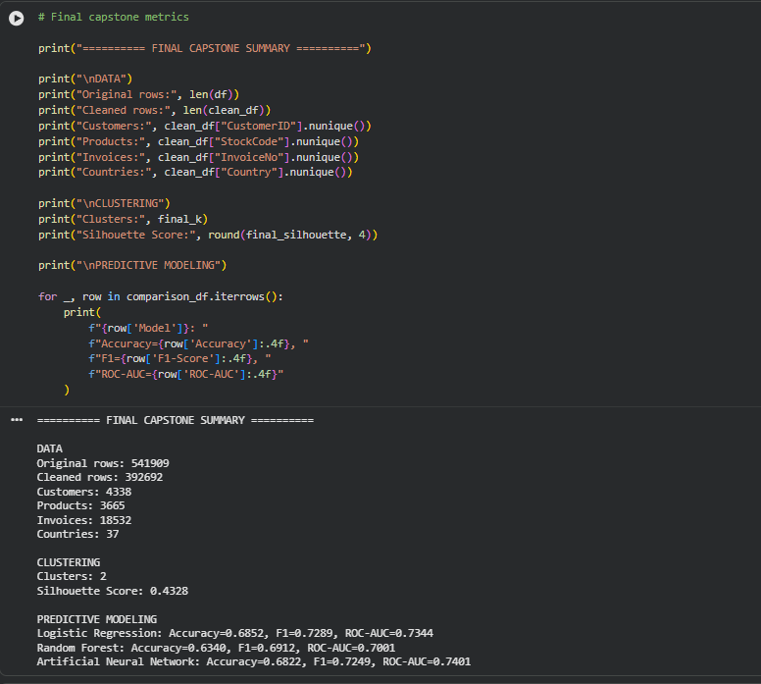
Figure 20. Final capstone metrics summary.

Appendix B. Final Capstone Metrics
Component | Key result
Data cleaning | 392,692 cleaned rows; 72.46% retention
EDA | £8.89M transaction amount; 4,338 customers; 37 countries
Clustering | K = 2; silhouette = 0.4328
Cluster 0 | 2,672 customers; 28.73% repeat rate
Cluster 1 | 1,666 customers; 96.41% repeat rate
Logistic Regression | 68.52% accuracy; 72.89% F1; 73.44% ROC-AUC
Random Forest | 63.86% accuracy; 69.31% F1; 70.01% ROC-AUC
ANN | 68.22% accuracy; 72.49% F1; 74.01% ROC-AUC
ANN training | 23 epochs; best epoch 13; best validation loss 0.59217
Supporting artifacts can be stored in the Task-6-Integrative-Capstone GitHub folder alongside the notebook and report. Suggested files include the final customer segments table, model comparison table, integrated segment analysis, recommendations table and cleaned dataset.

