YUVA INTERNSHIP • DATA SCIENCE
TASK 2
Exploratory Data Analysis
& Visualization
Online Retail Transaction Dataset

Prepared By | Suryansh Nigam
Domain | Data Science / Exploratory Analytics
Tools | Python • Pandas • Matplotlib • Seaborn
Dataset Period | December 2010 – December 2011*
Professional EDA Report • September 2026

Executive Summary
This report presents a structured Exploratory Data Analysis (EDA) of the cleaned Online Retail transaction dataset prepared during Task 1. The analysis combines descriptive statistics, aggregation, customer and product analysis, temporal analysis, relationship analysis, and correlation analysis to identify measurable patterns in transaction activity.
The cleaned dataset contains 392,692 valid transaction rows, representing 4,338 customers, 18,532 invoices, 3,665 products, and 37 countries. The calculated transaction amount across the cleaned records is £8,887,208.89, with 5,152,002 units sold.
The analysis shows strong concentration in the United Kingdom, a pronounced increase in transaction revenue during September–November 2011, a highly right-skewed customer purchase-frequency distribution, and a strong mathematical relationship between Quantity and TotalAmount. These findings are presented descriptively and are not treated as causal conclusions.

1. Project Snapshot
Metric | Result
Cleaned records | 392,692
Customers | 4,338
Invoices | 18,532
Products | 3,665
Countries | 37
Total quantity sold | 5,152,002
Transaction revenue | £8,887,208.89
Highest-revenue month | November 2011 — £1,156,205.61
Top country by transaction revenue | United Kingdom — £7,285,024.64

2. Introduction
Exploratory Data Analysis is a critical stage of the data science workflow because it converts a prepared dataset into an evidence-based understanding of distributions, trends, relationships, concentration, and anomalies. In this task, the cleaned Online Retail dataset was examined using numerical summaries and visualizations to identify patterns that can guide later analytical or machine-learning work.

3. Objectives
- Understand the structure and statistical characteristics of the cleaned dataset.
- Measure transaction activity across time, countries, products, and customers.
- Identify high-volume and high-value products and customers.
- Study customer purchase-frequency behavior.
- Examine the relationship between UnitPrice and Quantity using an appropriate log-scaled visualization.
- Analyze the relationship among Quantity, UnitPrice, and TotalAmount using a correlation matrix.
- Document findings with clear, labeled visualizations and analytical interpretations.

4. Dataset & Analytical Environment
The source data is the Online Retail transaction dataset. Task 1 preprocessing was used as the analytical starting point. Invalid/non-positive transaction quantities and prices, cancellation invoices, duplicate records, and required missing values were handled before the EDA stage. Additional analytical features included TotalAmount and calendar components derived from InvoiceDate.
Field | Value
Initial dataset | 541,909 rows × 8 columns
EDA dataset | 392,692 rows × 13 columns
Date range | 2010-12-01 08:26 to 2011-12-09 12:50
Customers | 4,338
Invoices | 18,532
Products | 3,665
Countries | 37
Tools and libraries: Python, Pandas, Matplotlib, Seaborn, and Jupyter/Google Colab. Pandas was used for aggregation and statistical analysis, while Matplotlib and Seaborn were used for visualization.

5. Data Preparation for EDA
- Used the cleaned Task 1 dataset as the analytical base.
- Confirmed the final shape as 392,692 rows × 13 columns.
- Used TotalAmount = Quantity × UnitPrice for transaction-value analysis.
- Derived Year, Month, Day, and Hour from InvoiceDate for temporal analysis.
- Used groupby-based aggregations for monthly, country, product, and customer analysis.
- Used log scales for the UnitPrice–Quantity scatter plot because both variables contain highly skewed values.

6. Descriptive Statistics
The main numerical variables show substantial dispersion. Quantity has a mean of 13.12 units but a maximum of 80,995, while UnitPrice has a mean of £3.13 and a maximum of £8,142.75. TotalAmount has a mean of £22.63 and a maximum of £168,469.60. These ranges indicate strong right tails and justify the use of robust summaries and appropriately scaled visualizations.
Variable | Mean | Median | Minimum | Maximum
Quantity | 13.12 | 6 | 1 | 80,995
UnitPrice (£) | 3.13 | 1.95 | 0.001 | 8,142.75
TotalAmount (£) | 22.63 | 12.45 | 0.001 | 168,469.60
Purchase frequency | 4.27 | 2 | 1 | 209

7.1 Monthly Revenue Trend
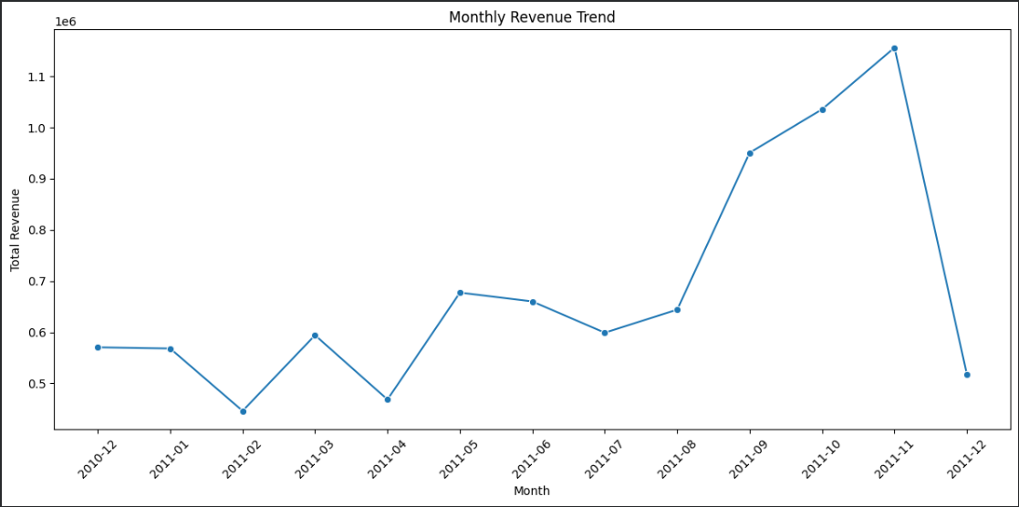
Figure 7.1 — Monthly Revenue Trend
Key observation: November 2011 records the highest monthly transaction revenue at £1,156,205.61. Revenue rises strongly from August through November.
Interpretation: The late-2011 increase indicates a period of substantially higher transaction activity. December 2011 must be interpreted carefully because the dataset ends on 9 December, making it a partial month rather than a complete monthly period.

7.2 Top 10 Countries by Revenue
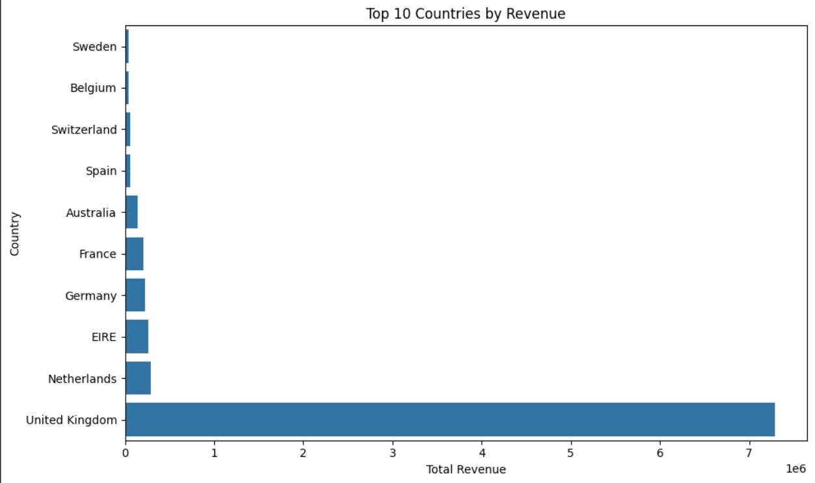
Figure 7.2 — Top 10 Countries by Revenue
Key observation: The United Kingdom contributes £7,285,024.64, substantially more than the other countries in the top ten.
Interpretation: The transaction-value distribution is geographically concentrated. The UK accounts for approximately 81.9% of total transaction revenue in the cleaned dataset, while the Netherlands, EIRE, Germany, and France form the next major contributors.

7.3 Top 10 Products by Quantity Sold
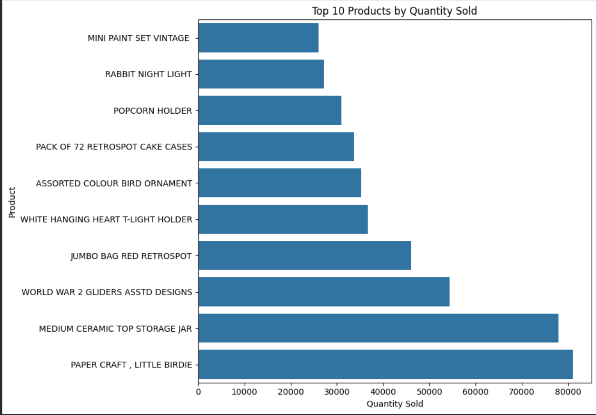
Figure 7.3 — Top 10 Products by Quantity Sold
Key observation: PAPER CRAFT, LITTLE BIRDIE has the highest recorded quantity at 80,995 units, followed by MEDIUM CERAMIC TOP STORAGE JAR at 77,916.
Interpretation: The ranking identifies products associated with high transaction volume. High quantity does not automatically imply the highest transaction value because transaction value also depends on unit price.

7.4 Top 10 Products by Revenue
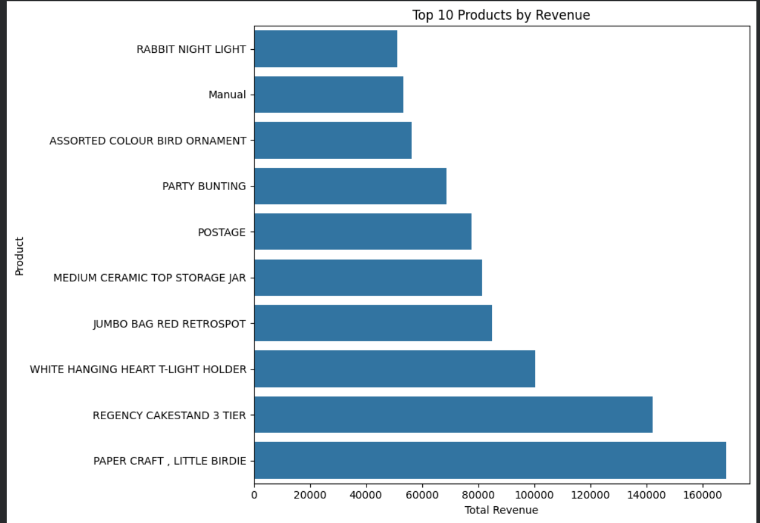
Figure 7.4 — Top 10 Products by Revenue
Key observation: PAPER CRAFT, LITTLE BIRDIE leads the displayed product-level transaction revenue at £168,469.60, followed by REGENCY CAKESTAND 3 TIER at £142,264.75.
Interpretation: Comparing quantity and revenue rankings shows that product volume and transaction value are related but not identical. POSTAGE and Manual also appear in the top revenue list and should be treated as transaction categories rather than conventional merchandise.

7.5 Top 10 Customers by Revenue
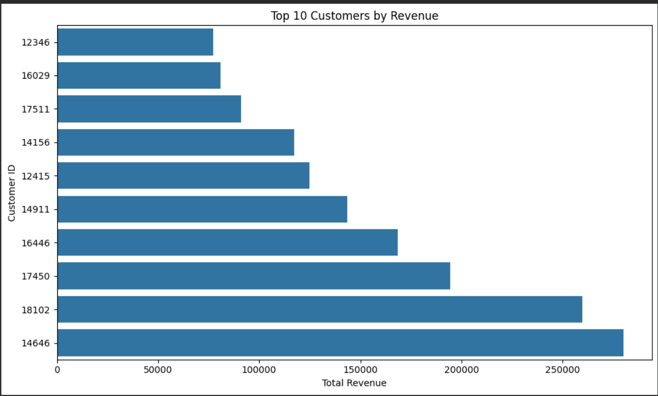
Figure 7.5 — Top 10 Customers by Revenue
Key observation: Customer 14646 has the highest cumulative transaction revenue at £280,206.02, followed by customers 18102 and 17450.
Interpretation: The customer-level distribution shows that a relatively small group of customers contributes substantial transaction value. This is useful for segmentation and customer-value analysis, although the chart alone does not establish why these customers spend more.

7.6 Distribution of Purchase Frequency per Customer
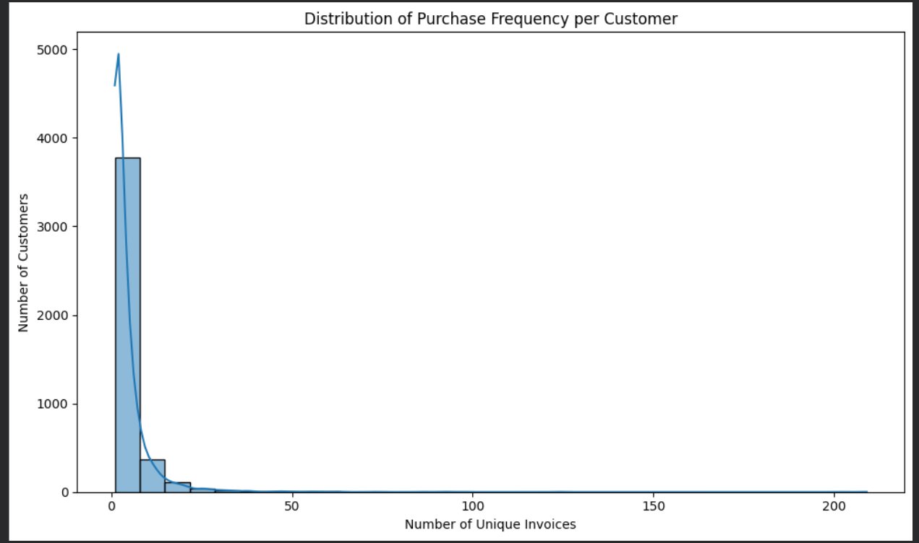
Figure 7.6 — Distribution of Purchase Frequency per Customer
Key observation: The median customer has 2 unique invoices, the mean is 4.27, and the maximum is 209. The distribution has a pronounced right tail.
Interpretation: Most customers have relatively few unique invoices, while a smaller number of customers transact much more frequently. This pattern can support later customer segmentation or RFM-style analysis.

7.7 Relationship Between Unit Price and Quantity
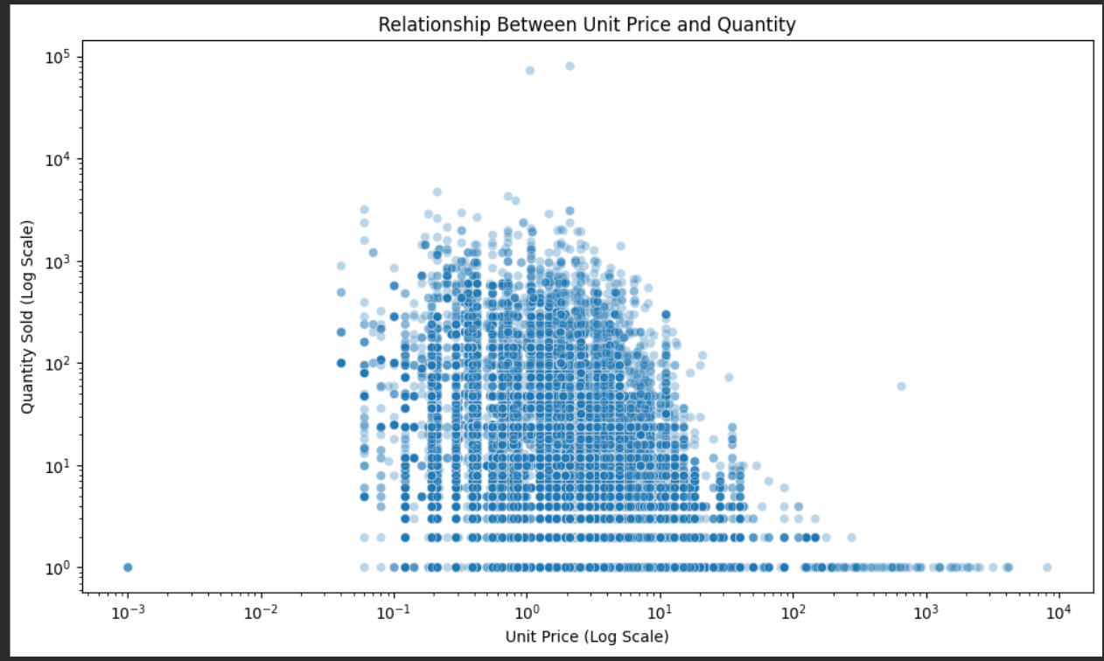
Figure 7.7 — Relationship Between Unit Price and Quantity
Key observation: The log-log scatter plot shows a dense concentration at lower unit prices and lower-to-moderate quantities, with a small number of extreme observations.
Interpretation: The variables do not show a strong linear association in the correlation analysis (approximately -0.005). The log transformation is useful because the raw values span several orders of magnitude. The plot describes association only and should not be interpreted as evidence of causation.

7.8 Revenue Distribution by Hour of Day
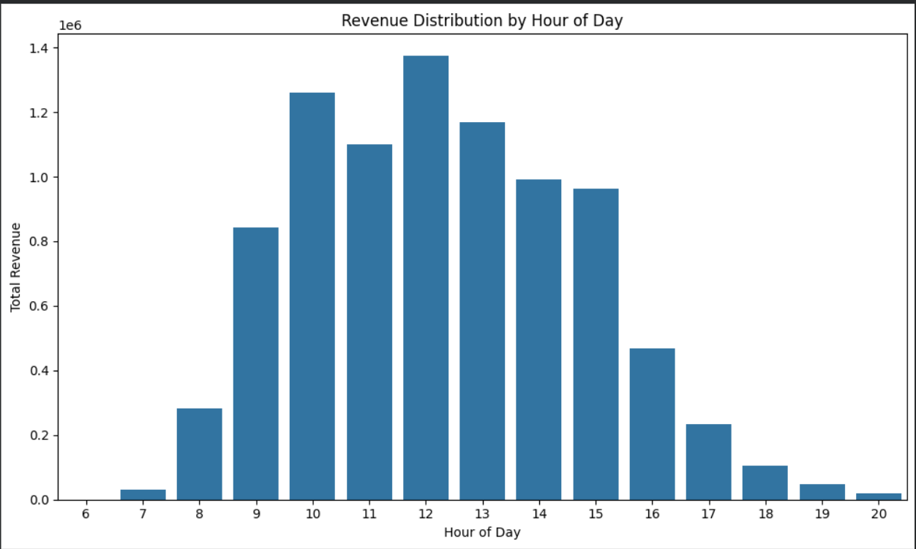
Figure 7.8 — Revenue Distribution by Hour of Day
Key observation: Transaction revenue is concentrated during daytime hours, with the highest aggregated value occurring around 12:00, followed by 10:00, 13:00, and 11:00.
Interpretation: The pattern suggests that transaction activity is concentrated within the operating hours represented in the dataset. Hourly totals should be interpreted as aggregated transaction value, not as a causal measure of customer behavior.

7.9 Correlation Matrix of Numerical Variables
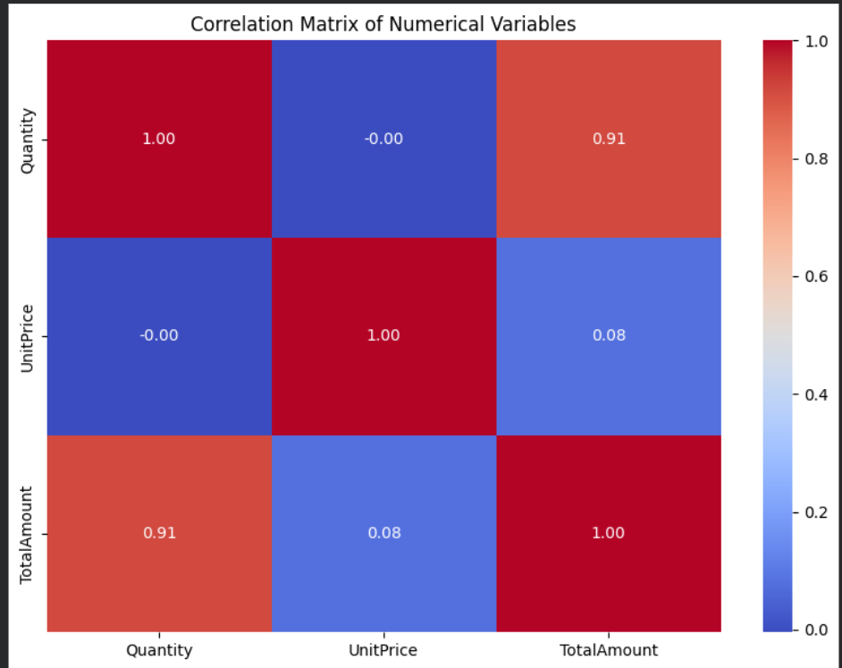
Figure 7.9 — Correlation Matrix of Numerical Variables
Key observation: Quantity and TotalAmount have a correlation of approximately 0.91, while UnitPrice and TotalAmount are about 0.08 and Quantity and UnitPrice are approximately -0.00.
Interpretation: The strong Quantity–TotalAmount relationship is expected because TotalAmount is mathematically calculated as Quantity × UnitPrice. Therefore, this correlation should not be presented as an independent business discovery. UnitPrice and Quantity show almost no linear correlation in the cleaned data.

8. Key Findings
Area | Finding
Temporal trend | November 2011 is the highest-revenue month at £1,156,205.61; December is incomplete and therefore not directly comparable.
Geographic concentration | The United Kingdom contributes £7,285,024.64, approximately 81.9% of total transaction revenue.
Product volume | PAPER CRAFT, LITTLE BIRDIE records the highest quantity at 80,995 units.
Product value | PAPER CRAFT, LITTLE BIRDIE also leads the displayed product revenue ranking at £168,469.60.
Customer value | Customer 14646 has the highest cumulative transaction value at £280,206.02.
Customer frequency | Purchase frequency is strongly right-skewed: median 2 invoices, mean 4.27, maximum 209.
Time-of-day pattern | Aggregated transaction revenue peaks around midday, particularly at 12:00.
Correlation | Quantity and TotalAmount are strongly correlated, largely because TotalAmount is derived from Quantity and UnitPrice.

9. Analytical Interpretation
The EDA indicates that transaction value is not evenly distributed across time, geography, customers, or products. The strong UK concentration suggests that the dataset is dominated by one market, while the late-2011 revenue increase indicates a period of elevated transaction activity.
Customer behavior is highly heterogeneous. Most customers appear at the lower end of purchase frequency, while a smaller group records substantially more invoices and cumulative value. This structure can be useful for later segmentation, retention analysis, or customer lifetime value modeling.
Product analysis demonstrates why both volume and value metrics should be considered together. A product can sell many units without ranking equally highly in transaction revenue, and transaction categories such as POSTAGE and Manual require careful semantic treatment before being interpreted as merchandise.
The numerical relationship analysis also highlights an important modeling consideration: derived variables can create mechanically strong correlations. Because TotalAmount is constructed directly from Quantity and UnitPrice, its relationship with those variables should not be treated as independent evidence of customer or market behavior.

10. Data Considerations, Anomalies & Limitations
- The dataset contains extreme values, including a maximum Quantity of 80,995, UnitPrice of £8,142.75, and TotalAmount of £168,469.60. These observations were retained because EDA should not automatically remove potentially valid business transactions.
- December 2011 is only partially represented through 9 December and should not be compared with full months without adjustment.
- The analysis uses transaction amount rather than audited accounting revenue; therefore, “transaction revenue” is the more precise term.
- POSTAGE and Manual appear among high-value transaction descriptions and may represent service or operational entries rather than ordinary products.
- Correlation measures linear association and does not establish causation.
- The hourly analysis reflects timestamps present in the dataset and should not be interpreted as a controlled experiment or causal estimate of customer demand.

11. Conclusion
Task 2 successfully transformed the cleaned Online Retail dataset into a structured analytical view through descriptive statistics, aggregation, visualization, and relationship analysis. The resulting EDA identified major temporal, geographic, product, customer, and transaction-level patterns while explicitly documenting important data limitations.
The analysis provides a strong foundation for subsequent data-science tasks such as customer segmentation, RFM analysis, anomaly investigation, demand forecasting, product-level analysis, and predictive modeling. It also demonstrates the importance of combining numerical summaries with visual evidence rather than relying on a single analytical technique.

12. Appendix — Core Analytical Operations
# Monthly revenue
monthly_revenue = clean_df.groupby(["Year", "Month"])["TotalAmount"].sum().reset_index()
# Country revenue
country_revenue = clean_df.groupby("Country")["TotalAmount"].sum().sort_values(ascending=False)
# Product quantity and revenue
product_quantity = clean_df.groupby("Description")["Quantity"].sum().sort_values(ascending=False)
product_revenue = clean_df.groupby("Description")["TotalAmount"].sum().sort_values(ascending=False)
# Customer revenue and purchase frequency
customer_revenue = clean_df.groupby("CustomerID")["TotalAmount"].sum().sort_values(ascending=False)
customer_frequency = clean_df.groupby("CustomerID")["InvoiceNo"].nunique()
# Correlation
correlation_data = clean_df[["Quantity", "UnitPrice", "TotalAmount"]].corr()

13. Submission Checklist
- EDA notebook with complete code and outputs
- Professional Task 2 report with embedded visualizations
- Interpretation of trends, distributions, relationships, and anomalies
- Documented data preparation and aggregation methodology
- Clear conclusions and limitations
- Ready for GitHub placement under Task-2-EDA-Visualization/

