YUVAINTERN DATA SCIENCE INTERNSHIP
WEEK 5 TASK
Deep Learning Application
in Data Science
Customer Repeat-Purchase Prediction using an Artificial Neural Network
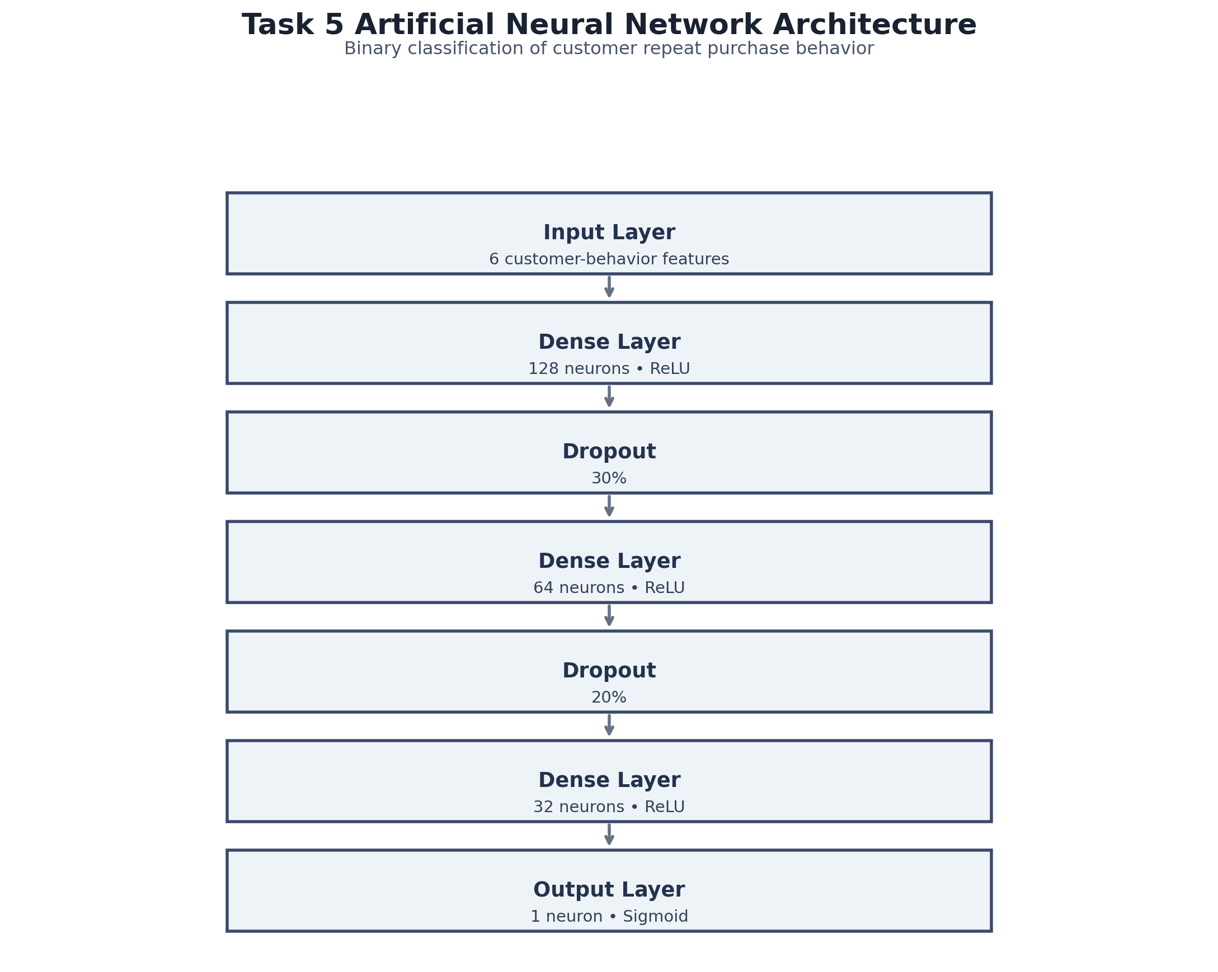
ANN architecture used for the final binary classifier.
TensorFlow / Keras • Online Retail • Binary Classification
Comprehensive technical report with notebook evidence

1. Executive Summary
This project applies an Artificial Neural Network (ANN) to customer repeat-purchase prediction using TensorFlow/Keras. It continues the same Online Retail workflow developed in Tasks 1–4, creating a coherent progression from data cleaning and EDA to RFM clustering, classical supervised learning, and finally deep learning.
The prediction problem is binary classification. Customer behavior observed before 1 September 2011 is used to construct six historical features. A customer is labeled as a repeat purchaser if that customer appears in the future transaction period beginning 1 September 2011. The future period is therefore used to define the target rather than as model input.
Final held-out test result
Accuracy 68.22% • Precision 73.94% • Recall 71.10% • F1 72.49% • ROC-AUC 74.02%.

Item | Result
Dataset | Online Retail transaction dataset
Cleaned transactions | 392,692
Customers modeled | 3,317
Input features | 6
Train / validation / test | 2,122 / 531 / 664
ANN parameters | 11,265
Best validation-loss epoch | 13
Total epochs trained | 23 of 100

2. Problem Statement and Business Context

2.1 Problem definition
The task is to estimate whether a customer will make another purchase in a defined future period. The model outputs a probability of RepeatPurchase = 1, which can be used as a predictive signal for customer analysis.
Component | Definition
Input | Historical customer behavior before 1 September 2011
Target 0 | No purchase in the future period
Target 1 | At least one purchase in the future period
Problem type | Binary classification
Output | Sigmoid probability

2.2 Why an ANN?
- ANNs can represent nonlinear interactions among behavioral variables.
- The project provides a deep-learning benchmark against Task 4 Logistic Regression and Random Forest models.
- The network is deliberately compact because the modeling table contains only 3,317 customers and six engineered features.

2.3 Business relevance
Repeat-purchase prediction can support retention analysis, customer prioritization and campaign experimentation. The model is predictive rather than causal: it estimates behavior and does not prove that an intervention will cause a customer to purchase.

3. Dataset, Project Continuity and Preparation
The Online Retail dataset originally contains 541,909 transaction rows and eight raw columns. The same validated cleaning procedure used in earlier tasks was reused: duplicate rows, missing customer/product information, cancellation invoices and non-positive quantities/prices were removed.
Stage | Rows | Purpose
Original dataset | 541,909 | Raw transaction data
Cleaned dataset | 392,692 | Validated transactions + derived fields
Historical period | 224,036 | Feature construction
Future period | 168,656 | Target construction only
Customer modeling table | 3,317 | Six features + binary target

3.1 Project continuity
- Task 1 — Data acquisition, cleaning and preprocessing.
- Task 2 — Exploratory Data Analysis and visualization.
- Task 3 — RFM customer segmentation with K-Means.
- Task 4 — Repeat-purchase prediction with Logistic Regression and Random Forest.
- Task 5 — Repeat-purchase prediction with an ANN.
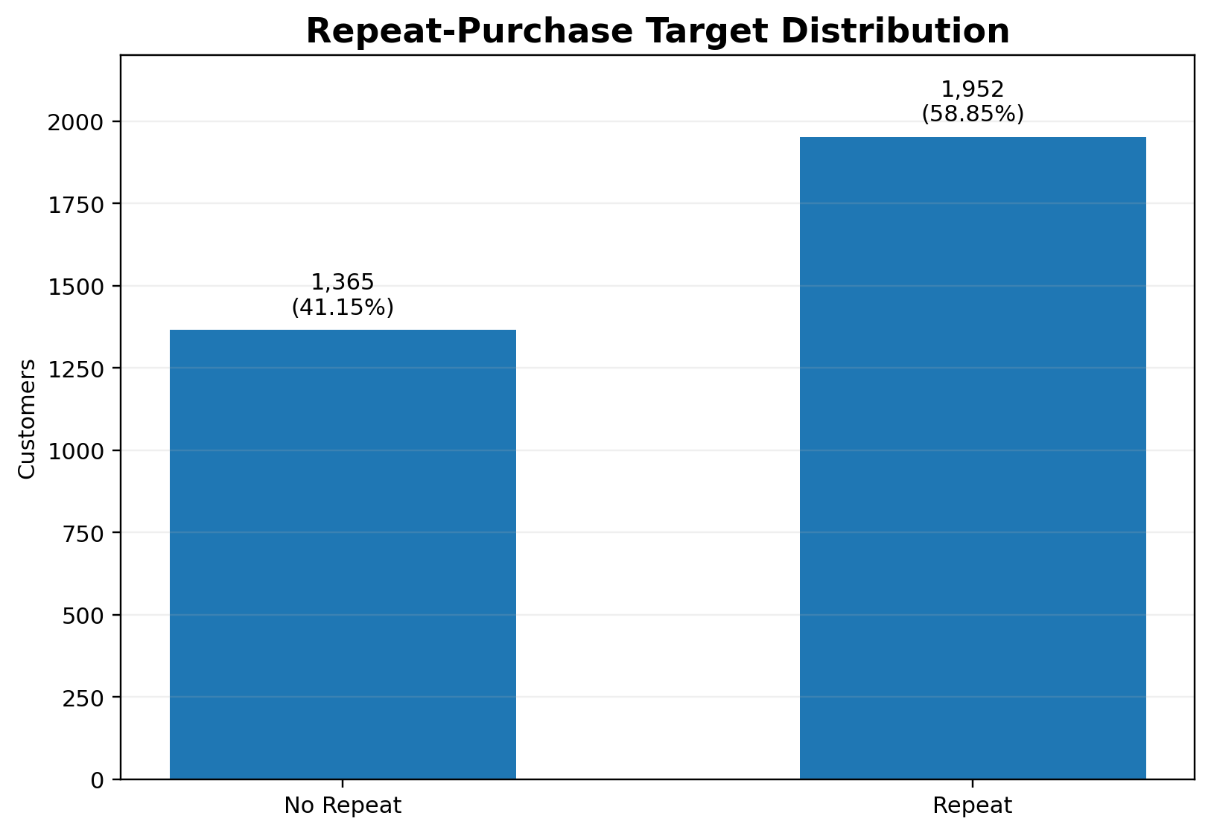
Repeat-purchase target distribution: 1,952 repeat customers (58.85%) and 1,365 non-repeat customers (41.15%).

4. Leakage-Controlled Target Construction
A chronological cutoff of 1 September 2011 was applied. Transactions before the cutoff form the historical dataset; transactions on or after the cutoff form the future dataset. This prevents future transactions from becoming model features.
Period | Date range | Rows
Historical | 2010-12-01 08:26 to 2011-08-31 17:16 | 224,036
Future | 2011-09-01 08:25 to 2011-12-09 12:50 | 168,656
Customer-level target construction produced 3,317 customers. Of these, 1,952 customers (58.85%) repeated and 1,365 (41.15%) did not.

4.1 Customer feature engineering
Feature | Definition
Recency | Days since most recent historical purchase
Frequency | Unique historical invoices
Monetary | Historical transaction amount
TotalQuantity | Historical units purchased
UniqueProducts | Distinct stock codes purchased
AvgOrderValue | Monetary / Frequency

4.2 Transformation and scaling
Because customer monetary and quantity variables are right-skewed, log1p transformation was applied to all six features. StandardScaler was then fitted only on the training data and used to transform validation and test data.

5. Data Split and Model Inputs
Subset | Customers | Role
Final training | 2,122 | Fit neural-network weights
Validation | 531 | Monitor generalization and early stopping
Test | 664 | Final held-out evaluation

5.1 Feature statistics
Feature | Mean | Median | Maximum
Recency | 93.11 | 73 | 274
Frequency | 3.44 | 2 | 127
Monetary | 1,575.97 | 552.80 | 176,355.94
TotalQuantity | 923.76 | 305 | 126,731
UniqueProducts | 49.09 | 29 | 1,190
AvgOrderValue | 399.43 | 283.50 | 77,183.60
Leakage-control rule
All six features are calculated exclusively from historical transactions. Future transactions are used only to create RepeatPurchase.

6. ANN Architecture and Design Justification
ANN architecture: 6 inputs → 128 → 64 → 32 → 1 sigmoid output, with dropout regularization.
Layer | Configuration | Parameters | Purpose
Input | 6 features | — | Receive standardized inputs
Dense 1 | 128, ReLU | 896 | Nonlinear feature interactions
Dropout | 30% | 0 | Regularization
Dense 2 | 64, ReLU | 8,256 | Higher-level representation
Dropout | 20% | 0 | Regularization
Dense 3 | 32, ReLU | 2,080 | Representation compression
Output | 1, Sigmoid | 33 | Binary probability
Total | — | 11,265 | Trainable parameters

6.1 Hyperparameters
Hyperparameter | Value
Optimizer | Adam
Loss | Binary cross-entropy
Maximum epochs | 100
Batch size | 32
Early stopping | val_loss, patience 10
Restore best weights | True
Hidden activation | ReLU
Output activation | Sigmoid

7. Training Process and Early Stopping
The ANN was trained with a maximum of 100 epochs and a batch size of 32. EarlyStopping monitored validation loss with patience 10 and restored the best weights. The model completed 23 epochs, with the best validation loss occurring at epoch 13.
Training result | Value
Total epochs trained | 23
Best epoch | 13
Best validation loss | 0.59217
Best validation AUC observed | ≈ 0.7204
Best validation accuracy observed | ≈ 66.10%
Why early stopping matters
The network was not allowed to continue training indefinitely once validation performance stopped improving. Restoring the best weights ensures the final model corresponds to the strongest validation-loss point.

8. Training Dynamics and Overfitting Analysis
The learning curves show a consistent training/validation performance gap, which is expected in a supervised neural network. Validation loss improves early and then fluctuates, while validation AUC remains around the low 0.70 range. The gap does not show uncontrolled divergence, and the combination of dropout and early stopping provides explicit regularization.
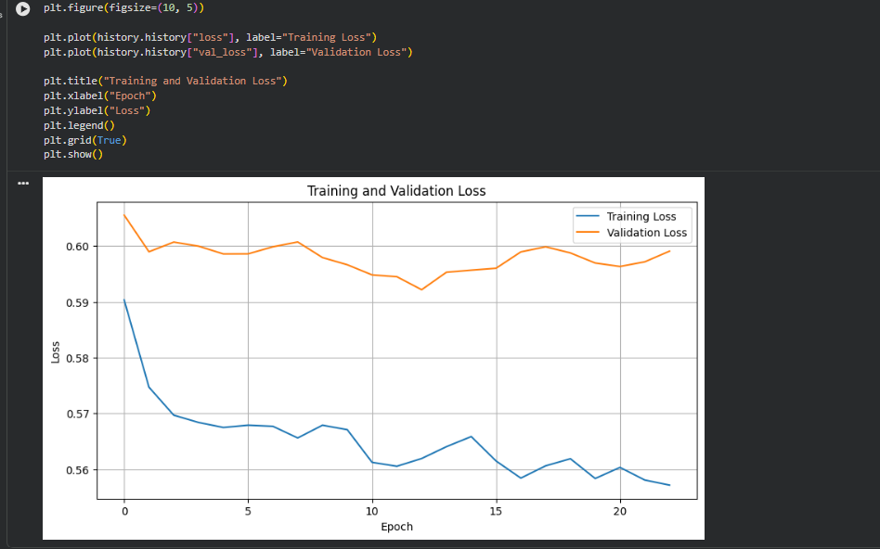  12. Training and validation loss | 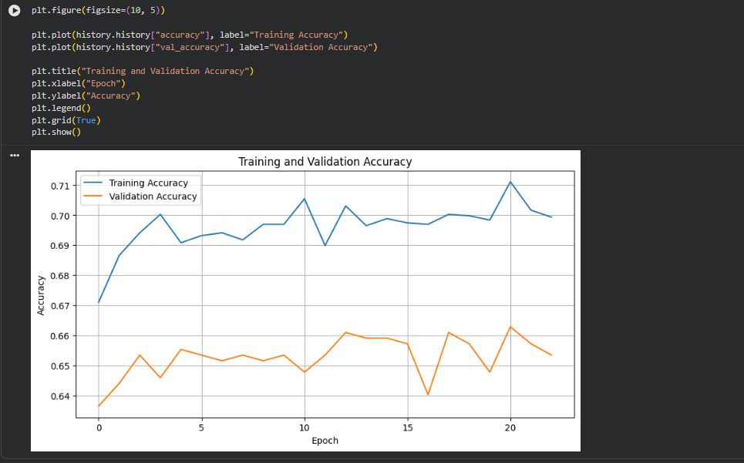  13. Training and validation accuracy

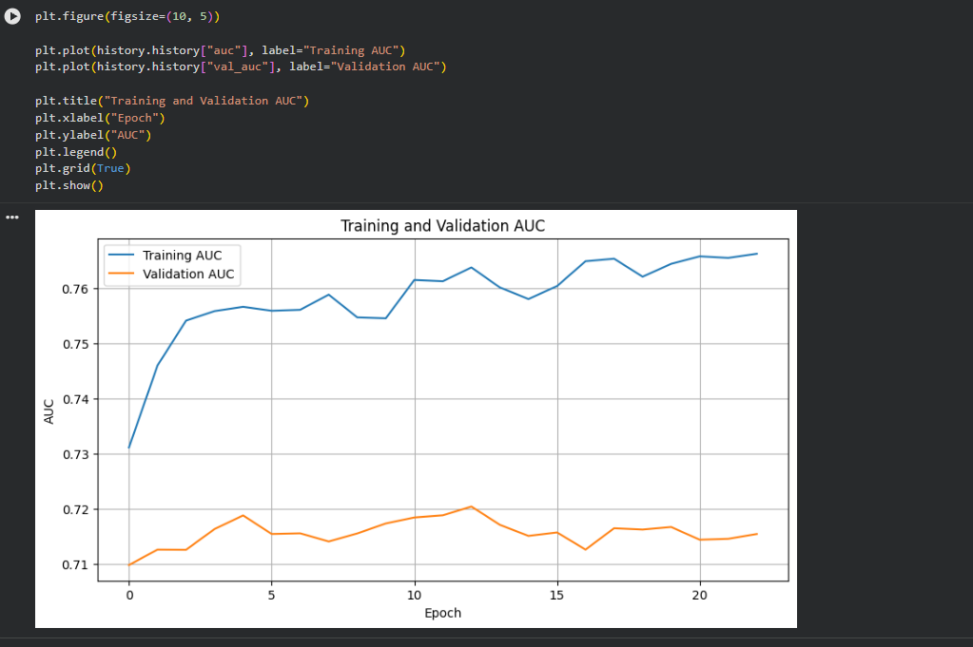  14. Training and validation AUC | 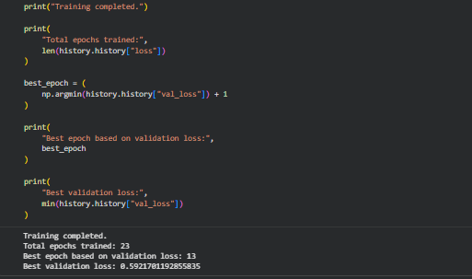  11. Training completion and early-stopping summary

9. Final Test Evaluation
Metric | ANN result | Meaning
Test loss | 0.5798 | Binary cross-entropy on unseen customers
Accuracy | 68.22% | Overall correct classification rate
Precision | 73.94% | Correctness of positive predictions
Recall | 71.10% | Repeat customers detected
F1-score | 72.49% | Precision/recall balance
ROC-AUC | 74.02% | Discrimination across thresholds

9.1 Classification report
Class | Precision | Recall | F1 | Support
0 — No Repeat | 0.61 | 0.64 | 0.62 | 273
1 — Repeat | 0.74 | 0.71 | 0.72 | 391
Macro average | 0.67 | 0.68 | 0.67 | 664
Weighted average | 0.69 | 0.68 | 0.68 | 664
The model identifies repeat purchasers more strongly than non-repeat customers in precision terms, while both classes remain imperfectly separated. This is consistent with the overall moderate predictive performance.

10. Confusion Matrix and ROC Analysis

10.1 Confusion matrix
The confusion matrix shows the distribution of correct and incorrect predictions at the default 0.50 probability threshold. It provides a more operational view than accuracy alone because false positives and false negatives are separated by class.
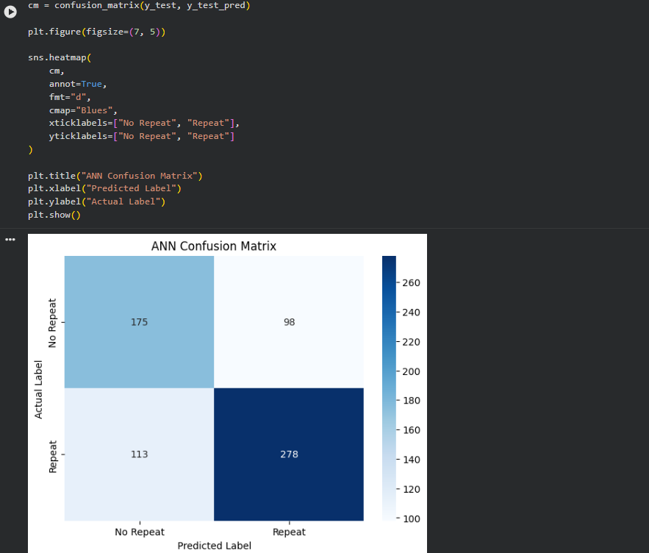
Figure 5. ANN confusion matrix on the held-out test set.

10.2 ROC curve
The ROC-AUC of 0.7401 is materially above random discrimination (0.50), indicating useful ranking capability. However, the model is not close to perfect discrimination, leaving room for better features, validation design and threshold selection.
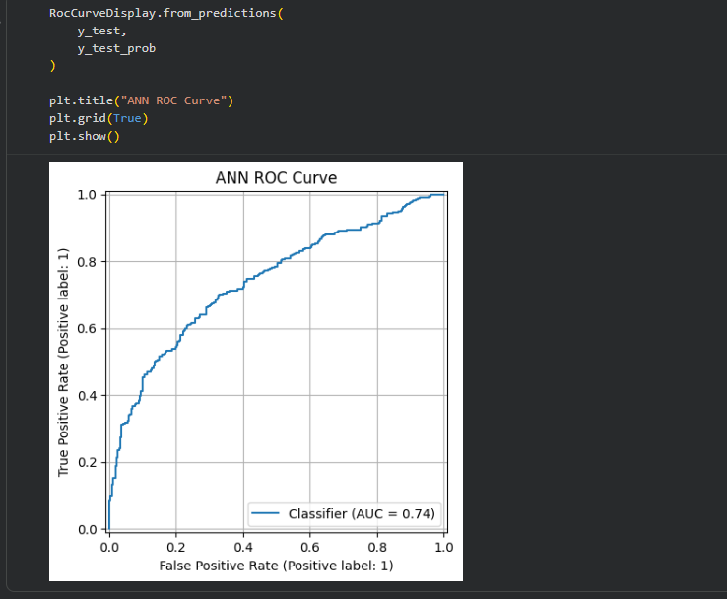
Figure 6. ANN ROC curve and test ROC-AUC.

11. Task 4 vs Task 5 Model Comparison
Model | Accuracy | Precision | Recall | F1 | ROC-AUC
Logistic Regression | 68.52% | 73.95% | 71.87% | 72.89% | 73.44%
Random Forest | 63.86% | 69.31% | 69.31% | 69.31% | 70.01%
Artificial Neural Network | 68.22% | 73.94% | 71.10% | 72.49% | 74.02%
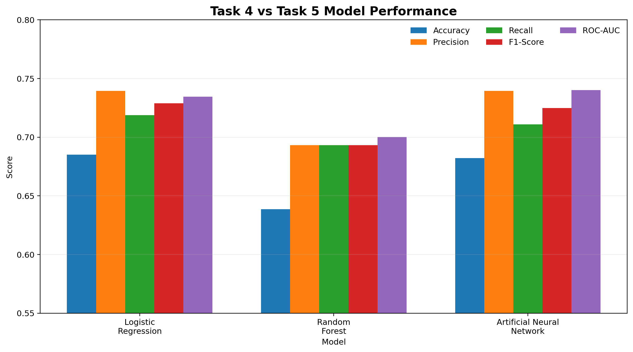
Figure 7. Test-set comparison of the three recorded models.

11.1 Interpretation
- The ANN has the highest recorded ROC-AUC (74.02%), narrowly above Logistic Regression (73.44%).
- Logistic Regression has slightly higher accuracy and F1-score than the ANN in this experiment.
- Random Forest records lower accuracy, F1 and ROC-AUC than the other two models.
- The close ANN and Logistic Regression results suggest that the engineered six-feature representation already captures much of the available predictive signal.
- Deep learning should therefore be evaluated on measured performance and operational requirements rather than assumed to be superior because it is more complex.

12. Strengths, Limitations and Challenges

12.1 Strengths
- Complete start-to-finish deep-learning workflow.
- Chronological target construction reduces future-information leakage.
- Appropriate transformations for skewed customer-level variables.
- Regularization through dropout and early stopping.
- Multiple evaluation metrics and a held-out test set.
- Direct benchmark against Task 4 classical models.

12.2 Limitations
- The dataset contains only 3,317 customer-level modeling records and six engineered features, limiting the amount of information available to a neural network.
- The target uses one future window; performance may change for another cutoff or horizon.
- One train/validation/test split does not fully characterize temporal stability.
- The default 0.50 classification threshold may not align with a particular business cost structure.
- ANN predictions are less inherently interpretable than a linear model.

12.3 Challenges and mitigation
Challenge | Mitigation
Feature skew | log1p transformation
Different feature scales | StandardScaler fitted only on training data
Overfitting risk | Dropout + validation monitoring + early stopping
Future leakage risk | Chronological cutoff
Small tabular dataset | Compact 11,265-parameter architecture
Training beyond best validation point | restore_best_weights=True

13. Improvements and Business Implications

13.1 Technical improvements
- Use rolling or repeated chronological validation to test temporal robustness.
- Optimize the decision threshold for the cost of false positives versus false negatives.
- Engineer richer temporal features such as purchase intervals, recent spending trend and order-frequency changes.
- Add product/category and basket-level features while preserving the temporal leakage constraint.
- Perform controlled hyperparameter tuning or compare a smaller ANN against the current architecture.
- Apply explainability techniques such as SHAP or permutation importance.
- Calibrate probabilities if predicted probabilities will be used for customer prioritization.

13.2 Potential business applications
- Prioritize customers for retention or follow-up analysis.
- Combine repeat-purchase probability with the RFM segments from Task 3.
- Design controlled experiments to test targeted campaigns for different predicted-risk groups.
- Use model probabilities as one decision input rather than an automatic business rule.
Causal caution
A prediction model identifies customers with different probabilities of future purchase. It does not establish that contacting a customer, offering a discount or changing an experience will cause the predicted outcome.

14. Conclusion
The Week 5 task successfully implemented an Artificial Neural Network for customer repeat-purchase prediction using TensorFlow/Keras. The project demonstrates a complete deep-learning workflow: data preparation, leakage-aware target definition, customer-level feature engineering, log transformation, scaling, neural-network design, regularized training, early stopping, held-out testing and comparative evaluation.
The final ANN achieved 68.22% accuracy, 73.94% precision, 71.10% recall, 72.49% F1-score and 74.02% ROC-AUC. Its performance was close to Logistic Regression while producing a slightly higher ROC-AUC in the recorded comparison. The results therefore provide a realistic deep-learning benchmark rather than an unsupported claim that a neural network must outperform classical machine learning.
Final takeaway
The strongest aspect of the project is the rigor of the pipeline: future transactions are kept out of the input features, validation is used for model selection, the test set is held out for final evaluation, and the ANN is compared directly with Task 4 baselines.

Appendix A — Complete Notebook Evidence
All 19 screenshots supplied in the Task 5 ZIP are embedded below. The evidence is arranged compactly so the evaluator can trace each major stage without turning the main report into a screenshot dump.
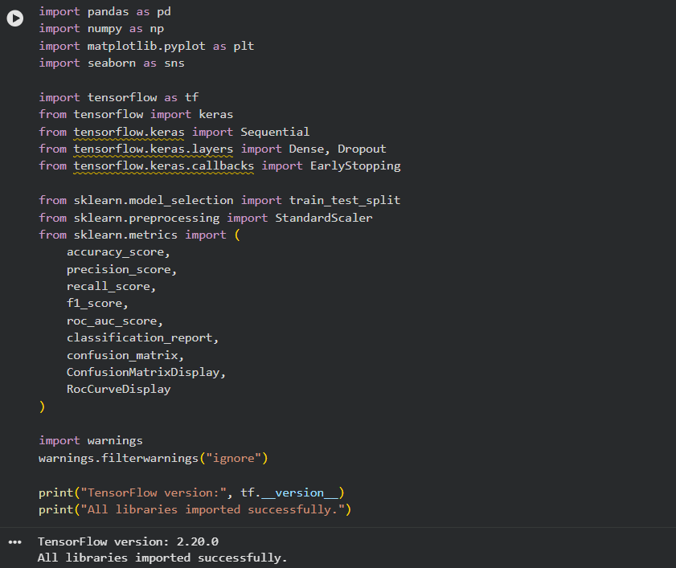  1. Python environment and imports | 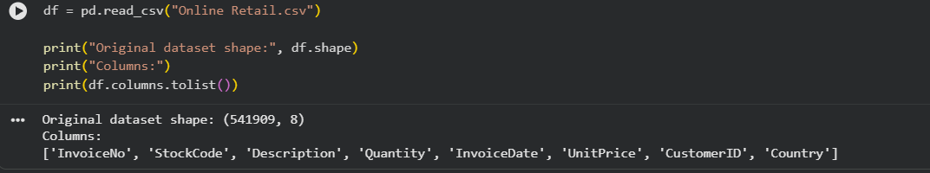  2. Original dataset verification

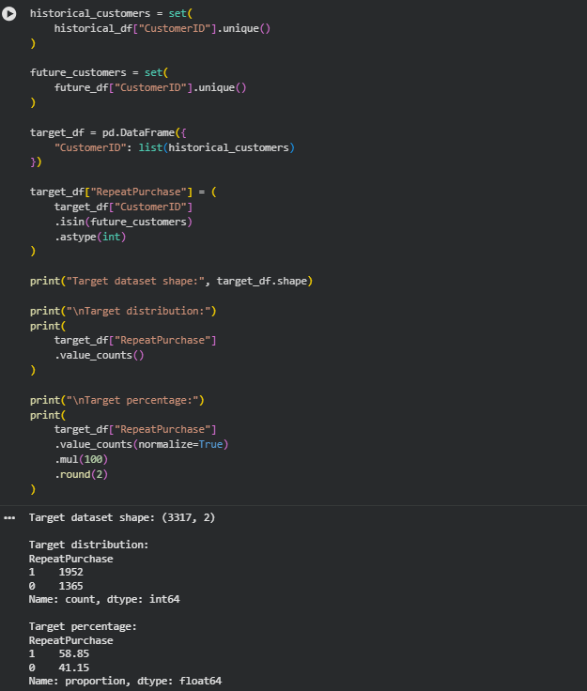  3. Temporal split and target construction | 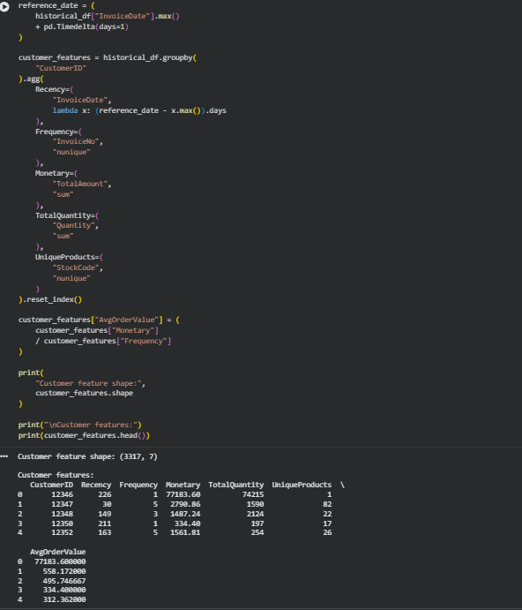  4. Customer feature engineering

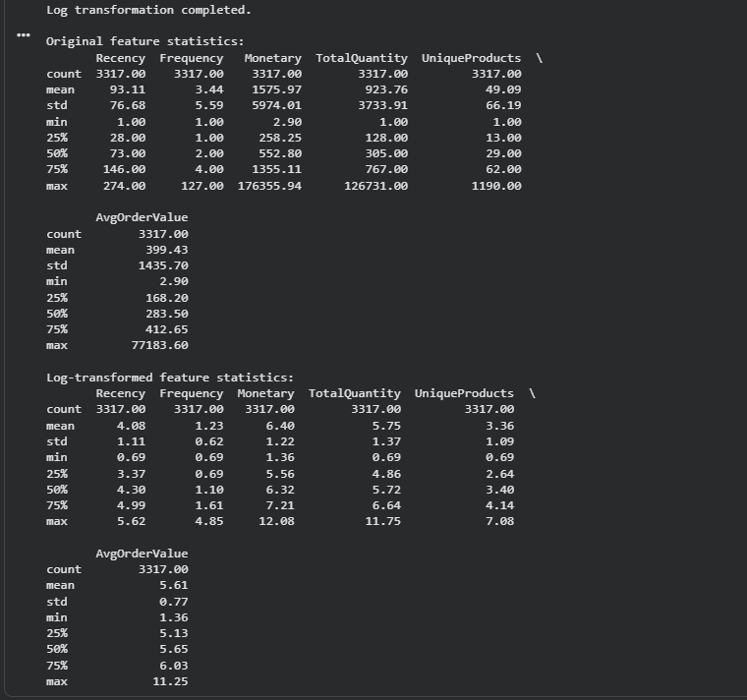  5. Feature statistics and log transformation | 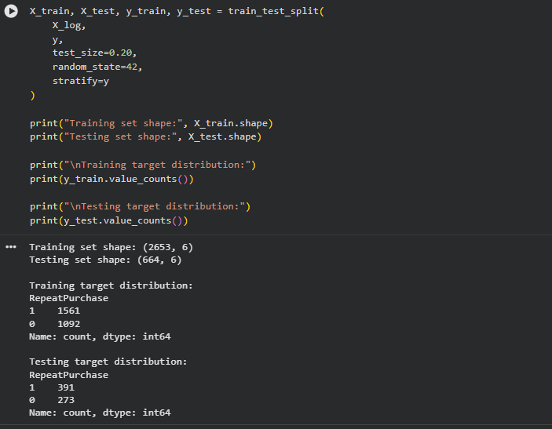  6. Train/test split

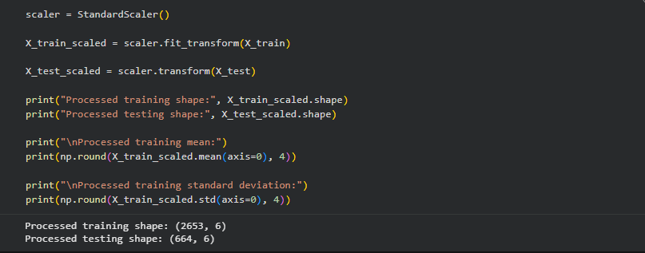  7. StandardScaler processing | 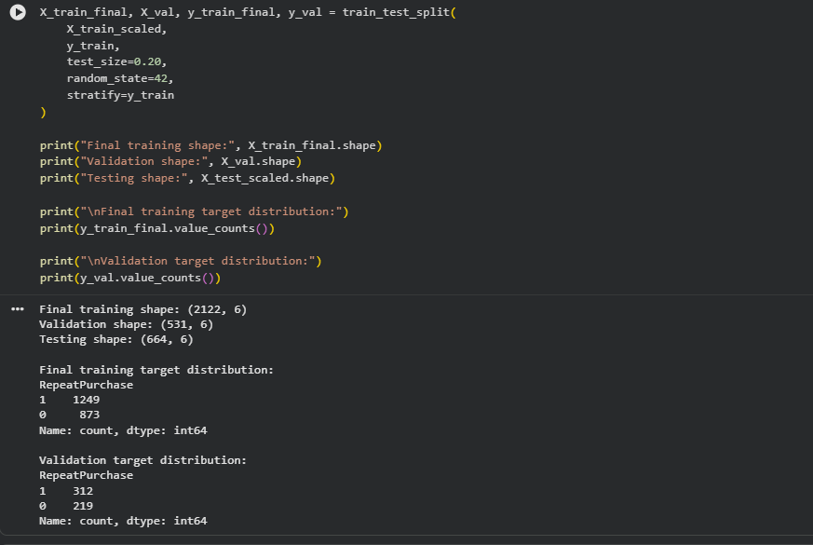  8. Validation split

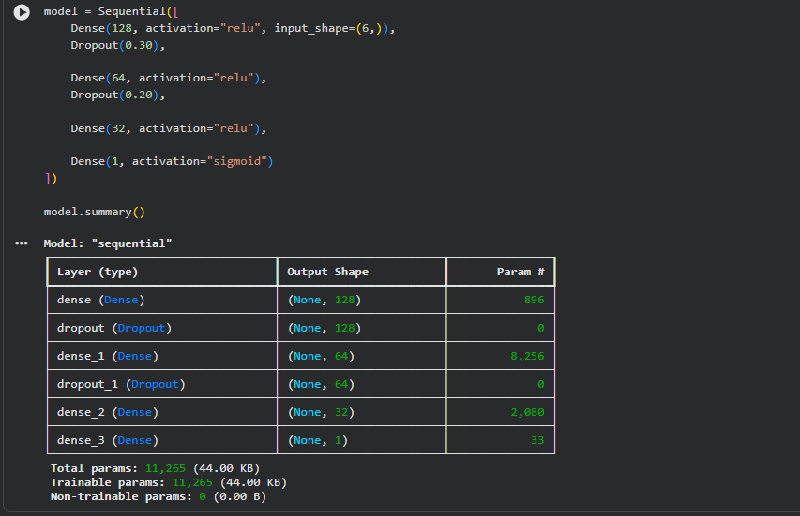  9. ANN model summary | 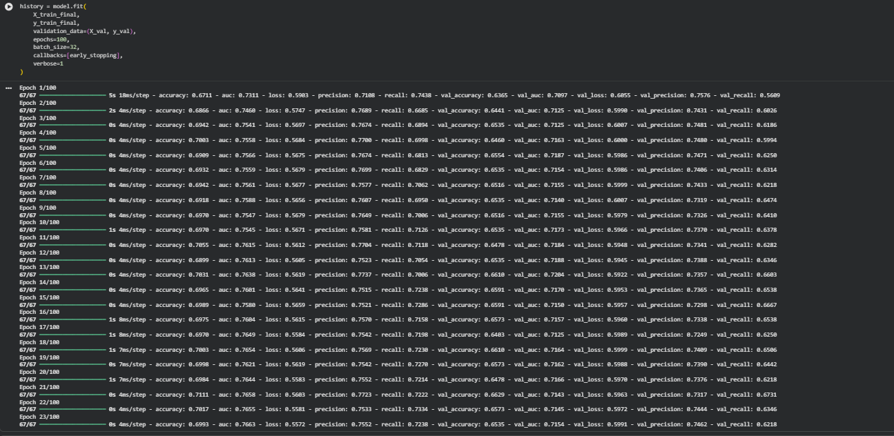  10. Training epoch output

11. Early-stopping summary | 12. Training/validation loss

13. Training/validation accuracy | 14. Training/validation AUC

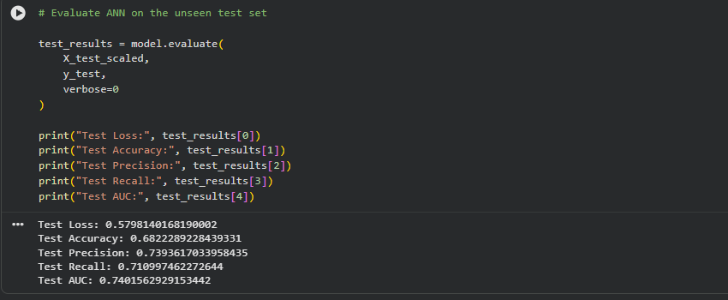  15. Keras test evaluation | 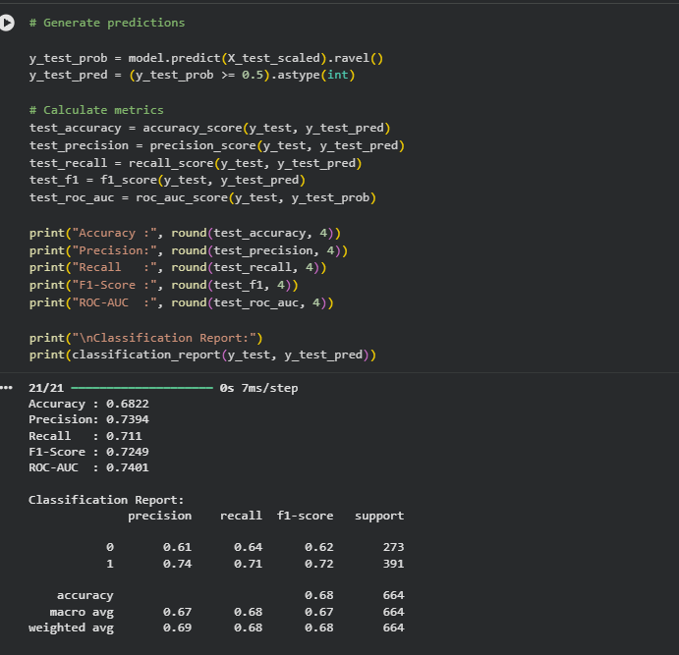  16. Final test metrics and classification report

17. Confusion matrix | 18. ROC curve

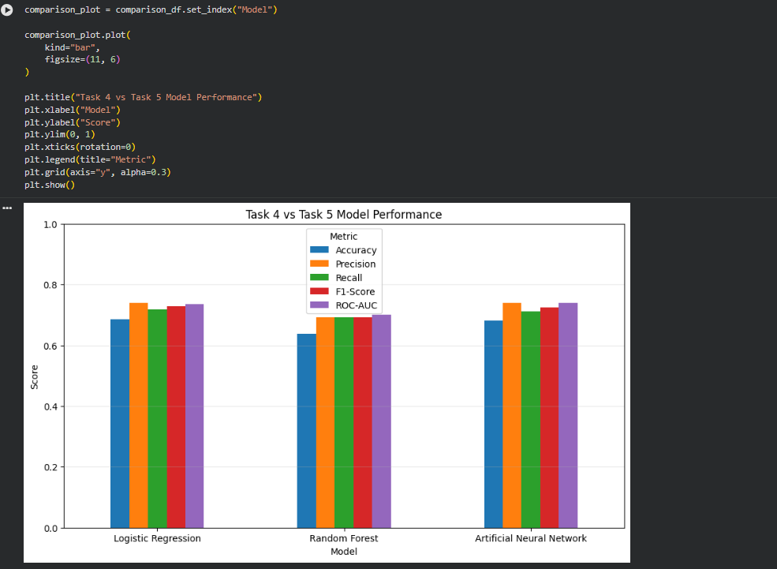
19. Task 4 vs Task 5 model comparison screenshot.

Appendix B — Reproducibility Artifacts
Artifact | Filename | Purpose
Notebook | Task_5_Deep_Learning_ANN.ipynb | Full executable workflow
Trained model | task5_customer_repeat_purchase_ann.keras | Saved ANN weights and architecture
Predictions | task5_ann_predictions.csv | 664 held-out predictions and probabilities
Report | YuvaIntern_Task_5_Deep_Learning_Report_FINAL.docx | Comprehensive submission document

