INTERNSHIP TASK 1
DATA CLEANING AND PREPROCESSING
Online Retail Transaction Dataset

Submitted by
Suryansh Nigam
B.Tech – Artificial Intelligence & Machine Learning
SRMCEM, Lucknow

Prepared as part of Internship Task 1

1. Executive Summary
This report documents the complete data cleaning, validation, preprocessing, and feature-engineering workflow performed on an Online Retail transaction dataset. The original dataset contained 541,909 transaction records and 8 columns. The analysis identified missing values, duplicate records, cancelled transactions, non-positive quantities, non-positive prices, and extreme observations.
A business-rule-based cleaning process was applied rather than blindly removing every statistical outlier. After cleaning, 392,692 valid transaction records remained. The dataset was then preprocessed by converting CustomerID to an integer, creating TotalAmount, and extracting Year, Month, Day, and Hour from InvoiceDate. Final validation confirmed zero missing values, zero duplicate rows, positive quantities and prices, and consistent date and identifier fields.

2. Project Snapshot
Metric | Result
Original dataset | 541,909 rows × 8 columns
Cleaned dataset | 392,692 rows × 13 columns
Rows removed | 149,217 (27.53%)
Customers in final dataset | 4,338
Invoices in final dataset | 18,532
Countries in final dataset | 37
Missing values after cleaning | 0
Duplicate rows after cleaning | 0

3. Introduction
Data cleaning and preprocessing are essential stages of a data-science workflow. Raw transaction datasets often contain missing identifiers, duplicate records, cancellations, invalid numeric values, inconsistent data types, and extreme observations. If these issues are not addressed, subsequent analysis can produce misleading results.
The purpose of this task was to inspect the raw retail data, identify data-quality issues, apply transparent cleaning rules, validate the resulting dataset, and create analytical features that make the data suitable for further business and machine-learning analysis.

4. Objectives
- Load and inspect the raw retail transaction dataset.
- Understand the structure, data types, and quality of each field.
- Identify and quantify missing values and duplicate records.
- Detect cancellations, invalid quantities, invalid prices, and unusual observations.
- Apply documented business rules to create a reliable transaction-level analysis dataset.
- Validate the cleaned dataset after every major transformation.
- Engineer useful features such as TotalAmount, Year, Month, Day, and Hour.
- Produce visual evidence showing the impact of cleaning and the distribution of transaction values.

5. Dataset Description
The dataset used for this task is an Online Retail transaction dataset. Each row represents a transaction line and includes invoice, product, quantity, date-time, price, customer, and country information.
Column | Data Type (Initial) | Description
InvoiceNo | object | Invoice or transaction identifier
StockCode | object | Product/stock identifier
Description | object | Product description
Quantity | int64 | Number of units in the transaction line
InvoiceDate | object → datetime64[ns] | Transaction date and time
UnitPrice | float64 | Price per unit
CustomerID | float64 → int64 | Customer identifier
Country | object | Customer/transaction country

6. Tools and Technologies
- Python – primary programming language.
- Pandas – data loading, inspection, cleaning, transformation, and validation.
- NumPy – numerical operations and logarithmic bin construction for visualization.
- Matplotlib – creation of report visualizations.
- Jupyter/Notebook environment – iterative execution and inspection of results.

7. Data Loading and Initial Inspection
The raw dataset was loaded into a Pandas DataFrame and inspected using shape, info, null-value, duplicate, and descriptive-statistics checks. The initial shape was 541,909 rows and 8 columns.
df.shape
# Output:
(541909, 8)
df.info()
# Key observations:
# InvoiceDate was initially an object column.
# CustomerID contained missing values.
# Description contained missing values.
InvoiceDate was converted to datetime format before feature engineering so that calendar and time components could be extracted reliably.

8. Data Quality Analysis

8.1 Missing Values
Column | Missing Count | Missing Percentage
Description | 1,454 | 0.27%
CustomerID | 135,080 | 24.93%
Other columns | 0 | 0%

Description had a small number of missing values, while CustomerID had a substantial number of missing identifiers. Missing CustomerID values were excluded from the customer-linked analysis dataset because reliable customer-level linkage could not be established for those rows. This is a documented analytical choice rather than an assertion that every transaction without a CustomerID is invalid.
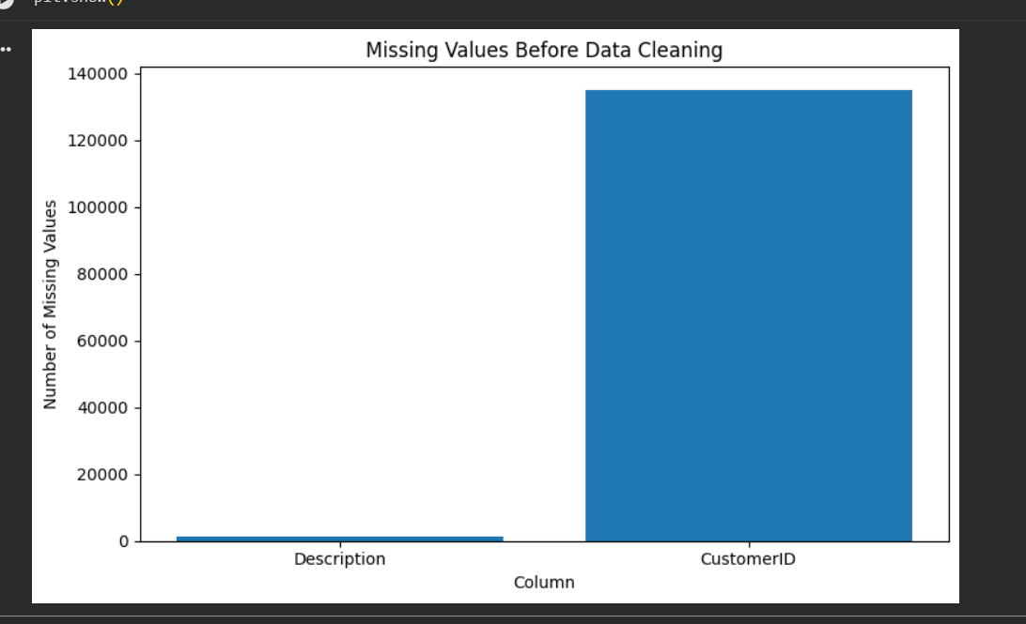
Figure 1: Missing Values Before Data Cleaning

8.2 Duplicate Records
Duplicate transaction rows were identified using Pandas duplicate detection. The later full-dataset validation identified 10,147 duplicate rows. Exact duplicate records were removed during the cleaning stage to prevent the same transaction line from being counted more than once.
df.duplicated().sum()
# Result:
10147
clean_df = df.copy()
clean_df = clean_df.drop_duplicates()

8.3 Quantity Validation
The original dataset contained 10,624 negative quantity records and no zero-quantity records. Negative quantities included cancellation/return-related records and operational entries such as disposal or damaged stock. Cancelled invoices were separately identified using InvoiceNo values beginning with 'C'.
Quantity Check | Result
Negative quantities | 10,624
Zero quantities | 0
Cancellation invoice rows | 9,288
Negative quantity without cancellation invoice | 1,336

8.4 UnitPrice Validation
The initial data contained 2,515 zero-price records and 2 negative UnitPrice records. The negative prices were associated with adjustment/bad-debt records. Since the objective was to create a positive-sales analysis dataset, non-positive UnitPrice values were excluded.
Price Check | Result
Zero UnitPrice | 2,515
Negative UnitPrice | 2
Initial maximum UnitPrice | 38,970
Final maximum UnitPrice | 8,142.75

9. Outlier Analysis
Potential outliers were assessed using descriptive statistics and the Interquartile Range (IQR) method. The purpose of this analysis was to identify observations requiring investigation, not to automatically delete every value outside the IQR bounds.
Variable | Q1 | Q3 | IQR | Upper IQR Bound | Potential Outliers
Quantity | 1.00 | 10.00 | 9.00 | 23.50 | 58,619
UnitPrice | 1.25 | 4.13 | 2.88 | 8.45 | 39,627

Inspection showed that some extreme quantities were associated with legitimate bulk transactions, while other extreme records in the original data were cancellations or operational entries. Therefore, business rules were used for cleaning instead of deleting all statistical outliers. This preserves potentially valid high-value transactions while removing clearly unsuitable records.

10. Data Cleaning Methodology
The following cleaning rules were applied sequentially to a copy of the original DataFrame:
- Remove exact duplicate rows.
- Remove records with missing Description.
- Remove records with missing CustomerID for the customer-linked analysis dataset.
- Remove cancelled invoices identified by InvoiceNo beginning with 'C'.
- Retain only Quantity values greater than zero.
- Retain only UnitPrice values greater than zero.
clean_df = df.copy()
clean_df = clean_df.drop_duplicates()
clean_df = clean_df.dropna(subset=["Description"])
clean_df = clean_df.dropna(subset=["CustomerID"])
clean_df = clean_df[
~clean_df["InvoiceNo"].astype(str).str.startswith("C")
]
clean_df = clean_df[clean_df["Quantity"] > 0]
clean_df = clean_df[clean_df["UnitPrice"] > 0]
# Final cleaning result:
# Original shape: (541909, 8)
# Cleaned shape: (392692, 8)
# Rows removed: 149217
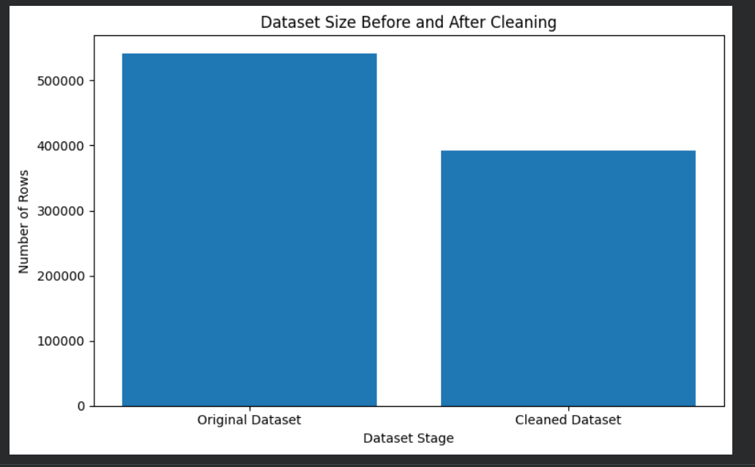
Figure 2: Dataset Size Before and After Cleaning

11. Cleaning Validation
After the cleaning rules were applied, the resulting dataset was validated to ensure that the intended quality conditions had been achieved.
Validation Check | Result
Final shape after cleaning | (392,692, 8)
Missing values | 0 in every column
Duplicate rows | 0
Negative quantities | 0
Zero quantities | 0
Non-positive UnitPrice | 0
Cancelled invoices | 0
InvoiceDate type | datetime64[ns]

12. Preprocessing and Feature Engineering
After cleaning, the data was prepared for further analysis. CustomerID was converted from float64 to int64 because it functions as an identifier and all missing CustomerID values had already been removed.
A new TotalAmount feature was created using Quantity × UnitPrice. InvoiceDate was decomposed into Year, Month, Day, and Hour to enable time-based analysis.
clean_df["CustomerID"] = clean_df["CustomerID"].astype(int)
clean_df["TotalAmount"] = (
clean_df["Quantity"] * clean_df["UnitPrice"]
)
clean_df["Year"] = clean_df["InvoiceDate"].dt.year
clean_df["Month"] = clean_df["InvoiceDate"].dt.month
clean_df["Day"] = clean_df["InvoiceDate"].dt.day
clean_df["Hour"] = clean_df["InvoiceDate"].dt.hour
Feature | Purpose
TotalAmount | Transaction-level monetary value
Year | Year-based analysis
Month | Monthly trends and seasonality
Day | Day-level transaction analysis
Hour | Time-of-day analysis

13. Final Preprocessing Validation
The final validation confirmed that preprocessing did not introduce missing values or duplicate rows and that all retained transactions satisfy the positive-quantity and positive-price rules.
Final Metric | Result
Rows | 392,692
Columns | 13
Missing values | 0
Duplicate rows | 0
Minimum Quantity | 1
Maximum Quantity | 80,995
Minimum UnitPrice | 0.001
Maximum UnitPrice | 8,142.75
Minimum TotalAmount | 0.001
Maximum TotalAmount | 168,469.60
Invoice date range | 2010-12-01 08:26 to 2011-12-09 12:50
Unique customers | 4,338
Unique invoices | 18,532
Unique countries | 37

14. Data Visualization
Three focused visualizations were created to communicate the most important outcomes of the data preparation process: missing-value concentration, dataset reduction, and transaction-value distribution.
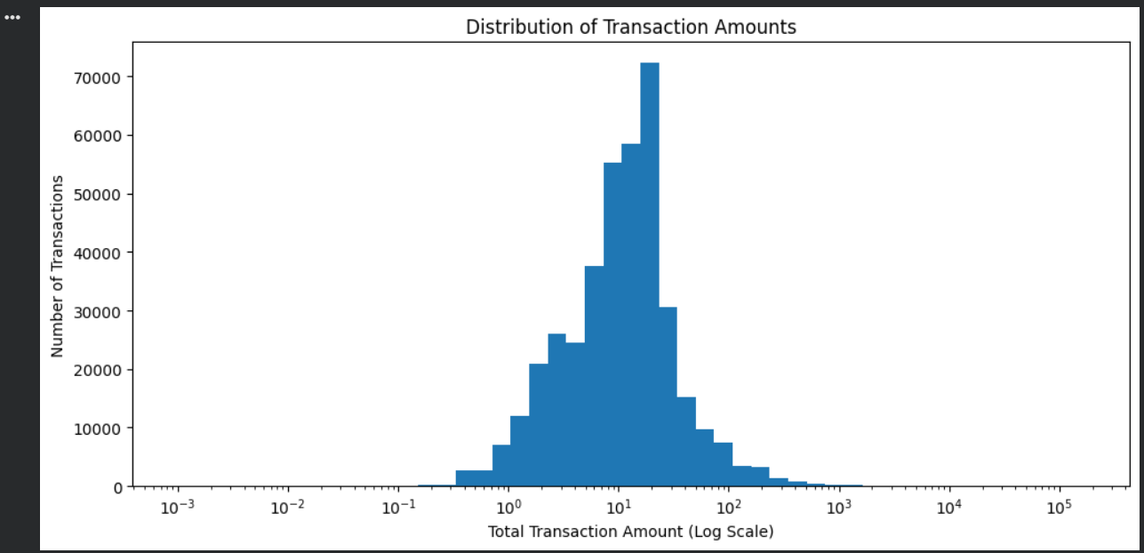
Figure 3: Distribution of Transaction Amounts
The transaction amount distribution is strongly right-skewed. Most transaction values are concentrated in a lower range, while a smaller number of high-value transactions form a long right tail. A logarithmic x-axis was used because transaction amounts vary substantially in magnitude.

15. Before-and-After Summary
Aspect | Before Cleaning | After Cleaning & Preprocessing
Rows | 541,909 | 392,692
Columns | 8 | 13
Missing CustomerID | 135,080 | 0
Missing Description | 1,454 | 0
Duplicate rows | 10,147 identified | 0
Cancelled invoices | 9,288 identified | 0
Negative quantities | 10,624 | 0
Non-positive UnitPrice | 2,517 | 0
TotalAmount feature | Not available | Created
Date-time features | InvoiceDate only | Year, Month, Day, Hour

16. Data-Handling Decisions and Limitations
- Missing CustomerID values were excluded because the intended cleaned dataset requires reliable customer-level linkage. This reduces coverage and should be considered if the dataset is later used for transaction-only analysis.
- Cancelled transactions were excluded to create a positive-sales analysis dataset. Cancellation/refund behavior can instead be studied separately when the business question requires it.
- Negative quantities that were not marked as cancellation invoices were also excluded because the final dataset is intended to represent positive sales transactions.
- Statistical IQR outliers were investigated rather than automatically deleted. Extreme values can represent legitimate bulk orders or other valid business events.
- The cleaned dataset is therefore an analysis-specific dataset rather than a claim that every excluded row is globally erroneous.

17. Challenges Encountered
- A substantial proportion of rows had missing CustomerID values, requiring a clear analytical decision.
- The raw dataset contained cancellation and operational records mixed with regular sales transactions.
- Quantity and UnitPrice contained extreme values, making simple outlier deletion inappropriate.
- Transaction amounts were highly skewed, requiring logarithmic visualization for clearer interpretation.
- InvoiceDate required conversion from object format to datetime before time-based feature extraction.

18. Conclusion
The data cleaning and preprocessing task successfully transformed the raw Online Retail dataset into a structured analysis-ready dataset. The workflow systematically identified missing data, duplicates, cancelled transactions, invalid numeric values, and extreme observations before applying transparent business rules.
The final dataset contains 392,692 rows and 13 columns, with zero missing values and zero duplicate rows. Additional analytical features including TotalAmount, Year, Month, Day, and Hour were created. The final validation confirmed that the resulting dataset satisfies the defined quality checks and is suitable for downstream exploratory analysis, customer analysis, visualization, and future machine-learning workflows.

19. Appendix – Final Dataset Columns
Column | Final Data Type
InvoiceNo | object
StockCode | object
Description | object
Quantity | int64
InvoiceDate | datetime64[ns]
UnitPrice | float64
CustomerID | int64
Country | object
TotalAmount | float64
Year | int32
Month | int32
Day | int32
Hour | int32

— End of Report —

