YUVAINTERN
WEEK 3 PROJECT REPORT
Unsupervised Learning &
Customer Segmentation
RFM Analysis with K-Means Clustering

Internship | YuvaIntern – Data Science Internship
Task | Week 3: Unsupervised Learning and Clustering Analysis
Dataset | Online Retail Transaction Dataset
Student | Suryansh Nigam
Date | 27 September 2026

PROJECT THEME
Transform transaction history into actionable customer segments using Recency, Frequency and Monetary (RFM) behavior, then discover natural customer groups with K-Means clustering.

Table of Contents
1. Executive Summary ................................... 3
2. Project Objective ................................... 3
3. Dataset and Project Continuity ...................... 4
4. Methodology ......................................... 4
5. RFM Feature Engineering ............................. 5
6. RFM Distribution and Transformation ................. 7
7. K-Means Model Selection ............................. 9
8. Final Clustering Results ............................ 11
9. Cluster Visualization and Interpretation ............ 12
10. Business Implications .............................. 15
11. Limitations and Considerations ..................... 16
12. Conclusion ......................................... 17
Appendix A. Key Code Snippets .......................... 18
Appendix B. Evidence Screenshots ....................... 20

1. Executive Summary
This project applies unsupervised learning to customer transaction behavior using the Online Retail dataset. Building directly on the cleaned dataset prepared in Week 1 and the exploratory analysis completed in Week 2, the project converts transaction-level records into customer-level RFM features: Recency, Frequency and Monetary value. These features are log-transformed and standardized before applying K-Means clustering.
Two candidate-model diagnostics were used to select the number of clusters. The elbow analysis showed progressively decreasing within-cluster sum of squares, while silhouette analysis provided a clearer separation signal. Among K=2 to K=10, K=2 achieved the highest silhouette score of 0.4328, so the final model uses two clusters.
The resulting segmentation separates 4,338 known customers into two behaviorally distinct groups. Cluster 0 contains 2,672 customers (61.6%) with average recency of 134.09 days, average purchase frequency of 1.67 invoices and average monetary value of £495.59. Cluster 1 contains 1,666 customers (38.4%) with substantially lower average recency of 25.89 days, higher average frequency of 8.44 invoices and higher average monetary value of £4,539.60. For reporting purposes, these groups are described as Low-Engagement Customers and High-Engagement Customers respectively; the labels summarize observed RFM behavior rather than claiming a causal customer type.
KEY RESULT
The final K-Means solution uses K=2 and achieves a silhouette score of 0.4328. The first segment is larger and shows lower engagement, while the second segment is smaller but more recent, frequent and higher-value.

2. Project Objective
- Apply an unsupervised learning technique to a publicly available transaction dataset.
- Create meaningful customer-level features suitable for clustering.
- Use K-Means clustering with a defensible choice of the number of clusters.
- Visualize and profile the resulting customer segments.
- Interpret cluster characteristics and discuss practical business implications.
- Document the methodology, code evidence, figures and results in a structured report.

3. Dataset and Project Continuity
The project uses the cleaned Online Retail transaction dataset developed in the earlier internship tasks. Week 1 focused on data cleaning and preprocessing; Week 2 explored transaction patterns through descriptive statistics, aggregations and visualization. Week 3 uses that same analytical foundation and moves from transaction-level exploration to customer-level behavioral segmentation.
Dataset characteristic | Value
Cleaned transactions | 392,692
Known customers | 4,338
Unique invoices | 18,532
Products | 3,665
Countries | 37
Final RFM records | 4,338 customers × 4 base fields
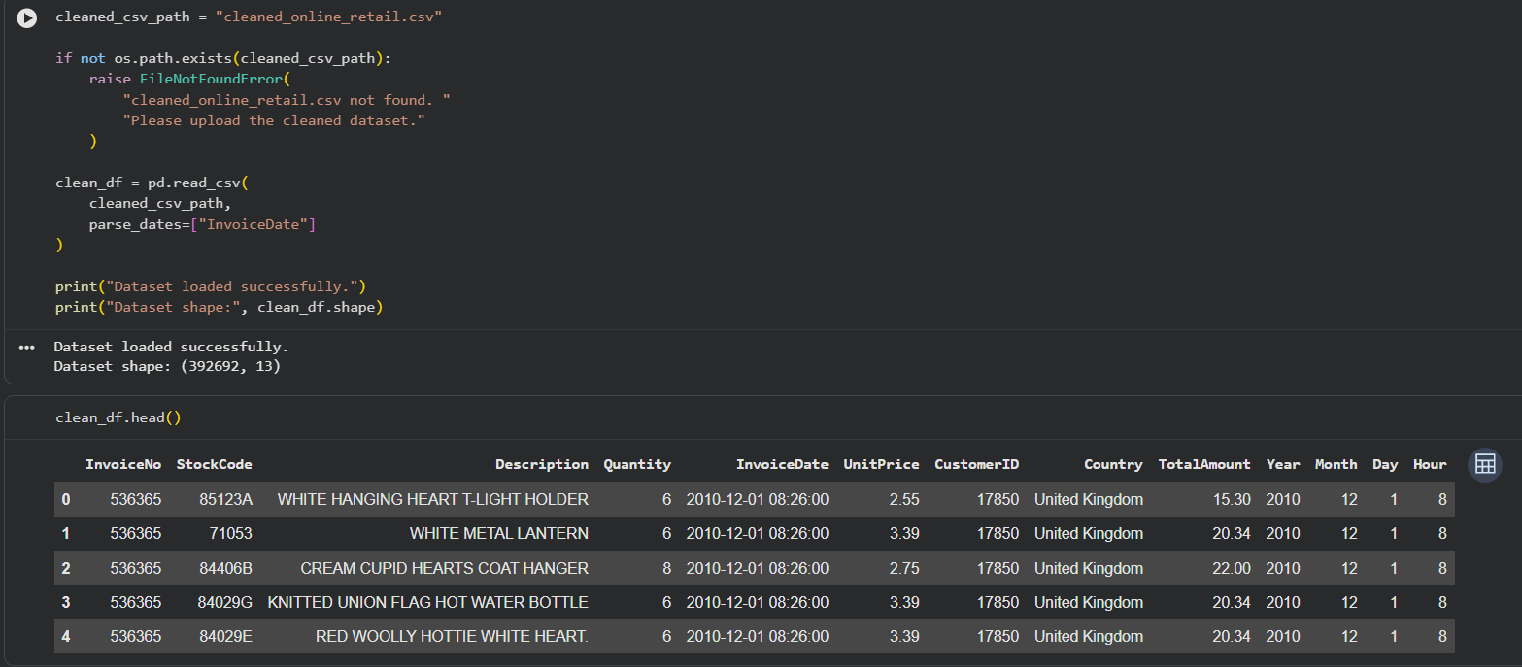
Figure 1. Cleaned transaction dataset loaded for Week 3 analysis.
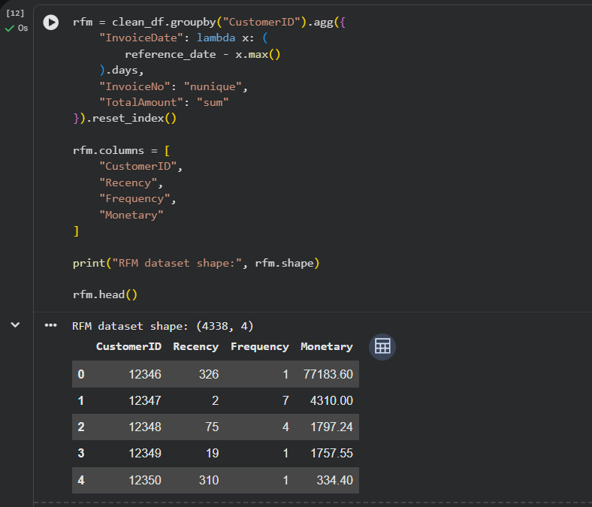
Figure 2. Customer-level RFM dataset creation and first records.

4. Methodology

4.1 Analytical Pipeline
- Load the cleaned transaction dataset and parse InvoiceDate as a datetime field.
- Derive one RFM record per known customer.
- Inspect RFM distributions and identify strong skew/outlier behavior.
- Apply log1p transformations to Recency, Frequency and Monetary value.
- Standardize the transformed features using StandardScaler.
- Evaluate K-Means solutions from K=2 through K=10 using inertia and silhouette score.
- Select the final K based on the combined diagnostics, with silhouette providing the clearest separation criterion.
- Fit the final K-Means model, assign cluster labels and profile each cluster using means, medians and customer counts.
- Use PCA and feature-level boxplots/3D visualization to communicate cluster structure.

4.2 RFM Definitions
Feature | Definition in this project | Interpretation
Recency | Days between the reference date and the customer’s most recent invoice | Lower values indicate more recent activity.
Frequency | Number of unique invoices associated with the customer | Higher values indicate more repeated purchasing.
Monetary | Sum of TotalAmount across the customer’s transactions | Higher values indicate greater transaction value in the dataset.
REFERENCE DATE
Recency is measured relative to one day after the maximum InvoiceDate in the cleaned dataset. This makes the recency scale internally consistent with the historical dataset window, which ends on 9 December 2011.

5. RFM Feature Engineering
The customer-level RFM table contains 4,338 customers. The base RFM statistics show substantial skew, especially in Frequency and Monetary value. This is expected in retail transaction data because a small subset of customers can place many orders or generate very large transaction amounts.
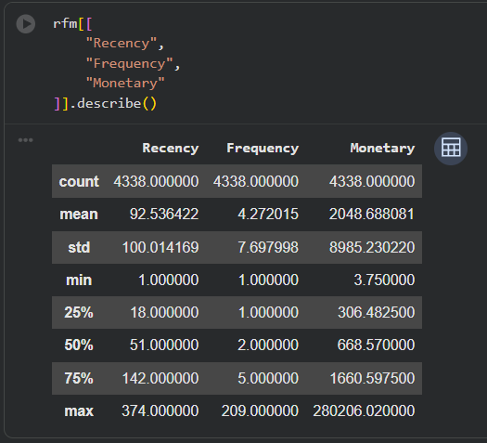
Figure 3. Descriptive statistics for the RFM variables.
reference_date = clean_df["InvoiceDate"].max() + pd.Timedelta(days=1)
rfm = clean_df.groupby("CustomerID").agg({
"InvoiceDate": lambda x: (reference_date - x.max()).days,
"InvoiceNo": "nunique",
"TotalAmount": "sum"
}).reset_index()
rfm.columns = ["CustomerID", "Recency", "Frequency", "Monetary"]
The resulting RFM table is then examined through distributions and boxplots before modeling. This step is important because K-Means is distance-based; extreme scale differences and highly skewed variables can otherwise dominate the clustering geometry.
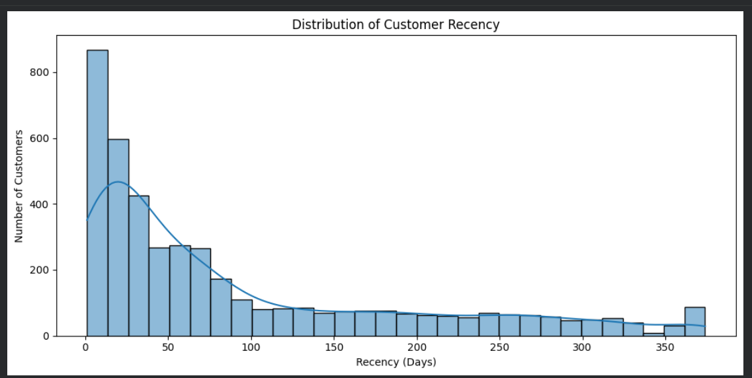
Figure 4. Distribution of customer Recency.
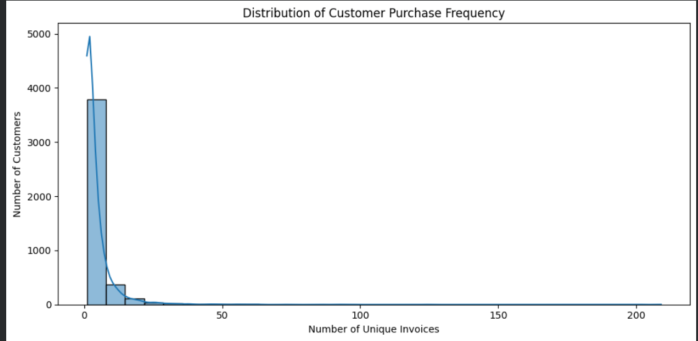
Figure 5. Distribution of customer purchase Frequency.
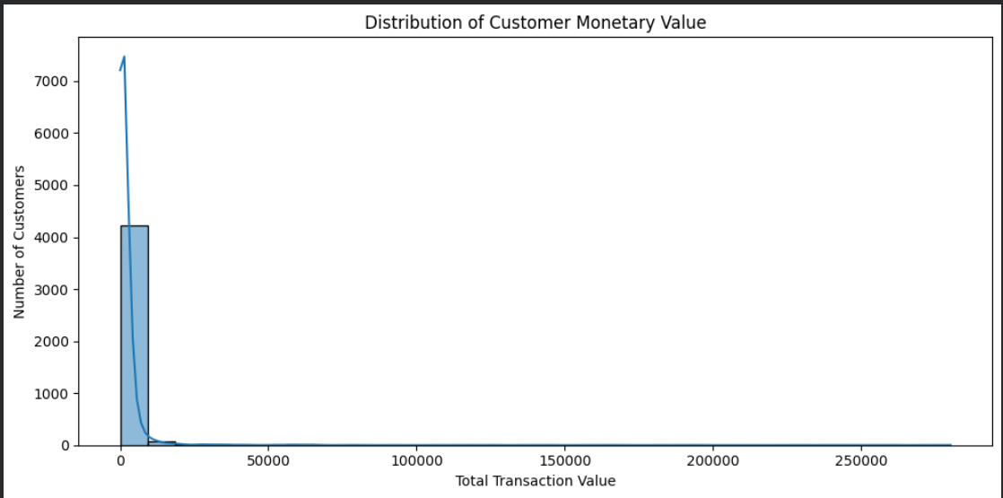
Figure 6. Distribution of customer Monetary value.
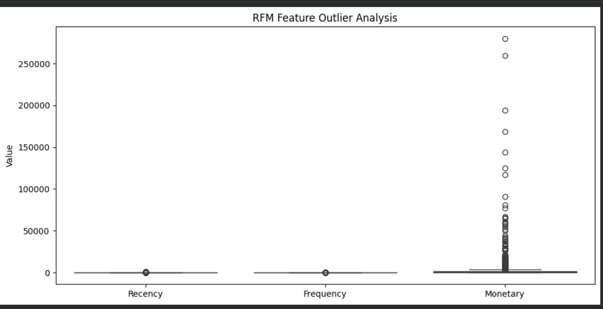
Figure 7. RFM feature outlier comparison before transformation.

6. RFM Distribution and Transformation
The distributions demonstrate strong right-skew in Frequency and Monetary value, with Recency also showing a non-symmetric distribution. Rather than deleting high-value customers simply because they appear as statistical outliers, the project uses log1p transformation to compress the dynamic range while retaining the observations.
rfm["Recency_Log"] = np.log1p(rfm["Recency"])
rfm["Frequency_Log"] = np.log1p(rfm["Frequency"])
rfm["Monetary_Log"] = np.log1p(rfm["Monetary"])
features = rfm[["Recency_Log", "Frequency_Log", "Monetary_Log"]]
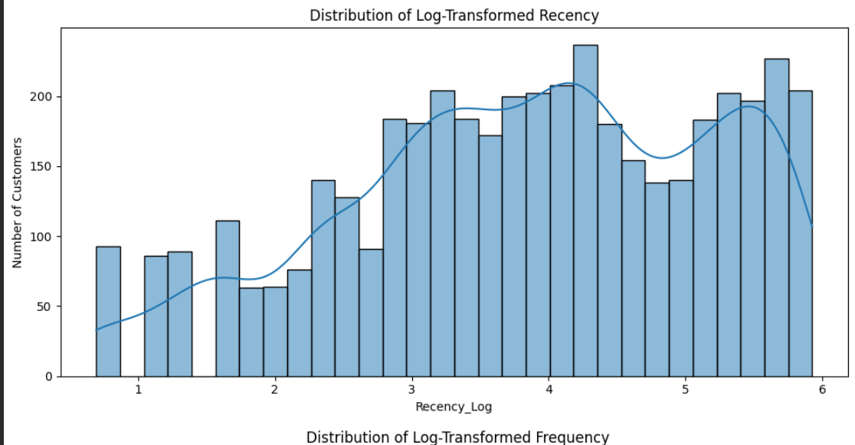
Figure 8. Distribution of log-transformed Recency.
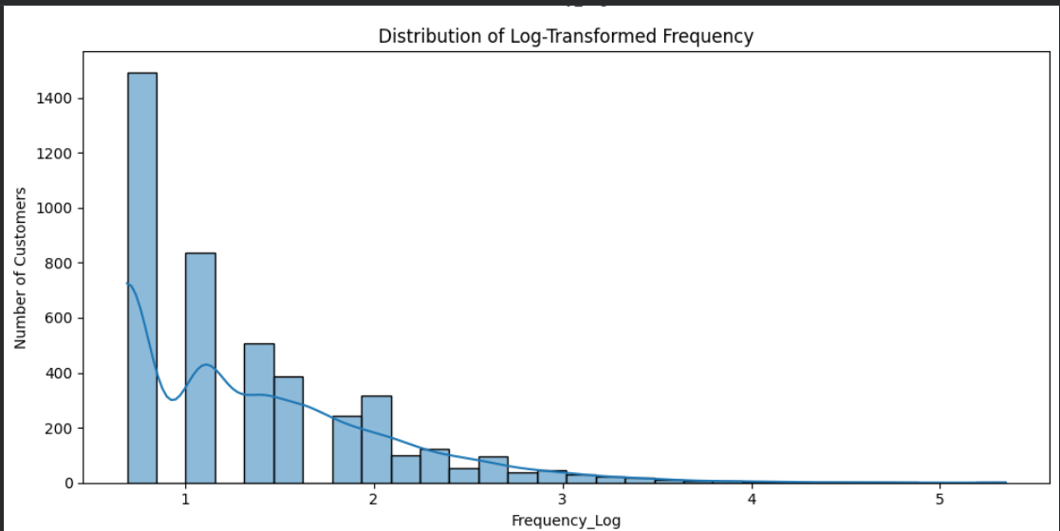
Figure 9. Distribution of log-transformed Frequency.
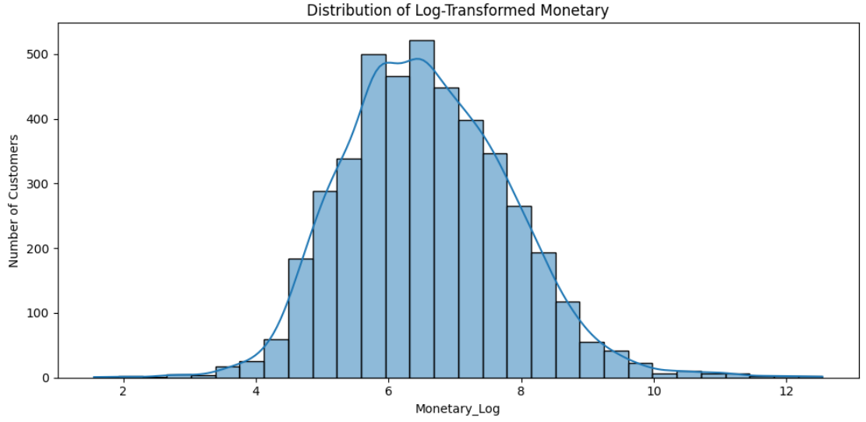
Figure 10. Distribution of log-transformed Monetary value.

6.1 Standardization
After transformation, StandardScaler is applied so that each clustering feature has approximately zero mean and unit standard deviation. The screenshot evidence confirms means of approximately 0 and standard deviations of 1 after scaling. This prevents a feature with a larger numeric range from dominating Euclidean distance calculations.
scaler = StandardScaler()
rfm_scaled = scaler.fit_transform(features)
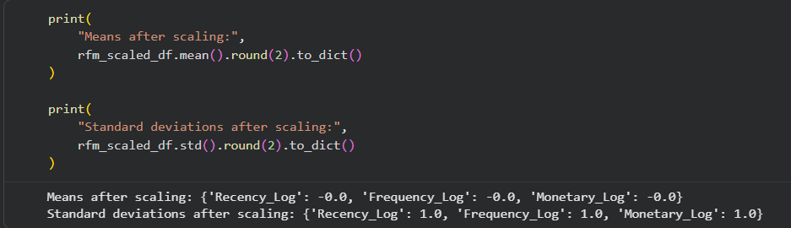
Figure 11. Standardization check: transformed features have mean ≈ 0 and standard deviation ≈ 1.

7. K-Means Model Selection
K-Means partitions observations into K groups by minimizing within-cluster squared Euclidean distances. The key model-selection question is the appropriate value of K. The project evaluates K=2 through K=10 using two complementary diagnostics: inertia (elbow method) and silhouette score.

7.1 Elbow Method
K | Inertia
2 | 6483.59
3 | 4869.49
4 | 3939.05
5 | 3296.71
6 | 2855.76
7 | 2548.82
8 | 2336.34
9 | 2156.01
10 | 2005.75
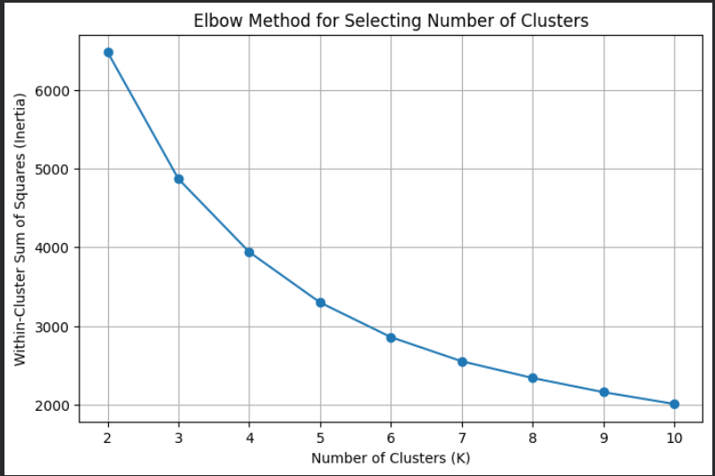
Figure 12. Elbow curve for K=2 to K=10.
The elbow curve decreases continuously. It does not display one overwhelmingly sharp elbow, so inertia alone is not sufficient to justify a final K.

7.2 Silhouette Analysis
K | Silhouette Score
2 | 0.4328
3 | 0.3365
4 | 0.3375
5 | 0.3162
6 | 0.3124
7 | 0.3092
8 | 0.3033
9 | 0.2811
10 | 0.2767
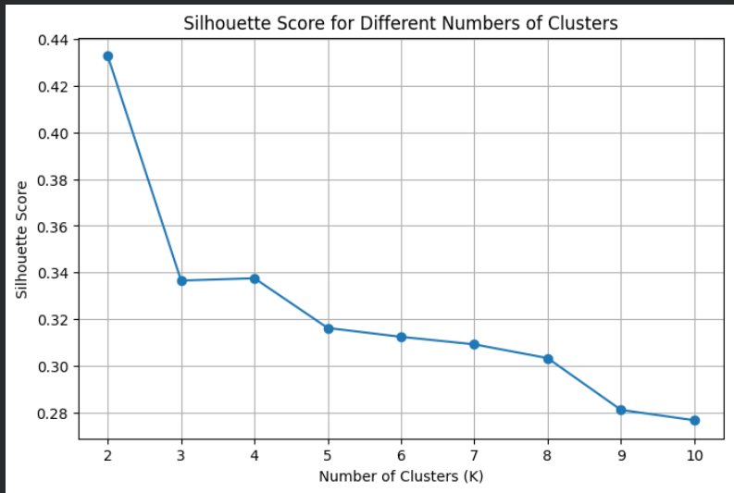
Figure 13. Silhouette scores for K=2 to K=10.
MODEL-SELECTION DECISION
K=2 is selected because it produces the highest silhouette score in the tested range (0.4328). The result is supported by the model-selection evidence even though the elbow curve itself is gradual.

8. Final Clustering Results
The final model is K-Means with n_clusters=2, random_state=42 and n_init=10. The model is fitted on the three standardized log-transformed RFM features.
final_k = 2
kmeans_final = KMeans(n_clusters=final_k, random_state=42, n_init=10)
rfm["Cluster"] = kmeans_final.fit_predict(rfm_scaled)
Cluster | Customers | Share | Avg Recency | Median Recency | Avg Frequency | Median Frequency | Avg Monetary | Median Monetary | Analytical label
0 | 2,672 | 61.6% | 134.09 | 96.0 | 1.67 | 1.0 | £495.59 | £363.08 | Low-Engagement Customers
1 | 1,666 | 38.4% | 25.89 | 16.0 | 8.44 | 6.0 | £4,539.60 | £2,061.07 | High-Engagement Customers
Cluster 0 is the larger segment and has substantially higher recency values, meaning its customers are typically less recent in the historical observation window. It also has low repeat-purchase frequency and lower transaction value. Cluster 1 is smaller but shows much more recent purchasing, more unique invoices per customer and materially higher transaction value.
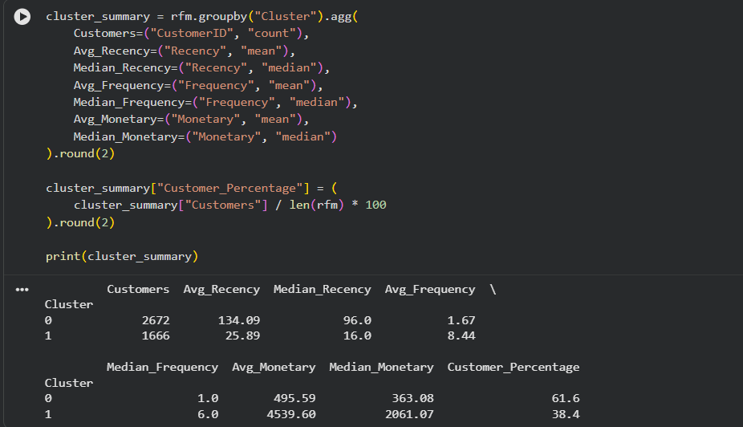
Figure 14. Final cluster summary generated from the RFM segmentation.

9. Cluster Visualization and Interpretation

9.1 PCA Visualization
Because the clustering model operates in three-dimensional standardized RFM feature space, PCA is used to project the data into two dimensions for visual inspection. The first principal component explains 75.08% of variance and the second explains 18.79%, giving a combined two-component representation of approximately 93.87% of the standardized feature variance. The PCA plot shows two visibly separated customer groups, consistent with the final K-Means assignments.
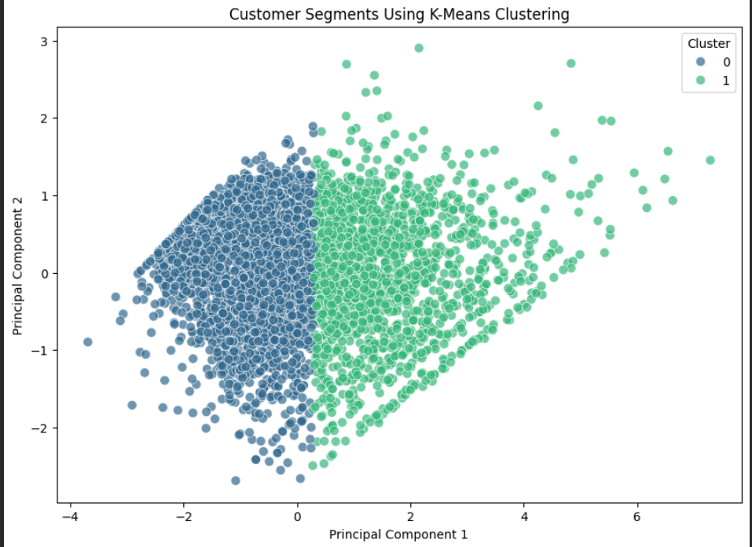
Figure 15. PCA projection of customers colored by K-Means cluster.

9.2 Three-Dimensional Cluster View
The 3D visualization provides an additional view of the customer groups in log-transformed RFM space. It is useful for communicating the multivariate structure, while the numerical cluster profile remains the primary basis for interpretation.
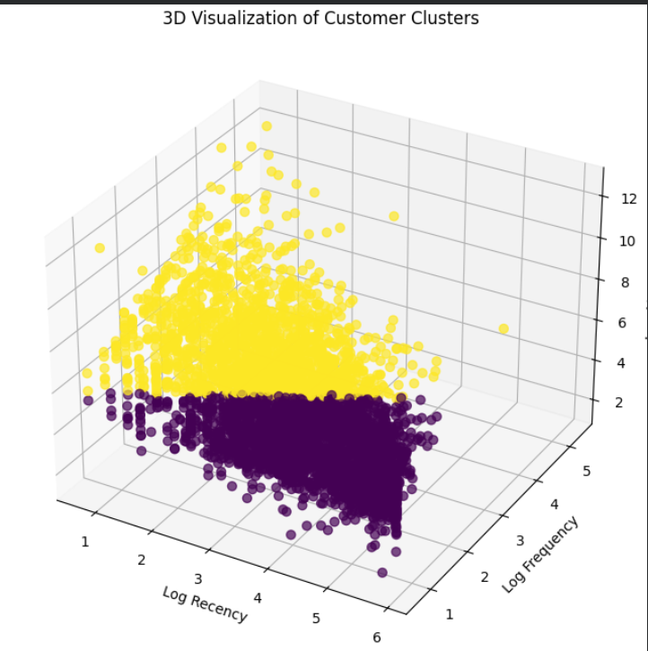
Figure 16. Three-dimensional visualization of customer clusters.

9.3 Feature-Level Cluster Comparisons
The boxplots reinforce the differences observed in the numerical profile. Recency is substantially higher for Cluster 0, while Frequency and Monetary value are substantially higher for Cluster 1. The monetary plot uses a logarithmic y-axis because transaction value spans a wide range.
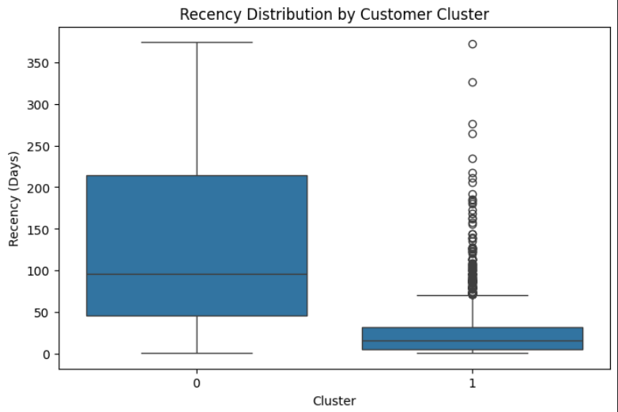
Figure 17. Recency distribution by customer cluster.
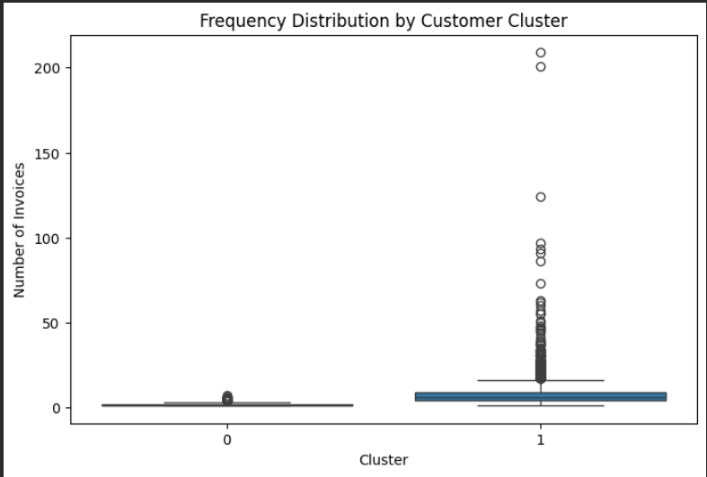
Figure 18. Frequency distribution by customer cluster.
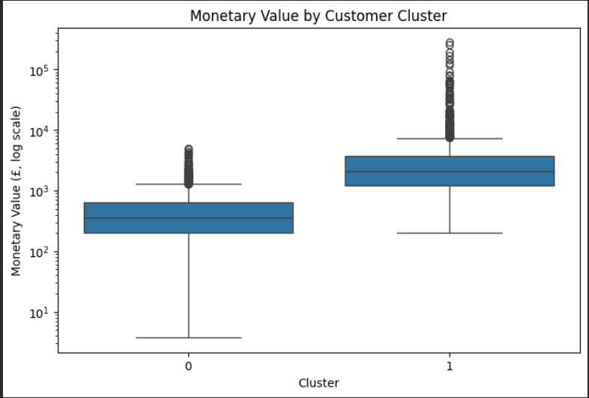
Figure 19. Monetary value distribution by customer cluster on a logarithmic scale.

9.4 Cluster Profiles
Cluster | Observed RFM profile | Interpretation
Cluster 0 | Higher recency; low frequency; lower monetary value; 61.6% of customers | Lower-engagement group in the observed historical window. Customers have generally purchased less often and less recently.
Cluster 1 | Lower recency; high frequency; higher monetary value; 38.4% of customers | Higher-engagement group in the observed historical window. Customers purchase more recently and repeatedly and generate greater transaction value.

10. Business Implications
RFM segmentation is useful because it converts raw transaction history into customer groups that can support differentiated marketing and retention hypotheses. The implications below are recommendations for analysis and experimentation, not causal conclusions.
- Cluster 0 – Low-Engagement Customers: investigate re-engagement strategies such as personalized product recommendations, reminders, limited-time offers or targeted campaigns. The objective would be to test whether reduced recency and low purchase frequency can be improved.
- Cluster 1 – High-Engagement Customers: focus on retention and relationship-building strategies such as loyalty programs, personalized experiences, cross-sell opportunities and service continuity. Their higher frequency and transaction value make retention behavior worth studying.
- Campaign design can be more targeted than a one-size-fits-all approach because the two groups exhibit clearly different transaction behavior.
- Future analysis can test campaign response, repeat purchase rate, customer lifetime value and retention over a subsequent time window to determine whether these clusters remain stable and operationally useful.
IMPORTANT INTERPRETATION NOTE
The labels “Low-Engagement” and “High-Engagement” are descriptive summaries of RFM behavior. They are not predictions of future customer behavior and do not prove that any specific marketing action will cause a change.

11. Limitations and Considerations
- The segmentation uses known CustomerID records, so transactions without CustomerID are excluded from customer-level clustering.
- The dataset is historical and ends on 9 December 2011. Recency therefore measures distance from the end of this dataset rather than the present day.
- K=2 is selected from the tested range K=2–10. A different dataset window, feature set or clustering algorithm could produce a different segmentation.
- K-Means assumes distance-based, relatively compact cluster structure. Alternative methods such as hierarchical clustering or DBSCAN could be evaluated as robustness checks.
- Log transformation reduces the influence of extreme values but does not remove their underlying business meaning.
- Monetary is based on TotalAmount constructed from Quantity × UnitPrice and therefore represents transaction value in this analytical dataset, not audited accounting revenue.
- The analysis is descriptive and unsupervised. A future validation period would be required to test whether the clusters predict future purchase behavior or campaign response.

12. Conclusion
This Week 3 project demonstrates a complete unsupervised-learning workflow from cleaned transaction data to customer-level segmentation. RFM feature engineering reduced 392,692 transaction records to 4,338 customer profiles. Log transformation and standardization prepared the features for distance-based clustering. K-Means solutions from K=2 to K=10 were compared using inertia and silhouette score, with K=2 selected because it achieved the strongest silhouette score of 0.4328.
The final segmentation identifies two clearly differentiated behavioral groups. The larger Cluster 0 has lower purchase recency, lower invoice frequency and lower transaction value, while Cluster 1 contains customers with substantially more recent and repeated purchasing and higher transaction value. PCA and feature-level visualizations support the numerical profile. Overall, the project demonstrates how unsupervised learning can transform raw retail transactions into interpretable customer segments that can support further experimentation and business analysis.

Appendix A. Key Code Snippets

A.1 Feature transformation and scaling
rfm["Recency_Log"] = np.log1p(rfm["Recency"])
rfm["Frequency_Log"] = np.log1p(rfm["Frequency"])
rfm["Monetary_Log"] = np.log1p(rfm["Monetary"])
features = rfm[["Recency_Log", "Frequency_Log", "Monetary_Log"]]
scaler = StandardScaler()
rfm_scaled = scaler.fit_transform(features)

A.2 Elbow and silhouette evaluation
inertia = []
silhouette_scores = []
for k in range(2, 11):
model = KMeans(n_clusters=k, random_state=42, n_init=10)
labels = model.fit_predict(rfm_scaled)
inertia.append(model.inertia_)
silhouette_scores.append(silhouette_score(rfm_scaled, labels))

A.3 Final clustering
final_k = 2
kmeans_final = KMeans(n_clusters=final_k, random_state=42, n_init=10)
rfm["Cluster"] = kmeans_final.fit_predict(rfm_scaled)

A.4 PCA for visualization
from sklearn.decomposition import PCA
pca = PCA(n_components=2)
rfm_pca = pca.fit_transform(rfm_scaled)
rfm["PCA1"] = rfm_pca[:, 0]
rfm["PCA2"] = rfm_pca[:, 1]

Appendix B. Evidence Screenshots
The following screenshots are included as execution evidence from the Week 3 notebook. They document the dataset, RFM creation, distributions, transformation, scaling, model selection and final segmentation results.
Evidence B1. Dataset loading and inspection.
Evidence B2. RFM dataset creation.
Evidence B3. RFM descriptive statistics.
Evidence B4. Recency distribution.
Evidence B5. Purchase frequency distribution.
Evidence B6. Monetary distribution.
Evidence B7. RFM feature outlier analysis.
Evidence B8. Log-transformed Recency.
Evidence B9. Log-transformed Frequency.
Evidence B10. Log-transformed Monetary value.
Evidence B11. Scaling verification.
Evidence B12. Elbow method.
Evidence B13. Silhouette analysis.
Evidence B14. PCA cluster visualization.
Evidence B15. 3D cluster visualization.
Evidence B16. Recency by cluster.
Evidence B17. Frequency by cluster.
Evidence B18. Monetary value by cluster.
Evidence B19. Final cluster summary.

