High-Speed RJ45 Coupler PCB Design (10 Gbps)
Technical Design Report — Passive 10GBASE-T Pass-Through PCB

1. Objective
This report documents the design of a passive, pass-through printed circuit board that bridges two RJ45 jacks to support 10GBASE-T (10 Gbps) Ethernet. The board carries the four differential signal pairs directly between connectors with no active components or magnetics, so signal integrity is governed entirely by controlled-impedance routing, layer stackup, and layout discipline. The design was implemented in KiCad and is described below using the actual stackup, net-class, and layout parameters from the project files.
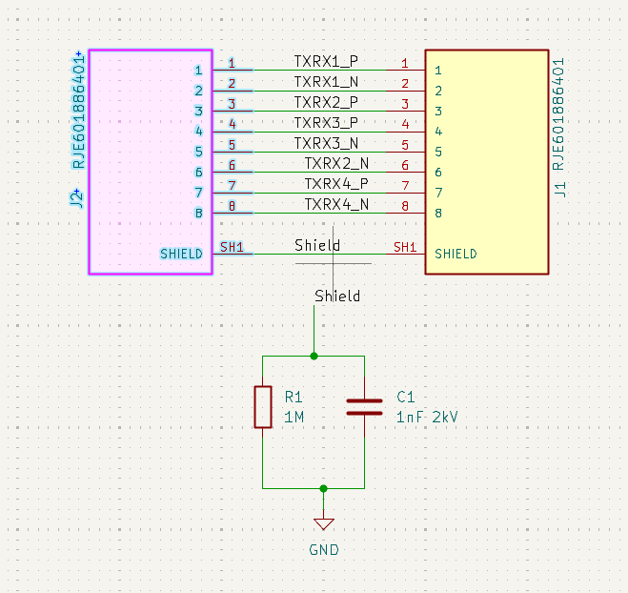
Figure 0: Schematic — J1/J2 (Amphenol RJE601886401) pass-through pinout and shield Bob-Smith termination (R1 = 1 MΩ ∥ C1 = 1 nF/2 kV to GND).
The schematic shows the direct pass-through mapping between the two RJ45 jacks — each of the four differential pairs (TXRX1–TXRX4) is wired straight from one connector's pins to the corresponding pins on the other, with no series or magnetic components in the signal path, consistent with a passive coupler. The two connector shields are tied together and routed through a single Bob-Smith network (R1 = 1 MΩ in parallel with C1 = 1 nF/2 kV) to board GND.

2. Tooling and Layer Stackup
Tooling: KiCad 10.0 (schematic capture, PCB layout, and DRC).
The board uses a 4-layer stackup, chosen over a 2-layer board because 10GBASE-T requires a continuous reference plane directly beneath each signal layer to hold differential impedance tolerance and to give each of the four differential pairs a low-inductance return path. A 2-layer board would force all four pairs to share a single reference plane on the opposite side of the board with no internal ground layers, making tight impedance control and pair-to-pair isolation far harder to achieve at 10G rates.

2.1 Stackup (as configured in KiCad, total 1.60 mm)
Layer | Type | Material | Thickness | Notes
F.Cu | Copper (external) | 1 oz (35 µm) | 0.035 mm | Top signal layer
Dielectric 1 | Prepreg | FR4 (εr 4.5) | 0.20 mm | F.Cu ↔ In1.Cu
In1.Cu | Copper (internal) | 1 oz (35 µm) | 0.035 mm | GND pour ("L2 gnd pour") + Pair 1 routing
Dielectric 2 | Core | FR4 (εr 4.5) | 1.04 mm | In1.Cu ↔ In2.Cu
In2.Cu | Copper (internal) | 1 oz (35 µm) | 0.035 mm | GND pour ("L1 GND pour") + Pair 4 routing
Dielectric 3 | Prepreg | FR4 (εr 4.5) | 0.20 mm | In2.Cu ↔ B.Cu
B.Cu | Copper (external) | 1 oz (35 µm) | 0.035 mm | Bottom signal layer
Loss tangent for all FR4 dielectrics is set to 0.02 in the KiCad stackup manager.

3. Track Geometry and Impedance Calculations
The differential-pair geometry actually configured in the KiCad “Default” net class (which is applied to all four TXRX pairs) is:
Parameter | Value (mm) | Value (mil)
Differential trace width | 0.2216 | 8.73
Differential pair gap (edge-to-edge) | 0.1151 | 4.53
Single-ended track width (default) | 0.15 | 5.91
Clearance | 0.10 | 3.94
Via diameter / drill | 0.60 / 0.30 | 23.6 / 11.8

3.1 Impedance verification (KiCad PCB Calculator)
The configured geometry (W = 0.221643 mm, S = 0.115084 mm) was verified in KiCad's built-in PCB Calculator using the Coupled Microstrip Line model, with substrate parameters matching the stackup (εr = 4.5, tan δ = 0.02, copper thickness T = 0.035 mm, substrate height H = 0.2 mm to the reference plane):
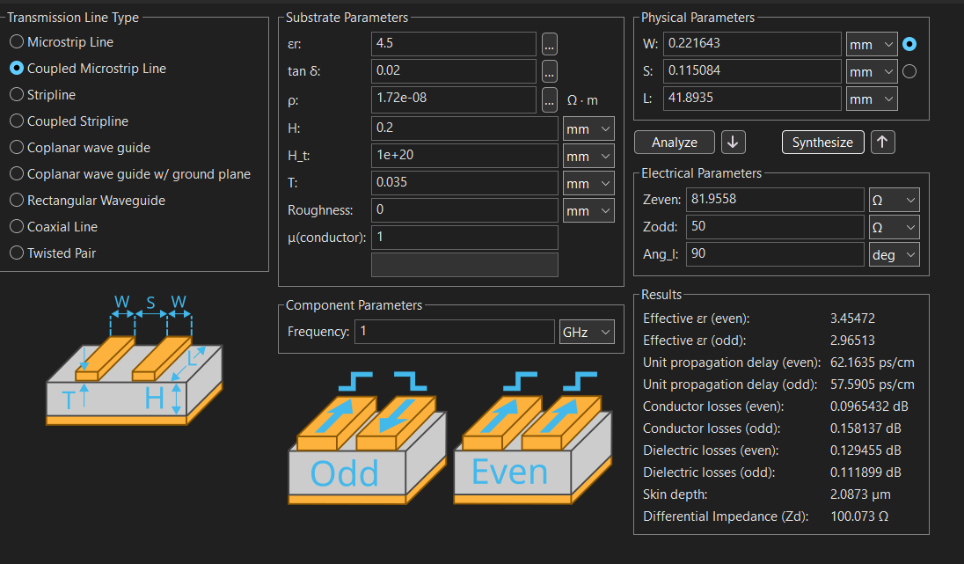

Figure 1: KiCad PCB Calculator — Coupled Microstrip Line, differential impedance result.
Quantity | Result
Even-mode impedance (Zeven) | 81.96 Ω
Odd-mode impedance (Zodd) | 50.0 Ω
Differential impedance (Zdiff) | 100.07 Ω
This confirms the 100 Ω differential target is met by the current trace geometry, with less than 0.1% error. A quick hand check with the simpler IPC-2141 edge-coupled-microstrip formula at H = 0.1 mm (the raw prepreg thickness for the outer dielectric layers) undershoots to roughly 62 Ω — the gap comes from the field solver using the true coupled-microstrip field distribution rather than the simplified single-ended formula, and from the effective reference height (H = 0.2 mm) rather than the raw dielectric thickness. The field-solver result is the more accurate of the two and is used as the reference value for this design.

3.2 Maximum conductor length check
Saturn PCB Toolkit's Bandwidth & Max Conductor Length tool was used to sanity-check trace length against signal bandwidth, assuming a 500 MHz effective frequency (representative of the fundamental/edge-rate content relevant to 10GBASE-T signaling), 1 oz base copper, and a λ/7 length rule:
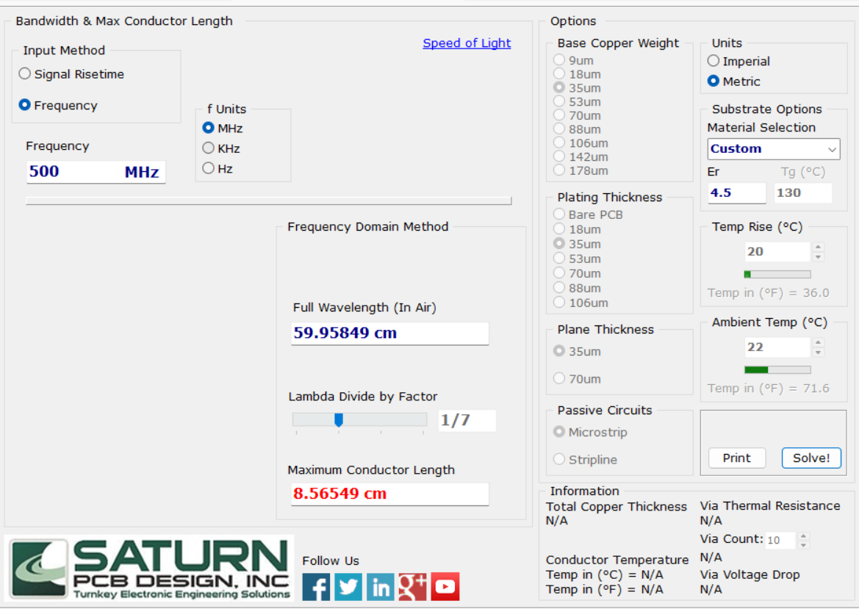
Figure 2: Saturn PCB Toolkit — maximum conductor length before transmission-line effects dominate.
This gives a maximum recommended conductor length of 8.57 cm (85.7 mm) before the trace must be treated strictly as a transmission line rather than a lumped connection. Every routed pair on this board is well under that (22–42 mm, see Section 4), which is expected — the traces are of course still routed and impedance-matched as transmission lines regardless — but it confirms none of the pairs are in a length regime where additional termination or segmentation would be needed.

4. High-Speed Routing
Each of the four differential pairs is routed on its own layer or layer pair, which is the primary inter-pair isolation strategy in this layout: no two pairs share a routing layer over any significant length, and each pair runs directly over a solid ground pour on the adjacent internal layer (“L2 gnd pour” on In1.Cu, “L1 GND pour” on In2.Cu). Exact per-net lengths below are read directly from KiCad's net class/length inspector (Total Length, including via barrel length):
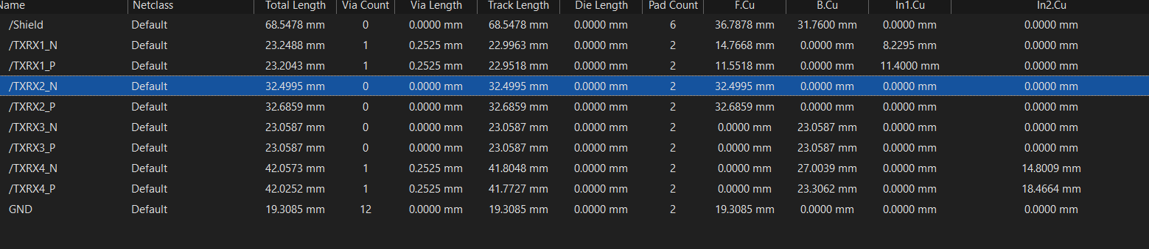
Figure 3: KiCad net-length report — total length, via count, track length, and per-layer breakdown for every net.
Pair | N Length (mm) | P Length (mm) | Skew (mm) | Skew (mil)
TXRX1 | 23.2488 | 23.2043 | 0.0445 | 1.75
TXRX2 | 32.4995 | 32.6859 | 0.1864 | 7.34
TXRX3 | 23.0587 | 23.0587 | 0.0000 | 0.0
TXRX4 | 42.0573 | 42.0252 | 0.0321 | 1.26
Three of the four pairs (TXRX1, TXRX3, TXRX4) are matched to within 0.035 mm — TXRX3 is exact. TXRX2, which stays entirely on F.Cu with no via, has the largest skew at 0.318 mm; this is simply a routing-length difference between the two traces rather than a via-related effect, since it's the only pair here without a layer transition. All four pairs remain well within the sub-mm skew budget typically used for 10GBASE-T, corresponding to a small fraction of a unit interval at the 800 MHz-class symbol rate 10GBASE-T uses — not a signal-integrity concern.

4.1 Inter-pair isolation / crosstalk
Isolation between the four differential pairs comes from two mechanisms working together: layer separation and lateral spacing.
- Layer separation: no two pairs are ever routed on layers that face each other across a thin dielectric. TXRX1 and TXRX2 are the only pairs that share a layer (F.Cu); TXRX3 and TXRX4 are the only pairs that share a layer (B.Cu). Every other pair combination sits on opposite sides of the board with the continuous In1.Cu/In2.Cu ground pours sitting between them — a solid reference plane between two signal layers gives very high isolation by construction, since the plane intercepts the fringing field before it can couple to the far layer.
- Lateral spacing (same-layer pairs): where two pairs do share a layer, their measured minimum edge-to-edge separation is ≈ 1.82 mm (TXRX1↔TXRX2 on F.Cu) and ≈ 1.18 mm (TXRX3↔TXRX4 on B.Cu). Against the 0.2216 mm differential trace width, that is roughly 8× and 5× the trace width respectively — both comfortably clear of the common “3W rule” guideline (≥ 2× trace-width edge gap, i.e. ≥ 3× width center-to-center) used to keep pair-to-pair coupling low.

In practice this means the only same-layer near-neighbor pairs are TXRX1/TXRX2 and TXRX3/TXRX4, and both are spaced well beyond the 3W minimum; every other pair combination is additionally separated by a full ground plane. No explicit guard traces or extra ground stitching between pairs were needed as a result.
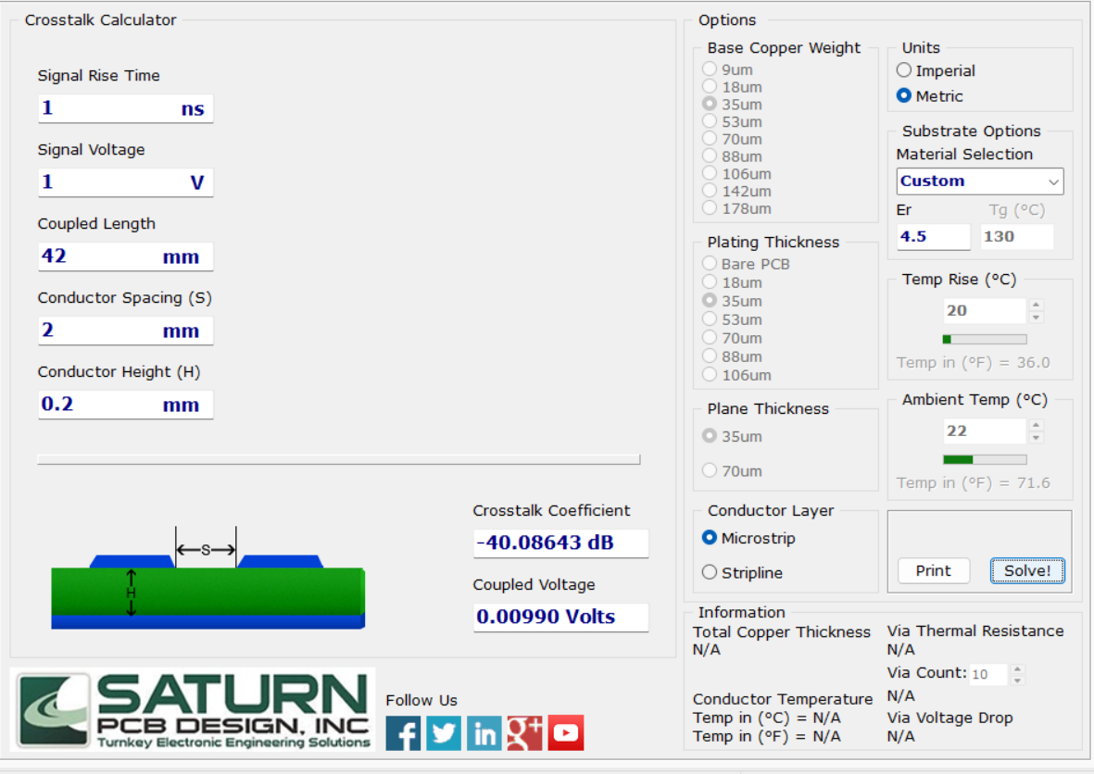

4.2 Return-path and isolation stitching
Sixteen 0.6 mm/0.3 mm vias are placed on the board, split across four distinct layer-pair drill classes (confirmed against the actual Gerber/NC-drill output, one drill file per class — front-in1, front-in2, back-in1, back-in2). Two of these classes (front-in1, back-in2) span a single dielectric layer and are true microvias. The other two (front-in2, back-in1) span two dielectric layers each — including, for front-in2, the full 1.24 mm core — which at this drill diameter is well beyond microvia aspect-ratio limits, so despite sharing the same drill spec, front-in2 and back-in1 are blind vias, not microvias:
Drill class | Layer pair | Count | Purpose
front-in1 | F.Cu ↔ In1.Cu | 6 | 4× GND stitching + TXRX1 P/N layer transition (true microvia — single dielectric layer)
front-in2 | F.Cu ↔ In2.Cu | 6 | GND stitching (blind via — spans dielectric 1 + core, i.e. two dielectric layers)
back-in1 | In1.Cu ↔ B.Cu | 2 | GND stitching (blind via — spans core + dielectric 3, i.e. two dielectric layers)
back-in2 | In2.Cu ↔ B.Cu | 2 | TXRX4 P/N layer transition (true microvia — single dielectric layer)
The GND stitching keeps the return current path continuous under each layer transition, which limits the discontinuity a via crossing would otherwise introduce. Common-mode / shield handling: a single 1 nF / 2 kV capacitor (C1) in parallel with a 1 MΩ resistor (R1) — a standard Bob-Smith termination — ties the RJ45 shield net to board GND, bleeding off common-mode noise and ESD while keeping the shield DC-isolated from signal ground.

4.3 Routed layout
Views of the fabrication output (Gerber/NC-drill viewer) confirming the routed geometry described above:
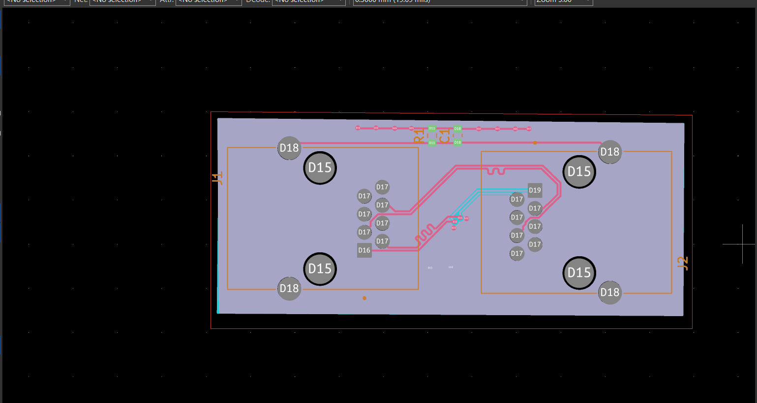
Figure 4: All copper layers overlaid — J1/J2 footprints, GND pours (In1.Cu/In2.Cu), and the four differential pairs routed between connectors.
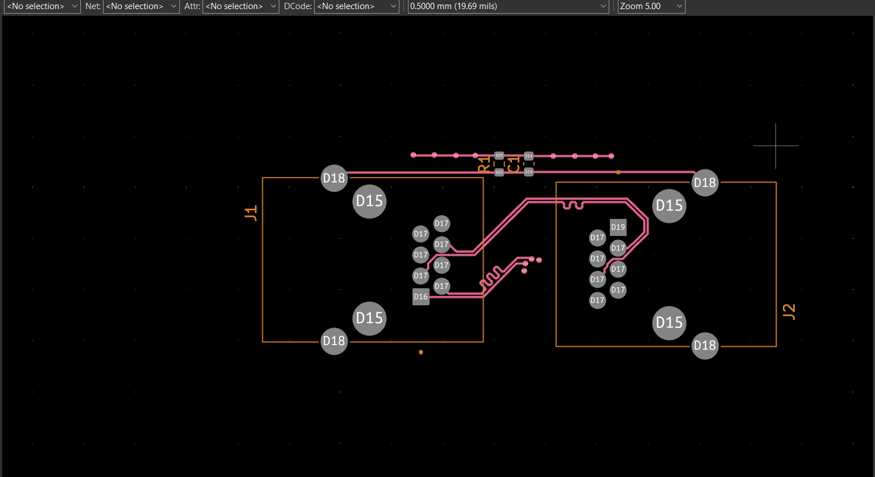
Figure 5a: F.Cu (top, L1) — TXRX1 and TXRX2 traces plus the shield RC network to R1/C1.
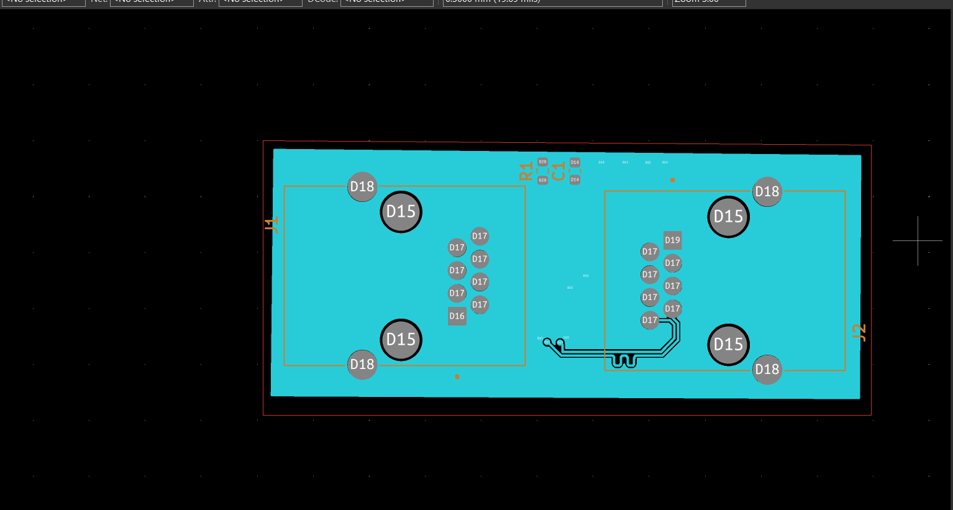
Figure 5b: B.Cu (bottom, L4) — TXRX3 and TXRX4 traces.
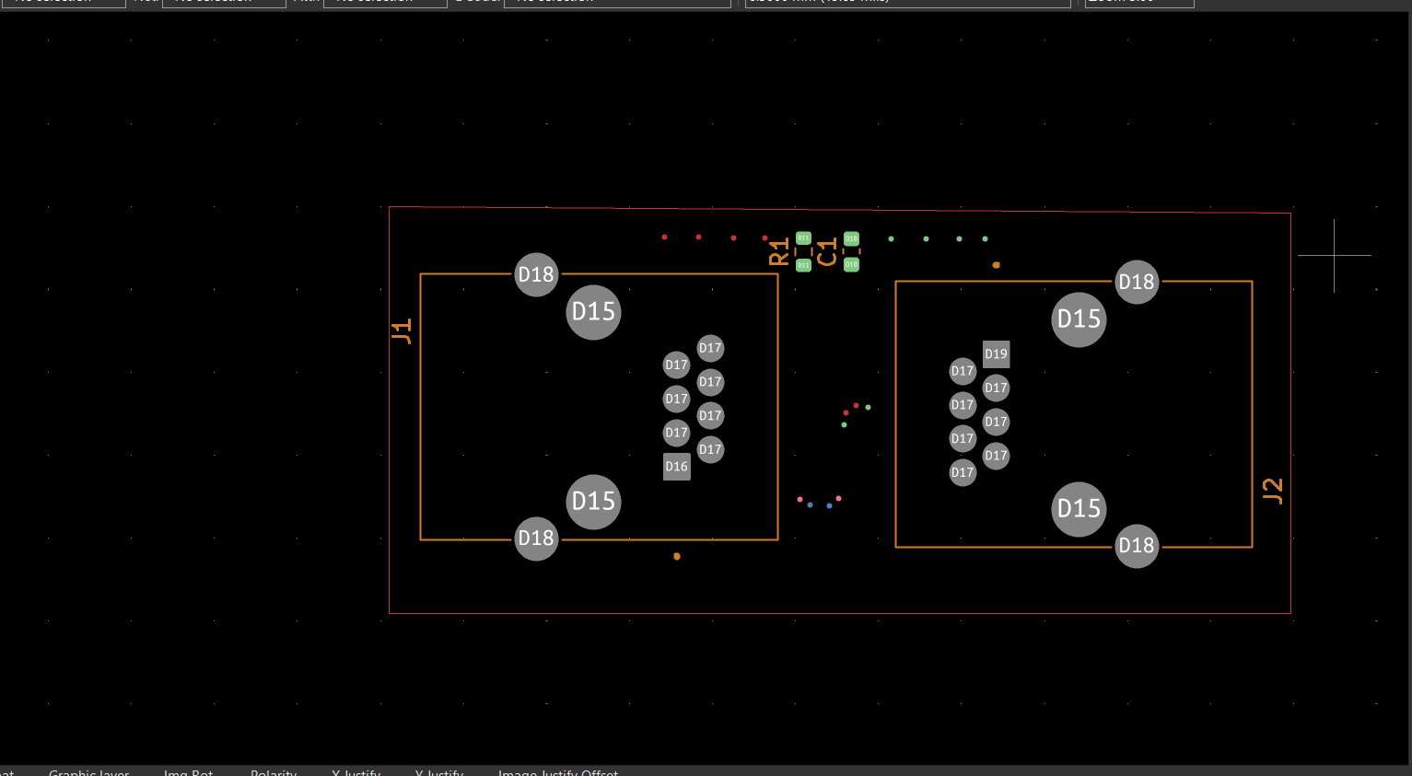
Figure 6: All four via drill classes overlaid (front-in1/front-in2/back-in1/back-in2) — front-in1 and back-in2 are true microvias, front-in2 and back-in1 are blind vias — showing the physical via positions.

4.4 3D View

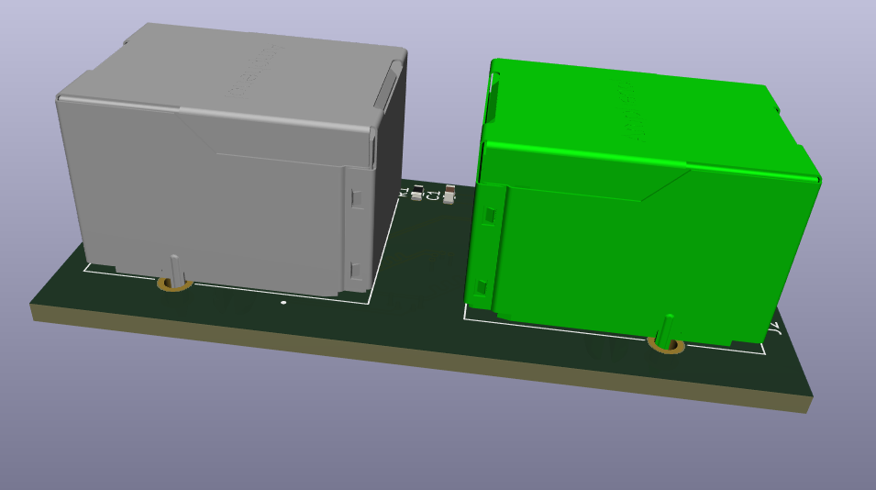
Fig. Side view of PCB with RJ45 Jack

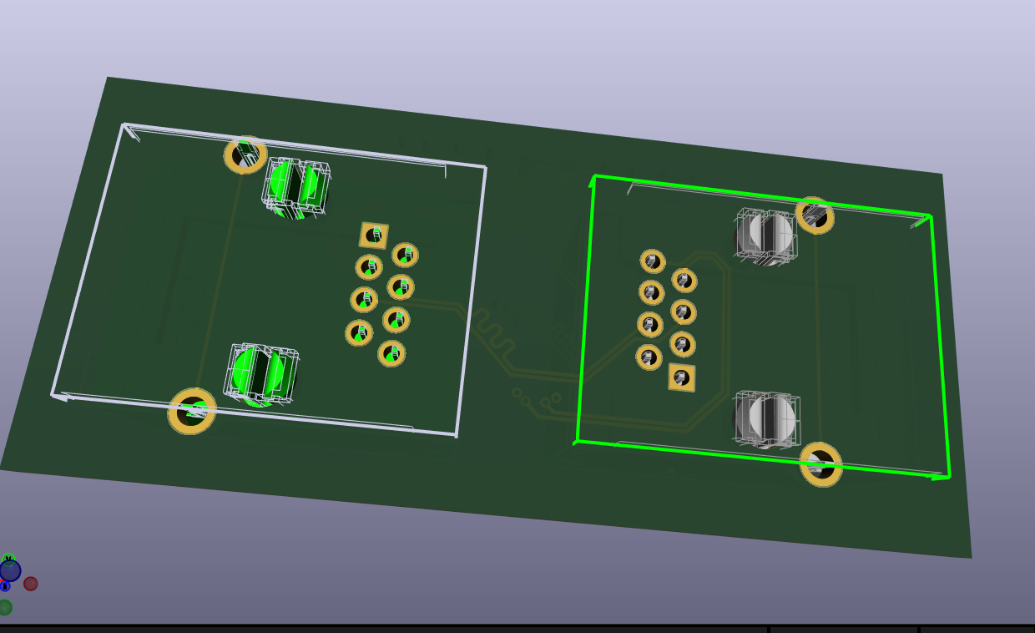
Fig. Back view of PCB with RJ45 Jack

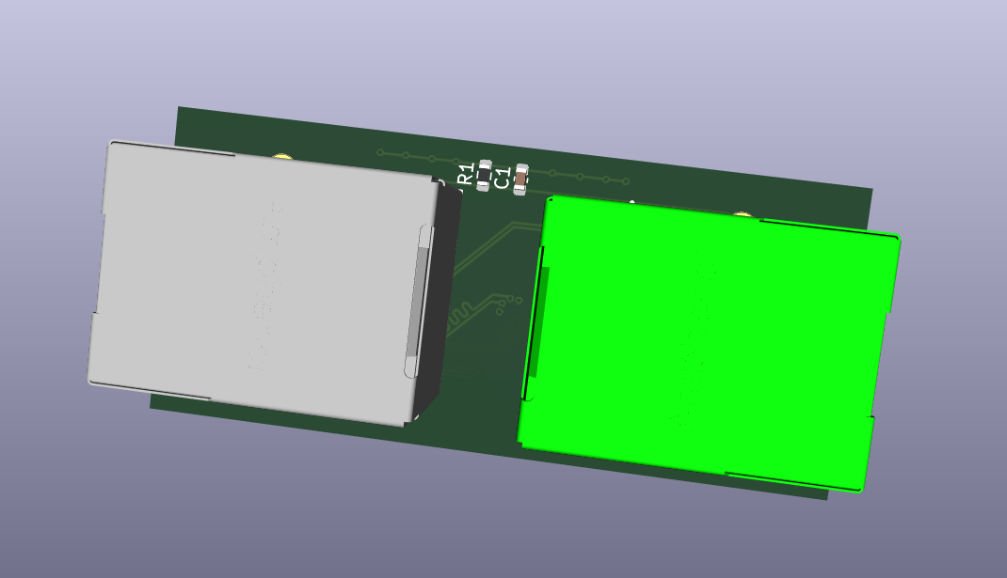
Fig. Top view of PCB with RJ45 Jack

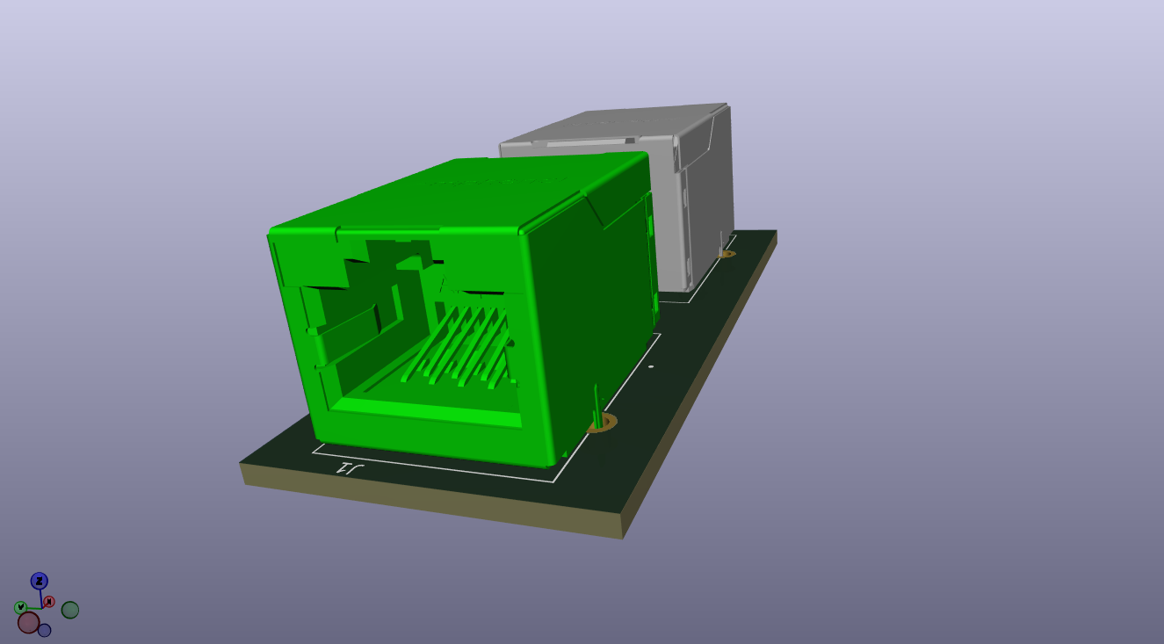
Fig. Front view of PCB with RJ45 Jack

5. Mechanical Dimensions
Parameter | Value
Board outline | ≈ 54.4 mm × 24.3 mm
Board thickness | 1.60 mm (per stackup)
Connector J1 position | (152.85, 107.09) mm, rotated −90°
Connector J2 position | (182.10, 107.53) mm, rotated +90°
J1–J2 center spacing | ≈ 29.3 mm
Mounting holes | None currently defined
The two Amphenol RJE601886401 RJ45 jacks are mirrored (rotated −90° and +90°) and placed at opposite ends of the board so their cable-entry faces point outward from opposite edges — the standard geometry for a pass-through coupler, keeping the four differential pairs routed as directly as possible between connectors with minimal detours. The board outline is sized close to the footprint of the two connectors plus edge clearance, which keeps trace lengths (and therefore skew and loss) to a minimum, at the cost of not currently including mounting holes.

6. Manufacturing Strategy

6.1 Fabrication parameters
Parameter | Chosen value | Rationale
Copper weight | 1 oz (35 µm) on all 4 layers | Matches stackup as designed; standard weight, adequate for signal-only (non-power) traces
Core / prepreg | FR4, εr 4.5 | Standard, low-cost, adequate loss tangent (0.02) for a short pass-through link at 10G
Surface finish | ENIG (recommended) | Not yet set in the KiCad stackup
Solder mask / silkscreen | Standard LPI mask, single-sided silkscreen | As placed in the KiCad footprints
.

6.2 Files to hand off to the fabricator
- Gerber files (RS-274X / Gerber X2) for all copper layers, solder mask (top & bottom), and silkscreen (top).
- NC Drill file(s) (Excellon format) for the plated through-holes and the 0.3 mm via drills — a mix of true microvias (front-in1, back-in2) and blind vias (front-in2, back-in1; see Section 4.2). Note this board needs four separate drill files by layer pair rather than a single drill file, since the vias don't all span the same pair of layers, and front-in2/back-in1 should be flagged to the fab specifically as blind vias (not microvias) given their two-dielectric-layer span.
- Board outline / Edge.Cuts layer as a separate Gerber.
- Drill map / drill legend.
- IPC-2581 (or ODB++) as a single combined manufacturing archive, if the fab house supports it — preferred over loose Gerbers where available since it carries stackup and net data in one file.
- Fabrication drawing / README noting: 4-layer stackup with dielectric thicknesses above, 1 oz copper all layers, ENIG finish, controlled-impedance requirement (100 Ω differential) called out on the affected nets/layers, and the DRC constraints already encoded in try2.kicad_dru (0.25–0.35 mm via hole, 0.55–0.65 mm via diameter, 0.1 mm min clearance, 0.3 mm edge clearance).
- Pick-and-place / BOM is not required for fabrication alone here since assembly is limited to two RJ45 jacks, one 0603 capacitor, and one 0603 resistor, but should be included if the fab house is also doing assembly.

7. Design Verification
The KiCad DRC report (DRC.rpt, run against try2.kicad_pcb) shows:
- 0 DRC violations
- 0 unconnected pads
- 0 footprint errors

