**INTERNSHIP REPORT**

*A report submitted in partial fulfilment of the requirements for the Award of Degree*

*of*

**BACHELOR OF TECHNOLOGY**

**IN**

**COMPUTER SCIENCE AND ENGINEERING**

**(GAMING TECHNOLOGY)**

by

**SURYANSH SINGH – 20BCG10055**

**DURATION: 15-05-2023 TO 15-07-2023**

**ACADAMIC YEAR - 2022-2023**



**SCHOOL OF COMPUTING SCIENCE AND ENGINEERING**

**VIT BHOPAL UNIVERSITY**

**April -2024**



**SCHOOL OF COMPUTING SCIENCE AND ENGINEERING**

**VIT BHOPAL UNIVERSITY**

**INTERNSHIP CERTIFICATE**

This is to certify that the “INTERNSHIP REPORT” submitted by SURYANSH SINGH (20BCG10055) for the internship done by him/her during the academic year 2022-2023 from 15-05-23to 15-07-23(2 Months), is the partial fulfilment of the requirements for the awarding the degree of B. Tech – CSE (GAMING TECHNOLOGY).

**Internship In-Charge Program Chair**

Dr. Ajay Sharma Dr. Balaji A

Assistant Professor Senior Assistant Professor (Gr-2)

**INDEX**

|  |  |  |
| --- | --- | --- |
| S.No. | Title | Page Number |
| 1. | Internship Certificate | 4 |
| 2. | Acknowledgment | 5 |
| 3. | Abstract | 6 |
| 4. | Challenges Learned Through Internship | 7-9 |
| 5. | Weekly Progress Charts | 10-12 |
| 6. | Conclusion | 13 |
| 7. | References | 14 |
| 8. | Annexure | 15-17 |

**INTERNSHIP CERTIFICATE(CATEGORY-1)**

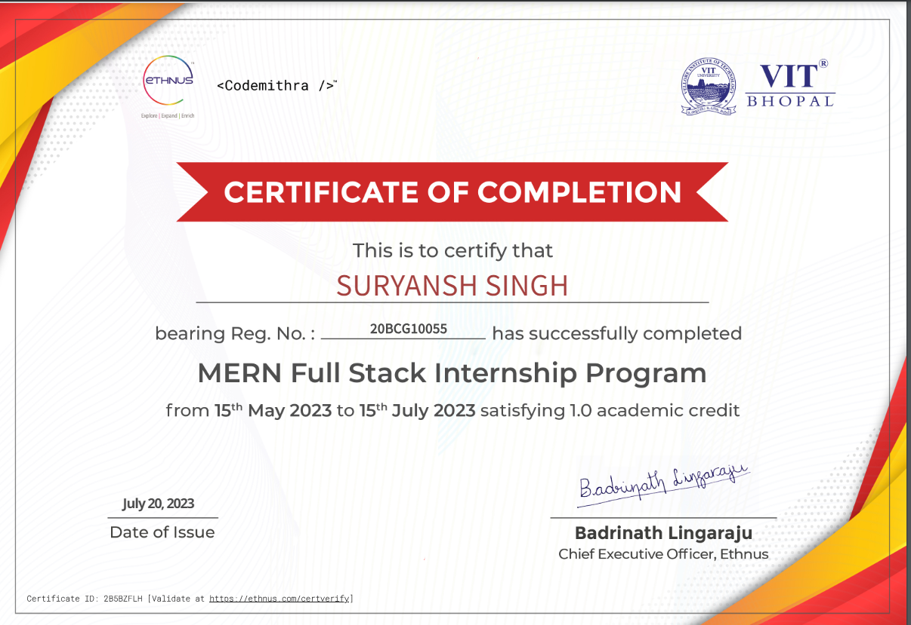

**ACKNOWLEDGMENT**

First and foremost, I would like to thank the Lord Almighty for His presence and immense blessings throughout the project work.

I wish to express my heartfelt gratitude to Dr. A. Balaji, Head of the Department, School of Computer Science and Engineering specialization in Gaming Technology, for much of his valuable support and encouragement in carrying out this work.

I would like to thank my internal guide at ETHNUS, Mr. Arun Kh, for continually guiding and actively participating in my project, giving valuable suggestions to complete the project works.

I would like to thank all the technical and teaching staff of the School of Computing Science and Engineering, who extended directly or indirectly all support.

Last, but not least, I am deeply indebted to my parents who have been the greatest support while I worked day and night for the project to make it a success.

**ABSTRACT**

The MERN Full Stack internship program, administered by ETHNUS, embodies a structured approach to web application development, providing a comprehensive framework for learning and growth. Throughout the internship, I embarked on a transformative journey, acquiring valuable skills and insights that have profoundly impacted my understanding of web development. This report delineates the objectives I endeavoured to accomplish and the significant learning outcomes derived from this enriching experience. These objectives encompassed not only attaining proficiency in web application development using the MERN stack (MongoDB, Express.js, React.js, and Node.js) but also gaining practical expertise in crafting dynamic and responsive web applications. Moreover, I delved into the intricacies of GitHub code hosting, mastering version control and collaboration techniques essential for professional software development. The opportunity to engage in real project work was invaluable, allowing me to apply MERN stack skills in real-world scenarios and hone my problem-solving abilities. Beyond technical skills, the internship provided a platform for personal and professional growth, fostering confidence, resilience, and effective communication. Guided by experienced mentors, I navigated through challenges, received constructive feedback, and emerged with a deeper understanding of industry best practices. As a result, I am equipped with the knowledge, skills, and confidence to pursue a successful career in full-stack web development.

**CHALLENGES EXPERIENCE LEARNED THROUGH INTERNSHIP**

1. **Challenges and Methodologies**

Throughout my internship, I embarked on an immersive journey into the realm of web application development, guided by the comprehensive methodologies of the MERN stack. This multifaceted approach exposed me to a diverse range of tools and technologies, each contributing to the intricate process of building dynamic and responsive web applications. At the outset, I grappled with understanding the foundational principles of MongoDB, a NoSQL database system known for its flexibility and scalability. Delving into its document-oriented structure and mastering the intricacies of querying and indexing proved to be an initial challenge. Similarly, navigating the intricacies of Express.js, a minimalist web application framework for Node.js, required a deep dive into middleware, routing, and request handling mechanisms. Concurrently, mastering React.js, a powerful library for building user interfaces, involved grappling with concepts such as components, state management, and JSX syntax. Furthermore, integrating these backend and frontend technologies through Node.js to create a cohesive, full-stack architecture demanded a meticulous approach to server-side scripting, API development, and client-server communication. Each stage of the process presented its own set of challenges, from conceptualizing data models and designing UI components to implementing authentication mechanisms and optimizing application performance. However, through perseverance and a commitment to continuous learning, I navigated through these challenges, gaining invaluable insights and proficiency in utilizing the MERN stack to develop robust and scalable web applications. The experience was not only transformative but also instrumental in shaping my understanding of modern web development practices and preparing me for future challenges in the field.

1. **Skills Learned During the Internship**

My internship experience provided a rich learning environment, equipping me with a diverse array of both scientific and professional skills essential for a career in web development. From a scientific standpoint, I honed my proficiency in the foundational principles of web application development, mastering the intricacies of the MERN stack. This included gaining expertise in MongoDB for efficient database management, Express.js for building robust backend systems, React.js for designing interactive user interfaces, and Node.js for server-side scripting. Additionally, I developed a deep understanding of modern web technologies such as HTML, CSS, and JavaScript, essential for creating dynamic and responsive web applications. Furthermore, the internship fostered the development of professional skills vital for success in the workplace. Effective communication and collaboration were paramount, as I worked alongside team members to tackle complex projects and navigate challenging problem-solving scenarios. Time management and organizational skills were put to the test as I juggled multiple tasks and deadlines, ensuring timely completion of project deliverables. Moreover, the internship provided an opportunity to refine my critical thinking and analytical abilities, as I approached each challenge with a methodical and strategic mindset. Overall, the internship experience not only expanded my technical skill set but also nurtured a holistic approach to problem-solving and collaboration, preparing me for the demands of a career in the dynamic field of web development.

1. **Results/Observations from the Internship**

The internship experience was an immersive journey that yielded a multitude of results, observations, and invaluable work experiences, profoundly enriching my understanding and proficiency in web development. Engaging in hands-on projects provided me with a platform to bridge the gap between theoretical knowledge and practical application, allowing me to apply concepts learned in academic settings to real-world scenarios. Through collaborative efforts with team members, I not only contributed to the successful completion of projects but also gained invaluable insights into effective communication, teamwork dynamics, and project management strategies. Moreover, the opportunity to receive guidance and mentorship from seasoned professionals within the industry offered invaluable perspectives and best practices, significantly enhancing my problem-solving abilities, decision-making skills, and overall professional growth.

Additionally, the internship served as a gateway to exploring emerging technologies and industry trends, offering a glimpse into the ever-evolving landscape of web development. Engaging with cutting-edge tools and methodologies broadened my horizons and kept me abreast of advancements in the field, fostering a sense of curiosity and adaptability essential for continued growth and innovation. Furthermore, the experience of working in a professional setting nurtured personal growth, resilience, and adaptability, as I navigated through challenges and embraced opportunities for learning and self-improvement. Whether it was troubleshooting technical issues, meeting tight deadlines, or adapting to evolving project requirements, each challenge presented an opportunity for growth and development.

Overall, the internship experience was instrumental in shaping my career trajectory, instilling confidence and competence in web development, and laying a solid foundation for future endeavours. The combination of hands-on experience, collaborative teamwork, mentorship, and exposure to emerging technologies has equipped me with the skills, knowledge, and confidence to thrive in the dynamic and competitive field of web development.

WEEKLY PROGRESS OF INTERNSHIP ACTIVITIES

|  |  |  |  |
| --- | --- | --- | --- |
| **1ST WEEK** | **DATE** | **DAY** | **LEARNED/EXPERIENCED TOPIC / MODULE / TASK** |
| 15-05-2023 | Monday | Introduction to Web Development |
| 16-05-2023 | Tuesday | Learn HTML and CSS |
| 17-05-2023 | Wednesday | Learn Bootstrap (BS) |
| 18-05-2023 | Thursday | Introduction to JavaScript |
| 19-05-2023 | Friday | Apply HTML, CSS, and JavaScript to basic web development tasks |
| 20-05-2023 | Saturday | Apply skills to practical web development projects |

|  |  |  |  |
| --- | --- | --- | --- |
| **2nd WEEK** | **DATE** | **DAY** | **LEARNED/EXPERIENCED TOPIC / MODULE / TASK** |
| 22-05-2023 | Monday | Review and reinforce HTML, CSS, and JavaScript concepts |
| 23-05-2023 | Tuesday | Start exploring MongoDB |
| 24-05-2023 | Wednesda y | Start exploring Express.js |
| 25-05-2023 | Thursday | Start exploring React.js |
| 26-05-2023 | Friday | Start exploring Node.js |
| 27-05-2023 | Saturday | Review and practice basic concepts in preparation for next stage |

|  |  |  |  |
| --- | --- | --- | --- |
| **3rd WEEK** | **DATE** | **DAY** | **LEARNED/EXPERIENCED TOPIC / MODULE / TASK** |
| 29-05-2023 | Monday | Deep dive into MongoDB, understanding its document-oriented structure, querying capabilities, and indexing strategies |
| 30-05-2023 | Tuesday | Explore MongoDB CRUD operations (Create, Read, Update, Delete) |
| 01-06-2023 | Wednesda y | Learn about MongoDB aggregation framework for data analysis and manipulation |
| 02-06-2023 | Thursday | Practice MongoDB queries and operations through hands-on exercises |
| 03-06-2023 | Friday | Work on MongoDB project, applying learned concepts to real-world scenarios |
| 04-06-2023 | Saturday | Review and reinforce MongoDB concepts, prepare for next stage |

|  |  |  |  |
| --- | --- | --- | --- |
| **4th WEEK** | **DATE** | **DAY** | **LEARNED/EXPERIENCED TOPIC / MODULE / TASK** |
| 06-06-2023 | Monday | Introduction to Express.js, understanding its role as a web application framework |
| 07-06-2023 | Tuesday | Explore middleware in Express.js for handling requests and responses |
| 08-06-2023 | Wednesda y | Learn about routing in Express.js, defining routes for different endpoints |
| 09-06-2023 | Thursday | Work on building a basic Express.js server and RESTful API endpoints |
| 10-06-2023 | Friday | Implement error handling and validation in Express.js applications |
| 11-06-2023 | Saturday | Review and reinforce Express.js concepts, prepare for next stage |

|  |  |  |  |
| --- | --- | --- | --- |
| **5th WEEK** | **DATE** | **DAY** | **LEARNED/EXPERIENCED TOPIC / MODULE / TASK** |
| 12-06-2023 | Monday | Introduction to React.js, understanding its component-based architecture |
| 13-06-2023 | Tuesday | Explore React.js components, state management, and JSX syntax |
| 14-06-2023 | Wednesda y | Learn about Node.js, understanding its role as a server-side JavaScript runtime |
| 15-06-2023 | Thursday | Dive deeper into React.js hooks for managing component state and lifecycle |
| 16-06-2023 | Friday | Work on building a basic React.js application, integrating with Node.js backend |
| 17-06-2023 | Saturday | Review and reinforce React.js and Node.js concepts, prepare for project work |

|  |  |  |  |
| --- | --- | --- | --- |
| **6th WEEK** | **DATE** | **DAY** | **LEARNED/EXPERIENCED TOPIC / MODULE / TASK** |
| 18-06-2023 | Monday | Review and reinforce concepts learned in the past weeks |
| 19-06-2023 | Tuesday | Work on practice exercises and mini-projects to solidify understanding |
| 20-06-2023 | Wednesda y | Prepare for any pending assessments or quizzes |
| 21-06-2023 | Thursday | Conduct a comprehensive review of MERN stack technologies and concepts |
| 22-06-2023 | Friday | Reflect on learning progress and identify areas for improvement |
| 23-06-2023 | Saturday | Wrap up week with a review session, clarifying any doubts or questions |

|  |  |  |  |
| --- | --- | --- | --- |
| **7th WEEK** | **DATE** | **DAY** | **LEARNED/EXPERIENCED TOPIC / MODULE / TASK** |
| 25-06-2023 | Monday | Begin project development: Set up project structure and environment |
| 26-06-2023 | Tuesday | Implement frontend components: Home page, login page, register page |
| 27-06-2023 | Wednesday | Continue frontend development: Implement classroom page, teacher pages, student pages |
| 28-06-2023 | Thursday | Start backend development: Set up Express.js server, define API endpoints |
| 29-06-2023 | Friday | Implement backend functionality: Database integration, authentication, CRUD operations |
| 30-06-2023 | Saturday | Collaborative development: Merge frontend and backend, start integration testing |

|  |  |  |  |
| --- | --- | --- | --- |
| **8th WEEK** | **DATE** | **DAY** | **LEARNED/EXPERIENCED TOPIC / MODULE / TASK** |
| 31-06-2023 | Monday | Prepare for final presentation: Review project documentation, create presentation slides |
| 01-07-2023 | Tuesday | Practice presentation: Rehearse presentation, gather feedback, make necessary adjustments |
| 02-07-2023 | Wednesday | Refine presentation: Incorporate feedback, finalize presentation slides, and rehearse again |
| 03-07-2023 | Thursday | Conduct a dry run: Run through the presentation one final time, focusing on timing and delivery |
| 04-07-2023 | Friday | Finalize preparations: Ensure all technical aspects are in place, double-check equipment and setup |
| 05-07-2023-  15-07-2023 | Saturday | Final Presentation: Present the Skillmastery project to stakeholders, demo key features, answer questions |

**CONCLUSION**

Reflecting on my internship experience, I am grateful for the invaluable platform it provided in acquiring practical skills and insights within the expansive field of web development. The meticulously structured approach of the internship program, complemented by engaging in hands-on projects and fostering collaborative teamwork, has significantly enriched my understanding of web development methodologies and proficient utilization of the MERN stack. Throughout the internship tenure, I encountered a diverse array of challenges, each serving as a crucible that tested and refined my problem-solving abilities and resilience. These experiences have been pivotal in fostering not only my technical acumen but also my professional growth and development.

Moreover, the unwavering guidance and mentorship from seasoned professionals have played an indispensable role in refining my skills and offering invaluable insights into industry standards and best practices. Their expertise has served as a beacon, illuminating the path towards excellence in web development and empowering me to navigate through intricate technical landscapes with confidence and proficiency.

As I draw the curtains on this enriching internship journey, I am imbued with a profound sense of confidence in my ability to confront and conquer real-world challenges in web development. I am poised to leverage the wealth of knowledge and experience garnered during this internship to contribute meaningfully to projects within this dynamic domain. Grateful for the opportunity to learn and grow within a professional setting, I am eager and enthusiastic about embarking on future endeavours, where I can apply my newfound skills and knowledge to create impactful solutions and drive innovation in the ever-evolving landscape of web development.

[**Presentation Recording Link**](https://drive.google.com/file/d/1CDPNE5u02E4M61i8ZY97MrPay6timuSs/view?usp=sharing)

**REFERENCES**

|  |  |
| --- | --- |
| Resource | Links |
| MongoDB Documentation | <https://docs.mongodb.com/> |
| Express.js Documentation | <https://expressjs.com/> |
| React.js Documentation | <https://react.dev/> |
| Node.js Documentation | <https://nodejs.org/> |

**ANNEXURE-I**

1. **Project Screenshots**

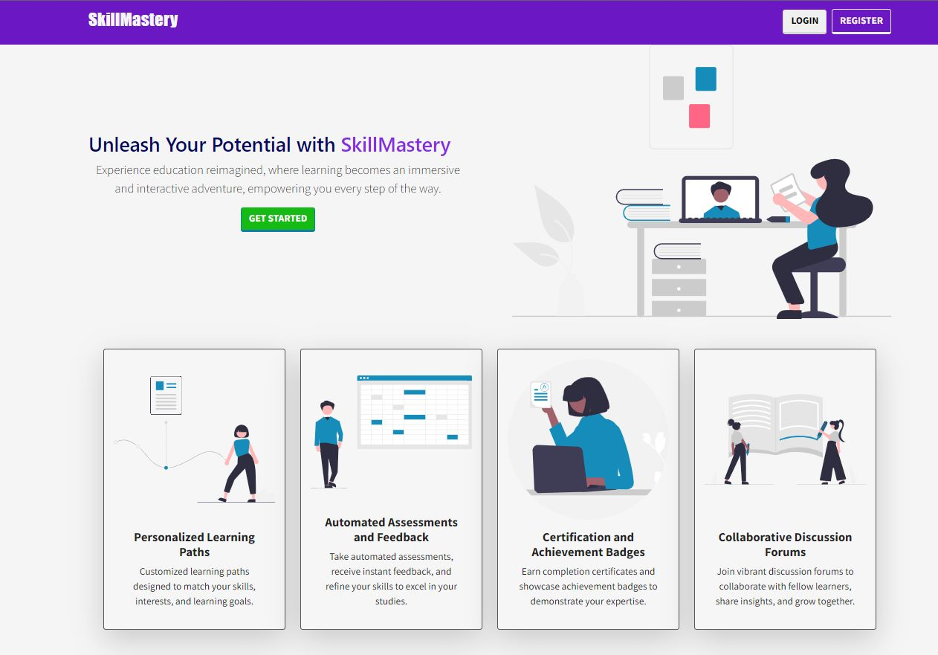

**Figure 1 – Home Page**

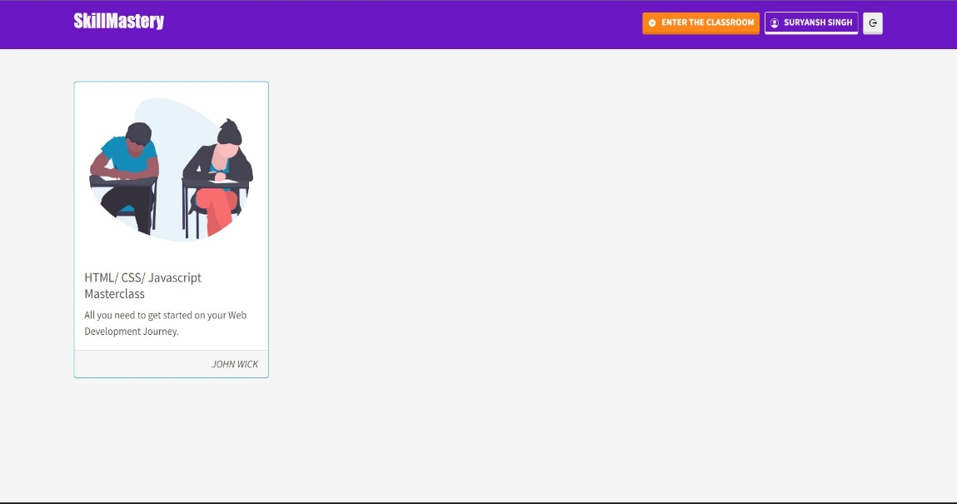

**Figure 2- Student Dashboard**

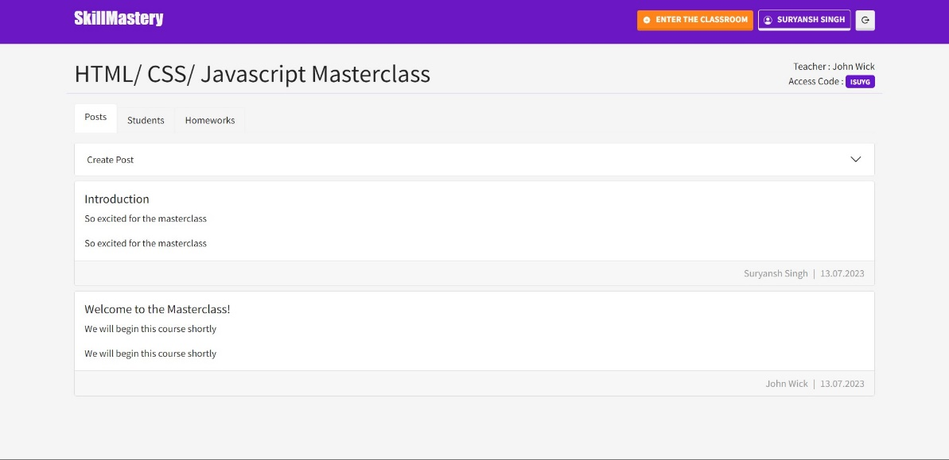

**Figure 3- Student Classroom View**

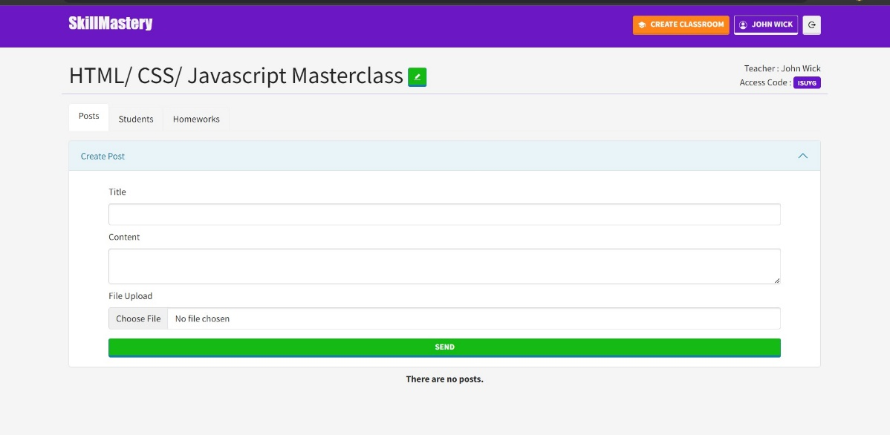

**Figure 4- Teacher Classroom View**

1. **GitHub Repository**

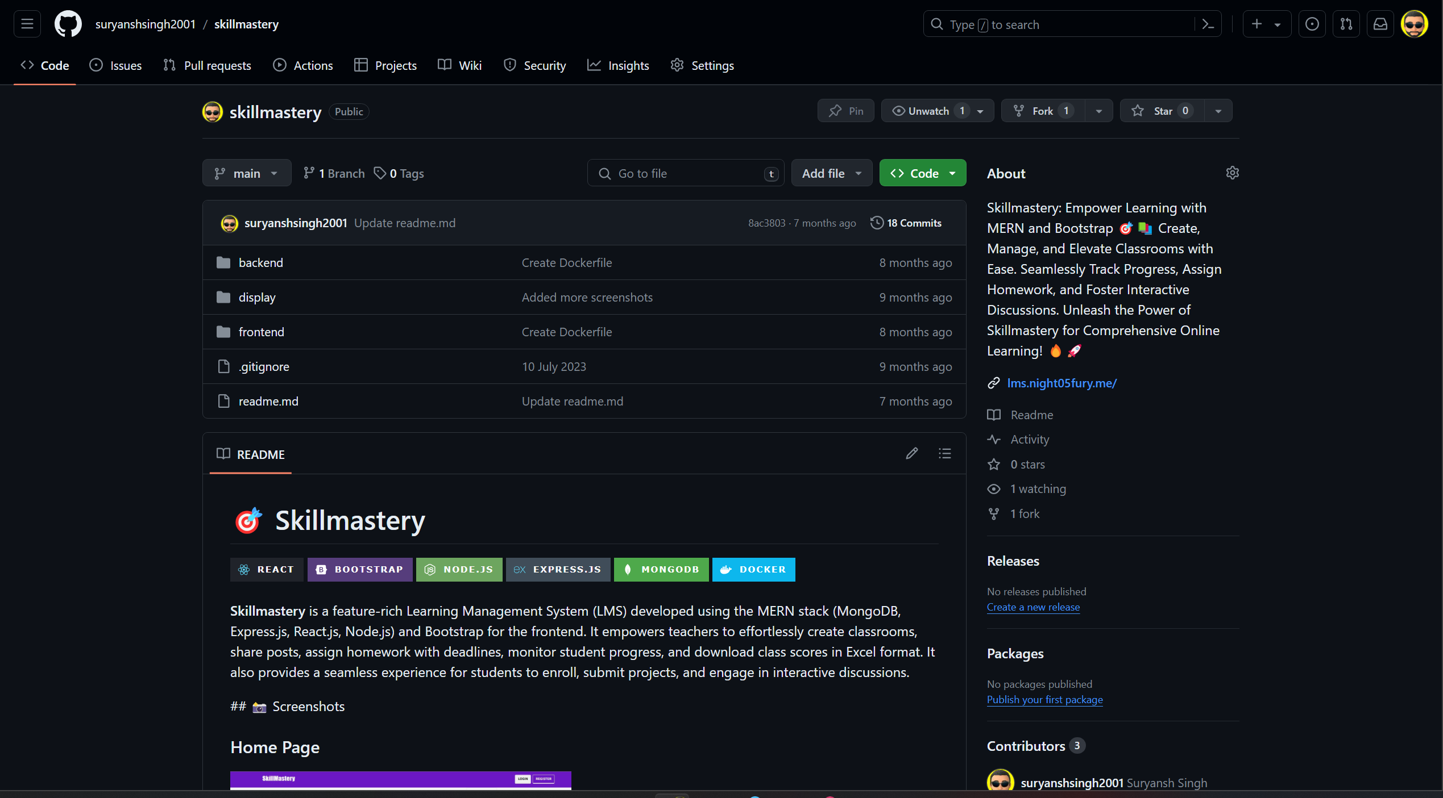

**Figure 5-** [**Skill mastery Repository**](https://github.com/suryanshsingh2001/skillmastery/tree/main)