**PROJECT 1**

**Apple store management system**

**Main UI**

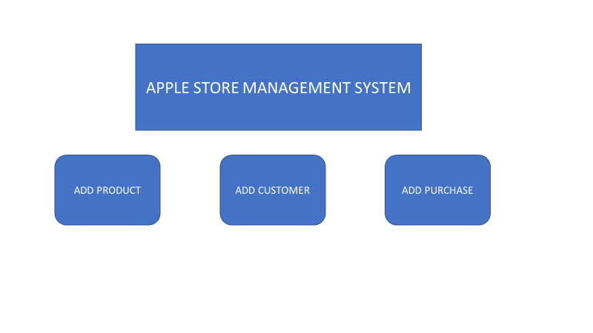

**Add Product UI**

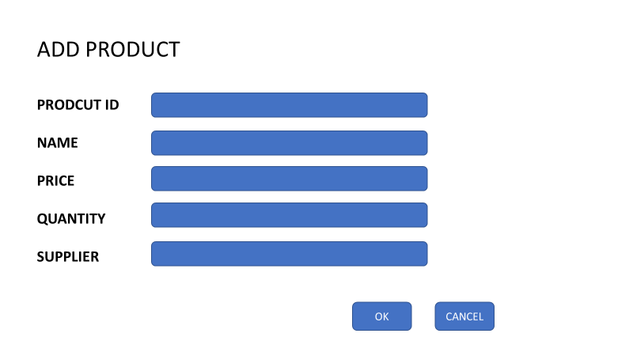

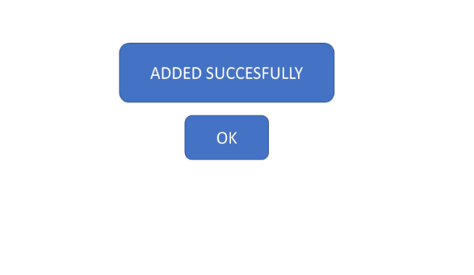Added product successfully

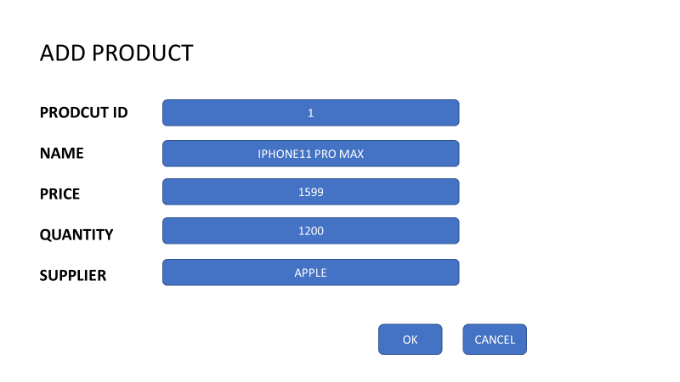

Exception in adding product

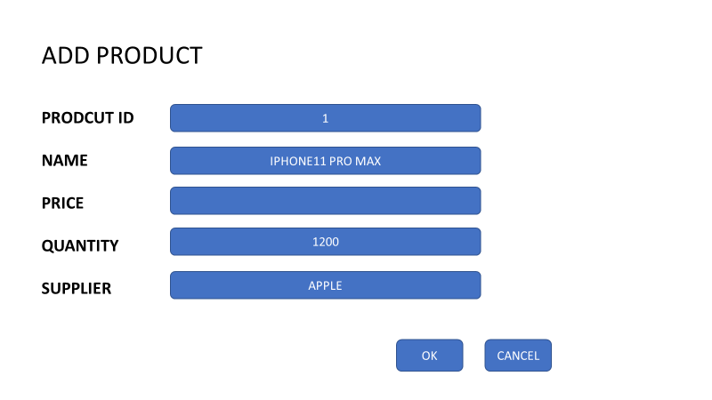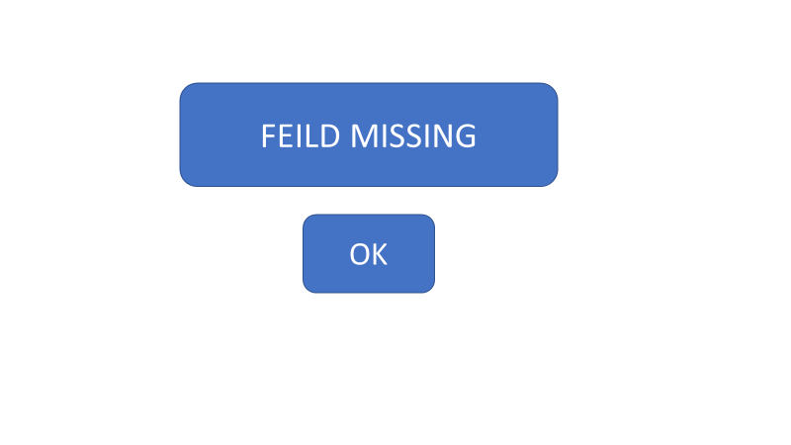

**Add Customer UI**

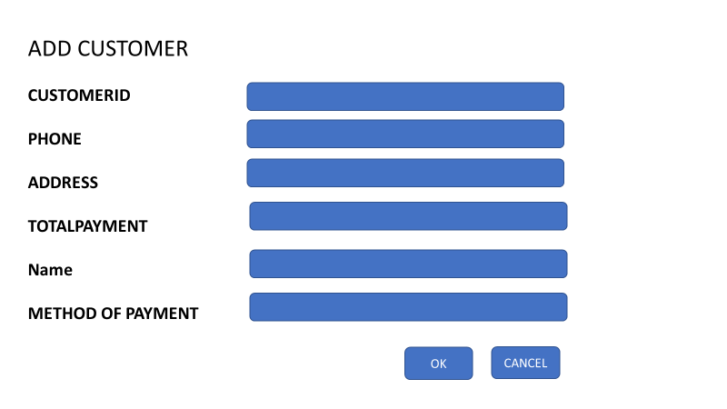

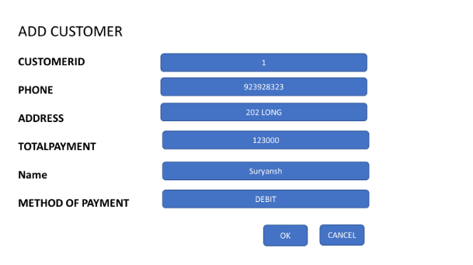Added customer successfully

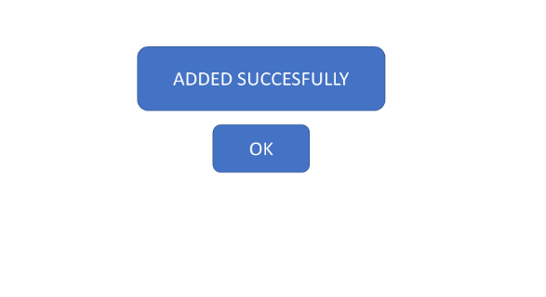

Exception in adding customer

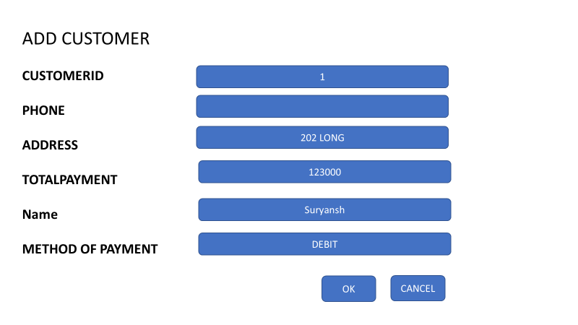

**Add Purchase UI**

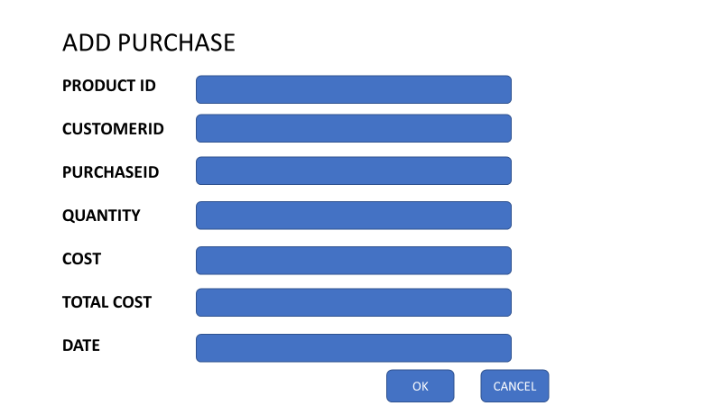

Added purchase successfully

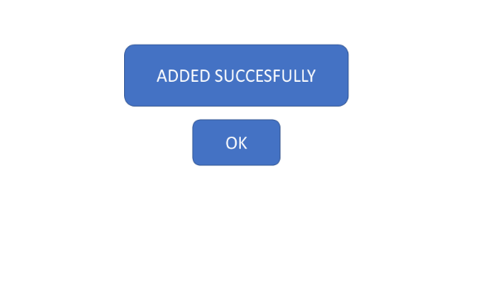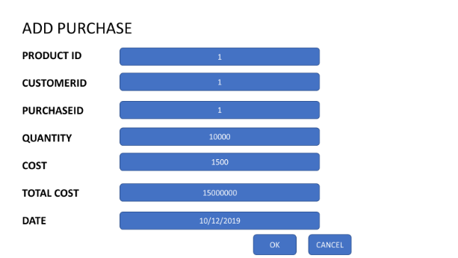

Exception in adding purchase

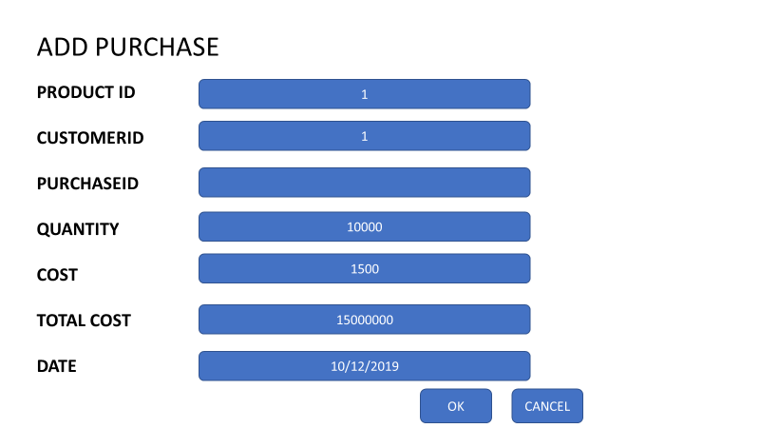

Return to the main UI

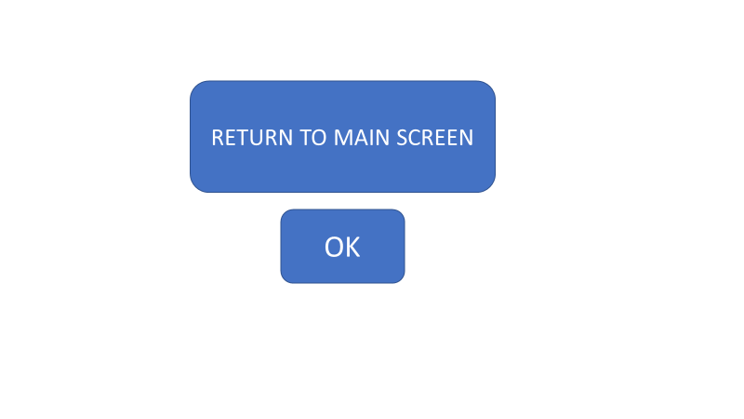

Stories case:

As a owner I want to add product

1st case – product added successfully when all the information available

2nd case – exception when a field is missing

Stories case:

As a owner I want to add customer information

1st case – customer added successfully when all the information available

2nd case – exception when a field is missing

Stories case:

As a owner I want to add purchase

1st case – purchase added successfully when all the information available

2nd case – exception when a field is missing

Products

customer

Buy