[WRITE: Title, 10–15 words]
[WRITE: Author names and register numbers]
[WRITE: Course code and title, faculty name, SCOPE, VIT, month and year]

Aim
[WRITE: Aim, 1–2 sentences, 30–60 words]

Objective
[WRITE: Objectives as 4–6 numbered points, 80–150 words]

Abstract
[WRITE: Abstract, 500–700 words]
[WRITE: Keywords, 5–7 terms]

Introduction
[WRITE: Background and motivation, 300–400 words]
[WRITE: Problem statement, 150–200 words]
[WRITE: Contributions of this work, 150–250 words]
[WRITE: Organisation of the report, 50–100 words]

Related Material / Literature Review
[WRITE: Literature review, 1,000–1,500 words]
[ADD: Summary table of 8–12 related studies (author, year, dataset, method, key result) and a research-gap paragraph, 150–250 words]

Proposed Methodology

Overall architecture
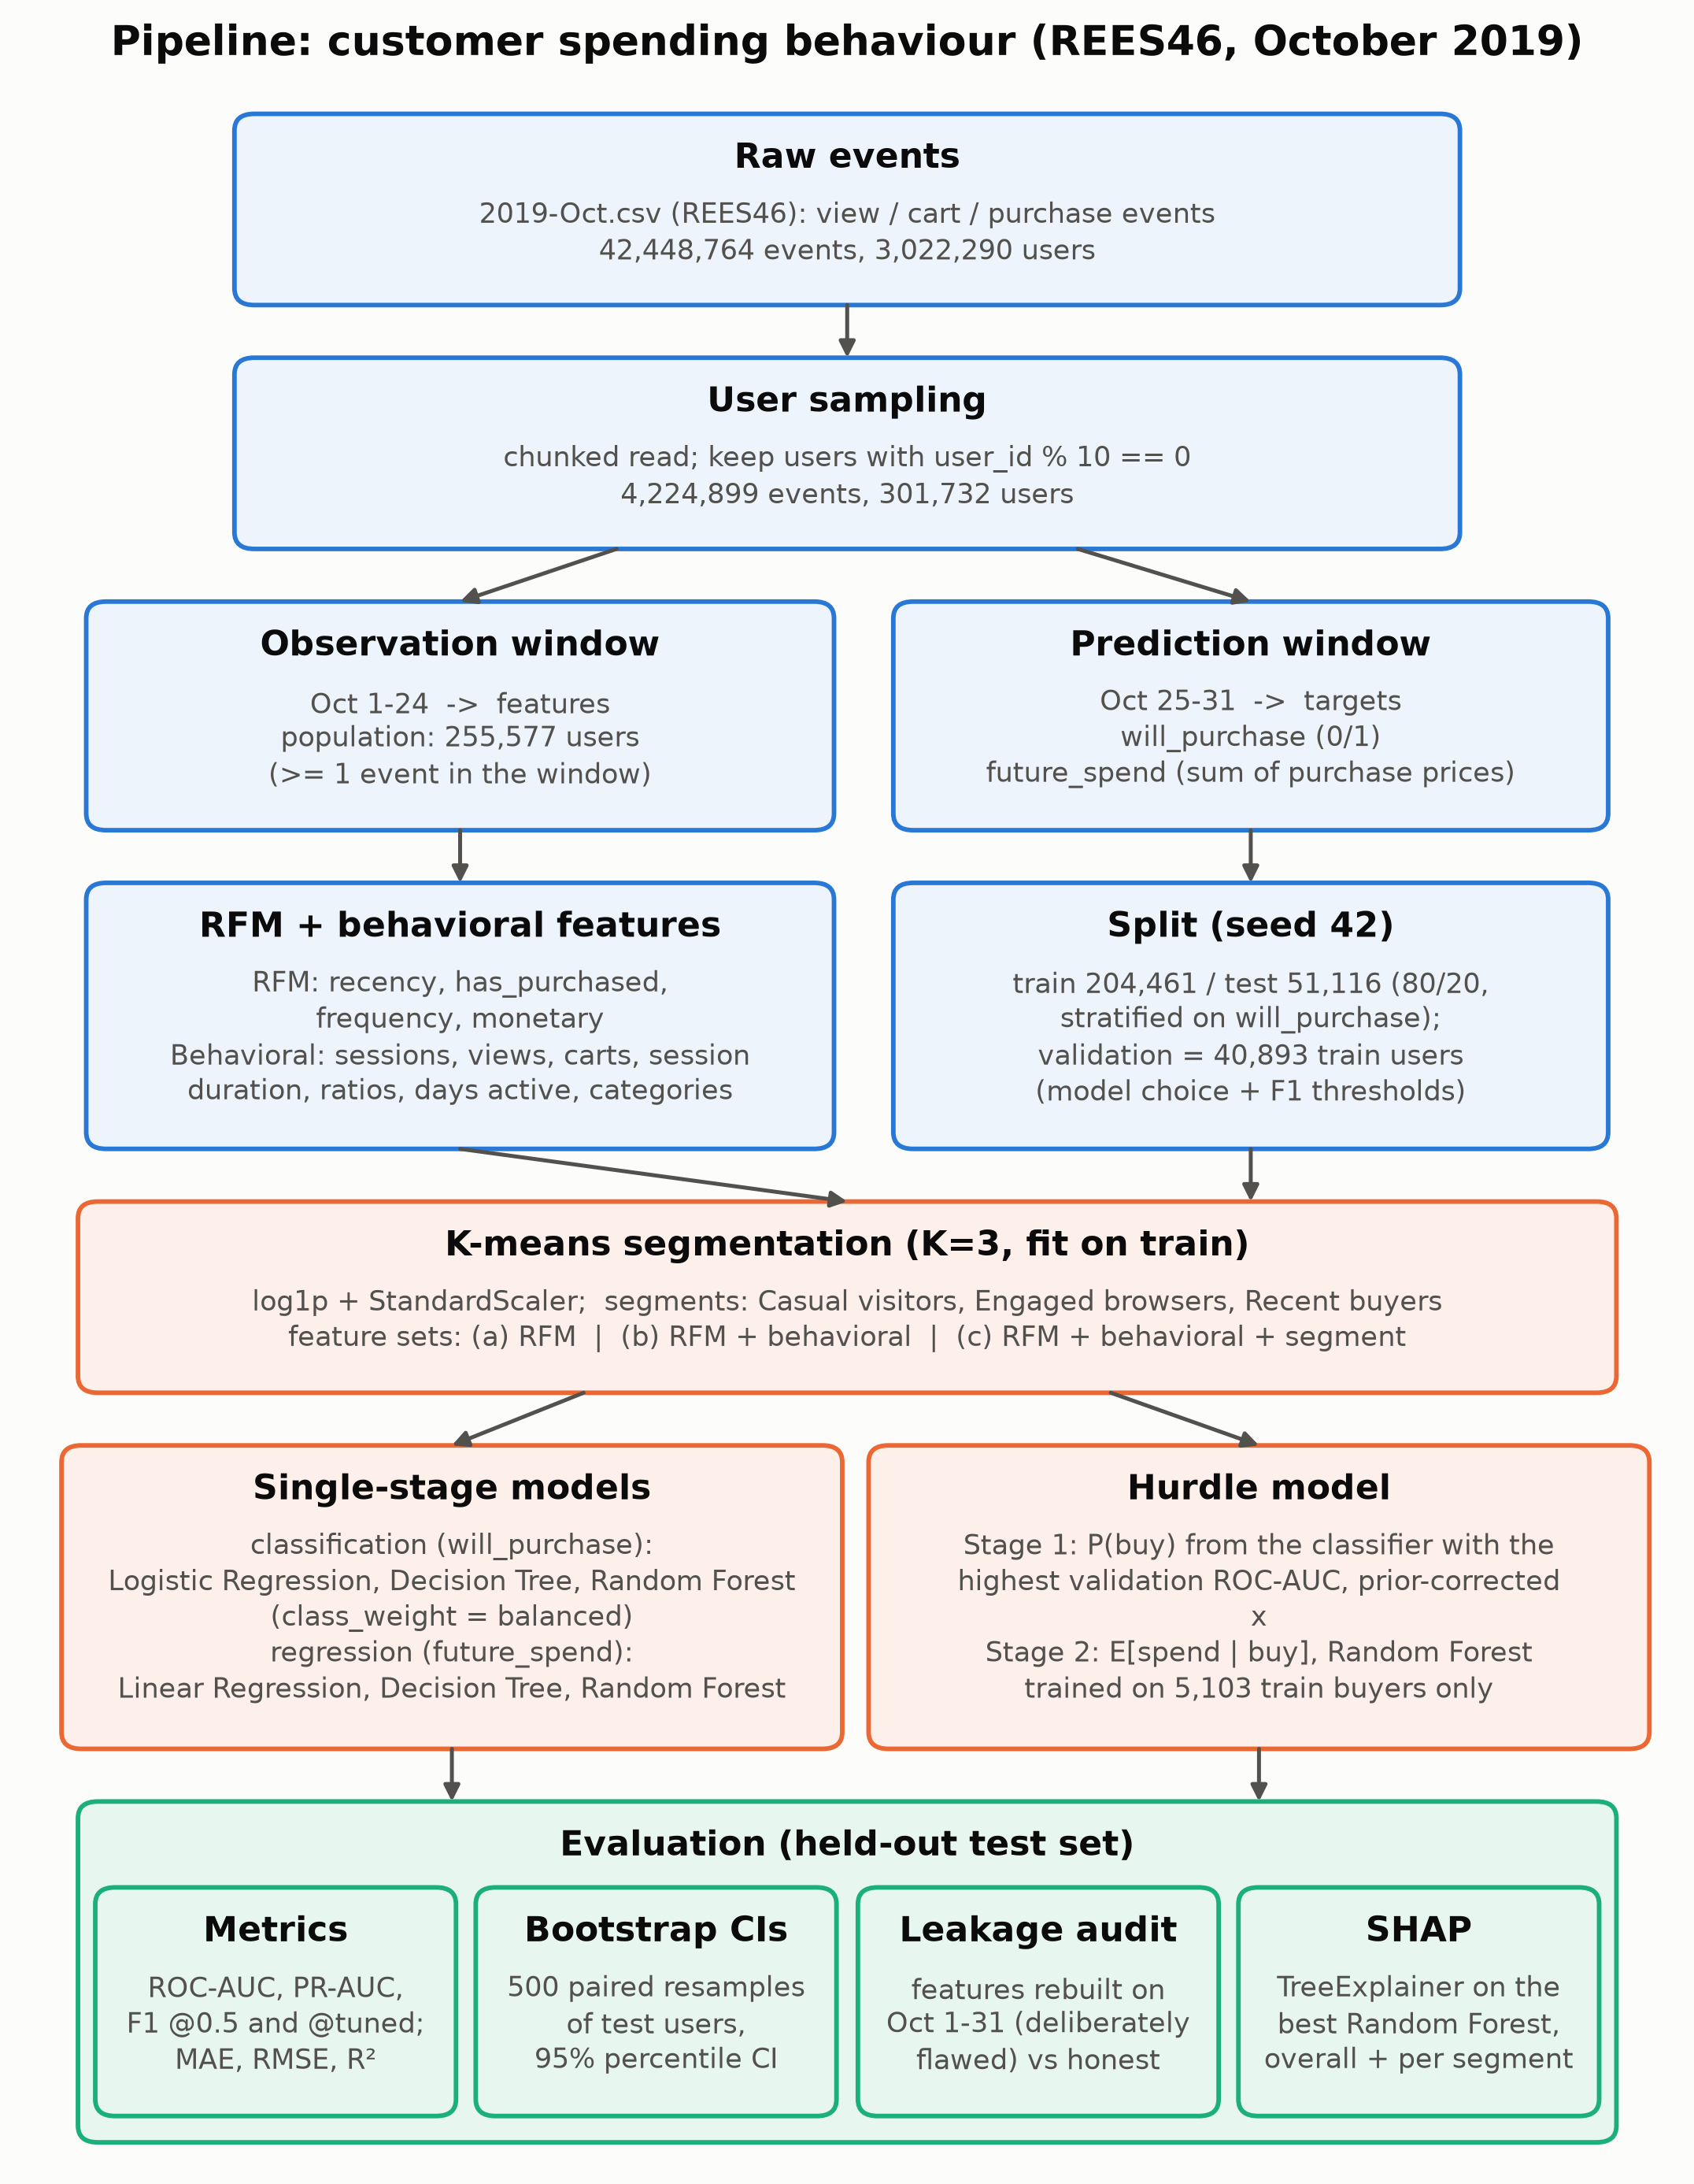
Figure 1. Block diagram of the pipeline: raw events, sampling, windows, features, split, K-means segmentation, single-stage and hurdle models, evaluation.
[WRITE: Walk-through of Figure 1, 150–250 words]

Dataset
Table 1. Dataset summary
Item | Value
Source file | 2019-Oct.csv (Kaggle: mkechinov/ecommerce-behavior-data-from-multi-category-store)
Raw events | 42,448,764
Raw users | 3,022,290
Sampling rule | user_id % 10 == 0
Sampled events | 4,224,899
Sampled users | 301,732
Sample fraction (users) | 0.0998
Observation window (features) | 2019-10-01 to 2019-10-24 23:59:59 UTC
Events in observation window | 3,314,829
Prediction window (targets) | 2019-10-25 to 2019-10-31 23:59:59 UTC
Events in prediction window | 910,070
Population (users with >= 1 event in observation window) | 255,577
Buyers in prediction window (population) | 6,379
Buy rate in prediction window (all / train / test) | 0.0250 / 0.0250 / 0.0250
Mean spend among prediction-window buyers | 532.949
Median spend among prediction-window buyers | 225.870
Train users (all) | 204,461
of which inner-train users | 163,568
of which validation users | 40,893
Test users | 51,116
Test buyers (prediction window) | 1,276

[WRITE: Dataset description and user sampling, 150–250 words]

Observation and prediction windows
[WRITE: Time-window design and why it prevents leakage, 100–200 words]

Feature engineering (RFM and behavioral features)
$R_{u} = t_{ref} − \max_{i∈P_{u}}{ t}_{i}$ (1)
Recency (R_u = 60 days when the user has no purchase in the window)
$F_{u} = |P_{u}|$ (2)
Frequency
$M_{u} = \sum_{i∈P_{u}}{{price}_{i}}$ (3)
Monetary
[WRITE: Symbols in Equations (1)–(3) and the behavioral features, 200–300 words]

Customer segmentation (K-means)
$J = \sum_{k=1}^{K}{\sum_{x_{i}∈C_{k}}{{‖x_{i} − μ_{k}‖}^{2}}}$ (4)
K-means objective
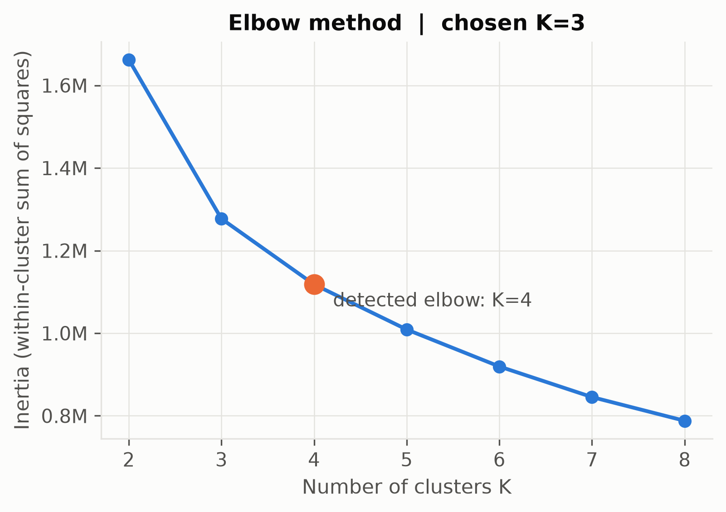
Figure 2. K-means inertia (within-cluster sum of squares) for K = 2..8 on train users; the detected elbow is marked.
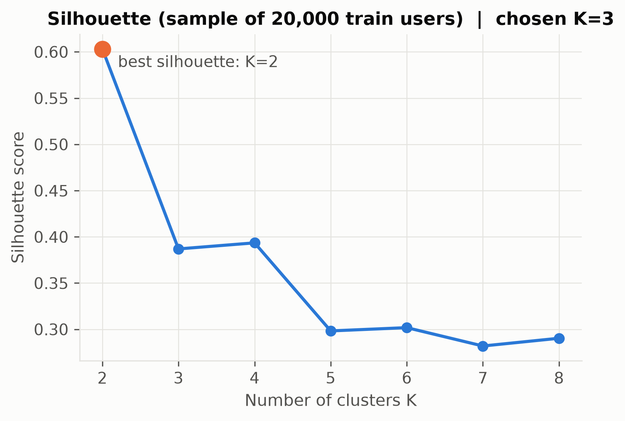
Figure 3. Silhouette score for K = 2..8 on a 20,000-user train sample; the maximum is marked.
[WRITE: Scaling, choice of K and segment naming, 150–250 words]

Predictive models
$ŷ(x) = \frac{1}{T}\sum_{t=1}^{T}{h_{t}(x)}$ (5)
Random Forest average over T trees
[WRITE: Classification and regression models, class weighting and hyperparameters, 200–300 words]

Hurdle model for expected spend
$E[S | x] = P(Y = 1 | x) · E[S | Y = 1, x]$ (6)
Hurdle model expected spend
$odds = \frac{p}{1 − p} · \frac{n_{1}}{n_{0}}, p′ = \frac{odds}{1 + odds}$ (7)
Prior correction of class-weighted probabilities
[WRITE: Two-stage design, stage-1 selection and probability correction, 150–250 words]

Evaluation metrics
$MAE = \frac{1}{n}\sum_{i=1}^{n}{|y_{i} − ŷ_{i}|}$ (8)
Mean absolute error
$RMSE = \sqrt{\frac{1}{n}\sum_{i=1}^{n}{{(y_{i} − ŷ_{i})}^{2}}}$ (9)
Root mean squared error
$R^{2} = 1 − \frac{\sum_{i=1}^{n}{{(y_{i} − ŷ_{i})}^{2}}}{\sum_{i=1}^{n}{{(y_{i} − ȳ)}^{2}}}$ (10)
Coefficient of determination
$Precision = \frac{TP}{TP + FP}$ (11)
Precision
$Recall = \frac{TP}{TP + FN}$ (12)
Recall
$F_{1} = \frac{2 · Precision · Recall}{Precision + Recall}$ (13)
F1 score
[WRITE: Metrics, threshold tuning, bootstrap confidence intervals and leakage audit, 150–250 words]

Results and Discussion

Purchase prediction and feature-set comparison
Table 2. Classification: will_purchase (test set)
Feature set | Model | ROC-AUC  [95% CI] | PR-AUC  [95% CI] | F1 @0.5 [95% CI] | Precision / Recall @0.5 | Tuned threshold | F1 @tuned [95% CI] | Precision / Recall @tuned
(a) RFM | Logistic Regression | 0.7031  [0.6890, 0.7174] | 0.1602  [0.1403, 0.1829] | 0.1785  [0.1655, 0.1907] | 0.1092 / 0.4882 | 0.8485 | 0.2522  [0.2287, 0.2728] | 0.2678 / 0.2382
(a) RFM | Decision Tree | 0.6936  [0.6798, 0.7088] | 0.1621  [0.1407, 0.1836] | 0.1790  [0.1667, 0.1915] | 0.1106 / 0.4687 | 0.8781 | 0.2331  [0.2109, 0.2537] | 0.2796 / 0.1998
(a) RFM | Random Forest | 0.7022  [0.6883, 0.7169] | 0.1703  [0.1487, 0.1930] | 0.1817  [0.1690, 0.1947] | 0.1123 / 0.4765 | 0.8190 | 0.2347  [0.2129, 0.2544] | 0.2305 / 0.2390
(b) RFM + behavioral | Logistic Regression | 0.7783  [0.7628, 0.7912] | 0.1688  [0.1484, 0.1904] | 0.1538  [0.1430, 0.1626] | 0.0883 / 0.5956 | 0.8710 | 0.2312  [0.2084, 0.2505] | 0.2253 / 0.2375
(b) RFM + behavioral | Decision Tree | 0.7766  [0.7627, 0.7902] | 0.1822  [0.1606, 0.2046] | 0.1235  [0.1156, 0.1308] | 0.0679 / 0.6795 | 0.8836 | 0.2381  [0.2148, 0.2605] | 0.3034 / 0.1959
(b) RFM + behavioral | Random Forest | 0.7973  [0.7840, 0.8107] | 0.2026  [0.1801, 0.2264] | 0.1492  [0.1395, 0.1580] | 0.0846 / 0.6348 | 0.8578 | 0.2445  [0.2206, 0.2691] | 0.3493 / 0.1881
(c) RFM + behavioral + segment | Logistic Regression | 0.7819  [0.7663, 0.7951] | 0.1803  [0.1592, 0.2024] | 0.1234  [0.1161, 0.1305] | 0.0678 / 0.6889 | 0.8567 | 0.2430  [0.2204, 0.2629] | 0.2408 / 0.2453
(c) RFM + behavioral + segment | Decision Tree | 0.7743  [0.7588, 0.7893] | 0.1830  [0.1612, 0.2055] | 0.1360  [0.1272, 0.1440] | 0.0758 / 0.6583 | 0.8836 | 0.2381  [0.2148, 0.2605] | 0.3034 / 0.1959
(c) RFM + behavioral + segment | Random Forest | 0.7955  [0.7821, 0.8090] | 0.2029  [0.1805, 0.2261] | 0.1443  [0.1352, 0.1531] | 0.0813 / 0.6403 | 0.8275 | 0.2582  [0.2327, 0.2806] | 0.2937 / 0.2304
Note: Test set: 51,116 users. 95% CI = percentile interval over 500 paired bootstrap resamples of test users (seed 42).
Note: Tuned threshold = threshold maximising F1 on the validation split (part of train); never chosen on test.
Note: All classifiers use class_weight='balanced'. PR-AUC = average precision.

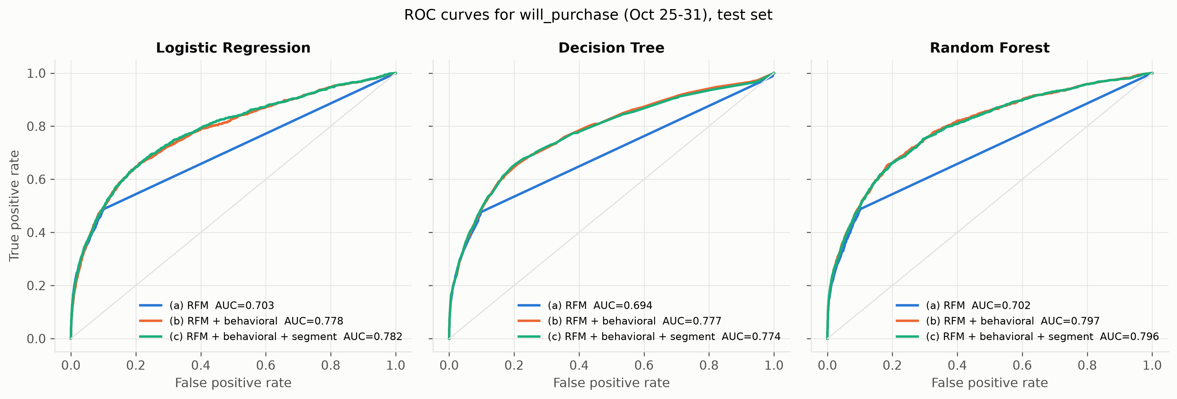
Figure 4. Test-set ROC curves for will_purchase, one panel per classifier, one line per feature set, with ROC-AUC in the legend.
[WRITE: Discussion of Table 2 and Figure 4, 200–300 words]

Spend prediction: single-stage vs hurdle
Table 3. Spend prediction: single-stage vs hurdle (future_spend, Oct 25-31, test set)
Feature set | Evaluated on | n | Model | MAE  [95% CI] | RMSE  [95% CI] | R²  [95% CI]
(a) RFM | All test users | 51,116 | Linear Regression (single-stage) | 23.562  [22.154, 25.353] | 196.533  [136.076, 280.519] | -0.1416  [-2.2154, 0.5280]
(a) RFM | All test users | 51,116 | Decision Tree (single-stage) | 21.824  [20.503, 23.402] | 173.424  [133.639, 225.163] | 0.1111  [-0.1272, 0.2167]
(a) RFM | All test users | 51,116 | Random Forest (single-stage) | 21.501  [20.240, 23.050] | 168.153  [130.582, 216.933] | 0.1643  [-0.0956, 0.2879]
(a) RFM | All test users | 51,116 | Hurdle: P(buy) x E[spend | buy] | 22.017  [20.652, 23.684] | 175.351  [139.166, 220.363] | 0.0912  [-0.3036, 0.2811]
(a) RFM | Test buyers only | 1,276 | Linear Regression (single-stage) | 429.291  [394.039, 472.789] | 859.092  [718.420, 1,018.028] | 0.3361  [-0.1315, 0.6143]
(a) RFM | Test buyers only | 1,276 | Decision Tree (single-stage) | 455.883  [413.435, 510.967] | 1,024.249  [758.115, 1,370.480] | 0.0563  [-0.2508, 0.1781]
(a) RFM | Test buyers only | 1,276 | Random Forest (single-stage) | 440.615  [401.101, 492.743] | 987.847  [734.772, 1,308.328] | 0.1222  [-0.1934, 0.2630]
(a) RFM | Test buyers only | 1,276 | Hurdle: P(buy) x E[spend | buy] | 451.075  [410.211, 505.456] | 1,009.734  [769.185, 1,304.358] | 0.0829  [-0.3409, 0.2751]
(b) RFM + behavioral | All test users | 51,116 | Linear Regression (single-stage) | 23.622  [22.202, 25.416] | 196.634  [135.924, 280.896] | -0.1428  [-2.2203, 0.5273]
(b) RFM + behavioral | All test users | 51,116 | Decision Tree (single-stage) | 21.764  [20.463, 23.340] | 174.883  [134.581, 226.225] | 0.0960  [-0.1498, 0.2070]
(b) RFM + behavioral | All test users | 51,116 | Random Forest (single-stage) | 21.407  [20.140, 22.969] | 169.160  [131.891, 217.242] | 0.1542  [-0.1156, 0.2793]
(b) RFM + behavioral | All test users | 51,116 | Hurdle: P(buy) x E[spend | buy] | 19.271  [18.044, 20.894] | 164.302  [123.945, 213.152] | 0.2021  [0.0284, 0.2973]
(b) RFM + behavioral | Test buyers only | 1,276 | Linear Regression (single-stage) | 427.176  [392.086, 470.913] | 859.131  [717.551, 1,019.007] | 0.3361  [-0.1314, 0.6141]
(b) RFM + behavioral | Test buyers only | 1,276 | Decision Tree (single-stage) | 457.318  [415.292, 515.181] | 1,032.870  [761.504, 1,374.134] | 0.0404  [-0.2803, 0.1770]
(b) RFM + behavioral | Test buyers only | 1,276 | Random Forest (single-stage) | 442.007  [401.885, 494.213] | 992.576  [740.237, 1,308.607] | 0.1138  [-0.2114, 0.2556]
(b) RFM + behavioral | Test buyers only | 1,276 | Hurdle: P(buy) x E[spend | buy] | 441.947  [401.024, 494.216] | 1,001.196  [735.570, 1,324.430] | 0.0983  [-0.1882, 0.2396]
(c) RFM + behavioral + segment | All test users | 51,116 | Linear Regression (single-stage) | 23.635  [22.217, 25.430] | 196.624  [135.919, 280.880] | -0.1427  [-2.2199, 0.5273]
(c) RFM + behavioral + segment | All test users | 51,116 | Decision Tree (single-stage) | 21.742  [20.444, 23.327] | 174.880  [134.582, 226.228] | 0.0961  [-0.1497, 0.2071]
(c) RFM + behavioral + segment | All test users | 51,116 | Random Forest (single-stage) | 21.406  [20.137, 22.962] | 169.169  [131.899, 217.246] | 0.1541  [-0.1158, 0.2793]
(c) RFM + behavioral + segment | All test users | 51,116 | Hurdle: P(buy) x E[spend | buy] | 19.296  [18.068, 20.912] | 163.701  [123.839, 212.133] | 0.2079  [0.0339, 0.3036]
(c) RFM + behavioral + segment | Test buyers only | 1,276 | Linear Regression (single-stage) | 427.175  [392.055, 470.934] | 859.108  [717.543, 1,018.977] | 0.3361  [-0.1315, 0.6141]
(c) RFM + behavioral + segment | Test buyers only | 1,276 | Decision Tree (single-stage) | 457.622  [415.631, 515.492] | 1,032.892  [761.592, 1,374.148] | 0.0404  [-0.2799, 0.1770]
(c) RFM + behavioral + segment | Test buyers only | 1,276 | Random Forest (single-stage) | 441.926  [401.733, 494.133] | 992.626  [740.314, 1,308.646] | 0.1137  [-0.2116, 0.2555]
(c) RFM + behavioral + segment | Test buyers only | 1,276 | Hurdle: P(buy) x E[spend | buy] | 441.845  [400.818, 493.732] | 997.511  [734.765, 1,316.492] | 0.1050  [-0.1861, 0.2474]
Note: Hurdle stage 1 = classifier with the highest validation ROC-AUC per feature set ((a) RFM: Logistic Regression, (b) RFM + behavioral: Random Forest, (c) RFM + behavioral + segment: Random Forest), probabilities prior-corrected for class_weight='balanced'.
Note: Hurdle stage 2 = Random Forest regressor trained on 5,103 train users with future_spend > 0.
Note: 95% CI = percentile interval over 500 bootstrap resamples of test users; the buyers-only intervals use the buyers inside each resample.

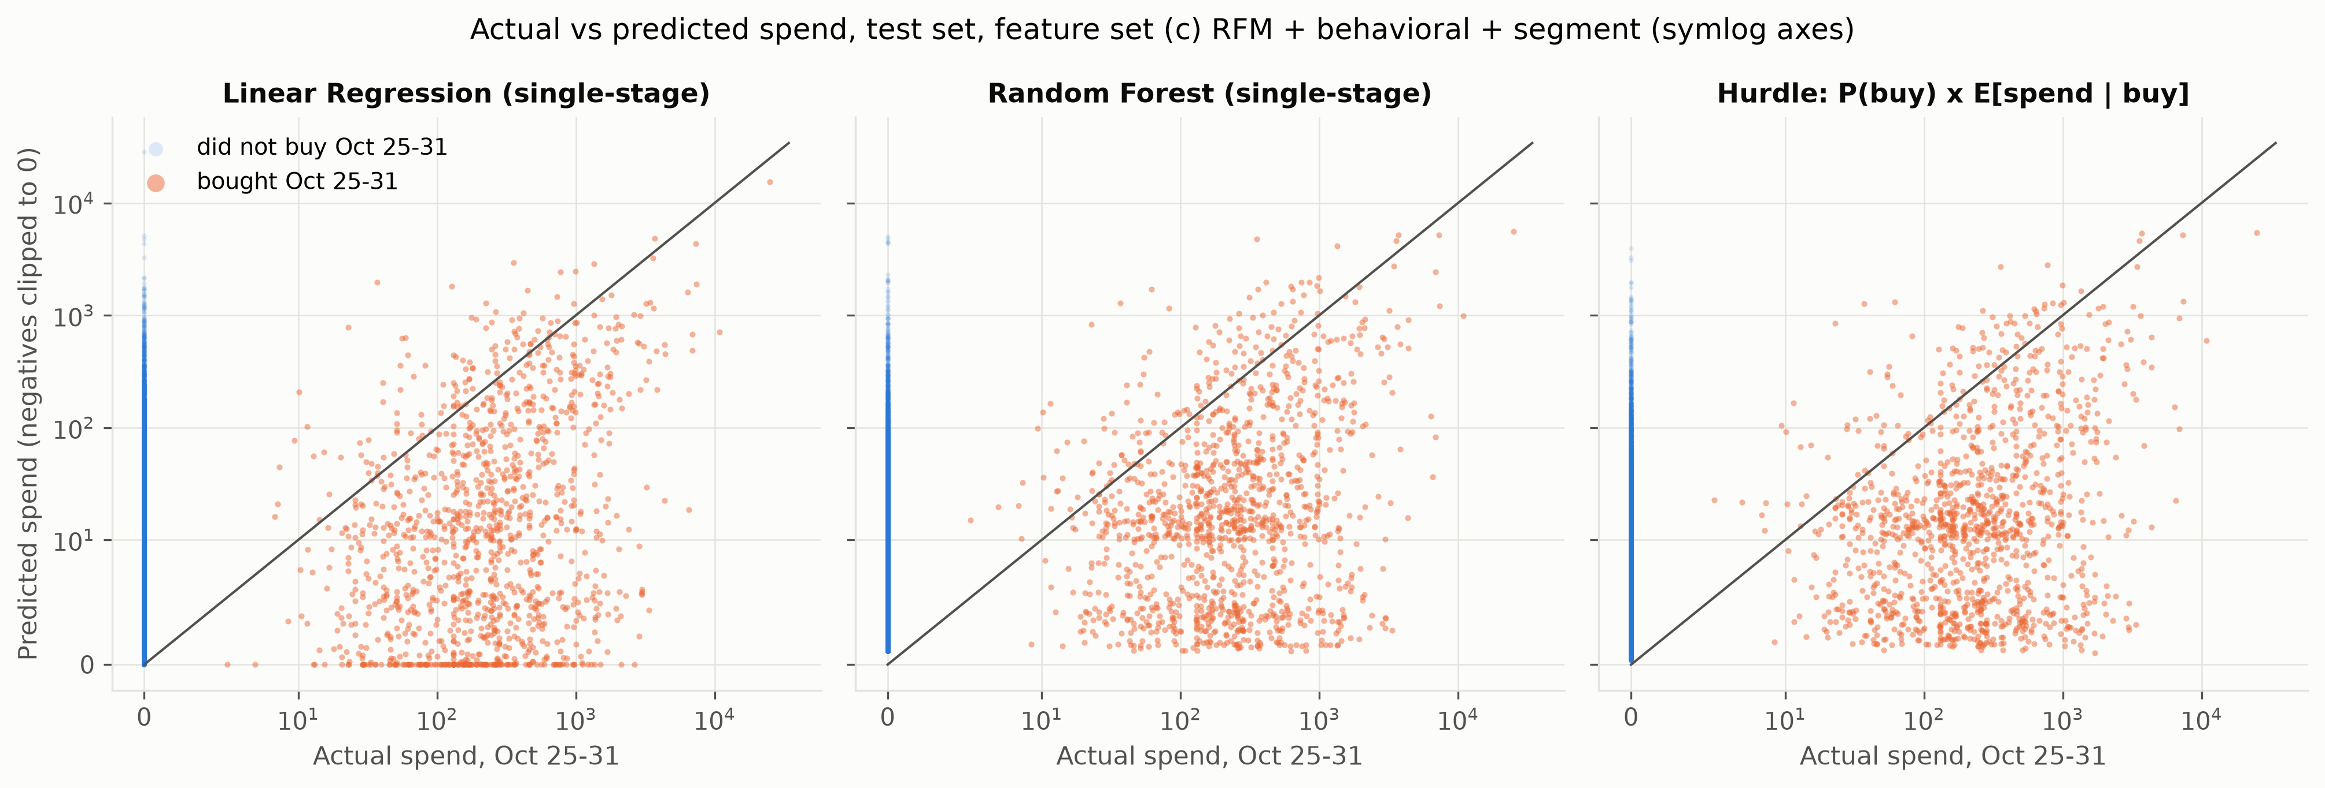
Figure 5. Actual vs predicted Oct 25-31 spend for test users (symlog axes), feature set (c) RFM + behavioral + segment: Linear Regression, Random Forest and hurdle model.
[WRITE: Discussion of Table 3 and Figure 5, 200–300 words]

Leakage audit
Table 4. Leakage audit: honest vs deliberately leaky features (test set)
Task | Feature set | Model | Metric | Honest (features Oct 1-24) | Leaky (features Oct 1-31) | Inflation (leaky - honest)
Classification | (a) RFM | Logistic Regression | ROC-AUC | 0.7031 | 1.0000 | +0.2969
Classification | (a) RFM | Logistic Regression | PR-AUC | 0.1602 | 1.0000 | +0.8398
Classification | (a) RFM | Logistic Regression | F1 @0.5 | 0.1785 | 0.9101 | +0.7317
Classification | (a) RFM | Decision Tree | ROC-AUC | 0.6936 | 1.0000 | +0.3064
Classification | (a) RFM | Decision Tree | PR-AUC | 0.1621 | 1.0000 | +0.8379
Classification | (a) RFM | Decision Tree | F1 @0.5 | 0.1790 | 1.0000 | +0.8210
Classification | (a) RFM | Random Forest | ROC-AUC | 0.7022 | 1.0000 | +0.2978
Classification | (a) RFM | Random Forest | PR-AUC | 0.1703 | 1.0000 | +0.8297
Classification | (a) RFM | Random Forest | F1 @0.5 | 0.1817 | 1.0000 | +0.8183
Regression | (a) RFM | Linear Regression | R² | -0.1416 | -0.0368 | +0.1048
Regression | (a) RFM | Linear Regression | RMSE | 196.533 | 187.295 | -9.239
Regression | (a) RFM | Linear Regression | MAE | 23.562 | 19.706 | -3.857
Regression | (a) RFM | Decision Tree | R² | 0.1111 | 0.4421 | +0.3310
Regression | (a) RFM | Decision Tree | RMSE | 173.424 | 137.390 | -36.033
Regression | (a) RFM | Decision Tree | MAE | 21.824 | 6.678 | -15.146
Regression | (a) RFM | Random Forest | R² | 0.1643 | 0.5387 | +0.3744
Regression | (a) RFM | Random Forest | RMSE | 168.153 | 124.935 | -43.217
Regression | (a) RFM | Random Forest | MAE | 21.501 | 6.222 | -15.279
Classification | (b) RFM + behavioral | Logistic Regression | ROC-AUC | 0.7783 | 1.0000 | +0.2217
Classification | (b) RFM + behavioral | Logistic Regression | PR-AUC | 0.1688 | 0.9999 | +0.8311
Classification | (b) RFM + behavioral | Logistic Regression | F1 @0.5 | 0.1538 | 0.9088 | +0.7551
Classification | (b) RFM + behavioral | Decision Tree | ROC-AUC | 0.7766 | 1.0000 | +0.2234
Classification | (b) RFM + behavioral | Decision Tree | PR-AUC | 0.1822 | 1.0000 | +0.8178
Classification | (b) RFM + behavioral | Decision Tree | F1 @0.5 | 0.1235 | 1.0000 | +0.8765
Classification | (b) RFM + behavioral | Random Forest | ROC-AUC | 0.7973 | 1.0000 | +0.2027
Classification | (b) RFM + behavioral | Random Forest | PR-AUC | 0.2026 | 1.0000 | +0.7974
Classification | (b) RFM + behavioral | Random Forest | F1 @0.5 | 0.1492 | 1.0000 | +0.8508
Regression | (b) RFM + behavioral | Linear Regression | R² | -0.1428 | -0.0424 | +0.1004
Regression | (b) RFM + behavioral | Linear Regression | RMSE | 196.634 | 187.795 | -8.839
Regression | (b) RFM + behavioral | Linear Regression | MAE | 23.622 | 21.072 | -2.550
Regression | (b) RFM + behavioral | Decision Tree | R² | 0.0960 | 0.4369 | +0.3409
Regression | (b) RFM + behavioral | Decision Tree | RMSE | 174.883 | 138.022 | -36.861
Regression | (b) RFM + behavioral | Decision Tree | MAE | 21.764 | 6.723 | -15.041
Regression | (b) RFM + behavioral | Random Forest | R² | 0.1542 | 0.5368 | +0.3825
Regression | (b) RFM + behavioral | Random Forest | RMSE | 169.160 | 125.192 | -43.968
Regression | (b) RFM + behavioral | Random Forest | MAE | 21.407 | 6.279 | -15.128
Classification | (c) RFM + behavioral + segment | Logistic Regression | ROC-AUC | 0.7819 | 1.0000 | +0.2181
Classification | (c) RFM + behavioral + segment | Logistic Regression | PR-AUC | 0.1803 | 0.9999 | +0.8196
Classification | (c) RFM + behavioral + segment | Logistic Regression | F1 @0.5 | 0.1234 | 0.9092 | +0.7858
Classification | (c) RFM + behavioral + segment | Decision Tree | ROC-AUC | 0.7743 | 1.0000 | +0.2257
Classification | (c) RFM + behavioral + segment | Decision Tree | PR-AUC | 0.1830 | 1.0000 | +0.8170
Classification | (c) RFM + behavioral + segment | Decision Tree | F1 @0.5 | 0.1360 | 1.0000 | +0.8640
Classification | (c) RFM + behavioral + segment | Random Forest | ROC-AUC | 0.7955 | 1.0000 | +0.2045
Classification | (c) RFM + behavioral + segment | Random Forest | PR-AUC | 0.2029 | 1.0000 | +0.7971
Classification | (c) RFM + behavioral + segment | Random Forest | F1 @0.5 | 0.1443 | 1.0000 | +0.8557
Regression | (c) RFM + behavioral + segment | Linear Regression | R² | -0.1427 | -0.0413 | +0.1014
Regression | (c) RFM + behavioral + segment | Linear Regression | RMSE | 196.624 | 187.700 | -8.924
Regression | (c) RFM + behavioral + segment | Linear Regression | MAE | 23.635 | 21.187 | -2.447
Regression | (c) RFM + behavioral + segment | Decision Tree | R² | 0.0961 | 0.4369 | +0.3409
Regression | (c) RFM + behavioral + segment | Decision Tree | RMSE | 174.880 | 138.022 | -36.858
Regression | (c) RFM + behavioral + segment | Decision Tree | MAE | 21.742 | 6.723 | -15.019
Regression | (c) RFM + behavioral + segment | Random Forest | R² | 0.1541 | 0.5368 | +0.3826
Regression | (c) RFM + behavioral + segment | Random Forest | RMSE | 169.169 | 125.191 | -43.978
Regression | (c) RFM + behavioral + segment | Random Forest | MAE | 21.406 | 6.279 | -15.127
Note: LEAKY setup is deliberately flawed and used only for comparison: features are rebuilt from Oct 1-31, which overlaps the Oct 25-31 target window. Same users, targets, split, models and K-means K.
Note: For RMSE and MAE a negative inflation means the leaky model looks better.

[WRITE: Discussion of Table 4, 150–200 words]

Customer segments
Table 5. Segment profiles (K-means, K=3; means over all population users)
Segment | Casual visitors | Engaged browsers | Recent buyers
Users | 163,717 | 63,493 | 28,367
Share of users | 0.6406 | 0.2484 | 0.1110
Train users | 130,792 | 50,967 | 22,702
Purchased Oct 1-24 (share) | 0.0012 | 0.0002 | 0.9988
Mean monetary | 0.053 | 0.001 | 654.002
Mean frequency | 0.001 | 0.000 | 2.057
Mean recency (days) | 59.950 | 59.994 | 10.561
Mean sessions | 1.341 | 4.989 | 6.474
Mean product views | 3.295 | 26.708 | 33.330
Mean add-to-cart events | 0.033 | 0.225 | 1.968
Mean days active | 1.163 | 3.358 | 3.580
Mean session duration (min) | 2.388 | 71.536 | 9.443
Mean categories viewed | 1.293 | 4.649 | 4.149
Mean days since last event | 11.224 | 6.302 | 7.672
Mean cart-to-view ratio | 0.011 | 0.011 | 0.160
Mean purchase-to-cart ratio | 0.000 | 0.000 | 0.596
Oct 25-31 purchase rate | 0.0088 | 0.0280 | 0.1117
Oct 25-31 mean spend | 3.524 | 9.625 | 77.963
Note: Features are from Oct 1-24. The two Oct 25-31 columns are descriptive only and were not used for clustering or naming.
Note: Naming rule and the numbers behind each name: outputs/report/cluster_naming.md.

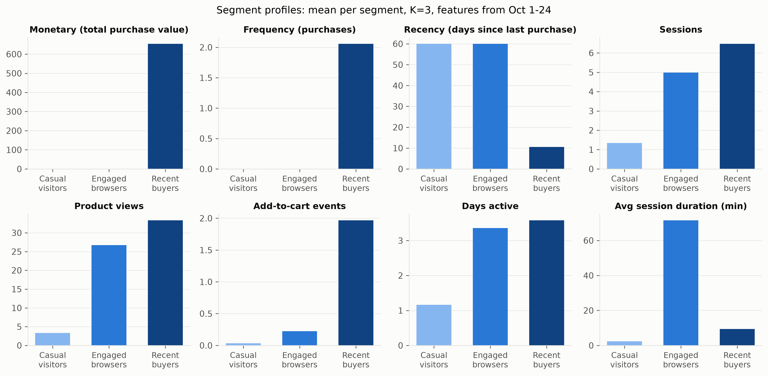
Figure 6. Mean of eight Oct 1-24 features per segment (K=3), one panel per feature.
[WRITE: Discussion of Table 5 and Figure 6, 150–250 words]

Explainability
Table 6. Top SHAP features, overall (top 10) and per segment (top 5)
Scope | Ranking | n users | Rank | Feature | Mean |SHAP|
Overall | all features | 2,000 | 1 | Days since last event | 0.0528
Overall | all features | 2,000 | 2 | Recency (days since last purchase) | 0.0428
Overall | all features | 2,000 | 3 | Segment: Casual visitors | 0.0395
Overall | all features | 2,000 | 4 | Monetary (total purchase value) | 0.0311
Overall | all features | 2,000 | 5 | Avg session duration (min) | 0.0305
Overall | all features | 2,000 | 6 | Frequency (purchases) | 0.0226
Overall | all features | 2,000 | 7 | Has purchased (0/1) | 0.0214
Overall | all features | 2,000 | 8 | Product views | 0.0194
Overall | all features | 2,000 | 9 | Days active | 0.0174
Overall | all features | 2,000 | 10 | Segment: Engaged browsers | 0.0149
Segment: Casual visitors | all features | 1,000 | 1 | Days since last event | 0.0483
Segment: Casual visitors | all features | 1,000 | 2 | Recency (days since last purchase) | 0.0430
Segment: Casual visitors | all features | 1,000 | 3 | Segment: Casual visitors | 0.0387
Segment: Casual visitors | all features | 1,000 | 4 | Avg session duration (min) | 0.0345
Segment: Casual visitors | all features | 1,000 | 5 | Monetary (total purchase value) | 0.0306
Segment: Casual visitors | excluding seg dummies | 1,000 | 1 | Days since last event | 0.0483
Segment: Casual visitors | excluding seg dummies | 1,000 | 2 | Recency (days since last purchase) | 0.0430
Segment: Casual visitors | excluding seg dummies | 1,000 | 3 | Avg session duration (min) | 0.0345
Segment: Casual visitors | excluding seg dummies | 1,000 | 4 | Monetary (total purchase value) | 0.0306
Segment: Casual visitors | excluding seg dummies | 1,000 | 5 | Frequency (purchases) | 0.0220
Segment: Engaged browsers | all features | 1,000 | 1 | Days since last event | 0.0618
Segment: Engaged browsers | all features | 1,000 | 2 | Segment: Casual visitors | 0.0433
Segment: Engaged browsers | all features | 1,000 | 3 | Recency (days since last purchase) | 0.0395
Segment: Engaged browsers | all features | 1,000 | 4 | Monetary (total purchase value) | 0.0252
Segment: Engaged browsers | all features | 1,000 | 5 | Segment: Engaged browsers | 0.0229
Segment: Engaged browsers | excluding seg dummies | 1,000 | 1 | Days since last event | 0.0618
Segment: Engaged browsers | excluding seg dummies | 1,000 | 2 | Recency (days since last purchase) | 0.0395
Segment: Engaged browsers | excluding seg dummies | 1,000 | 3 | Monetary (total purchase value) | 0.0252
Segment: Engaged browsers | excluding seg dummies | 1,000 | 4 | Frequency (purchases) | 0.0200
Segment: Engaged browsers | excluding seg dummies | 1,000 | 5 | Days active | 0.0185
Segment: Recent buyers | all features | 1,000 | 1 | Days since last event | 0.0605
Segment: Recent buyers | all features | 1,000 | 2 | Recency (days since last purchase) | 0.0517
Segment: Recent buyers | all features | 1,000 | 3 | Monetary (total purchase value) | 0.0469
Segment: Recent buyers | all features | 1,000 | 4 | Has purchased (0/1) | 0.0427
Segment: Recent buyers | all features | 1,000 | 5 | Segment: Casual visitors | 0.0337
Segment: Recent buyers | excluding seg dummies | 1,000 | 1 | Days since last event | 0.0605
Segment: Recent buyers | excluding seg dummies | 1,000 | 2 | Recency (days since last purchase) | 0.0517
Segment: Recent buyers | excluding seg dummies | 1,000 | 3 | Monetary (total purchase value) | 0.0469
Segment: Recent buyers | excluding seg dummies | 1,000 | 4 | Has purchased (0/1) | 0.0427
Segment: Recent buyers | excluding seg dummies | 1,000 | 5 | Frequency (purchases) | 0.0328
Note: Model: Random Forest classifier for will_purchase on (c) RFM + behavioral + segment (highest validation ROC-AUC among Random Forest classifiers). TreeExplainer, positive class.
Note: Segment indicators are constant within a segment, so their per-segment SHAP reflects the gap to the overall baseline; the 'excluding seg dummies' ranking leaves them out.

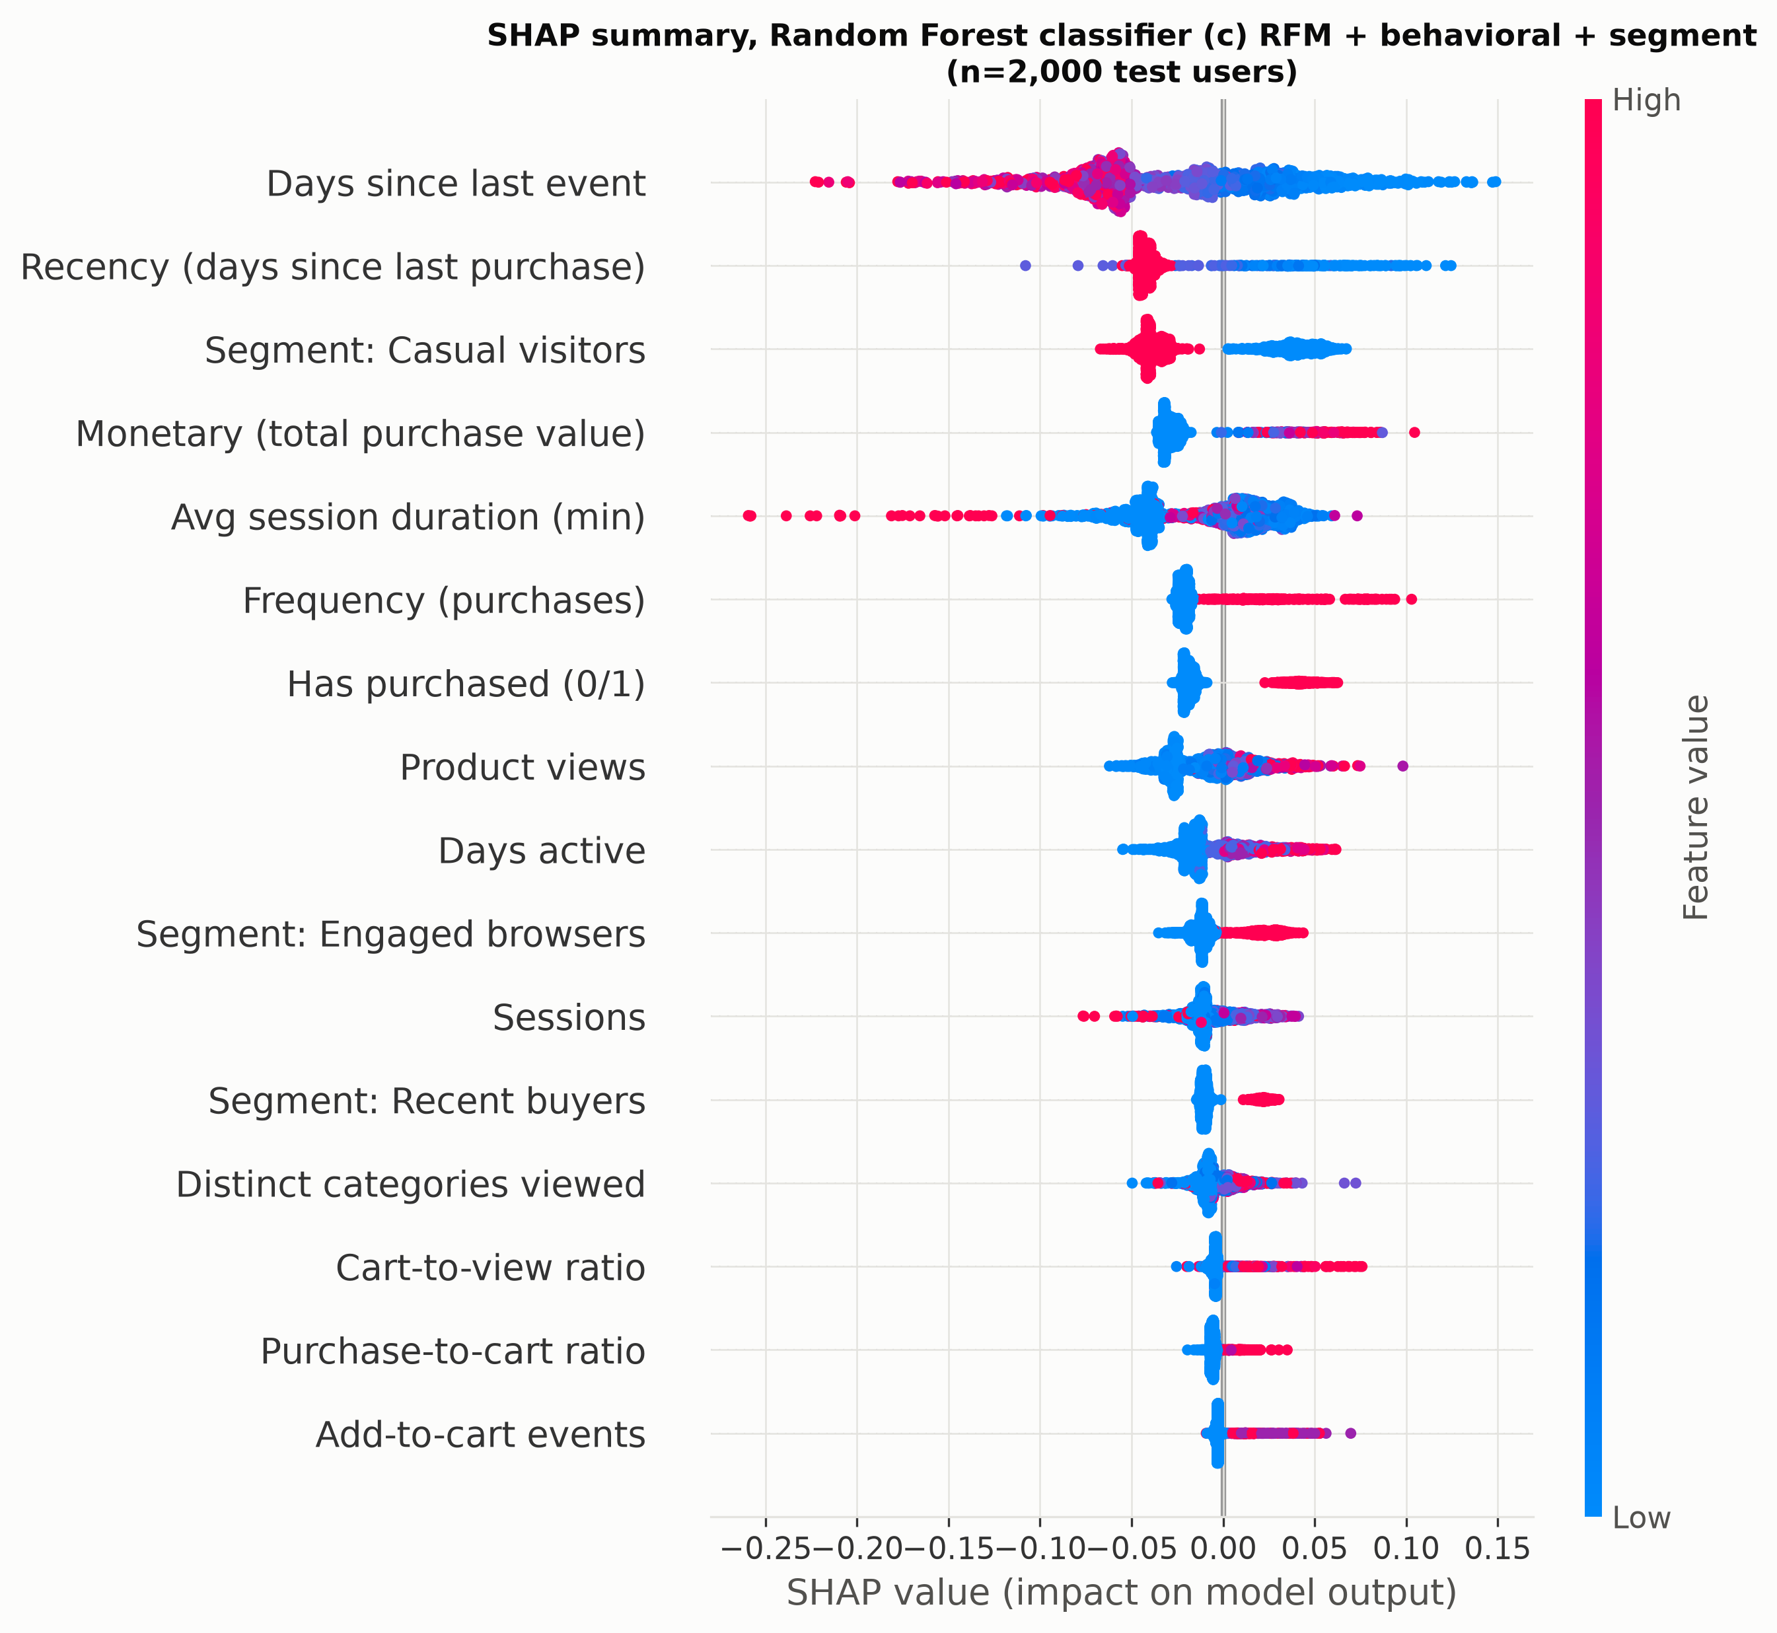
Figure 7. SHAP beeswarm for the Random Forest classifier ((c) RFM + behavioral + segment) on 2,000 random test users; colour = feature value.
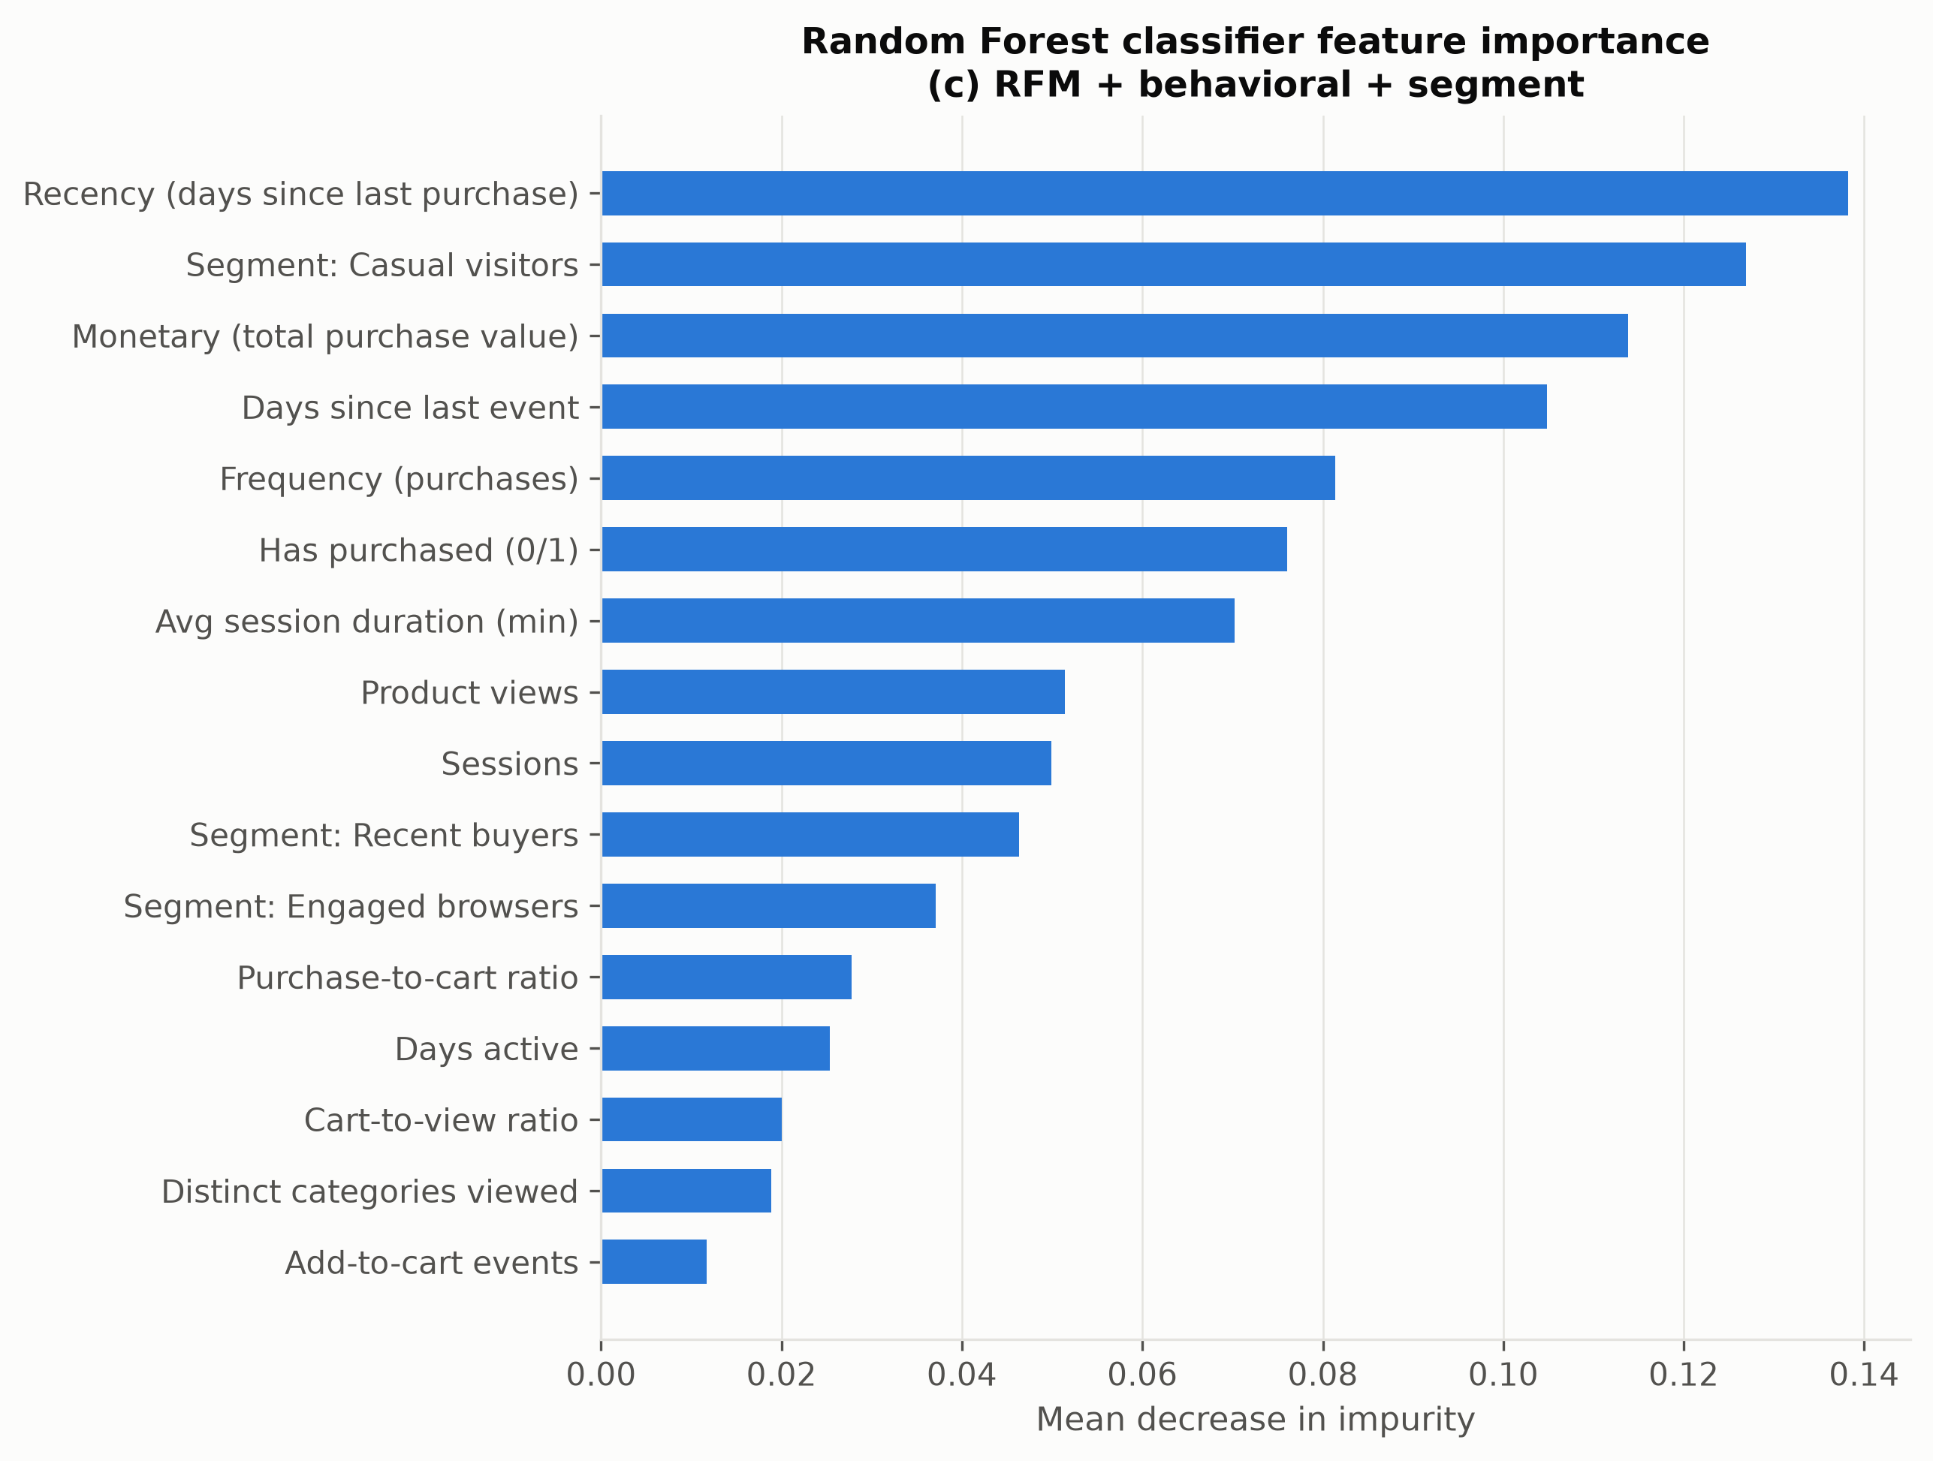
Figure 8. Impurity-based feature importance of the Random Forest classifier, (c) RFM + behavioral + segment.
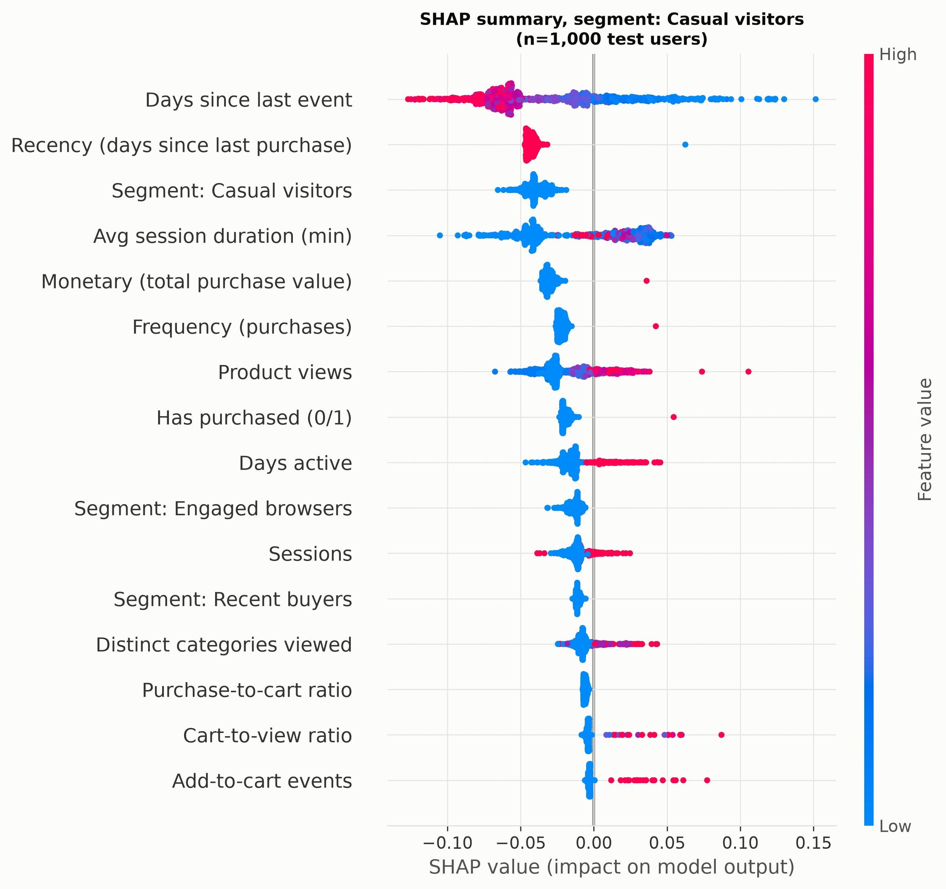
Figure 9. SHAP beeswarm for the same model on up to 1,000 test users in segment 'Casual visitors'.
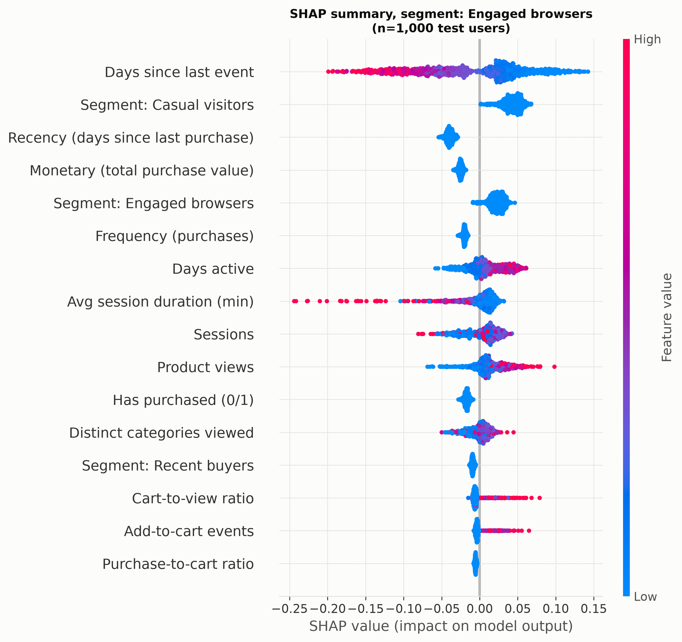
Figure 10. SHAP beeswarm for the same model on up to 1,000 test users in segment 'Engaged browsers'.
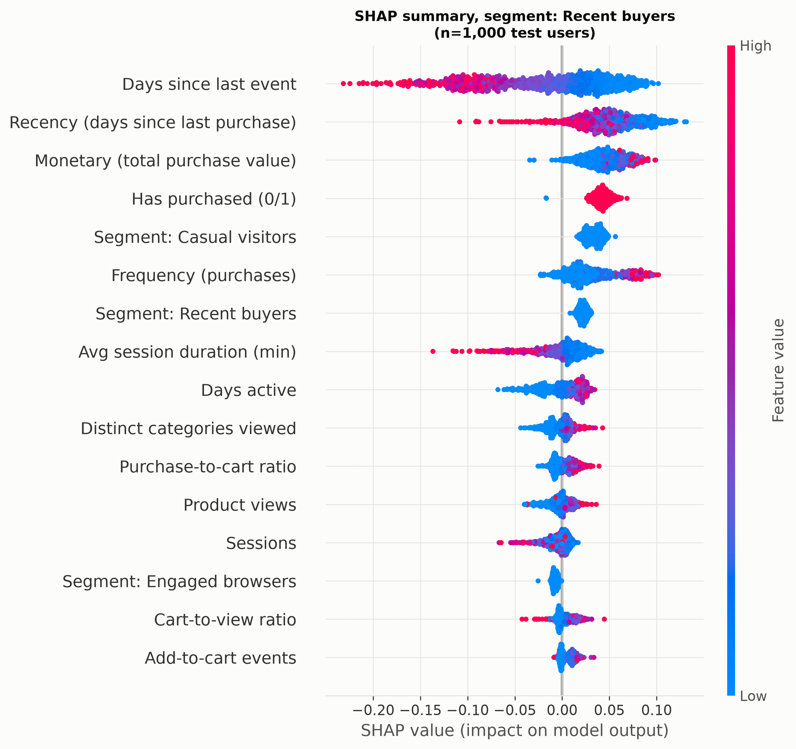
Figure 11. SHAP beeswarm for the same model on up to 1,000 test users in segment 'Recent buyers'.
[WRITE: Discussion of Table 6 and Figures 7–11, 250–350 words]

Discussion
[WRITE: Overall discussion, limitations and threats to validity, 300–500 words]

Conclusion
[WRITE: Conclusion, 250–400 words]
[WRITE: Future work, 100–150 words]

References
[ADD: 15–25 references in the required citation style]

