A PROJECT REPORT ON-

AI-BASED SAFETY DOCUMENT QUIZ PORTAL

CONDUCT AT

HINDUSTAN AERONAUTICS LIMITED, ENGINE DIVISION,KORAPUT ,ODISHA

GUIDED BY-

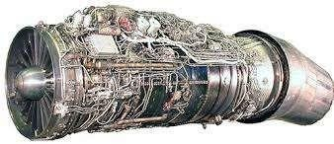

SHRI LAXMIKANT KHILLO, PB NO - 8171, SR.MANAGER(IT)

DEPT – 72-IT

SUBMITTED BY-

MR.SURYANSU MISHRA MS.ANKITA KUMARI PATNAIK MR.SATYAPREET HANTAL MS.SUSHREE S.M SUTAR

B.TECH IN COMPUTER SCIENCE AND ENGINEERING



##### ACKNOWLEDGEMENT

We take immense pleasure in thanking **Mr.Basanta Kumar Nayak , Sr.Manager**, **Training and Development Institute, HAL** for permitting me to carry out the internship at **Hindustan Aeronautics Limited, Engine Division, Koraput.**

We wish to express our deep sense of gratitude to our guide **SHRI LAXMIKANT KHILLO, SR.MANAGER(IT) for his able guidance and useful suggestions, which helped us in completing the project work in time.**

Words are inadequate in offering thanks to the project assistants and all the employees in Engine Division and Sukhoi Engine Division who helped us in understanding machine operations during the project work.

Finally, We are highly thankful to our family members and well wishers who supported us and bestowed their good wishes for the successful completion of this project.

## PREFACE



This report presents a detailed account of our technical project titled “AI-Based Safety Document Quiz Portal”, undertaken as part of our academic curriculum.

The primary objective of this project is to automate the process of quiz generation from safety documents using Artificial Intelligence. In many organizations and institutions, safety manuals and compliance documents are extensive and text- heavy, making it difficult to ensure that users have fully understood the material. Our solution addresses this challenge by enabling automatic quiz creation from PDF, DOCX, or text files, allowing for faster, smarter, and more effective training.

The project combines multiple technologies such as React.js for frontend development, Python (FastAPI) for backend APIs, and Natural Language Processing (NLP) for understanding and generating questions. A structured database and authentication system are integrated to manage both admin and user functionalities efficiently.

Conducted from 16-06-2025 to 12-07-2025, this project aims to solve a practical problem using modern web and AI tools. This report details every component of the system—from architecture, technology stack, and user interface, to database design and deployment strategy.

We hope this work will contribute to the ongoing efforts of making training systems smarter, more interactive, and automated.

## DECLARATION

We, hereby declare that the Internship/Vocational Training report titled “AI-BASED SAFETY QUIZ PORTAL” is the result of our training and learning experience at HAL Engine Division, Koraput. This report is a true and original work submitted towards the fulfillment of our vocational training requirements.

We further declare that the contents of this report are based on our observations and knowledge acquired during the training period, and have not been copied or submitted elsewhere.

Period of the Internship: 16 June to 12 July 2025 Duration of the Internship: 28 Days

Location: Hindustan Aeronautics Limited (HAL), Engine Division, Koraput

SURYANSU MISHRA NIST UNIVERSITY

(VT.NO.-25-435)

ANKITA KUMARI PATNAIK NIST UNIVERSITY

(VT.NO.-25-436)

SATYAPREET HANTAL

GIET

(VT.NO.-25-437)

SUSHREE S.M SUTAR

SOA

(VT.NO.-25-438)

SHRI LAXMIKANT KHILLO SR.MANAGER(IT)



PB NO-8171

MR. BASANTA KUMAR NAYAK SENIOR MANAGER TRAINING & DEVELOPMENT INSTITUTE

### CONTENTS

SL.NO SUBJECT

1. INTRODUCTION
2. HISTORY OF HAL
3. HAL KORAPUT DIVISION
4. Document Processing Engine (DPE)
   1. Introduction
   2. Working
5. AI-POWERED QUIZ GENERATOR
   1. Introduction
   2. Working Principle
   3. Basic Steps
6. KEY FUNCTIONAL COMPONENTS

i)

ii) iii)

Admin Panal Generation Logic

User Panel



1. WORKFLOW DIAGRAM
2. REFERENCES
3. CONCLUSION

INTRODUCTION

Hindustan AeronauticsLimited(HAL)cameinto existence on 1st October 1964. The company was formed by merger of Hindustan Aircraft Limited with Aeronautics India Limited and Aircraft Manufacturing Depot, Kanpur.

Today, HAL has 19 Production Units and 10 research and Design Centers in 8 locations in India. The company has an impressive productive track record 15 types of aircraft and helicopter manufactured with in-house R&D and 14 types produced under license. HAL has manufactured over 3658 aircraft or helicopters, 4178 engines and upgraded 272 aircraft and over9643 aircraft and 2799 engines. HAL has successful enormous R&D Programs developed for both defence and civil aviation sectors. HAL has made successfully success in its current project:

* Advanced Light Helicopter- Human system integration(ALHWSI)
* Tejas-Light Combat Aircraft(LCA)
* Intermediate Jet Trainer (IGIT)
* Light Combat Aircraft(LCH)
* Various military and civil upgrades

There are 5 main complexes of HAL for the design, manufacturing and overhauling of the f ighter aircrafts, engines and helicopters and its accessories:

* Bangalore Complex
* MIG Complex
* Accessories Complex
* Design Complex
* Helicopter Complex

HISTORY OF HINDUSTAN AERONATICS

LIMITED

Hindustan Aeronautics Limited (HAL) came into existence on 1st October 1964. The company was formed by the merger of Hindustan Aircraft Limited with Aeronautics India Limited and Aircraft Manufacturing Depot, Kanpur. The company traces its roots to the pioneering efforts of an industrialist with extraordinary vision, the late Seth WalchandHirachand, who set up Hindustration Aircraft Limited at Bangalore in association with the erstwhile princely State of Mysore in December 1940. The government of India became a shareholder in march 1941 and took over the management in 1942.

Today,HAL has 18 Production divisions and 9 Reaserch and Design Centres in 7 locations in india. The company has an impressive product track record_12 types of aircraft manufactured with in house R&D and 14 types produced under licence. HAL has manufactured 3550 aircraft (which includes 11 types designed indigenously) 3600 engines and

overhauled over 8150 aircraft and 27300 engines approximately.

HAL has made successfully success in its current project:

* Advanced Light Helicopter- Human system integration(ALHWSI)
* Tejas-Light Combat Aircraft(LCA)
* Intermediate Jet Trainer (IGIT)
* Light Combat Aircraft(LCH)
* Various military and civil upgrades

Dhruv was delivered to the Indian army, Navy, Air Force and the Coast Guard in March 2002, in the very first year of its production, a unique achievement.

HAL has played a significant role for India’s space programs by participating in the manufacture of structures for Satellite Launch Vehicles like

* PSLV (Polar Satellite Launch Vehicle)
* GSLV (Geo Stationary Launch Vehicle)
* IRS (Indian Remote Satellite)
* INSAT (Indian National Satellite)

There are about eight major joint venture companies established by HAL during the recent future. Apart from these, other major diversification projects are Industrial Marine Gas Turbine and Airport Services. Several co-production and joint

ventures with consideration.

international participation are under



HAL’s supplies or services are mainly to Indian Defence Services, Coast Guards and Border Security Forces etc. Transport Aircraft and helicopters have also been supplied to Airlines as well as State Governments of India. The company has also quality and price competitiveness.

HAL has won several International and National Awards for achievements in R&D, technology, Managerial Performance, Exports, Energy Conservation, Quality and fulfilment of Social Responsibilities.

* + HAL has been awarded the “INTERNATIONAL GOLD MEDAL” for Corporate Achievement in Quality and Efficiency at the International Summit (Global Rating Leaders 2003), London, UK by M/s Global Rating, UK in conjunction with the International Information and Marketing Centre (IIMC).
  + HAL was presented the International – “ARCH OF

EUROPE” Award in Gold Category in recognition for its commitment to Quality. Leadership, Technology and innovation.

* + At the National level, HAL won the “GOLD TROPHY” for excellence in Public Sector Management. Instituted by the Standing Conference of Public Enterprises (SCOPE).

HAL KORAPUT DIVISION

The year2014 is the mile stone for Koraput division because the division is celebrating its 50 years of aero engine manufacturing and overhauling. The government sanction for the first phase of construct of the aero engine factory Sunabeda (Koraput) was accorded March 1964 and the factory started manufacture of E11F2-Series III engines for fitment on Mig-21FL aircraft from 1969 onwards. The first engines of imported category manufactured in December 1968 and various categories of engines were produced during the subsequent years. The first raw materials engine was produced in February 1971.

To meet the Air Force requirement for improved fight interceptor aircraft, an agreement was signed with USSR in August 1976 for manufacturing MIG-21BIS Aircraft. The power plant of this aircraft is the R25 turbojet engine. The government approval for the setting up capital facilities. FIG R11 engine was capital facilities. FIG R11 engine was accorded in October 1977. The first engine of imported category

rdaewl ivered to HAL Nasik Division in the year 1978-79. The F1 material engine was delivered during January 1983.

# Introduction

*The "AI-Based Safety Document Quiz Portal" is a smart, web- based application designed to transform traditional safety manuals and training documents into interactive quizzes using Artificial Intelligence and Natural Language Processing (NLP). This portal aims to improve knowledge retention and ensure effective safety training across organizations and institutions by automating quiz generation from uploaded PDF, DOCX, or TXT files.*

# Working

*The project consists of two main user roles: Admin and User.*

* *The Admin uploads safety documents and configures the number of quiz questions to be generated.*
* *The AI module scans the document, extracts important content, and generates multiple types of questions.*
* *Once a quiz is generated, it can be saved and downloaded.*
* *The User, after logging in, receives a randomly assigned quiz set from the available pool. Each question is time- bound (30 seconds/question), and the final score is calculated and stored.*

# Document Processing Engine (DPE)

This is the core of the system responsible for:

* Reading the content from uploaded documents (PDF/DOCX/TXT)
* Running NLP models to identify concepts and generate questions
* Tagging question difficulty (easy, medium, hard)
* Mapping each quiz to a unique token ID

# AI-Powered Quiz Generator

#### Introduction -

The quiz generator uses AI to eliminate the manual effort of creating quizzes from dense safety manuals.

#### Working Principle -

* + Uses Natural Language Processing (NLP) models like transformer-based architectures to parse and understand text.
  + Applies question classification algorithms to determine the appropriate question types.
  + Uses distractor generation techniques to create incorrect but plausible options.

# Basic Steps

* + 1. Document Upload
    2. Text Extraction and Preprocessing
    3. Keyword and Sentence Analysis
    4. Question Type Prediction
    5. Option Generation (Correct and Distractors)
    6. Quiz Assembly with timer tags

# WORKFLOW DIAGRAM

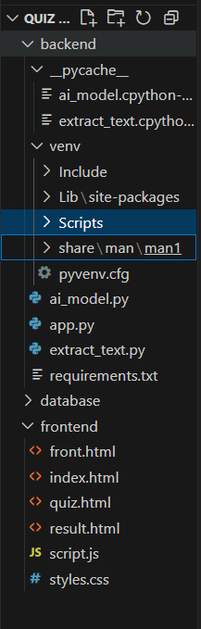

 ***Frontend Folder*** (/frontend/)

o index.html – Landing page where the user starts the quiz.

o quiz.html – Displays quiz questions with options and timer.

o result.html – Shows the quiz result, score, and performance summary.

o styles.css – Contains styling using Tailwind CSS or regular CSS to make the UI responsive and clean.

* ***Backend Folder*** (/backend/)

o app.py – Main Python file that runs the backend server (e.g., Flask or FastAPI).

o ai_model.py – Responsible for AI-powered question generation using NLP.

o extract_text.py – Extracts text from uploaded PDF, DOCX, or TXT files.

o requirements.txt – Lists all Python packages (e.g., Flask, transformers) required to run the backend

🗄 ***Database Folder*** (/database/)

o quiz.db – SQLite database file (used for local storage of users, quiz sets, results).

* + Firebase Config (optional) – Can be used as an alternative to SQLite if hosting on the cloud (e.g., Firestore).

#### These components work together to allow:

* Admins to upload documents.
* AI to extract and generate questions.
* Users to take quizzes with auto-timing and scoring.
* Storage of results for analysis.



***SIGNUP PAGE***



***LOGIN PAGE***

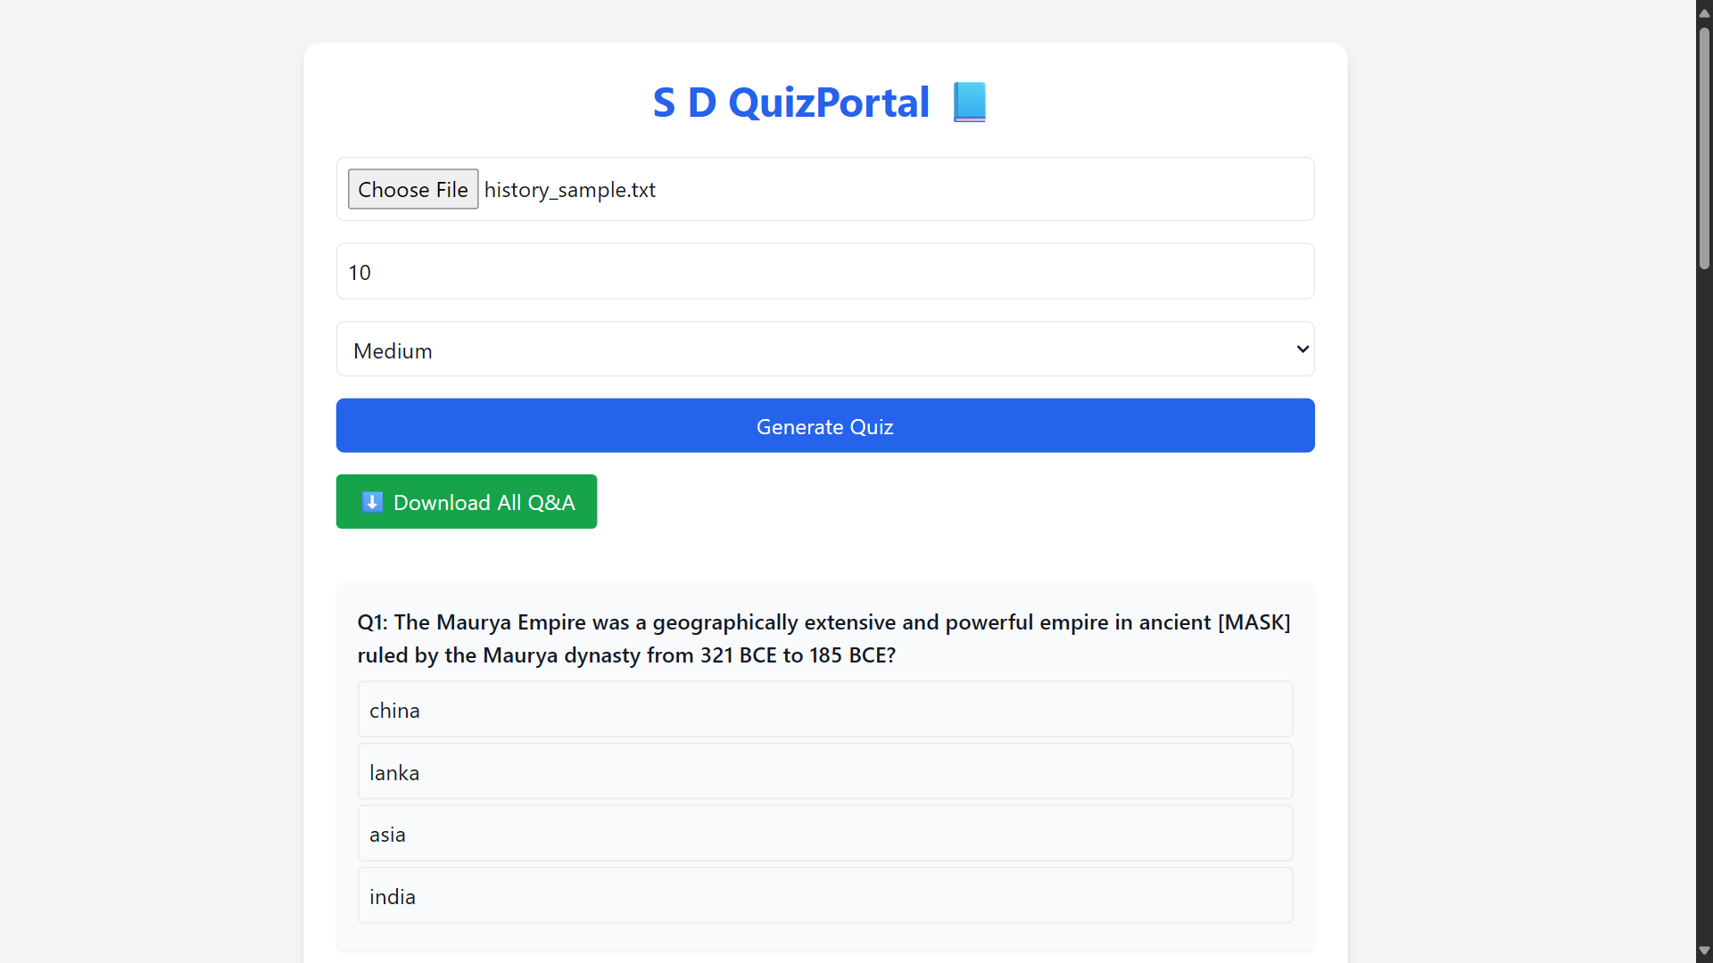

***QUIZ PORTAL PAGE***

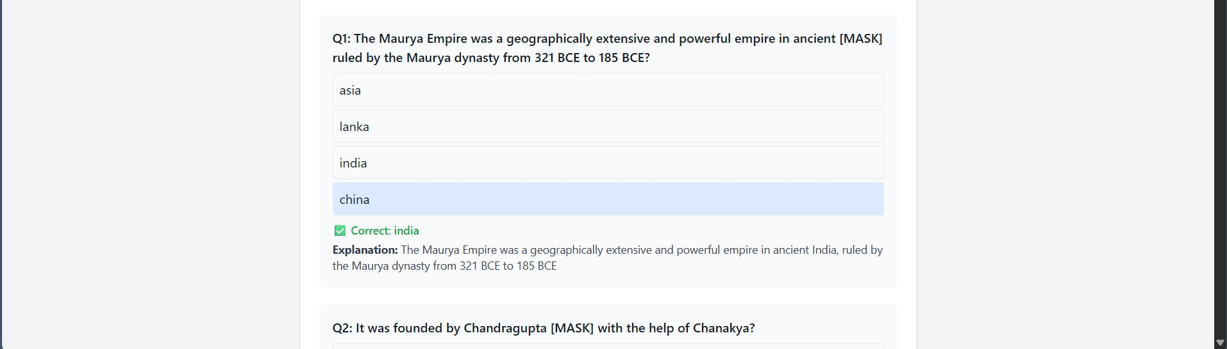

***Q & A***

##### FINAL RESULT

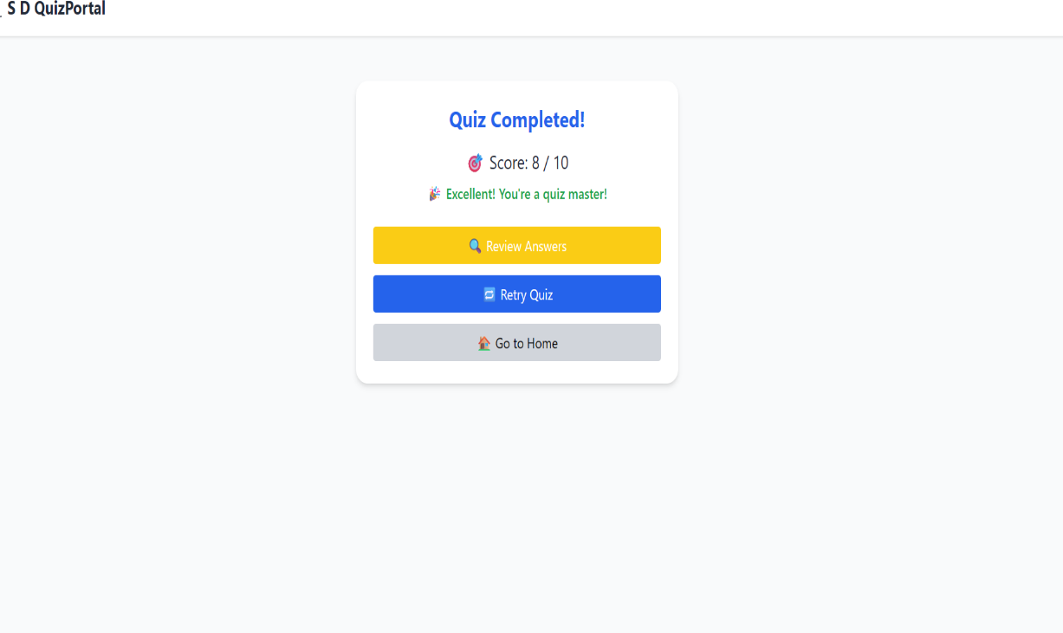

* Each quiz question is timed (30 seconds per question).
* Auto-submission occurs when time expires.
* Marks are awarded for correct answers; optional negative marking can be applied.
* Final score, correct/incorrect count, and percentage are shown after submission.
* Results are securely saved in the database with user ID and quiz token.
* Each user gets a different quiz set, ensuring fair evaluation.

Reference

This is to certify that Shri Laxmikant Khillo has successfully completed a community outreach project as part of his training under our supervision.

The project demonstrated his initiative, organizational skills, and commitment to social impact.

We commend his performance and wish him continued success in his professional journey.

# Conclusion

Our project was on the topic of “AI-Based Safety Document Quiz Portal” we got to know about many things about the process under the guidance of SHRI LAXMIKANT KHILLO Sir. We concluded that AI-Based Safety Document Quiz Portal simplifies and automates the process of safety training by turning bulky documents into quick, interactive, and intelligent assessments. With advanced AI techniques, time-based testing, random quiz allocation, and multiple difficulty levels, this project enhances compliance, engagement, and learning across industries and institutions.



### CERTIFICATE

This is to certify that **SURYANSU MISHRA** pursuing **BACHELOR OF TECHNOLOGY** in **COMPUTER SCIENCE Engineering** from **NIST BERHAMPUR** have successfully undergone **One Month Internship/ Vocational Training at, Hindustan Aeronautics Limited , Engine Division, Koraput** from **16nd June 2025 to 12st July 2025** of **VT.NO.-25- 435**

He has taken keen interest in understanding the core concepts of Artificial Intelligence and Software Development, and has successfully completed the project on ***“*AI-Based Safety Document Quiz Portal Using Automated Question Generation*”***, which demonstrates the practical application of AI in educational and safety training domains.

We found his sincere, hard work and his performance was very good during the training period. Their character and conduct were very good during the training period.

We wish him good luck in his future endeavour.

SHRI LAXMIKANT KHILLO, PB NO - 8171, SR.MANAGER(IT)

DEPT – 72-IT

MR. BASANTA KUMAR NAYAK

Sr.Manager

Training & Development Institute



### CERTIFICATE

This is to certify that **ANKITA KUMARI PATNAIK** pursuing **BACHELOR OF TECHNOLOGY** in **COMPUTER SCIENCE Engineering** from **NIST BERHAMPUR** have successfully undergone **One Month Internship/ Vocational Training at, Hindustan Aeronautics Limited , Engine Division, Koraput** from **16nd June 2025 to 12st July 2025** of **VT.NO.-25- 436**

She has taken keen interest in understanding the core concepts of Artificial Intelligence and Software Development, and has successfully completed the project on ***“*AI-Based Safety Document Quiz Portal Using Automated Question Generation*”***, which demonstrates the practical application of AI in educational and safety training domains.

We found her sincere, hard work and her performance was very good during the training period. Their character and conduct were very good during the training period.

We wish her good luck in his future endeavour.

SHRI LAXMIKANT KHILLO, PB NO - 8171, SR.MANAGER(IT)

DEPT – 72-IT

MR. BASANTA KUMAR NAYAK

Sr.Manager

Training & Development Institute

### CERTIFICATE

This is to certify that **SATYAPREET HANTAL** pursuing **BACHELOR OF TECHNOLOGY** in **COMPUTER SCIENCE Engineering** from **GIET,GUNUPUR** have successfully undergone **One Month Internship/ Vocational Training at, Hindustan Aeronautics Limited , Engine Division, Koraput** from **16nd June 2025 to 12st July 2025** of **VT.NO.-25- 437**

He has taken keen interest in understanding the core concepts of Artificial Intelligence and Software Development, and has successfully completed the project on ***“*AI-Based Safety Document Quiz Portal Using Automated Question Generation*”***, which demonstrates the practical application of AI in educational and safety training domains.

We found his sincere, hard work and his performance was very good during the training period. Their character and conduct were very good during the training period.

We wish him good luck in his future endeavour.

SHRI LAXMIKANT KHILLO, PB NO - 8171, SR.MANAGER(IT)



DEPT – 72-IT

MR. BASANTA KUMAR NAYAK

Sr.Manager

Training & Development Institute

### CERTIFICATE

This is to certify that **SUSHREE S.M SUTAR** pursuing **BACHELOR OF TECHNOLOGY** in **COMPUTER SCIENCE Engineering** from **SOA BHUBANESWAR** have successfully undergone **One Month Internship/ Vocational Training at, Hindustan Aeronautics Limited , Engine Division, Koraput** from **16nd June 2025 to 12st July 2025** of **VT.NO.-25- 438**

She has taken keen interest in understanding the core concepts of Artificial Intelligence and Software Development, and has successfully completed the project on ***“*AI-Based Safety Document Quiz Portal Using Automated Question Generation*”***, which demonstrates the practical application of AI in educational and safety training domains.

We found her sincere, hard work and her performance was very good during the training period. Their character and conduct were very good during the training period.

We wish her good luck in his future endeavour.

SHRI LAXMIKANT KHILLO, PB NO - 8171, SR.MANAGER(IT)



DEPT – 72-IT

MR. BASANTA KUMAR NAYAK

Sr.Manager

Training & Development Institute