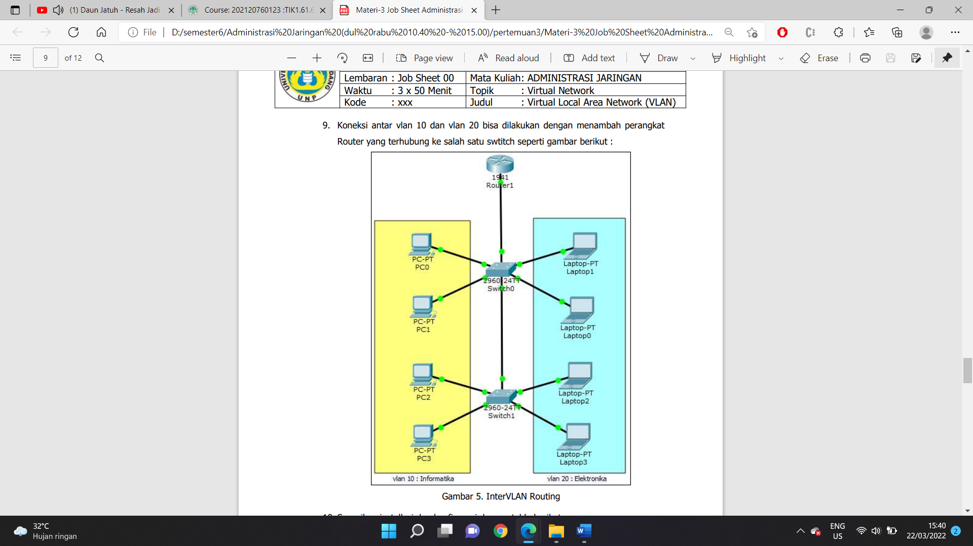

SW1#conf t

SW1(config)#int f0/11

SW1(config-if)#switchport mode trunk

SW1(config-if)#

Router>enable

Router#conf t

Router(config)#int g0/1

Router(config-if)#no shut

Router(config-if)#

Router(config-if)#int g0/1.10

Router(config-subif)#

Router(config-subif)#encapsulation dot1q 10

Router(config-subif)#ip addr 192.168.10.254 255.255.255.0

Router(config-subif)#exit

Router(config)#int g0/1.20

Router(config-subif)#

Router(config-subif)#encapsulation dot1q 20

Router(config-subif)#ip addr 192.168.20.254 255.255.255.0

Router(config-subif)#

PC>ping 192.168.10.254

Pinging 192.168.10.254 with 32 bytes of data:

Reply from 192.168.10.254: bytes=32 time=1ms TTL=255

Reply from 192.168.10.254: bytes=32 time=11ms TTL=255

Reply from 192.168.10.254: bytes=32 time=0ms TTL=255

Reply from 192.168.10.254: bytes=32 time=0ms TTL=255

PC>ping 192.168.20.254

Pinging 192.168.20.254 with 32 bytes of data:

Reply from 192.168.20.254: bytes=32 time=0ms TTL=255

Reply from 192.168.20.254: bytes=32 time=0ms TTL=255

Reply from 192.168.20.254: bytes=32 time=0ms TTL=255

Reply from 192.168.20.254: bytes=32 time=1ms TTL=255

PC>ping 192.168.20.1

Pinging 192.168.20.1 with 32 bytes of data:

Reply from 192.168.20.1: bytes=32 time=1ms TTL=127

Reply from 192.168.20.1: bytes=32 time=0ms TTL=127

Reply from 192.168.20.1: bytes=32 time=0ms TTL=127

Reply from 192.168.20.1: bytes=32 time=1ms TTL=127