



## ABSTRACT

### Chatbot is used to conversation with users , when we give what ever the question it will instantly replay the answer.

* And it is helping to purchasing product, current updates and etc....

### We want to create a Chatbot by using the Watson assistant

* Chatbot to assist users on popular messaging platforms like Facebook Messenger and Slack

### Let’s we see about how to create chatbot using

Watson under the slides



## PROBLEM DEFINITION

### The project involves creating a chatbot using IBM Cloud Watson Assistant. The goal is to develop a virtual guide that assists users on messaging platforms like Facebook Messenger and Slack. The chatbot should provide helpful information, answer frequently asked questions (FAQs), and offer a friendly conversational experience. The project includes designing the chatbot's persona, configuring responses, integrating with messaging platforms, and ensuring a seamless user experience.



DESIGN THINKING .



PERSONA DESIGN:

* Persona Design:
* Name “Sonychat”," embodies a persona that tone ,voice and personality of your virtual assistant associated with IBM's Watson technology with a friendly to the user.
* Tone :
* SonyChat tone like friendly, professional, witty based on our brand values and target audience.
* Style:
* Its style of voice and language are unique, clarity and a commitment to providing accurate information.

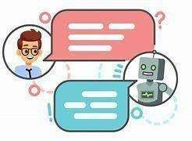

## USER SCENARIOS

* + A chatbot powered by Watson can be designed to address a wide range of user scenarios and frequently asked questions (FAQs) across various domains.
  + It use machine learning technology and natural language pocessing to identify common user scenarios and FAQs that the chatbot should be able to

address

* + It is used to resolve what ever the problem ,error or any questions it give accurate answer

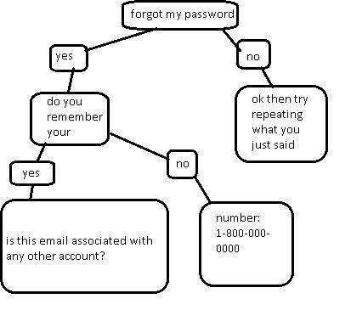

## CONVERSATION FLOW

* + - Conversation flow: a chatbot powered by Watson involves creating a structure of our chatbot conversational flow.
    - Start with a greeting message, ask a question, provide multiple choices for answers, and mockup what your chatbot will say in response to each answer.
    - Chatbot able to handle various type of question format like program,text,image,etc...

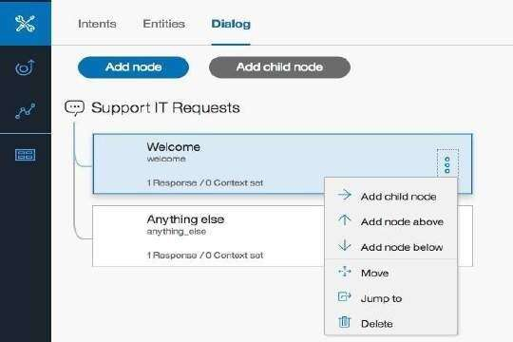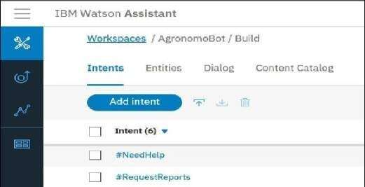

* + - Five steps for creating conversational flow:Greetings, Asking, Suggestions, Failure and End

RESPONSIBLE CONFIGURATION

* chatbot using Watson Assistant it involves intents,entities and dialog nodes

### **Intents:**An intent represents the purpose of a user's input. You define an intent for each type of user request you want your application to support.

* **Entity**: An entity represents a term or object that is relevant to your

intents and that provides a specific context for an intent. You list the possible values for each entity and synonyms that users might enter.



* **Dialog**: A dialog is a branching conversation flow that defines responses to the defined intents and entities. You use the dialog builder in the tool to create conversations with users to provide responses

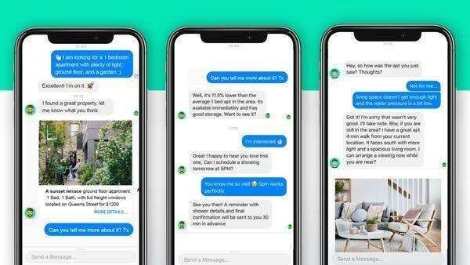

# PLATFORM INTEGRATION

* + We use the Watson assistant to develop chatbot to Integrate with the popular messaging platforms
  + Now a days more of the messanger platforms are integrated with chatbot
  + If we integrate messanger platforms with it's for customer support, information queries, or any other purpose, users can access the chatbot effortlessly.
  + Using Watson assistant to develop a chatbot is integrate with the facebook messanger and slack.



* Chatbots are integrated with various social platforms and application. Some of the platforms that chatbots can be integrated with include:Websites
* Facebook messanger,Slack

#### Slack:

Slack is a popular communication and collaboration platform used in various professional settings.

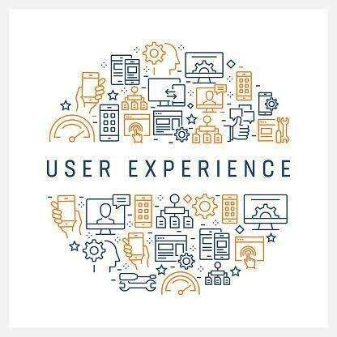

# USER EXPERIENCE

### User Experience: A

seamless user

experience refers to a smooth, intuitive, and frictionless journey that users have while interacting with a digital product. It involves delivering an experience that is easy to navigate, visually appealing, and efficient in fulfilling user needs

* + setting a welcoming tone for the interaction. Clear and concise prompts should

NATURAL LANUGAGE

UNDERSTANDING (NLU)

* Natural language understanding (NLU) is a field of computer science that deals with the interaction between computers and human

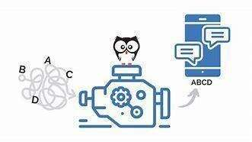

(natural) languages. It is a subfield of artificial intelligence that deals with the ability of computers to understand and process human language, including speech and

text.

* + NLU can be used to improve the accuracy of user intent recognition in a number of ways. ● Natural Language

Understanding (NLU) is crucial for improving user intent recognition in various applications, including chatbots, virtual assistants, and customer support systems.

* Identify the key entities in a user's utterance (e.g., the name of a product or service, the location of a store, etc.)
* Understand the relationships between the different entities in a user's utterance
* Identify the sentiment of a user's utterance (e.g., whether they are happy, angry, frustrated, etc.)
* Disambiguate between different possible
* interpretations of a user's utterance By using NLU to better understand the meaning of user
* utterances, conversational AI systems can more accurately identify the user's intent and respond in a way that is more relevant and helpful.

Here are some specific examples of how NLU can be used to improve the accuracy of user intent recognition in conversational AI systems:

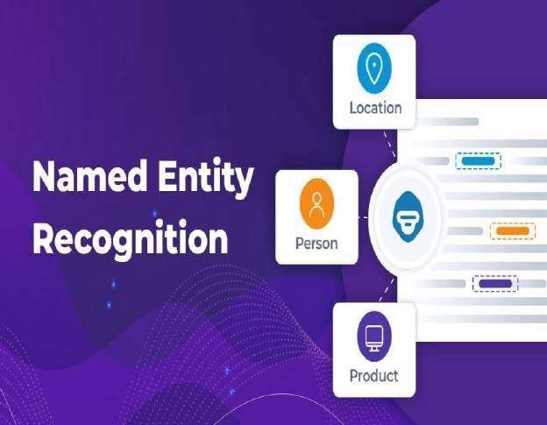

**FEATURES**

* **Identifying key entities:** NLU can be used to identify the key entities in a user's utterance, such as the name of a product or service, the location of a store,

or the date and time of an appointment. This information

can then be used to better understand the user's intent and respond in a more relevant way. For example, if a user says "I'm looking for a restaurant in San Francisco that serves Italian food," the NLU system can identify the key entities "restaurant," "San Francisco," and "Italian

food." This information can then be used to provide the user with a list of Italian restaurants in San Francisco.

#### Understanding relationships between entities:

NLU can also be used to understand the relationships

between the different entities in a user's utterance. For example, if a user says "I'm flying from New York to London on June 10th," the NLU system can understand that the "New

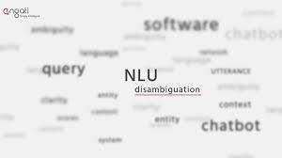

York" and "London" are the origin and destination of the flight, and that the "June 10th" is the date of the flight. This information can then be used to provide the user with

information about the

●

flight, such as the flight number, departure and arrival

times, and gate number.

|  |  |  |  |
| --- | --- | --- | --- |
| * **Disambiguating** | **between** | **different** | **possible** |
| **interpretations:** | NLU can | also be | used to |

disambiguate between different possible interpretations of a user's utterance. For example, if a user says "I'm looking for a bank," the NLU system could understand

that they could be referring to a financial institution or to the side of a river. The system could then ask the user to clarify what they mean, or it could provide information about both types of banks. By using NLU to better understand the meaning of user utterances, conversational AI systems can more accurately identify the user's intent and respond in a way that is more relevant and helpful.

#### Data Collection and Annotation

Gather a diverse and representative dataset of user queries and corresponding intents.

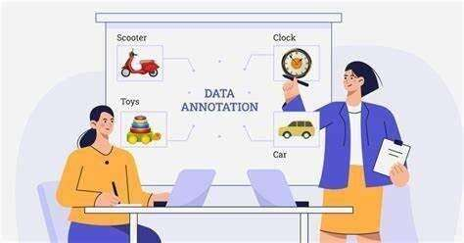

Annotate the data with intent labels and, if needed, entity information (such as dates, locations, or product names). ● **Text Preprocessing:**

Tokenize user input into words or subword tokens.

Remove stop words, punctuation, and other noise from the text.

Normalize text by converting it to lowercase or applying stemming/lemmatization.

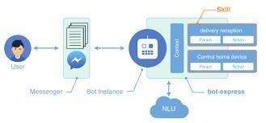

* **Model Training**: The annotated dataset is then used to train an NLU model. There are several machine learning algorithms that can be

used for this purpose, including logistic regression, decision trees, and neural networks.

* + **Model Evaluation**: The trained model needs to be evaluated on a separate test dataset to ensure that it is generalizing well to new data.
* **Model Tuning**: If the model is not performing well, it may need to be finetuned by adjusting hyperparameters or using more advanced techniques such as transfer learning.

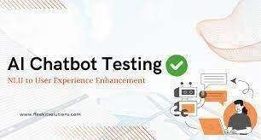

* **Deployment**: Once the model is trained and evaluated, it can be deployed in a production environment where it can be used to recognize user

intents in realtime.

* + **User Testing**: In addition to automated testing, real user testing and feedback are essential. Conducting usability tests and collecting user feedback can reveal issues that may not be

apparent through automated evaluation alone.



**CHATBOT PERSONA & CONVERSATION FLOW**

**NAME : SONY**

Our chat bot name is sony and every one can easliy to remember and they can easily know the name

**Tone and Style:**

The chatbot's tone can be friendly and the language should be commom every one can be understandable

**Emotions:** chatbots are designed to express emotions like happiness, frustration, or

empathy.

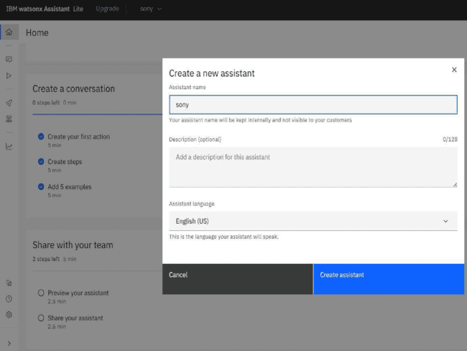

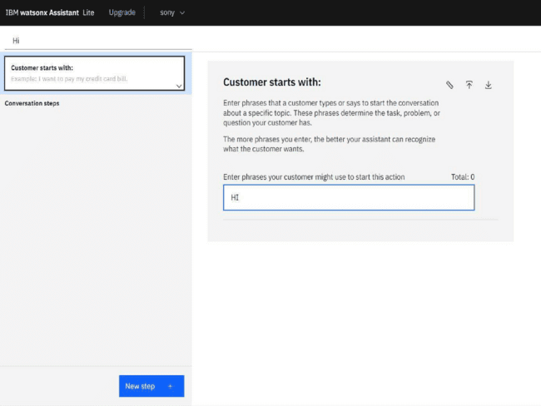

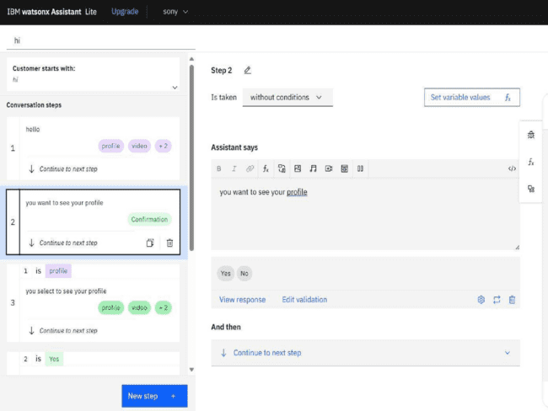

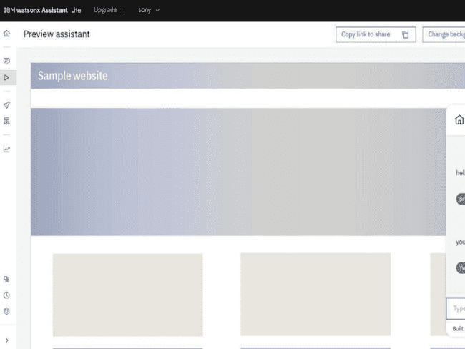

## INTENTS, ENTITIES, AND DIALOG

NODES IN WATSON ASSISTENT



To configure intents, entities, and dialog nodes in Watson Assistant to handle user queries, follow these steps:

**Create intents:**

Intents represent the goals or actions that users want to

achieve with your assistant. For each intent, provide at least five examples of utterances that users might say to express that intent.

**Create entities:**

Entities are specific pieces of information that are relevant to

your assistant's domain. For each entity, define a name and a type. You can also provide a list of values for the entity.



**Create dialog nodes**

Dialog nodes represent the different paths that a conversation can take. Each

dialog node has a condition and a response. The condition specifies what must be present in the user input for the node to be triggered. The response is the utterance that your assistant uses to respond to the user.

To create a dialog node that handles a user query, follow these steps:

1. Create a new dialog node.
2. Enter a name for the node.
3. In the **Condition** field, specify the intent and any entities that must be present in the user input for the node to be triggered.





Enter a response for the node. You can use text, images, and other multimedia elements in your response.

Click **Create**.

You can also use dialog nodes to collect information from the user, ask follow-up questions, and branch the conversation based on the user's input.



INTEGRATE CHATBOT WITH FACEBOOK

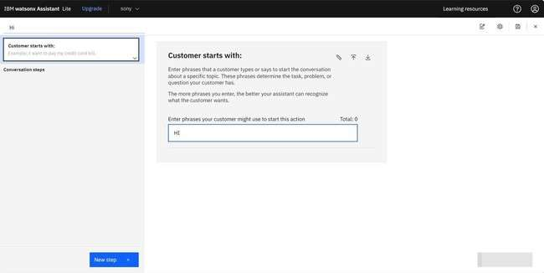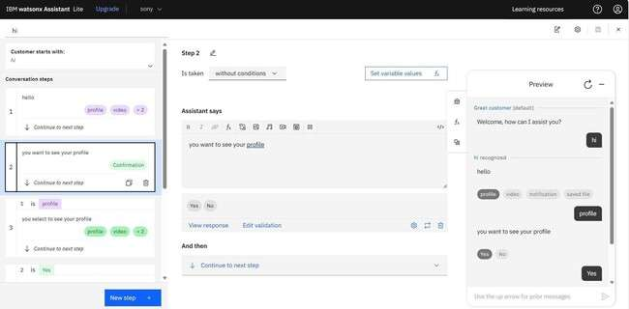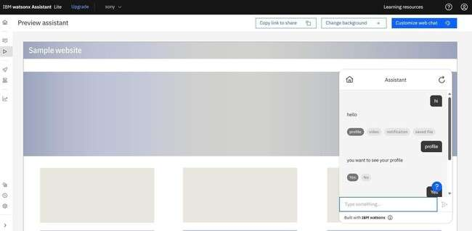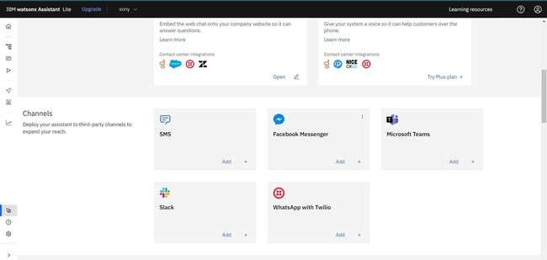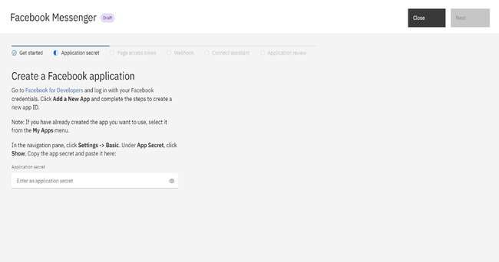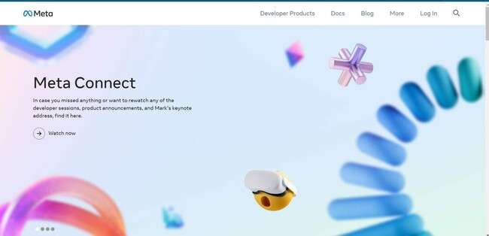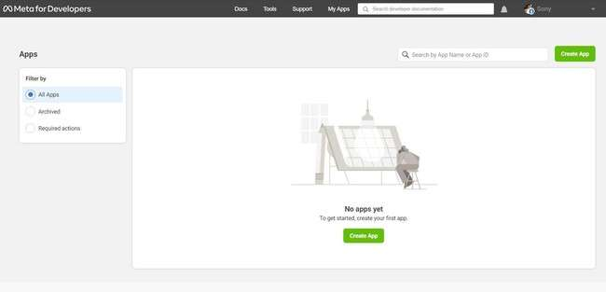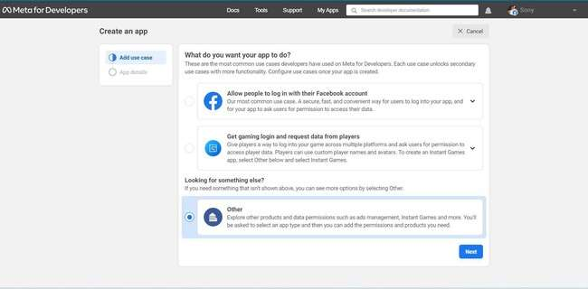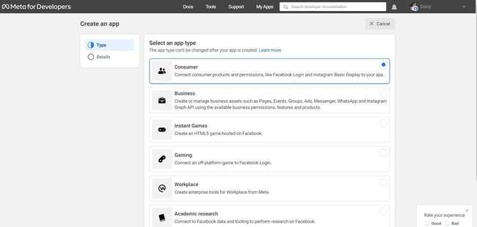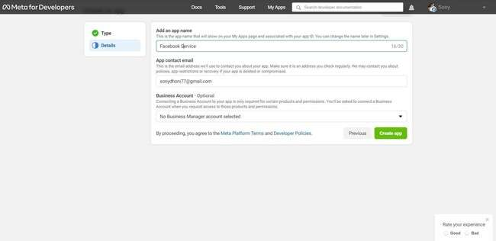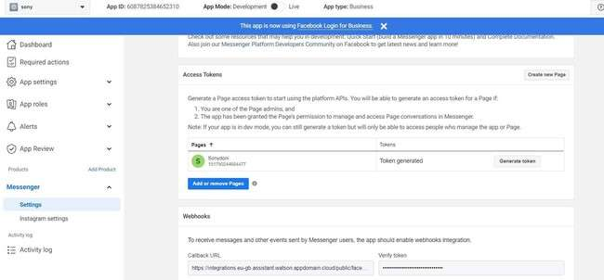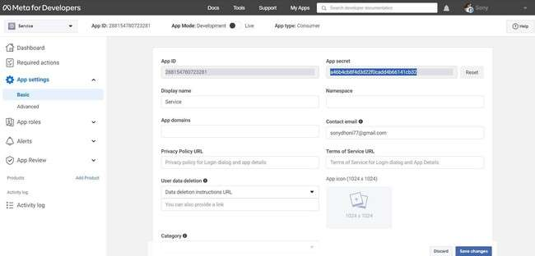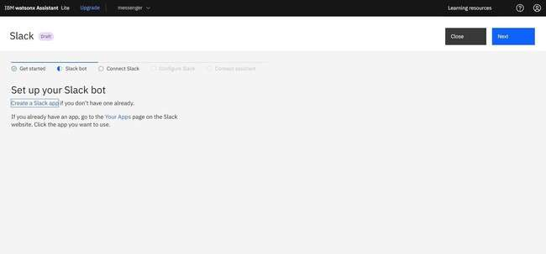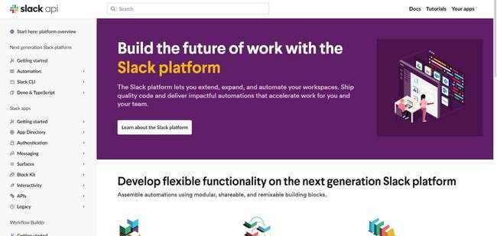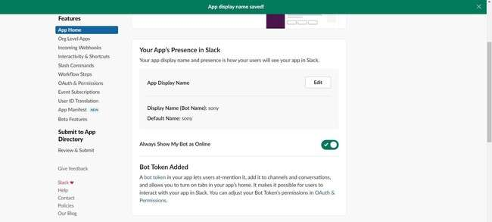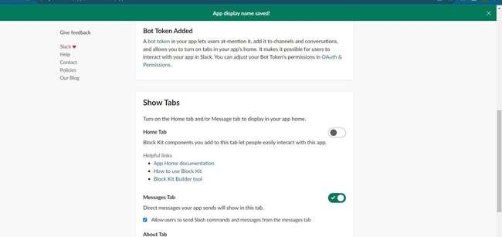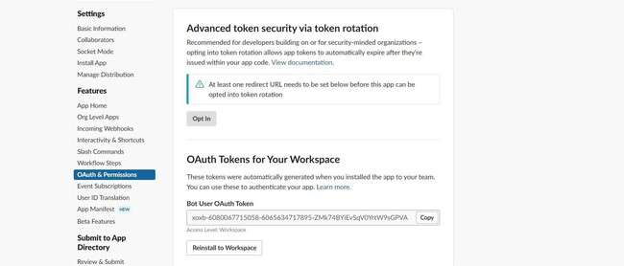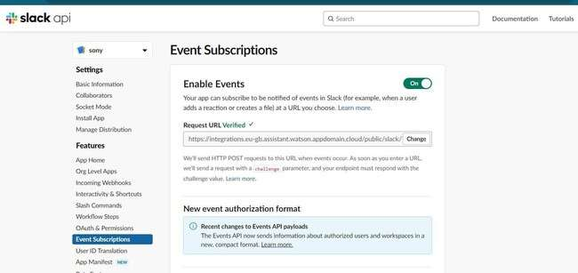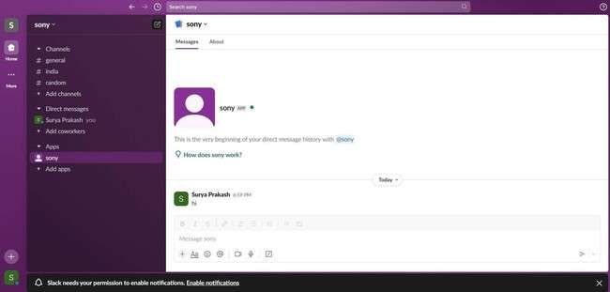

THANK YOU

