20MSS46 - MICROPROCESSORS AND MICROCONTROLLERS LABORATORY
Advanced Hybrid File Compression and Integrity Verification System
Using 8086 Microprocessor Core
Abstract
This project implements an Advanced Hybrid File Compression and Integrity Verification System based on the 8086 microprocessor architecture integrated with a web-based interface. The system demonstrates the use of low-level assembly programming along with high-level software processing to perform efficient file compression and decompression.
The primary compression logic for text and structured data files is implemented using 8086 assembly language in the EMU8086 emulator, utilizing Run-Length Encoding (RLE) and pattern-based encoding techniques. File operations such as open, read, write, and close are performed using DOS Interrupt 21H services (3Dh, 3Fh, 40h, and 3Eh), demonstrating interrupt-driven file handling and register-level data manipulation in the microprocessor environment.
The system also incorporates Python-based processing modules that handle additional file processing tasks and support compression or decompression for other supported file types. A web-based interface developed using HTML, CSS, and Bootstrap allows users to upload files, perform compression or decompression operations, and download the resulting output files.
Compressed files generated by the 8086 engine are stored in a custom Hybrid File Compression (.HFC) format, while the decompression process reconstructs the original data by reversing the applied compression logic. An integrity verification step compares the original and decompressed files to ensure accurate data recovery.
The system demonstrates how microprocessor-level compression algorithms can be integrated with high-level software processing and web technologies to build a hybrid file compression platform.

System Modules
i) User Interface Module (Web Frontend)
Description
Provides a web-based interface that allows users to upload files and perform compression or decompression operations.

Responsibilities
• File upload and selection
• Compression and decompression operation control
• Display of compression results
• Download of processed files

Tools Used
• HTML
• CSS
• Bootstrap
• JavaScript

ii) Backend Controller Module (Execution Bridge)
Description
The Backend Controller Module manages communication between the web interface and the compression engines. It receives files from the user interface, determines the file type, and invokes the appropriate compression or decompression logic.

Responsibilities
• Receive uploaded files from the web interface
• Detect file type and select the processing method
• Execute the 8086 compression program for supported files
• Execute Python-based compression or decompression modules when required
• Return processed files for download

Tools Used
• Python
• Flask
• subprocess module
• os module

iii) 8086 Compression Engine Module (Core Processing Unit)
Description
This module implements the core compression and decompression algorithms using 8086 assembly language in the EMU8086 emulator. It processes text and structured data files using RLE and pattern encoding techniques.
Responsibilities
• File open using INT 21H – 3Dh
• File read using INT 21H – 3Fh
• File write using INT 21H – 40h
• File close using INT 21H – 3Eh
• Run-Length Encoding compression
• Pattern detection and encoding
• Generation of compressed .HFC files
• Decompression to restore original data
Tools Used
• EMU8086 Emulator
• 8086 Assembly Language

iv) Python Compression and Processing Module
Description
This module handles additional compression or decompression operations using Python, especially for file types that are not processed by the 8086 compression engine.

Responsibilities
• File type analysis and preprocessing
• Compression or decompression of supported file types
• Integration with the backend controller
• Output file generation and transfer

Tools Used
• Python
• Standard file I/O libraries

v) Integrity Verification Module
Description
Ensures that the decompressed file matches the original input file to maintain lossless compression.
Responsibilities
• Compare original and decompressed files
• Detect mismatched data
• Confirm successful data recovery
Tools Used
• Python file comparison logic

Workflow diagram:
Layered System Architecture
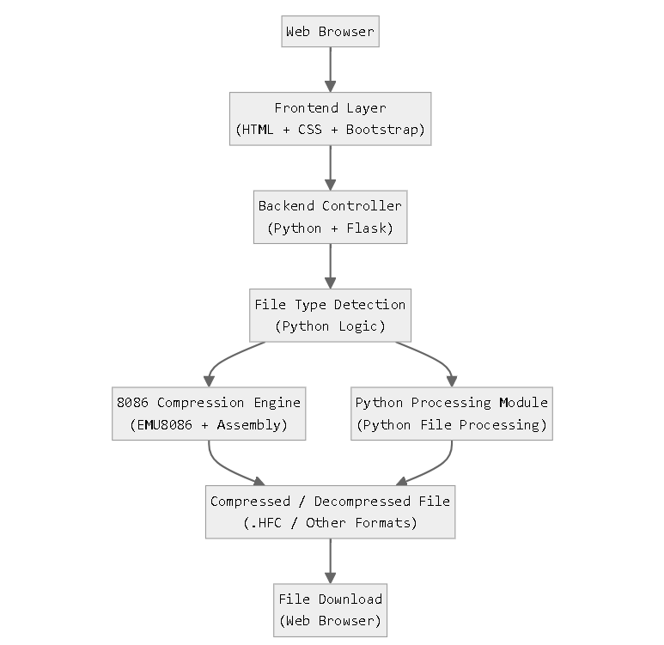

Functional Logic Flow :
