Netflix Originals Data Analysis: Exploring Trends and Insights

Objective:
The objective of this project is to analyze the Netflix Originals dataset using MySQL queries to extract meaningful insights and trends. By performing various SQL operations such as GROUP BY, HAVING, ORDER BY, LIMIT, JOINS, WINDOW FUNCTIONS, and SUBQUERIES, participants will gain hands-on experience in data analysis and be better prepared for data analyst job roles.

Datasets Description:
- Netflix Originals: This dataset contains information about Netflix Originals including title, genre ID, runtime, IMDb score, language, premiere date, etc.
- Genre Details: This dataset contains information about genres such as genre ID and genre name.

Analyses to make:
- What are the average IMDb scores for each genre of Netflix Originals?
SELECT
gd.genre_name,
ROUND (AVG (no.imdb_score), 2) AS average_imdb_score
FROM netflix_originals AS no
INNER JOIN genre_details AS gd
ON no.genre_id = gd.genre_id
GROUP BY gd.genre_name
ORDER BY average_imdb_score DESC;
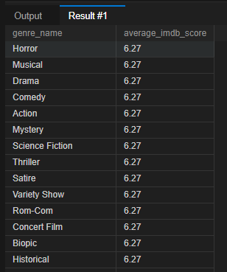
- Which genres have an average IMDb score higher than 7.5?

SELECT
gd.genre_name,
ROUND (AVG (no.imdb_score), 2) AS average_imdb_score
FROM netflix_originals AS no
INNER JOIN genre_details AS gd
ON no.genre_id = gd.genre_id
GROUP BY gd.genre_name
HAVING AVG (no.imdb_score) > 7.5
ORDER BY average_imdb_score DESC;
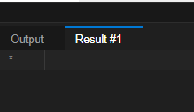

- List Netflix Original titles in descending order of their IMDb scores.

SELECT
title,
imdb_score
FROM netflix_originals
ORDER BY imdb_score DESC;
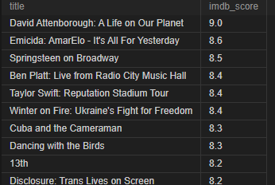

- Retrieve the top 10 longest Netflix Originals by runtime.

SELECT
title,
runtime
FROM netflix_originals
ORDER BY runtime DESC
LIMIT 10;
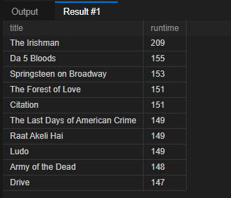

- Retrieve the titles of Netflix Originals along with their respective genres.

SELECT
no.title,
gd.genre_name
FROM netflix_originals AS no
INNER JOIN genre_details AS gd
ON no.genre_id = gd.genre_id
ORDER BY gd.genre_name, no.title;
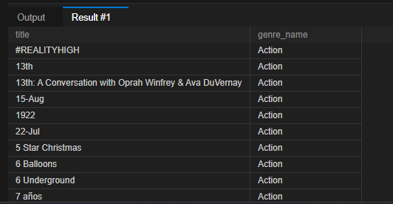

- Rank Netflix Originals based on their IMDb scores within each genre

SELECT
gd.genre_name,
no.title,
no.imdb_score,
RANK() OVER (
PARTITION BY no.genre_id
ORDER BY no.imdb_score DESC
) AS imdb_rank
FROM netflix_originals AS no
INNER JOIN genre_details AS gd
ON no.genre_id = gd.genre_id
ORDER BY gd.genre_name, imdb_rank;
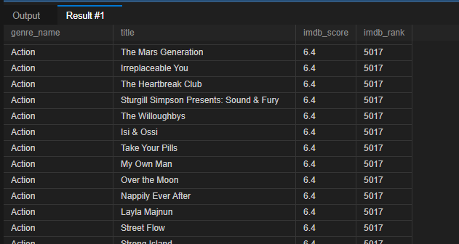

- Which Netflix Originals have IMDb scores higher than the average IMDb score of all titles?

SELECT
title,
imdb_score
FROM netflix_originals
WHERE imdb_score > (
SELECT AVG(imdb_score)
FROM netflix_originals
)
ORDER BY imdb_score DESC;
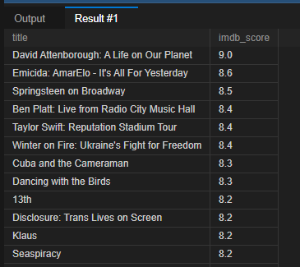
- How many Netflix Originals are there in each genre?

SELECT
gd.genre_name,
COUNT(no.title) AS total_netflix_originals
FROM netflix_originals AS no
INNER JOIN genre_details AS gd
ON no.genre_id = gd.genre_id
GROUP BY gd.genre_name
ORDER BY total_netflix_originals DESC;
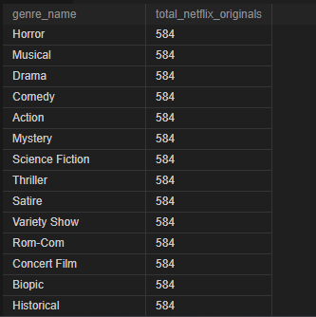

- Which genres have more than 5 Netflix Originals with an IMDb score higher than 8?

SELECT
gd.genre_name,
COUNT(no.title) AS titles_above_8
FROM netflix_originals AS no
INNER JOIN genre_details AS gd
ON no.genre_id = gd.genre_id
WHERE no.imdb_score > 8
GROUP BY gd.genre_name
HAVING COUNT(no.title) > 5
ORDER BY titles_above_8 DESC;
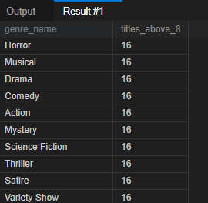

- What are the top 3 genres with the highest average IMDb scores, and how many Netflix Originals do they have?

SELECT
gd.genre_name,
ROUND(AVG(no.imdb_score), 2) AS average_imdb_score,
COUNT(no.title) AS total_netflix_originals
FROM netflix_originals AS no
INNER JOIN genre_details AS gd
ON no.genre_id = gd.genre_id
GROUP BY gd.genre_name
ORDER BY average_imdb_score DESC
LIMIT 3;
