LUMINARA
Phase 2 Game Design: Final Submission
Funobotz 3D Hackathon · Discovery World
Theme #2: Adventure Quest World · Category #4: Engineering Puzzle Game
Team Nandha - ML
17 September 2026

Build baseline: Unity 6000.6.0f1 · AR Foundation 6.6.2 · ARCore XR Plugin 6.6.2 · URP 17.6 · Android ARM64 (IL2CPP)

Game Concept
Aethyra's light has failed. The player wakes Petalo, a light-signaling diagnostic drone, and restores the world's broken structures by placing and turning physical cards on a real table. Petalo answers with a GPU-simulated swarm that shows where light can flow. The journey crosses the Grand Gateway and the Rainbow Bridge and ends in the pitch-black Mystery Cave, where the player must route the swarm into the Lumenforge to ignite it.

Core Gameplay Loop
Scan → Discover the dormant node → Place card → Rotate to align → Read swarm feedback → Adjust → Ignite → Unlock next zone

How to read the evidence
The Funobotz sample asks for real live screenshots. Each snap below states its source. Snaps 4 and 6 come from the Unity project; Snaps 1 and 8 are generated from project data; Snaps 2, 3, 5, 7 and 9 are design mockups of states that are not built yet and will be replaced by live captures as those states are built.
Status | Meaning
Implemented | In the Unity project and running in the Editor under XR Simulation.
Pending verification | Built, but not yet measured on an Android ARM64 device.
Planned | Designed in this document; not yet built.

1. 3D Level / World Map
Required evidence: start point, challenge area and progression.
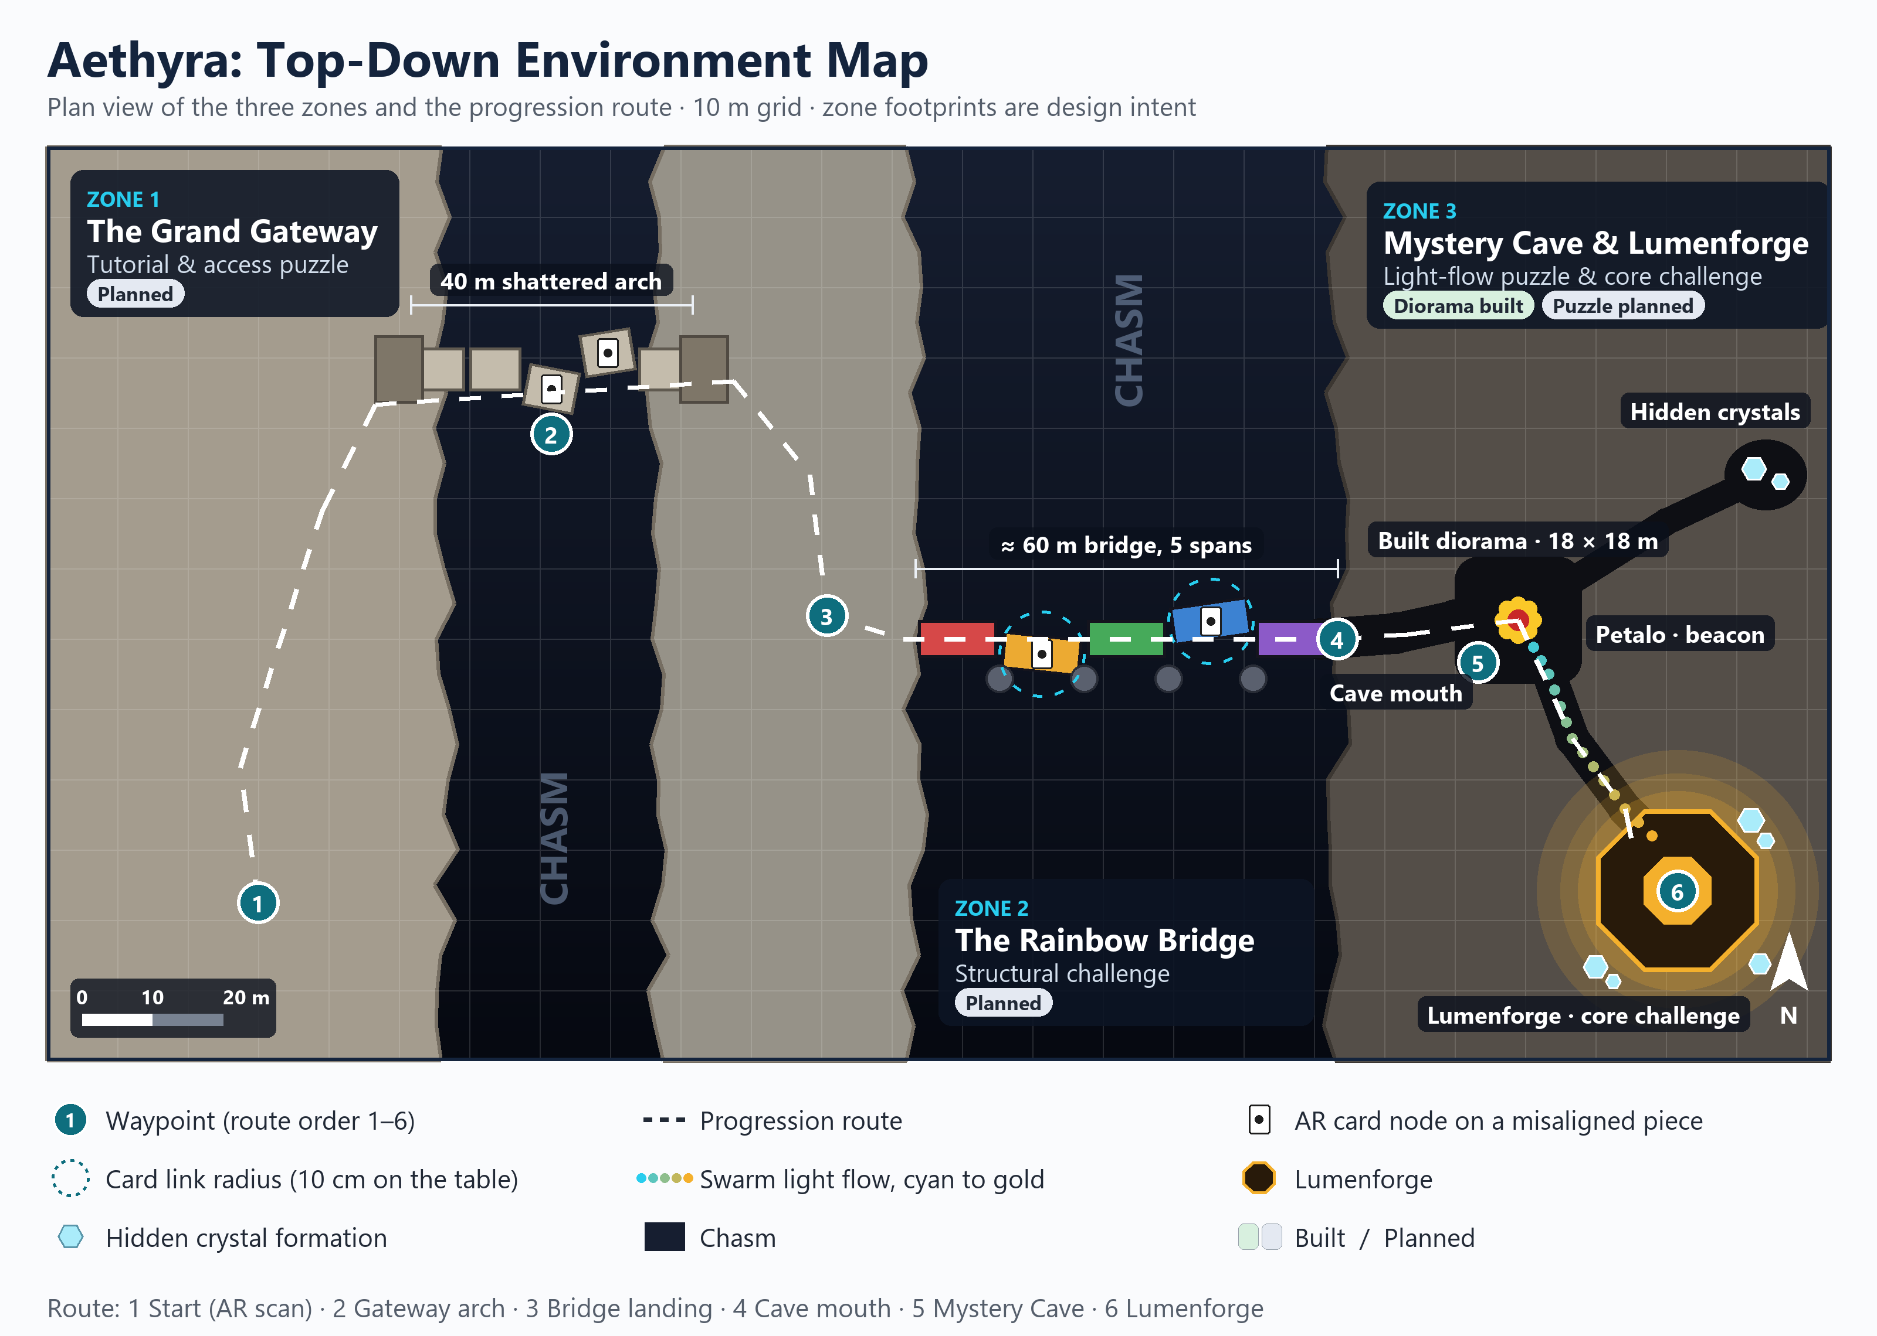
Live Snap 1: 3D world / level overview
The player starts on the Gateway plateau, crosses the arch and the Rainbow Bridge, and enters the Mystery Cave, where the Lumenforge is the final challenge. Source: top-down plan generated by the review script (design diagram, not an in-engine capture).
Zone | Space and layout | Core puzzle | Status
Zone 1: The Grand Gateway  Tutorial & access puzzle | 40 m shattered stone arch spanning a dark chasm; arch segments sit off their load path. | Seat each segment by placing a card on its node and rotating it into line. | Planned
Zone 2: Rainbow Bridge  Structural challenge | About 60 m of five broken load-bearing spans across the second chasm. | Align the spans so every load path connects, linking cards within 10 cm. | Planned
Zone 3: Mystery Cave & Lumenforge  Light-flow puzzle & core challenge | Pitch-black cavern with the forge at its deepest node. Built diorama: 18 × 18 m chamber, 10 m walls, stalactites, near-black PBR. | Route Petalo's swarm through the fissures into the Lumenforge until it ignites. | Implemented (diorama); puzzle Planned

Design Notes
- The player moves through the world by moving the phone around the table; puzzles sit in the level, not in menus.
- Each zone's broken structure physically blocks the route, and repairing it opens the next zone.
- Card slots are placed on the broken structure itself, so the mechanism reads as part of the world.
- Each zone adds one mechanic (rotate, then link, then route light) and removes light, ending in total darkness.

2. Complete Gameplay Loop
Snaps 2–6 walk through one full loop in the Mystery Cave.
# | Beat | Player does | System responds | Status
2 | Start + mission | Opens the app and points the camera at the table. | AR session starts; the mission card reads "Ignite the Lumenforge". | Implemented (AR start); Planned (mission card)
3 | Challenge | Finds the dark structural node. | Node shows DORMANT; fissures are blocked; a card slot is marked. | Planned
4 | Interaction | Places the King of Spades and turns it. | Card is tracked; ARBoidBridge spawns the swarm at the card. | Implemented (tracking + spawn); Planned (rotation check)
5 | Feedback | Watches the swarm. | Misaligned: cyan, scattered, hint pulse. Aligned (±10°): gold stream into the fissure. | Planned
6 | Completion | Sees the forge ignite. | Lumenforge lights up and reveals the crystals; progress is saved. | Planned (the cave itself is built)

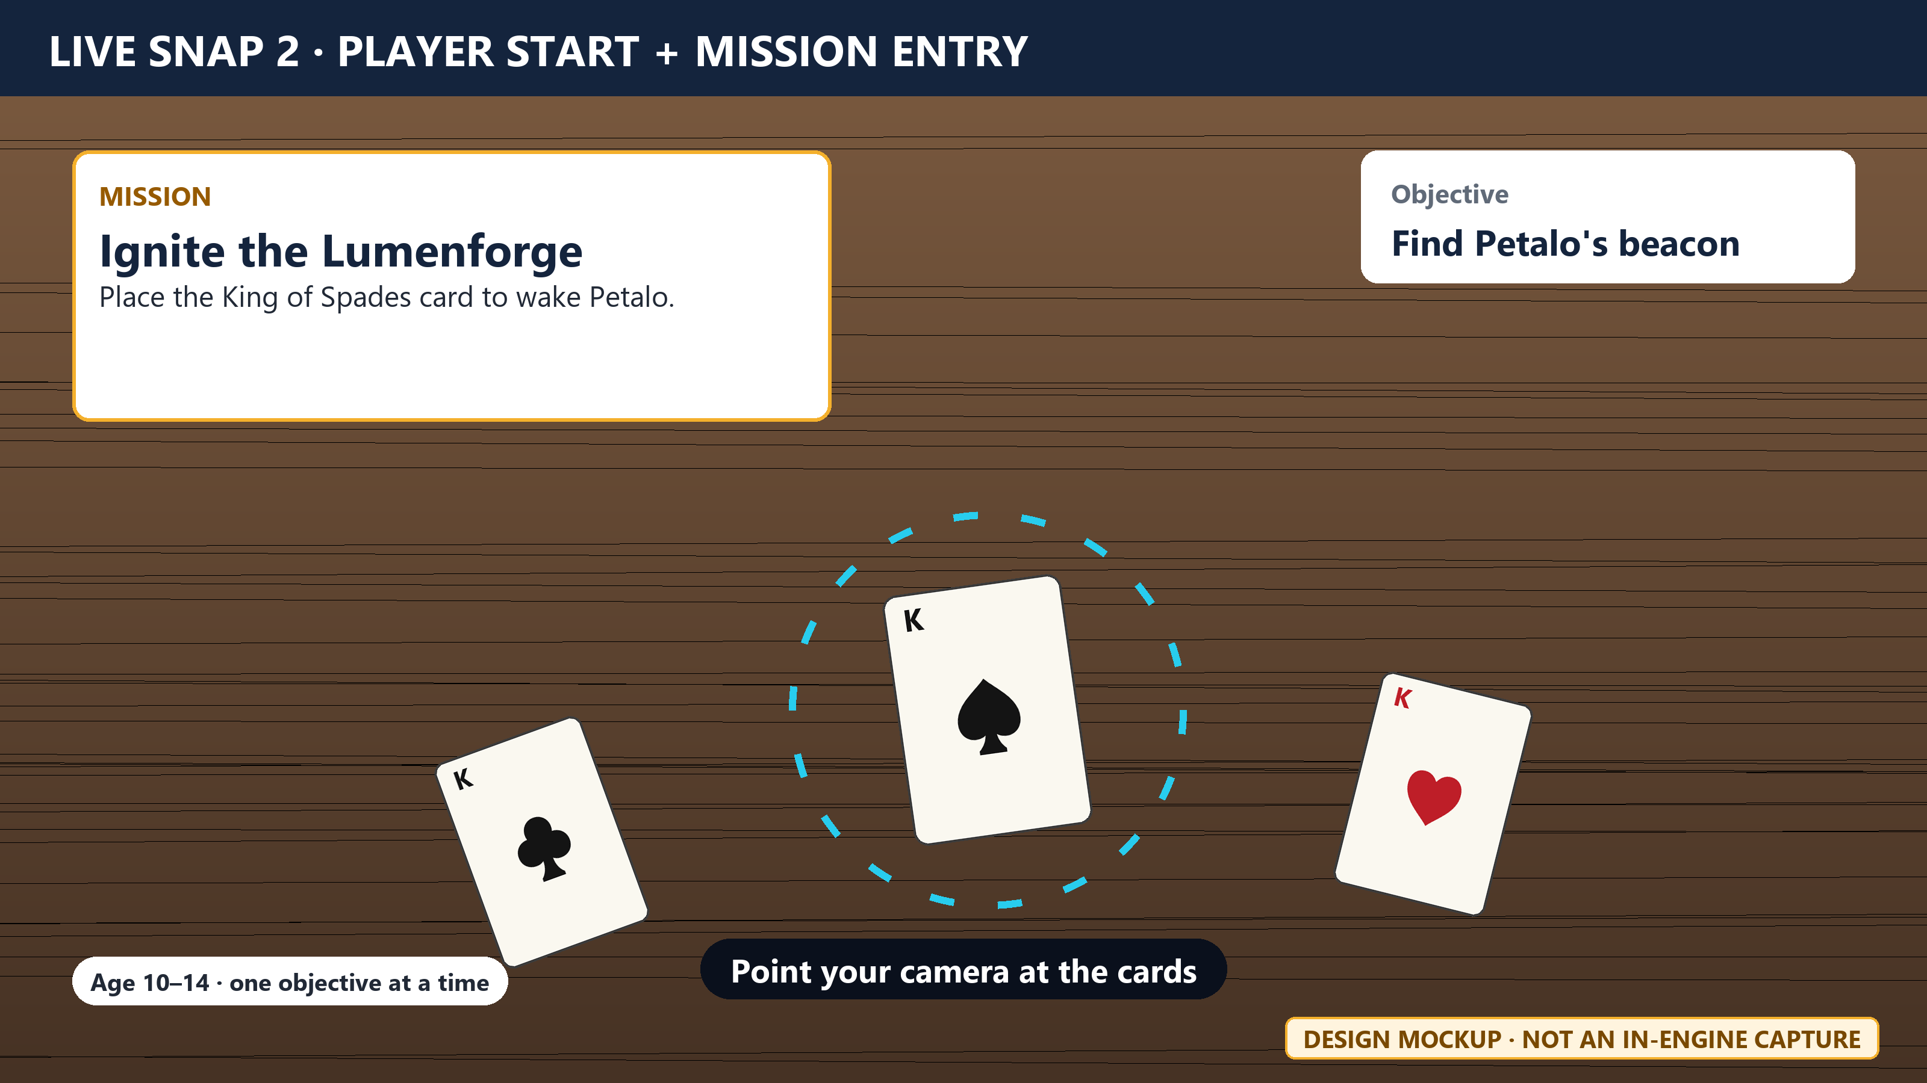
Live Snap 2: Player start + mission entry
One short mission card and a scan prompt start the game. Source: design mockup; the mission card is not built yet.
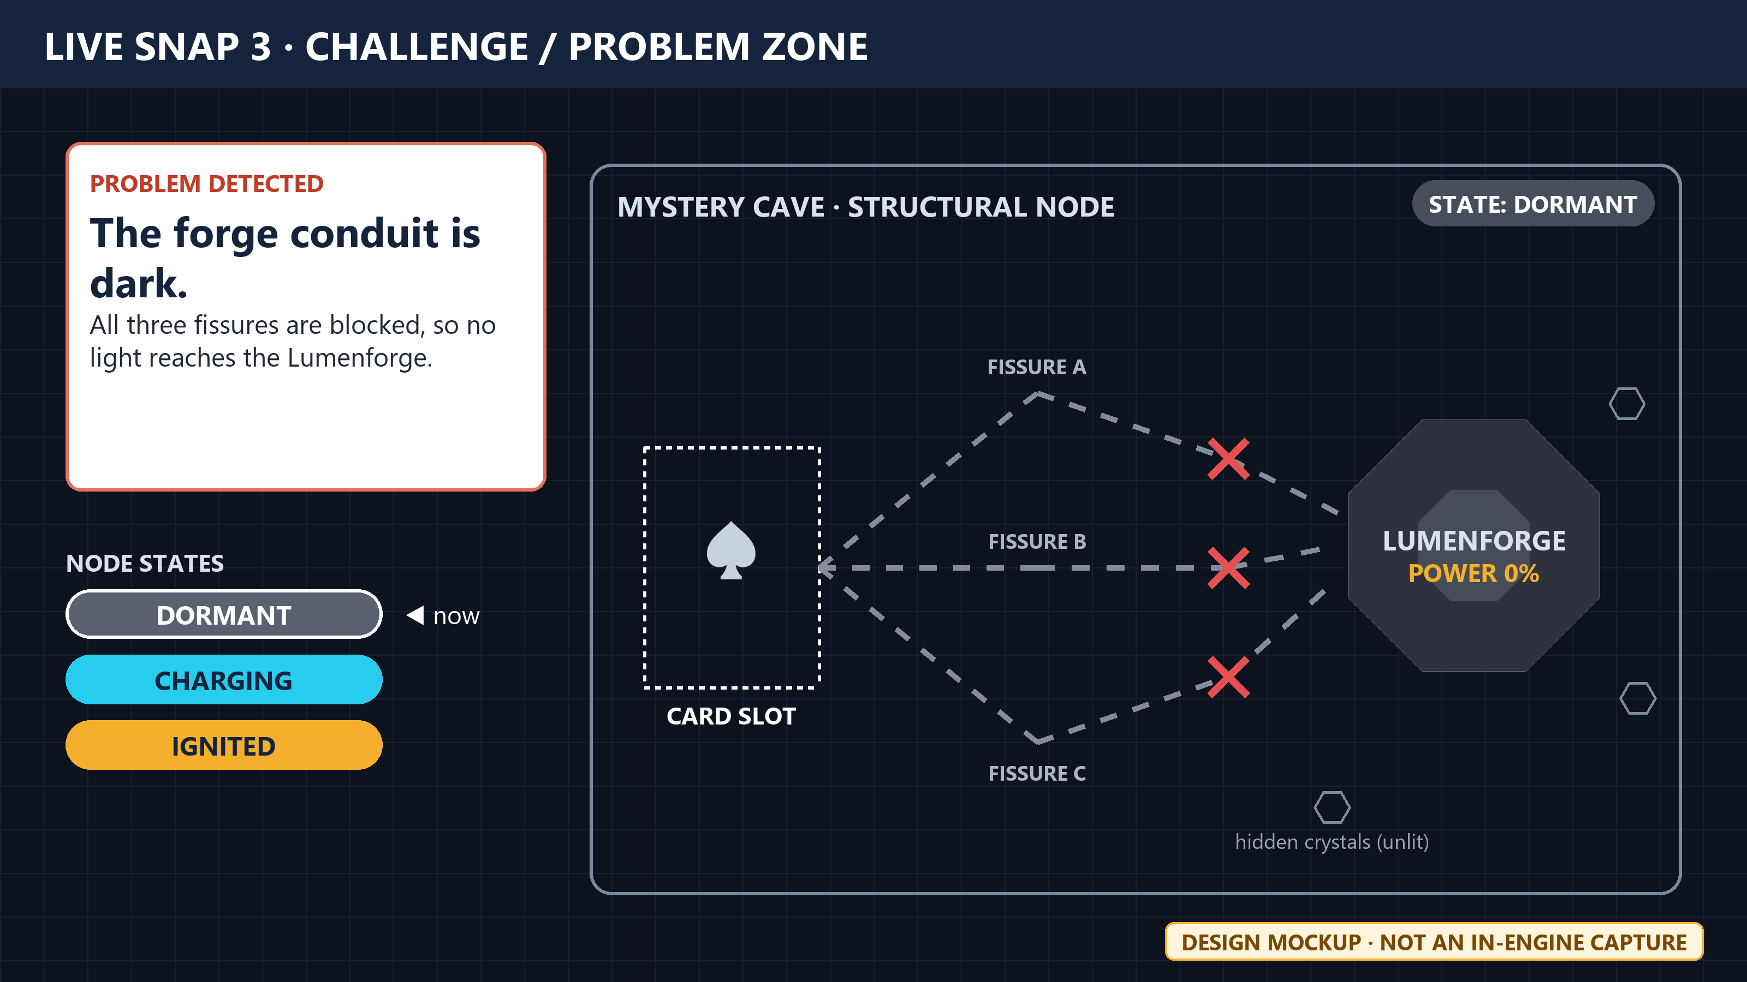
Live Snap 3: Challenge / problem zone
The node is visibly dormant, the blocked fissures are marked, and the card slot shows where to act. Source: design mockup; the dormant node is not built yet.
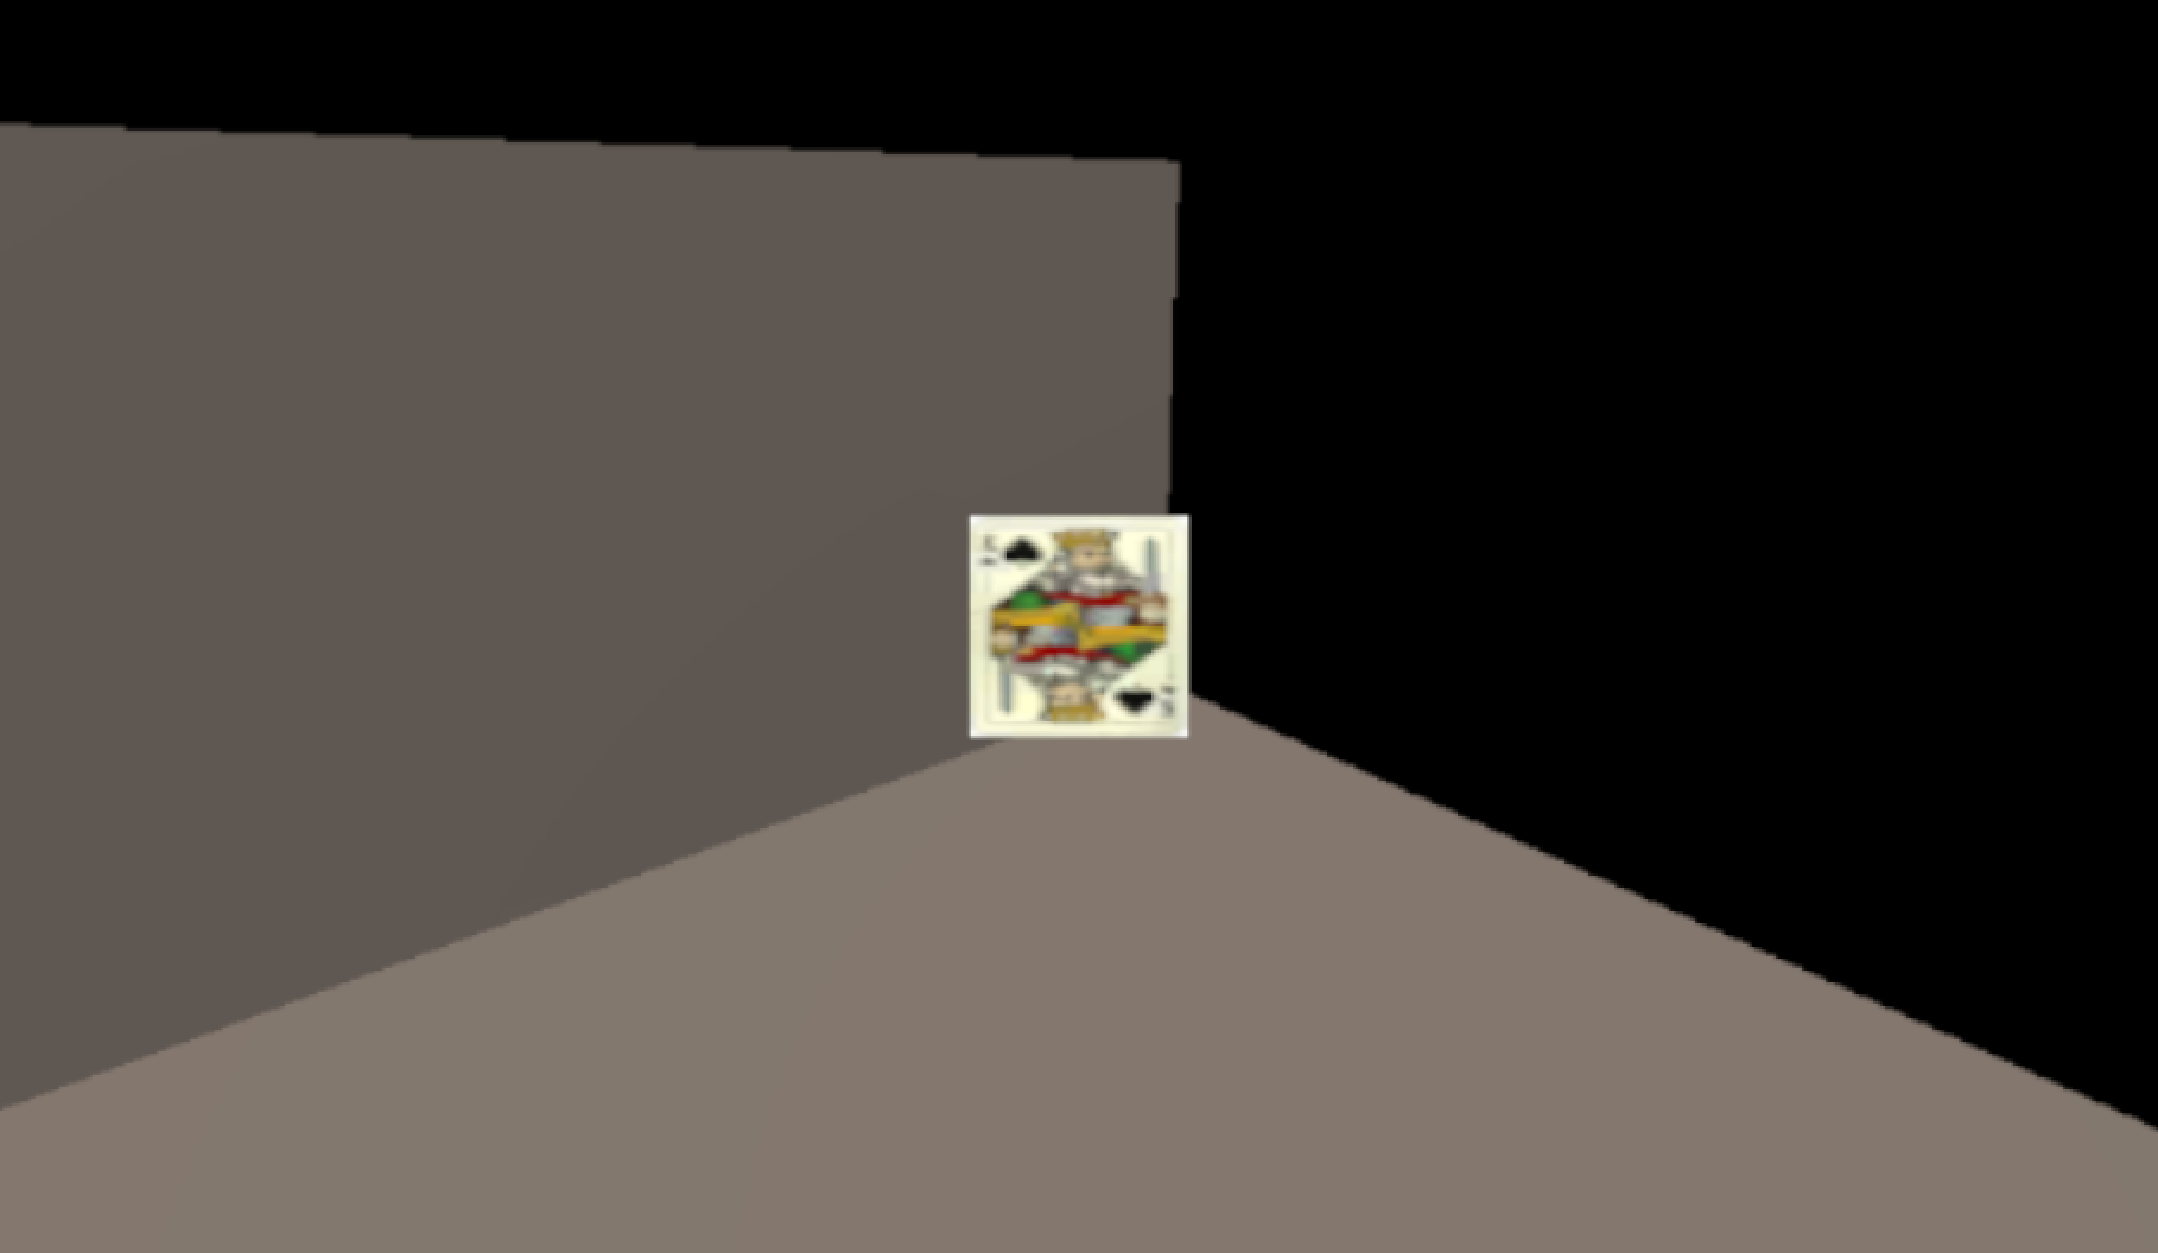
Live Snap 4: Core engineering / gameplay interaction
The King of Spades tracking card in the AR scene, which anchors Petalo's swarm. Source: Unity Editor capture under XR Simulation. The tracking target is staged; the hologram and swarm are not visible in this frame.
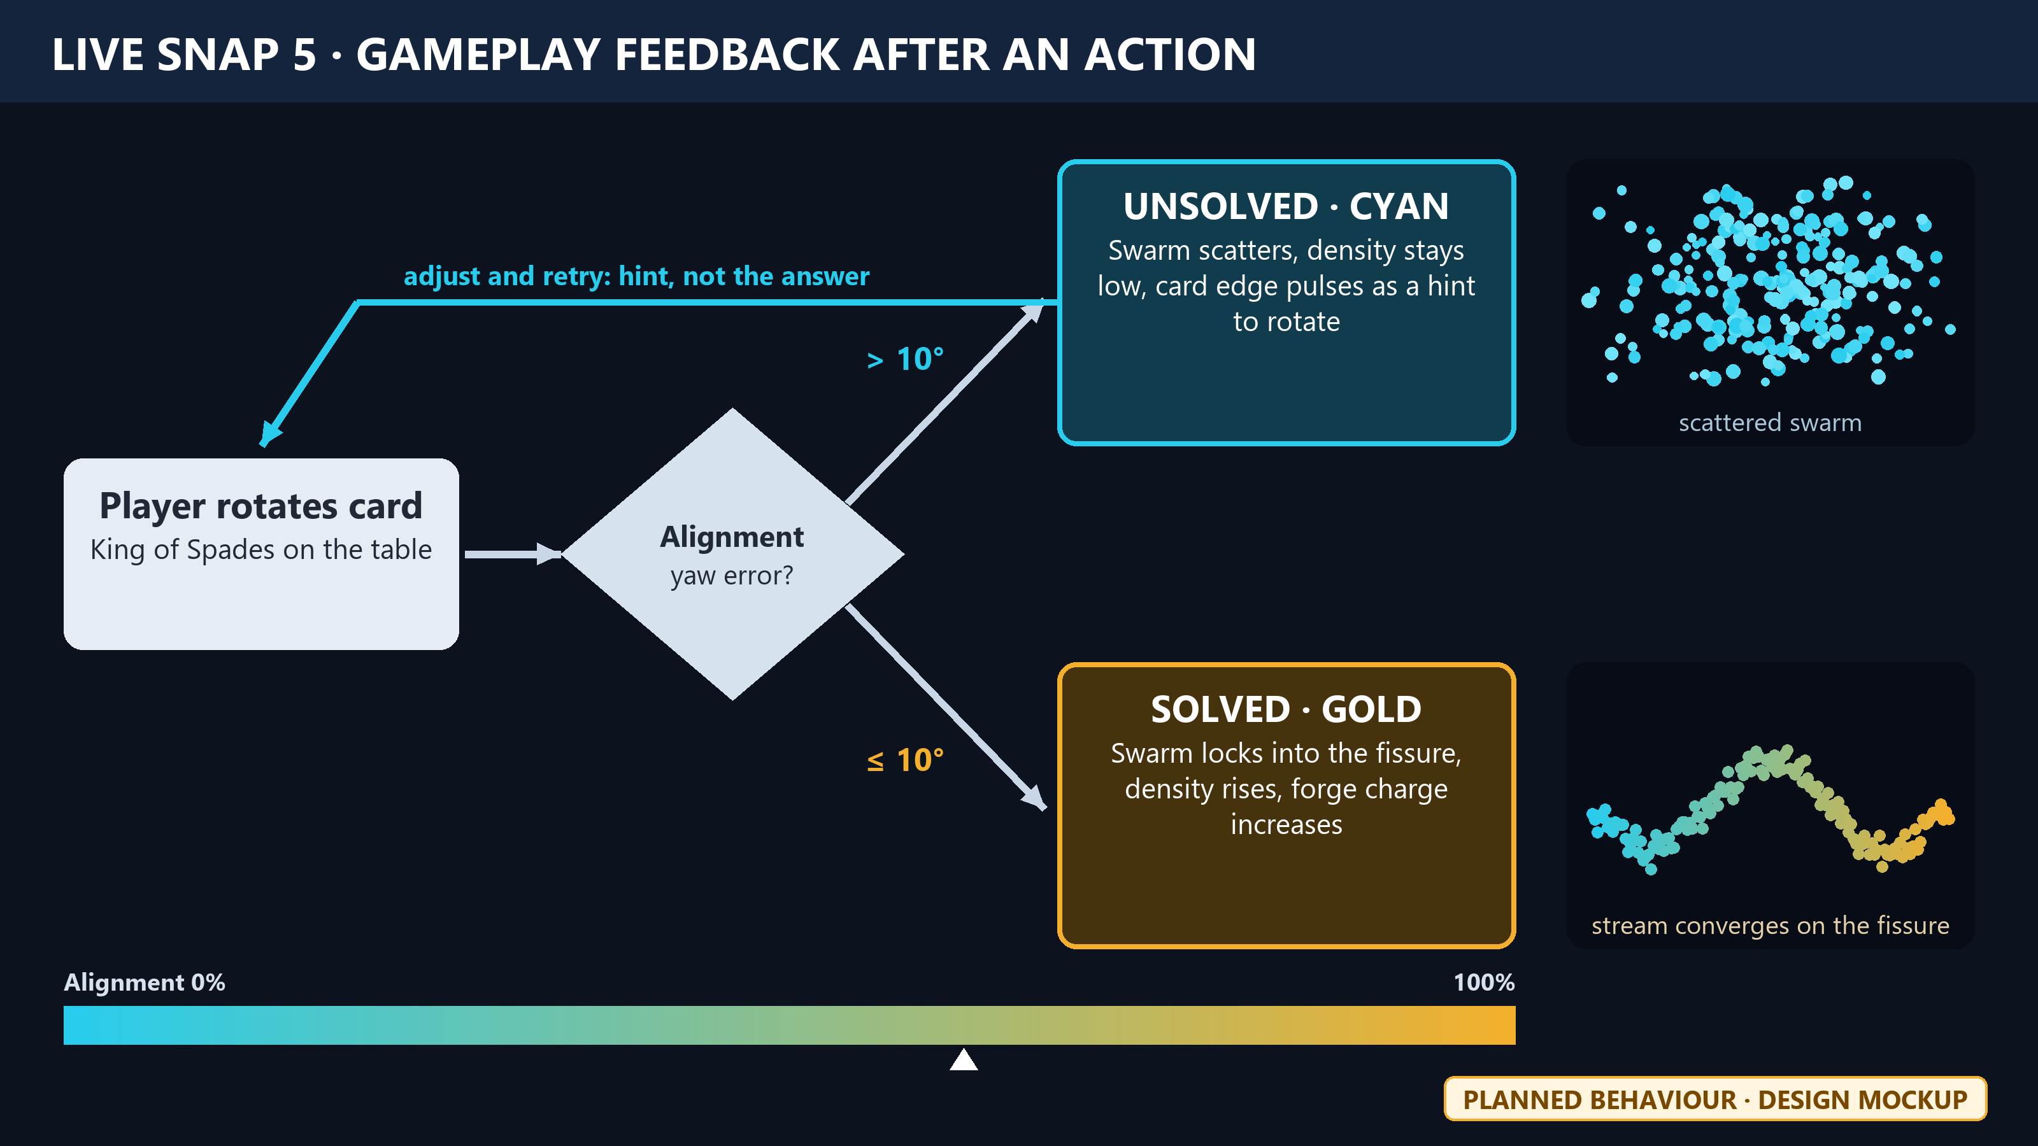
Live Snap 5: Gameplay feedback after an action
Turning the card changes the swarm: cyan and scattered when wrong, a gold stream when aligned, with a hint instead of the answer. Source: design mockup of planned behaviour.
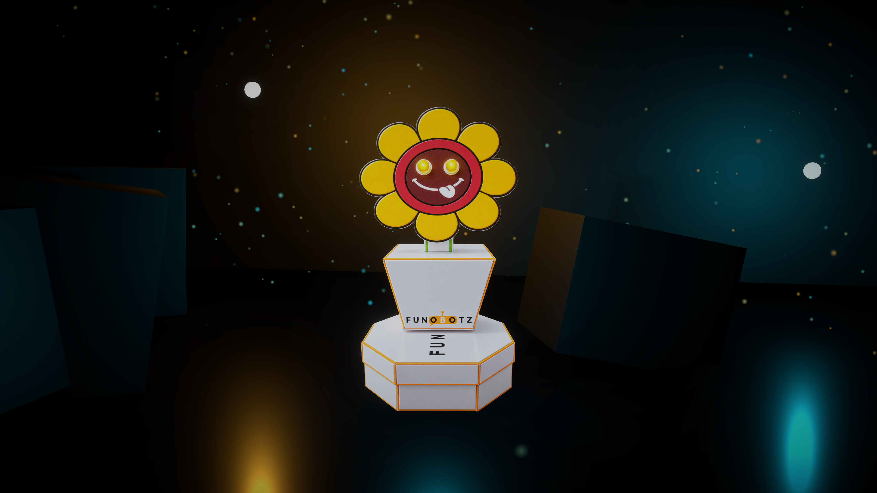
Live Snap 6: Completion / progression
Petalo inside the Mystery Cave, the zone the loop completes in. Source: Unity URP render of the built Mystery Cave diorama. The forge-ignition completion state is not built yet.

Failure and retry
Losing the card is never a fail state: the swarm pauses and resumes when the card is seen again (Implemented). A wrong angle gives a hint pulse, never the solution (Planned).

3. Essential UI / Child Usability
Only the interfaces needed to understand, play and complete the mission.
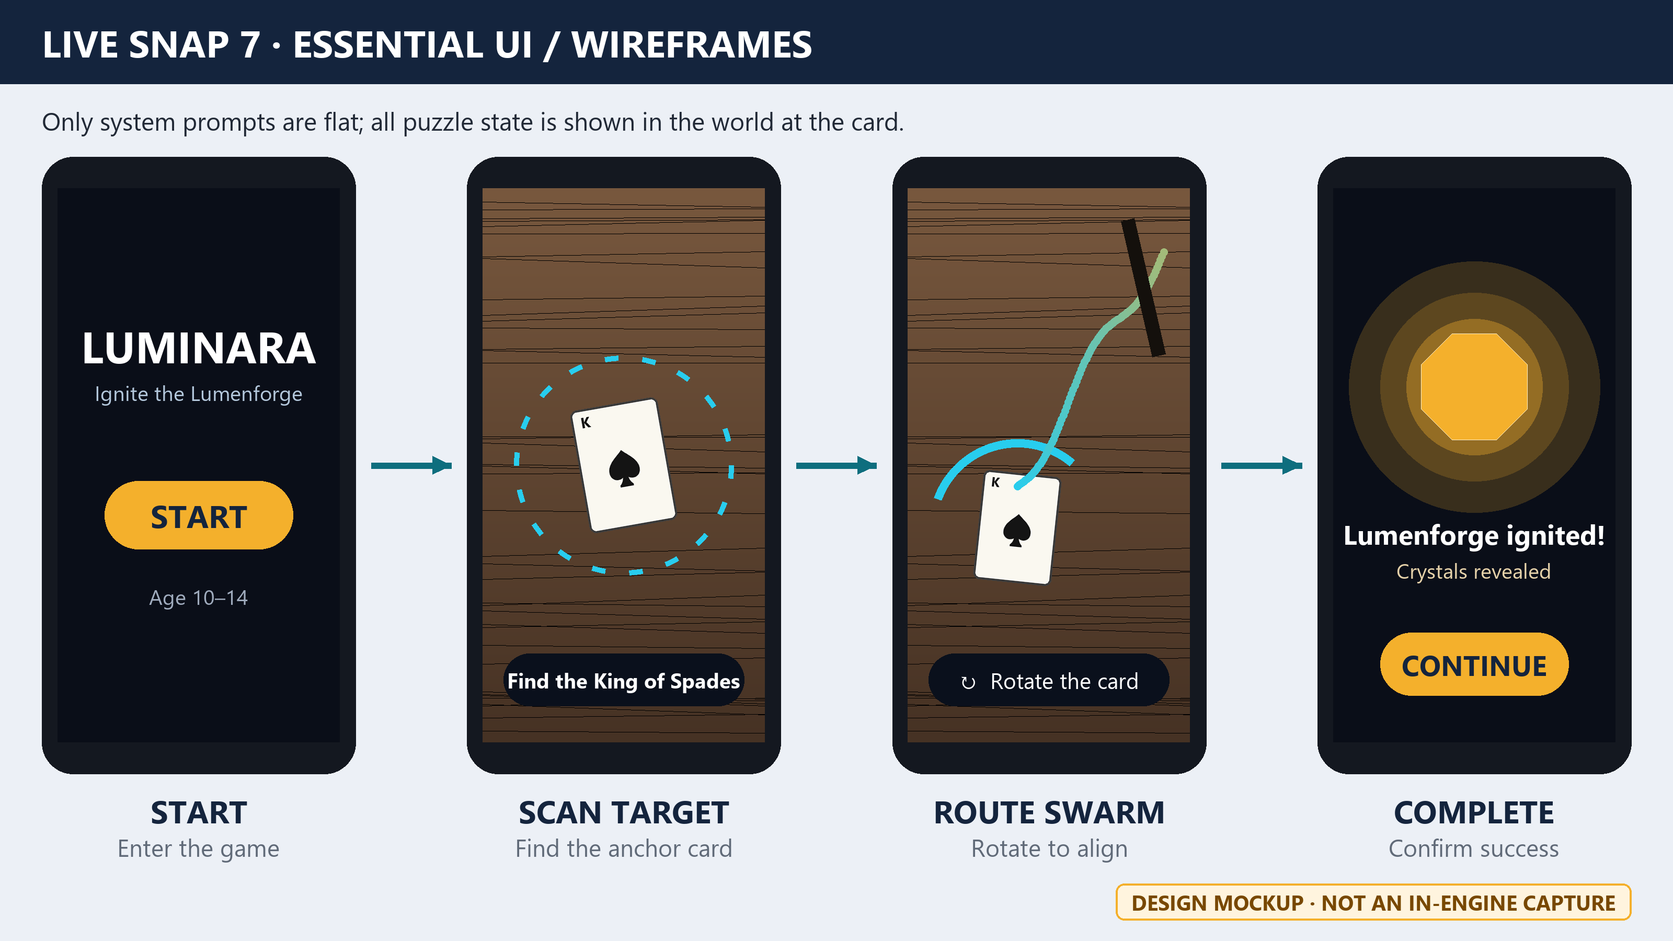
Live Snap 7: Essential UI / wireframes
Start, Scan Target, Route Swarm and Complete. Buttons are large, text is short, and puzzle state is shown in the world. Source: design mockup of the four essential states.

Child Usability Decisions
- Target age: 10–14 (the Funobotz sample's band; the team to confirm).
- One objective at a time, stated in one line; no instruction paragraphs during play.
- Large buttons only on Start and Complete; during play the phone is a window, not a control panel.
- Feedback is carried by swarm density and motion as well as the cyan-to-gold colour, so it does not rely on colour alone.
- A wrong move produces a hint, not the answer; losing the card never costs progress.

Essential UI Flow
Screen | Purpose | Status
Start | Enter the game; show the mission "Ignite the Lumenforge". | Planned
Scan Target | Find the King of Spades; a dashed ring shows the camera is searching. | Implemented (tracking); Planned (ring)
Route Swarm | Rotate the card until the swarm flows gold; one-line rotate hint. | Planned
Complete | Forge ignites; confirm success and continue. | Planned

4. Technical Plan & Interaction List
What the team has built, and what one playable loop still needs.
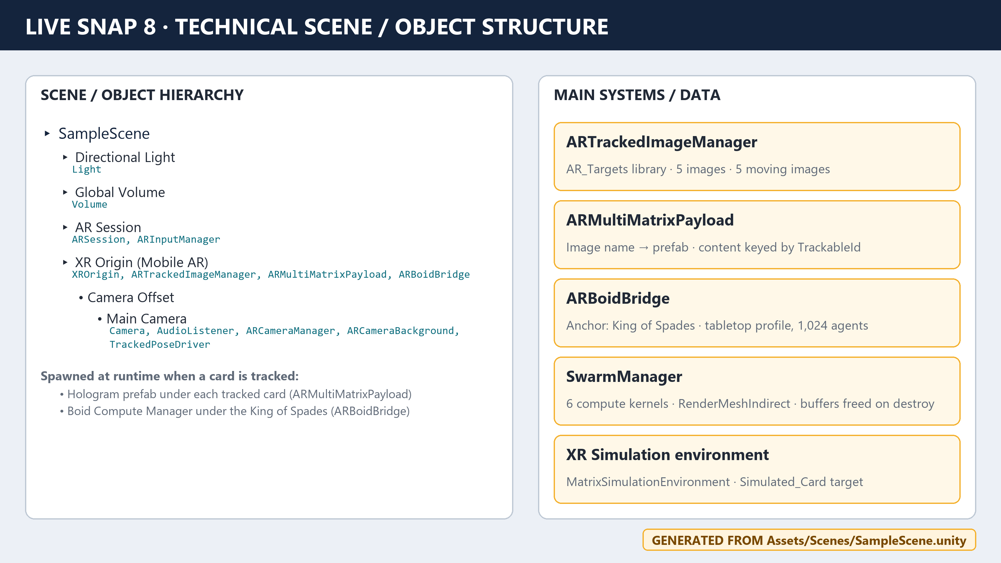
Live Snap 8: Technical scene / object structure
SampleScene objects and the systems that run one loop. Source: generated from the real SampleScene.unity hierarchy; replace with a Unity Hierarchy screenshot of the same name if preferred.

Technical Plan
System | Responsibility | Stored state | Status
ARTrackedImageManager | Detects the 5 reference cards (10 cm wide). | TrackableId, pose, tracking state | Implemented
ARMultiMatrixPayload | Spawns each card's hologram; hides it when tracking is lost. | TrackableId → instance | Implemented
ARBoidBridge | Spawns and pauses Petalo's swarm on the King of Spades. | Anchor id, swarm instance | Implemented
SwarmManager + SwarmCompute | GPU boids: grid hash, bitonic sort, update, indirect draw. | GPU buffers (≈ 0.14 MB at 1,024) | Implemented
Mission / node state | DORMANT → CHARGING → IGNITED; alignment check (±10°). | Node state, alignment % | Planned
Progression | Unlocks the next zone after ignition. | Unlocked zone | Planned

Interaction List
Object | Player action | Response | Status
Any target card | Place in view | Its hologram appears on the card | Implemented
King of Spades | Place in view | Petalo's swarm anchors to the card | Implemented
Any card | Cover or lift | Content hides; swarm pauses | Implemented
King of Spades | Rotate | Swarm aligns with a fissure; cyan to gold | Planned
Two cards | Place within 10 cm | Cards link; swarm flows between them | Planned
Lumenforge | Sustain gold flow | Forge ignites; crystals revealed | Planned

Platform
Android, IL2CPP, ARM64, minimum API 27, OpenGL ES 3 only, URP with the AR Background feature. Risk: many Mali GPUs expose no vertex-stage buffers under OpenGL ES, which the swarm shader needs; ARBoidBridge detects this and disables the swarm cleanly. Mitigation: enable Vulkan on compute-capable devices.

5. Riskiest Mechanic Prototype
Prove the hardest interaction before full production.
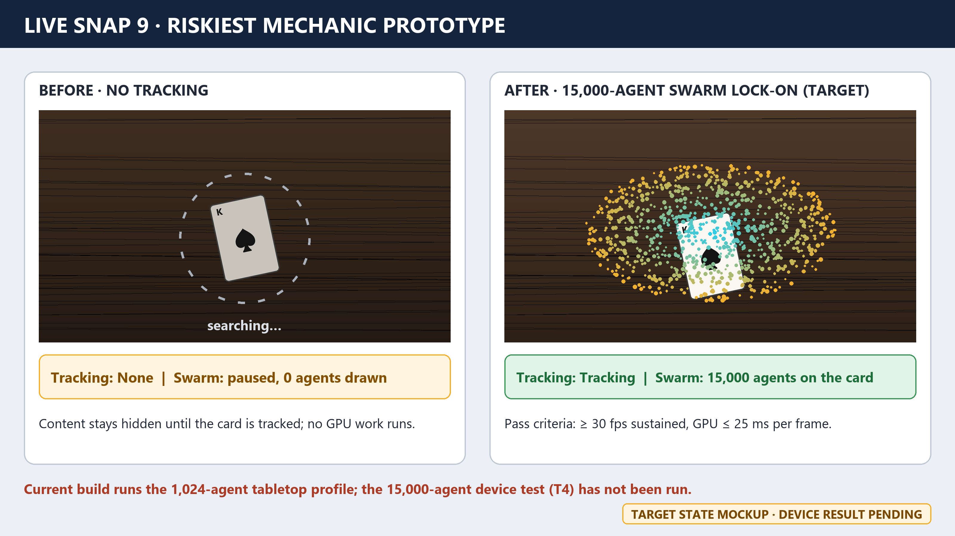
Live Snap 9: Riskiest mechanic prototype
Before: no tracking, so nothing draws. After (target): the card is tracked and 15,000 agents flow around it. Source: target-state design mockup. The current build runs 1,024 agents; the 15,000-agent device test has not been run.

Why this is the riskiest mechanic
The game only works if a phone can keep tracking the cards while running Petalo's swarm fast enough to read. If this fails, the swarm cannot be the feedback channel, so it is proven before any zone art or extra puzzles.

Prototype Acceptance Test
Test | Expected result | Status
Card detected in XR Simulation | Simulated King of Spades resolves to the AR_Targets entry | Implemented
Swarm spawns on the anchor card | One swarm at the card pose; paused when tracking is lost | Implemented
Capability gate on device | Swarm enabled, or disabled cleanly with a logged reason | Pending verification
1,024 agents on device | ≥ 30 fps sustained for 5 min | Pending verification
15,000 agents on device | ≥ 30 fps; GPU ≤ 25 ms per frame | Pending verification
Tracking under load | 5 cards moved quickly; re-acquire in < 1 s | Pending verification

6. Asset Plan
What is custom, third-party or AI-assisted.
Asset | Source | License / note | Phase 2 status
Petalo character image | Funobotz kit image | Usage rights to be confirmed | Implemented
5 AR card faces | Card-face images | Source to be confirmed | Implemented
Boid Swarm Engine | Team package | Team-created | Implemented
Mystery Cave diorama | Procedural, team scripts | Team-created | Implemented
Card holograms (5 primitives) | Procedural, team scripts | Team-created; placeholders | Implemented
Snap 1 map and Snaps 2, 3, 5, 7, 9 mockups | Generated by the review scripts | AI-assisted (Claude) and edited; declared | Implemented
Gateway arch, bridge spans, Lumenforge, crystals | Team, to be modelled | Team-created | Planned
AR Foundation, ARCore XR Plugin, URP, Input System | Unity packages | Unity package licenses | Implemented
Audio | Not started | — | Planned

24-Hour Scope
- One complete Mystery Cave loop: dormant node, card rotation, cyan-to-gold feedback, forge ignition.
- One success state and one failure (hint) state.
- One unlock/progression event.
- Gateway and Bridge stay as layout only until the cave loop is stable.

7. Playtest Plan & Evidence
What must we learn from another player before Phase 3?
[Evidence pending: 10_Playtest.jpg not found in the project root]
Live Snap 10: Playtest evidence
A tester attempts the mission without explanation. Source: no playtest session has been run yet; add 10_Playtest.jpg to the project root and re-run the script.
Question | Observation | Action before Phase 3
Understands the mission without help? | Not yet tested | —
Finds and places the King of Spades? | Not yet tested | —
Discovers that rotating the card matters? | Not yet tested | —
Reads cyan vs gold without explanation? | Not yet tested | —
Completes the loop? | Not yet tested | —

Plan: 5 first-time players aged 10–14, one 15-minute session each; success when 4 of 5 complete the loop without verbal help.

8. Phase 2 Self-Check Against 20 Points
Checked against the Funobotz filled sample before upload.
Criterion | Max | Evidence | Honest check
Core game loop quality | 5 | Snaps 2–6 + loop table | Designed; tracking and swarm spawn built; puzzle not yet playable
3D experience design | 4 | Snap 1 + Snaps 3, 4, 6 | Cave diorama built; Gateway and Bridge planned
Child usability | 3 | Snap 7 + usability decisions | Designed; not yet tested with players
Engineering / problem-solving | 3 | Snaps 4, 5, 9 | Rotate-and-route mechanic designed; not yet built
Technical feasibility | 3 | Snap 8 + technical plan + asset plan | AR tracking and GPU swarm running in Editor; device test pending
Visual / interaction clarity | 2 | Snaps 3, 5, 7 | Designed as mockups; live captures pending

Minimum Live Snap Set
Snap | Required | File | Source
1 | 3D world / level overview | LUMINARA_Game_Design_Map.png | Generated diagram
2 | Player start + mission entry | 2_StartUI.png | Design mockup
3 | Challenge / problem zone | 3_ChallengeZone.png | Design mockup
4 | Core engineering / gameplay interaction | Funobotz_ARMatrix_Scene.png | Editor capture
5 | Gameplay feedback | 5_Feedback.png | Design mockup
6 | Completion / progression | Funobotz_Petalo_BeautyShot.png | Editor render
7 | Essential UI / wireframes | 7_Wireframes.png | Design mockup
8 | Technical scene / object structure | 8_Hierarchy.png | Generated from SampleScene
9 | Riskiest mechanic prototype | 9_RiskiestMechanic.png | Target-state mockup
10 | Playtest evidence | 10_Playtest.jpg | Missing: no playtest run yet

