**INTERACTIVE CALENDER**

End Term Report

***By***

***B.S.V.SURYA PRATHAP***

Section: - K19TP

Roll Number: - 61



Department of Intelligent Systems

School of Computer Science Engineering

Lovely Professional University, Jalandhar

2019-20

**Student Declaration**

This is to declare that this report has been written by me. No part of the report is copied from other sources. All information included from other sources have been duly acknowledged. I am ever that if any part of the report is found to be copied, i shall take full responsibility for it.

B.S.V.SURYA PRATHAP

ROLL NO:61

Place: - Lovely Professional University, Phagwara, Punjab

Date: - 9/4/2020

TABLE OF CONTENTS

TITLE

1. **Introduction…………………………………………………**

**1.1** Background………………………………………………

**1.2** Motivation……………………………………………….

**1.3** Outcomes…………………………………………………

**1.4** Concrete Goals……………………………………………

**1.5** Objectives…………………………………………………

2. **Description……………………………………………………**

**2.1 I**nterface and Objective……………………………….

**2.2** Content……………………………………………………

3. **Frameworks and Technologies………………………………**

**3.1** Technologies and software…………………………………

4. **Work Division……………………………………………………**

5. **SWOT Analysis………………………………………………….**

BONAFIDE CERTIFICATE

Certified that this project report “INTRACTIVE CALENDER” is the work of “B.S.V.SURYA PRATHAP” who carried out the project work under my supervision.

<<Signature of the Supervisor>>

<<Name of supervisor>>

<<Academic Designation>>

<<ID of Supervisor>>

<<Department of Supervisor>>

**Introduction**

* 1. **Background**

Interactive calendar system is a platform where  people manage their personal schedules, time and activities, particularly when individuals have numerous work, school, and family commitments. People frequently use multiple systems and may keep both a business and family calendar to help prevent them from over committing their time..

* 1. **Motivation**

The ideas and motivation regarding the theme given to me is done by discussing with my friends and some of them were browsed online .I have referred internet to get the basic ideas and then implemented the ideas in a creative way . Almost all the concepts thought by our faculty helped me in this assignment.

* 1. **Outcomes**

During the designing and coding of the assignment I have done the coding several times and got several outcomes .I have tested even with small changes which, can give our web page a perfect finishing. In this project I have used taken the motive that the calender form must be easy to handle by the user and I have done that in the expected level.

* 1. **Concrete Goals**

Our goals in this assignment is to develop a webpage which include

the required outcomes given to me.

Also to attract the reader all the creative and attractive look must be given to the page

To include html ,Css, JavaScript in the coding.

* 1. **Objectives**

The code is also pretty easy for the user to read

I have also given some comments where required and I have

Done the webpage in a way where the user can easily understand the

Instructions.

**Description**

**2.1 I**nterface and Objective

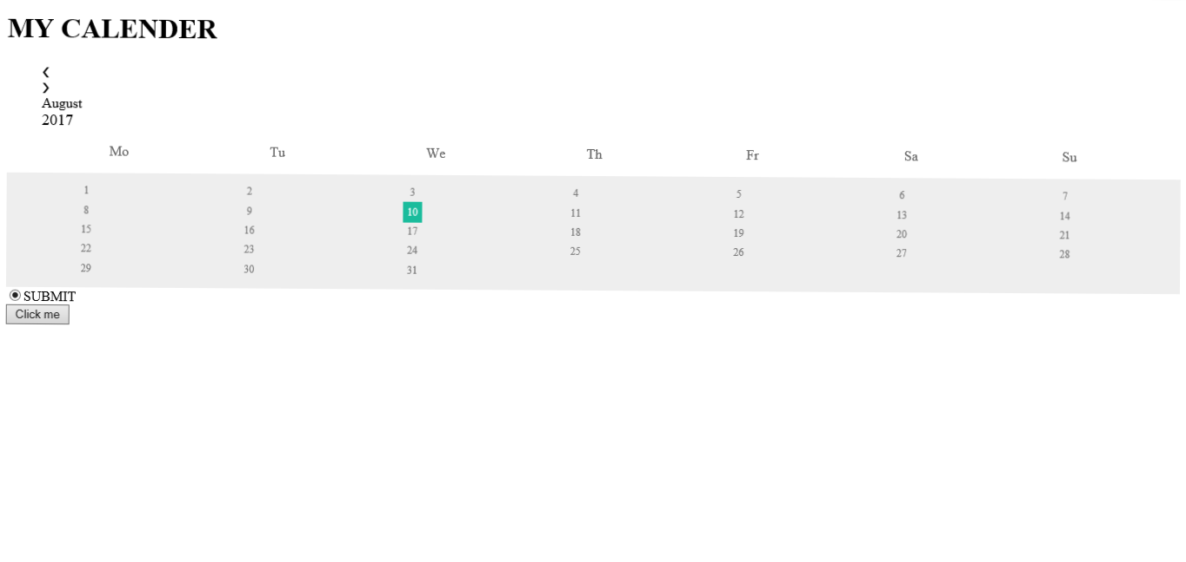

We designed Title of our page “My Calender ” with good looking background and visible font with animation. Title should always attractive

It classifies the work in it so we designed in animation style.

We choosen a background related to calender among we selected a perfect background image related to our requirements

**2.2 Content**

The motive of our project is to create user comfort interface and good attractive modal.

* This is the title with animate moving style, title gives good impact on body

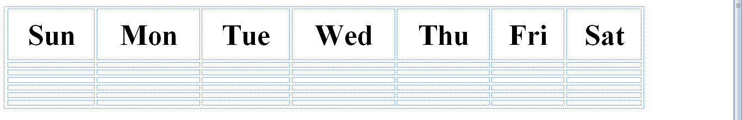

You can use the Calendar view during team meetings to plan team activities and check the schedule for the coming week.

**Frameworks and Technologies Used**

**3.1 Technologies and software**

I used atom software powered by GIT hub. It helped me to gave an easy understanding about the coding .I have also taken help of simple snippets an YouTube channel to help the coding of Css and java script.

**SWOT Analysis**

Strengths

* Attractive background
* Date selection
* Designing

Weaknesses

* Working with js
* Working with css

Opportunities

* To create beautiful outputs with the help of Css , Java Script
* Put out creativity on this platform.
* Work with js and css