Fill in the blanks-1 Section 1 Time 1 hour

**Instructions:**

1. If the output has multiple values/ multiple new line values write it as comma space separated.
2. use the following Notations for writing Complexity Answers: N, 1, log(N), N^2, N*log(N), 2^N, N^3, log(N)

1. What does the following code fragment print when N is 50 ?

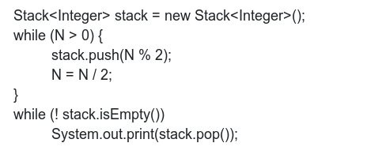

2. Give the output printed by Queue for the input at the end of all operations  
If “-” perform dequeue else enqueue each word.  
Playing Cricket - is - a hobby - - of - - mentor - deepak

3. Suppose that a client performs an intermixed sequence of (stack) push and pop operations. The push operations put the integers 0 through 9 in order onto the stack; the pop operations print out the return values. Which of the following sequence(s) could not occur?  
**Note:** For answer write the options in order separated with comma and space eg: a, b, d   
a. 5 4 3 1 2 0 9 8 7 6  
b. 0 9 8 7 6 5 4 3 2 1  
c. 0 1 2 3 4 5 6 7 8 9  
d. 1 3 5 7 9 2 4 6 8 0  
e. 1 5 0 2 3 4 6 7 8 9

4. Give the minimum and maximum occupancy percentages for resizing arrays?

Give the number of components remain at the end of Quick Find Algorithm for the following union operations.  
a. 3-4  
b. 4-9  
c. 8-0  
d. 2-3  
e. 5-6  
f. 5-9  
g. 7-3  
h. 4-8  
i. 6-1

5. {[]()} If you use stacks for checking parentheses balanced or not ? After each iteration, Print the size of the stack.

6. Give the order of growth (as a function of N, k ) of the running times of the following code fragment:

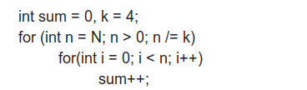

7. Give the order of growth (as a function of n ) of the running times of the following code fragment:

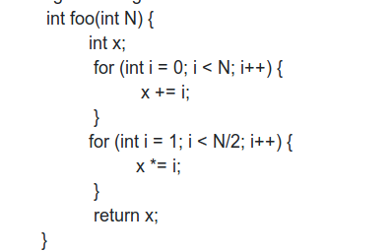

8. Give the order of growth (as a function of n ) of the running times of the following code fragment:

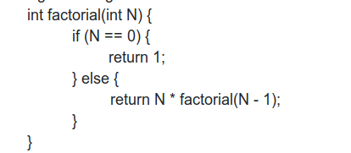

9. Give the order of growth (as a function of n ) of the running times of the following code fragment:

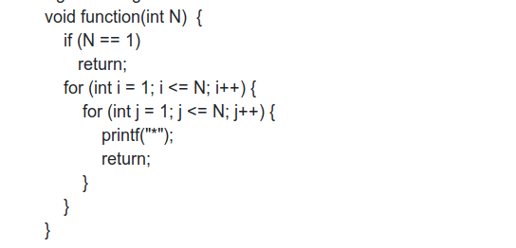

10. Give the number of components remain at the end of Quick Find Algorithm for the following union operations.  
a. 3-4  
b. 4-9  
c. 8-0  
d. 2-3  
e. 5-6  
f. 5-9  
g. 7-3  
h. 4-8  
i. 6-1

Section 2 Time 3 hours

* Download the zip file to find the question and testcases; the directory structure is similar to the sample-assignment seen in the previous activity
* Add a subfolder m6 for Module 6
* Unzip the starter code into m6 folder. You should see a folder with the name Assignment-1
* You should write your solution in the file Solution.java
* There are a few lines of code to handle the input testcases
* After you write the code use eval to check if you got all the testcases right
* submit commit ID in the textbox below.