**Test Strategy Document**

**AMAZON APPLICATION**

**Document Control:**

**Document Details:**

|  |  |
| --- | --- |
| Title | Test strategy document for Amazon Application |
| Version | 13.20.1 |
| Date | 13th 2021 |
| File Name | Test Strategy-Amazon |
| File Location | Document/ Test Strategy-Amazon |
| Author | TEAM AMAZON |
| Contributor | Aarthi,Surya,Swetha,TamilSelvan |

**Contents**

1. Scope and overview 4

2. Test Approach 4

3. Test Levels 4

4. Test Types 4

5. Roles and Responsibilities 4

6. Environment requirements 4

7. Testing tools 4

8. Industry standards to follow 4

9. Test deliverables 4

10. Testing metrics 4

11. Requirement Traceability Matrix 4

12. Risk and mitigation 4

13. Reporting tool 5

14 Test summary 5

15. Approvals 5

**1.Scope and overview:**

**Scope:**

This system allows the customer’s to maintain their cart for add or remove the product over the internet.The customer can purchase any product from the product page. This will includes functional and non functional requirement .

**Functional Requirement:**

* Secure registration and profile management facilities for Customers
* Adequate searching mechanisms for easy and quick access to particular products and services.
* Creating a Shopping cart so that customers can shop ‘n’ no. of items and checkout finally with the entire shopping carts. Customers can add or delete items in the cart.
* Maintaining database of regular customers of different needs.
* Shop employees are responsible for internal affairs like processing orders, assure home delivery, getting customer's delivery-time feedback, updating order's status and answering client's queries online.
* Feedback mechanism, so that customers can give feedback for the product or service which they have purchased. Also facility rating of individual products by relevant customers.
* Adequate payment mechanism and gateway for all popular credit cards, cheques and other relevant payment options, as available from time to time.

**Non Functional Requirement:**

* Secure access of confidential data (user’s details).
* 24 X 7 availability
* **Performance:**

The performance depends on hardware specification

* **Reliability:**

The system is available during online time only .

**Overview:**

This system provides an easy solution for customers to buy the product without going to the shop and also to shop owner to sale the product. This proposed system can be used by any naïve users and it does not require any educational level,experience or technical expertise in computer field but it will be of good use if user has the good knowledge of how to operate a computer.

# **2. Test Approach:**

# Test levels

# Test types

# Roles and responsibilities

# Environment requirements

# **3. Test Levels:**

# Levels of testing such as unit testing, integration testing, system testing and user acceptance testing should be used while developing an application.

# **4. Test Types:**

# For developing this application we need to perform some testing for better quality of a software or a product. The type testing used for this application includes,

## 

### **a) SMOKE TESTING**

* This testing was done whenever a Build is received (deployed into Test environment) for Testing to make sure the major functionalities are working fine, Build can be accepted and Testing can start.

### **b) SYSTEM INTEGRATION TESTING**

* This is the Testing performed on the Application under test, to verify the entire application works as per the requirements.
* Critical Business scenarios were tested to make sure important functionalities in the application works as intended without any errors.

### **c) RETESTING TESTING**

* Re-testing is executing a previously failed test against new software to check if the problem is resolved. After a defect has been fixed, re-testing is performed to check the scenario under the same environmental conditions.
* Retesting ensures that the issue has been fixed and is working as expected.
* In some cases the entire module is required to be re-tested to ensure the quality of the module.

**d)SANITY TESTING**

* Sanity testing is done to check the bugs have been fixed after the build.
* Sanity tests helps to avoid wasting time and cost involved in testing if the build is failed. Tester should reject the build upon build failure.

**e) COMPONENT TESTING**

* Component testing is a software testing method where “units”—the individual components of software—are tested. Developers write unit tests for their code to make sure that the code works correctly. This helps to detect and protect against bugs in the future.

# **5. Roles and Responsibilities**

|  |  |
| --- | --- |
| **Role** | **Responsibilities** |
| Project Manger | AnuMeha mam |
| Project Lead | Surya |
| QA | Aarthi,Surya,Swetha,Tamil |

# **6. Environment requirements:**

**Software Environment**

* Operating System: Windows7 Ultimate which supports networking.
* JAVA development toolkit. Hardware Interface:

**Hardware requirements**

* Processor: Dual Core
* RAM:2 GB
* Hard Disk:320 GB

# **7. Testing tools:**

Test Automation Tools

* Selenium
* TestNG
* Test management tools-Jira

# 

# **8. Industry standards to follow:**

* IEEE- **Standard** for Software **Test** Documentation: This documentation should be follow during developing high quality software. IEEE series defines an internationally-agreed set of standards for software testing of software testing standards.
* The main purpose of the IEEE series is to provide such guidelines that can be used by any organization when performing any form of software testing.They should follow some documents that documents should provide requirements, specifications, guidelines, or characteristics that can be used consistently to ensure that materials, products, processes, and services are fit for their purpose.

# **9. Test deliverables:**

|  |  |
| --- | --- |
| **Before Testing Phase** | Test plan documents. Test case execution documents. |
| **During Testing Phase** | Test Data, Requirement Traceability matrix |
| **After Testing Phase** | Test closure report, Test Metrics |

These are the documents we have created before starting our testing .

**Test Scenario For Amazon Application**

|  |  |
| --- | --- |
| **Test scenario ID** | **Test Objective/Test scenarios** |
| TS_amazon_001 | Validate the "Personal Information" feature as a new user |
| TS_amazon_002 | Validate Email_id and phone number fileds |
| TS_amazon_003 | Validate already existing users username and password |
| TS_amazon_004 | Checking for product page availablilty |
| TS_amazon_005 | Checking the product page,that user can select the desired attribute of the product. |
| TS_amazon_006 | Searching for the product by their names |
| TS_amazon_007 | Check the product availability,product price and product descriptions |
| TS_amazon_008 | Selecting the product and adding product to the cart. |
| TS_amazon_009 | Selecting the Payment button for buying the product |
| TS_amazon_0010 | Verifying the mode of payment. |
| TS_amazon_0011 | Customers Giving the reviews and feedback of the products. |
| TS_amazon_0012 | Check the modules are present while opening the browser |

**Test case(Before starting our testing, we have created our test case documents for amazon)**

|  |  |
| --- | --- |
| **Test case ID** | **Test Case** |
| TC_newuser_01 | Valid Usename |
|  | Valid Password |
|  | Valid Email_id |
|  | Valid Phone_No |
| TC_newuser_02 | Valid Usename |
|  | Valid Password |
|  | Invalid Email_id |
|  | Valid Phone_No |
|  |  |
| TC_newuser_03 | check the phone number fields |
|  |  |
|  |  |
| TC_newuser_04 | To chech the email_id field |
|  |  |
|  |  |
| TC_existinguser_05 | Valid Username |
|  | Valid Password |
|  |  |
|  |  |
|  |  |
| TC_existinguser_06 | Invalid Username |
|  | Invalid Password |
|  |  |
|  |  |
| TC_existinguser_07 | Valid Username |
|  | Invalid Password |
|  |  |
|  |  |
|  |  |
| TC_existinguser_08 | Invalid Username |
|  | Valid Password |
|  |  |
|  |  |
| TC_product_09 | Verify the product page is visible to |
|  | the user or not |
| TC_product_10 | Verify the product colour ,size and |
|  | brand are clearly mentioned |
|  |  |
|  |  |
| TC_search_11 | Verify that search functionality field is available |
|  | in the Screen od page of the application |
|  |  |
| TC_search_12 | Verify that the search functionality is able to do |
|  | search according to the entered text in the search |
|  | field while typing the text. |
|  |  |
| TC_search_13 | Verify that the product available or not and check |
|  | whether the product price and description is |
|  | available on that particular product |
|  |  |
| TC_cart_14 | Verify that user can add any number of item to |
|  | the shopping cart functionality |
|  |  |
| TC_cart_15 | Check for price update when the user add or |
|  | remove a new item to/from the cart |
|  |  |
| TC_payment_16 | Check whether the procced to pay option |
|  | available or not and to click |
|  |  |
|  |  |
| TC_payment_17 | To select the payment option |
|  |  |
|  |  |
| TC_feedback_18 | To verify the rating given by customer |
|  |  |
|  |  |
| TC_feedback_19 | To check whether user can write review |
|  | for the product |
|  |  |
| TC_feedback_20 | To verify whether user can support review by |
|  | clicking the helpful button |

**10. Testing metrics:**

**Software testing metrics** - Improves the efficiency and effectiveness of a **software testing** process

**Some of these QA metrics examples are:**

* Number of **tests** in a certain time period = Number of **tests** run/Total time.
* Test design efficiency = Number of **tests** designed/Total time.
* Test review efficiency = Number of **tests** reviewed/Total time.
* Number of bugs per test = Total number of defects/Total number of **tests**.

# **11.Requirement Traceability Matrix:**

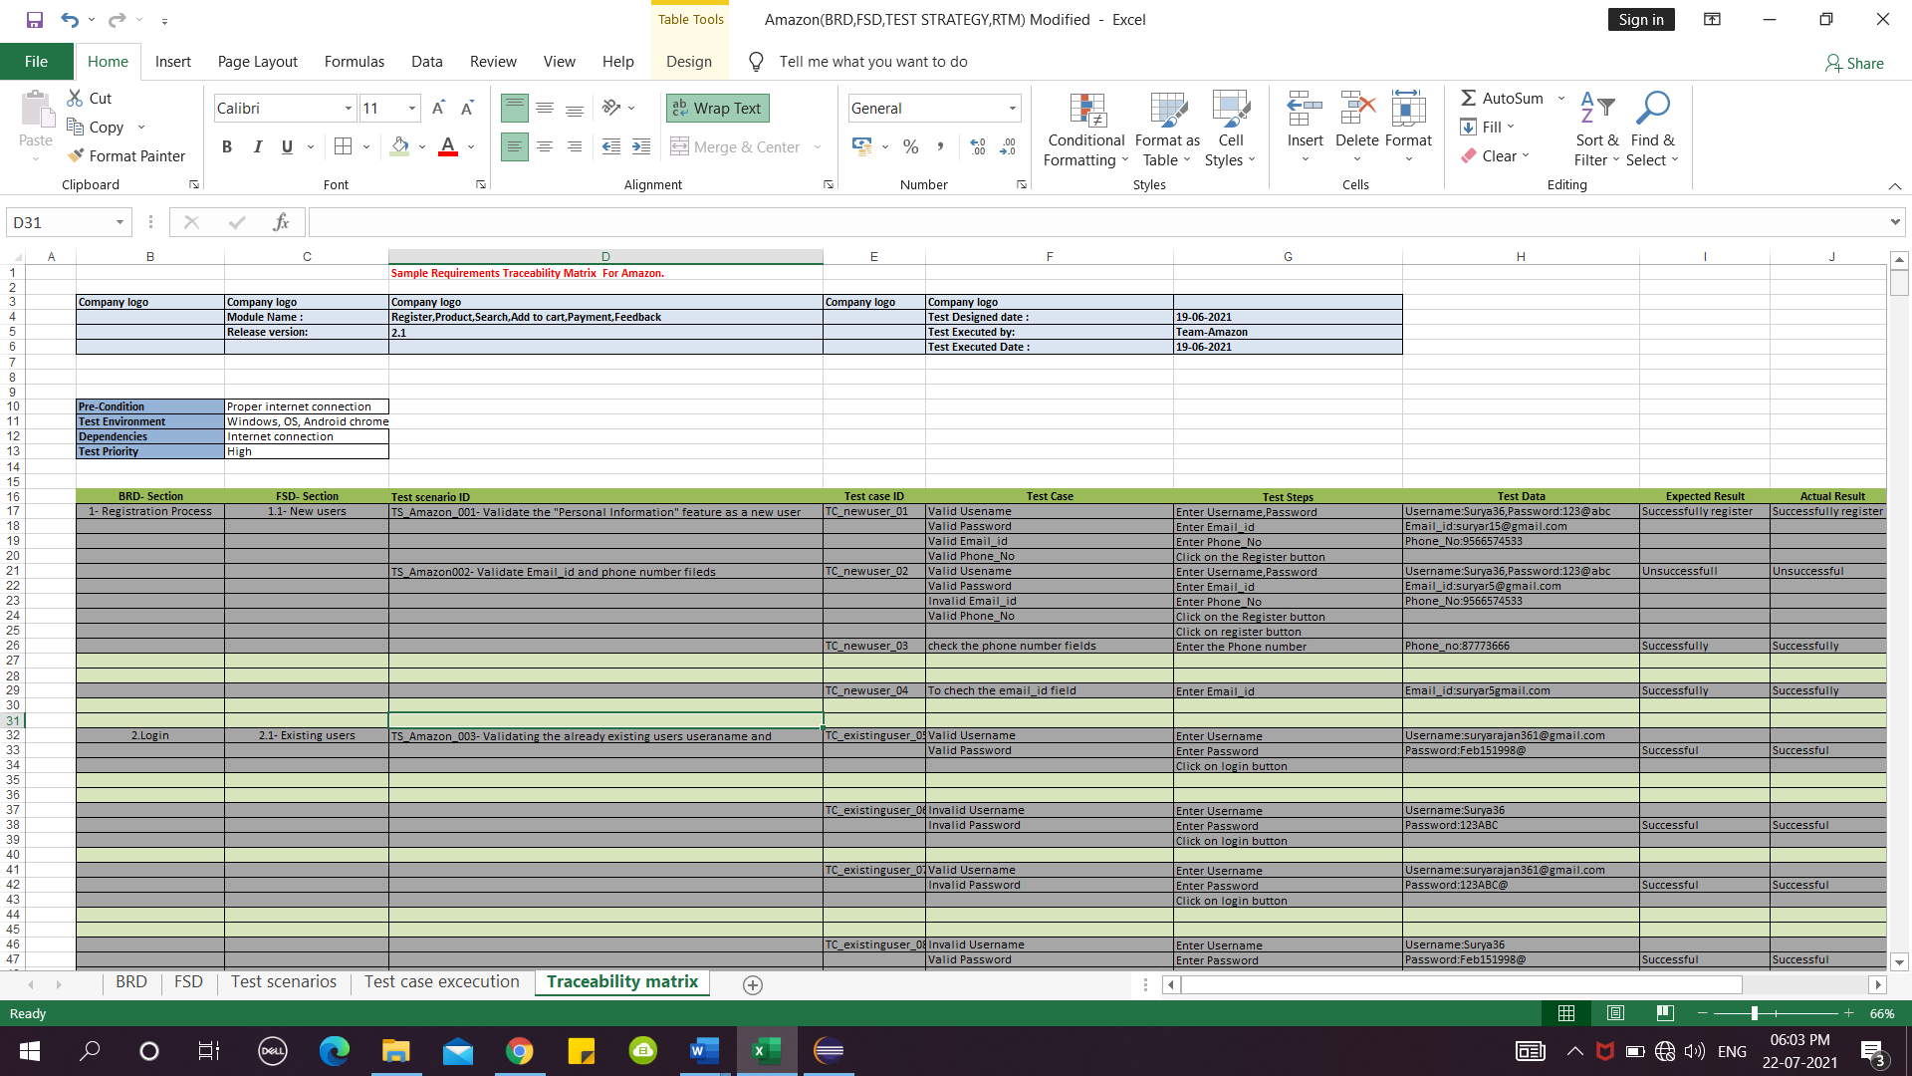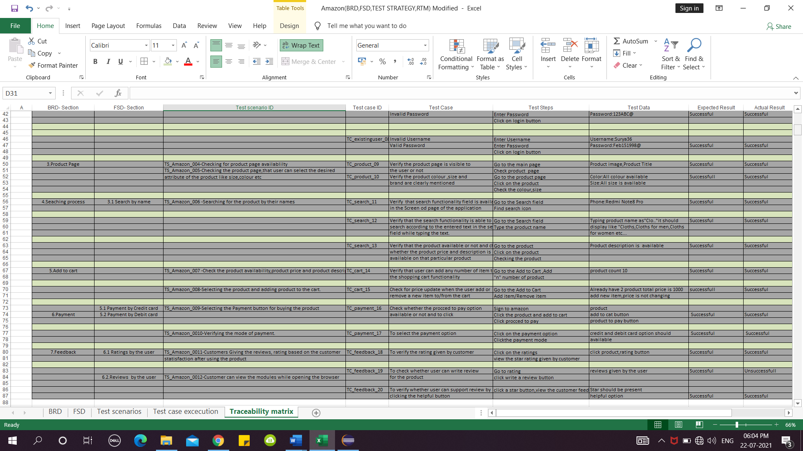

# 

# **12. Risk and mitigation**

* Use secure passwords
* Payment Security
* Privacy issues
* System reliability

# **13. Reporting tool:**

# JIRA will be the reporting tool for this project.

# **14 Test summary:**

The test strategy document is created for Amazon as per the document content. It needs to be reviewed for sign-off by all entities involved in project management, business team, development team, and system administration (or environment management) team

# **15. Approvals:**

The following people are required to approve the Test Strategy

|  |  |
| --- | --- |
| **Approved By Role** | **Approved By Name** |
| Project Coordinator | Anu Meha |
|  |  |
|  |  |