**SECURING CLOUD INFORMATION UNDER KEY INTRODUCTION**

|  |  |  |
| --- | --- | --- |
| Jeffin Gracewell J  Assistant Proffessor  Saveetha Engineering College | Jayabalan RK  ECE Dept  Saveetha Engineering College | Kadhiresan S  ECE Dept  Saveetha Engineering College |
| Chennai,India  jeffingracewellj@saveetha.ac.in | Chennai, India  [balakumar9776@gmail.com](mailto:balakumar9776@gmail.com) | Chennai,India  kadhirsudarsan5@gmail.com |
|  |  |  |

***Abstract*— Ongoing news uncover a strong assailant what breaks information privacy by gaining cryptographic keys, through compulsion or secondary passages in cryptographic programming. When the encryption key is uncovered, the main reasonable measure to protect information secrecy is to restrict the assailant's admittance to the cipher text. This might be accomplished, for instance, by spreading cipher text blocks across servers in various managerial spaces — subsequently expecting that the enemy can't think twice about of them. In any case, on the off chance that information is encoded with existing plans, an enemy outfitted with the encryption key, can in any case think twice about single server and unscramble the cipher text blocks put away in that. The proposed framework is formed with block chain empowered Stronghold Host (BH) or Stronghold server (BS) based remarkable insurance framework(UPF) for secure cloud figuring model. The proposed approach considers the AWS amazon web administrations cloud empowered entryway for testing the BH empowered UPF that influence more from weak movement. The essential objective of the framework is to give full insurance to the framework over the cloud utilizing BH and UPF and relieve the security assaults.. The framework examine the security of Bastion, and we assess its presentation through a model execution. The framework likewise talk about reasonable experiences concerning the combination of Bastion in business scattered capacity frameworks. Our assessment results propose that Bastion is appropriate for reconciliation in existing frameworks since it brings about under 5% above contrasted with existing semantically secure encryption modes.**

***Keywords***— ***Machine learning, Block chain, Cryptography, Data security, Cloud computing*.**

# INTRODUCTION

The idea of Cloud Security is only giving strong system are controls to safeguard the cloud climate from on approved admittance are private access. different cryptographic methods are executed in cloud figuring climate to safeguard the openness of cyphertext and keys acting over the verification cycle. safeguarding the digital cases is a urgent undertaking since the essential substance for encoded and decrypted design age protection upon the key[1]. in the event that the cloud security frameworks uncovered the usage of key, the encode information can be handily recovered by the programmers. creating exhaustive technique for producing such keys in Real Time systems is fundamental. the greater part of the cloud registering applications work with the idea of cryptography technique hens the key procedure can be adjusted in view of the intricacy of the organization utilizing different calculations.

Leakage resilient Cryptography is a sort of system adaptively empowered with the information on shortcoming of key age process in various elements in our utilization and change the security key to give Robert result. in customary Cryptography structures security keys are used for encryption and decryption process. though in unique applications the effect of side channel assaults power utilization electro attractive radiations can Modify The key component and effect the outcomes[2].

Leakage resilient Cryptography strategies are utilized to address the weak FX happening over the clouds climate through different conventions. satisfy sort of assaults should be distinguished in the yearly stages and eliminated from the digital cloud.

Different advancement models are engaged with improvement of leakage occupant cryptography framework in which the models break down the leakages and essential driver for leakages and assess the component. these models are useful for the scientists to recognize different weak assaults over the cloud organization and alleviate the issue over the cryptographic frameworks and safeguard the key and conventions[3].

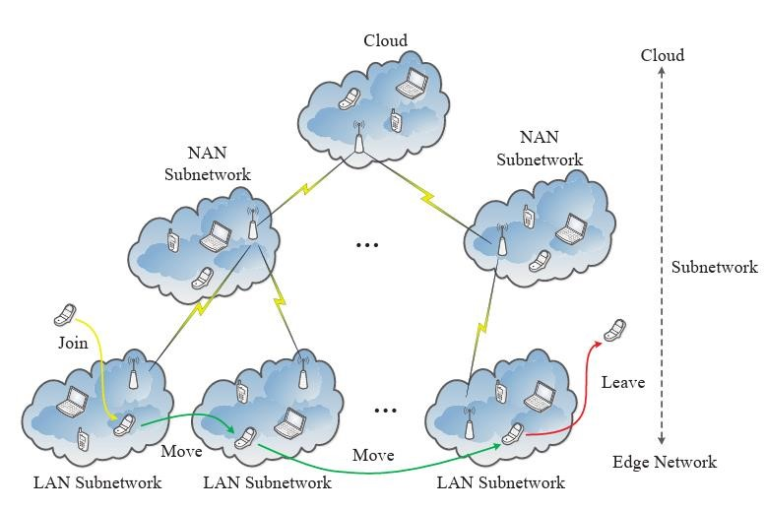

Fig 1. Key management framework

Fig 1. Show various cloud Key management framework AES encryption[4] is the regularly used cryptographic procedure which has progressed encryption norms.

The information secretly is the essential objective of the encryption cycle in the ongoing time the circulated and encoded information across the cloud figuring climate improve versatility in light of outsider access and accessibility

Within furnishing the encryptions key with the particular security the key administration framework should be developed. the key can't be uncovered on the web to all clients rather just the validated client can see the key and give Direct Admittance to the information. The essential component of safeguarding the key in digital cryptographic frameworks is proposed here. The scramble of information and privacy of the information relies on the key administration quality[5].

In specific cases in the event that the key is uncovered on the web the cloud the board framework can avoid the encryption cycle without permitting the client to see the key as well as any of the information over the web. Deniable encryption strategies are executed in network safety frameworks to safeguard the scramble the information as well as the d debasement key. in this stage text is additionally used for procuring the information about the key. deniable encryption framework are used to shield delicate data to be gained from the sites. in this situation the classified protection of the key is keep up with utilizing key administration framework. in specific cases the cloud specialist organizations absolutely get a sense of ownership with the key Administration Administrations under the equipment security empowered key Administration administrations are frequently given.

The proposed system is formulated with block chain enabled Bastion Host (BH) or Bastion server (BS) based unique protection framework(UPF) for secure cloud computing model.

The proposed approach considers the AWS amazon web services cloud enabled portal for testing the BH enabled UPF that impact more from vulnerable activity.

The primary goal of the system is to give full protection to the system over the cloud using BH and UPF and mitigate the security attacks.

The rest of the paper is formulated as making detailed literature study in Section II. The system tool selection, problem identifications are discussed in Section III. The system architecture, detailed system design steps are discussed in Section IV. The rest of the paper is concluded with future enhancement.

# BACKGROUND STUDY

1. ***Shen et al. (2019)*** the author introduced a system in which novel execution of key getting configuration is carried out focused on key understanding convention. it upholds numerous keys taking care of ability with secure cloud climate. the greater number of access increments then, at that point, plan impedes additionally getting expanded.

***Y. Wu et al., (2021)*** The author presented a system, where mobile edge devices are considered for fast improvement of distributed computing and mobile cloud computing. the system considers various physical boundaries in the cloud computing environment and detects various collisions in the cloud to serve with privacy and secure accessibility. Since people often utilizing the cloud for easy accessibility and numerous day today task, the reliability of the cloud is high and the risk of third party access is feasible.

***V. B. Gisin et al. (2021)*** A novel method is introduced for securely outsourcing data through the integration of fuzzy logic. This innovative approach leverages the power of linear regression algorithms to enhance computational capabilities significantly. Furthermore, it employs cryptographic techniques to ensure the secure transmission of data.

1. ***Geetha et al. (2021)*** The focal point of our discussion is the critical need for secure access to cloud services, which are increasingly central to modern computing. These cloud services are remotely operated, making it imperative to employ diverse access strategies that cater to different scenarios and security requirements. We delve into the nuances of these access strategies, exploring how they can be fine-tuned to suit the specific needs of users and applications. This may involve role-based access for personnel, time-based access for scheduled tasks, location-based access for geospecific services, and more.

***S. Rathore et al. (2023)*** the author presented IoT enabled network security for next generation applications. Blockchain enabled mobile edge computing that supports various levels of network issues are discussed. Through deep learning models the secure computations are enabled. The major drawback of the presented system is large occupation of GPU space. In the context of mobile edge computing, where computational resources are located closer to the end-users, the need for robust and secure communication is paramount. This is where blockchain technology steps in to provide a trust layer for communication channels. It offers an immutable record of all data transactions and interactions, ensuring that data integrity is maintained throughout the communication process.

# SYSTEM DESIGN

The cloud computing systems are capable of processing the data effectively and communicate with edge devices at high speed.

The proposed approach considers Bastion, an efficient scheme for data confidentiality management through deep understanding of encryption key standards and improving the robustness of the cipher text. Large fraction of cipher blocks is getting involved in generating unique encryption key.

The system analyses the security of Bastion, and we show that it prevents leakage of any plaintext block as long as the adversary has access to the encryption key and to all but two cipher text blocks.

The system discusses practical insights with respect to the deployment of Bastion within existing storage systems, such as the grid storage system. Keeping various existing constraints the proposed approach is implemented with Blockchain enabled secure key generation framework.

# METHODOLOGY

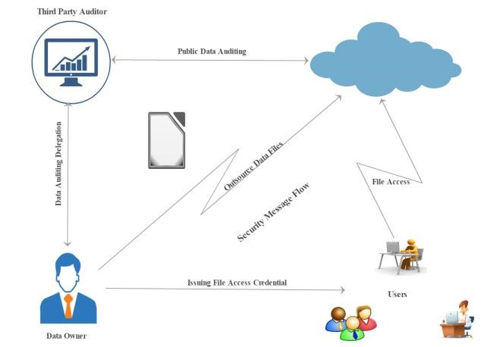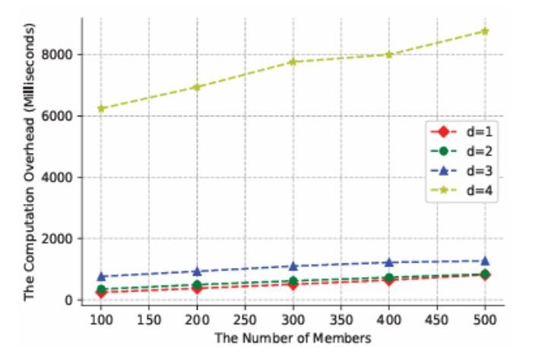

|  |
| --- |
|  |

Fig. 2. System architecture of Proposed secure communication model

The Fig 2. Shows the system architecture of proposed secure communication protocol.

The proposed approach considers Bastion based secure cloud accessing model used to enhance the security of cloud based infrastructure planning. The Bastion server or host represented as BH or BS work with unique access point and communicated through private area network or virtual area network. The authorized person in the organization have the credential accessibility to cloud network.

Because of BH implementation in the secure cloud platforms, continuous monitoring and resource validation is performed. The primary benefit of BH implies minimal impact from the network attacks. Third party services and ports are disabled to access the BH connected platforms.

The proposed BH model is placed in a unique network with isolated private network and server. organizations can significantly enhance the security of their cloud-based infrastructure, reducing the risk of unauthorized access to critical systems and data. It acts as a gatekeeper, ensuring that only authorized individuals can gain access to the internal resources while keeping a watchful eye on all activities for security and compliance purposes.

# RESULTS AND DISCUSSIONS

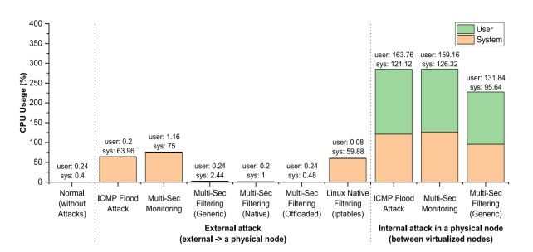

Fig 3. Attacks impacted in cloud

Fig 4. Blockchain blocks vs overhead

Fig 4. Shows the number of Blockchain blocks vs overhead often provided in the clopud computing environment. If more computational blocks are involved then most of the attack scenario is retained in the chain. This may tamper the data and keep the cloud active.

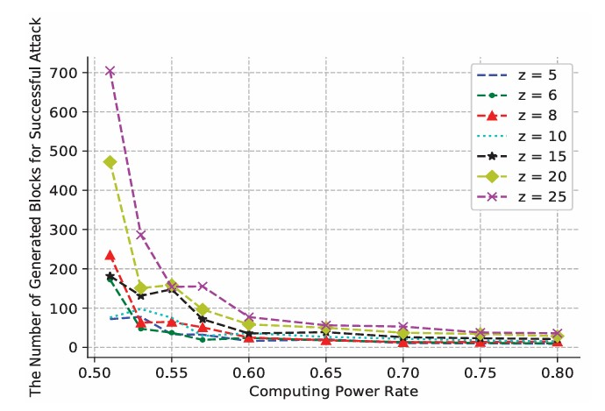

Fig 5. Computing power vs. attacks

Fig 5 shwos various levels of attacks that drain the computing power in the network. The higher the security incraeses through BH-UPF model then the number of attacks are reduced.

* The major challenge of proposed approach is that the cloud environment changes with dynamic data access.
* Everytime the system works with BH and UPF loops into the cloud access and audits the security hence the latency of process is considered as imporatnt problem.
* In future cases optimization methods are implemented to enhance the accessibility speed and robustness.

# CONCLUSION

Progressing news reveal areas of strength for a which breaks data security by acquiring cryptographic keys, through impulse or optional sections in cryptographic programming. At the point when the encryption key is revealed, the vitally sensible measure to safeguard data mystery is to limit the aggressor's induction to the code text. This may be achieved, for example, by spreading figure text blocks across servers in different administrative spaces — accordingly expecting that the adversary can't mull over of them. Regardless, if data is encoded with existing plans, a foe equipped with the encryption key, can anyway mull over single server and unscramble the code text blocks set aside in that. The proposed system is shaped with block chain engaged Fortification Host (BH) or Fortification server (BS) based noteworthy protection framework(UPF) for secure cloud figuring model. The proposed approach considers the AWS amazon web organizations cloud enabled entrance for testing the BH engaged UPF that impact more from feeble development. The fundamental target of the structure is to give full protection to the system over the cloud using BH and UPF and ease the security attacks.. The structure look at the security of Stronghold, and we evaluate its show through a model execution. The structure similarly discuss sensible encounters concerning the blend of Stronghold in business dispersed limit systems. Our appraisal results recommend that Stronghold is suitable for compromise in existing systems since it achieves under 5% above stood out from existing semantically secure encryption modes.

# REFERENCES

1. J. -S. Shin and J. Kim, "SmartX Multi-Sec: A Visibility-Centric MultiTiered Security Framework for Multi-Site Cloud-Native Edge Clusters," in IEEE Access, vol. 9, pp. 134208-134222, 2021, doi:

10.1109/ACCESS.2021.3115523.

1. J. Shen, T. Zhou, D. He, Y. Zhang, X. Sun and Y. Xiang, "Block Design-Based Key Agreement for Group Data Sharing in Cloud Computing," in IEEE Transactions on Dependable and Secure Computing, vol. 16, no. 6, pp. 996-1010, 1 Nov.-Dec. 2019, doi: 10.1109/TDSC.2017.2725953.
2. T. Halabi and M. Bellaiche, "Towards Security-Based Formation of

Cloud Federations: A Game Theoretical Approach," in IEEE Transactions on Cloud Computing, vol. 8, no. 3, pp. 928-942, 1 JulySept. 2020, doi: 10.1109/TCC.2018.2820715.

1. X. Li, Q. Wang, X. Lan, X. Chen, N. Zhang and D. Chen, "Enhancing Cloud-Based IoT Security Through Trustworthy Cloud Service: An Integration of Security and Reputation Approach," in IEEE Access, vol.

7, pp. 9368-9383, 2019, doi: 10.1109/ACCESS.2018.2890432.

1. S. An, A. Leung, J. B. Hong, T. Eom and J. S. Park, "Toward Automated Security Analysis and Enforcement for Cloud Computing Using Graphical Models for Security," in IEEE Access, vol. 10, pp. 75117-75134, 2022, doi: 10.1109/ACCESS.2022.3190545.
2. J. Shen, T. Zhou, D. He, Y. Zhang, X. Sun and Y. Xiang, "Block Design-Based Key Agreement for Group Data Sharing in Cloud Computing," in IEEE Transactions on Dependable and Secure Computing, vol. 16, no. 6, pp. 996-1010, 1 Nov.-Dec. 2019, doi: 10.1109/TDSC.2017.2725953.
3. Y. Wu et al., "Efficient Server-Aided Secure Two-Party Computation in Heterogeneous Mobile Cloud Computing," in IEEE Transactions on Dependable and Secure Computing, vol. 18, no. 6, pp. 2820-2834, 1 Nov.-Dec. 2021, doi: 10.1109/TDSC.2020.2966632.
4. V. B. Gisin and E. S. Volkova, "Secure Outsourcing of Fuzzy Linear Regression in Cloud Computing," 2021 XXIV International Conference on Soft Computing and Measurements (SCM), St.

Petersburg, Russia, 2021, pp. 172-174, doi:

10.1109/SCM52931.2021.9507102.

1. K. Geetha, "Secured Health Data Access in Cloud Computing Using Multiple Attribute-Based Encryptions," 2021 7th International Conference on Advanced Computing and Communication Systems (ICACCS), Coimbatore, India, 2021, pp. 1756-1758, doi: 10.1109/ICACCS51430.2021.9441883.
2. S. Rathore, P. K. Sharma and H. Rathore, "A Distributed Deep Learning Approach with Mobile Edge Computing for Next Generation IoT Networks Security," 2023 World Conference on Communication & Computing (WCONF), RAIPUR, India, 2023, pp. 1-3, doi:

10.1109/WCONF58270.2023.10235095.