Updated tomato genome assembly based on FISH results.

Using FISH results Steven Stack, the tomato genome scaffolds were re-ordered, re-oriented, and gap sizes between scaffolds were set. The citation for the FISH and optical mapping work is

Lindsay A. Shearer, Lorinda K. Anderson, Hans de Jong, Sandra Smit, José Luis Goicoechea, Bruce A. Roe, Axin Hua, James J. Giovannoni, and Stephen M. Stack. 2014. Fluorescence in situ hybridization and optical mapping To correct scaffold arrangement in the tomato genome.G3 g3.114.011197; doi:10.1534/g3.114.011197 (<http://www.g3journal.org/content/early/2014/05/30/g3.114.011197.abstract>)

Tiling Path Files (TPF) were modified using perl scripts in the Bio::GenomeUpdate package (authored by Surya Saha and Jeremy Edwards at SGN) available at <https://github.com/solgenomics/Bio-GenomeUpdate>. Accessioned Golden Path (AGP) and assembled chromosome and scaffold sequences were generated from the TPFs by tools available through the NCBI Genome Reference Consortium (GRC). Table 1 lists the order and orientation changes made. Table 2 lists the gap sizes that were set. Figures 1-12 show the dotplot alignments between the original build SL2.40 chromosome sequences and the new SL2.50 assemblies based on FISH results. The MUMmer version used is 3.23 and alignments of more than 1000bp with 100% identity we used to construct the dot plots.

Table 1. Order and orientation of scaffolds from FISH results.

|  |  |  |  |
| --- | --- | --- | --- |
| Chr. | Scaffold | Original Scaffold# | Reversed |
| 1 | SL2.40sc04133 | 1 |  |
| 1 | SL2.40sc04191 | 3 | yes |
| 1 | SL2.40sc03666 | 2 |  |
| 1 | SL2.40sc03594 | 4 |  |
| 1 | SL2.40sc05010 | 5 |  |
| 1 | SL2.40sc05941 | 6 |  |
| 1 | SL2.40sc06917 | 8 |  |
| 1 | SL2.40sc06903 | 7 |  |
| 1 | SL2.40sc04323 | 9 |  |
| 2 | SL2.40sc04732 | 4 | yes |
| 2 | SL2.40sc04208 | 6 | yes |
| 2 | SL2.40sc05776 | 5 |  |
| 2 | SL2.40sc06593 | 1 |  |
| 2 | SL2.40sc04142 | 2 |  |
| 2 | SL2.40sc03766 | 3 |  |
| 2 | SL2.40sc03665 | 7 |  |
| 3 | SL2.40sc04439 | 1 |  |
| 3 | SL2.40sc04696 | 4 |  |
| 3 | SL2.40sc05330 | 5 |  |
| 3 | SL2.40sc04126 | 6 |  |
| 3 | SL2.40sc04616 | 9 |  |
| 3 | SL2.40sc06725 | 7 |  |
| 3 | SL2.40sc04704 | 8 |  |
| 3 | SL2.40sc04822 | 2 | yes |
| 3 | SL2.40sc03721 | 12 |  |
| 3 | SL2.40sc03806 | 10 |  |
| 3 | SL2.40sc03796 | 11 |  |
| 3 | SL2.40sc06911 | 3 | yes |
| 3 | SL2.40sc03701 | 13 |  |
| 4 | SL2.40sc03604 | 1 |  |
| 4 | SL2.40sc05339 | 3 | yes |
| 4 | SL2.40sc03683 | 2 | yes |
| 4 | SL2.40sc06101 | 4 |  |
| 4 | SL2.40sc04680 | 5 |  |
| 4 | SL2.40sc04135 | 6 |  |
| 5 | SL2.40sc03726 | 1 |  |
| 5 | SL2.40sc06155 | 2 | yes |
| 5 | SL2.40sc03902 | 3 |  |
| 6 | SL2.40sc04474 | 1 |  |
| 6 | SL2.40sc06140 | 3 | yes |
| 6 | SL2.40sc05383 | 2 |  |
| 6 | SL2.40sc04279 | 4 |  |
| 6 | SL2.40sc05188 | 5 | yes |
| 6 | SL2.40sc05732 | 6 |  |
| 6 | SL2.40sc05054 | 7 |  |
| 6 | SL2.40sc03622 | 8 |  |
| 7 | SL2.40sc03731 | 1 |  |
| 7 | SL2.40sc05397 | 2 |  |
| 7 | SL2.40sc03685 | 3 |  |
| 7 | SL2.40sc04626 | 4 |  |
| 8 | SL2.40sc04813 | 1 |  |
| 8 | SL2.40sc03770 | 2 |  |
| 8 | SL2.40sc04167 | 7 |  |
| 8 | SL2.40sc03749 | 5 | yes |
| 8 | SL2.40sc04236 | 6 | yes |
| 8 | SL2.40sc03835 | 3 | yes |
| 8 | SL2.40sc04701 | 4 | yes |
| 8 | SL2.40sc04948 | 8 |  |
| 8 | SL2.40sc03923 | 9 |  |
| 9 | SL2.40sc03771 | 1 |  |
| 9 | SL2.40sc06916 | 2 |  |
| 9 | SL2.40sc04008 | 4 |  |
| 9 | SL2.40sc04950 | 3 | yes |
| 9 | SL2.40sc04785 | 5 |  |
| 9 | SL2.40sc04777 | 6 |  |
| 9 | SL2.40sc05269 | 7 |  |
| 9 | SL2.40sc03852 | 8 |  |
| 9 | SL2.40sc04828 | 9 |  |
| 9 | SL2.40sc06214 | 10 |  |
| 10 | SL2.40sc05925 | 1 |  |
| 10 | SL2.40sc03798 | 2 |  |
| 10 | SL2.40sc04872 | 4 |  |
| 10 | SL2.40sc05632 | 3 |  |
| 10 | SL2.40sc04534 | 5 |  |
| 10 | SL2.40sc04199 | 6 |  |
| 11 | SL2.40sc03748 | 1 |  |
| 11 | SL2.40sc06763 | 4 |  |
| 11 | SL2.40sc04054 | 2 |  |
| 11 | SL2.40sc03752 | 3 | yes |
| 11 | SL2.40sc06137 | 5 |  |
| 11 | SL2.40sc03876 | 6 |  |
| 12 | SL2.40sc04607 | 1 |  |
| 12 | SL2.40sc06147 | 2 |  |
| 12 | SL2.40sc04039 | 3 | yes |
| 12 | SL2.40sc04878 | 4 |  |
| 12 | SL2.40sc04266 | 5 |  |
| 12 | SL2.40sc04757 | 6 |  |
| 12 | SL2.40sc04057 | 7 |  |
| 12 | SL2.40sc04915 | 8 |  |
| 12 | SL2.40sc05611 | 9 |  |
| 12 | SL2.40sc05380 | 10 |  |

Table 2. Gap sizes between scaffolds determined by FISH.

|  |  |  |  |
| --- | --- | --- | --- |
| Chr. | Gap start | Gap end | Size (Mb) |
| 1 | SL2.40sc04133 | SL2.40sc04191 | 2.28 |
| 1 | SL2.40sc04191 | SL2.40sc03666 | 2.13 |
| 1 | SL2.40sc03666 | SL2.40sc03594 | 0.57 |
| 1 | SL2.40sc03594 | SL2.40sc05010 | 2.12 |
| 1 | SL2.40sc05010 | SL2.40sc05941 | 0.51 |
| 1 | SL2.40sc05941 | SL2.40sc06917 | 0.25 |
| 1 | SL2.40sc06917 | SL2.40sc06903 | 0.17 |
| 1 | SL2.40sc06903 | SL2.40sc04323 | 0.21 |
| 2 | SL2.40sc04732 | SL2.40sc04208 | 0.34 |
| 2 | SL2.40sc04208 | SL2.40sc05776 | 0.10 |
| 2 | SL2.40sc05776 | SL2.40sc06593 | 0.10 |
| 2 | SL2.40sc06593 | SL2.40sc04142 | 3.05 |
| 2 | SL2.40sc04142 | SL2.40sc03766 | 0.49 |
| 2 | SL2.40sc03766 | SL2.40sc03665 | 1.34 |
| 3 | SL2.40sc04439 | SL2.40sc04696 | 0.09 |
| 3 | SL2.40sc04696 | SL2.40sc05330 | 0.10 |
| 3 | SL2.40sc05330 | SL2.40sc04126 | 0.32 |
| 3 | SL2.40sc04126 | SL2.40sc04616 | 2.58 |
| 3 | SL2.40sc04616 | SL2.40sc06725 | 0.16 |
| 3 | SL2.40sc06725 | SL2.40sc04704 | 0.74 |
| 3 | SL2.40sc04704 | SL2.40sc04822 | 1.09 |
| 3 | SL2.40sc04822 | SL2.40sc03806 | -0.37 |
| 3 | SL2.40sc03806 | SL2.40sc03796 | 0.10 |
| 3 | SL2.40sc03796 | SL2.40sc06911 | 0.07 |
| 3 | SL2.40sc06911 | SL2.40sc03701 | 0.08 |
| 4 | SL2.40sc03604 | SL2.40sc05339 | 0.30 |
| 4 | SL2.40sc05339 | SL2.40sc03683 | 0.47 |
| 4 | SL2.40sc03683 | SL2.40sc06101 | 0.08 |
| 4 | SL2.40sc06101 | SL2.40sc04680 | 0.03 |
| 4 | SL2.40sc04680 | SL2.40sc04135 | 1.53 |
| 5 | SL2.40sc03726 | SL2.40sc06155 | 0.85 |
| 5 | SL2.40sc06155 | SL2.40sc05339 | 0.75 |
| 6 | SL2.40sc04474 | SL2.40sc06140 | 2.34 |
| 6 | SL2.40sc06140 | SL2.40sc05383 | 0.61 |
| 6 | SL2.40sc05383 | SL2.40sc04279 | 0.34 |
| 6 | SL2.40sc04279 | SL2.40sc05188 | 1 |
| 6 | SL2.40sc05188 | SL2.40sc05732 | 1 |
| 6 | SL2.40sc05732 | SL2.40sc05054 | 1 |
| 6 | SL2.40sc05054 | SL2.40sc03622 | 1 |
| 7 | SL2.40sc03731 | SL2.40sc05397 | 0.39 |
| 7 | SL2.40sc05397 | SL2.40sc03685 | 2.29 |
| 7 | SL2.40sc03685 | SL2.40sc04626 | 0.10 |
| 8 | SL2.40sc04813 | SL2.40sc03770 | 0.10 |
| 8 | SL2.40sc03770 | SL2.40sc04167 | 0.52 |
| 8 | SL2.40sc04167 | SL2.40sc03749 | 0.26 |
| 8 | SL2.40sc03749 | SL2.40sc04236 | 0.10 |
| 8 | SL2.40sc04236 | SL2.40sc03835 | 0.04 |
| 8 | SL2.40sc03835 | SL2.40sc04701 | 0.97 |
| 8 | SL2.40sc04701 | SL2.40sc04948 | 0.80 |
| 8 | SL2.40sc04948 | SL2.40sc03923 | 0.04 |
| 9 | SL2.40sc03771 | SL2.40sc04008 | 1.46 |
| 9 | SL2.40sc04008 | SL2.40sc04950 | 0.72 |
| 9 | SL2.40sc04950 | SL2.40sc04785 | 1.05 |
| 9 | SL2.40sc04785 | SL2.40sc04777 | 1.25 |
| 9 | SL2.40sc04777 | SL2.40sc05269 | 1 |
| 9 | SL2.40sc05269 | SL2.40sc03852 | 1 |
| 9 | SL2.40sc03852 | SL2.40sc04828 | 0.04 |
| 9 | SL2.40sc04828 | SL2.40sc06214 | 0.07 |
| 10 | SL2.40sc05925 | SL2.40sc03798 | 0.10 |
| 10 | SL2.40sc03798 | SL2.40sc04872 | 0.39 |
| 10 | SL2.40sc04872 | SL2.40sc05632 | 0.10 |
| 10 | SL2.40sc05632 | SL2.40sc04199 | 0.10 |
| 11 | SL2.40sc03748 | SL2.40sc06763 | 0.35 |
| 11 | SL2.40sc06763 | SL2.40sc04054 | 0.53 |
| 11 | SL2.40sc04054 | SL2.40sc03752 | 1.31 |
| 11 | SL2.40sc03752 | SL2.40sc06137 | 0.07 |
| 11 | SL2.40sc06137 | SL2.40sc03876 | 0.65 |
| 12 | SL2.40sc04607 | SL2.40sc06147 | 0.17 |
| 12 | SL2.40sc06147 | SL2.40sc04039 | 0.01 |
| 12 | SL2.40sc04039 | SL2.40sc04878 | 0.08 |
| 12 | SL2.40sc04878 | SL2.40sc04266 | 0.55 |
| 12 | SL2.40sc04266 | SL2.40sc04757 | 0.47 |
| 12 | SL2.40sc04057 | SL2.40sc04915 | 0.01 |
| 12 | SL2.40sc04915 | SL2.40sc05611 | 0.07 |
| 12 | SL2.40sc05611 | SL2.40sc05380 | 0.01 |

Figure 1. Chromosome 1: Dotplot of original vs FISH-modified chromosome sequence. 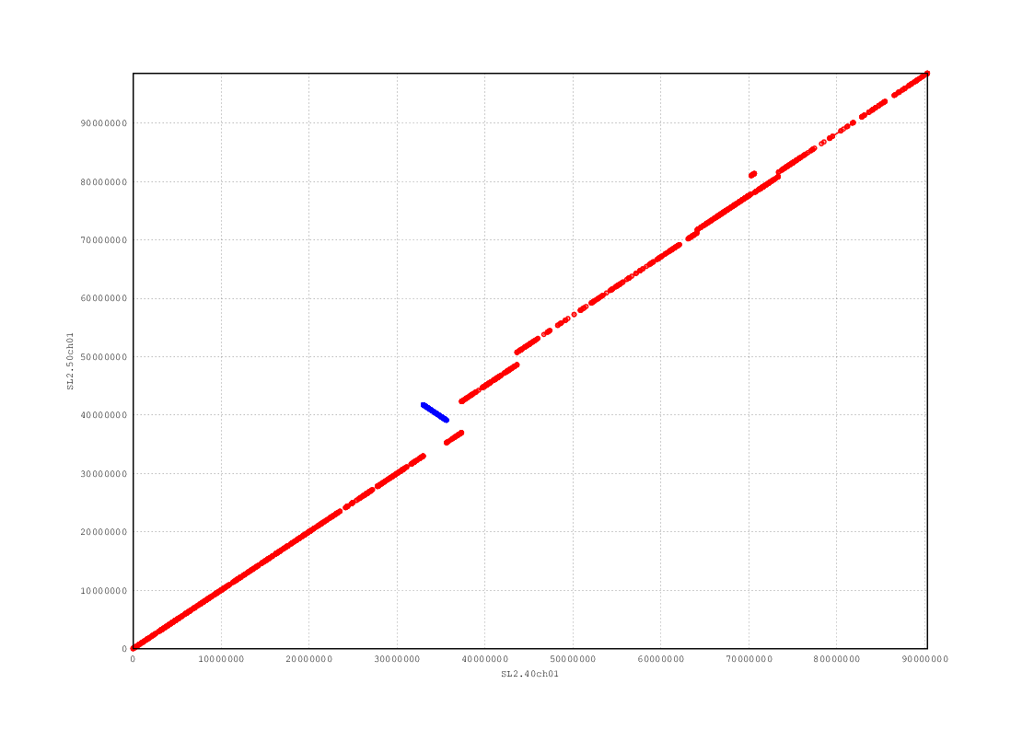

Figure 2. Chromosome 2: Dotplot of original vs FISH-modified chromosome sequence.

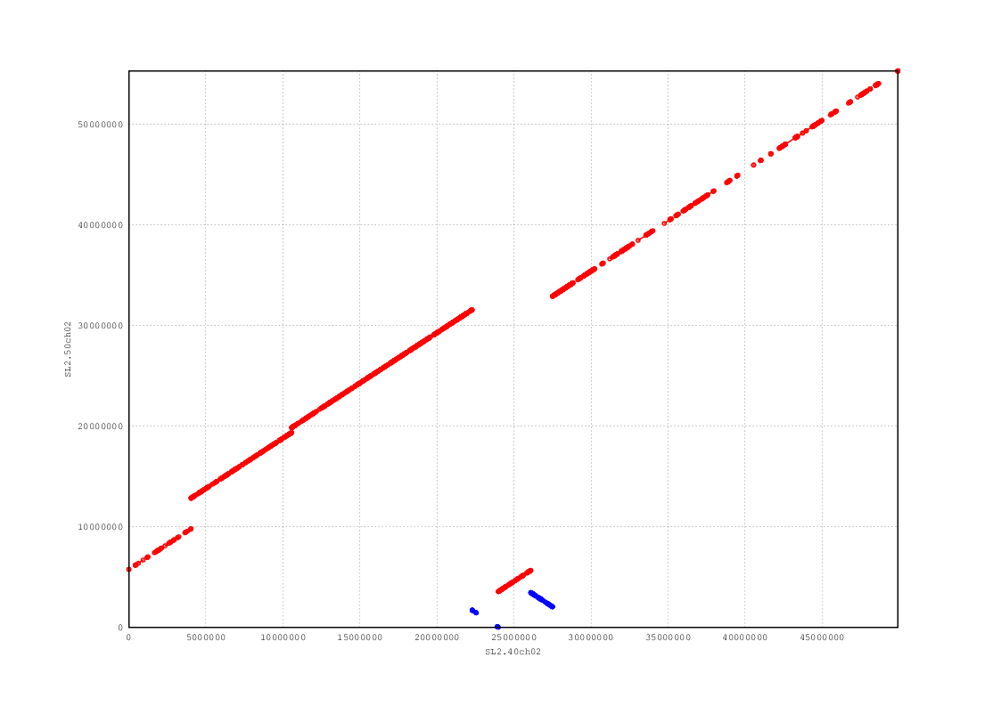

Figure 3. Chromosome 3: Dotplot of original vs FISH-modified chromosome sequence.

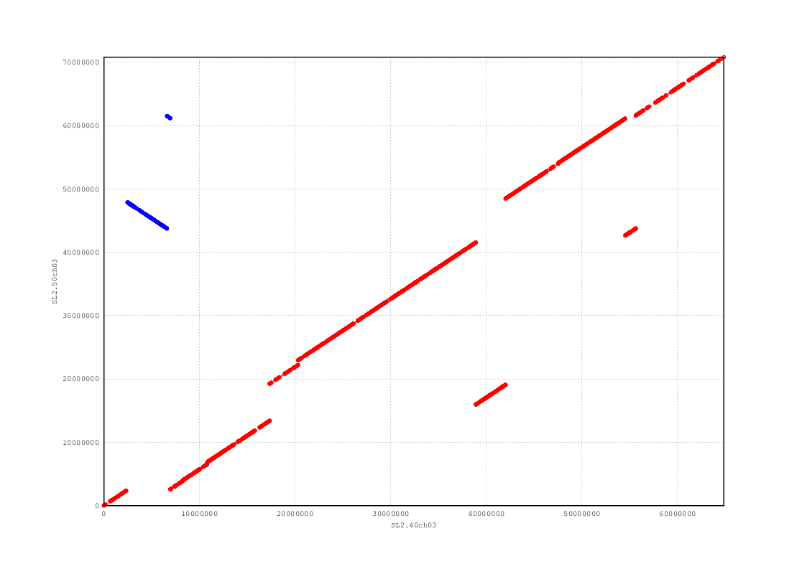

Figure 4. Chromosome 4: Dotplot of original vs FISH-modified chromosome sequence.

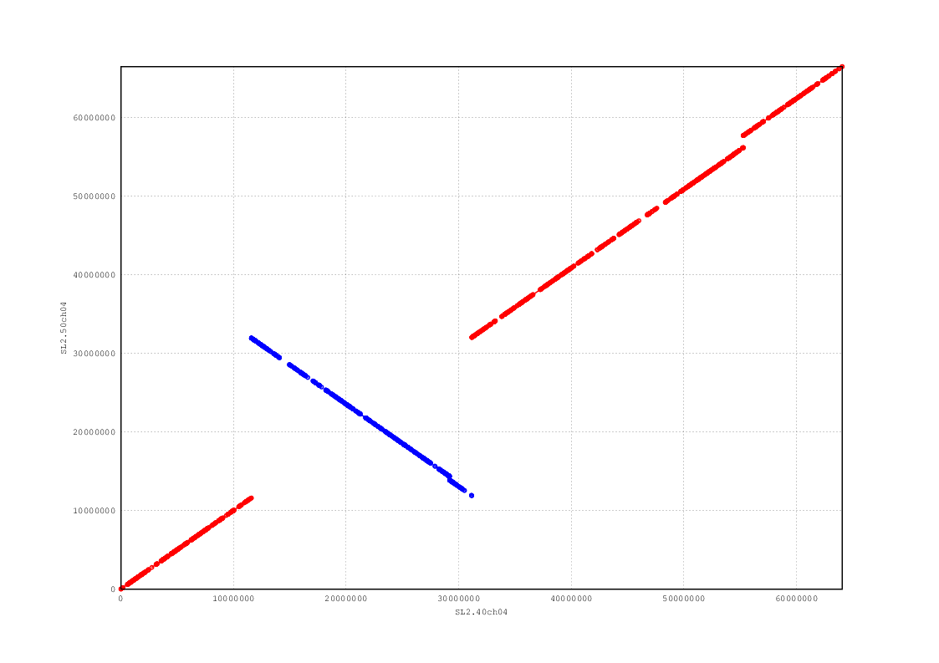

Figure 5. Chromosome 5: Dotplot of original vs FISH-modified chromosome sequence.

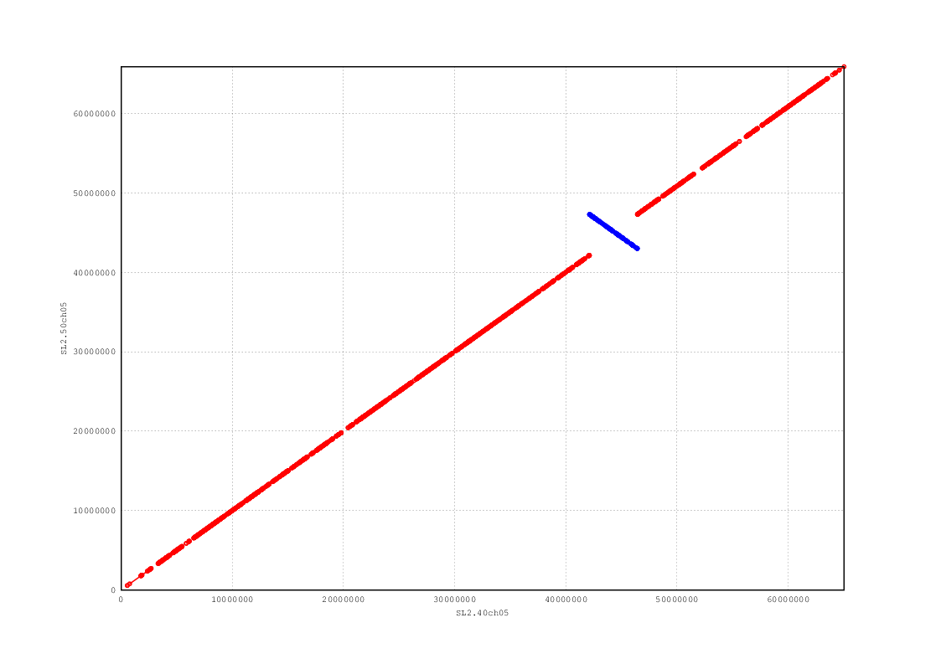

Figure 6. Chromosome 6: Dotplot of original vs FISH-modified chromosome sequence.

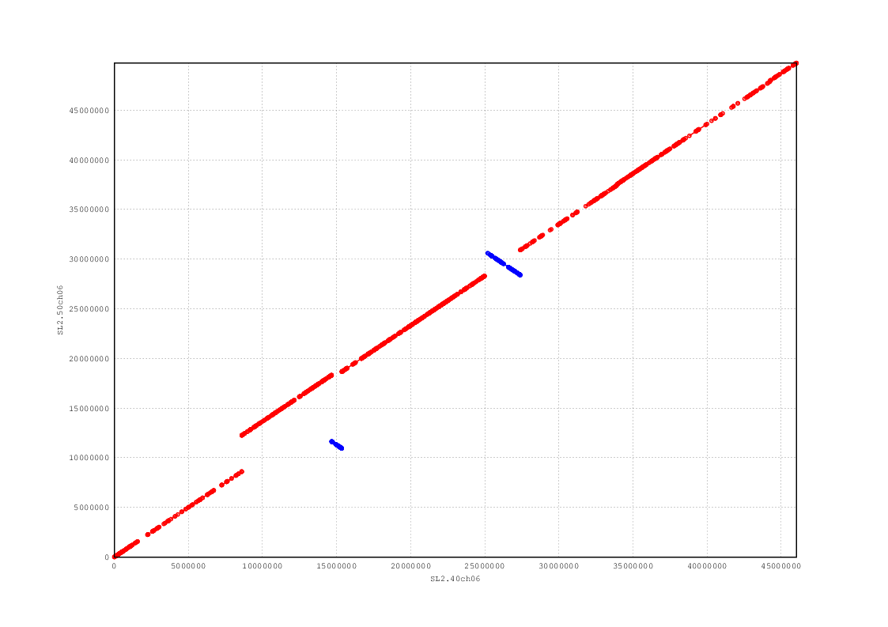

Figure 7. Chromosome 7: Dotplot of original vs FISH-modified chromosome sequence.

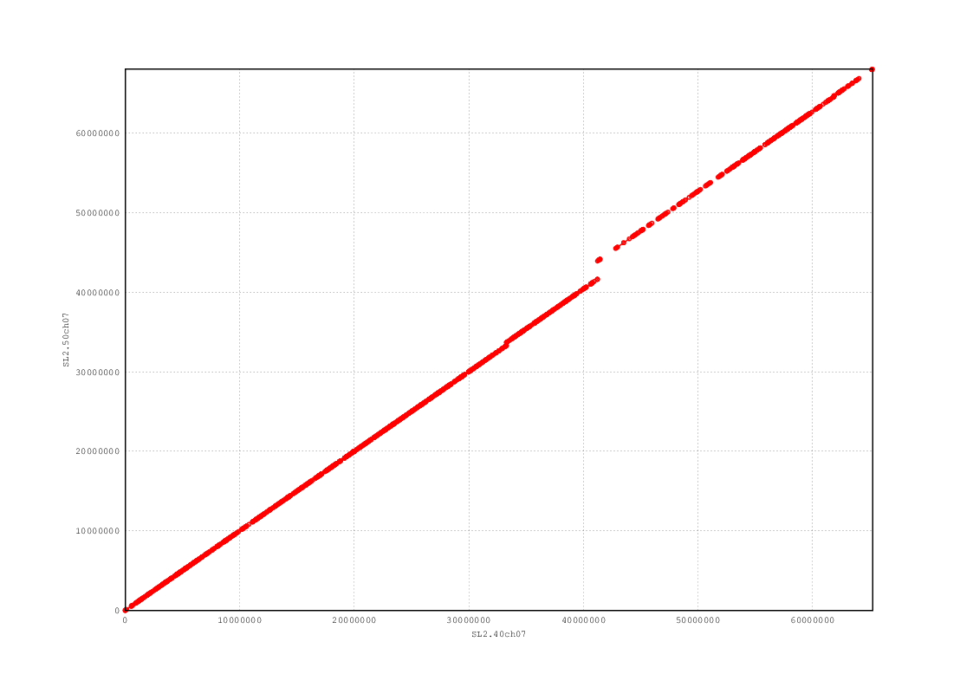

Figure 8. Chromosome 8: Dotplot of original vs FISH-modified chromosome sequence.

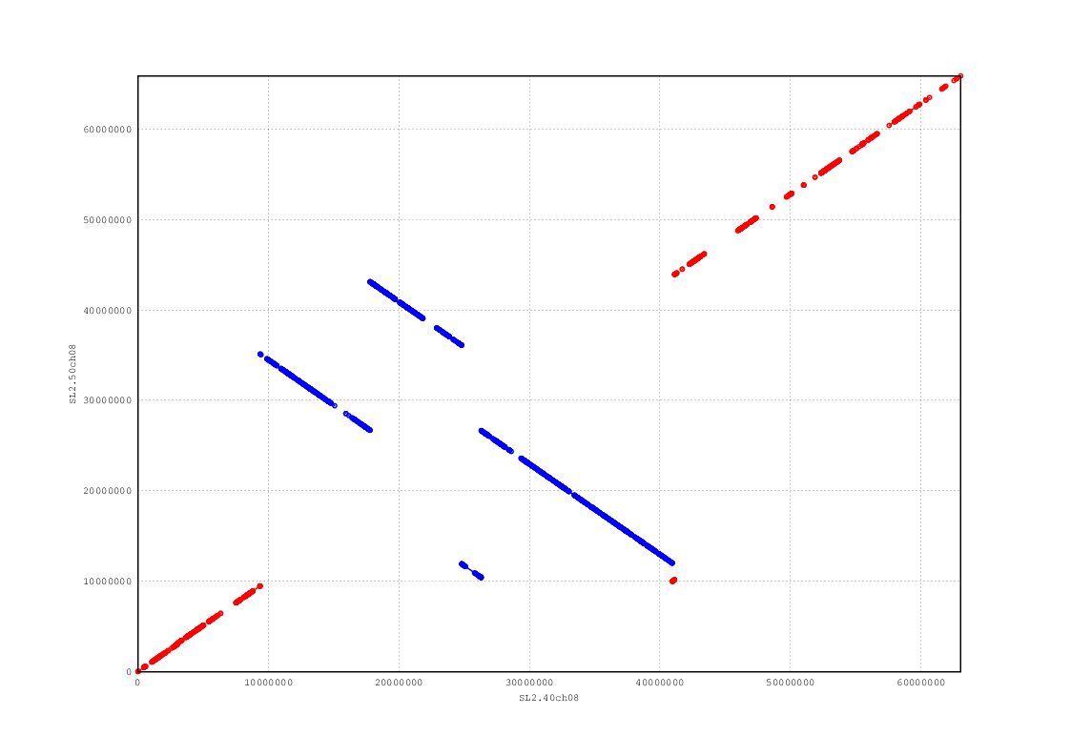

Figure 9. Chromosome 9: Dotplot of original vs FISH-modified chromosome sequence.

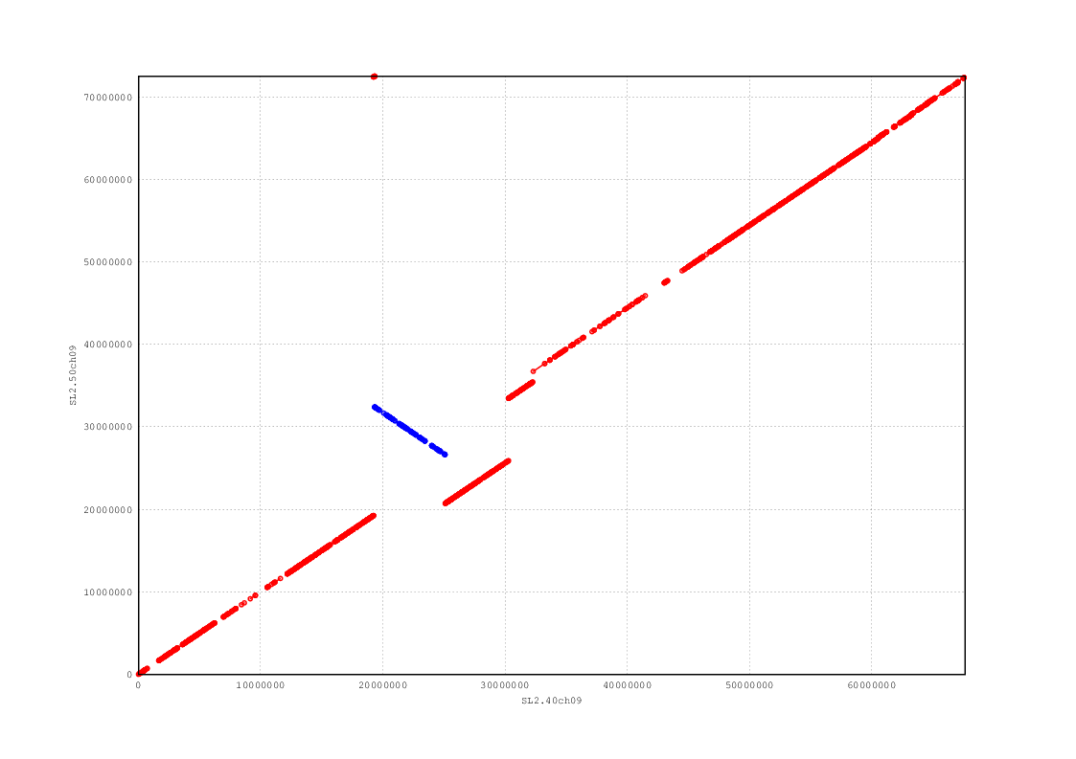

Figure 10. Chromosome 10: Dotplot of original vs FISH-modified chromosome sequence.

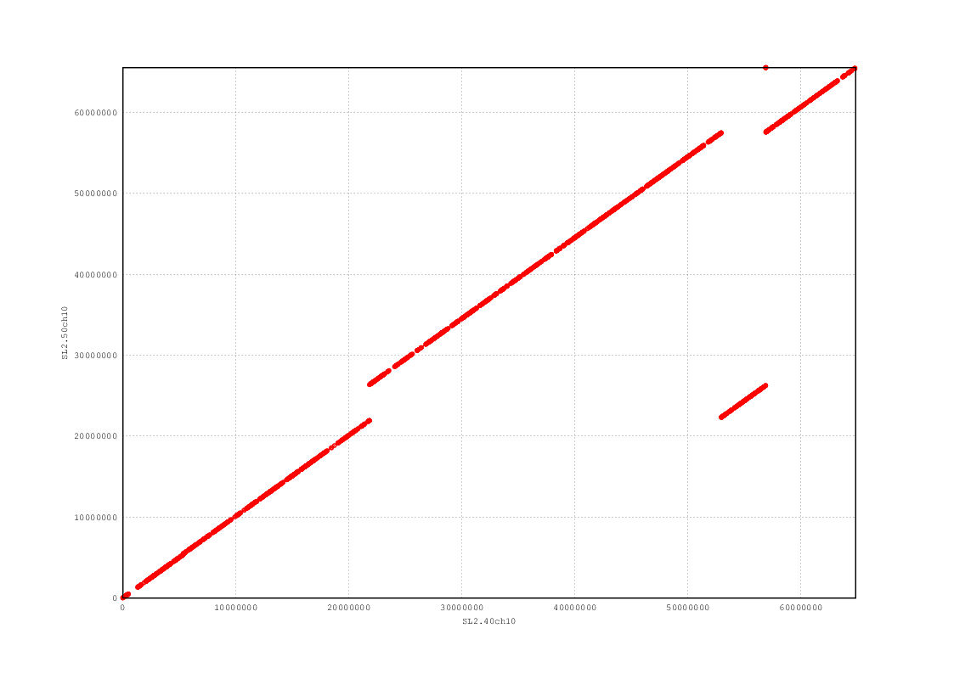

Figure 11. Chromosome 11: Dotplot of original vs FISH-modified chromosome sequence.

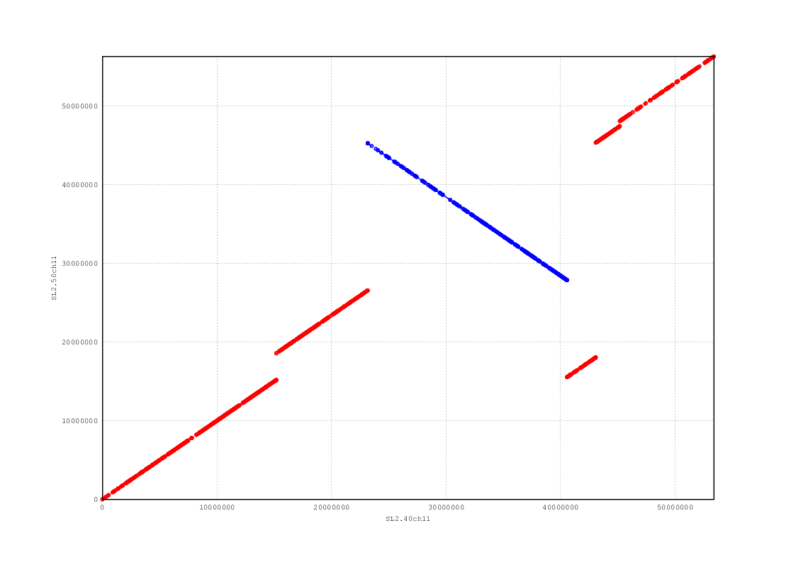

Figure 12. Chromosome 12: Dotplot of original vs FISH-modified chromosome sequence.

