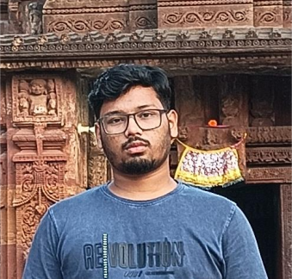
TECHNICAL SKILLS
EXPERIENCE
Being a Data Science enthusiast I aims to provide values to the industry with my detailed knowledge and ideas which can put a acceleration to the future of the industry. My strong problem solving skill can result to the intense discovery of insights. Passionate towards learning new stuff and exploring the ocean of data and information.

- Brain Tumor Classifiation and Segmentation:
The System classifies Brain Tumor types and extract the tumor segment part using advanced Deep Learning Approach.
- Movie Recommendation System:
The Movie Recommedation System used the approach of content based filtering to recommend the appropriate movie.
- Chronic Kidney Disease Prediction:
Developed a Hybrid ML model that predicts the presence of CKD in a person.
- Hate Speech Detection:
Developed a NLP model that can detect Hate Speeches and classify it out.
- SuperMarket Sales Analysis and Prediction:
Extracted the valuable insigts from super market data and presented using advance visualization technic and text.
- Loan Approval Prediction:
Visualized the important imformation using advance graphs. Reported the useful insights using text.
AJAY BINAY INSTITUTE OF TECHNOLOGY, CUTTACK
B.TECH (COMPUTER SCIENCE AND ENGINEERING) 2021 - PRESENT
CGPA: 8.0

JAWAHAR NAVODAY VIDYALAY, KHORDHA
HIGHER SECONDARY (12TH) 2019 - 2021
84.6%

JAWAHAR NAVODAY VIDYALAY, PURI
MATRICULATION (10TH) 2014 - 2019
81%

SUMMARY
EDUCATION

PROJECT WORKS
LANGUAGES

HOBIES

ACHIEVEMENTS
1. Data Science (Data Analysis, Visualization, Feature Engineering etc.)
2. Machine Learning (Supervised, Unsupervised, Deep Learing etc.)
3. Python (Pandas, Numpy, Matplotlib, Sci-Kit Learn, Tensorflow, Keras, TKinter etc.)
4. MySQL

- 1st in Coding Competition in 25th ISTE State Level Annual Student Convention

- 2nd in Paper Presentation in 25th ISTE State Level Annual Student Convention

CERTIFICATIONS
1. AIML with Python
Central Tool-room and Training Center, Bhubaneswar
15 June 2024 - 13 July 2024
2. Data Science and Machine Learning with Python
Whizzo Infotech Pvt. Ltd., Bhubaneswar
23 Nov 2023 - 22 Mar 2024

- 5 Star in Hacker Rank
1. Problem Solving
2. Python Programming
3. SQL
2. AIML Training Certification
3. Data Science and ML Training Certifications

- ENGLISH (ADVANCED)
- HINDI (ADVANCED)
- ODIA (PROFICIENT)

- Solving to coding problems
- Listening to music

SURYA NARAYAN SAHOO
Katatpur, Puri, Odisha - 752119 +91 9938406590

suryasahoo1631992@gmail.com www.linkedin.com/in/suryasahoo163

