- 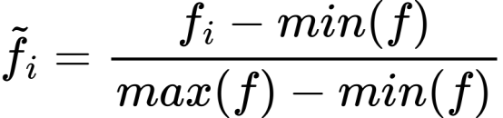
- 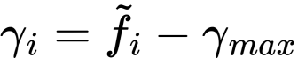
- 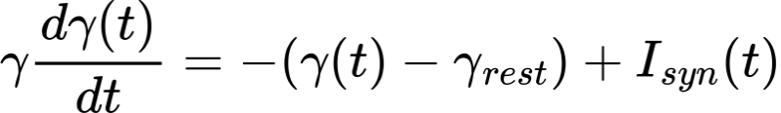
- If presynaptic spikes occure at time {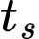} with weight 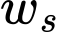.
  - 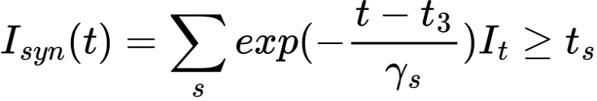
- Using surrogate derivative 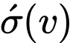 for non-differentiable spke:

 