Business Oriented Program (BOP) Project Report

on

**ONLINE QUIZ APPLICATION**

Submitted to:

Mr. Valan Arasu



**Submitted by:**

|  |  |
| --- | --- |
| **Pankaj Yadav** | **20099031** |
| **Surya Saini** | **20098973** |
| **Devika S** | **40034072** |
| **Vaibhavi N V** | **20099147** |
| **Shreya Powar** | **20099140** |
| **Manish Kumar Sharma** | **20099032** |
| **Roja Rose Thomas** | **40033441** |

**ABSTRACT**

It is good source of interactivities among students and between the teacher and students. It is done in order to improve student‘s comprehension levels and learning motivation. As one of their tools, online test tools are quite effective. However, in order to use the online test tool, a teacher is generally required a great deal of labor. For example, a teacher needs to create quizzes and input them in the online test tool. In order to solve these problems, we have developed a Web-based online test system which can create quizzes competitively and collaboratively by students for the purpose of reducing the load required for a teacher and promoting interactions among students and between the teacher and students.

**INTRODUCTION**

The ONLINE QUIZ APPLICATION is a web application for to take online test in an efficient manner and no time wasting for checking the paper. The main objective of ONLINE QUIZ APPLICATION is to efficiently evaluate the candidate thoroughly through a fully automated system that not only saves lot of time but also gives fast results. For students they give papers according to their convenience and time and there is no need of using extra thing like paper, pen etc. This can be used in educational institutions as well as in corporate world. Can be used anywhere any time as it is a web based application (user location doesn’t matter). No restriction that examiner has to be present when the candidate takes the test.

This Web Application provides facility to conduct online examination worldwide.

It saves time as it allows number of students to give the exam at a time and displays the results as the test gets over, so no need to wait for the result. It is automatically generated by the server. Administrator has a privilege to create, modify and delete the test

papers and its particular questions. User can register, login and give the test with his specific id, and can see the results as well.

**TECHNOLOGY/ SOFTWARE USED**

1. **Eclipse Software:** Eclipse software is used in the project to make the quiz application. It includes use of applications such as HTML, CSS, JSP, Servlet, and JavaScript.
2. **MySQL:** Database is created, stored and updated using MySQL. The relevant queries are executed in MySQL using JDBC.
3. **MVC** design Pattern is used in the entire project to maintain the folders throughout the project.

**PROJECT DETAILS**

**Home-Page:** The home-page consists of navigation bar to toggle through different pages of the online quiz application. The navigation bar consists of Home, About Us, Login, Register, and Contact Us. Clicking on any one button in the navigation bar, the page will scroll to different sections of the page. Clicking on the Login button will redirect the application to the login page.



Figure1: Online Quiz Application Home Page.

**Login:** This page will give the user, the choice to select his/her type (student or professor) and separate database will be maintained for student and professor.

If the user will click on the professor login button, then the user will be redirected to login/signup page where he/she can fill up the required credentials if signing in. If the user has not registered already, he/she will have to sign up to access the application. The sign Up and Log In contains required validations. For eg. In sign up, the user will have to fill up all required personal details to register in the quiz application. The password contains required specifications (Uppercase letters, lowercase letters, numbers, special characters and it must be 12-characters long).

**Professor Login:** Once the professor has logged in, the professor is able to do changes like add or delete topics, add or view or edit questions, can view student details. Clicking on the profile button, the user can view his profile containing the details, he/she has entered while registering (signing up), and also can change the password in the quiz application. The “profile” page has various validations like the new password and confirm password must be same, user must fill out all the fields in the form, user must provide correct email Id and old password. The password entered by the user will be checked with the password in the database

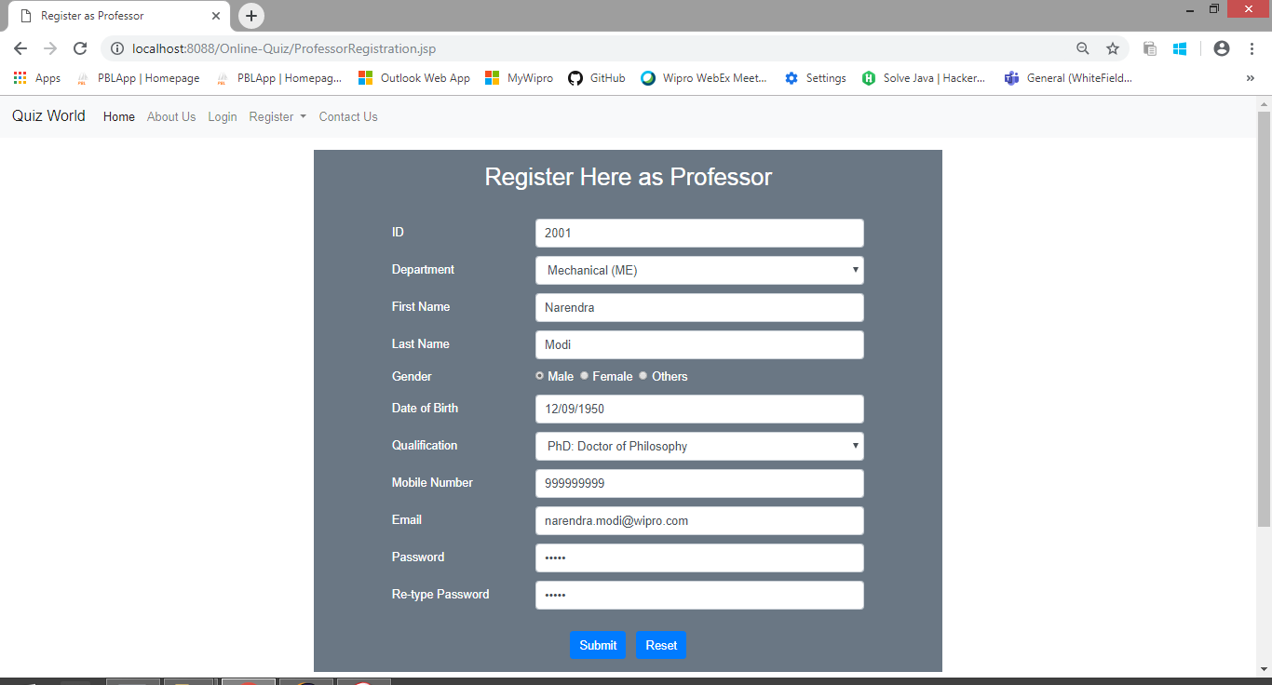

Figure 2: Professor Registration Page

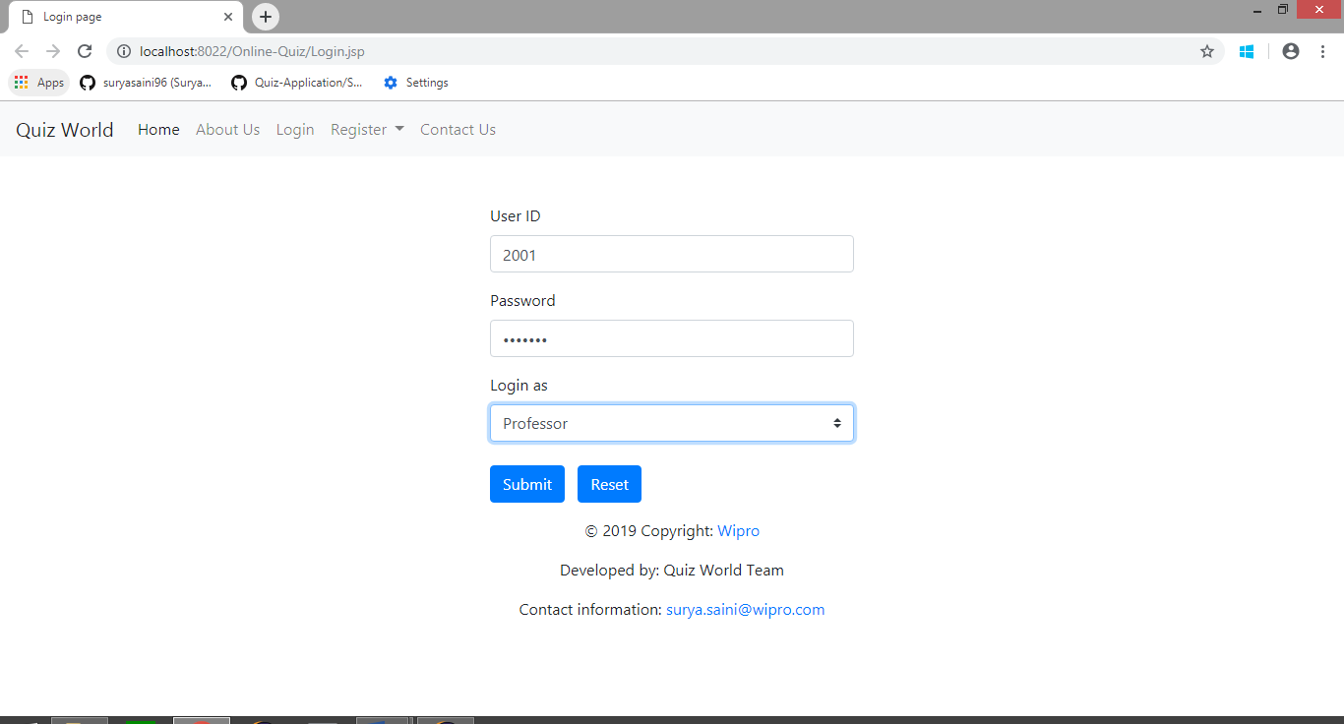

Figure 3: Professor Login Page

After the professor clicks on “Add and View Question” button provided, the professor can edit, view, delete the questions in the quizzes present in the database, else he/she can only view the quizzes provided by other professors. The professor can also delete the whole quiz, provided in any subject. The professor can also change the name of the title of the quiz

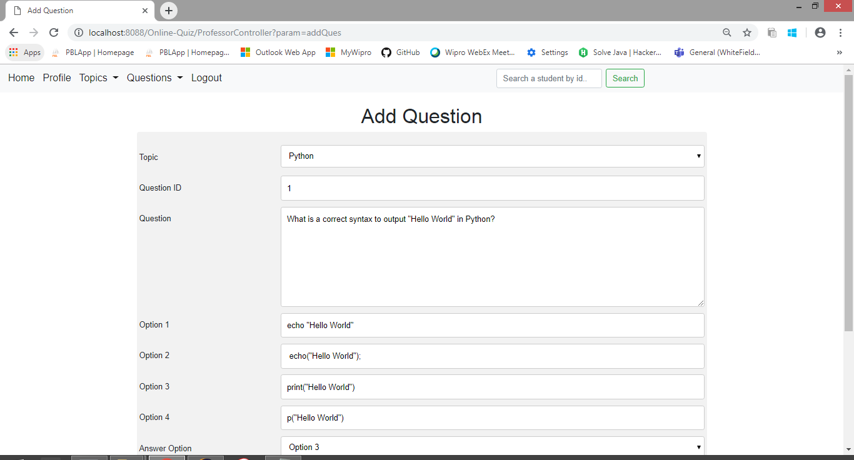

Figure 4: Add Question Page

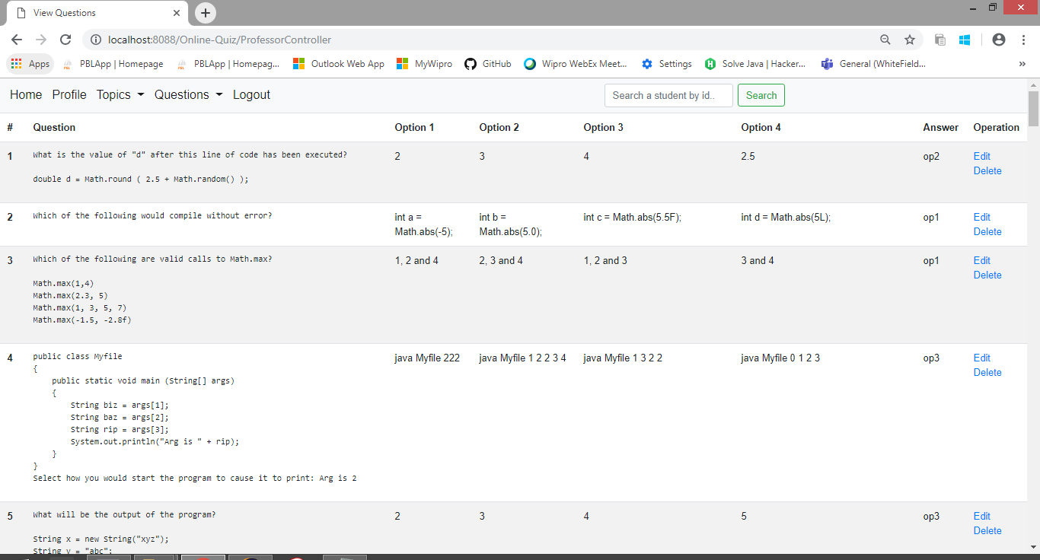Figure 5: View Question Page.

**Student Login:** Once the student has logged in, the following student home page will appear on the screen.

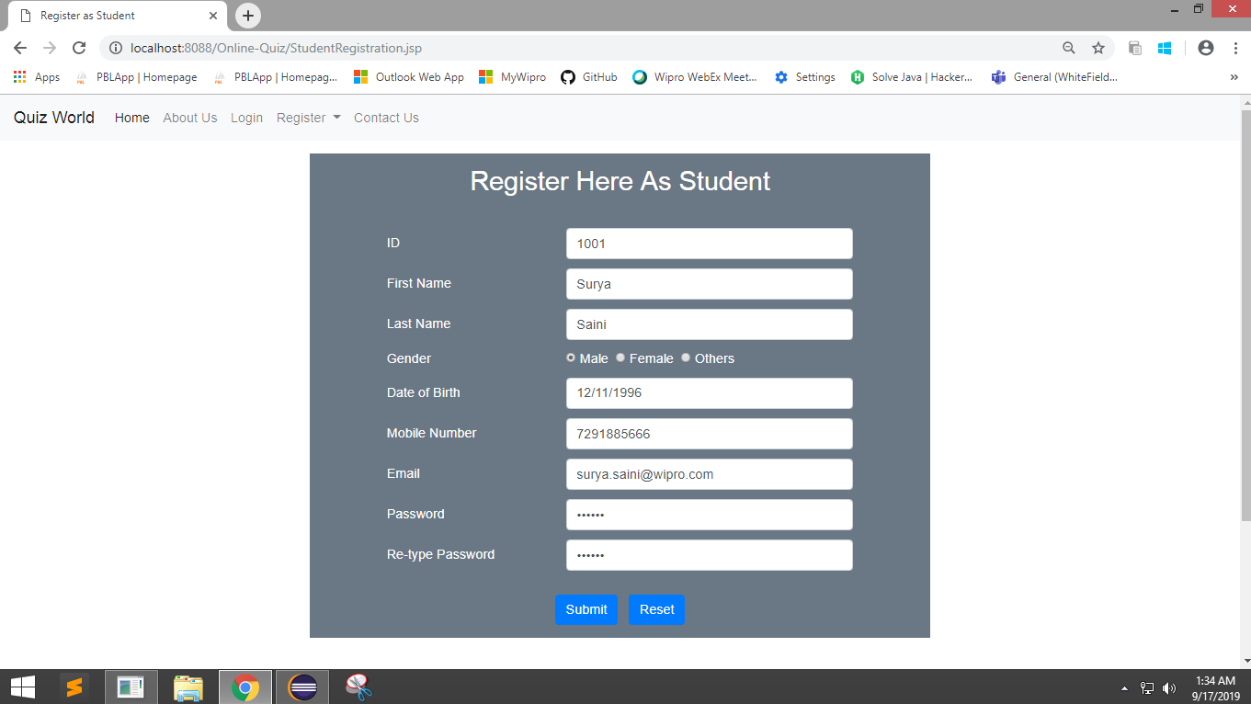

Figure 6: Student Registration Page

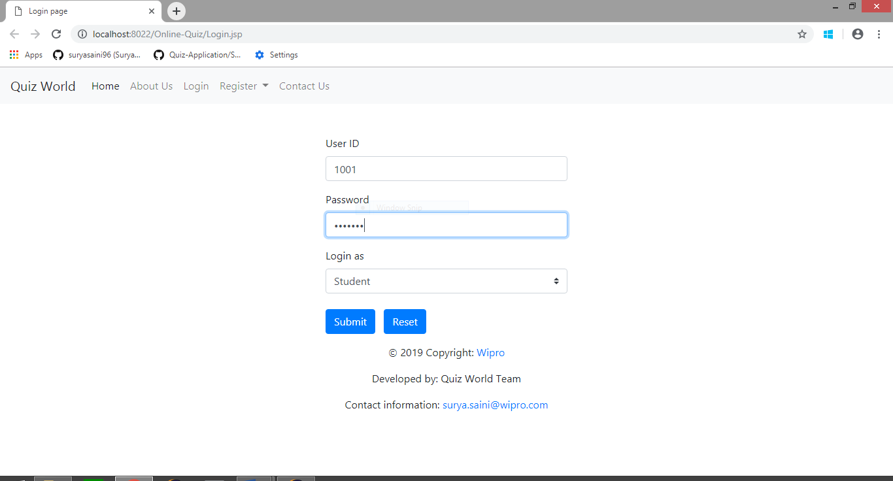

Figure 7: Student Login Page



Figure 8: Student Home Page

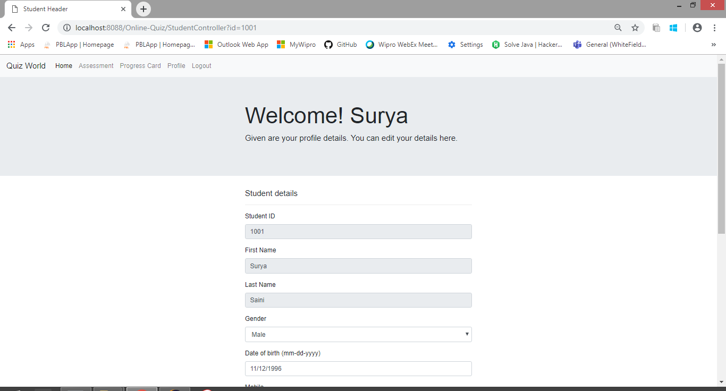

Figure 9: Student Profile Page

Clicking on the “Assessment” button provided, the student is provided with various quizzes, the different professors have uploaded along with the name of the topics. The student can choose any one quiz and start the test.

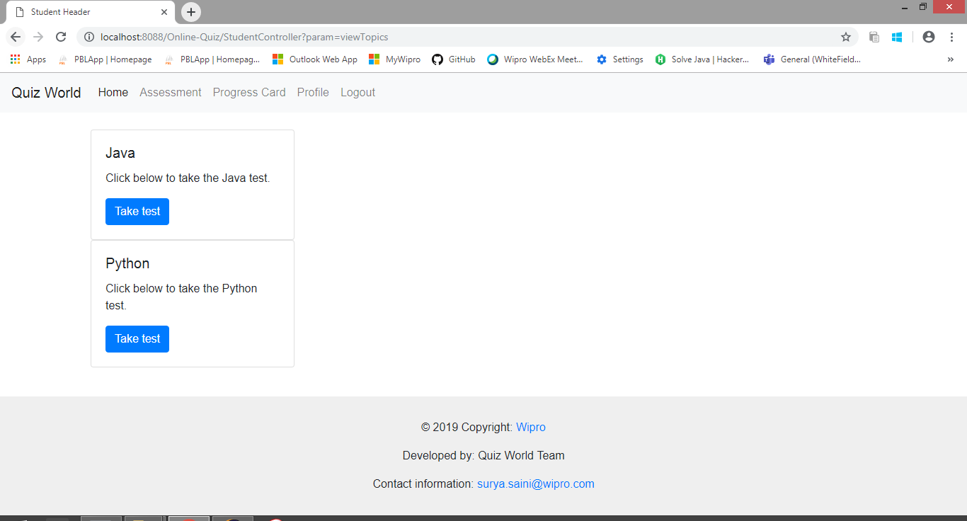

Figure 10: Topic Page

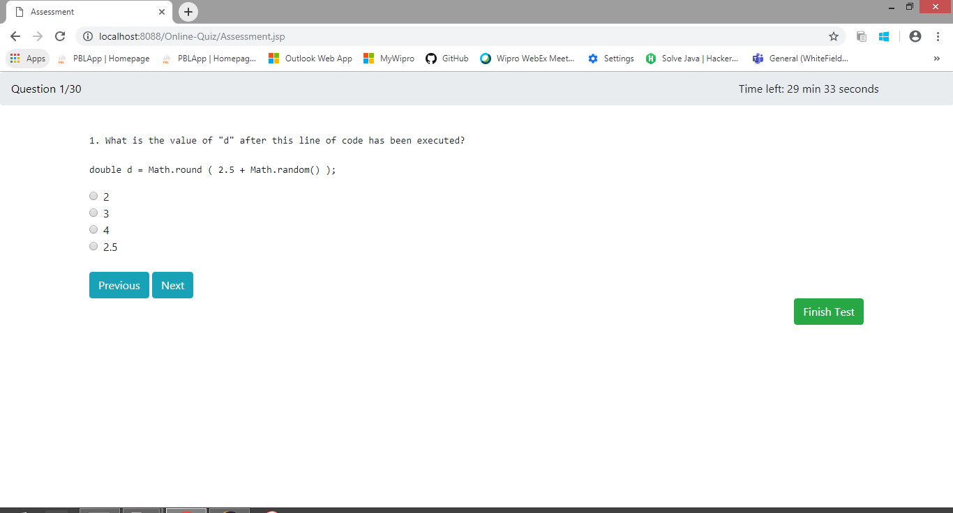

Figure 11: Assessment Page.

Once the test begins, the student has to give answer to all the question within 30 minutes and clicking on finish button student can finish the test.

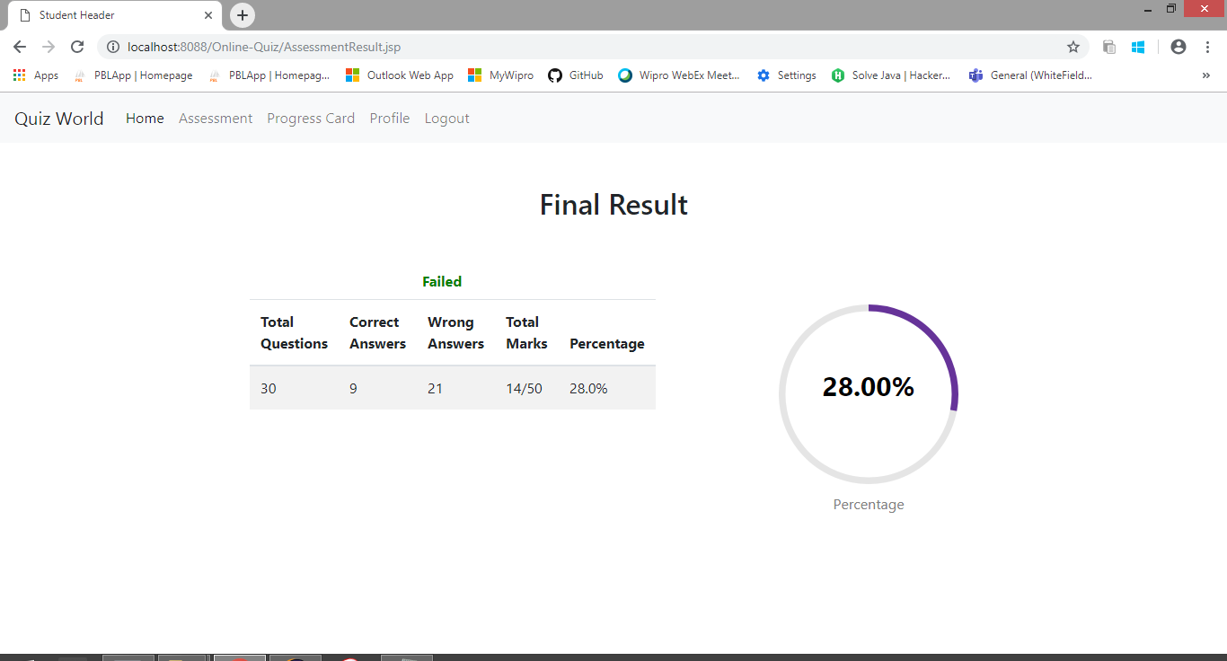

Figure 12: Result Page

As the student precedes with his test, a progress report is provided at the navigation bar to enable the user to check the report. After completion of the test, the student will be provided with test summary, the percentage of marks secured, the number of correct answers, the number of wrong answers and the table containing the user’s input and the correct answer.

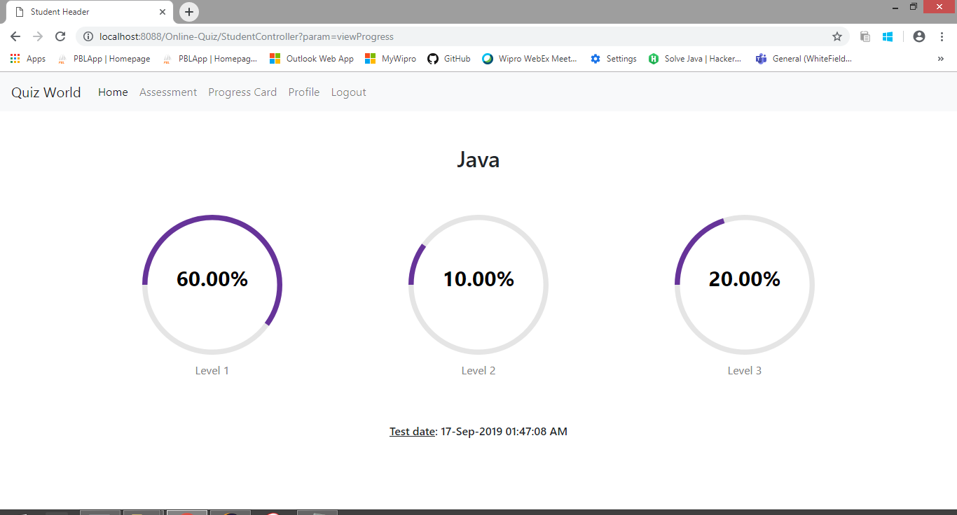

Figure 13: Report Page

All the results will be saved in the database of the student and these results can be viewed by the student by clicking on his/her Progress card option.

**TABLES**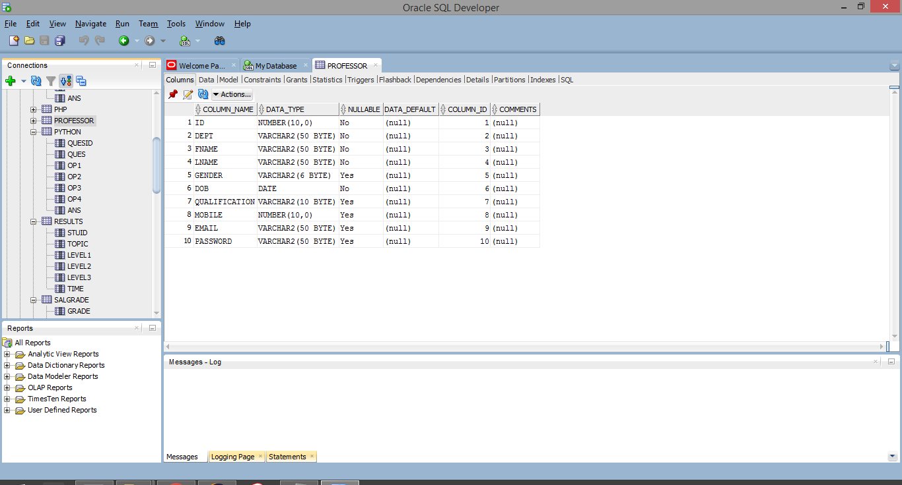

Figure 14: Table for Professor Details

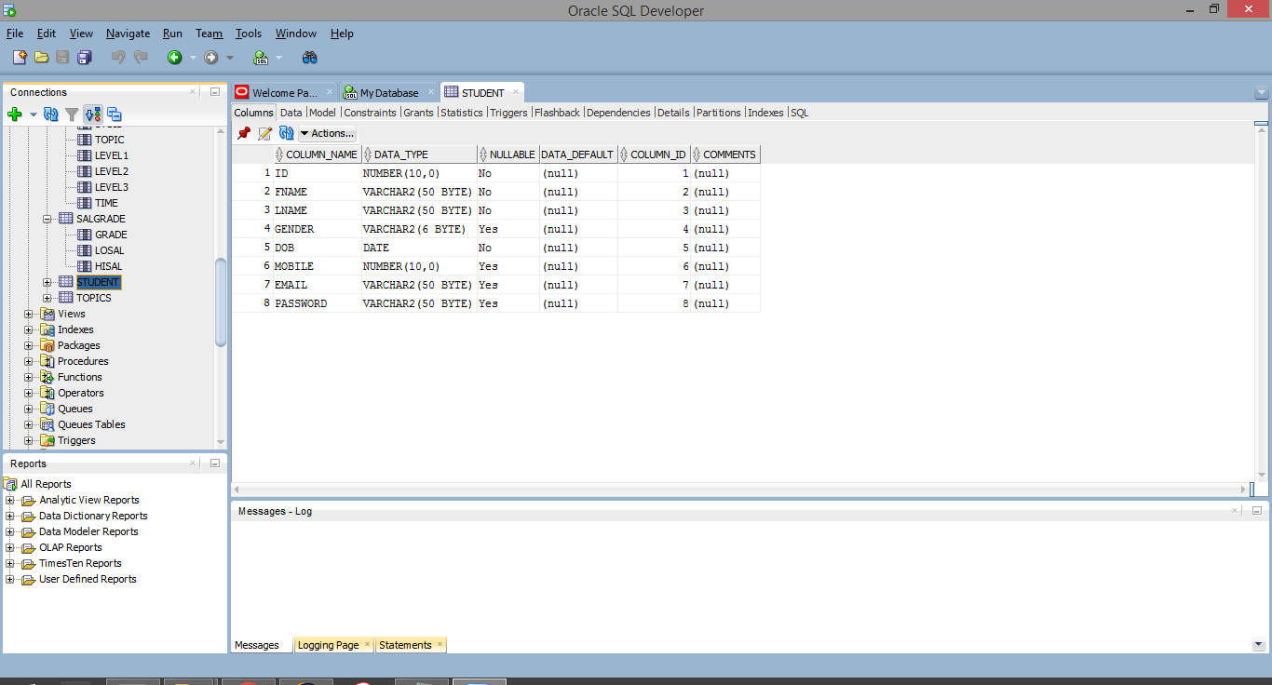

Figure 15: Table for Student details

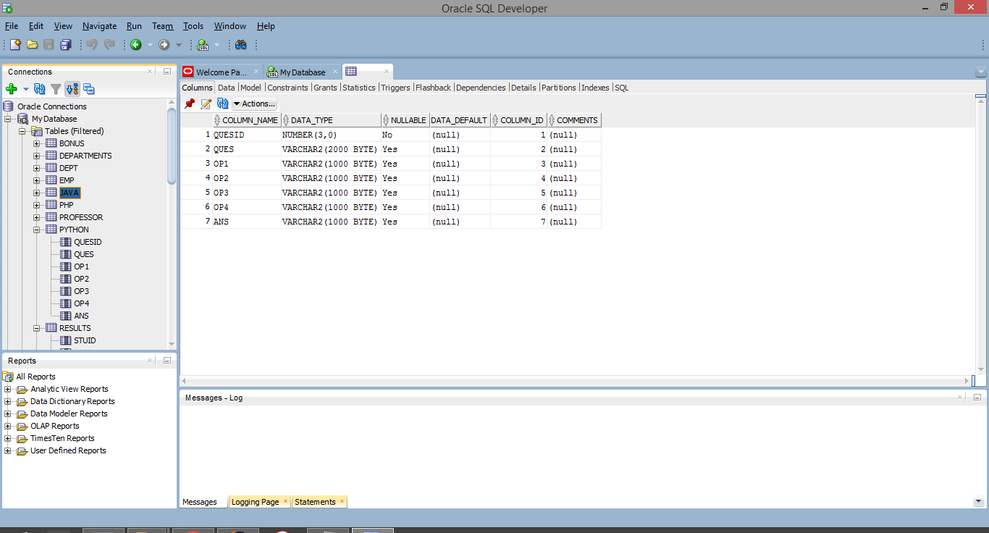

Figure 16: Table for Java Questions

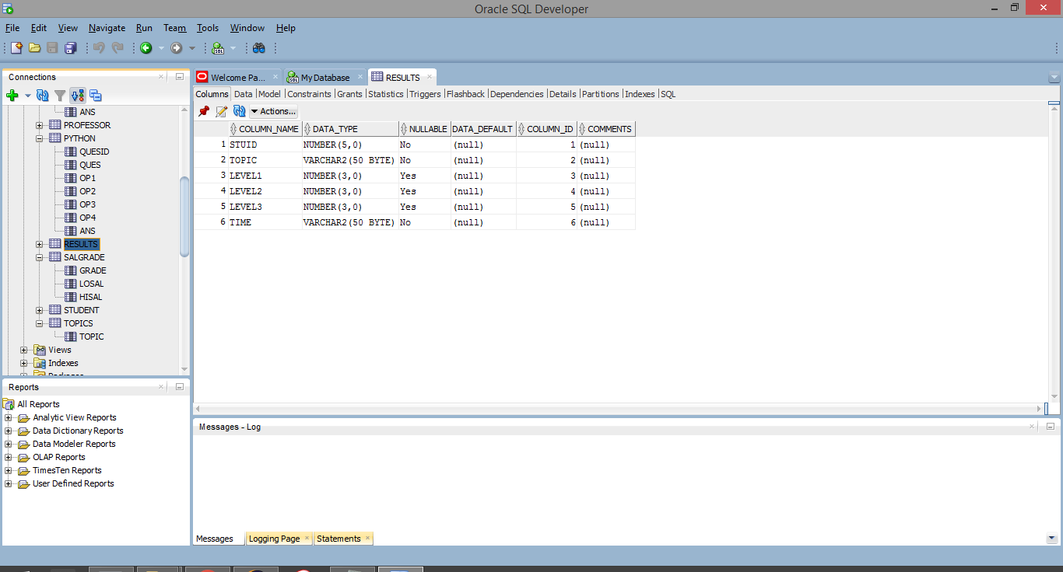

Figure 16: Table for Result storage

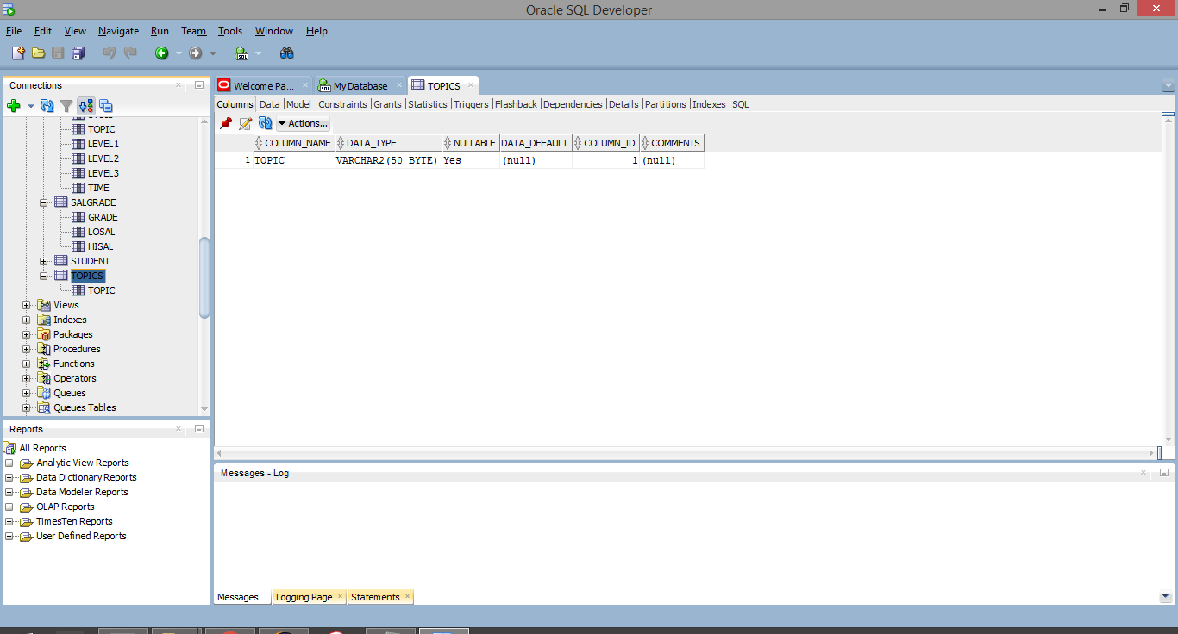

Figure 17: Table for Topic details

**ADVANTAGES AND DISADVANTAGES OF ONLINE QUIZ APPLICATION**

**Advantages:**

* The ultimate aim of this project is to help the quiz analysis and facilitate the faculties for easy evaluation of the students and generation of the automatic score cards.
* The system shall display the set of questions. It also displays the category for which the students wish to answer.
* Once the student has completed choosing the category starts answering the questions. The mark is given and report is generated based on the correct answers.
* The scope of this project gives immense opportunity for the students to know their levels in quiz.
* It provides effective software so as to help the students as well as the evaluators who are involved in evaluating the student’s performance.
* The data in this project are maintained in the tabular form using MYSQL in the form of database. It provides easy access to the user. Easy category questions are maintained in the database which provides easy for the user to access and choose the category.
* No data loss occurs in the quiz system.
* It is very much protected in such a way that it gives permission to the students to access only when the user id and password is correct.
* The results are produced electronically so that nobody is prone to mistakes.
* We assure that the project is completely authenticated in order to enhance security and corruptions of database as well as the software. The person is given access only if he/she has a valid username and password.

**Disadvantages:**

* It becomes a problem in itself to find space to keep the sheets of paper being generated as a result of the ongoing discussion. The documents being generated are too important to be ill-treated.
* Adding Questions in the documents categorically is a time consuming and tedious exercise.
* It becomes hard to filter relevant documents for the irrelevant ones if the count of the same crosses a certain manageable number.
* All the process done manually at the centres and all the records are maintained on the papers. So the maintenance of the record is very difficult in the departments and as well as it’s very difficult for the workers to check the record.
* It is slow due to paper work and requirement of staff.

**CONCLUSION**

The online quiz application is executed successfully using eclipse and MySQL software. The quiz application maintains all the database in MYSQL when queries are executed from eclipse using JDBC. Model View Controller (MVC) is used throughout the project to maintain the sequence of folders in the project. In this system, an educational institute can make their examination procedure automated. It gives the opportunity to the authority to register teachers for different subjects and also give the facility to the students to register their courses for the examinations

**FUTURE SCOPE**

This system is designed basically for the educational institute but also can be developed for other examination systems like job interview, quiz contest and for other criteria.