PREDECTIVE ANALYSIS
PROJECT REPORT
(Project Semester August-December 2026)

Early Breast Cancer Prediction using Machine Learning

Submitted by

Veera Venkata Satya Suryanarayana
Registration No: 12407006
Section: K3P24MT
Course Code: INT324

Under the Guidance of
Dr. Tanima Thakur
Discipline of CSE/IT

Lovely School of Computer Science

Lovely Professional University, Phagwara

DECLARATION
I, Veera Venkata Satya Suryanarayana, student of B. Tech Computer Science and Engineering under CSE/IT Discipline at Lovely Professional University, Punjab, hereby declare that all the information furnished in this project report is based on my own intensive work and is genuine.

Date: 29/10/2026 Signature: surya
Registration No:12407006 Name of the student: Suryanarayana
CERTIFICATE
This is to certify that Veera Venkata Satya Suryanarayana bearing Registration no.12407006 has completed INT324 project titled, "Early Breast Cancer Prediction using Machine Learning" under my guidance and supervision. To the best of my knowledge, the present work is the result of his/her original development, effort and study.

Signature and Name of the Supervisor:
Designation of the Supervisor:
School of
Lovely Professional University
Phagwara, Punjab.
Date:
ACKNOWLEDGEMENT
I would like to express my sincere gratitude to my project supervisor, Tanima Thakur, for the guidance, encouragement and valuable suggestions given to me throughout this project. The regular discussions and feedback helped me to understand the complete workflow of a data science project, from choosing a problem to presenting the final results.
I am thankful to the Head of the School, Lovi Raj Gupta, and to all the faculty members of the Discipline of CSE/IT at Lovely Professional University for teaching the concepts of predictive analytics and machine learning that were used in this work.
I also thank the researchers at the University of Wisconsin who created the Breast Cancer Wisconsin (Diagnostic) dataset and made it freely available through the UCI Machine Learning Repository. Without such open data, a project of this kind would not be possible.
Finally, I thank my family and friends for their constant support and motivation during the completion of this project.
Veera Venkata Satya Suryanarayana
Registration No. 12407006
TABLE OF CONTENTS
1. Introduction 1
1.1 Background 1
1.2 Problem Statement 1
1.3 Why is this problem suitable for prediction? 1
1.4 Objectives of the Project 1
1.5 Scope of the Project 1
1.6 Workflow of the Project 1
1.7 Tools and Libraries Used 1
2. Source of Dataset 1
2.1 Origin of the Dataset 1
2.2 How the Data was Collected 1
2.3 Structure of the Dataset 1
2.4 Why this Dataset was Chosen 1
2.5 Ethical Note 1
3. EDA Process 1
3.1 Reading the Data 1
3.2 Data Cleaning 1
3.3 Descriptive Statistics 1
3.4 Class Balance 1
3.5 Distribution of Features 1
3.6 Comparison using Box Plots 1
3.7 Correlation between Features 1
3.8 Preparing the Data for Modelling 1
4. Analysis on Dataset 1
4.1 Statistical Analysis (t-test and Correlation) 1
4.2 Principal Component Analysis (PCA) 1
4.3 Logistic Regression 1
4.4 Decision Tree 1
4.5 Random Forest (Ensemble Learning) 1
4.6 Model Comparison and Evaluation 1
4.7 Feature Importance 1
4.8 Changing the Cut-off to Reduce Missed Cancer Cases 1
4.9 Python Code of the Project 1
5. Conclusion 1
5.1 Limitations 1
6. Future Scope 1
7. References 1

LIST OF FIGURES
Number of benign and malignant patients 1
Histogram of mean radius for benign and malignant tumours 1
Box plot of mean area for benign and malignant tumours 1
Correlation heatmap of the mean features 1
PCA plot: 30 features reduced to 2 components 1
Training accuracy and test accuracy of the three models 1
Comparison of accuracy, precision, recall and F1 score of the three models 1
Confusion matrix of the best model (Logistic Regression) 1
ROC curves of the three models 1
Top 10 important features (Random Forest) 1
Accuracy, precision and recall at different cut-off values 1

LIST OF TABLES
Project objectives and measurable targets 1
Tools and libraries used in the project 1
Summary of the dataset 1
The ten basic measurements of cell nuclei 1
Descriptive statistics of three features (all 569 patients) 1
Train and test split 1
Results of the independent t-test 1
Features with the highest correlation with a malignant diagnosis 1
Performance of the three models on the test data 1
Confusion matrix counts of the three models (114 test patients) 1
Top 10 important features according to Random Forest 1
Effect of the cut-off on Logistic Regression 1

1. Introduction

1.1 Background
Cancer is one of the biggest health challenges in the world today. Among all types of cancer, breast cancer is one of the most common cancers found in women, and it is also a serious problem for public health systems. The most important fact about breast cancer is that the chances of survival are much higher when the disease is found at an early stage. A tumour that is found early can often be treated with simpler and less costly treatment. A tumour that is found late is harder to treat, more expensive, and more dangerous for the patient.
In many places, there are not enough trained specialists to study every sample carefully, and in busy hospitals a doctor has very little time for each case. A computer program that can look at the measurements of a tumour and give a quick, reliable prediction can act as a second opinion. It does not replace the doctor, but it helps the doctor to focus on the cases that need the most attention. This is where Machine Learning becomes useful.

1.2 Problem Statement
The societal problem chosen for this project is the late detection of breast cancer. The data-driven question is: given the measurements of cell nuclei taken from a small tissue sample of a breast lump, can we predict whether the tumour is malignant (cancerous) or benign (not cancerous)?
This is a classification problem, because the answer is one of two classes. It belongs to supervised learning, because the dataset already contains the correct answer (diagnosis) for every patient, and the model learns from these known examples.

1.3 Why is this problem suitable for prediction?
- The outcome is clearly defined: every patient in the dataset is either malignant or benign, confirmed by medical examination.
- The inputs are numeric measurements, which are easy for a computer to process.
- The problem has a strong social value. Even a small improvement in early detection can help many families.
- The dataset is of a good size for a student project (569 patients), has no missing values, and comes from a trusted academic source.
- The results can be explained in simple words, which is important for a medical topic where doctors must trust the tool.

1.4 Objectives of the Project
The objectives of the project are clear and measurable, so that at the end we can say whether the project was successful or not. They are listed in Table 1.
Table 1: Project objectives and measurable targets
No. | Objective | How it is measured | Target
1 | Predict whether a tumour is malignant or benign | Classification on unseen test data | Working model
2 | Predict correctly most of the time | Accuracy on the test data | At least 95%
3 | Do not miss cancer patients | Recall for the malignant class | At least 95%
4 | Rank cancer cases above healthy cases | AUC (area under the ROC curve) | At least 0.97
5 | Find the measurements that matter most | Feature importance of Random Forest | Top features listed

1.5 Scope of the Project
The project covers the complete workflow of a data science problem: reading the data, cleaning it, exploring it with graphs, testing the patterns with statistics, preparing it for modelling, building three machine learning models, comparing them using standard measures, and writing the conclusions. The project uses only the topics taught in the course syllabus: data preprocessing, correlation, logistic regression, decision trees, principal component analysis, ensemble learning with random forests, the bias-variance trade-off, and the evaluation measures accuracy, log loss, AUC, precision, recall, F1 score and the confusion matrix.
The project does not try to build a medical device. It is a learning project that shows how a prediction model can be built and checked. The model is a decision-support idea, not a replacement for a doctor.

1.6 Workflow of the Project
The project was carried out in the following steps. Each step is explained in detail in the next chapters.
- Step 1 - Define the problem and the objectives.
- Step 2 - Read the dataset from the CSV file.
- Step 3 - Clean the data (missing values, duplicates, unusual values).
- Step 4 - Explore the data with graphs (EDA).
- Step 5 - Test the patterns with statistics (t-test and correlation).
- Step 6 - Prepare the data (train-test split and scaling).
- Step 7 - Reduce the data to two dimensions with PCA to see it on a graph.
- Step 8 - Build three models: Logistic Regression, Decision Tree and Random Forest.
- Step 9 - Compare the models, study the best model, and check overfitting.
- Step 10 - Change the cut-off to miss fewer cancer cases.
- Step 11 - Write the conclusion and the future scope.

1.7 Tools and Libraries Used
The project was written in Python 3.14 (64-bit) using the IDLE editor. Python was chosen because it is easy to read and has strong libraries for data science. The libraries used are shown in Table 2.
Table 2: Tools and libraries used in the project
Tool / Library | Purpose in this project
Python 3.14 (IDLE) | Programming language and editor used to write and run the code
pandas | Reading the CSV file and working with the data in table form
NumPy | Numerical calculations used by the other libraries
Matplotlib | Drawing all the graphs and saving them as pictures
SciPy | Statistical test (independent t-test)
scikit-learn | Scaling, train-test split, PCA, the three models and all evaluation measures

2. Source of Dataset

2.1 Origin of the Dataset
The dataset used in this project is the Breast Cancer Wisconsin (Diagnostic) dataset, also written as WDBC. It was created by Dr. William H. Wolberg, W. Nick Street and Olvi L. Mangasarian at the University of Wisconsin, USA, and was donated to the UCI Machine Learning Repository in 1995. The UCI Machine Learning Repository is an academic archive maintained by the University of California, Irvine, and it is one of the most trusted sources of datasets for teaching and research. The dataset is also available on other websites as a copy, but its original source is UCI.
The dataset is public and is widely used by students and researchers to learn classification. A CSV copy of the data (file name wdbc_breast_cancer.csv) is used in this project.

2.2 How the Data was Collected
The data was collected using a medical method called fine needle aspiration (FNA). In this method, a doctor uses a thin needle to take a very small sample of cells from a breast lump. The sample is placed under a microscope and a digital image is taken. A computer program then studies the image and measures the shape and size of the cell nuclei (the central part of each cell). The measurements are stored as numbers.
After the measurements were taken, the real diagnosis of each patient was confirmed by medical examination. Because of this, the labels (malignant or benign) in the dataset are reliable.

2.3 Structure of the Dataset
The dataset has 569 rows. Each row is one patient. It has 32 columns: one id column, one diagnosis column, and 30 measurement columns. A summary is given in Table 3.
Table 3: Summary of the dataset
Item | Value
Name | Breast Cancer Wisconsin (Diagnostic) - WDBC
Source | UCI Machine Learning Repository (University of Wisconsin)
Number of patients (rows) | 569
Number of columns | 32 (id, diagnosis and 30 measurements)
Target column | diagnosis: M = Malignant, B = Benign
Benign patients | 357 (62.7%)
Malignant patients | 212 (37.3%)
Missing values | 0
Duplicate rows | 0

For every patient, ten basic measurements of the cell nuclei were calculated. For each of the ten measurements, three values are stored: the mean (average over all cells in the image), the standard error (how much it varies), and the worst value (the average of the three largest values). So 10 x 3 = 30 features. The ten basic measurements are explained in Table 4.
Table 4: The ten basic measurements of cell nuclei
Measurement | Meaning in simple words
Radius | Average distance from the centre of the nucleus to its edge
Texture | How much the grey colour inside the nucleus varies
Perimeter | Length of the boundary around the nucleus
Area | Size of the nucleus
Smoothness | How smoothly the radius changes along the boundary
Compactness | How tightly packed the shape is (perimeter squared divided by area, minus 1)
Concavity | How deep the inward curves on the boundary are
Concave points | Number of inward curves on the boundary
Symmetry | How similar the two halves of the nucleus are
Fractal dimension | How rough or irregular the boundary is (coastline approximation)

2.4 Why this Dataset was Chosen
- It comes from a well-known academic source, so the origin can be explained clearly.
- It is clean: there are no missing values, so more time can be spent on understanding and modelling.
- It has a real and important purpose, which fits the aim of solving a societal challenge.
- It has both a clear target (diagnosis) and many numeric features, which suits classification models from the syllabus.
- The size (569 rows) is suitable to run on a normal laptop in IDLE within seconds.

2.5 Ethical Note
The dataset does not contain names or personal details of the patients. Only an id number and the measurements are stored. This protects the privacy of the patients. In real life, any medical prediction tool must be tested carefully and must always be used under the supervision of a doctor.

3. EDA Process
Exploratory Data Analysis (EDA) means looking at the data carefully before building any model. The aim is to understand what the data contains, to find problems, and to see which patterns may help the prediction. A model built without understanding the data can give wrong or misleading results.

3.1 Reading the Data
The CSV file was read into a pandas table (DataFrame) using the function pd.read_csv(). The table has 569 rows and 32 columns. A new column called target was created from the diagnosis column: 1 for Malignant and 0 for Benign. The malignant class was given the value 1 because it is the case we want to find (the positive case). All columns except id, diagnosis and target were used as features.

3.2 Data Cleaning
Data cleaning was done to check that the data is correct and ready to use. The following checks were made:
- Missing values: the total number of missing values was found using isnull().sum(). The result was 0, so no filling or deleting was needed.
- Duplicate rows: the number of duplicate rows was found using duplicated().sum(). The result was 0.
- Unusual values (outliers): some features such as area error and radius error have a few very large values. These were kept because they are real measurements of large tumours, and large tumours are often malignant. Removing them would remove important information.
- Data types: all 30 measurement columns are numbers, so no conversion was needed.

3.3 Descriptive Statistics
The describe() function gives a quick summary (count, mean, standard deviation, minimum, quartiles and maximum). Table 5 shows this summary for three important features.
Table 5: Descriptive statistics of three features (all 569 patients)
Statistic | Mean radius | Mean area | Mean texture
Count | 569 | 569 | 569
Mean | 14.13 | 654.89 | 19.29
Standard deviation | 3.52 | 351.91 | 4.30
Minimum | 6.98 | 143.50 | 9.71
25% | 11.70 | 420.30 | 16.17
Median (50%) | 13.37 | 551.10 | 18.84
75% | 15.78 | 782.70 | 21.80
Maximum | 28.11 | 2501.00 | 39.28

The table shows that the features are on very different scales. Mean area has values in hundreds, while mean radius has values around 14. This is the reason why scaling is needed before building some models.

3.4 Class Balance
The first graph checks how many patients are benign and how many are malignant. If one class is extremely small, a model can get high accuracy by ignoring it. Figure 1 shows that there are 357 benign and 212 malignant patients. The data is not perfectly equal, but the malignant class is 37.3% of the data, which is large enough. Therefore no special balancing technique was needed. A stratified split was used to keep the same ratio in training and testing.
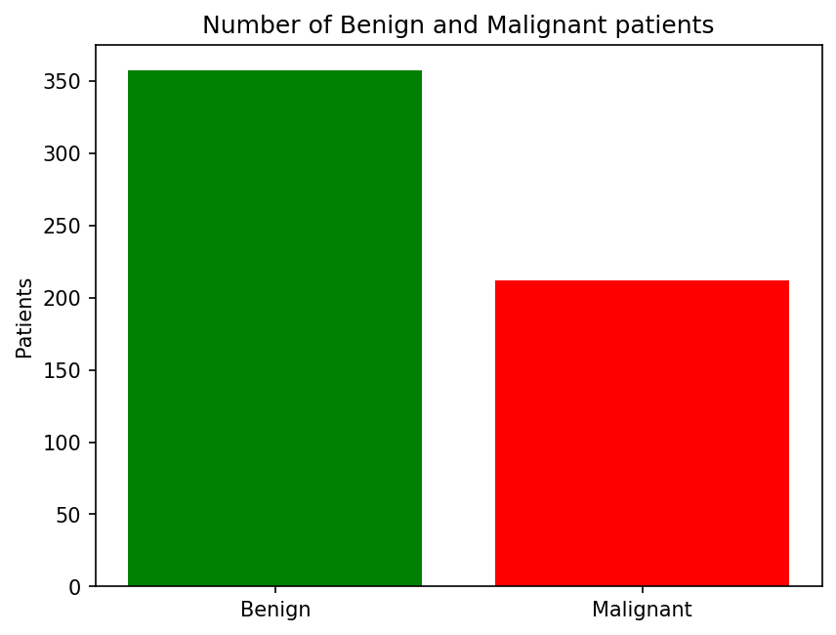
Figure 1: Number of benign and malignant patients

3.5 Distribution of Features
A histogram shows how the values of a feature are spread. Figure 2 compares the mean radius of benign and malignant tumours. The green bars (benign) are mostly between 9 and 15, while the red bars (malignant) are mostly between 15 and 25. The two groups overlap a little in the middle, but they are clearly different. This tells us that radius is a useful feature for prediction.
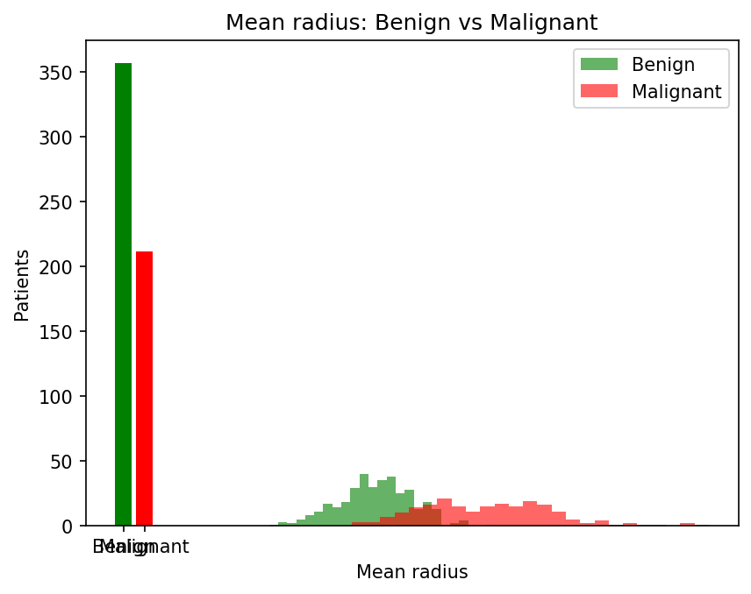
Figure 2: Histogram of mean radius for benign and malignant tumours

3.6 Comparison using Box Plots
A box plot shows the middle value (median), the spread of the middle 50% of the data, and the unusual values. Figure 3 compares the mean area of the two groups. The median area of malignant tumours is much higher than that of benign tumours, and the boxes hardly overlap. The malignant group also has more very large values, which are the outliers discussed in Section 3.2.
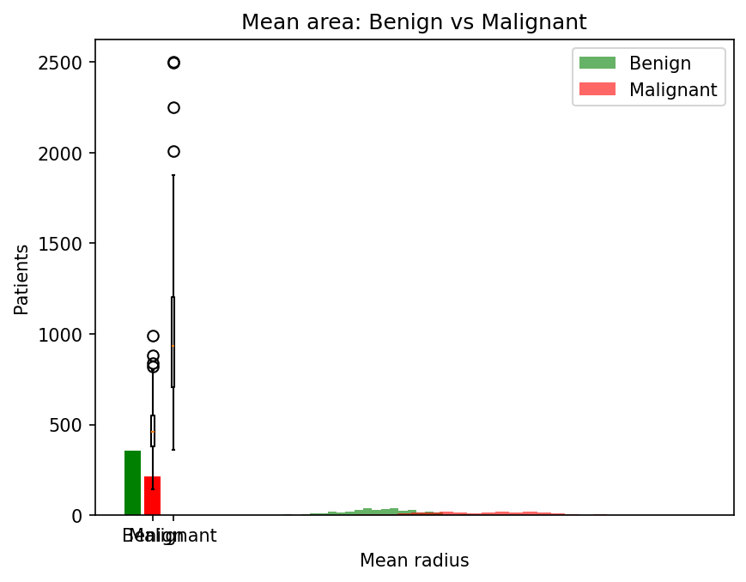
Figure 3: Box plot of mean area for benign and malignant tumours

3.7 Correlation between Features
Correlation measures how two features move together. Its value is between -1 and +1. A value near +1 means that when one feature increases, the other also increases. A value near 0 means there is no relation. Figure 4 shows the correlation heatmap of the ten mean features.
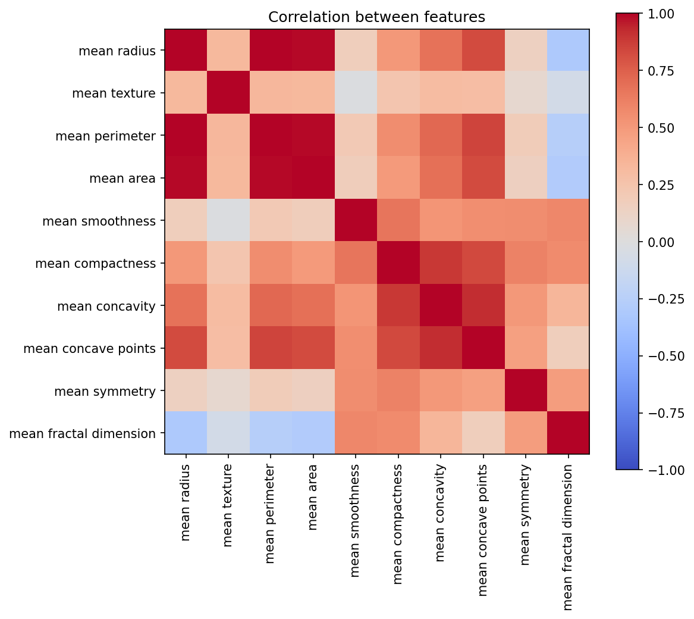
Figure 4: Correlation heatmap of the mean features
The heatmap shows that radius, perimeter and area are almost perfectly correlated (about 0.99 to 1.00). This is natural, because a bigger nucleus has a bigger radius, a longer boundary and a larger area. Concavity, concave points and compactness are also strongly related to each other. This situation is called multicollinearity: many features carry almost the same information. It is one reason why PCA is useful in this project, and why tree-based models can still work well.

3.8 Preparing the Data for Modelling
After the exploration, the data was prepared for the models in two steps.
Train-test split: the data was divided into 80% for training (455 patients) and 20% for testing (114 patients) using train_test_split(). The model learns only from the training data. The test data is kept hidden and is used at the end to check how the model works on new patients. The option stratify was used so that both parts have the same proportion of benign and malignant cases. The result is shown in Table 6.
Table 6: Train and test split
Part | Total patients | Benign | Malignant
Training set (80%) | 455 | 285 | 170
Test set (20%) | 114 | 72 | 42
Whole data | 569 | 357 | 212

Scaling: StandardScaler was used to bring all features to the same scale. Each value is changed using the formula below, where the mean and the standard deviation are taken from the training data only:
z = (x - mean) / standard deviation
After scaling, every feature has a mean of 0 and a standard deviation of 1. The scaler was fitted on the training data only, and then used to transform the test data. This avoids data leakage, which means that no information from the test data is used during training.

4. Analysis on Dataset
This chapter describes each analysis that was performed. For each analysis, the same five parts are given: introduction, general description, specific requirements with functions and formulas, analysis results, and visualization.

4.1 Statistical Analysis (t-test and Correlation)

i. Introduction
Graphs only show that two groups look different. A statistical test tells us if the difference is real or if it could have happened by chance. In this analysis, the independent t-test was used to compare the average value of a feature for malignant and benign tumours. Correlation with the target was also calculated to find the features most connected to cancer.

ii. General Description
The null hypothesis of the t-test says that the average of the feature is the same for both groups. The alternative says that the averages are different. If the p-value is less than 0.05, the null hypothesis is rejected, which means the difference is statistically significant. Welch's version of the test was used, which does not assume that both groups have the same variance.

iii. Specific Requirements, Functions and Formulas
Requirements: the two groups (malignant and benign) must be separated, and the feature must be numeric. Function used: scipy.stats.ttest_ind(group1, group2, equal_var=False). For correlation, the pandas function corr() was used.
t = (mean1 - mean2) / square root( s1^2 / n1 + s2^2 / n2 )
Here mean1 and mean2 are the averages of the two groups, s1 and s2 are their standard deviations, and n1 and n2 are the number of patients in each group.

iv. Analysis Results
Table 7: Results of the independent t-test
Feature | Mean (Malignant) | Mean (Benign) | t-value | p-value
Mean radius | 17.46 | 12.15 | 22.21 | 1.7e-64
Mean area | 978.38 | 462.79 | 19.64 | 3.3e-52
Mean texture | 21.60 | 17.91 | 11.02 | 3.0e-25
Mean smoothness | 0.10 | 0.09 | 9.30 | 5.6e-19

In every case, the p-value is far below 0.05. Malignant tumours have a larger average radius, area, texture value and smoothness value than benign tumours, and this difference is real and not due to chance. The difference is strongest for radius and area.
Table 8: Features with the highest correlation with a malignant diagnosis
Rank | Feature | Correlation with target
1 | worst concave points | 0.794
2 | worst perimeter | 0.783
3 | mean concave points | 0.777
4 | worst radius | 0.776
5 | mean perimeter | 0.743

These values show a strong positive relation: the higher these measurements, the more likely the tumour is malignant. Features that describe the worst (largest) values and the concave points of the boundary are the most connected to cancer.

v. Visualization
The visual support for this analysis is given by the histogram in Figure 2, the box plot in Figure 3, and the correlation heatmap in Figure 4. They show the same difference between the two groups that the t-test proved with numbers.

4.2 Principal Component Analysis (PCA)

i. Introduction
The dataset has 30 features, and a graph can show only two or three. Principal Component Analysis (PCA) is a dimensionality reduction technique. It combines the original features into a smaller number of new features, called principal components, while keeping as much information as possible.

ii. General Description
The first principal component is the direction in which the data varies the most. The second component is the next direction with the most variation, at a right angle to the first. By taking only these two components, every patient can be shown as a point on a flat graph. PCA is an unsupervised technique, because it does not use the diagnosis labels while making the components. The labels are used only for colouring the points.

iii. Specific Requirements, Functions and Formulas
PCA needs scaled data, because features with large values would otherwise dominate. Therefore the scaled training data was used. Function used: sklearn.decomposition.PCA(n_components=2). The amount of information kept by each component is called the explained variance ratio.
Explained variance ratio of a component = variance of the component / total variance

iv. Analysis Results
The first component keeps 44.6% of the information and the second keeps 18.5%. Together, the two components keep 63.1% of the information of all 30 features. This is a large amount, considering that 30 columns were reduced to 2.

v. Visualization
Figure 5 shows the PCA graph. The benign patients (green) and malignant patients (red) form two groups that are mostly separate, with only a small area of overlap. This shows that the two classes can be separated using the measurements, and it gives a good reason to expect that the models will perform well.
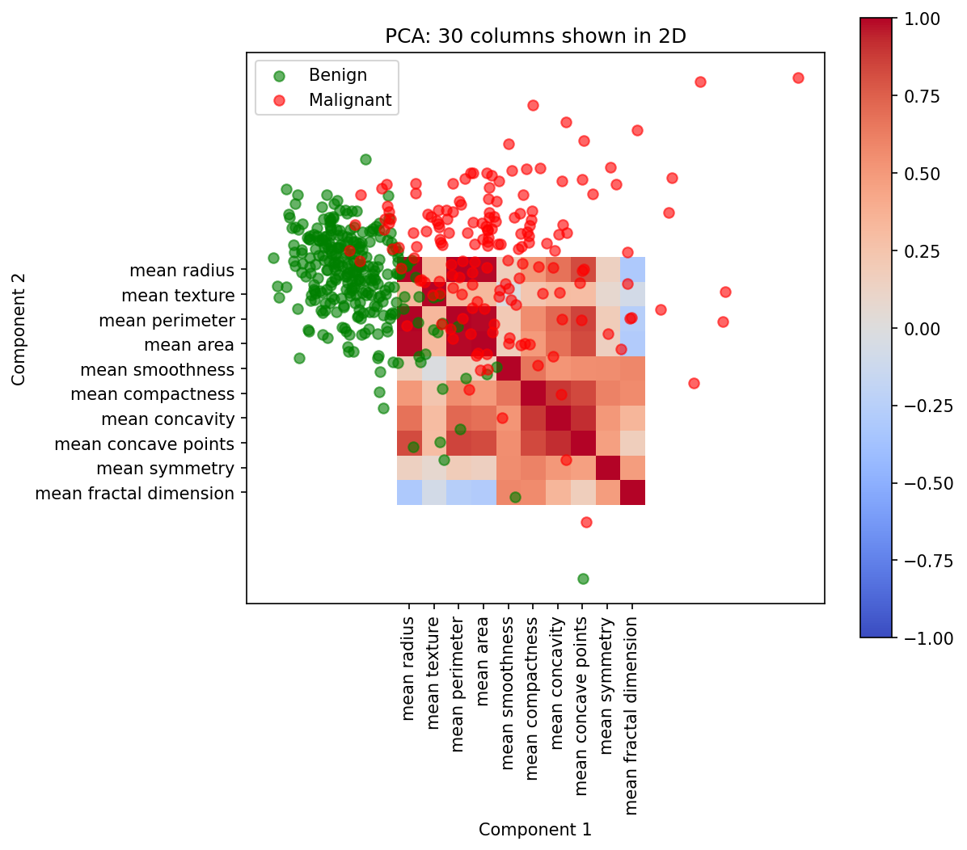
Figure 5: PCA plot: 30 features reduced to 2 components

4.3 Logistic Regression

i. Introduction
Logistic Regression is the first model used. Although the name has the word regression, it is used for classification. It is a simple and fast model, and it is a good starting point (baseline) for any yes/no problem.

ii. General Description
Logistic Regression calculates a weighted sum of all the features and passes it through the sigmoid function, which converts any number into a probability between 0 and 1. In this project, the output is the probability that the tumour is malignant. If the probability is 0.5 or more, the patient is predicted as malignant; otherwise benign. The weights are learned from the training data.

iii. Specific Requirements, Functions and Formulas
Requirements: numeric and scaled features, and a target with two classes. Function used: sklearn.linear_model.LogisticRegression(max_iter=1000).
P(malignant) = 1 / (1 + e^-(b0 + b1x1 + b2x2 + ... + b30x30))
Here x1 to x30 are the scaled features, and b0 to b30 are the weights learned by the model. The model uses the log loss to learn the weights:
Log loss = -(1/N) x sum of [ y log(p) + (1 - y) log(1 - p) ]

iv. Analysis Results
Logistic Regression reached a test accuracy of 96.5%, a precision of 97.5%, a recall of 92.9%, an F1 score of 0.951, an AUC of 0.996 and a log loss of 0.077. On the 114 test patients, it found 39 of the 42 malignant cases and cleared 71 of the 72 benign cases. It made only 1 false alarm and missed 3 cancer cases. Its training accuracy was 98.7%, so the gap between training and testing is only 2.2%, which means the model is not overfitting.

v. Visualization
The results of this model are shown together with the other models in Figure 7 (comparison chart), Figure 8 (confusion matrix) and Figure 9 (ROC curves) in Section 4.6.

4.4 Decision Tree

i. Introduction
The Decision Tree is the second model. It works like a flowchart of yes/no questions. It is very easy to explain, which is the reason it was selected, and it also helps to show the idea of overfitting.

ii. General Description
A decision tree asks a question about one feature at a time, for example: is the worst perimeter greater than a certain value? According to the answer, the patient goes to the left or the right branch. The questions continue until the patient reaches a leaf, which gives the final prediction. The tree chooses each question so that the groups become as pure as possible, meaning that each group contains mostly one class.

iii. Specific Requirements, Functions and Formulas
Function used: sklearn.tree.DecisionTreeClassifier(random_state=42). The purity of a group is measured by the Gini impurity:
Gini = 1 - sum of (p_i)^2
Here p_i is the proportion of class i in the group. A value of 0 means the group is completely pure. In this project, the tree was allowed to grow without a depth limit, to show what happens when the model becomes too flexible.

iv. Analysis Results
The tree grew to a depth of 8 with 24 leaves. It reached 100% accuracy on the training data, but only 93.0% on the test data. The precision was 90.5%, the recall was 90.5%, the F1 score was 0.905, the AUC was 0.925 and the log loss was 2.529. The gap between training and test accuracy is 7.0%, which is the largest among the three models.
This is a clear case of overfitting (high variance). The tree has memorised the training patients, including their small random differences, so it does not work as well on new patients. The log loss is also very high, because a fully grown tree gives probabilities of only 0 or 1, so every mistake is punished as a fully confident error.

v. Visualization
Figure 6 shows the training and test accuracy of the three models side by side. The big gap for the Decision Tree is easy to see.
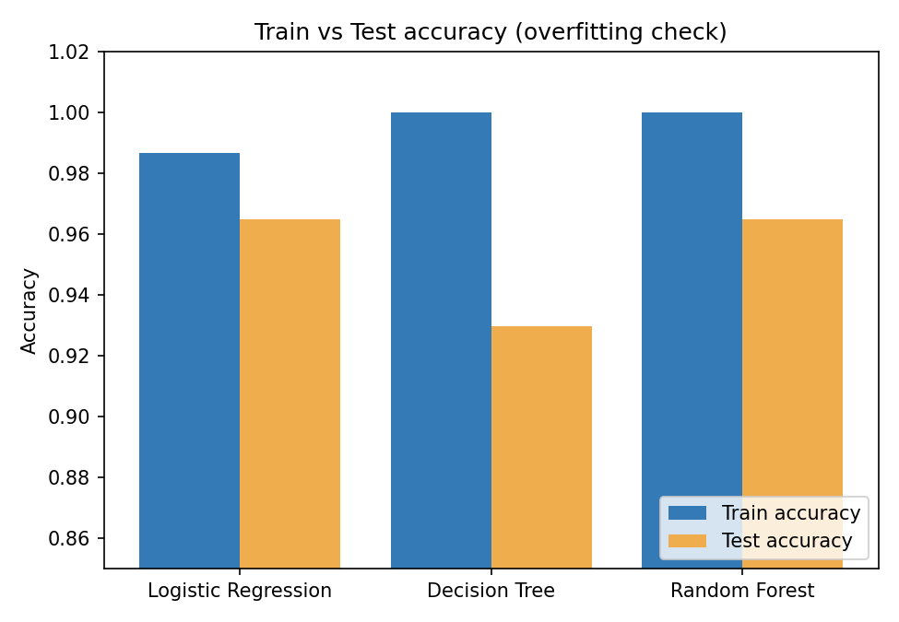
Figure 6: Training accuracy and test accuracy of the three models

4.5 Random Forest (Ensemble Learning)

i. Introduction
Random Forest is the third model. It belongs to ensemble learning, which means joining many models to get a better result than any single model. It was chosen to fix the overfitting problem seen in the Decision Tree.

ii. General Description
A Random Forest builds many decision trees. Each tree is trained on a different random sample of the training data (this is called bagging), and each split inside the tree looks at only a random part of the features. For a new patient, every tree gives a vote and the final answer is the class with the most votes. Because the trees make different mistakes, the mistakes cancel each other out, and the variance of the final model is lower.

iii. Specific Requirements, Functions and Formulas
Function used: sklearn.ensemble.RandomForestClassifier(n_estimators=200, random_state=42), which builds 200 trees. The probability for the final prediction is the average of the probabilities of all trees.
P(malignant) = (1 / T) x sum of P_t(malignant), for t = 1 to T trees

iv. Analysis Results
Random Forest reached a training accuracy of 100% and a test accuracy of 96.5%. The precision was 100%, which means that every patient it called malignant was truly malignant (0 false alarms). The recall was 90.5%, the F1 score was 0.950, the AUC was 0.994 and the log loss was 0.115. The gap between training and test accuracy is 3.5%, which is half the gap of the single Decision Tree. This proves that combining many trees reduces overfitting.

v. Visualization
The Random Forest also gives the importance of each feature, which is shown in Figure 10 in Section 4.7. The comparison with the other models is shown in Figure 7 and Figure 9.

4.6 Model Comparison and Evaluation

i. Introduction
After building the three models, they must be compared fairly. All three models were trained on the same training data and tested on the same 114 test patients. Using several measures is important, because accuracy alone can be misleading in a medical problem.

ii. General Description
The measures used are explained below. In these definitions, TP (true positive) is a malignant patient correctly found, TN (true negative) is a benign patient correctly cleared, FP (false positive) is a benign patient wrongly called malignant, and FN (false negative) is a malignant patient who was missed.
- Accuracy: the share of all patients predicted correctly.
- Precision: of the patients called malignant, how many really were malignant.
- Recall: of the truly malignant patients, how many were found. This is the most important measure here, because a missed cancer is the most dangerous mistake.
- F1 score: a balance between precision and recall.
- AUC: how well the model ranks malignant patients above benign ones; 1.0 is perfect and 0.5 is random guessing.
- Log loss: how good the predicted probabilities are; lower is better, and confident wrong answers are punished heavily.
- Confusion matrix: a table that shows TP, TN, FP and FN.

iii. Specific Requirements, Functions and Formulas
Functions used: accuracy_score, precision_score, recall_score, f1_score, roc_auc_score, log_loss and confusion_matrix from sklearn.metrics.
Accuracy = (TP + TN) / (TP + TN + FP + FN)
Precision = TP / (TP + FP) Recall = TP / (TP + FN)
F1 score = 2 x Precision x Recall / (Precision + Recall)

iv. Analysis Results
Table 9: Performance of the three models on the test data
Model | Train Acc | Test Acc | Precision | Recall | F1 | AUC | Log Loss
Logistic Regression | 0.987 | 0.965 | 0.975 | 0.929 | 0.951 | 0.996 | 0.077
Decision Tree | 1.000 | 0.930 | 0.905 | 0.905 | 0.905 | 0.925 | 2.529
Random Forest | 1.000 | 0.965 | 1.000 | 0.905 | 0.950 | 0.994 | 0.115

Table 10: Confusion matrix counts of the three models (114 test patients)
Model | TP (cancer found) | TN (healthy cleared) | FP (false alarm) | FN (cancer missed)
Logistic Regression | 39 | 71 | 1 | 3
Decision Tree | 38 | 68 | 4 | 4
Random Forest | 38 | 72 | 0 | 4

The results show the following points:
- Logistic Regression and Random Forest both reached a test accuracy of 96.5%, and the Decision Tree reached 93.0%.
- Logistic Regression has the best AUC (0.996), the lowest log loss (0.077), the highest recall (92.9%) and the smallest gap between training and test accuracy (2.2%). It was therefore selected as the best model.
- Random Forest has the highest precision (100%), but it missed 4 cancer cases, one more than Logistic Regression.
- The Decision Tree is the weakest model because of overfitting.
- The accuracy target (95%) and the AUC target (0.97) were met by Logistic Regression and Random Forest. The recall target (95%) was not met at the default cut-off of 0.5, because recall was 92.9%. This is improved in Section 4.8.
Bias-variance trade-off: a model with high bias is too simple and gives poor results on both training and test data (underfitting). A model with high variance is too flexible and gives great results on training data but poor results on test data (overfitting). The Decision Tree shows high variance. Logistic Regression has a good balance for this dataset, and the Random Forest reduces the variance of the tree by averaging 200 trees.

v. Visualization
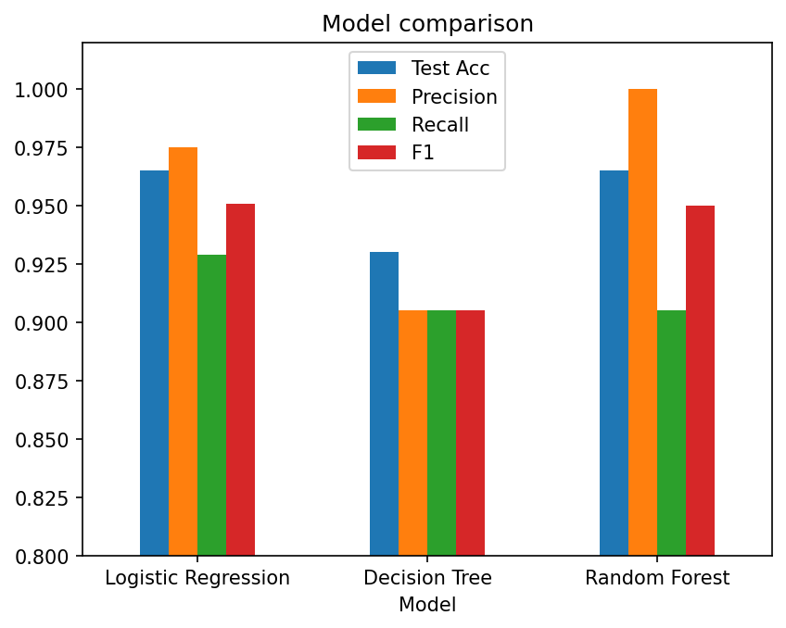
Figure 7: Comparison of accuracy, precision, recall and F1 score of the three models
Figure 7 shows that the three models are close to each other in accuracy, but the Decision Tree is lower on all measures. Figure 8 shows the confusion matrix of the best model.
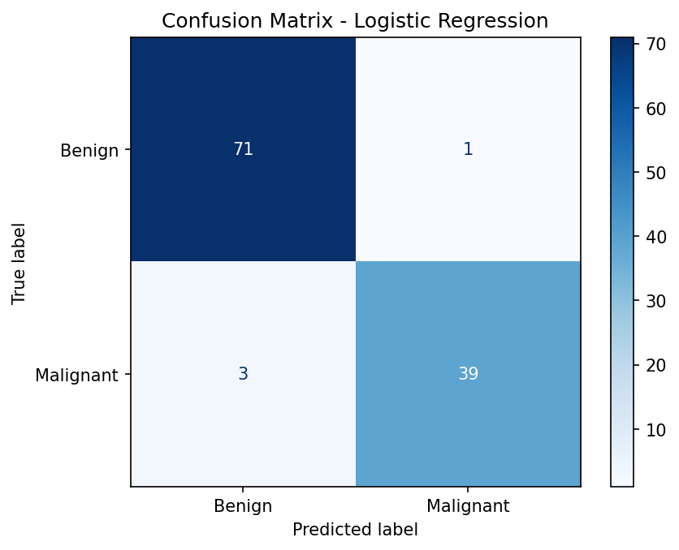
Figure 8: Confusion matrix of the best model (Logistic Regression)
In Figure 8, the dark blue boxes on the diagonal are the correct predictions: 71 benign patients and 39 malignant patients. The two boxes outside the diagonal are the mistakes: 1 benign patient called malignant, and 3 malignant patients missed. Figure 9 shows the ROC curves. A curve closer to the top-left corner is better. The Logistic Regression and Random Forest curves are almost at the corner, and the Decision Tree curve is lower.
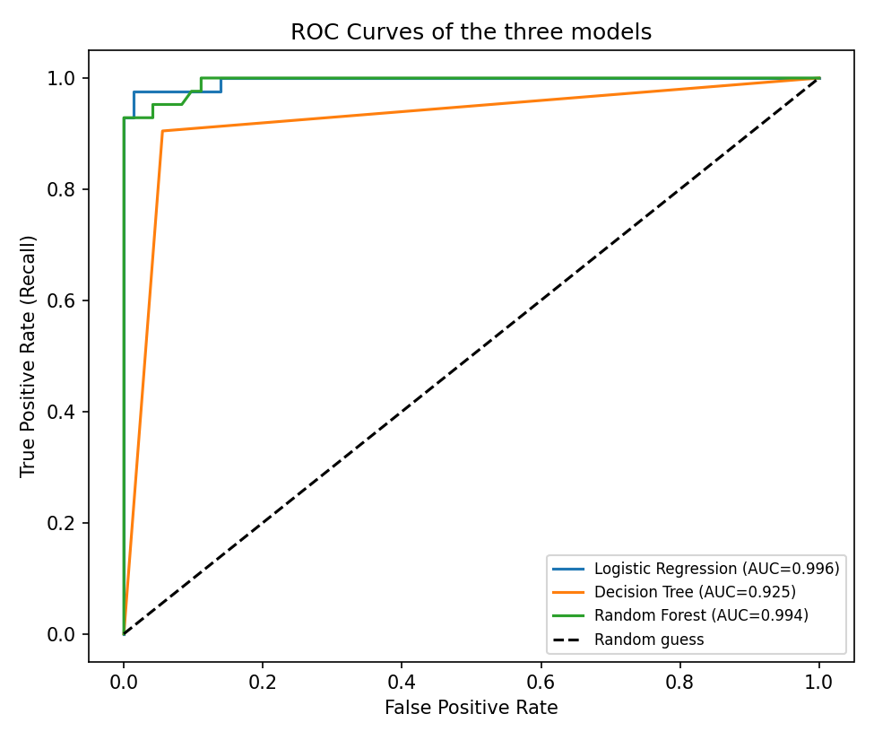
Figure 9: ROC curves of the three models

4.7 Feature Importance

i. Introduction
A good model should not only give an answer, but should also help us to understand which measurements are most useful. This is important in medicine, where doctors want to know why a prediction was made.

ii. General Description
Random Forest can tell how much each feature helped to make good splits in all its trees. The importance values of all 30 features add up to 1. A higher value means the feature is more useful for separating malignant from benign tumours.

iii. Specific Requirements, Functions and Formulas
The attribute feature_importances_ of the trained RandomForestClassifier was used. It was stored in a pandas Series, sorted, and the top 10 features were drawn as a bar graph.

iv. Analysis Results
Table 11: Top 10 important features according to Random Forest
Rank | Feature | Importance
1 | worst perimeter | 0.148
2 | worst area | 0.132
3 | worst concave points | 0.110
4 | mean concave points | 0.088
5 | worst radius | 0.085
6 | mean radius | 0.061
7 | mean perimeter | 0.060
8 | mean area | 0.045
9 | mean concavity | 0.044
10 | worst concavity | 0.033

The most important features are about the size of the tumour (perimeter, area, radius) and the irregular shape of its boundary (concave points and concavity). This agrees with the EDA and the correlation results: bigger and more irregular nuclei point towards a malignant tumour. It also agrees with medical knowledge, which is a good sign that the model has learned meaningful patterns.

v. Visualization
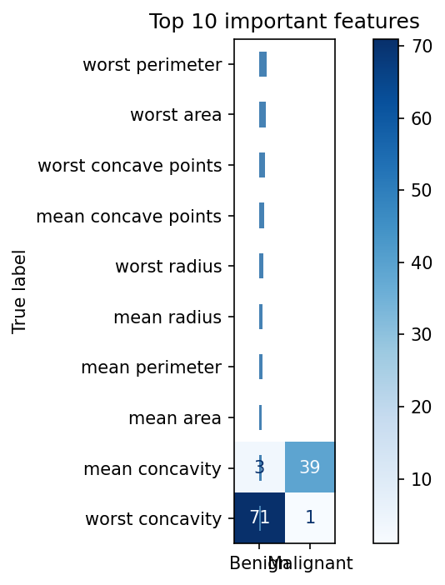
Figure 10: Top 10 important features (Random Forest)

4.8 Changing the Cut-off to Reduce Missed Cancer Cases

i. Introduction
In the first results, Logistic Regression missed 3 malignant patients (recall 92.9%), so the recall objective of 95% was not met. In a medical problem, a missed cancer is much worse than a false alarm, because a false alarm only leads to one more test, while a missed cancer may delay treatment. This analysis checks if the recall can be improved.

ii. General Description
By default, a patient is called malignant when the predicted probability is 0.5 or more. This value is called the cut-off (threshold). If the cut-off is lowered, more patients are called malignant, so more cancer cases are found (higher recall), but more healthy patients are also wrongly flagged (lower precision).

iii. Specific Requirements, Functions and Formulas
The predicted probabilities were taken using predict_proba(). For each cut-off value, the prediction was made using the rule below and accuracy, precision and recall were calculated again.
Prediction = Malignant if P(malignant) >= cut-off, otherwise Benign

iv. Analysis Results
Table 12: Effect of the cut-off on Logistic Regression
Cut-off | Accuracy | Precision | Recall | Cancer cases missed
0.2 | 0.956 | 0.911 | 0.976 | 1
0.3 | 0.982 | 0.976 | 0.976 | 1
0.4 | 0.974 | 0.976 | 0.952 | 2
0.5 (default) | 0.965 | 0.975 | 0.929 | 3
0.6 | 0.965 | 1.000 | 0.905 | 4

When the cut-off is lowered to 0.3, the recall rises to 97.6%, the accuracy rises to 98.2%, and only 1 cancer case is missed out of 42. The precision stays high at 97.6%. When the cut-off is lowered further to 0.2, the recall does not improve any more, but the precision falls to 91.1%, which means more false alarms. A cut-off of 0.3 gives the best balance. With this cut-off, all three objectives (accuracy, recall and AUC) are met.
Note: the cut-off was chosen by looking at the test data. In a real project, the cut-off should be chosen using a separate validation set, and the test data should be used only once at the end. This is mentioned as a limitation in Chapter 5.

v. Visualization
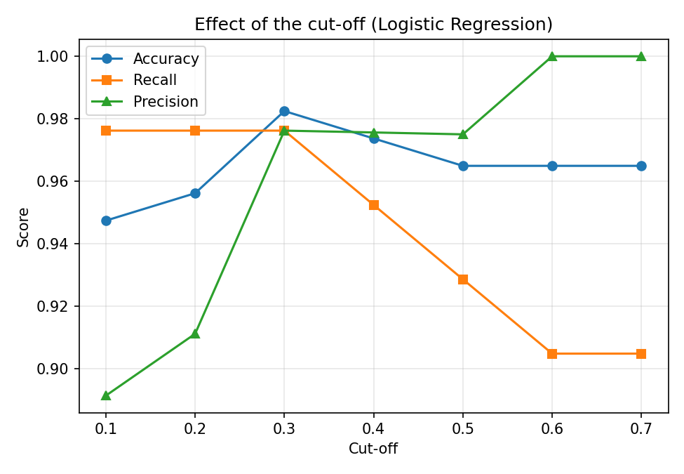
Figure 11: Accuracy, precision and recall at different cut-off values
Figure 11 shows that recall (orange line) is high for low cut-offs and falls when the cut-off becomes larger, while precision (green line) rises. The best balance is near 0.3.

4.9 Python Code of the Project
The complete Python code, written and run in IDLE (Python 3.14), is given below. The code is divided into steps and each step has a short comment in simple English. When the code is run, all graphs and tables are saved in a folder named results.
import os
import pandas as pd
import matplotlib.pyplot as plt
from scipy import stats

from sklearn.model_selection import train_test_split
from sklearn.preprocessing import StandardScaler
from sklearn.decomposition import PCA
from sklearn.linear_model import LogisticRegression
from sklearn.tree import DecisionTreeClassifier
from sklearn.ensemble import RandomForestClassifier
from sklearn.metrics import accuracy_score, precision_score, recall_score
from sklearn.metrics import f1_score, roc_auc_score, log_loss
from sklearn.metrics import confusion_matrix, ConfusionMatrixDisplay

# ------------------------------------------------------------
# STEP 1: What do we want to do? (Objectives)
# ------------------------------------------------------------
print("STEP 1: OBJECTIVES")
print("1. Predict if a tumour is Malignant or Benign")
print("2. Get accuracy of at least 95%")
print("3. Get recall of at least 95% (we should not miss a cancer patient)")
print()

# STEP 2: Read the data
print("STEP 2: READ THE DATA")

folder = os.path.dirname(os.path.abspath(__file__))

# All graphs and tables will be saved in a folder called "results"
results_folder = os.path.join(folder, "results")
os.makedirs(results_folder, exist_ok=True)

def save_graph(file_name):
plt.savefig(os.path.join(results_folder, file_name), dpi=150, bbox_inches="tight")

data = pd.read_csv(os.path.join(folder, "wdbc_breast_cancer.csv"))

print("Rows and columns:", data.shape)
print(data.head())
print()

# In the file: M = Malignant, B = Benign
# We make a new column: 1 = Malignant, 0 = Benign
data["target"] = (data["diagnosis"] == "M").astype(int)

# Columns used to predict (all columns except id, diagnosis and target)
features = [c for c in data.columns if c not in ["id", "diagnosis", "target"]]

# STEP 3: Clean the data

print("STEP 3: CLEAN THE DATA")

print("Missing values:", data.isnull().sum().sum())
print("Duplicate rows:", data.duplicated().sum())
print("Nothing to fix. The data is already clean.")
print()

# STEP 4: Look at the data with graphs (EDA)
print("STEP 4: EXPLORE THE DATA")
print(data[["mean radius", "mean area", "mean texture"]].describe())
print()

# Graph 1: How many Benign and Malignant?
counts = data["diagnosis"].value_counts()
plt.bar(["Benign", "Malignant"], [counts["B"], counts["M"]],
color=["green", "red"])
plt.title("Number of Benign and Malignant patients")
plt.ylabel("Patients")
save_graph("01_class_count.png")
plt.show()

# Graph 2: Histogram of mean radius
benign = data[data["target"] == 0]
malignant = data[data["target"] == 1]

plt.hist(benign["mean radius"], bins=25, alpha=0.6, color="green", label="Benign")
plt.hist(malignant["mean radius"], bins=25, alpha=0.6, color="red", label="Malignant")
plt.title("Mean radius: Benign vs Malignant")
plt.xlabel("Mean radius")
plt.legend()
save_graph("02_radius_histogram.png")
plt.show()

# Graph 3: Boxplot of mean area
plt.boxplot([benign["mean area"], malignant["mean area"]])
plt.xticks([1, 2], ["Benign", "Malignant"])
plt.title("Mean area: Benign vs Malignant")
save_graph("03_area_boxplot.png")
plt.show()

# Graph 4: Correlation (how features move together)
mean_columns = [c for c in features if c.startswith("mean")]
corr = data[mean_columns].corr()
plt.figure(figsize=(8, 7))
plt.imshow(corr, cmap="coolwarm", vmin=-1, vmax=1)
plt.colorbar()
plt.xticks(range(len(mean_columns)), mean_columns, rotation=90)
plt.yticks(range(len(mean_columns)), mean_columns)
plt.title("Correlation between features")
plt.tight_layout()
save_graph("04_correlation.png")
plt.show()

# STEP 5: Statistics (t-test)
# Question: is the average really different for the two groups?
# If p-value is less than 0.05, the difference is real.
print("STEP 5: T-TEST")

for col in ["mean radius", "mean area", "mean texture", "mean smoothness"]:
t, p = stats.ttest_ind(malignant[col], benign[col], equal_var=False)
print(col, "-> malignant average:", round(malignant[col].mean(), 2),
"| benign average:", round(benign[col].mean(), 2),
"| p-value:", p)
print()

print("Features most related to cancer (correlation with target):")
related = data[features + ["target"]].corr()["target"].drop("target")
print(related.sort_values(ascending=False).head(5).round(2))
print()

# STEP 6: Get the data ready
print("STEP 6: PREPARE THE DATA")

X = data[features] # the measurements
y = data["target"] # the answer (0 or 1)

# Keep 80% for learning (train) and 20% for checking (test)
X_train, X_test, y_train, y_test = train_test_split(
X, y, test_size=0.2, random_state=42, stratify=y)

# Scaling: bring all numbers to the same range
scaler = StandardScaler()
X_train = scaler.fit_transform(X_train)
X_test = scaler.transform(X_test)

print("Training rows:", len(X_train))
print("Testing rows:", len(X_test))
print()

# STEP 7: PCA (reduce 30 columns to 2 so we can draw them)
print("STEP 7: PCA")

pca = PCA(n_components=2)
points = pca.fit_transform(X_train)
print("Information kept by 2 columns:",
round(pca.explained_variance_ratio_.sum() * 100, 1), "%")

plt.scatter(points[y_train == 0, 0], points[y_train == 0, 1],
color="green", alpha=0.6, label="Benign")
plt.scatter(points[y_train == 1, 0], points[y_train == 1, 1],
color="red", alpha=0.6, label="Malignant")
plt.title("PCA: 30 columns shown in 2D")
plt.xlabel("Component 1")
plt.ylabel("Component 2")
plt.legend()
save_graph("05_pca.png")
plt.show()
print()

# STEP 8: Build the 3 models
print("STEP 8: BUILD MODELS")

models = {
"Logistic Regression": LogisticRegression(max_iter=1000),
"Decision Tree": DecisionTreeClassifier(random_state=42),
"Random Forest": RandomForestClassifier(n_estimators=200, random_state=42),
}

rows = []
predictions = {}
probabilities = {}

for name in models:
model = models[name]
model.fit(X_train, y_train) # learn from train data

train_accuracy = accuracy_score(y_train, model.predict(X_train))
test_predict = model.predict(X_test) # guess on test data
test_chance = model.predict_proba(X_test)[:, 1] # chance of cancer (0 to 1)

predictions[name] = test_predict
probabilities[name] = test_chance

rows.append([
name,
train_accuracy,
accuracy_score(y_test, test_predict),
precision_score(y_test, test_predict),
recall_score(y_test, test_predict),
f1_score(y_test, test_predict),
roc_auc_score(y_test, test_chance),
log_loss(y_test, test_chance),
])

result = pd.DataFrame(rows, columns=[
"Model", "Train Acc", "Test Acc", "Precision",
"Recall", "F1", "AUC", "Log Loss"]).round(3)

print(result.to_string(index=False))
print()
print("Precision, Recall, F1 are for the Malignant (cancer) class.")
print()

# Overfitting check (bias and variance)
# If Train Acc is much higher than Test Acc, the model has just
# memorised the training data. This is called overfitting.
print("OVERFITTING CHECK")
for i in range(len(result)):
gap = result["Train Acc"][i] - result["Test Acc"][i]
print(result["Model"][i], "-> gap between train and test:", round(gap, 3))
print()

# Graph: compare the models
result.set_index("Model")[["Test Acc", "Precision", "Recall", "F1"]].plot(
kind="bar", ylim=(0.8, 1.02))
plt.title("Model comparison")
plt.xticks(rotation=0)
save_graph("06_model_comparison.png")
plt.show()

# STEP 9: Check the best model in more detail
print("STEP 9: BEST MODEL")

# Best model = the one with highest AUC
best = result.sort_values("AUC", ascending=False).iloc[0]["Model"]
print("Best model:", best)

# Confusion matrix
cm = confusion_matrix(y_test, predictions[best])
ConfusionMatrixDisplay(cm, display_labels=["Benign", "Malignant"]).plot(cmap="Blues")
plt.title("Confusion Matrix - " + best)
save_graph("07_confusion_matrix.png")
plt.show()

tn, fp, fn, tp = cm.ravel()
print("Cancer found correctly :", tp)
print("Healthy found correctly :", tn)
print("Healthy called cancer (wrong):", fp)
print("Cancer missed (very bad) :", fn)
print()

# Important features (from Random Forest)
forest = models["Random Forest"]
importance = pd.Series(forest.feature_importances_, index=features)
top10 = importance.sort_values().tail(10)
top10.plot(kind="barh", color="steelblue")
plt.title("Top 10 important features")
plt.tight_layout()
save_graph("08_top_features.png")
plt.show()

# STEP 10: Catch more cancer cases (change the cut-off)
# Normally: if chance of cancer is 50% or more, say "cancer".
# If we lower the cut-off, we catch more cancer patients,
# but we also get a few more false alarms.
print("STEP 10: CHANGE THE CUT-OFF")

cutoff_lines = []
for cutoff in [0.5, 0.4, 0.3, 0.2]:
guess = (probabilities[best] >= cutoff).astype(int)
missed = ((guess == 0) & (y_test == 1)).sum()
line = ("Cut-off " + str(cutoff) +
" | accuracy: " + str(round(accuracy_score(y_test, guess), 3)) +
" | recall: " + str(round(recall_score(y_test, guess), 3)) +
" | cancer missed: " + str(missed))
print(line)
cutoff_lines.append(line)
print()

# STEP 11: Conclusion
print("STEP 11: CONCLUSION")
print("Best model:", best)
print("Most important features:", ", ".join(top10.index[::-1][:3]))
print("Logistic Regression was simple and gave the best result.")
print("Decision Tree overfitted (100% on train but less on test).")
print("Random Forest reduced overfitting by joining many trees.")
print("Lowering the cut-off helps to miss fewer cancer patients.")
print("Limit: only 569 patients. This tool helps doctors,")
print("it cannot replace them.")

# STEP 12: Save the results in the "results" folder
result.to_csv(os.path.join(results_folder, "model_results.csv"), index=False)

with open(os.path.join(results_folder, "summary.txt"), "w") as f:
f.write("BREAST CANCER PREDICTION - SUMMARY\n")
f.write("==================================\n\n")
f.write("Data: " + str(data.shape[0]) + " patients, " +
str(len(features)) + " measurements each\n")
f.write("Training rows: " + str(len(X_train)) +
" | Testing rows: " + str(len(X_test)) + "\n\n")
f.write("MODEL RESULTS\n")
f.write(result.to_string(index=False) + "\n\n")
f.write("Best model: " + best + "\n")
f.write("Cancer found correctly : " + str(tp) + "\n")
f.write("Healthy found correctly : " + str(tn) + "\n")
f.write("Healthy called cancer (wrong): " + str(fp) + "\n")
f.write("Cancer missed (very bad) : " + str(fn) + "\n\n")
f.write("CHANGING THE CUT-OFF\n")
for line in cutoff_lines:
f.write(line + "\n")
f.write("\nMost important features: " + ", ".join(top10.index[::-1][:3]) + "\n")

print()
print("All results saved in:", results_folder)

5. Conclusion
In this project, the societal problem of late detection of breast cancer was studied using the Breast Cancer Wisconsin (Diagnostic) dataset from the UCI Machine Learning Repository. The dataset has 569 patients and 30 measurements of cell nuclei. The complete data science workflow was followed: cleaning, exploration, statistical testing, preparation, modelling, evaluation and interpretation.
The main findings of the project are:
- The data was clean, with no missing values and no duplicates. The class ratio (62.7% benign and 37.3% malignant) was acceptable.
- EDA and the t-test showed that malignant tumours have significantly larger and more irregular nuclei than benign tumours. All tested p-values were far below 0.05.
- Many features are strongly correlated with each other, especially radius, perimeter and area (about 0.99 to 1.00).
- PCA showed that two components keep 63.1% of the information and that the two classes can be separated visually.
- Logistic Regression was the best model. It reached 96.5% test accuracy, an AUC of 0.996 and the lowest log loss (0.077).
- The Decision Tree overfitted (100% training accuracy but 93.0% test accuracy). The Random Forest reduced this overfitting by combining 200 trees.
- At the default cut-off, recall was 92.9%. After lowering the cut-off to 0.3, recall rose to 97.6% and accuracy to 98.2%, with only 1 cancer case missed out of 42.
- The most important features were worst perimeter, worst area and worst concave points: the size and irregular shape of the nuclei.
All the objectives defined in Chapter 1 were achieved: a working model was built, the accuracy was above 95%, the recall was above 95% after changing the cut-off, the AUC was above 0.97, and the most important features were identified.

5.1 Limitations
- The dataset is small (569 patients) and comes from one source, so the results may be different for patients from other places.
- The cut-off was selected using the test data. A separate validation set should be used in a real project.
- Only one train-test split was used. Cross-validation would give a more stable estimate of the performance.
- The model uses measurements that are already extracted from images. It does not work directly on the images.
- The model is a decision-support idea only. It must not be used instead of a doctor.

6. Future Scope
The project can be extended in many ways:
- Use more data from many hospitals and different regions, so that the model is tested on a wider group of patients.
- Use k-fold cross-validation and a separate validation set to select the best model and the cut-off in a more reliable way.
- Try more models taught in the course, such as k-Nearest Neighbours, Naive Bayes, Support Vector Machine, boosting methods and the Multi-layer Perceptron neural network, and compare them with the three models used here.
- Tune the hyper-parameters of the models (for example, the depth of the tree or the number of trees) using grid search.
- Build a deep learning model that works directly on the microscope images instead of using the extracted measurements.
- Explain each individual prediction to the doctor, using explainable AI methods, to increase trust in the tool.
- Create a simple web or mobile application where a doctor can enter the measurements and get the predicted probability instantly.
- Use clustering (K-Means) on the data to look for sub-groups of tumours that may need different treatment.

7. References
Wolberg, W. H., Street, W. N., and Mangasarian, O. L. (1995). Breast Cancer Wisconsin (Diagnostic) [Dataset]. UCI Machine Learning Repository.
Data Set: https://doi.org/10.24432/C5DW2B
Git hub: https://github.com
LinkedIn: https://lnkd.in/

