

Project Title
Healthcare Patient Analytics and Health Outcome Prediction

Python (Google Colab) & Power BI Desktop
July 7, 2026
SURYA R
Aspiring Data Analyst

🏥 PROJECT SUMMARY

Healthcare Patient is designed to analyze patient records and healthcare performance using Power BI.

The dashboard provides insights into patient demographics, treatment costs, recovery scores, length of stay, and readmission risk.

It helps healthcare professionals monitor trends, compare departments and regions, and support better decision-making through interactive visualizations.

📄 DATASET DESCRIPTION
Dataset Name: Healthcare Patient Analytics Dataset
Total Records: 5,000+ Patients
Number of Columns: 12
Dataset Fields: Patient ID, Visit Date, Age Group, Gender, Region, Department, Treatment Type, Visit Type, Length of Stay (Days) , TreatmentCost,, Recovery Score, Readmission Risk

🛠️ TOOLS & SOFTWARE USED

- Python (Google Colab) – Data Cleaning, Data Pre-processing, Exploratory Data Analysis (EDA), and Data Manipulation.
- NumPy – Numerical calculations and array-based operations.
- Pandas – Data loading, cleaning, transformation, grouping, filtering, and manipulation.
- Matplotlib – Created statistical charts and graphical visualizations.
- Seaborn – Developed advanced visualizations such as heatmaps, box plots, violin plots, and pair plots.
- Power BI Desktop – Designed interactive dashboards with KPI cards, charts, slicers, and business insights

🧹 DATA CLEANING
- The healthcare dataset was cleaned to improve data quality and ensure accurate analysis.
- Duplicate records were identified and removed to avoid repeated patient information.
- Missing values were handled appropriately, and incorrect or inconsistent data entries were corrected.
- Column names were standardized, and data types such as visit date, treatment cost, and recovery score were converted into the correct format.
- The cleaned dataset provides reliable and consistent data for analysis and visualization.
🔄 DATA MANIPULATION
After cleaning, the dataset was transformed to make it suitable for reporting and dashboard creation. Data was filtered, grouped, and aggregated to calculate key performance indicators (KPIs). Calculated columns and DAX measures were created to analyse patient count, treatment cost, recovery score, and length of stay. The transformed data was then used to build interactive Power BI visualizations.
Visualizations :
1. Count Plot - Gender Distribution
- The count plot represents the number of patients in each gender category. It helps identify which gender has more patients and provides a clear comparison of the gender distribution in the dataset.
2. Histogram Plot- Treatment Cost Distribution
- The histogram illustrates the frequency distribution of treatment costs. It helps identify the range where most treatment costs are concentrated and shows whether the data is evenly distributed or skewed.
3. Box Plot – Treatment Cost
- The box plot represents the distribution of treatment costs. The line inside the box indicates the median, the box shows the middle 50% of the data, and the points outside the box represent outliers. It helps identify the spread and unusual values in treatment costs.
4. Bar Chart – Age Group Distribution
- The Age Group Distribution chart shows the number of patients in each age group. It helps identify which age group has the highest and lowest patient counts. This analysis provides an overview of the patient population and supports an understanding of the age-wise distribution."

5. Scatter Plot – Treatment Cost vs Recovery Score
- The scatter plot compares treatment cost with recovery score. It shows how these two variables are related and helps identify whether there is a positive, negative, or weak relationship between them.
6. correlation heatmap
- The correlation heatmap shows the relationship between the numerical variables in the healthcare dataset. Treatment cost, recovery score, and length of stay in days are compared using correlation values. Positive correlation values indicate that two variables increase together, while negative correlation values indicate an inverse relationship.
7. Pair Plot - Report
- The pair plot shows the relationship between the numeric variables. The diagonal plots show the distribution of each variable, while the scatter plots show how pairs of variables are related. It helps identify trends, clusters, and possible correlations among the variables.
8. Pie Plot - percentage distribution
- The pie chart shows the percentage distribution of patients across different age groups. It helps identify which age group represents the largest and smallest share of patients.
9. Bar Chart - Department-wise Patient Count
- The bar chart shows the number of patients in each hospital department. It helps identify which department receives the highest and lowest patient visits. This analysis supports understanding patient demand across different departments and can help in resource planning.

10. Violin Plot - Treatment Cost by Age Group
- The violin plot shows the distribution of treatment costs across different age groups. It highlights the spread, density, and variation in treatment costs for each age group. This helps identify whether certain age groups tend to have higher or more variable treatment expenses.

POWER BI DESKTOP
Data Integration & Dashboard Development in Power BI
- Power BI Desktop was used to import, clean, and transform the healthcare patient dataset.
- The dataset was connected successfully, and data types were validated to ensure accurate analysis.
- Interactive dashboards were developed using various visualizations such as KPI cards, bar charts, pie charts, line charts, scatter plots, and donut charts.
- Slicers were added for Gender, Region, Department, Age Group, Treatment Type, Visit Type, Readmission Risk, and Visit Year to enable dynamic filtering.
- The dashboard provides real-time insights into patient demographics, treatment costs, recovery scores, and readmission risks, supporting informed healthcare decision-making.

Healthcare Analytics Dashboard Overview
- The Healthcare Analytics Dashboard was developed using Power BI Desktop to provide an interactive and user-friendly visualization of healthcare patient data. The dashboard integrates key healthcare metrics
and presents them through KPI cards, charts, and slicers, enabling users to analyze patient trends, treatment costs, recovery performance, and readmission risks.
- Interactive filters allow users to explore data by Gender, Region, Department, Age Group, Treatment Type, Visit Type, and Visit Year.
- This dashboard helps healthcare professionals identify patterns, monitor performance, and make informed decisions to improve patient care and operational efficiency.

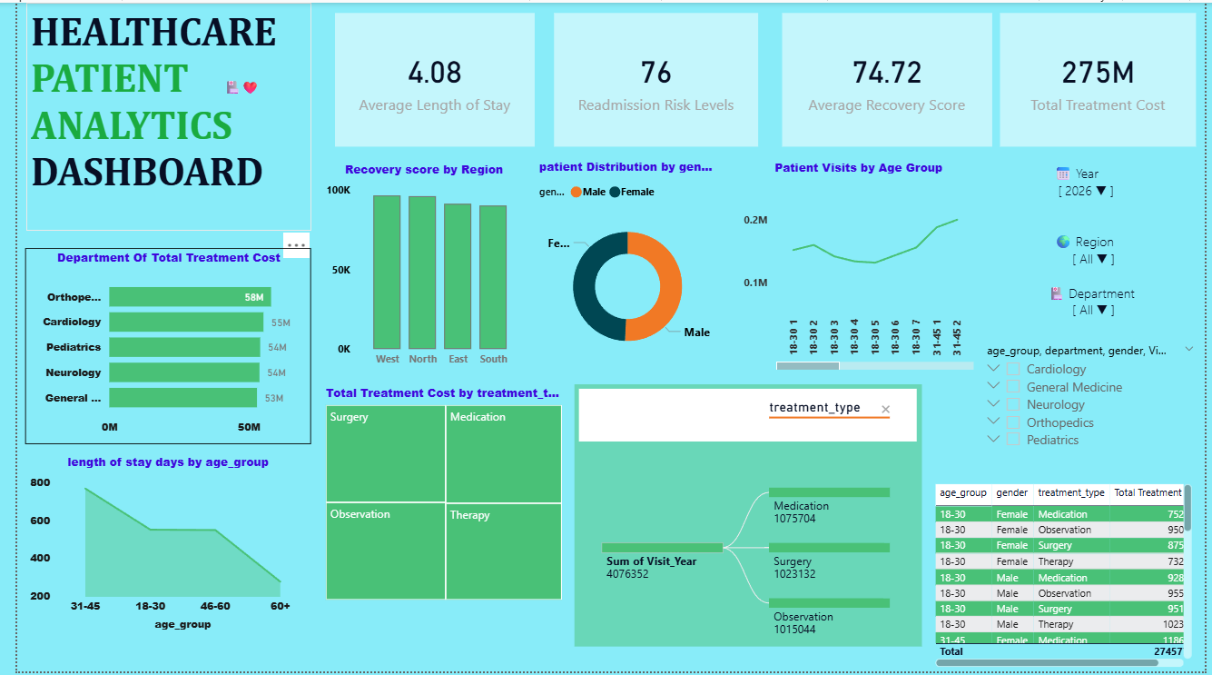

Dashboard Analysis & Key Findings
- The Healthcare Analytics Dashboard provides a comprehensive overview of patient data, treatment performance, and healthcare trends through interactive visualizations. The dashboard enables users to monitor patient distribution, treatment costs, recovery scores, and readmission risks across different departments and regions. By using interactive filters, users can quickly explore specific patient groups and identify important healthcare patterns.
Project Conclusion
- The Healthcare Patient Analytics and Health Outcome Prediction project successfully analyzed healthcare patient data using Python, Pandas, NumPy, Matplotlib, Seaborn, and Power BI Desktop. The dataset was cleaned and preprocessed by handling missing values, removing duplicates, correcting data types, and creating derived features. Exploratory Data Analysis (EDA) was performed to identify important trends and relationships among patient demographics, treatment costs, recovery scores, and readmission risks.
- An interactive Power BI dashboard was developed with KPI cards, charts, and slicers to provide clear and meaningful insights into healthcare performance. The dashboard enables users to monitor patient distribution, compare treatment outcomes, evaluate recovery performance, and analyze readmission risks across different departments and regions.
- Overall, this project demonstrates how data analytics and visualization can support data-driven healthcare decision-making, improve hospital resource planning, enhance patient care, and identify key healthcare trends. The project highlights the importance of business intelligence tools in transforming raw healthcare data into actionable insights for healthcare professionals and management.
Future Enhancements
- Integrate real-time patient data from hospital management systems for live monitoring.
- Apply Machine Learning models to predict disease risk, patient recovery, and hospital readmission.
- Develop AI-based healthcare recommendations to support clinical decision-making.
- Add advanced forecasting and trend analysis for patient admissions and treatment costs.
- Integrate the dashboard with cloud platforms for secure data storage and remote access.
- Include geographical mapping to analyze patient distribution across different regions.
- Implement role-based access control to improve data security and privacy.
- Enable automatic report generation and scheduled dashboard refresh for updated insights.
Scope of Improvement
- Increase the dataset size by including multiple hospitals and healthcare centers.
- Add more healthcare attributes such as medical history, diagnosis, medications, and laboratory results.
- Improve dashboard interactivity with additional KPIs, drill-through pages, and advanced filters.
- Optimize dashboard performance for faster analysis of large healthcare datasets.
- Ensure compliance with healthcare data privacy and security standards.
- Expand the project to support predictive analytics, healthcare resource planning, and population health management.
These enhancements will improve the accuracy, usability, and scalability of the healthcare analytics system, enabling better patient care, efficient hospital management, and more informed healthcare decision-making.

