FORM DESIGN

**Submitted by: Surya S**

**S3 LEMCA**

**Roll no: 55**

**Login form**

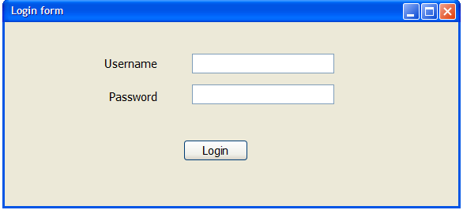

**Registration form**

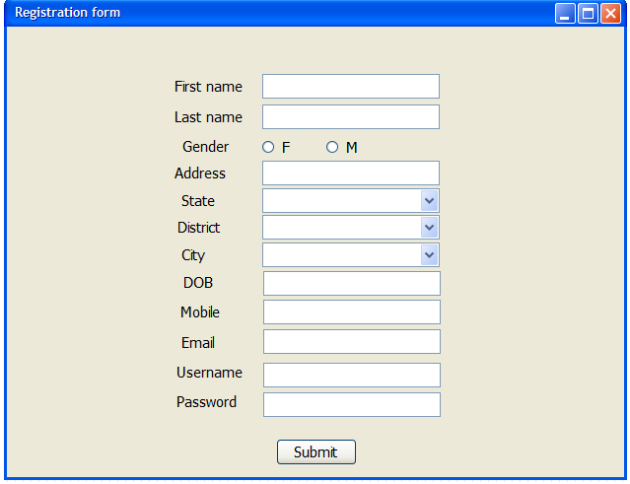

**Add Car Details**

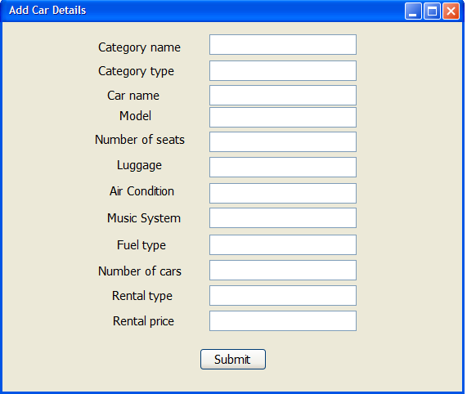

**Booking details**

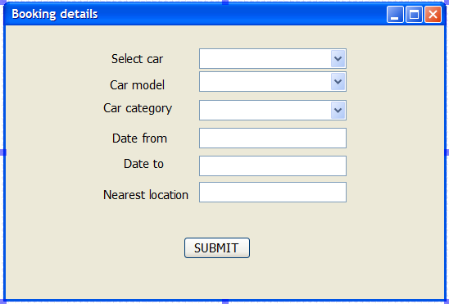

**ADDING IMAGES**

