--------------------jenkins build fails

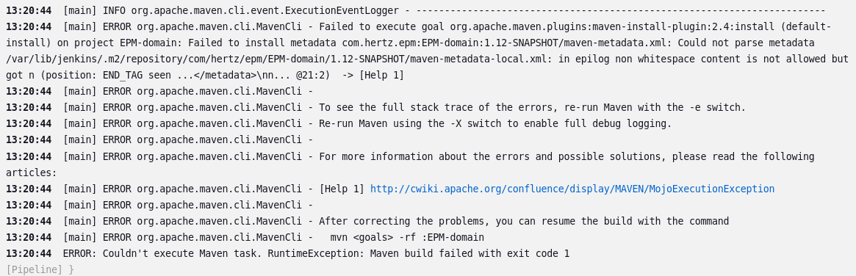

solution: go to server 68

vim /var/lib/jenkins/.m2/repository/com/hertz/epm/EPM-domain/1.12-SNAPSHOT/maven-metadata-local.xml

and remove some bellow lines . Then save and again try to build it.