--→ whenever you ssh you find this error

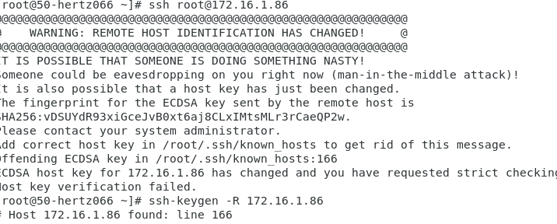

Solution----

ssh-keygen -R 172.16.1.86

( the IP address you can change as per your requirement)