1. Edit save Not working

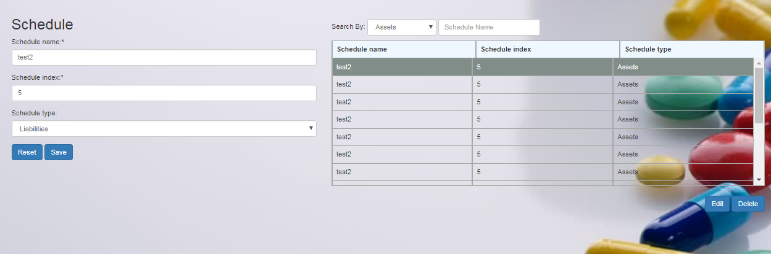

2. Error : Data Replication

