# WireFrames and Table Names

# 1.Schedule Information :

Inputs :

1. Schedule( As Schedule Name In Wireframe) : varchar(40) Unique
2. Main schedule( As Schedule Type in Wireframe) : char(15) Combobox ( Assets,

Liabilities, Trading, Profit and Loss)

1. Schedule Index :Tinyint(2) Unique

Table Name : Schedules (1.schid mediumint(3),2. schname varchar(40),3. Schtype

char(15),4.schindex tinyint(2))

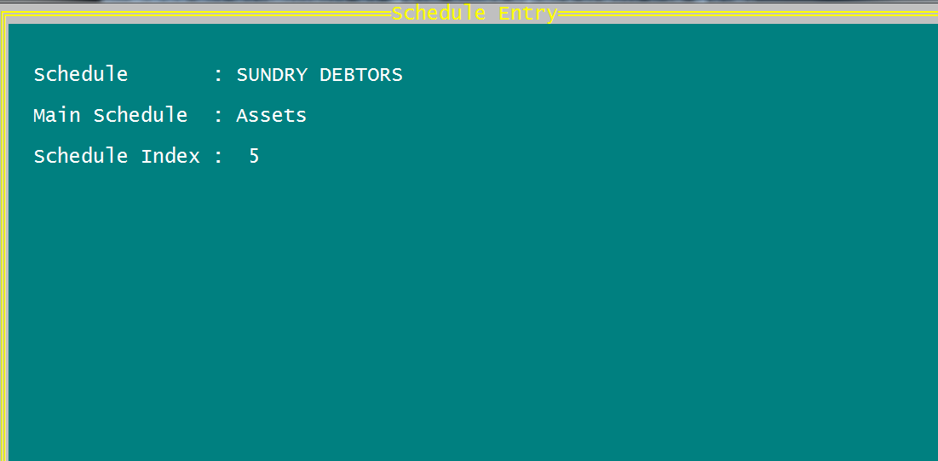

# Sub Schedule Information :

Inputs :

1. Schedule( As Schedule Name In Wireframe) : varchar(40) Unique
2. Main schedule( As Schedule Type in Wireframe) : char(15) Combobox ( Assets,

Liabilities, Trading, Profit and Loss)

1. Schedule Index :Tinyint(2) Unique

Table Name : Schedules (schname varchar(40),Schtype char(15),schindex tinyint(2)

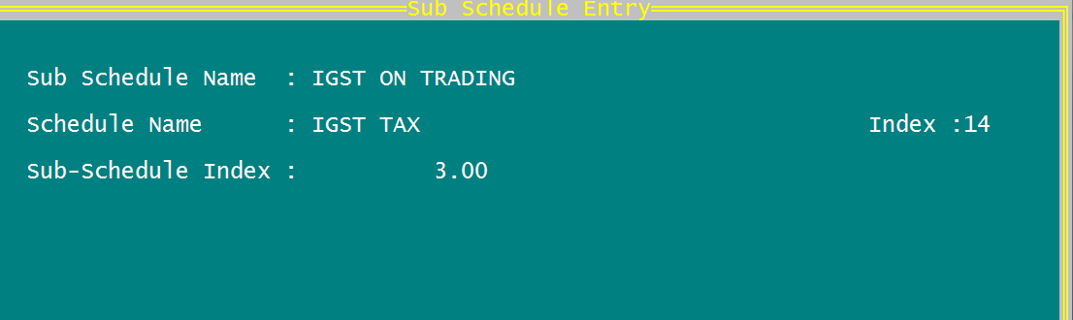

Manufacturer screen. Akum Drugs ,Saar Biotech etc.,

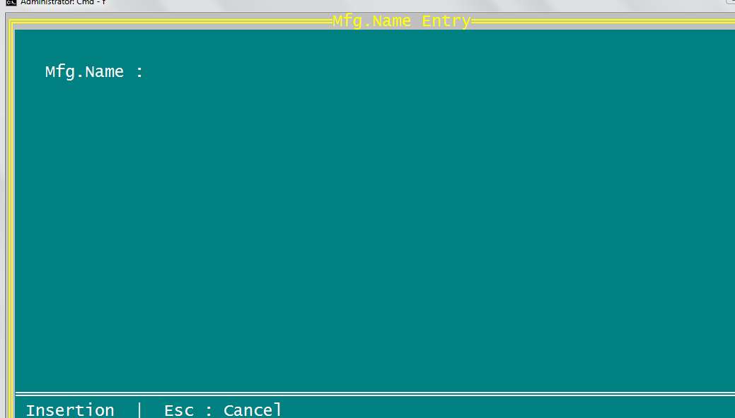

Notes:

1. No edit.
2. Required search by Name only.
3. Input Should be in Capital Letters

Dated : 31st December 2017

Company Grouping : e.g. : Cipla Group, Ranbaxy Group

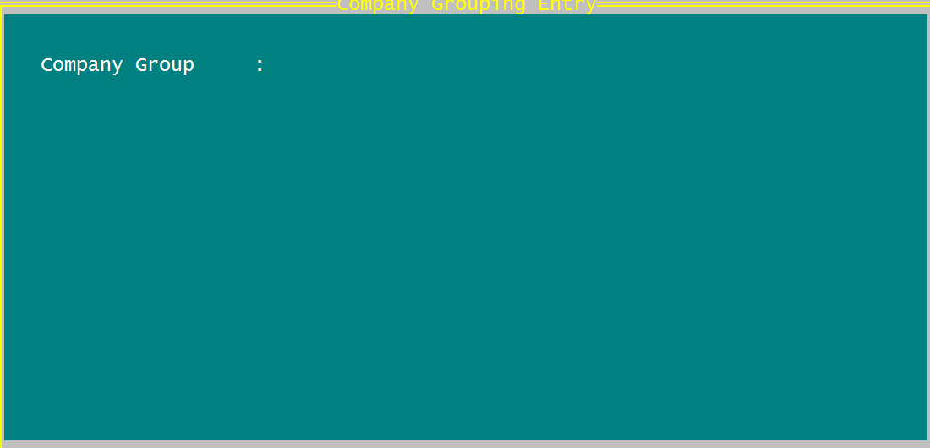

Notes:

1. No edit.
2. Required search by Company Group only.
3. Input Should be in Capital Letters

Companies : Input e.g. CIPLA SPECIALITY DIVISION,CIPLA CARDIO DIVISION , RANBAXY ORTHI DIVISION etc.,

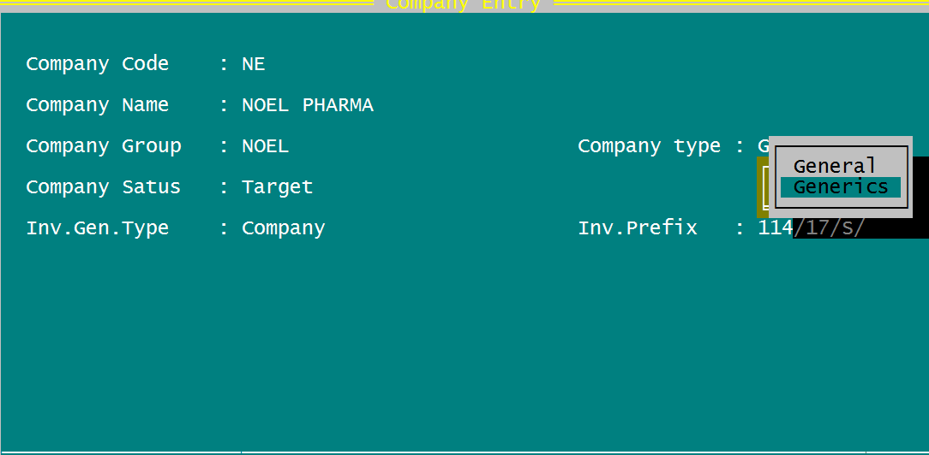

Notes:

1. Company Status : Dropdown Target/Non Target
2. Company Status : Ethical/Generics/Sugical/General/Others
3. Inv.Gen.Type : Regular/Company ( If we select Company Invoice No. Generation based on Inv.Prefix+ continuous serial(Back End Validation)
4. Search Criteria Company Group/Company Type + Company Name
5. Company Name input Should be in Capital Letters
6. Company Status input in Proper case
7. Company Type input in Proper case
8. Inv.Gen.Type input in Proper case

Product Grouping : Input E.g. Paracetamol, Amoxycillin, Aceclofenac etc.,

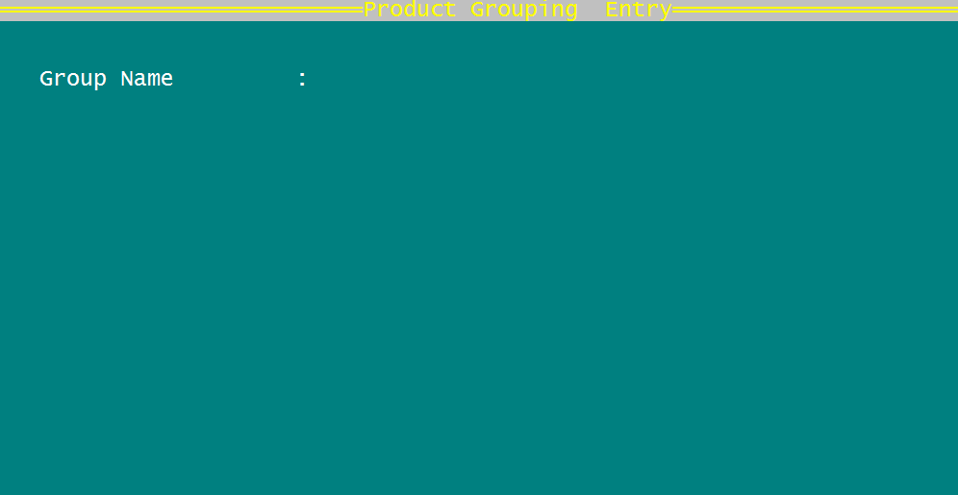

Notes:

1. No edit.
2. Required search by Group Name only.
3. Change Group Name Label as Name
4. Group Name Input in Capital Letters only

Product Category : Input e.g. Tablets, Capsules, Lotions etc.,

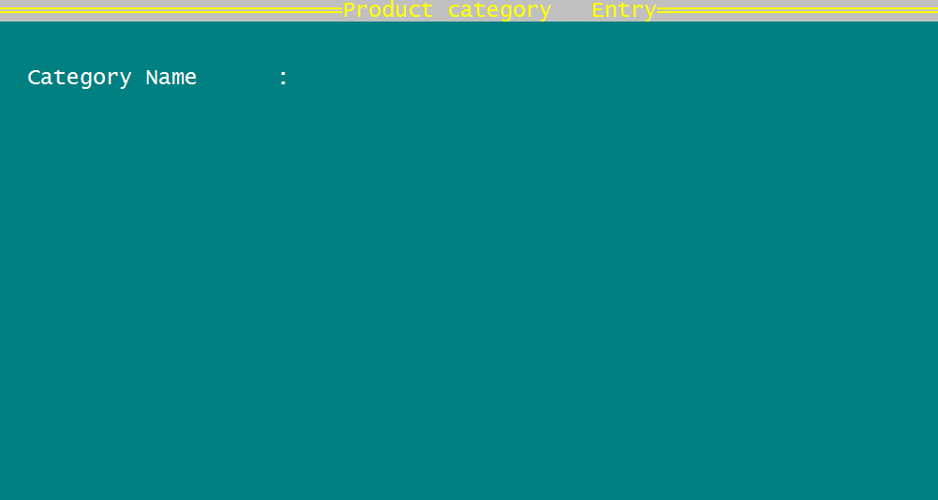

Notes:

1. No edit.
2. Required search by Category Name only.
3. Change Category Name Label as Name
4. Category Name input in capital Letters only

Products :

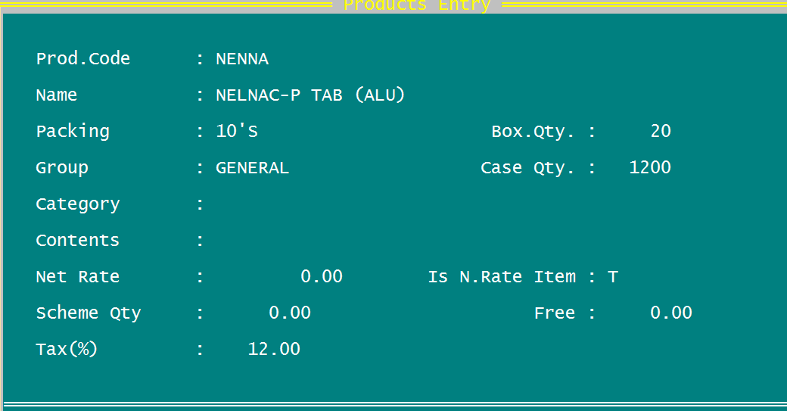

Notes:

1. Required search by Group/Category + Name only.

**Date : 02-01-2018**

# Account Information

|  |
| --- |
| **General Information** :  Account Name : varchar(50)  Sub Schedule : varchar(40) notes 1. Schedule : varchar(40)  HSN Code : bigint(8) 2 SAC Code : bigint(8)  Opening Balance : float(12,2) Opening Type : Credit/Debit char(6)  Code : char(6)  **Personal Information** :  Contact Person : varchar(30)  Address1 : varchar(50)  Address2 : varchar(50)  Town : varchar(20) Pin : 6 (Mediumint)  Area Name : varchar(40)  District : varchar(20) State : varchar(20)  Special Remarks : varchar(60)  Phone : bigint(10) Mobile : bigint(10)  Email :  **Registration Information** :  Lic.No1 : varchar(25) Lic.No2 : varchar(25)  Lic.Expiry : date format  Ret.Lic.No1 : varchar(25) Ret.Lic.No2 : varchar(25)  Ret.Expiry : date format Food Lic.No. : varchar(25)  Other.License : varchar(25) Oth.Lic.Expiry : date format  GST Type : char(5)(RGST/UGST/IGST/IUGST)  If gsttype=’RGST’ or ’IGST’  GSTIN : varchar(15) Nature of GST : Regular/Composite  char(9)  Else  UIN : varchar(25) eg. Aadhar,Pan  endif    **Credentials :**  Sale Type : Cash/Credit(char(6)) Customer Type : Whole Sale/Retail Char(10)  Credit Limit : Float (12,2) Due Days : Mediumint(3) |

**Date : 03-01-2018**

# Customer/Company wise Discounts

When Select Option Select Clicked

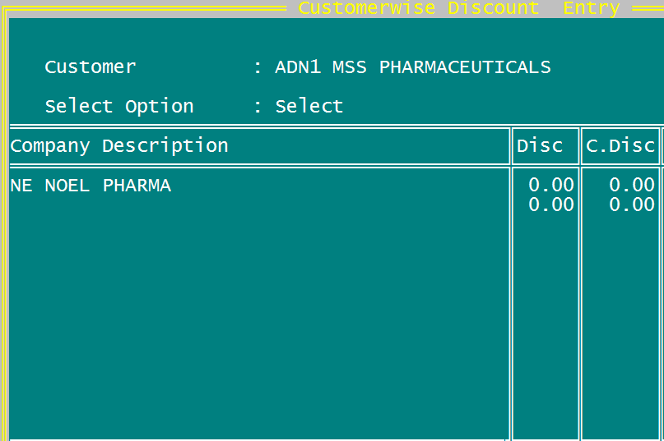

Note :

1. Customer : Should Be Auto populated From accounts table
2. Company Description should be auto populated from company table.

When Select Option All Clicked

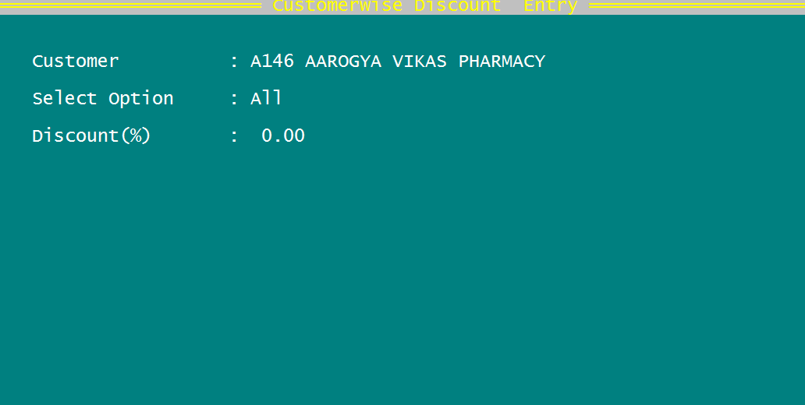

Note :

1. Customer : Should Be Auto populated From accounts table
2. Selection Option : Select/All

# Accounts Openings :

