

CIS 581 001 – COMPUTATIONAL LEARNING

MIDTERM PROJECT

POLYNOMIAL CURVE FITTING REGRESSION FOR WORKING-AGE DATA

|  |  |  |
| --- | --- | --- |
| NAME | : | SURYA SUBRAMANI |
| UMID | : | 69499602 |
| DATE OF SUBMISSION | : | 30-13-2023 |

1. The averages of the RMSE values obtained during the 6-fold CV for each case

The below error charts shows the optimal **d = 6** and alpha = exp(-3) or 0.049

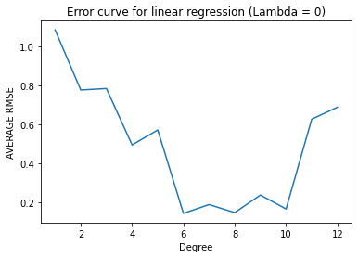

|  |  |
| --- | --- |
| d | avg RMSE |
| 1 | 1.083556162 |
| 2 | 0.775429312 |
| 3 | 0.783001685 |
| 4 | 0.493481844 |
| 5 | 0.570135013 |
| 6 | 0.142352625 |
| 7 | 0.187508475 |
| 8 | 0.146310074 |
| 9 | 0.236472911 |
| 10 | 0.1648808 |
| 11 | 0.625783576 |
| 12 | 0.686978331 |

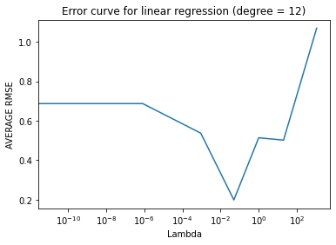

|  |  |
| --- | --- |
| l | avg RMSE |
| 0 | 0.686978 |
| 1.39E-11 | 0.686978 |
| 2.06E-09 | 0.686978 |
| 8.32E-07 | 0.686958 |
| 0.000912 | 0.53732 |
| 0.049787 | 0.198978 |
| 1 | 0.513969 |
| 1096.633 | 1.069071 |
| 20.08554 | 0.501868 |

1. The optimal degree d∗ and regularization parameter λ∗ obtained via the 6-fold CV

d* = **6** withλ = 0

RMSE Average is **0.14235265**

λ∗ = **e-3** with d = 12

RMSE Average is **0.198978**

1. The coefficient-weights of the d∗-degree polynomial and the λ∗-regularized 12-degree learned on all the training data

Weights for d* = **6** all training data

|  |  |  |  |  |  |
| --- | --- | --- | --- | --- | --- |
| w1 | w2 | w3 | w4 | w5 | w6 |
| 0.416333 | 3.93562 | 0.159123 | -3.44054 | 0.00982416 | 0.627914 |

Weights for d = **12**, λ∗ = **e-3** , all training data

|  |  |  |  |  |  |
| --- | --- | --- | --- | --- | --- |
| w1 | w2 | w3 | w4 | w5 | w6 |
| 0.46638 | 2.84362 | 0.0968637 | -1.19065 | -0.00451745 | -0.97337 |

|  |  |  |  |  |  |
| --- | --- | --- | --- | --- | --- |
| w7 | w8 | w9 | w10 | w11 | w12 |
| 0.0164566 | 0.274471 | -0.000703978 | 0.106803 | -0.0000783 | -0.0306244 |

1. The training and test RMSE of that final, learned polynomials

Training RMSE for d* = **6** is (Best Degree)

**0.105401066732**

Testing RMSE for d* = **6** is (Best Degree)

**0.11432570919500**

Training RMSE for d = **12**, λ∗ = **e-3** is

**0.12755963811596235**

Testing RMSE for d = **12**, λ∗ = **e-3** is

**0.12863909044553795**

1. The 2 plots containing all the training data along with the  
   resulting polynomial curves for d∗ and λ∗, for the range of years 1968-2023 as input

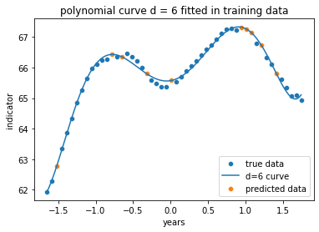

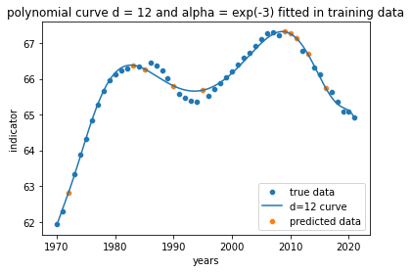

1. Brief discussion of your findings and observations.

From the data and the graph, we can able to observe that for every 20 years the age indicator goes to the peak and starts descending. This repeats for every 30 years with an increase in indicator. With the training data year ranges from 1970 to 2021.

|  |  |  |
| --- | --- | --- |
| **Criteria** | **Year** | **True Values** |
| **count** | 42 | 42 |
| **mean** | 1994.80952 | 65.70398 |
| **std** | 15.209493 | 1.181847 |
| **min** | 1970 | 61.93886 |
| **25%** | 1981.25 | 65.35731 |
| **50%** | 1995 | 65.98761 |
| **75%** | 2005.75 | 66.36326 |
| **max** | 2021 | 67.29843 |

*(the above shown Data is before scaling)*

To reduce the standard deviation, which can affect the model training, The input matrix is scaled to minimum values using (X-mean)/std.

|  |  |  |
| --- | --- | --- |
| **Criteria** | **Year** | **True Values** |
| **count** | 42.00 | 42.00 |
| **mean** | 0.00 | 65.70 |
| **std** | 1.00 | 1.18 |
| **min** | -1.63 | 61.94 |
| **25%** | -0.89 | 65.36 |
| **50%** | 0.01 | 65.99 |
| **75%** | 0.72 | 66.36 |
| **max** | 1.72 | 67.30 |

*(the above shown Data is after scaling)*

Repeating the same process inside cross validation for each training test pair

To train model and calculate weights I have used the below equation

|  |
| --- |
| W = (XT.X + lambda*I).XT.y |

Which is the derivation of

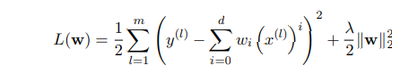

The randomized data is benefitted for training since it is a time series data. If it is sorted based on training the cross validation will leads to information leak. Prophet and XGB can be a better models for this data to train and forecast.