BIJU PATNAIK UNIVERSITY OF TECHNOLOGY
ROURKELA , ODISHA-769004


A Minor-Project Report On
“CHATliFY–CHAT APP”
A Minor -Project report submitted in partial fulfillment of the requirements for
the 7th Semester degree of Bachelor of Technology in Computer Science and Engineering
of Biju Patnaik University of Technology ,Rourkela

Submitted by
Sl. No. | Name | Registration No.
1 | Santosh Padhiali | 2201329056
2 | Soubhagya Panigrahy | 2201329062
3 | Suryakanta Muduli | 2201329069
4 | Monalisa Behera | 2201329041
Under the Guidance of
Mr. SANGRAM KESHARI TRIPATHY
Head of the department


Department of Computer Science and Engineering

KMBB College of Engineering and Technology
Daleiput,Khurda,Odisha-752056

( 2025-2026 )



CERTIFICATE

Certified that the minor project on the topic “ChatliFy – ChatApp” has been successfully submitted at KMBB College of Engineering and Technology by Santosh Padhiali (Regd. No.: 2201329056), Soubhagya Panigrahy (Regd. No.: 2201329062), Suryakanta Muduli (Regd. No.: 2201329069), and Monalisa Behera(Regd. No.: 2201329041), in partial fulfillment of the requirements for the 7th Semester Degree of Bachelor of Technology in Computer Science and Engineering of Biju Patnaik University of Technology, Rourkela, during the academic year 2025–2026.

It is certified that all corrections/suggestions indicated for Internal Assessment have been incorporated in the report deposited in the Department Library. The Internship-cum-Project report has been approved as it satisfies the academic requirements in respect of Major Project work for the said degree.

Mr.Sangram Keshari Tripathy
Head of department (CSE)

DECLARATION

I, Santosh Padhiali (Regd. No.: 2201329056), a student of 7th Semester B.Tech. in Computer Science and Engineering at KMBB College of Engineering and Technology, hereby declare that the Major Project entitled “ChatliFy – ChatApp” has been carried out by me and submitted in partial fulfillment of the requirements for the 7th Semester Degree of Bachelor of Technology in Computer Science and Engineering of Biju Patnaik University of Technology, Rourkela, during the academic year 2025–2026.

Date: 21.Aug.2026
Place: Khordha

Santosh Padhiali
Regd No. 2201329056

DECLARATION

I, Soubhagya Panigrahy (Regd. No.: 2201329062), a student of 7th Semester B.Tech. in Computer Science and Engineering at KMBB College of Engineering and Technology, hereby declare that the Major Project entitled “ChatliFy – ChatApp” has been carried out by me and submitted in partial fulfillment of the requirements for the 7th Semester Degree of Bachelor of Technology in Computer Science and Engineering of Biju Patnaik University of Technology, Rourkela, during the academic year 2025–2026.

Soubhagya Panigrahy
Regd No. 2201329062
Date: 21.Aug.2026
Place: Khordha

DECLARATION

I, Suryakanta Muduli (Regd. No.: 2201329069), a student of 7th Semester B.Tech. in Computer Science and Engineering at KMBB College of Engineering and Technology, hereby declare that the Major Project entitled “ChatliFy – ChatApp” has been carried out by me and submitted in partial fulfillment of the requirements for the 7th Semester Degree of Bachelor of Technology in Computer Science and Engineering of Biju Patnaik University of Technology, Rourkela, during the academic year 2025–2026.

Date: 21.Aug.2026
Place: Khordha

Suryakanta Muduli
Regd No. 2201329069

DECLARATION

I, Monalisa Behera (Regd. No.: 2201329041), a student of 7th Semester B.Tech. in Computer Science and Engineering at KMBB College of Engineering and Technology, hereby declare that the Major Project entitled “ChatliFy – ChatApp” has been carried out by me and submitted in partial fulfillment of the requirements for the 7th Semester Degree of Bachelor of Technology in Computer Science and Engineering of Biju Patnaik University of Technology, Rourkela, during the academic year 2025–2026.

Date: 21.Aug.2026
Place: Khordha

Monalisa Behera
Regd No. 2201329041

ACKNOWLEDGEMENT

The satisfaction and euphoria that accompany the successful completion of any task would be incomplete without the mention of the people who made it possible ,whose constant guidance and encouragement crowned the efforts with success.
we would like to profoundly thank Management of KMBB College of Engineering and Technology for providing such a healthy environment for the successful completion of Internship-cum-Project work.
we would like to express my thanks to the Principal Prof.(Dr.)Amar Nath Nayak for his encouragement that motivates me for the successful completion of Internship-Cum-Project work.
It gives me immense pleasure to thank Mr.Sangram Keshri Tripathy , HOD for his constant support and encouragement.
Also, we would like to express my deepest sense of gratitude to my Seminar guide Mr.Sangram Tripathy Head of Department of Computer Science & Engineering for his constant support and guidance throughout the Internship-Cum-Project work.

we would also like to thank all other teaching and non-teaching staff of Computer Science & Engineering Department who has directly or indirectly helped me in the completion of the Internship-Cum-Project work.

Last, but not the least, we would hereby acknowledge and thank my parents who have been a source of inspiration and also instrumental in the successful completion of the Internship-Cum- Project work.

-Santosh padhiali
- Soubhagya panigrahy
- Suryakanta Muduli
- Monalisa Behera

Abstract
This project is a simplified Chat web app built using the MERN stack— MongoDB, Express.js, React.js, and Node.js—alongside Socket.io for real-time features. The system is designed to simulate the core functionality of real time chat, allowing users to Online features, update the profile pic , and send images &Chat in real time. The frontend, developed with React.js, provides a responsive and intuitive user interface, while the backend, powered by Express and Node.js, handles API requests and real-time communication.

ChatliFy – ChatApp integrates Socket.io to provide real-time messaging, ensuring instant delivery of chats without the need for page refreshes. MongoDB is used to store user information, chat history, and media files, maintaining a smooth and efficient data flow across the application. Secure authentication and authorization mechanisms are implemented to safeguard user data and maintain privacy.

This version of ChatliFy – ChatApp is a showcase model and does not include advanced features such as voice or video calling. It focuses solely on demonstrating the operational flow of a real-time chat application, with a primary emphasis on instant messaging, secure authentication, and a clean user experience.
The architecture emphasizes clarity, modularity, and modern web development practices, making it ideal for both learning and demonstration purposes, while providing a strong foundation for future enhancements like group chats, multimedia sharing, and AI-powered suggestions.

Table of Content
CHAPTER 1
Introduction Problem Statement Objective CHAPTER 2
Project-Scope Feasibility-Study System Architecture CHAPTER 3
Tools & Platform Used Frontend-used Backend-used Database used
IDE used
CHAPTER 4
Frontend Code Backend Code CHAPTER 5
Future Scope & limitation
CHAPTER 6
Conclusion
CHAPTER 7
Reference

CHAPTER 1
  - Introduction
Introduction Our Chat Application Project
The rapid advancement of technology and the internet has revolutionized how people communicate, making real-time messaging an essential part of modern digital life. Traditional communication methods like SMS or email, while still relevant, often lack the speed, interactivity, and rich features that today’s users demand. This has created a rising need for instant, secure, and user-friendly chat platforms. Applications such as WhatsApp, Messenger, and Slack have transformed communication by enabling instant, real-time conversations across devices.

The purpose of this project is to develop a real-time web-based chat application that enables users to send and receive messages instantly, share media, and stay connected with peers. The application is built using the MERN stack (MongoDB, Express.js, React.js, and Node.js), and it integrates Socket.io for real-time bidirectional communication between the client and server. Additionally, Cloudinary is used for media storage (e.g., images), and JWT authentication ensures secure login and message exchange.

Unlike traditional chat systems that store messages locally or lack real-time capabilities, this application provides a seamless digital experience with instant message delivery, media sharing, and user profile management. It is designed with scalability and modularity in mind, allowing future enhancements such as video/audio calling, read receipts, group chats, and push notifications.

With the growing demand for real-time applications, this project serves as a practical full-stack development exercise, showcasing how to build a robust and interactive chat platform. It emphasizes concepts such as client-server communication, RESTful APIs, WebSockets, secure authentication, and cloud-based file storage.

The application caters to two primary roles:
Users – who can register, log in, send/receive text messages, and share images in real-time.
Server – which authenticates users, manages message flow, and ensures reliable delivery using sockets.

Moreover, this project demonstrates how modern web technologies can handle real-time data flow and concurrent interactions, strengthening the understanding of scalable backend systems, optimized frontend design, and secure data handling.
1.2 Problem Statement

In Problem Statement for Chat Application
In today’s digital-first world, communication has become the backbone of personal, educational, and professional interaction. Traditional methods of communication such as SMS or email, while still in use, often lack the speed, interactivity, and collaborative features demanded in real-time environments. Popular platforms like WhatsApp, Messenger, and Slack dominate the space, but they are proprietary, closed-source, and resource-heavy, which restricts customization and limits opportunities for students, developers, and small organizations to create tailored solutions.
Despite the abundance of messaging apps, there are persistent challenges:
- Lack of open-source real-time chat applications that can be easily customized and extended by learners or startups.
- No modular, full-stack examples showcasing seamless integration of front-end, back-end, and real-time communication for academic or training purposes.
- Limited access to lightweight web-based chat systems that don’t rely solely on mobile applications or third-party proprietary SDKs.
- Scalability and extensibility issues in beginner-level projects, making it hard to integrate advanced features such as file sharing, multimedia, encryption, or AI-powered chatbots.
- Inadequate demonstrations of modern technologies like Socket.io for WebSockets and JWT authentication in real-world chat solutions.
This project addresses these gaps by developing a full-stack web-based real-time chat application using the MERN stack (MongoDB, Express.js, React.js, Node.js) along with Socket.io for low-latency, bidirectional communication. The application enables user registration, login, one-to-one messaging, real-time updates, and media sharing, serving as both a learning resource and a scalable foundation for future enhancements such as group chats, video calling, and AI integrations.
Objective
Objectives of the Project (Chat Application)
The primary objective of this project is to design and develop a web-based real-time chat application that provides seamless, low-latency communication between users. The system aims to replicate the core functionalities of modern messaging platforms while being lightweight, scalable, and built entirely with open-source web technologies.
This project fulfills both technical and educational goals, with the following specific objectives:

1.1.1 Functional Objectives
- User Registration and Authentication
  - Implement secure user sign-up and login functionalities.
  - Use JWT (JSON Web Tokens) for session management and authentication.
- One-to-One Messaging
  - Allow users to send and receive messages in real-time.
  - Maintain chat history using a database for persistence.
- Real-Time Communication
  - Use Socket.io to establish bi-directional WebSocket connections.
  - Ensure instant message delivery and updates without page refresh.
- Typing Indicators & Message Status
  - Provide feedback such as “user is typing…” indicators.
  - Implement message sent, delivered, and seen status updates.
- Media Sharing
  - Allow users to share images, documents, and other files securely.
  - Store media efficiently in the backend or third-party storage services (e.g., Cloudinary).
- User Interface Design
  - Build a responsive, modern UI using React.js.
  - Provide intuitive chat layouts with a clean and user-friendly experience across devices.
- Backend Development
  - Develop a RESTful API using Node.js and Express.js to handle authentication, chat management, and media uploads.
- Database Management
  - Use MongoDB to store user profiles, conversations, and message logs.
  - Ensure efficient schema design for real-time query performance.

CHAPTER 2

Project Scope
The scope of this project is to build a web-based real-time chat application using the MERN stack (MongoDB, Express.js, React.js, Node.js) with Socket.io for instant bi-directional communication. The application aims to replicate the core functionalities of modern chat platforms (such as WhatsApp Web, Messenger, or Slack) while being lightweight, scalable, and open-source.
The system is designed primarily for end-users who want to communicate securely in real time through a simple and user-friendly web platform. Additionally, the application provides an admin dashboard for monitoring and analytics, ensuring maintainability and better insights into system usage.

In-Scope Features
- User Registration & Authentication
  - Secure signup and login using JWT-based authentication.
  - Password hashing and role-based access control (user, admin).
  - Profile management (username, profile picture, status).
- One-to-One Messaging
  - Secure and real-time private chat between authenticated users.
  - Delivery/read receipts for improved interactivity.
- Group Chat System
  - Ability for users to create, join, and leave groups.
  - Support for group admin privileges (e.g., removing members, renaming groups).
- Real-Time Communication
  - WebSocket-based instant messaging powered by Socket.io.
  - Dynamic chat updates without refreshing.
  - Typing indicators and message status (sent, delivered, seen).

Frontend UI/UX Development

Built with React.js for a responsive and modern chat interface.

Mobile-friendly design for cross-device accessibility.

Dark mode/light mode toggle.

Database Integration
  - MongoDB used to manage users, rides, sessions, and authentication.

Scalable Codebase
- Modular and maintainable backend and frontend code structure.

Codebase structured for adding future features like video calls, bots, or advanced analytics.

Out of Scope
- Voice/Video calling features (planned as future scope).
- End-to-end encryption (beyond basic encryption and authentication).
- Native mobile app versions (focus is on web-based application).
- Advanced AI chatbots or assistants (not part of initial release).

Feasibility Study
The feasibility study assesses the practicality of developing a ride-hailing web application using modern full-stack technologies. It evaluates the project based on key aspects such as technical, economic, operational, and time feasibility to ensure that the solution is implementable and sustainable within the given constraints.

Technical Feasibility
• Technology Stack: MERN stack (MongoDB, Express.js, React.js, Node.js) with Socket.io, which provides strong real-time capabilities.
• Real-time Messaging: Socket.io enables instant communication, compatible with the MERN stac

2.3.2 Economic Feasibility
This considers whether the chat application can be developed and deployed within an acceptable cost range.
- Development Cost: No significant hardware investment is required as he application can be developed and tested on a personal computer with standard specifications.
- APIs and Hosting: The project primarily uses open-source tools and libraries (React.js, Node.js, Express.js, MongoDB, Socket.io). Hosting can be managed on free or low-cost platforms like Render, Vercel, or free-tier services of cloud providers (e.g., MongoDB Atlas, Railway).
- Labor Cost: Since the project is being developed as a part of a college/internship project, no additional labour cost is incurred.
- Maintenance Cost: Minimal, as only periodic updates and bug fixes will be needed.
Conclusion: The chat application is economically feasible for development and testing purposes, requiring minimal to no financial investment, making it suitable for student or learning-based implementation.

Operational Feasibility
This checks if the system will operate efficiently after implementation and meet user needs.
      - Usability: The web-based system offers an intuitive interface for both drivers and riders, improving user experience.
      - Functionality: Core ride-sharing features are present (registration, request, real- time updates, tracking), making it operable in practical scenarios.
      - Responsiveness: The application is designed to be responsive for access via desktop and mobile browsers.
⬛ Conclusion: Operationally feasible with smooth, real-time interaction and user- friendly interfaces.

Schedule (Time) Feasibility
This measures whether the system can be developed within the allocated timeline.
      - Development Timeline: With clear division of tasks (frontend, backend, real- time logic, testing), the project can be completed within a typical academic semester.
      - Tools: The use of modern frameworks and libraries accelerates development and reduces redundancy.
      - Experience: The developer’s familiarity with JavaScript and prior project experience in web development enhances productivity.
  - System Architecture
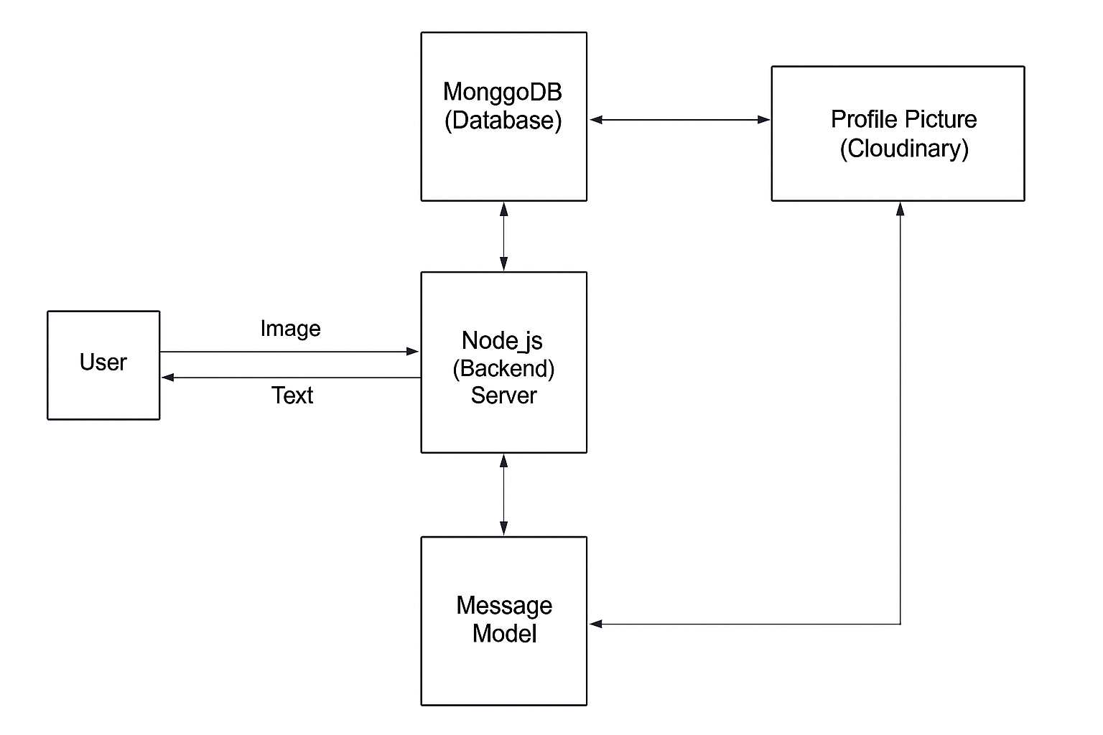
Dig. Of System Architecture
    - Overview
The CHATliFY system architecture follows a client-server model, enhanced with
WebSocket communication and RESTful APIs. The core components include:
      - Frontend Clients (user Interfaces)
      - Backend Server (Node.js with Express.js)

      - Real-time Communication Layer (Socket.io)
      - Database (MongoDB)

Component Breakdown

a. Frontend Clients (React.js)
- Provides an intuitive and responsive interface for users.
- Users can register, log in, and update their profile (including profile picture).
- Users can send and receive messages in real time.
- Displays online/offline status of contacts.
- Integrated with Socket.io client for live communication.

b. Backend Server (Node.js + Express.js)
- Handles user authentication and session management using JWT.
- Exposes RESTful APIs for user registration, login, profile management, and message history.
- Manages communication between users via Socket.io.
- Ensures security by encrypting passwords and validating tokens.

Real-time Layer (Socket.io)
  - Enables bi-directional communication between the Connected User.
  - Used for :
- Sending and receiving chat messages instantly.
- Broadcasting online/offline status updates.
- Notifying users about new messages in real time.

Database (MongoDB)
  - Stores user information, chat history, and authentication details.
Uses collections like:
    - Users: (userId, username, email, password, profilePic, onlineStatus)
    - Messages: (senderId, receiverId, message, timestamp, status)
- Third-party Integration (Cloudinary API)
Used to:Store and manage user profile pictures.
  - Provide secure and optimized image delivery.
  - Handle uploads directly from the client.

- Data Flow Summary (Chat Application)
- User Authentication – A user logs in or registers using the frontend (React.js).
- Frontend → Backend – Login or signup request is sent to the backend (Node.js + Express.js) via REST API.
- Token Validation – Backend verifies credentials, generates a JWT token, and responds to the frontend.
- Socket Connection Established – Once authenticated, the user connects to the server via Socket.io for real-time communication.
- Message Sending – A user types and sends a message; the frontend transmits the data through Socket.io.
- Backend Broadcasting – The backend receives the message and delivers it instantly to the target recipient(s) via WebSocket.
- Database Storage – All chat messages are stored in MongoDB (with sender, receiver, content, and timestamp).
- Real-time Updates – Online/offline status, typing indicators, and new messages are broadcast to connected clients in real time.
- Profile/Media Updates – If a user changes their profile picture (via Cloudinary API), the update is sent to the backend and reflected for all connected clients

CHAPTER 3
TOOLS & PLATFORM USED
To develop a fully functional Real-time Chat Application, a range of modern technologies and tools were used for both the frontend and backend. This chapter provides a summary of each component and its role in the system.

Frontend
The frontend is built using modern JavaScript frameworks and libraries that provide a responsive, fast, and user-friendly interface for both riders and drivers.

Vite
Vite is a modern build tool and development server for frontend applications. It offers:
      - Instant startup using native ES modules.
      - Fast hot module replacement (HMR) during development.
      - Optimized production builds.
In this project, Vite was used to scaffold the React application, ensuring a fast and efficient development experience.

React.js
React.js is a JavaScript library for building user interfaces. It allows for component- based architecture and efficient rendering.
      - JSX allows writing HTML-like syntax in JavaScript.
      - Reusable components make the UI modular.
- Socket.io
Socket.io enables the integration of real-time communication features into web applications. It allows:
- Bi-directional messaging between clients and server.
- Instant delivery of chat messages without refreshing the page.
- Broadcasting events like typing indicators and online/offline status.
- Efficient connection handling with fallback mechanisms.

- Cloudinary API
Cloudinary provides cloud-based storage and optimization of media files. It allows:
- Uploading and storing images/media shared in chats.
- Optimizing images for faster delivery.
- Generating secure URLs for profile pictures and shared media.

APIs Used:
• Authentication API: Handles user login, signup, and session management securely.
• Socket.io API: Provides real-time bi-directional communication for sending/receiving messages instantly.
• Cloudinary API: Used for uploading, storing, and retrieving profile pictures and media files.
• RESTful API (Express.js): Facilitates CRUD operations for users, messages, and conversations.
• JWT (JSON Web Token) API: Ensures secure authorization and token-based authentication between client and server.

Backend
The backend manages authentication, data storage, API logic, and real-time server communication.

Node.js
Node.js is a runtime environment that executes JavaScript code on the server-side.
      - Event-driven and non-blocking I/O model.
Acts as the base runtime for building the backend logic.

Express.js
Express is a fast, minimalist web framework for Node.js.
      - Used for creating REST APIs to manage users, rides, authentication, and data exchange.
Routes like /api/signIn, /api/login, /api/UpdateProfilePic were implemented.

Socket.io (Backend)
Socket.io on the backend listens to client events and broadcasts updates to connected users.
• Listens for events such as send-message, receive-message, and typing-status.
• Emits updates to all participants in a conversation in real-time.
• Ensures low-latency communication for instant chat delivery.
• Maintains active user connections and handles disconnect/reconnect gracefully.

MongoDB (Database Layer)
MongoDB is a NoSQL database that stores data in flexible JSON-like documents.
- Collections used: users, messages, and conversations.
- Mongoose ORM was used to interact with MongoDB through schemas and models.
- Each user document stores details like username, email, password hash, and profile picture URL.
- Each message document stores sender ID, receiver/conversation ID, message content (text/image), and timestamp.
- Each conversation document stores participants’ IDs and references the messages exchanged between them.

CHAPTER 4
SOURCE CODE
This chapter includes only selected portions of the source code relevant to the core functionality of the CHATliFY. To protect security and intellectual property, sensitive details such as API keys and critical backend logic have been excluded.
ı. Copyright Warning:
The source code presented here is the intellectual property of the project developer. Unauthorized use, reproduction, or distribution of this code in any form is strictly prohibited and may lead to legal action.

Project Structure Overview
The CHATliFY project is divided into two main parts: the backend and frontend, following a modular architecture to ensure scalability, reusability, and easier maintenance. Below is a structured breakdown of both codebases:

Backend Structure
The backend is developed using Node.js with Express.js, and follows a service- oriented directory pattern. The structure is as follows:
    - controllers/ – Contains logic for handling API endpoints like user management, ride creation, and status updates.
    - db/ – Manages the MongoDB connection logic using Mongoose.
    - middleware/ – Includes reusable middleware such as JWT authentication, error handlers, etc.
    - models/ – Contains Mongoose schemas for User, Driver, and Ride collections.
    - routes/ – Defines RESTful API routes and maps them to controller functions.
    - utils/ – Houses utility functions like token generators or validators.
    - app.js / server.js – Core files for setting up and running the server, middleware, and Socket.io.
    - .env – Environment variables (like DB URI, secret keys, and ports) are stored securely here and not exposed in the codebase.

Frontend Structure

The frontend is built with React.js using Vite for faster development and build performance. It follows a component-based structure:
    - assets/ – Stores images and static files used in the app.
    - Components/ – Includes modular and reusable UI components like buttons, forms, etc.
    - Context/ – Manages global state using React Context (e.g., auth state, ride details).
    - Pages/ – Full-page views like Home, Rider Dashboard, Driver Panel, etc.
    - App.jsx – Root component where routes and layout logic are defined.
    - main.jsx – Main entry point for rendering the application.
    - .env – Stores frontend-specific environment variables such as Vite port or Map API keys.
    - tailwind.config.js / vite.config.js / postcss.config.js – Tailwind and Vite configuration files for styling and build optimization.

FRONTEND CODE

App page (routing)

import React, { useEffect } from 'react';

import "tailwindcss";

import { Routes, Route, Navigate } from "react-router-dom";

import HomePage from "./pages/HomePage.jsx";

import SignUpPage from './pages/SignUpPage.jsx';

import LoginPage from "./pages/LoginPage.jsx";

import SettingsPage from './pages/SettingsPage.jsx';

import ProfilePage from './pages/ProfilePage.jsx';

import Navbar from './components/Navbar.jsx';

import { useAuthStore } from './stor/useAuthStor.js';

import { useThemeStore } from './stor/useThemeStor.js';

import { Loader } from "lucide-react";

import { Toaster } from 'react-hot-toast';

function App() {

const { authUser, checkAuth, isCheckingAuth,onlineUsers } = useAuthStore();

const {theme}= useThemeStore();

useEffect(() => {

checkAuth();

}, []);

useEffect(() => {

if (authUser?._id) {

useAuthStore.getState().connectSocket();

}

}, [authUser]);

console.log({onlineUsers});

if (isCheckingAuth && !authUser) {

return (

<div className="flex items-center justify-center h-screen">

<Loader className="size-10 animate-spin text-blue-500" />

</div>

);

}

return (

<div data-theme={theme}>

<Navbar />

<Routes>

<Route path='/' element={authUser ? <HomePage /> : <Navigate to="/login" />} />

<Route path='/signup' element={!authUser ? <SignUpPage /> : <Navigate to="/" />} />

<Route path='/login' element={!authUser ? <LoginPage /> : <Navigate to="/" />} />

<Route path='/settings' element={<SettingsPage />} />

<Route path='/profile' element={authUser ? <ProfilePage /> : <Navigate to="/login" />} />

</Routes>

<Toaster />

</div>

);

}

export default App;

main.jsx
import React, { StrictMode } from 'react';
import { createRoot } from 'react-dom/client';
import './index.css';
import App from './App.jsx';
import { BrowserRouter } from 'react-router-dom';

createRoot(document.getElementById('root')).render(
<StrictMode>
<BrowserRouter>

<App />
</BrowserRouter>
</StrictMode>,
);
navbar.jsx
import React from 'react'
import "tailwindcss"
import { Link } from 'react-router-dom';
import { User, MessageSquare ,Settings,LogOut} from "lucide-react"
import { useAuthStore } from '../stor/useAuthStor.js'

function Navbar() {
const { logout, authUser } = useAuthStore()
return (
<header className="bg-base-100 border-b border-base-300 fixed w-full top-0 z-40 backdrop-blur-lg">
<div className="container mx-auto px-4 h-16">

div className="flex items-center justify-between h-full">
<div className="flex items-center gap-8">
<Link to="/" className="flex items-center gap-2.5 hover:opacity-80 transition-all">
<div className="size-9 rounded-lg bg-primary/10 flex items-center justify-center">
<MessageSquare className="w-5 h-5 text-primary" />
</div>
<h1 className="text-lg font-bold">CHATliFY</h1>
</Link>
</div>
<div className='flex items-center gap-2'>
<Link
to={"/settings"}
className={`
btn btn-sm gap-2 transition-colors
`}
>
<Settings className="w-4 h-4" />
<span className="hidden sm:inline">Settings</span>
</Link>
{authUser && (
<>
<Link to={"/profile"} className={`btn btn-sm gap-2`}>
<User className="size-5" />
<span className="hidden sm:inline">Profile</span>
</Link>

<button className="flex gap-2 items-center cursor-pointer" onClick={logout}>

<LogOut className="size-5" />
<span className="hidden sm:inline">Logout</span>
</button>
</>
)}
</div>
</div>
</div>
</header>
)
}

export default Navbar

Chatcontainer.jsx
import React, { useEffect, useRef } from "react";
import { useChatStor } from "../stor/useChatStor";
import { useAuthStore } from "../stor/useAuthStor";
import ChatHeader from "./ChatHeader";
import MessageInput from "./MessgaeInput"; // Make sure filename matches
import MessageSkeleton from "./skeleton/MessageSkeleton";

function ChatContainer() {
const {
messages,
isMessagesLoading,

getMessages,
selectedUser,
subscribeToMessages,
unsubscribeFromMessages
} = useChatStor();
const { authUser } = useAuthStore();
const messageEndRef = useRef(null);

// ⬇️ Load messages and subscribe to socket when selectedUser changes
useEffect(() => {
if (!selectedUser?._id) return;
getMessages(selectedUser._id);
subscribeToMessages();
return () => {
unsubscribeFromMessages();
};
}, [selectedUser, getMessages, subscribeToMessages, unsubscribeFromMessages]);

// ⬇️ Auto-scroll on new message
useEffect(() => {
messageEndRef.current?.scrollIntoView({ behavior: "smooth" });
}, [messages]);

// ⬇️ Helper to format time
const formatMessageTime = (date) => {
return new Date(date).toLocaleTimeString("en-US",

minute: "2-digit",
hour12: false,
});
};

// ⬇️ Show loading skeleton
if (isMessagesLoading) {
return (
<div className="flex-1 flex flex-col overflow-auto">
<ChatHeader />
<MessageSkeleton />
<MessageInput />
</div>
);
}

// ⬇️ Render messages
return (
<div className="flex-1 flex flex-col overflow-auto">
<ChatHeader />
<div className="flex-1 overflow-y-auto p-4 space-y-4">
{messages.map((message) => (
<div
key={message._id}
className={`chat ${

message.senderId === authUser._id ? "chat-end" : "chat-start"

}`}
>
<div className="chat-image avatar">
<div className="size-10 rounded-full border">
<img
src={
message.senderId === authUser._id
? authUser.profilePic || "/avatar.png"
: selectedUser?.profilePic || "/avatar.png"
}
alt="profile pic"
/>
</div>
</div>
<div className="chat-header mb-1">
<time className="text-xs opacity-50 ml-1">
{formatMessageTime(message?.createdAt)}
</time>
</div>
<div className="chat-bubble flex flex-col">
{message.image && (
<img
src={message.image}
alt="Attachment"
className="sm:max-w-[200px] rounded-md mb-2"

/>
)}
{message.text && <p>{message.text}</p>}
</div>
</div>
))}
<div ref={messageEndRef} />
</div>
<MessageInput />
</div>
);
}

export default ChatContainer;

ChatHeader.jsx
import React from 'react'

import { X } from "lucide-react";
import { useAuthStore } from "../stor/useAuthStor";
import { useChatStor } from "../stor/useChatStor";

const ChatHeader = () => {
const { selectedUser, setSelectedUser } = useChatStor();
const { onlineUsers } = useAuthStore();

return (

<div className="p-2.5 border-b border-base-300">
<div className="flex items-center justify-between">
<div className="flex items-center gap-3">
{/* Avatar */}
<div className="avatar">
<div className="size-10 rounded-full relative">
<img src={selectedUser.profilePic || "/avatar.png"} alt={selectedUser.fullName} />
</div>
</div>

{/* User info */}
<div>
<h3 className="font-medium">{selectedUser.fullName}</h3>
<p className="text-sm text-base-content/70">
{onlineUsers.includes(selectedUser._id) ? "Online" : "Offline"}
</p>
</div>
</div>

{/* Close button */}
<button onClick={() => setSelectedUser(null)}>
<X />
</button>
</div>
</div>
);
};
export default ChatHeader;
NoChatSelected.jsx
import React from "react";
import { MessageSquare } from "lucide-react";

const NoChatSelected = () => {
return (
<div className="w-full flex flex-1 flex-col items-center justify-center p-16 bg-base-100/50">
<div className="max-w-md text-center space-y-6">
{/* Icon Display */}
<div className="flex justify-center gap-4 mb-4">
<div className="relative">
<div
className="w-16 h-16 rounded-2xl bg-primary/10 flex items-center
justify-center animate-bounce"
>
<MessageSquare className="w-8 h-8 text-primary " />
</div>
</div>
</div>

{/* Welcome Text */}
<h2 className="text-2xl font-bold">Welcome to CHATliFY</h2>
<p className="text-base-content/60">
Select a conversation from the sidebar to start chatting
</p>
</div>
</div>
);
};

export default NoChatSelected;
MessageInput.jsx
import React, { useRef, useState } from 'react';
import { useChatStor } from '../stor/useChatStor';
import { X, Image, Send } from 'lucide-react';
import toast from 'react-hot-toast';

function MessageInput() {
const [text, setText] = useState("");
const [imagePreview, setImagePreview] = useState(null);
const fileInputRef = useRef(null);
const { sendMessage } = useChatStor();

const handleImageChange = (e) => {
const file = e.target.files[0];
if (!file) return;

if (!file.type.startsWith("image/")) {
toast.error("Please select a valid image file");
return;
}

onst reader = new FileReader();
reader.onloadend = () => {
setImagePreview(reader.result);
};
reader.readAsDataURL(file); // This was missing
};

const removeImage = () => {
setImagePreview(null);
if (fileInputRef.current) fileInputRef.current.value = "";
};

const handleSendMessage = async (e) => {
e.preventDefault();
if (!text.trim() && !imagePreview) return;

try {
await sendMessage({
text: text.trim(),
image: imagePreview,
});

// Clear input
setText("");
setImagePreview(null);
if (fileInputRef.current) fileInputRef.current.value = "";
} catch (error) {

console.error("Failed to send message:", error);
}
};

return (
<div className="p-4 w-full">
{imagePreview && (
<div className="mb-3 flex items-center gap-2">
<div className="relative">
<img
src={imagePreview}
alt="Preview"
className="w-20 h-20 object-cover rounded-lg border border-zinc-700"
/>
<button
onClick={removeImage}
className="absolute -top-1.5 -right-1.5 w-5 h-5 rounded-full bg-base-300 flex items-center justify-center"
type="button"
>
<X className="size-3" />
</button>
</div>
</div>
)}

<form onSubmit={handleSendMessage} className="flex items-center gap-2">
<div className="flex-1 flex gap-2">

<input
type="text"
className="w-full input input-bordered rounded-lg input-sm sm:input-md"
placeholder="Type a message..."
value={text}
onChange={(e) => setText(e.target.value)}
/>
<input
type="file"
accept="image/*"
className="hidden"
ref={fileInputRef}
onChange={handleImageChange}
/>
<button
type="button"
className={`hidden sm:flex btn btn-circle ${
imagePreview ? "text-emerald-500" : "text-zinc-400"
}`}
onClick={() => fileInputRef.current?.click()}
>
<Image size={20} />
</button>
</div>

<button

type="submit"
className="btn btn-sm btn-circle"
disabled={!text.trim() && !imagePreview}
>
<Send size={22} />
</button>
</form>
</div>
);
}

export default MessageInput;
Message Skeleton.jsx
import React from 'react'

const MessageSkeleton = () => {
// Create an array of 6 items for skeleton messages
const skeletonMessages = Array(6).fill(null);

return (
<div className="flex-1 overflow-y-auto p-4 space-y-4">
{skeletonMessages.map((_, idx) => (
<div key={idx} className={`chat ${idx % 2 === 0 ? "chat-start" : "chat-end"}`}>
<div className="chat-image avatar">
<div className="size-10 rounded-full">
<div className="skeleton w-full h-full rounded-full" />

</div>
</div>

<div className="chat-header mb-1">
<div className="skeleton h-4 w-16" />
</div>

<div className="chat-bubble bg-transparent p-0">
<div className="skeleton h-16 w-[200px]" />
</div>
</div>
))}
</div>
);
};

export default MessageSkeleton;

Sidebar.jsx
import React, { useEffect, useState } from 'react';
import { useChatStor } from '../stor/useChatStor';
import { useAuthStore } from '../stor/useAuthStor';
import SidebarSkeleton from './skeleton/SidebarSkeleton.jsx';
import { Users as UsersIcon } from 'lucide-react';

function Sidebar() {
const {
getUsers,
users,
selectedUser,
setSelectedUser,
isUsersLoading,
} = useChatStor();

const { onlineUsers } = useAuthStore(); // ✅ Zustand global state
const [showOnlineOnly, setShowOnlineOnly] = useState(false);
const [filteredUsers, setFilteredUsers] = useState([]);

// Fetch all users on first render
useEffect(() => {
getUsers();
}, [getUsers]);

// Filter based on "Show online only" toggle
useEffect(() => {
if (!users) return;
const result = showOnlineOnly
? users.filter((user) => onlineUsers.includes(user._id))
: users;
setFilteredUsers(result);
}, [users, showOnlineOnly, onlineUsers]);

if (isUsersLoading) return <SidebarSkeleton />;

return (
<aside className="h-full w-20 lg:w-72 border-r border-base-300 flex flex-col transition-all duration-200">
{/* Header */}
<div className="border-b border-base-300 w-full p-5">
<div className="flex items-center gap-2">
<UsersIcon className="size-6" />
<span className="font-medium hidden lg:block">Contacts</span>
</div>

{/* Show online toggle */}
<div className="mt-3 hidden lg:flex items-center gap-2">
<label className="cursor-pointer flex items-center gap-2">
<input
type="checkbox"
checked={showOnlineOnly}
onChange={(e) => setShowOnlineOnly(e.target.checked)}
className="checkbox checkbox-sm"
/>
<span className="text-sm">Show online only</span>
</label>
<span className="text-xs text-zinc-500">
({onlineUsers.length} online)
</span>
</div>
</div>

{/* User List */}
<div className="overflow-y-auto w-full py-3">
{filteredUsers.map((user) => (
<button
key={user._id}
onClick={() => setSelectedUser(user)}
className={`w-full p-3 flex items-center gap-3 hover:bg-base-300 transition-colors ${
selectedUser?._id === user._id
? 'bg-base-300 ring-1 ring-base-300'
: ''
}`}
>
{/* Avatar */}
<div className="relative mx-auto lg:mx-0">
<img
src={user.profilePic || '/avatar.png'}
alt={user.fullName}
className="size-12 object-cover rounded-full"
/>
{onlineUsers.includes(user._id) && (
<span className="absolute bottom-0 right-0 size-3 bg-green-500 rounded-full ring-2 ring-zinc-900" />
)}
</div>

{/* Name & Status */}
<div className="hidden lg:block text-left min-w-0">
<div className="font-medium truncate">{user.fullName}</div>
<div className="text-sm text-zinc-400">
{onlineUsers.includes(user._id) ? 'Online' : 'Offline'}

</div>
</div>
</button>
))}

{/* No Users Message */}
{filteredUsers.length === 0 && (
<div className="text-center text-zinc-500 py-4">No one is Online </div>
)}

</div>
</aside>
);
}

export default Sidebar;
SidebarSkeleton.jsx
import React from "react";
import { Users } from "lucide-react";

const SidebarSkeleton = () => {
// Create 8 skeleton items
const skeletonContacts = Array(8).fill(null);

return (
<aside
className="h-full w-20 lg:w-72 border-r border-base-300
flex flex-col transition-all duration-200"
>
{/* Header */}
<div className="border-b border-base-300 w-full p-5">
<div className="flex items-center gap-2">
<Users className="w-6 h-6" />
<span className="font-medium hidden lg:block">Contacts</span>
</div>
</div>

{/* Skeleton Contacts */}
<div className="overflow-y-auto w-full py-3">
{skeletonContacts.map((_, idx) => (
<div key={idx} className="w-full p-3 flex items-center gap-3">
{/* Avatar skeleton */}
<div className="relative mx-auto lg:mx-0">
<div className="skeleton size-12 rounded-full" />
</div>

{/* User info skeleton - only visible on larger screens */}
<div className="hidden lg:block text-left min-w-0 flex-1">
<div className="skeleton h-4 w-32 mb-2" />
<div className="skeleton h-3 w-16" />
</div>
</div>
))}
</div>
</aside>

);
};

export default SidebarSkeleton;
Hear start with all the pages
HOME PAGE :
Homepage.jsx
import React from 'react'
import { useChatStor } from '../stor/useChatStor.js'
import ChatContainer from "../components/ChatContainer.jsx"
import Sidebar from '../components/Sidebar.jsx';
import NoChatSelected from '../components/NoChatSelected.jsx';

function HomePage() {
const {selectedUser}= useChatStor();
return (
<div className="h-screen bg-base-200">
<div className="flex items-center justify-center pt-20 px-4">
<div className="bg-base-100 rounded-lg shadow-cl w-full max-w-6xl h-[calc(100vh-8rem)]">
<div className="flex h-full rounded-lg overflow-hidden">
<Sidebar />

{!selectedUser ? <NoChatSelected /> : <ChatContainer />}
</div>
</div>
</div>

</div>
)
}
export default HomePage
//Loginpage.jsx
import React, { useState } from 'react'
import { useAuthStore } from '../stor/useAuthStor.js';
import AuthImagePattern from '../components/AuthImagePattern.jsx';
import{Mail,Lock,EyeOff,Eye,MessageSquare,Loader2 } from "lucide-react"
import { Link } from 'react-router-dom';

function LoginPage() {
const [showPassword,setShowPassword]=useState();
const [formData,setFormData]=useState({
email:"",
password:""
});

const {login,isLoggingIn} = useAuthStore();
const handleSubmit = async (e) => {
e.preventDefault();
await login(formData);
};

return (
<div className="h-screen grid lg:grid-cols-2">
{/* Left Side - Form */}

<div className="flex flex-col justify-center items-center p-6 sm:p-12">
<div className="w-full max-w-md space-y-8">
{/* Logo */}
<div className="text-center mb-8">
<div className="flex flex-col items-center gap-2 group">
<div
className="w-12 h-12 rounded-xl bg-primary/10 flex items-center justify-center group-hover:bg-primary/20
transition-colors"
>
<MessageSquare className="w-6 h-6 text-primary" />
</div>
<h1 className="text-2xl font-bold mt-2">Welcome Back</h1>
<p className="text-base-content/60">Sign in to your account</p>
</div>
</div>

{/* Form */}
<form onSubmit={handleSubmit} className="space-y-6">
<div className="form-control">
<label className="label">
<span className="label-text font-medium">Email</span>
</label>
<div className="relative">
<div className="absolute inset-y-0 left-0 pl-3 flex items-center pointer-events-none">
<Mail className="h-5 w-5 text-base-content/40" />
</div>
<input
type="email"

className={`input input-bordered w-full pl-10`}
placeholder="Enter your E-mail"
value={formData.email}
onChange={(e) => setFormData({ ...formData, email: e.target.value })}
/>
</div>
</div>

<div className="form-control">
<label className="label">
<span className="label-text font-medium">Password</span>
</label>
<div className="relative">
<div className="absolute inset-y-0 left-0 pl-3 flex items-center pointer-events-none">
<Lock className="h-5 w-5 text-base-content/40" />
</div>
<input
type={showPassword ? "text" : "password"}
className={`input input-bordered w-full pl-10`}
placeholder="••••••••"
value={formData.password}
onChange={(e) => setFormData({ ...formData, password: e.target.value })}
/>
<button

type="button"
className="absolute inset-y-0 right-0 pr-3 flex items-center"
onClick={() => setShowPassword(!showPassword)}
>
{showPassword ? (
<EyeOff className="h-5 w-5 text-base-content/40" />
) : (
<Eye className="h-5 w-5 text-base-content/40" />
)}
</button>
</div>
</div>

<button type="submit" className="btn btn-primary w-full" disabled={isLoggingIn}>
{isLoggingIn ? (
<>
<Loader2 className="h-5 w-5 animate-spin" />
Loading...
</>
) : (
"Sign in"
)}
</button>
</form>

<div className="text-center">

<p className="text-base-content/60">
Don&apos;t have an account?{" "}
<Link to="/signup" className="link link-primary">
Create account
</Link>
</p>
</div>
</div>
</div>

{/* Right Side - Image/Pattern */}
<AuthImagePattern
title={"Welcome back!"}
subtitle={"Sign in to continue your conversations and catch up with your messages."}
/>
</div>
)
}

export default LoginPage
// ProfilePage.jsx
import React, { useState } from 'react';
import { useAuthStore } from '../stor/useAuthStor.js';
import { Camera, Mail, User } from "lucide-react";

function ProfilePage() {
const { isUpdatingProfile, authUser, updateProfile } = useAuthStore();
const [selectedImage, setSelectedImage] = useState(null);

const handleImageUpload = async (e) => {
const file = e.target.files[0];
if (!file) return;

const reader = new FileReader();
reader.readAsDataURL(file);
reader.onload = async () => {
try {
const base64Image = reader.result;
setSelectedImage(base64Image);
await updateProfile({ profilePic: base64Image });
} catch (error) {
console.error("Image upload failed:", error);
}
};
};

return (
<div className="h-screen pt-20">
<div className="max-w-2xl mx-auto p-4 py-8">
<div className="bg-base-300 rounded-xl p-6 space-y-8">
<div className="text-center">
<h1 className="text-2xl font-semibold">Profile</h1>
<p className="mt-2">Your profile information</p>
</div>

{/* Avatar Upload Section */}
<div className="flex flex-col items-center gap-4">
<div className="relative">
<img
src={selectedImage || authUser?.profilePic || "/avatar.png"}
alt="Profile"
className="size-32 rounded-full object-cover border-4"
/>
<label
htmlFor="avatar-upload"
className={`absolute bottom-0 right-0 bg-base-content hover:scale-105
p-2 rounded-full cursor-pointer transition-all duration-200
${isUpdatingProfile ? "animate-pulse pointer-events-none" : ""}`}
>
<Camera className="w-5 h-5 text-base-200" />
<input
type="file"
id="avatar-upload"
className="hidden"
accept="image/*"
onChange={handleImageUpload}
disabled={isUpdatingProfile}
/>
</label>
</div>
<p className="text-sm text-zinc-400">
{isUpdatingProfile ? "Uploading..." : "Click the camera icon to update your photo"}
/p>
</div>

{/* Profile Info */}
<div className="space-y-6">
<div className="space-y-1.5">
<div className="text-sm text-zinc-400 flex items-center gap-2">
<User className="w-4 h-4" />
Full Name
</div>
<p className="px-4 py-2.5 bg-base-200 rounded-lg border">
{authUser?.fullName}
</p>
</div>

<div className="space-y-1.5">
<div className="text-sm text-zinc-400 flex items-center gap-2">
<Mail className="w-4 h-4" />
Email Address
</div>
<p className="px-4 py-2.5 bg-base-200 rounded-lg border">
{authUser?.email}
</p>
</div>
</div>

{/* Account Info */}

<div className="mt-6 bg-base-300 rounded-xl p-6">
<h2 className="text-lg font-medium mb-4">Account Information</h2>
<div className="space-y-3 text-sm">
<div className="flex items-center justify-between py-2 border-b border-zinc-700">
<span>Member Since</span>
<span>{authUser?.createdAt?.split("T")[0]}</span>
</div>
<div className="flex items-center justify-between py-2">
<span>Account Status</span>
<span className="text-green-500">Active</span>
</div>
</div>
</div>
</div>
</div>
</div>
);
}

export default ProfilePage;

SettingPage.jsx
import { THEMES } from "../constant/index.js"
import { useThemeStore } from "../stor/useThemeStor.js";
import { Send } from "lucide-react";
import React from "react";
const PREVIEW_MESSAGES = [
{ id: 1, content: "Hey! How's it going?", isSent: false },
{ id: 2, content: "I'm doing great! Just working on some new features.", isSent: true },
];

const SettingsPage = () => {
const { theme, setTheme } = useThemeStore();

return (
<div className="h-screen container mx-auto px-4 pt-20 max-w-5xl">
<div className="space-y-6">
<div className="flex flex-col gap-1">
<h2 className="text-lg font-semibold">Theme</h2>
<p className="text-sm text-base-content/70">Choose a theme for your chat interface</p>
</div>

<div className="grid grid-cols-4 sm:grid-cols-6 md:grid-cols-8 gap-2">
{THEMES.map((t) => (
<button
key={t}
className={`
group flex flex-col items-center gap-1.5 p-2 rounded-lg transition-colors
${theme === t ? "bg-base-200" : "hover:bg-base-200/50"}
`}
onClick={() => setTheme(t)}
>
<div className="relative h-8 w-full rounded-md overflow-hidden" data-theme={t}>
<div className="absolute inset-0 grid grid-cols-4 gap-px p-1">
<div className="rounded bg-primary"></div>
<div className="rounded bg-secondary"></div>
<div className="rounded bg-accent"></div>
<div className="rounded bg-neutral"></div>
</div>
</div>
<span className="text-[11px] font-medium truncate w-full text-center">
{t.charAt(0).toUpperCase() + t.slice(1)}
</span>
</button>
))}
</div>

{/* Preview Section */}
<h3 className="text-lg font-semibold mb-3">Preview</h3>
<div className="rounded-xl border border-base-300 overflow-hidden bg-base-100 shadow-lg">
<div className="p-4 bg-base-200">
<div className="max-w-lg mx-auto">
{/* Mock Chat UI */}
<div className="bg-base-100 rounded-xl shadow-sm overflow-hidden">
{/* Chat Header */}
<div className="px-4 py-3 border-b border-base-300 bg-base-100">
<div className="flex items-center gap-3">
<div className="w-8 h-8 rounded-full bg-primary flex items-center justify-center text-primary-content font-medium">
J
</div>
<div>
<h3 className="font-medium text-sm">Name </h3>
<p className="text-xs text-base-content/70">Online</p>
</div>
</div>
</div>

{/* Chat Messages */}
<div className="p-4 space-y-4 min-h-[200px] max-h-[200px] overflow-y-auto bg-base-100">
{PREVIEW_MESSAGES.map((message) => (
<div
key={message.id}
className={`flex ${message.isSent ? "justify-end" : "justify-start"}`}
>
<div
className={`
max-w-[80%] rounded-xl p-3 shadow-sm
${message.isSent ? "bg-primary text-primary-content" : "bg-base-200"}
`}
>
<p className="text-sm">{message.content}</p>
<p
className={`
text-[10px] mt-1.5
${message.isSent ? "text-primary-content/70" : "text-base-content/70"}
`}
>
12:00 PM
</p>
</div>
</div>
))}
</div>

{/* Chat Input */}
<div className="p-4 border-t border-base-300 bg-base-100">
<div className="flex gap-2">
<input
type="text"
className="input input-bordered flex-1 text-sm h-10"
placeholder="Type a message..."
value="This is a preview"
readOnly
/>
<button className="btn btn-primary h-10 min-h-0">
<Send size={18} />
</button>
</div>
</div>
</div>
</div>
</div>
</div>
</div>
</div>
);
};
export default SettingsPage;
SignIn.jsx
//Sign in page
import React, { useState } from 'react';
import { Link } from 'react-router-dom';
import { useAuthStore } from '../stor/useAuthStor.js';
import { User, MessageSquare, Mail, Lock, Eye, EyeOff, Loader2 } from 'lucide-react';
import AuthImagePattern from '../components/AuthImagePattern.jsx'
import toast from 'react-hot-toast';
function SignUpPage() {
const [showPassword, setShowPassword] = useState(false);
const [formData, setFormData] = useState({
fullName: '',
email: '',
password: '',
});

const { signup, isSigningUp } = useAuthStore();

const validForm = () => {
if (!formData.fullName.trim()) return toast.error("Full name is required");
if (!formData.email.trim()) return toast.error("Email is required");
if (!/^\S+@\S+\.\S+$/.test(formData.email)) return toast.error("Invalid email format");

if (!formData.password) return toast.error("Password is required");
if (formData.password.length < 6) return toast.error("Password must be at least 6 characters");

return true;
};

const handleSubmit = (e) => {
e.preventDefault();
validForm();
const sucess=validForm()
if (sucess ===true) {
signup(formData)

}
};

return (
<div className="min-h-screen grid lg:grid-cols-2">
{/* Left Side */}
<div className="flex flex-col justify-center items-center p-6 sm:p-12">
<div className="w-full max-w-md space-y-8">
{/* Header */}
<div className="text-center mb-8">
<div className="flex flex-col items-center gap-2 group">
<div className="size-12 rounded-xl bg-primary/10 flex items-center justify-center group-hover:bg-primary/20 transition-colors">
<MessageSquare className="size-6 text-primary" />

</div>
<h1 className="text-2xl font-bold mt-2">Create Account</h1>
<p className="text-base-content/60">Get started with your free account</p>
</div>
</div>

{/* Form */}
<form onSubmit={handleSubmit} className="space-y-6">
{/* Full Name */}
<div className="form-control">
<label className="label">
<span className="label-text font-medium">Full Name</span>
</label>
<div className="relative">
<div className="absolute inset-y-0 left-0 pl-3 flex items-center pointer-events-none">
<User className="size-5 text-base-content/40" />
</div>
<input
type="text"
className="input input-bordered w-full pl-10"
placeholder="Enter your Fullname"
value={formData.fullName}
onChange={(e) =>
setFormData({ ...formData, fullName: e.target.value })
}
/>
</div>
</div>
{/* Email */}
<div className="form-control">
<label className="label">
<span className="label-text font-medium">Email</span>
</label>
<div className="relative">
<div className="absolute inset-y-0 left-0 pl-3 flex items-center pointer-events-none">
<Mail className="size-5 text-base-content/40" />

</div>
<input
type="email"
className="input input-bordered w-full pl-10"
placeholder="Enter your Email"
value={formData.email}
onChange={(e) =>
setFormData({ ...formData, email: e.target.value })
}
/>
</div>
</div>

{/* Password */}
<div className="form-control">

<label className="label">
<span className="label-text font-medium">Password</span>
</label>
<div className="relative">
<div className="absolute inset-y-0 left-0 pl-3 flex items-center pointer-events-none">
<Lock className="size-5 text-base-content/40" />
</div>
<input
type={showPassword ? 'text' : 'password'}
className="input input-bordered w-full pl-10 pr-10"
placeholder="••••••••"
value={formData.password}
onChange={(e) =>
setFormData({ ...formData, password: e.target.value })
}
/>
<button
type="button"
className="absolute inset-y-0 right-0 pr-3 flex items-center"
onClick={() => setShowPassword(!showPassword)}
>
{showPassword ? (
<EyeOff className="size-5 text-base-content/40" />
) : (
<Eye className="size-5 text-base-content/40" />
)}

</button>
</div>
</div>

{/* Submit Button */}
<button
type="submit"
className="btn btn-primary w-full"
disabled={isSigningUp}
>
{isSigningUp ? (
<>
<Loader2 className="size-5 animate-spin mr-2" />
Loading...
</>
) : (
"Create Account"
)}
</button>
</form>

{/* Sign in Link */}
<div className="text-center">
<p className="text-base-content/60">
Already have an account?{" "}
<Link to="/login" className="link link-primary">
Sign in

</Link>
</p>
</div>
</div>
</div>
{/* right side of the code */}
<AuthImagePattern
title="Join our community"
subtitle="Welcome to our app,Chatlify "
/>

</div>
);
}

export default SignUpPage;

SeatingPage Theme
Theme.js
export const THEMES = [
"light",
"dark",
"cupcake",
"bumblebee",
"emerald",
"corporate",

"synthwave",
"retro",
"cyberpunk",
"valentine",
"halloween",
"garden",
"forest",
"aqua",
"lofi",
"pastel",
"fantasy",
"wireframe",
"black",
"luxury",
"dracula",
"cmyk",
"autumn",
"business",
"acid",
"lemonade",
"night",
"coffee",
"winter",
"dim",
"nord",
"sunset",
];

index.html
<!doctype html>
<html lang="en" >
<head>
<meta charset="UTF-8" />
<!-- <link rel="icon" type="image/png" href="/FRONTANT//vite-project/public/bg1.png" /> -->
<!-- <link rel="icon" type="image/jpg" href="/bg.jpg" /> -->

<!-- <link rel="icon" type="image/png" href="/bg1.png" /> -->

<meta name="viewport" content="width=device-width, initial-scale=1.0" />
<title>CHATliFY</title>
</head>
<body>
<div id="root"></div>
<script type="module" src="/src/main.jsx"></script>
</body>
</html>

// viteConfig.js
import { defineConfig } from 'vite'
import tailwindcss from '@tailwindcss/vite'
export default defineConfig({
plugins: [
tailwindcss(),
],
)
ALL BACKEND CODE

//CONTOROLLER
AuthContorolor.js
import express, { json } from "express";
import User from "../models/user.model.js"
import bcrypt from 'bcryptjs';
import { generatedToken } from "../lib/uitill.js";
import cloudinary from "../lib/cloudinary.js"

export const Signup = async (req, res) => {
const { fullName, email, password } = req.body;

try {
// Basic validation
if (!fullName || !email || !password) {
return res.status(400).json({ message: "All fields are required" });
}

if (password.length < 6) {
return res.status(400).json({ message: "Password must be at least 6 characters" });
}

// Check if user exists
const user = await User.findOne({ email });

if (user) return res.status(400).json({ message: "Email is already in use" });

// Hash password
const salt = await bcrypt.genSalt(10);
const hashedPassword = await bcrypt.hash(password, salt);

// Create new user
const newUser = new User({
fullName,
email,
password: hashedPassword,
profilePic
});

await newUser.save();

// Generate token and set cookie
generatedToken(newUser._id, res);

// Response
res.status(201).json({
_id: newUser._id,
fullName: newUser.fullName,
email: newUser.email,
profilePic: newUser.profilePic || null
});

} catch (error) {
console.log("Error in Signup controller:", error.message);
res.status(500).json({ message: "Internal server error" });
}
};

export const Login = async (req, res) => {
const { email, password } = req.body;

try {
// Await the user query
const user = await User.findOne({ email });
if (!user) {
return res.status(400).json({ message: "Invalid credentials" });
}

// Compare passwords
const isPasswordCorrect = await bcrypt.compare(password, user.password);
if (!isPasswordCorrect) {
return res.status(400).json({ message: "Invalid credentials" });
}

// Generate JWT token
generatedToken(user._id, res);

// Respond with user data
res.status(200).json({
_id: user._id,
fullName: user.fullName,
email: user.email,
profilePic: user.profilePic || null,
});

} catch (error) {
console.error("The error occurred at Login:", error.message);
res.status(500).json({ message: "Internal server error" });
}
};

export const Logout = (req, res) => {
try {
res.cookie("jwt", "", { maxAge: 0 });
res.status(200).json({ message: "Logout Successful" });
} catch (error) {
console.error("Error at logout:", error.message);
res.status(500).json({ message: "Internal server error" });
}
};

export const updateprofilepic = async (req, res) => {
try {
const { profilePic } = req.body;
const userId = req.user?._id;

if (!profilePic) {
return res.status(400).json({ message: "Profile picture is required" });
}

const uploadResponse = await cloudinary.uploader.upload(profilePic, {
folder: "profile_pictures"
});
console.log(uploadResponse);

const updatedUser = await User.findByIdAndUpdate(
userId,
{ profilePic: uploadResponse.secure_url },
{ new: true }
);

res.status(200).json(updatedUser);
} catch (error) {
console.error(" Error in updateprofilepic:", error);
res.status(500).json({ message: "Internal server error" });
}
};

export const checkAuth =(req,res) =>{
try {
res.status(200).json(req.user)
} catch (error) {
console.log("error at check auth",error.message);
res.status(500).json({message : "internal server error cheack auth"})

}
}
//Messgae Contoroller
messageContoroller.js
import User from "../models/user.model.js";
import Message from "../models/message.model.js";
import cloudinary from "../lib/cloudinary.js";
import { getRecevierSoketId, io } from "../lib/socket.js";

// ✅ 1. Get users for sidebar (excluding current user)
export const getUsersForSidebar = async (req, res) => {
try {
const loggedInUserId = req.user._id;

const filteredUsers = await User.find({ _id: { $ne: loggedInUserId } })
.select("-password");

res.status(200).json(filteredUsers);
} catch (error) {
console.error("❌ Error in getUsersForSidebar:", error.message);
res.status(500).json({ message: "Internal server error" });
}
};

// ✅ 2. Get messages between logged-in user and selected user
export const getMessages = async (req, res) => {
try {

const { id: userToChatId } = req.params;
const myId = req.user._id;

const messages = await Message.find({
$or: [
{ senderId: myId, receiverId: userToChatId },
{ senderId: userToChatId, receiverId: myId }
]
});

res.status(200).json(messages);
} catch (error) {
console.error("❌ Error at getMessages controller:", error.message);
res.status(500).json({ message: "Internal server error" });
}
};

// ✅ 3. Send a new message (with optional image)
export const sendMessages = async (req, res) => {
try {
const { text, image } = req.body;
const { id: receiverId } = req.params;
const senderId = req.user._id;

let imageUrl = null;

// Optional: upload image if provided
if (image && typeof image === 'string') {
const uploadResponse = await cloudinary.uploader.upload(image, {
folder: 'chat_images',
});
imageUrl = uploadResponse.secure_url;
}

// Validate that at least text or image is present
if (!text && !imageUrl) {
return res.status(400).json({ message: "Text or image is required." });
}

// Create and save message
const newMessage = new Message({
senderId,
receiverId,
text: text || "",
image: imageUrl,
});

await newMessage.save();

// ✅ Emit new message via socket if receiver is online
const receiverSocketId = getRecevierSoketId(receiverId);
if (receiverSocketId) {
io.to(receiverSocketId).emit("newMessage", newMessage);
}

res.status(201).json(newMessage);
} catch (error) {
console.error("❌ Error at sendMessages controller:", error.message);
res.status(500).json({ message: "Internal server error" });
}
};
//DATA BASE
Db.js
import monogos from "mongoose"

export const connectDB = async () => {

try {
const conn= await monogos.connect(process.env.DB_URL)
console.log(`mongo connection : ${conn.connection.host} `);

} catch (error) {
console.log("database connection error error " , error);

}
}

DATA BASE SCHEMA
MESSAGE SCHEMA
Message.model.js

import mongoose from "mongoose";

const messageSchema = new mongoose.Schema({
senderId: {
type: mongoose.Schema.Types.ObjectId,
ref: "User",
required: true
},
receiverId: { // corrected from "reciverId"
type: mongoose.Schema.Types.ObjectId,
ref: "User",
required: true
},
text: {
type: String
},
image: {
type: String
}
}, {
timestamps: true
});

const Message = mongoose.model("Message", messageSchema); // Capitalize model name
export default Message;

User Authentiation model database schema
import mongoose from "mongoose";
const userSchema = new mongoose.Schema(
{
email: {
type: String,
required: true,
unique: true,
},
fullName: {
type: String,
required: true,
},
password: {
type: String,
required: true,
minLength: 6,
},
profilePic: {
type: String,
default: "",
},
},
{ timestamps: true }
);

const User = mongoose.model("User", userSchema);

export default User;

Cloud Service
Cloudnari.js
import { v2 as cloudinary } from "cloudinary";

import { config } from "dotenv";

config();

cloudinary.config({
cloud_name:process.env.CLOUDNARY_CLOUD_NAME,
api_key:process.env.CLOUDINARY_API_KEY,
api_secret:process.env.CLOUDINARY_API_SECRET,
});

export default cloudinary;
Socket.io for real time converstion between client and server
Socket.js
import { Server } from "socket.io";
import http from "http";
import express from "express";

// Create express app and HTTP server

const app = express();
const server = http.createServer(app);

// Create socket.io instance
const io = new Server(server, {
cors: {
origin: ["http://localhost:5173"],
credentials: true,
},

});

// ✅ Global map to track userId -> socketId
export const userSocketMap = {};

// ✅ Helper to get a socket ID by user ID
export function getRecevierSoketId(userId) {
return userSocketMap[userId];
}

// ✅ Socket.IO connection handler
io.on("connection", (socket) => {
const userId = socket.handshake.query.userId;
console.log(" A user connected:", socket.id, "User ID:", userId);

if (userId) {
userSocketMap[userId] = socket.id;
io.emit("getOnlineUsers", Object.keys(userSocketMap));
}

socket.on("disconnect", () => {
console.log(" A user disconnected:", socket.id);
if (userId) {
delete userSocketMap[userId];
io.emit("getOnlineUsers", Object.keys(userSocketMap));
}
});});
// ✅ Export for server startupexport { io, app, server };

utility.js
import jwt from "jsonwebtoken";

export const generatedToken = (userId, res) => {
const token = jwt.sign(
{ userId },
process.env.JWT_SECRET,
{
expiresIn: "7d"
}
);
res.cookie("jwt", token, {
maxAge: 7 * 24 * 60 * 60 * 1000, // 7 days
httpOnly: true,
sameSite: "strict",
secure: process.env.NODE_ENV !== "development"
});return token;
};
// Backend route
Auth route
import express from "express";
import { Login, Logout, Signup , updateprofilepic,checkAuth} from "../controllers/auth.controllers.js";
import { protectRoute } from "../middleware/auth.middleware.js";
const router = express.Router();

router.post("/signup" ,Signup);

router.post("/login",Login);

router.post("/logout",Logout);

router.put("/update-profilepic", protectRoute, updateprofilepic);
router.get("/check", protectRoute, checkAuth)
export default router;
//Message route
MessasgeRoute.js
import express from "express";
import { protectRoute } from "../middleware/auth.middleware.js";
import {
getUsersForSidebar,
getMessages,
sendMessages,
} from "../controllers/message.controller.js";

const router = express.Router();

// GET all users except logged-in user
router.get("/user", protectRoute, getUsersForSidebar);

// GET messages with a specific user
router.get("/:id", protectRoute, getMessages);

// POST send a message to a user
router.post("/send/:id", protectRoute, sendMessages);

export default router;
index.js
import express from "express";
import authRoutes from "./routes/auth.routs.js";
import messageRoutes from "./routes/message.routs.js";
import dotenv from "dotenv";
import { connectDB } from "./lib/db.js";
import cookieParser from "cookie-parser";
import cors from "cors";
import { app,server } from "./lib/socket.js";
dotenv.config();
const PORT = process.env.PORT;
app.use(express.json({ limit: '50mb' }));
app.use(express.urlencoded({ extended: true, limit: '50mb' }));
// ✅ Cookie parser
app.use(cookieParser());

// ✅ CORS
app.use(cors({
origin: "http://localhost:5173",
credentials: true
}));

// ✅ Routes
app.use("/api/auth", authRoutes);
app.use("/api/messages", messageRoutes);

// ✅ Start server

server.listen(PORT, () => {
console.log("The app is running on the port: " + PORT);
connectDB();
});

HEAR ALL THE MIDDLEWARE COMPONENT
//Backend middle ware
AuthMiddleWarejs
import jwt from "jsonwebtoken"
import User from "../models/user.model.js"
import cookieParser from "cookie-parser"
export const protectRoute = async (req, res, next) => {
try {
let token = req.cookies.jwt;

// Fallback to Authorization header
if (!token && req.headers.authorization?.startsWith("Bearer ")) {
token = req.headers.authorization.split(" ")[1];
}

if (!token) {
return res.status(401).json({ message: "Unauthorized - No token provided" });
}

const decoded = jwt.verify(token, process.env.JWT_SECRET);
if (!decoded) {
return res.status(401).json({ message: "Unauthorized - Invalid token" });

}

const user = await User.findById(decoded.userId).select("-password");
if (!user) {
return res.status(401).json({ message: "User not found" });
}

req.user = user;
next();
} catch (error) {
console.log("Error in protectRoute middleware:", error.message);
res.status(500).json({ message: "Internal server error protectRoute" });
}
};

// Forntend MiddleWare
Use Auth Store
import { create } from 'zustand';
import { axiosInstant } from '../lib/axios.js';
import toast from 'react-hot-toast';
import io from "socket.io-client";

const BASE_URL = "http://localhost:5001";

export const useAuthStore = create((set, get) => ({
authUser: null,

isSigningIn: false,
isLoggingIn: false,
isUpdatingProfile: false,
isCheckingAuth: true,
onlineUsers: [],
socket: null,

checkAuth: async () => {
try {
const res = await axiosInstant.get("/auth/check");
set({ authUser: res.data });
} catch (error) {
console.log("Error in checkAuth:", error);
set({ authUser: null });
} finally {
set({ isCheckingAuth: false });
}
},

signup: async (data) => {
set({ isSigningIn: true });
try {
const res = await axiosInstant.post("/auth/signup", data);
toast.success("Your account was created successfully");
set({ authUser: res.data });
} catch (error) {
console.log("Error in signup:", error);
toast.error(error?.response?.data?.message || "Signup failed. Try again.");
set({ authUser: null });
} finally {
set({ isSigningIn: false });
}
},

login: async ({ email, password }) => {
set({ isLoggingIn: true });
try {
onst res = await axiosInstant.post("/auth/login", { email, password });
set({ authUser: res.data });
toast.success("Login successfully");
} catch (error) {
console.log("Error in login:", error);
toast.error(error?.response?.data?.message || "Login failed. Try again.");
set({ authUser: null });
} finally {
set({ isLoggingIn: false });
}
},

logout: async () => {
try {
await axiosInstant.post("/auth/logout");
set({ authUser: null });
toast.success("Logout successfully");
get().disconnectSocket();

} catch (error) {
console.log("Error in logout:", error);
toast.error(error?.response?.data?.message || "Logout failed. Try again.");
}
},
updateProfile: async (data) => {
set({ isUpdatingProfile: true });
try {
const res = await axiosInstant.put("/auth/update-profilepic", data);
set({ authUser: res.data });
toast.success("Profile updated successfully");
} catch (error) {
console.log("Error in updateProfile:", error);
toast.error("Profile update failed");
} finally {
set({ isUpdatingProfile: false });
}
},

connectSocket: () => {
const { authUser, socket } = get();
if (!authUser || socket?.connected) return;

const newSocket = io(BASE_URL, {
query: {
userId: authUser._id
}
});

newSocket.connect();

newSocket.on("connect", () => {
console.log("✅ Socket connected:", newSocket.id);
});

newSocket.on("getOnlineUsers", (userIds) => {

console.log("✅ Received online users:", userIds);
set({ onlineUsers: userIds });
});
set({ socket: newSocket });
},

disconnectSocket: () => {
const { socket } = get();
if (socket) {
socket.disconnect();
set({ socket: null });
console.log("Socket disconnected");
}
},
}));
// Use chat Stor
useChatSotr.js
import { create } from "zustand";
import toast from "react-hot-toast";
import { axiosInstant } from "../lib/axios.js";

import { useAuthStore } from "../stor/useAuthStor.js"; // ✅ double-check spelling
export const useChatStor = create((set, get) => ({
users: [],
selectedUser: null,
messages: [],

isUsersLoading: false,
isMessagesLoading: false,
// ✅ Fetch all users
getUsers: async () => {
set({ isUsersLoading: true });
try {
const res = await axiosInstant.get("/messages/user");
set({ users: res.data });
toast.success("Users loaded successfully");
} catch (error) {
console.error("❌ Error fetching users:", error);
toast.error("Failed to load users");
} finally {
set({ isUsersLoading: false });
}
},

// ✅ Fetch messages with selected user
getMessages: async (userId) => {
if (!userId) {
toast.error("User ID is missing");
return;
}

set({ isMessagesLoading: true });
try {
const res = await axiosInstant.get(`/messages/${userId}`);

set({ messages: res.data });
} catch (error) {
console.error("❌ Error fetching messages:", error);
toast.error(error?.response?.data?.message || "Failed to load messages");
} finally {
set({ isMessagesLoading: false });
}
},

// ✅ Set selected user
setSelectedUser: (selectedUser) => {
set({ selectedUser });
},

// ✅ Send a message
sendMessage: async (messageData) => {
const { selectedUser, messages } = get();

if (!selectedUser?._id) {
toast.error("No user selected");

return;
}

try {
const res = await axiosInstant.post(
`/messages/send/${selectedUser._id}`,
messageData
);
set({ messages: [...messages, res.data] });
} catch (error) {
console.error("❌ Error in sendMessage:", error);
toast.error(error?.response?.data?.message || "Failed to send message");
}
},

// ✅ Subscribe to real-time messages
subscribeToMessages: () => {
const { selectedUser } = get();
const socket = useAuthStore.getState().socket;

if (!selectedUser || !socket) return;
socket.on("newMessage", (newMessage) => {
const isMessageSentFromSelectedUser = newMessage.senderId === selectedUser._id;
if (!isMessageSentFromSelectedUser) return;

set({ messages: [...get().messages, newMessage] });
});
},

unsubscribeFromMessages: () => {
const socket = useAuthStore.getState().socket;
if (socket) {
socket.off("newMessage");
}

},
}));
CHANGE IN THEME
// Use theme Store
import { create } from "zustand";

export const useThemeStore = create((set) => ({

theme: localStorage.getItem("chat-theme") || "coffee",
setTheme: (theme) => {
localStorage.setItem("chat-theme", theme);
set({ theme: theme });
},

}));

.env file
PORT=5001
DB_URL=mongodb://localhost:27017/
JWT_SECRET=yourVeryStrongSecretKey
NODE_ENV=development

CLOUDNARY_CLOUD_NAME=dzqei69nr
CLOUDINARY_API_KEY=723887278467686
CLOUDINARY_API_SECRET=zkvys_8r-xghWeF7IM-QXv4PoFw

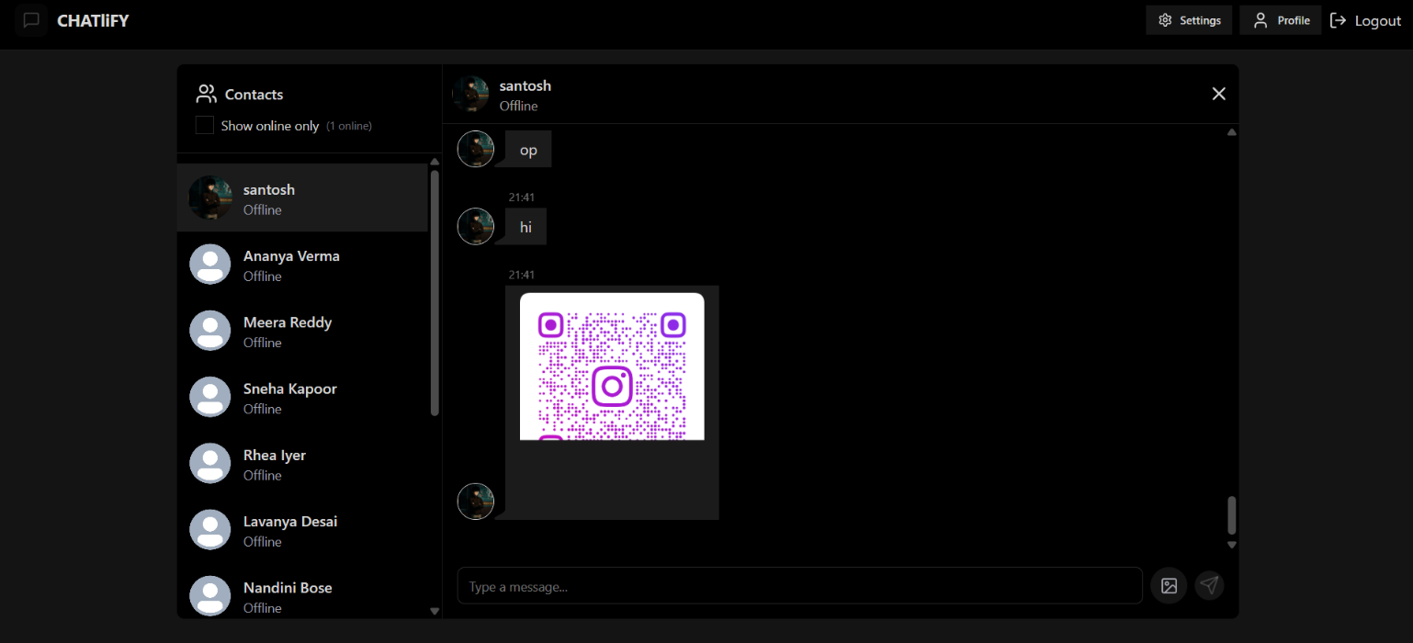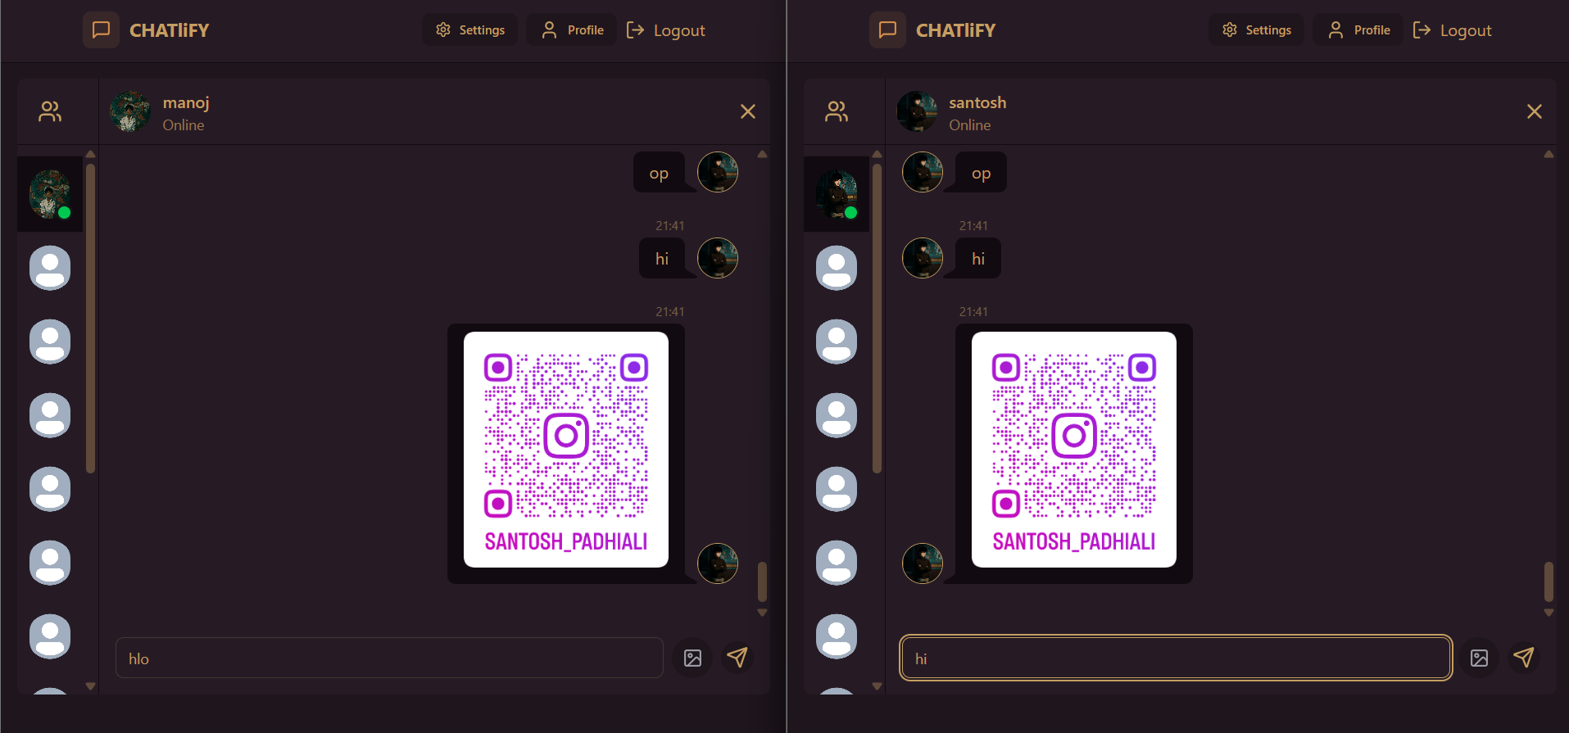
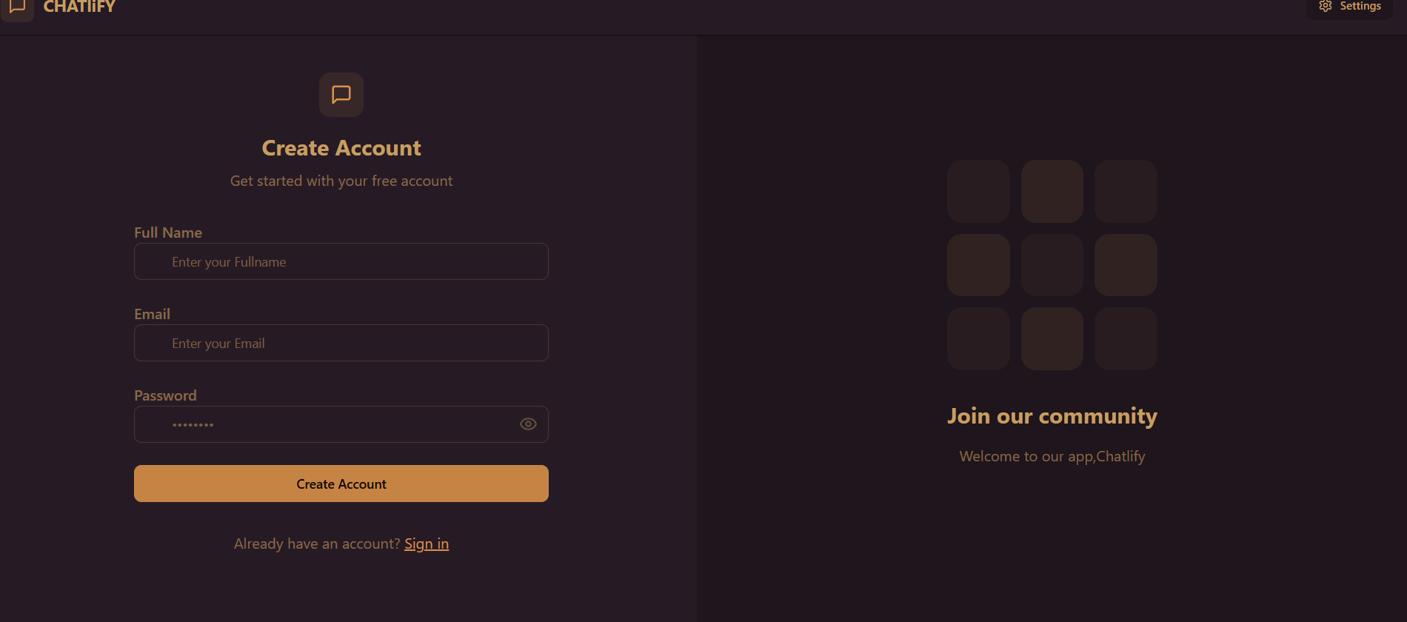

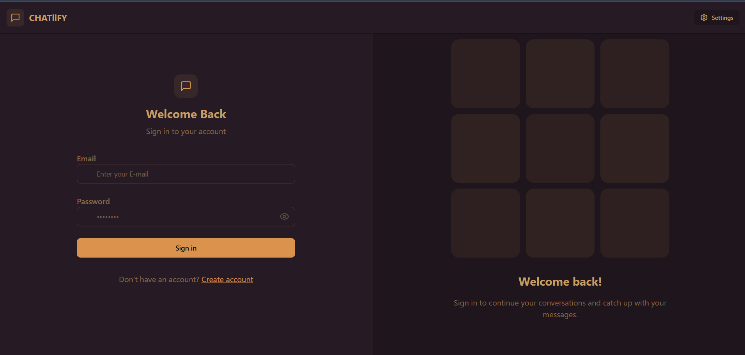
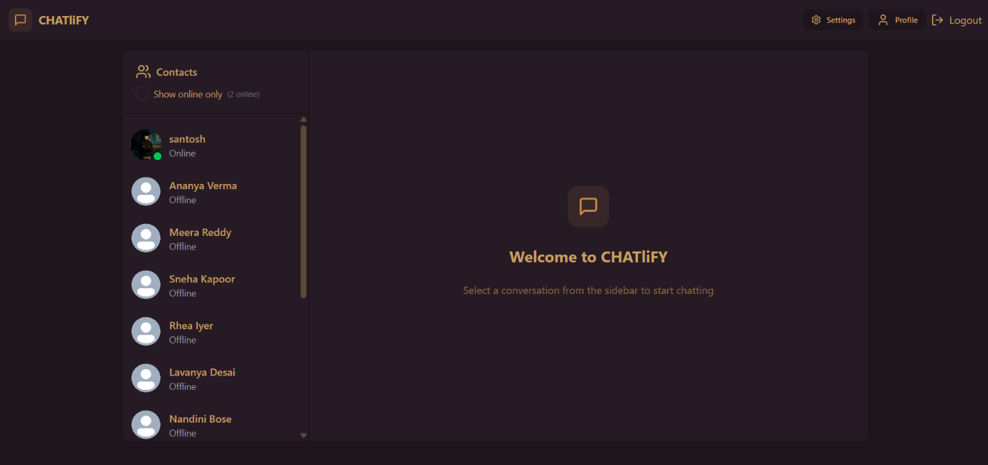

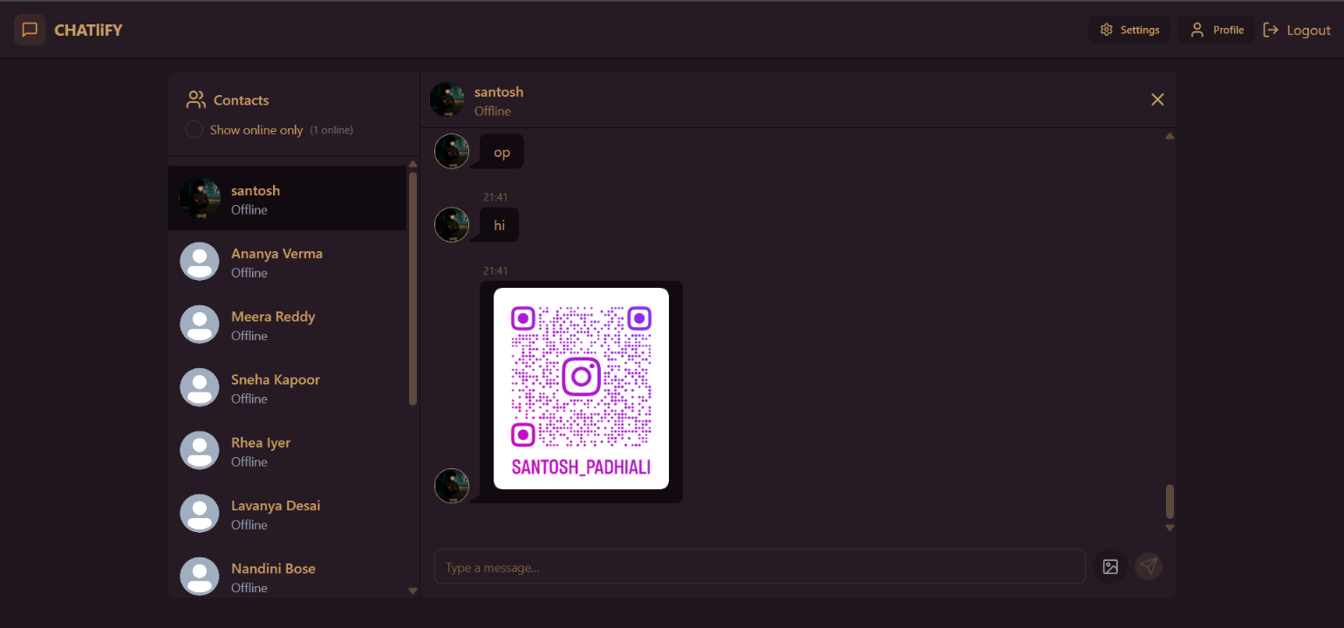

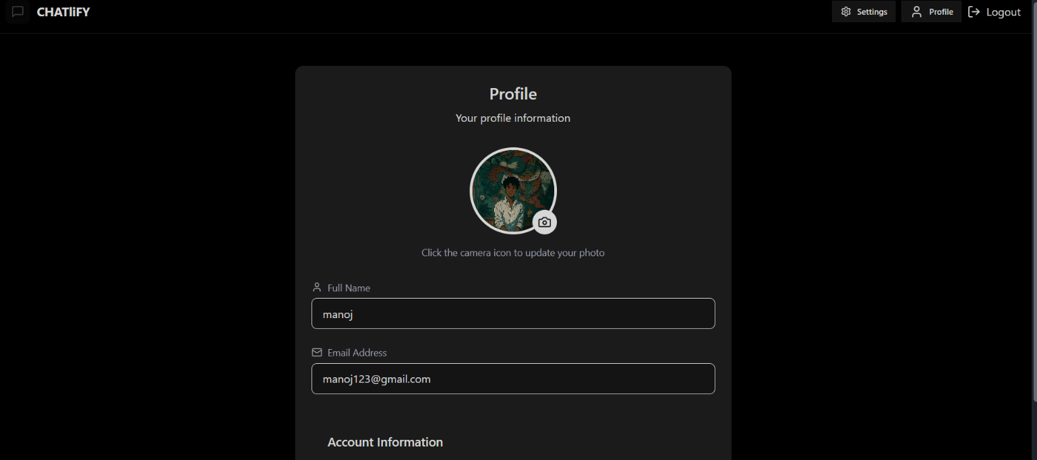
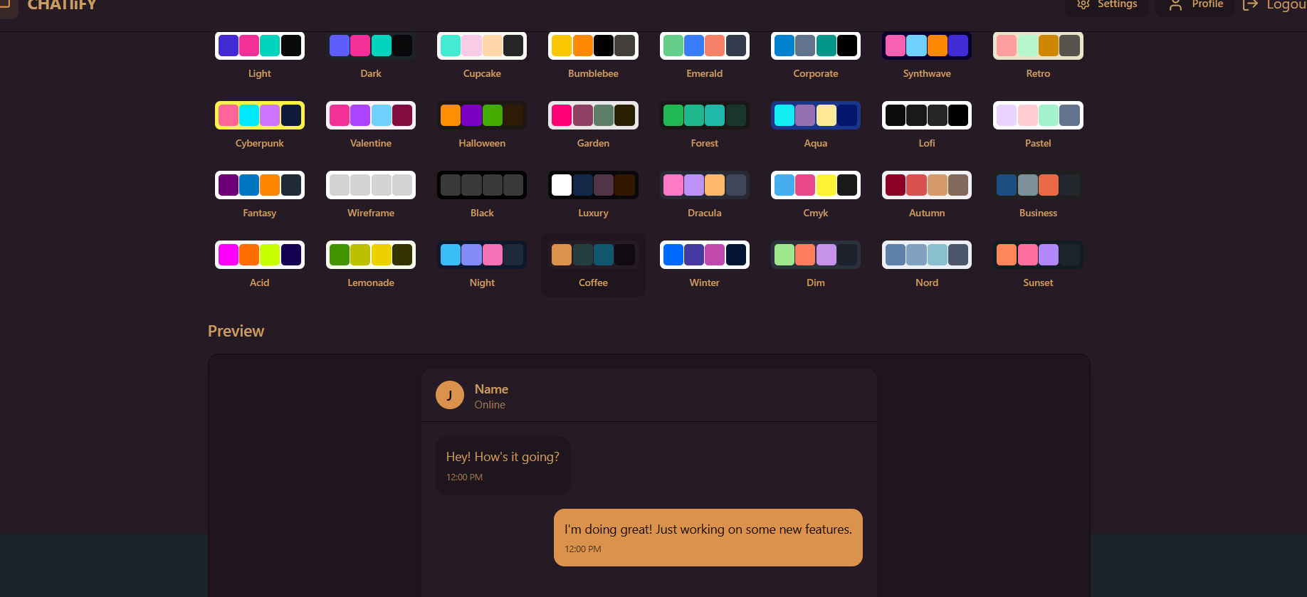

CHAPTER 5
Future Scope
The Chat Application provides a strong foundation for real-time communication and can be further enhanced with advanced features. Possible future improvements include:
- End-to-End Encryption: Implementing advanced encryption protocols to ensure privacy and security of messages.
- Voice & Video Calling: Extending beyond text messages to support real-time audio and video communication.
- Group Chats & Channels: Allowing multiple users to participate in shared chat spaces for team collaboration or communities.
- Message Reactions & Emojis: Adding rich interaction features like reactions, stickers, and GIF support.
- Push Notifications: Integrating services like Firebase Cloud Messaging to notify users of new messages even when offline.
- AI-Powered Features: Smart message suggestions, spam filtering, and chatbot integration for automated responses.
- Admin Dashboard: A central interface for managing users, monitoring activity, and moderating content.
- Cloud Scalability: Deploying on scalable cloud platforms (AWS, GCP, Azure) with containerization (Docker/Kubernetes) for high availability and performance.
- File Sharing Support: Enabling sharing of files, documents, and media beyond images.
- Cross-Platform Compatibility: Expanding to native mobile apps (Android/iOS) alongside the web version.

5.2 Limitations
While the current version of the Chat Application is functional and supports essential real-time messaging features, it has some limitations:

- No End-to-End Encryption: Messages are not yet fully encrypted, which may raise privacy concerns.
- Limited Media Support: Only text and images are supported; no support for documents, videos, or voice notes.
- No Group Chat: The current version only supports one-to-one conversations.
- Basic Authentication: JWT-based login works, but lacks multi-factor authentication for stronger security.
- No Cloud Deployment: The application is not yet hosted on a scalable cloud platform and lacks CI/CD pipeline automation.
- No Offline Mode: Users cannot send or queue messages when offline.

CHAPTER 6

Conclusion

The Chat Application project represents a successful implementation of a modern real-time messaging platform. By integrating full-stack technologies, the project demonstrates how seamless and interactive communication can be achieved on the web. The combination of a React.js frontend with Node.js and Express.js on the backend, along with MongoDB as the database and Socket.io for real-time communication, resulted in a lightweight yet powerful application.

The system enables users to register/login, update their profiles, and exchange messages instantly with other users. Real-time communication was made possible through Socket.io, which ensures instant message delivery and dynamic updates without requiring page reloads. This closely replicates the core functionality of popular chat platforms like WhatsApp Web, Messenger, or Slack.

One of the key learning outcomes of this project was the successful implementation of real-time bidirectional communication using WebSockets, enabling instant message broadcasting and reliable updates between users. The project also strengthened concepts such as RESTful API design, JWT-based authentication, modular coding practices, middleware integration, and secure user session management.

The codebase was structured with scalability in mind, following a clean separation of concerns across routes, controllers, middleware, and utility functions. Similarly, the frontend was designed with a modular component-based approach, making the application easier to scale and maintain in future iterations.

However, the current version has limitations, such as the absence of group chat functionality, advanced encryption, offline support, and cloud deployment. These gaps present opportunities for future development, including end-to-end encryption, multimedia support, push notifications, admin dashboards, and cloud scalability.

Despite these limitations, the Chat Application serves as a strong foundation for building production-grade communication platforms. The project not only demonstrates technical proficiency in full-stack development but also highlights problem-solving, modular design, and real-time system implementation.

In conclusion, this project showcases the practical application of full-stack web development concepts and provides a stepping stone toward more advanced, secure, and scalable real-time communication systems. It has been an enriching learning experience that reinforces the skills necessary for building impactful software solutions.

CHAPTER 7

References

React Documentation - https://react.dev/

(Used for building the frontend interface and component-based architecture)
- Node.js Documentation – https://nodejs.org/en/docs/
(used for backend development and server-side scripting) Express.js Documentation – https://expressjs.com/
(Used for developing RESTful APIs and handling routes)
- MongoDB Documentation – https://www.mongodb.com/docs/
(Used for NoSQL database design and queries)
- Mongoose Documentation – https://mongoosejs.com/docs/
(Used as an ORM to define schemas and interact with MongoDB)
- Socket.io Documentation – https://socket.io/docs/
(Used for real-time communication between users in chat rooms)
- JWT (JSON Web Token) Documentation – https://jwt.io/introduction/
(Used for secure authentication and authorization)
- Cloudinary Documentation – https://cloudinary.com/documentation
(Used for image upload and storage in the chat application)
- Vite Documentation – https://vitejs.dev/
(Used for fast frontend development and hot module replacement setup)
- MDN Web Docs – https://developer.mozilla.org/
(General reference for HTML, CSS, JavaScript, and Web APIs)

