**Personal  Blog  on  IBM  Cloud  Static  Web Application**

**Name: Surya.K**

**Introduction:**

                       The digital landscape is in a constant state of a evolution, with web development at its forefront. In a world that demands speed, security, and scalability, IBM Cloud Static Web Apps have emerged as a transformative force in the realm of web application development. This personal blog is an exploration of the incredible capabilities and opportunities that await those who venture into the dynamic universe of IBM Cloud Static Web Apps.

Web development is no longer a simple process of creating static web pages. Modern applications require a sophisticated approach that seamlessly integrates front-end and back-end components. IBM Cloud Static Web Apps are designed to make this complex process simpler, more efficient, and accessible to developers of all levels of expertise. This blog is your ticket to understanding the potential that this platform holds and how it can revolutionize your web development journey.

In this blog, we will embark on a journey through the world of IBM Cloud Static Web Apps. We will unravel the core concepts, discover the ease of setting up a development environment, and explore the advantages of Jamstack architecture. You'll learn about the painless deployment process, the magic of Continuous Integration and Continuous Deployment (CI/CD), and the robust scalability options at your disposal.

Security and compliance are paramount in today's digital world, and IBM Cloud Static Web Apps provide powerful safeguards to protect your applications and data. Plus, we'll delve into the cost-effectiveness and real-world applications of this groundbreaking platform. Whether you're a seasoned developer seeking to streamline your workflow or someone new to the exciting world of web development, this blog will be your guiding light. By the end of this journey, you'll have the tools, knowledge, and inspiration to harness the full potential of IBM Cloud Static Web Apps. It's time to unlock the true power of web development and embark on a path towards creating faster, more secure, and highly scalable web applications. Welcome to the future of web development with IBM Cloud Static apps.

**Problem statement:**

 The problem statement for a personal blog on IBM Cloud Static Web Apps might be:

"I want to create a personal blog where I can easily publish and manage my content, but I don't want the hassle of setting up and maintaining complex web hosting infrastructure. I need a solution that is secure, scalable, and cost-effective. Additionally, I want the flexibility to use my preferred static site generator and version control system while ensuring that my blog loads quickly and performs well for visitors worldwide. How can I leverage IBM Cloud Static Web Apps to address these challenges and streamline the process of creating and managing my personal blog?"

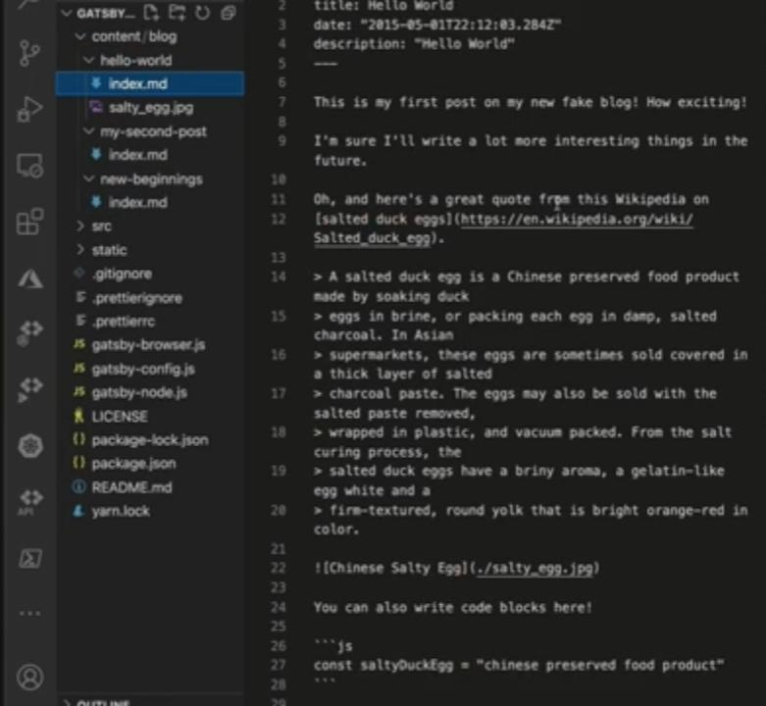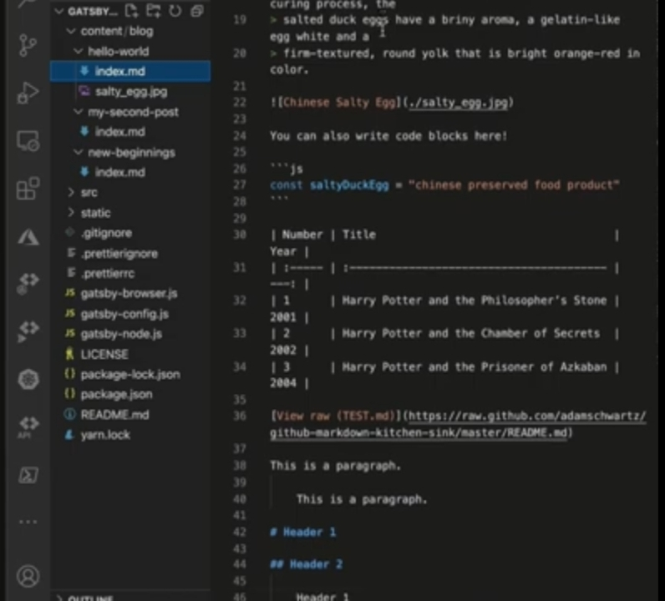**Code:**

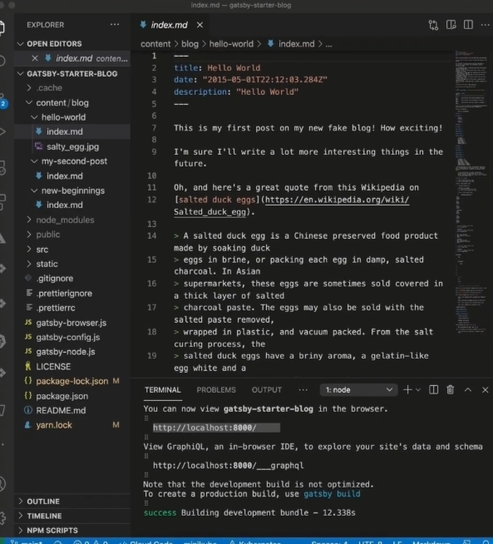

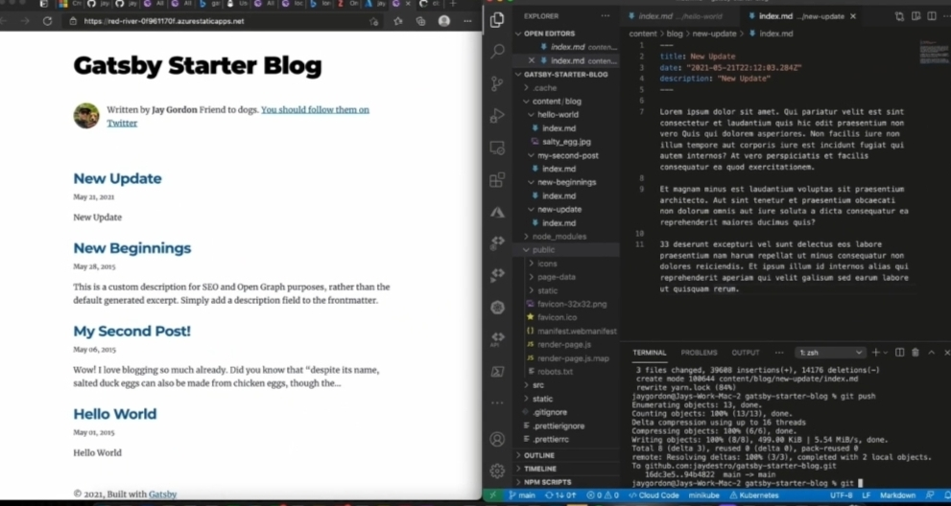**Output:**

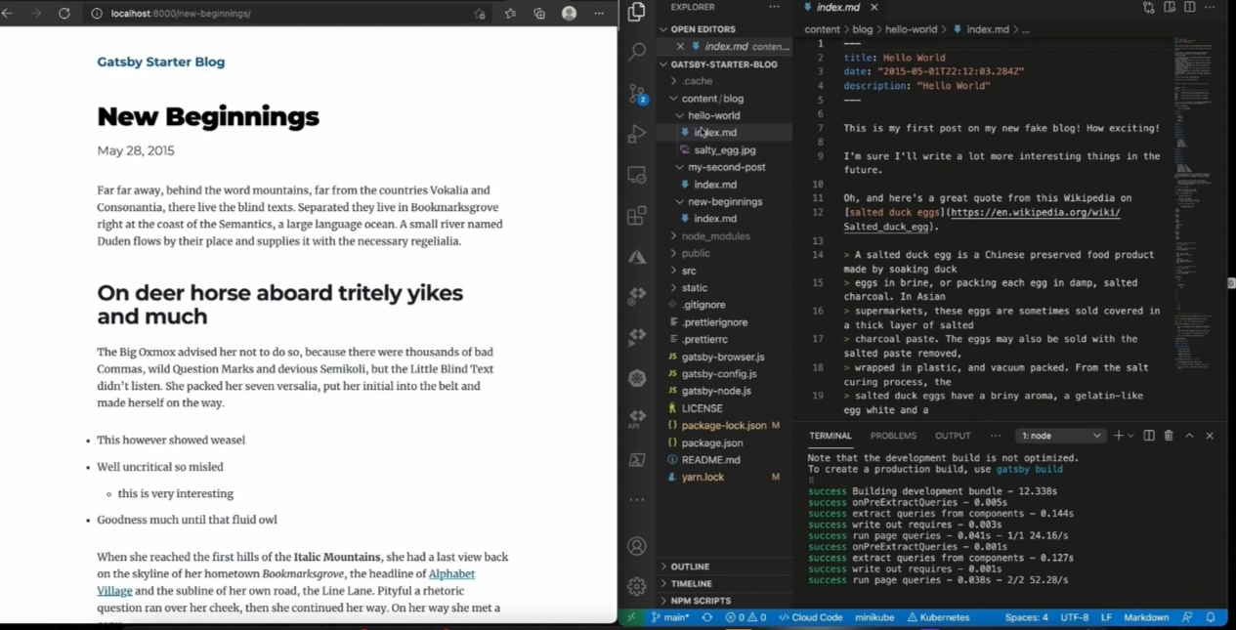

**Conclusion:**

As we draw the curtains on our exploration of IBM Cloud Static Web Apps, it's clear that we've uncovered a game-changing platform for web development. Throughout this blog, we've ventured into the realm of modern web applications, and we've seen how IBM Cloud Static Web Apps are revolutionizing the way developers create, deploy, and manage their projects.In conclusion, we've witnessed the power of simplicity. With IBM Cloud Static Web Apps, the once intricate process of web development has been streamlined, making it accessible to a broader audience.The ease of setting up a development environment, deploying code, and maintaining applications through automated CI/CD pipelines has undoubtedly lightened the load on developers. The scalability options provided by IBM Cloud ensure your applications can grow with your audience, and the robust security measures and compliance standards protect your hard work and sensitive data. Furthermore, we've explored real-world applications and case studies that demonstrate the tangible benefits of IBM Cloud Static Web Apps in diverse industries.