Project 4
Ethical Considerations in Deep Learning
A closer look at bias, privacy, and transparency in modern AI systems
Deep learning has quietly moved from research labs into the middle of everyday life. It decides who sees which job ad, who gets approved for a loan, and increasingly, who a court or a hospital should trust. That shift is exciting, but it also raises hard questions that have nothing to do with accuracy scores or training speed. This report walks through three of the most pressing ethical issues in deep learning, looks closely at one real case where things went wrong, and lays out practical steps that can help prevent the next one.

Task 1: Three Ethical Issues in Deep Learning
1. Bias and Discrimination
Deep learning models learn from historical data, and history is not neutral. If past hiring decisions favored one gender, or past policing focused disproportionately on certain neighborhoods, a model trained on that data will absorb the same pattern and repeat it at scale. The danger is that the bias is dressed up in the language of mathematics, which makes it feel objective even when it isn't.
2. Privacy Invasion
Deep learning systems are hungry for data, and that hunger often outpaces what people ever agreed to share. Facial recognition models trained on photos scraped from social media, voice assistants that quietly log conversations, and health apps that infer sensitive conditions from unrelated behavior all raise the same concern: consent is frequently assumed rather than given.
3. Lack of Transparency (the "Black Box" Problem)
Many deep neural networks are so layered and complex that even the engineers who built them cannot fully explain a specific decision. When a model denies a loan application or flags a medical scan as abnormal, the person affected deserves a reason. Without that, accountability becomes almost impossible to enforce.
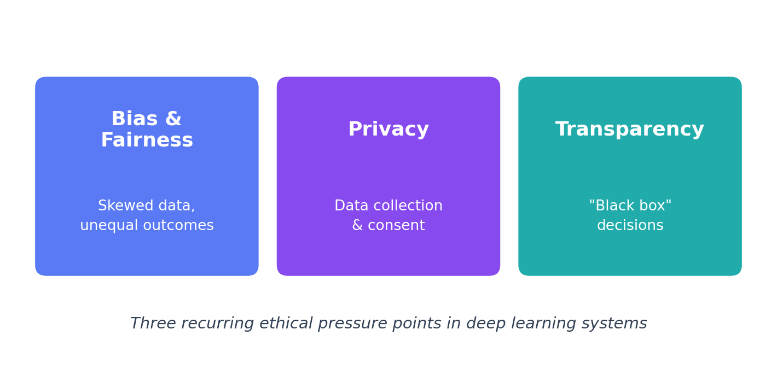
Figure 1: Three recurring ethical pressure points in deep learning systems.

Task 2: A Real-World Example — the COMPAS Recidivism Algorithm
One of the clearest illustrations of algorithmic bias in the real world is COMPAS (Correctional Offender Management Profiling for Alternative Sanctions), a risk-assessment tool used by several U.S. courts to help judges decide on bail and sentencing. The system analyzed a defendant's background to predict the likelihood of reoffending, and that score genuinely influenced how long someone might sit in jail while awaiting trial.
In 2016, investigative journalists at ProPublica examined thousands of COMPAS risk scores against actual outcomes and found a troubling pattern. Black defendants who did not reoffend were nearly twice as likely as white defendants to be wrongly labeled "high risk." White defendants who did go on to reoffend were, in turn, more often mislabeled as "low risk." The tool had never been told anyone's race directly, yet it had learned to reproduce racial disparities anyway, likely through proxy variables buried in the data.
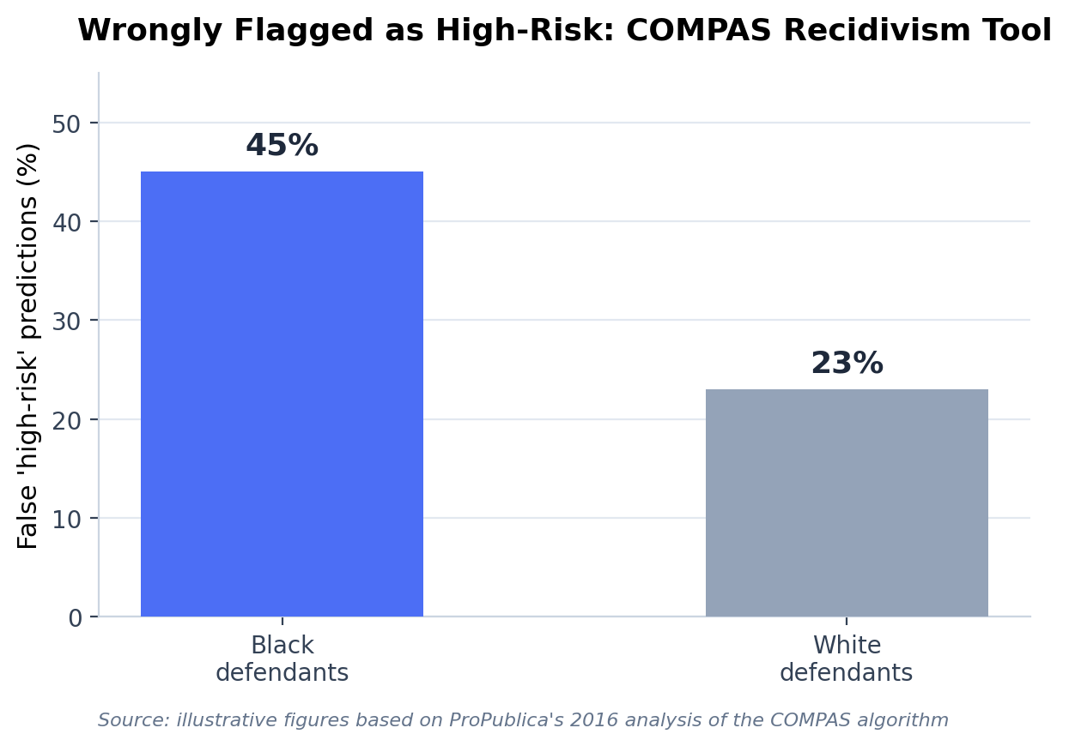
Figure 2: Illustrative false-positive rates for the COMPAS tool, based on ProPublica's 2016 analysis.
What makes this case so important isn't just the statistics, it's what they represent: a decision that affects someone's liberty, made partly by a system nobody could fully explain, built on data that carried the weight of decades of unequal policing. It is a compact example of all three issues from Task 1 showing up in a single deployed system.

Task 3: Measures to Address These Issues
None of these problems have a single fix, but a combination of technical and organizational measures can meaningfully reduce the risk.
- Diverse, audited training data: Every dataset used for training should be checked for who and what it underrepresents, and gaps should be actively filled rather than ignored.
- Routine fairness testing: Models should be tested for disparate outcomes across race, gender, and other protected groups before deployment, not after complaints arrive.
- Explainable AI (XAI) tools: Techniques like SHAP, LIME, or attention visualization can help translate a model's internal reasoning into something a human can actually evaluate.
- Human oversight on high-stakes decisions: High-stakes decisions, such as sentencing, hiring, or medical diagnosis, should always keep a qualified human in the loop with the power to override the model.
- Regulation and independent audits: Clear data-protection rules, informed consent, and independent audits give people recourse and give companies a reason to build responsibly from the start.
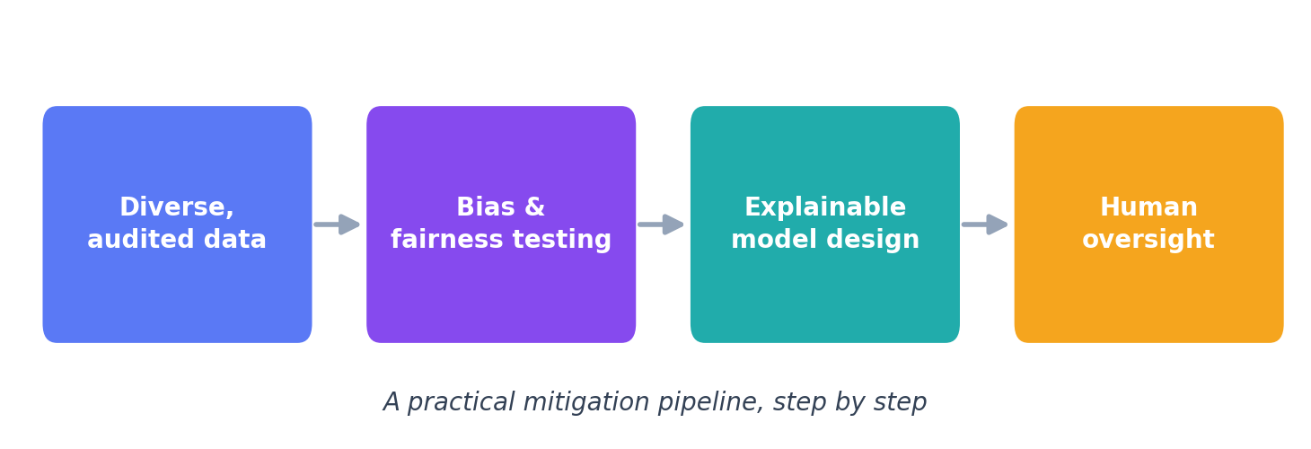
Figure 3: A practical mitigation pipeline for responsible deep learning deployment.
Closing Thoughts
Deep learning is not inherently unethical, but it is not automatically neutral either. It reflects the data, decisions, and priorities of the people who build it. The COMPAS case is a reminder that fairness has to be designed in on purpose; it rarely shows up by accident. As these systems take on more consequential roles in society, treating ethics as a core engineering requirement rather than an afterthought is the difference between AI that earns public trust and AI that quietly erodes it.

References
- Angwin, J., Larson, J., Mattu, S., & Kirchner, L. (2016). Machine Bias. ProPublica.
- Barocas, S., Hardt, M., & Narayanan, A. (2019). Fairness and Machine Learning. fairmlbook.org.
- Ribeiro, M. T., Singh, S., & Guestrin, C. (2016). "Why Should I Trust You?": Explaining the Predictions of Any Classifier (LIME).
- Lundberg, S. M., & Lee, S.-I. (2017). A Unified Approach to Interpreting Model Predictions (SHAP).
- European Commission (2024). EU Artificial Intelligence Act — Regulatory Framework for AI.
A Personal Note
Working through this project changed how I think about AI, less as a purely technical subject and more as a design choice with real consequences for real people. The COMPAS example stuck with me because the model never saw a courtroom or met a defendant, yet it still shaped someone's fate. That gap between the code and its consequences is exactly where ethics has to live.

