Linear Mixed Effect Models

#Importing Libraries  
library(readxl)  
library(car)

## Loading required package: carData

library(lmtest)

## Warning: package 'lmtest' was built under R version 4.0.4

## Loading required package: zoo

##   
## Attaching package: 'zoo'

## The following objects are masked from 'package:base':  
##   
## as.Date, as.Date.numeric

library(stargazer)

## Warning: package 'stargazer' was built under R version 4.0.3

##   
## Please cite as:

## Hlavac, Marek (2018). stargazer: Well-Formatted Regression and Summary Statistics Tables.

## R package version 5.2.2. https://CRAN.R-project.org/package=stargazer  
  
#Setting the Working Directory and Importing the Dataset  
setwd("C:/Users/surya/Downloads")  
  
bms <- read_excel("BigMartSales.xlsx", sheet = 'Data')  
names(bms) <- tolower(colnames(bms))  
  
#NA Values Column-Wise  
sapply(bms, function(x) sum(is.na(x)))

## item_id item_weight item_fat_content item_visibility   
## 0 1463 0 0   
## item_type item_mrp outlet_id outlet_year   
## 0 0 0 0   
## outlet_size city_type outlet_type item_sales   
## 2410 0 0 0

str(bms)

## tibble [8,523 x 12] (S3: tbl_df/tbl/data.frame)  
## $ item_id : chr [1:8523] "FDA15" "DRC01" "FDN15" "FDX07" ...  
## $ item_weight : num [1:8523] 9.3 5.92 17.5 19.2 8.93 ...  
## $ item_fat_content: chr [1:8523] "Low Fat" "Regular" "Low Fat" "Regular" ...  
## $ item_visibility : num [1:8523] 0.016 0.0193 0.0168 0 0 ...  
## $ item_type : chr [1:8523] "Dairy" "Soft Drinks" "Meat" "Fruits and Vegetables" ...  
## $ item_mrp : num [1:8523] 249.8 48.3 141.6 182.1 53.9 ...  
## $ outlet_id : chr [1:8523] "OUT049" "OUT018" "OUT049" "OUT010" ...  
## $ outlet_year : num [1:8523] 1999 2009 1999 1998 1987 ...  
## $ outlet_size : chr [1:8523] "Medium" "Medium" "Medium" NA ...  
## $ city_type : chr [1:8523] "Tier 1" "Tier 3" "Tier 1" "Tier 3" ...  
## $ outlet_type : chr [1:8523] "Supermarket Type1" "Supermarket Type2" "Supermarket Type1" "Grocery Store" ...  
## $ item_sales : num [1:8523] 3735 443 2097 732 995 ...

#Data Visualizations  
hist(bms$item_sales, col = 'lightcoral', main = "Histogram of Item Sales", xlab = 'Item_Sales', ylab = 'Frequency')

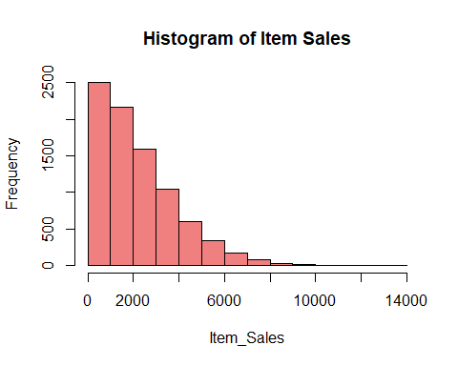

hist(log(bms$item_sales), col = 'lightgreen', main = "Histogram of log(Item Sales)", xlab = 'log(Item_Sales)', ylab = 'Frequency')

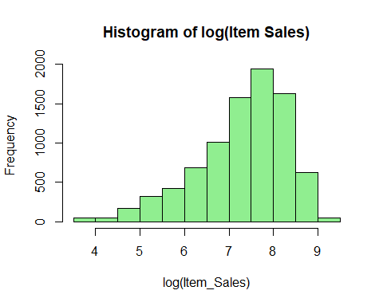

hist(bms$item_visibility)

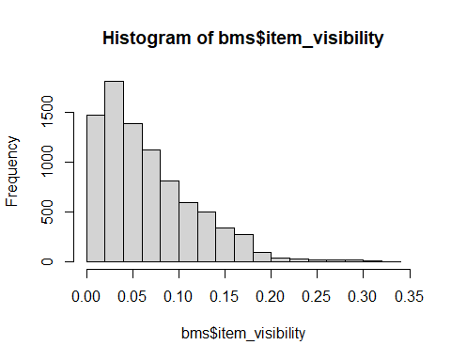

hist(log(bms$item_visibility))

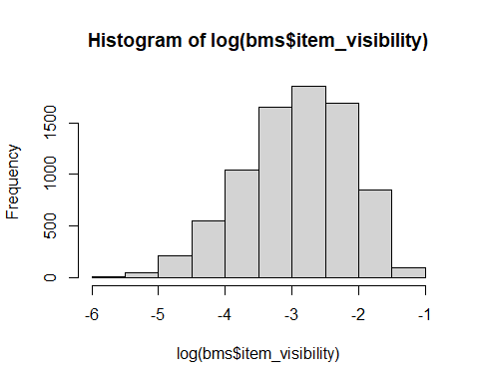

hist(bms$item_mrp)

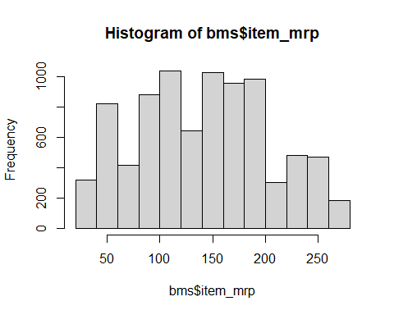

hist(log(bms$item_mrp))

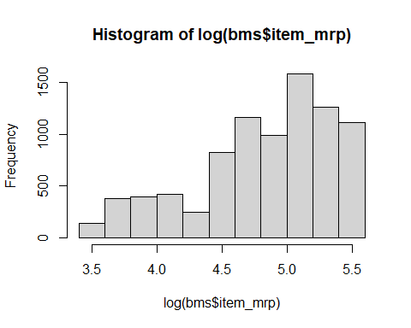

library(lattice)  
histogram(~item_sales, data = bms)

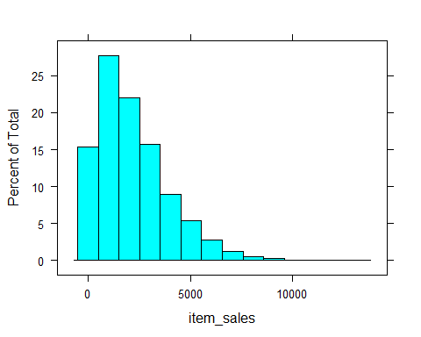

densityplot(~item_sales, data = bms)

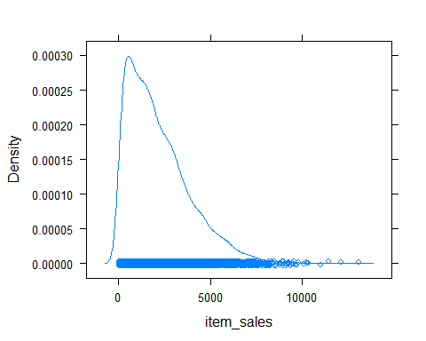

densityplot(~item_sales | outlet_type, data = bms)

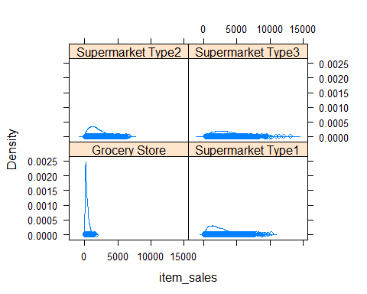

densityplot(~item_sales | city_type, data = bms)

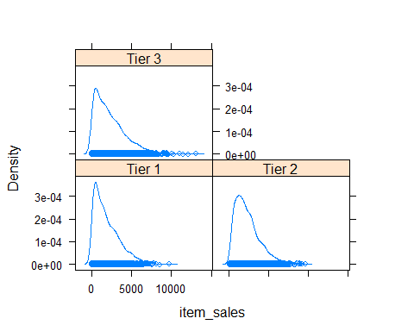

bwplot(item_sales ~ outlet_type, data = bms)

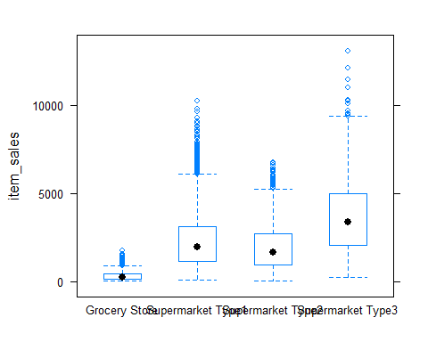

bwplot(item_sales ~ city_type, data = bms)

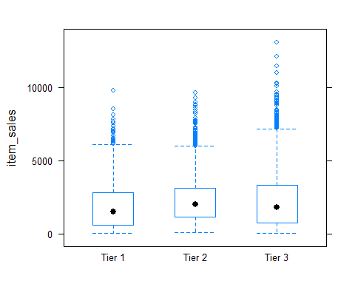

bwplot(item_sales ~ city_type | outlet_type, data = bms)

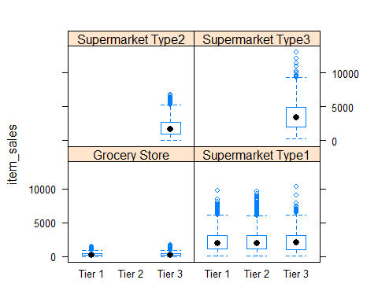

xyplot(item_sales ~ item_visibility | outlet_type, data = bms)

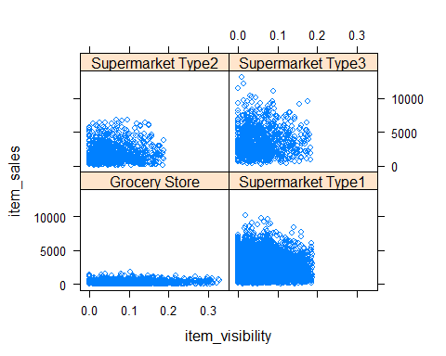

xyplot(item_sales ~ item_visibility | city_type, data = bms)

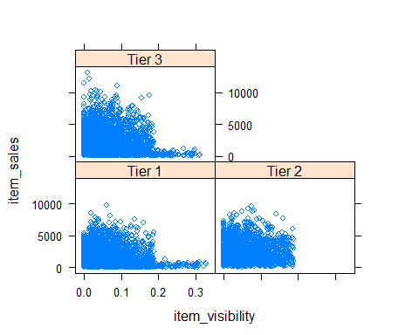

xyplot(item_sales ~ item_visibility | outlet_type*city_type, data = bms)

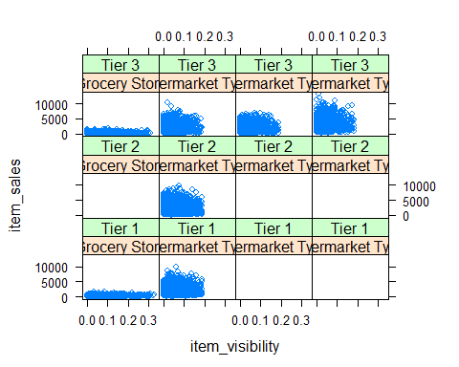

#Feature Engineering/Pre-processing  
bms$item_sales <- round(bms$item_sales)  
bms$item_fat_content <- tolower(bms$item_fat_content)  
bms$item_fat_content <- as.factor(bms$item_fat_content)  
bms$item_type <- as.factor(bms$item_type)  
bms$outlet_type <- as.factor(bms$outlet_type)  
bms$outlet_id <- as.factor(bms$outlet_id)  
bms$city_type <- as.factor(bms$city_type)  
bms$outlet_age <- 2013 - bms$outlet_year  
bms$outlet_year <- NULL  
bms$outlet_size <- NULL  
bms$item_id <- NULL  
str(bms)

## tibble [8,523 x 10] (S3: tbl_df/tbl/data.frame)  
## $ item_weight : num [1:8523] 9.3 5.92 17.5 19.2 8.93 ...  
## $ item_fat_content: Factor w/ 2 levels "low fat","regular": 1 2 1 2 1 2 2 1 2 2 ...  
## $ item_visibility : num [1:8523] 0.016 0.0193 0.0168 0 0 ...  
## $ item_type : Factor w/ 16 levels "Baking Goods",..: 5 15 11 7 10 1 14 14 6 6 ...  
## $ item_mrp : num [1:8523] 249.8 48.3 141.6 182.1 53.9 ...  
## $ outlet_id : Factor w/ 10 levels "OUT010","OUT013",..: 10 4 10 1 2 4 2 6 8 3 ...  
## $ city_type : Factor w/ 3 levels "Tier 1","Tier 2",..: 1 3 1 3 3 3 3 3 2 2 ...  
## $ outlet_type : Factor w/ 4 levels "Grocery Store",..: 2 3 2 1 2 3 2 4 2 2 ...  
## $ item_sales : num [1:8523] 3735 443 2097 732 995 ...  
## $ outlet_age : num [1:8523] 14 4 14 15 26 4 26 28 11 6 ...

#Checking for Correlations  
temp <- data.frame(bms$item_sales)  
temp$item_weight <- bms$item_weight  
temp$item_visibility <- bms$item_visibility  
temp$item_mrp <- bms$item_mrp  
temp <- temp[complete.cases(temp), ]  
corpl <- cor(cbind(temp))  
  
library(corrplot)

## corrplot 0.84 loaded

corrplot(corpl, method = "number", number.cex = 0.7)

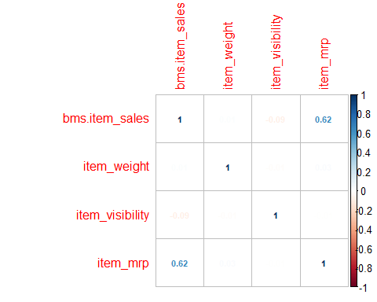

#Multi-Level Regression Analysis  
library(lme4)

## Warning: package 'lme4' was built under R version 4.0.4

## Loading required package: Matrix

## Registered S3 methods overwritten by 'lme4':  
## method from  
## cooks.distance.influence.merMod car   
## influence.merMod car   
## dfbeta.influence.merMod car   
## dfbetas.influence.merMod car

library(arm)

## Warning: package 'arm' was built under R version 4.0.4

## Loading required package: MASS

##   
## arm (Version 1.11-2, built: 2020-7-27)

## Working directory is C:/Users/surya/Downloads/Career/M.S. [2020-22]/3.Spring_2021/[ISM6137.001S21.20445 Statistical Data Mining]/Week_7/Assignment

##   
## Attaching package: 'arm'

## The following object is masked from 'package:corrplot':  
##   
## corrplot

## The following object is masked from 'package:car':  
##   
## logit

m1 <- lmer(item_sales ~ city_type + outlet_type + (1 | outlet_id), data = bms)  
  
m1.a <- lmer(item_sales ~ outlet_type + (1 | outlet_id), data = bms)  
  
m1.b <- lmer(item_sales ~ city_type + (1 | outlet_id), data = bms)  
  
m2 <- lmer(item_sales ~ item_type + item_visibility + item_mrp + outlet_type +   
 outlet_age + (1 | outlet_id), data = bms)

## Warning: Some predictor variables are on very different scales: consider  
## rescaling

m3 <- lmer(item_sales ~ item_type + item_visibility + item_mrp + outlet_type +   
 outlet_age + (1 | outlet_type/outlet_id), data = bms)

## Warning: Some predictor variables are on very different scales: consider  
## rescaling

#Final Models [3]  
m4 <- lmer(item_sales ~ item_type + item_visibility + item_mrp + city_type +   
 outlet_type + outlet_age + (1 | city_type/outlet_id), data = bms)

## Warning: Some predictor variables are on very different scales: consider  
## rescaling

#m5 <- lmer(item_sales ~ item_fat_content + item_visibility + item_mrp + city_type + outlet_type + outlet_age + (1 | city_type/outlet_id), data = bms)  
  
m5 <- lmer(log(item_sales) ~ item_type + item_fat_content + item_visibility + item_mrp + city_type +   
 outlet_type + outlet_age + (1 | city_type/outlet_id), data = bms)

## Warning: Some predictor variables are on very different scales: consider  
## rescaling

## Warning in checkConv(attr(opt, "derivs"), opt$par, ctrl = control$checkConv, :  
## unable to evaluate scaled gradient

## Warning in checkConv(attr(opt, "derivs"), opt$par, ctrl = control$checkConv, :  
## Model failed to converge: degenerate Hessian with 1 negative eigenvalues

m6 <- lmer(item_sales ~ item_type + item_fat_content + item_visibility + item_mrp + city_type +   
 outlet_type + outlet_age + (1 | city_type/outlet_id), data = bms)

## Warning: Some predictor variables are on very different scales: consider  
## rescaling

## Warning in checkConv(attr(opt, "derivs"), opt$par, ctrl = control$checkConv, :  
## unable to evaluate scaled gradient

## Warning in checkConv(attr(opt, "derivs"), opt$par, ctrl = control$checkConv, :  
## Model failed to converge: degenerate Hessian with 1 negative eigenvalues

confint(m6)

## Computing profile confidence intervals ...

## 2.5 % 97.5 %  
## .sig01 2.448133 84.449774  
## .sig02 0.000000 52.702565  
## .sigma 1110.957704 1144.838377  
## (Intercept) -1993.669333 -1502.938877  
## item_typeBreads -160.119913 168.858826  
## item_typeBreakfast -219.628069 236.946832  
## item_typeCanned -97.043912 148.737716  
## item_typeDairy -162.250395 81.201627  
## item_typeFrozen Foods -142.710981 87.740735  
## item_typeFruits and Vegetables -78.258358 136.762620  
## item_typeHard Drinks -177.324290 175.663992  
## item_typeHealth and Hygiene -144.163370 122.063174  
## item_typeHousehold -156.952006 77.508961  
## item_typeMeat -137.948383 138.654735  
## item_typeOthers -216.350965 169.583390  
## item_typeSeafood -105.773861 473.771825  
## item_typeSnack Foods -119.018868 97.224153  
## item_typeSoft Drinks -164.494673 110.233455  
## item_typeStarchy Foods -179.506512 223.746228  
## item_fat_contentregular -14.657550 95.869896  
## item_visibility -786.383082 187.507133  
## item_mrp 15.177711 15.951653  
## city_typeTier 2 -154.440850 119.433744  
## city_typeTier 3 -127.665215 103.341838  
## outlet_typeSupermarket Type1 1808.084321 2051.018280  
## outlet_typeSupermarket Type2 1335.400072 1810.028203  
## outlet_typeSupermarket Type3 3201.387294 3543.920775  
## outlet_age -12.452142 6.369317

fixef(m6)

## (Intercept) item_typeBreads   
## -1750.8566748 5.1770626   
## item_typeBreakfast item_typeCanned   
## 7.7177275 25.6236924   
## item_typeDairy item_typeFrozen Foods   
## -40.9817022 -28.0132081   
## item_typeFruits and Vegetables item_typeHard Drinks   
## 29.3565290 -0.1806822   
## item_typeHealth and Hygiene item_typeHousehold   
## -10.9757539 -39.6944500   
## item_typeMeat item_typeOthers   
## -0.3617348 -22.5729168   
## item_typeSeafood item_typeSnack Foods   
## 184.5274195 -11.4483433   
## item_typeSoft Drinks item_typeStarchy Foods   
## -27.3838449 21.2591460   
## item_fat_contentregular item_visibility   
## 40.6850720 -302.4878418   
## item_mrp city_typeTier 2   
## 15.5645067 -16.6802875   
## city_typeTier 3 outlet_typeSupermarket Type1   
## -14.2720014 1929.4810638   
## outlet_typeSupermarket Type2 outlet_typeSupermarket Type3   
## 1576.7092293 3372.3573458   
## outlet_age   
## -2.8639844

ranef(m6)

## $`outlet_id:city_type`  
## (Intercept)  
## OUT010:Tier 3 -1.600991e+01  
## OUT013:Tier 3 1.600991e+01  
## OUT017:Tier 2 3.190131e+01  
## OUT018:Tier 3 -3.472036e-11  
## OUT019:Tier 1 1.600991e+01  
## OUT027:Tier 3 1.474984e-10  
## OUT035:Tier 2 7.332675e+01  
## OUT045:Tier 2 -1.052281e+02  
## OUT046:Tier 1 -4.704390e+01  
## OUT049:Tier 1 3.103398e+01  
##   
## $city_type  
## (Intercept)  
## Tier 1 1.063993e-09  
## Tier 2 -2.319427e-10  
## Tier 3 3.505110e-09  
##   
## with conditional variances for "outlet_id:city_type" "city_type"

coef(m6)

## $`outlet_id:city_type`  
## (Intercept) item_typeBreads item_typeBreakfast item_typeCanned  
## OUT010:Tier 3 -1766.867 5.177063 7.717728 25.62369  
## OUT013:Tier 3 -1734.847 5.177063 7.717728 25.62369  
## OUT017:Tier 2 -1718.955 5.177063 7.717728 25.62369  
## OUT018:Tier 3 -1750.857 5.177063 7.717728 25.62369  
## OUT019:Tier 1 -1734.847 5.177063 7.717728 25.62369  
## OUT027:Tier 3 -1750.857 5.177063 7.717728 25.62369  
## OUT035:Tier 2 -1677.530 5.177063 7.717728 25.62369  
## OUT045:Tier 2 -1856.085 5.177063 7.717728 25.62369  
## OUT046:Tier 1 -1797.901 5.177063 7.717728 25.62369  
## OUT049:Tier 1 -1719.823 5.177063 7.717728 25.62369  
## item_typeDairy item_typeFrozen Foods  
## OUT010:Tier 3 -40.9817 -28.01321  
## OUT013:Tier 3 -40.9817 -28.01321  
## OUT017:Tier 2 -40.9817 -28.01321  
## OUT018:Tier 3 -40.9817 -28.01321  
## OUT019:Tier 1 -40.9817 -28.01321  
## OUT027:Tier 3 -40.9817 -28.01321  
## OUT035:Tier 2 -40.9817 -28.01321  
## OUT045:Tier 2 -40.9817 -28.01321  
## OUT046:Tier 1 -40.9817 -28.01321  
## OUT049:Tier 1 -40.9817 -28.01321  
## item_typeFruits and Vegetables item_typeHard Drinks  
## OUT010:Tier 3 29.35653 -0.1806822  
## OUT013:Tier 3 29.35653 -0.1806822  
## OUT017:Tier 2 29.35653 -0.1806822  
## OUT018:Tier 3 29.35653 -0.1806822  
## OUT019:Tier 1 29.35653 -0.1806822  
## OUT027:Tier 3 29.35653 -0.1806822  
## OUT035:Tier 2 29.35653 -0.1806822  
## OUT045:Tier 2 29.35653 -0.1806822  
## OUT046:Tier 1 29.35653 -0.1806822  
## OUT049:Tier 1 29.35653 -0.1806822  
## item_typeHealth and Hygiene item_typeHousehold item_typeMeat  
## OUT010:Tier 3 -10.97575 -39.69445 -0.3617348  
## OUT013:Tier 3 -10.97575 -39.69445 -0.3617348  
## OUT017:Tier 2 -10.97575 -39.69445 -0.3617348  
## OUT018:Tier 3 -10.97575 -39.69445 -0.3617348  
## OUT019:Tier 1 -10.97575 -39.69445 -0.3617348  
## OUT027:Tier 3 -10.97575 -39.69445 -0.3617348  
## OUT035:Tier 2 -10.97575 -39.69445 -0.3617348  
## OUT045:Tier 2 -10.97575 -39.69445 -0.3617348  
## OUT046:Tier 1 -10.97575 -39.69445 -0.3617348  
## OUT049:Tier 1 -10.97575 -39.69445 -0.3617348  
## item_typeOthers item_typeSeafood item_typeSnack Foods  
## OUT010:Tier 3 -22.57292 184.5274 -11.44834  
## OUT013:Tier 3 -22.57292 184.5274 -11.44834  
## OUT017:Tier 2 -22.57292 184.5274 -11.44834  
## OUT018:Tier 3 -22.57292 184.5274 -11.44834  
## OUT019:Tier 1 -22.57292 184.5274 -11.44834  
## OUT027:Tier 3 -22.57292 184.5274 -11.44834  
## OUT035:Tier 2 -22.57292 184.5274 -11.44834  
## OUT045:Tier 2 -22.57292 184.5274 -11.44834  
## OUT046:Tier 1 -22.57292 184.5274 -11.44834  
## OUT049:Tier 1 -22.57292 184.5274 -11.44834  
## item_typeSoft Drinks item_typeStarchy Foods  
## OUT010:Tier 3 -27.38384 21.25915  
## OUT013:Tier 3 -27.38384 21.25915  
## OUT017:Tier 2 -27.38384 21.25915  
## OUT018:Tier 3 -27.38384 21.25915  
## OUT019:Tier 1 -27.38384 21.25915  
## OUT027:Tier 3 -27.38384 21.25915  
## OUT035:Tier 2 -27.38384 21.25915  
## OUT045:Tier 2 -27.38384 21.25915  
## OUT046:Tier 1 -27.38384 21.25915  
## OUT049:Tier 1 -27.38384 21.25915  
## item_fat_contentregular item_visibility item_mrp city_typeTier 2  
## OUT010:Tier 3 40.68507 -302.4878 15.56451 -16.68029  
## OUT013:Tier 3 40.68507 -302.4878 15.56451 -16.68029  
## OUT017:Tier 2 40.68507 -302.4878 15.56451 -16.68029  
## OUT018:Tier 3 40.68507 -302.4878 15.56451 -16.68029  
## OUT019:Tier 1 40.68507 -302.4878 15.56451 -16.68029  
## OUT027:Tier 3 40.68507 -302.4878 15.56451 -16.68029  
## OUT035:Tier 2 40.68507 -302.4878 15.56451 -16.68029  
## OUT045:Tier 2 40.68507 -302.4878 15.56451 -16.68029  
## OUT046:Tier 1 40.68507 -302.4878 15.56451 -16.68029  
## OUT049:Tier 1 40.68507 -302.4878 15.56451 -16.68029  
## city_typeTier 3 outlet_typeSupermarket Type1  
## OUT010:Tier 3 -14.272 1929.481  
## OUT013:Tier 3 -14.272 1929.481  
## OUT017:Tier 2 -14.272 1929.481  
## OUT018:Tier 3 -14.272 1929.481  
## OUT019:Tier 1 -14.272 1929.481  
## OUT027:Tier 3 -14.272 1929.481  
## OUT035:Tier 2 -14.272 1929.481  
## OUT045:Tier 2 -14.272 1929.481  
## OUT046:Tier 1 -14.272 1929.481  
## OUT049:Tier 1 -14.272 1929.481  
## outlet_typeSupermarket Type2 outlet_typeSupermarket Type3  
## OUT010:Tier 3 1576.709 3372.357  
## OUT013:Tier 3 1576.709 3372.357  
## OUT017:Tier 2 1576.709 3372.357  
## OUT018:Tier 3 1576.709 3372.357  
## OUT019:Tier 1 1576.709 3372.357  
## OUT027:Tier 3 1576.709 3372.357  
## OUT035:Tier 2 1576.709 3372.357  
## OUT045:Tier 2 1576.709 3372.357  
## OUT046:Tier 1 1576.709 3372.357  
## OUT049:Tier 1 1576.709 3372.357  
## outlet_age  
## OUT010:Tier 3 -2.863984  
## OUT013:Tier 3 -2.863984  
## OUT017:Tier 2 -2.863984  
## OUT018:Tier 3 -2.863984  
## OUT019:Tier 1 -2.863984  
## OUT027:Tier 3 -2.863984  
## OUT035:Tier 2 -2.863984  
## OUT045:Tier 2 -2.863984  
## OUT046:Tier 1 -2.863984  
## OUT049:Tier 1 -2.863984  
##   
## $city_type  
## (Intercept) item_typeBreads item_typeBreakfast item_typeCanned  
## Tier 1 -1750.857 5.177063 7.717728 25.62369  
## Tier 2 -1750.857 5.177063 7.717728 25.62369  
## Tier 3 -1750.857 5.177063 7.717728 25.62369  
## item_typeDairy item_typeFrozen Foods item_typeFruits and Vegetables  
## Tier 1 -40.9817 -28.01321 29.35653  
## Tier 2 -40.9817 -28.01321 29.35653  
## Tier 3 -40.9817 -28.01321 29.35653  
## item_typeHard Drinks item_typeHealth and Hygiene item_typeHousehold  
## Tier 1 -0.1806822 -10.97575 -39.69445  
## Tier 2 -0.1806822 -10.97575 -39.69445  
## Tier 3 -0.1806822 -10.97575 -39.69445  
## item_typeMeat item_typeOthers item_typeSeafood item_typeSnack Foods  
## Tier 1 -0.3617348 -22.57292 184.5274 -11.44834  
## Tier 2 -0.3617348 -22.57292 184.5274 -11.44834  
## Tier 3 -0.3617348 -22.57292 184.5274 -11.44834  
## item_typeSoft Drinks item_typeStarchy Foods item_fat_contentregular  
## Tier 1 -27.38384 21.25915 40.68507  
## Tier 2 -27.38384 21.25915 40.68507  
## Tier 3 -27.38384 21.25915 40.68507  
## item_visibility item_mrp city_typeTier 2 city_typeTier 3  
## Tier 1 -302.4878 15.56451 -16.68029 -14.272  
## Tier 2 -302.4878 15.56451 -16.68029 -14.272  
## Tier 3 -302.4878 15.56451 -16.68029 -14.272  
## outlet_typeSupermarket Type1 outlet_typeSupermarket Type2  
## Tier 1 1929.481 1576.709  
## Tier 2 1929.481 1576.709  
## Tier 3 1929.481 1576.709  
## outlet_typeSupermarket Type3 outlet_age  
## Tier 1 3372.357 -2.863984  
## Tier 2 3372.357 -2.863984  
## Tier 3 3372.357 -2.863984  
##   
## attr(,"class")  
## [1] "coef.mer"

stargazer(m1, m1.a, m1.b, type='text', single.row = TRUE)

##   
## ================================================================================================  
## Dependent variable:   
## -------------------------------------------------------------------  
## item_sales   
## (1) (2) (3)   
## ------------------------------------------------------------------------------------------------  
## city_typeTier 2 12.553 (81.094) 667.785 (889.570)   
## city_typeTier 3 -9.058 (88.815) 426.388 (832.191)   
## outlet_typeSupermarket Type1 1,967.007*** (90.602) 1,976.346*** (68.942)   
## outlet_typeSupermarket Type2 1,660.149*** (124.954) 1,655.667*** (98.138)   
## outlet_typeSupermarket Type3 3,358.693*** (124.883) 3,354.211*** (98.047)   
## Constant 344.414*** (84.495) 339.839*** (61.467) 1,656.184*** (629.100)  
## ------------------------------------------------------------------------------------------------  
## Observations 8,523 8,523 8,523   
## Log Likelihood -74,325.440 -74,335.930 -74,360.810   
## Akaike Inf. Crit. 148,666.900 148,683.900 148,731.600   
## Bayesian Inf. Crit. 148,723.300 148,726.200 148,766.900   
## ================================================================================================  
## Note: *p<0.1; **p<0.05; ***p<0.01

stargazer(m2, m3, m4, m5, type='text', single.row = TRUE)

##   
## ========================================================================================================================  
## Dependent variable:   
## -----------------------------------------------------------------------------------------  
## item_sales log(item_sales)   
## (1) (2) (3) (4)   
## ------------------------------------------------------------------------------------------------------------------------  
## item_typeBreads 2.892 (84.000) 2.892 (84.000) 3.160 (84.002) 0.028 (0.040)   
## item_typeBreakfast 13.332 (116.536) 13.332 (116.536) 13.056 (116.537) -0.069 (0.056)   
## item_typeCanned 24.951 (62.763) 24.951 (62.763) 24.891 (62.764) 0.025 (0.030)   
## item_typeDairy -45.158 (62.097) -45.158 (62.097) -45.323 (62.097) -0.069** (0.030)   
## item_typeFrozen Foods -28.549 (58.847) -28.549 (58.847) -28.748 (58.848) -0.054* (0.028)   
## item_typeFruits and Vegetables 29.131 (54.911) 29.131 (54.911) 29.184 (54.912) -0.005 (0.026)   
## item_typeHard Drinks -20.389 (89.066) -20.389 (89.066) -20.212 (89.071) -0.022 (0.043)   
## item_typeHealth and Hygiene -30.937 (66.567) -30.937 (66.567) -30.890 (66.568) 0.011 (0.032)   
## item_typeHousehold -59.709 (58.245) -59.709 (58.245) -59.690 (58.246) -0.027 (0.029)   
## item_typeMeat 4.329 (70.567) 4.329 (70.567) 4.078 (70.568) 0.022 (0.034)   
## item_typeOthers -42.604 (97.577) -42.604 (97.577) -42.495 (97.581) 0.001 (0.047)   
## item_typeSeafood 181.509 (147.984) 181.509 (147.984) 181.635 (147.989) 0.005 (0.070)   
## item_typeSnack Foods -14.099 (55.188) -14.099 (55.188) -14.260 (55.189) -0.002 (0.026)   
## item_typeSoft Drinks -40.848 (69.529) -40.848 (69.529) -40.886 (69.529) -0.022 (0.033)   
## item_typeStarchy Foods 19.465 (102.966) 19.465 (102.966) 19.317 (102.970) -0.048 (0.049)   
## item_fat_contentregular 0.014 (0.013)   
## item_visibility -292.101 (248.591) -292.101 (248.591) -293.149 (248.615) -0.052 (0.118)   
## item_mrp 15.566*** (0.198) 15.566*** (0.198) 15.566*** (0.198) 0.008*** (0.0001)  
## city_typeTier 2 -17.264 (275.420) -0.014 (0.234)   
## city_typeTier 3 -13.932 (268.250) -0.035 (0.233)   
## outlet_typeSupermarket Type1 1,929.995*** (75.735) 1,929.995** (924.767) 1,930.103*** (96.531) 1.935*** (0.043)   
## outlet_typeSupermarket Type2 1,577.784*** (123.706) 1,577.784* (929.925) 1,576.256*** (189.514) 1.758*** (0.085)   
## outlet_typeSupermarket Type3 3,363.033*** (101.976) 3,363.033*** (927.285) 3,372.959*** (138.821) 2.507*** (0.062)   
## outlet_age -2.437 (4.337) -2.437 (4.337) -2.914 (7.546) -0.002 (0.003)   
## Constant -1,748.758*** (123.600) -1,748.758*** (663.329) -1,731.272*** (258.723) 4.447*** (0.183)   
## ------------------------------------------------------------------------------------------------------------------------  
## Observations 8,523 8,523 8,523 8,523   
## Log Likelihood -71,894.300 -71,894.300 -71,883.450 -6,872.745   
## Akaike Inf. Crit. 143,836.600 143,838.600 143,820.900 13,801.490   
## Bayesian Inf. Crit. 144,005.800 144,014.900 144,011.300 13,998.910   
## ========================================================================================================================  
## Note: *p<0.1; **p<0.05; ***p<0.01

#Final Model Comparisons  
stargazer(m4, m5, m6, type='text', single.row = TRUE)

##   
## ================================================================================================  
## Dependent variable:   
## -----------------------------------------------------------------  
## item_sales log(item_sales) item_sales   
## (1) (2) (3)   
## ------------------------------------------------------------------------------------------------  
## item_typeBreads 3.160 (84.002) 0.028 (0.040) 5.177 (84.008)   
## item_typeBreakfast 13.056 (116.537) -0.069 (0.056) 7.718 (116.589)   
## item_typeCanned 24.891 (62.764) 0.025 (0.030) 25.624 (62.762)   
## item_typeDairy -45.323 (62.097) -0.069** (0.030) -40.982 (62.166)   
## item_typeFrozen Foods -28.748 (58.848) -0.054* (0.028) -28.013 (58.847)   
## item_typeFruits and Vegetables 29.184 (54.912) -0.005 (0.026) 29.357 (54.908)   
## item_typeHard Drinks -20.212 (89.071) -0.022 (0.043) -0.181 (90.142)   
## item_typeHealth and Hygiene -30.890 (66.568) 0.011 (0.032) -10.976 (67.982)   
## item_typeHousehold -59.690 (58.246) -0.027 (0.029) -39.694 (59.871)   
## item_typeMeat 4.078 (70.568) 0.022 (0.034) -0.362 (70.631)   
## item_typeOthers -42.495 (97.581) 0.001 (0.047) -22.573 (98.549)   
## item_typeSeafood 181.635 (147.989) 0.005 (0.070) 184.527 (147.993)   
## item_typeSnack Foods -14.260 (55.189) -0.002 (0.026) -11.448 (55.220)   
## item_typeSoft Drinks -40.886 (69.529) -0.022 (0.033) -27.384 (70.153)   
## item_typeStarchy Foods 19.317 (102.970) -0.048 (0.049) 21.259 (102.972)   
## item_fat_contentregular 0.014 (0.013) 40.685 (28.224)   
## item_visibility -293.149 (248.615) -0.052 (0.118) -302.488 (248.683)   
## item_mrp 15.566*** (0.198) 0.008*** (0.0001) 15.565*** (0.198)   
## city_typeTier 2 -17.264 (275.420) -0.014 (0.234) -16.680 (194.947)   
## city_typeTier 3 -13.932 (268.250) -0.035 (0.233) -14.272 (184.668)   
## outlet_typeSupermarket Type1 1,930.103*** (96.531) 1.935*** (0.043) 1,929.481*** (96.571)   
## outlet_typeSupermarket Type2 1,576.256*** (189.514) 1.758*** (0.085) 1,576.709*** (189.592)   
## outlet_typeSupermarket Type3 3,372.959*** (138.821) 2.507*** (0.062) 3,372.357*** (138.880)   
## outlet_age -2.914 (7.546) -0.002 (0.003) -2.864 (7.549)   
## Constant -1,731.272*** (258.723) 4.447*** (0.183) -1,750.857*** (219.584)  
## ------------------------------------------------------------------------------------------------  
## Observations 8,523 8,523 8,523   
## Log Likelihood -71,883.450 -6,872.745 -71,878.150   
## Akaike Inf. Crit. 143,820.900 13,801.490 143,812.300   
## Bayesian Inf. Crit. 144,011.300 13,998.910 144,009.700   
## ================================================================================================  
## Note: *p<0.1; **p<0.05; ***p<0.01

#Assumptions  
#Multicollinearity  
vif(m6)

## GVIF Df GVIF^(1/(2*Df))  
## item_type 1.240235 15 1.007203  
## item_fat_content 1.216101 1 1.102770  
## item_visibility 1.027003 1 1.013411  
## item_mrp 1.012666 1 1.006313  
## city_type 1.455465 2 1.098375  
## outlet_type 3.440377 3 1.228667  
## outlet_age 3.107040 1 1.762680

#Autocorrelation (Independence)  
#Durbin-Watson Test  
#dwtest(m6)