**Commands and scenarios in docker:**

* To pull the docker image - (docker pull image name)
* To remove an image - (docker rmi image name)
* To see the list of docker images – (docker image ls)
* To search for a particular image – (docker search image name)
* To push an image – (docker push name of the docker registry or

image name)

* To log in the docker registry – (docker login)
* To log out from the docker registry - (docker logout)
* To get the admin access on “Ubuntu” machine
  + - * **Sudo su-**

Once the ‘’AWS” instance is up and running.

1. Update the “Ubuntu” with the help of

**Sudo apt -get update**

1. To install the docker

**Sudo apt install docker.io**

1. To verify the docker version

**Sudo docker version**

**Options for run command**

* -rm (remove an image)
* -p (specify the port number with the help of internal and external port)
* -P (publish the port number with the help of

docker host)

* -it (run the container in interactive terminal)
* --name (Provide the customised name for an

image)

* -v (with the help of this we can assign the docker image)
* -d (run the image in the detached mode)
* -- network (assign the network to an image)

**Scenario-1:** Start nginix as a container in a detached mode and give it a name like my webserver and map the internal port as 80 with external port 8080 of the docker host.

* docker run -d --name my webserver -p 8080:80 nginix.

**Scenario-2:** Start centos as a container as a container and login into its terminal.

* docker run -it –name my centos centos.

**Installing the Linux system in AWS:**

* Ec2 is a virtual machine and in EC2 we are launching the Linux based system.

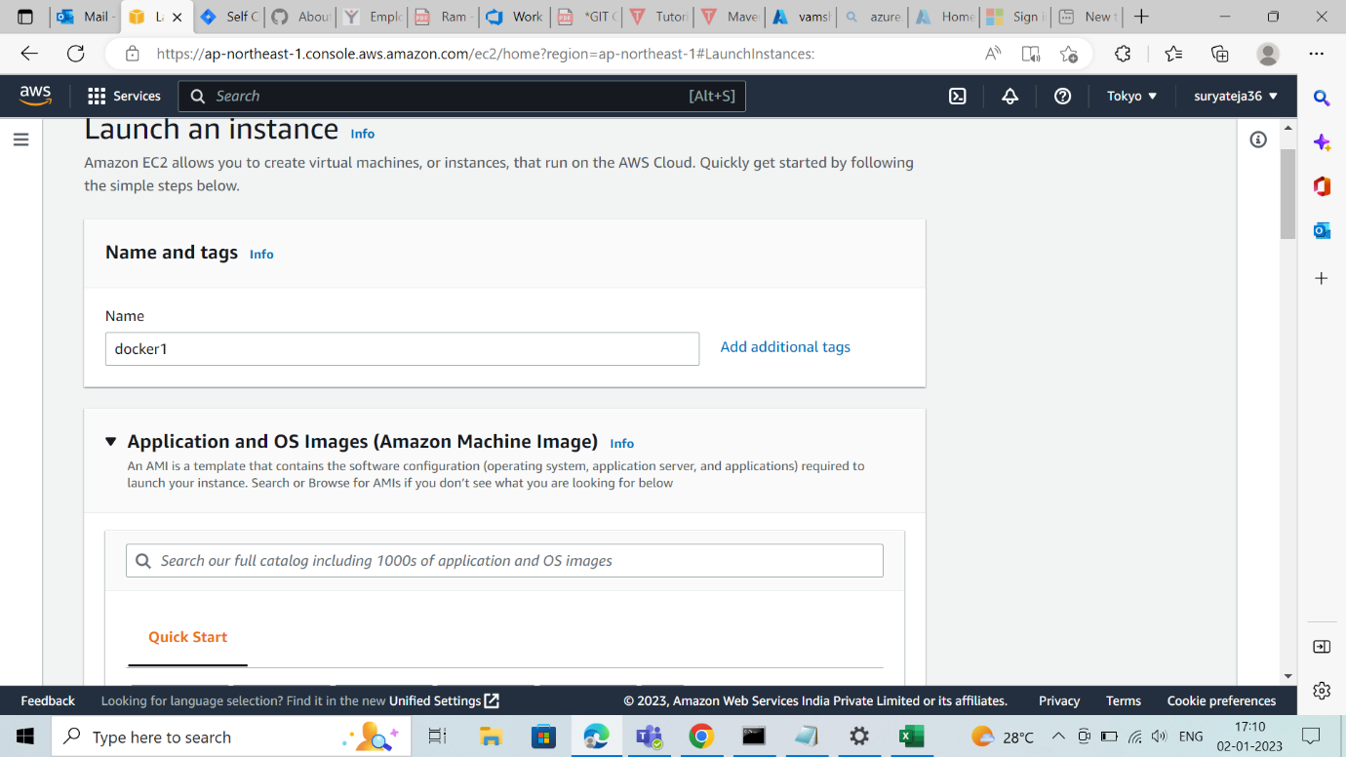

* Selecting the ubuntu flavour which is freely available.

* Creating a pem key to connect with local machine (putty, git bash).

* Here the instance has launched, after checks passed we have to connect:



