1. Q2
Created Polygon, which raises exception when polygon has less than 3 sides or if polygon has negative area.

Test cases for Q2

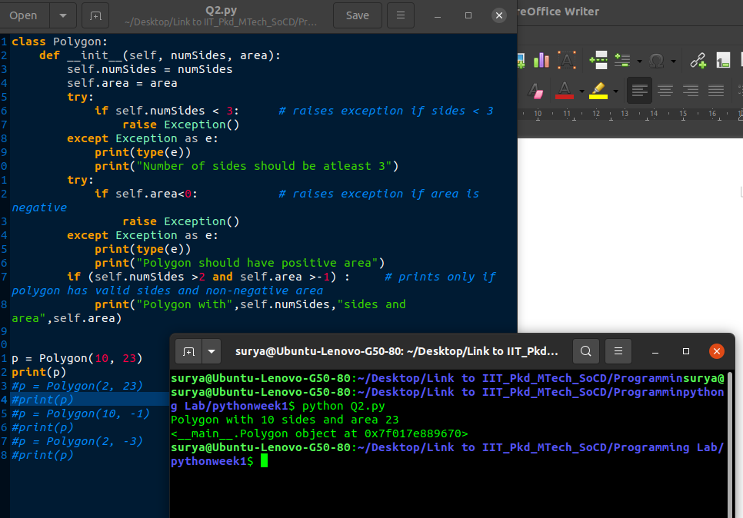
Fig 1

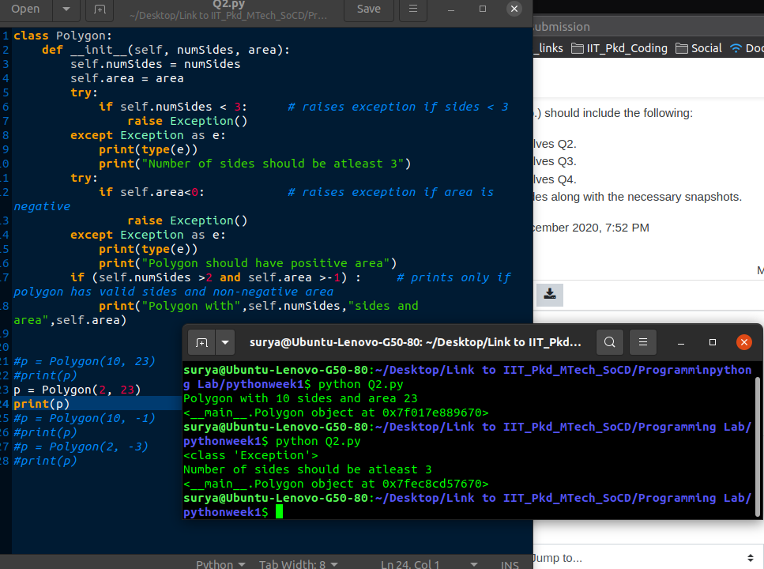
Fig 2
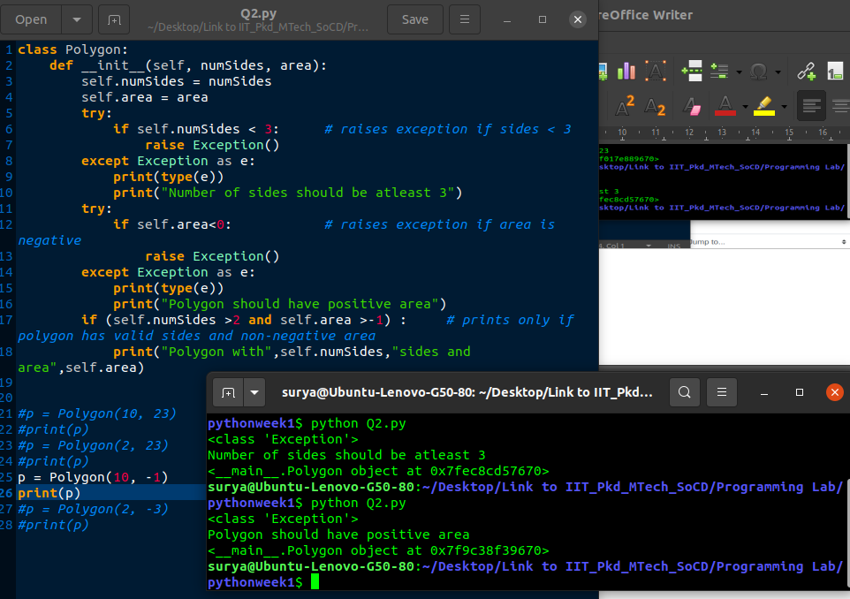
Fig 3

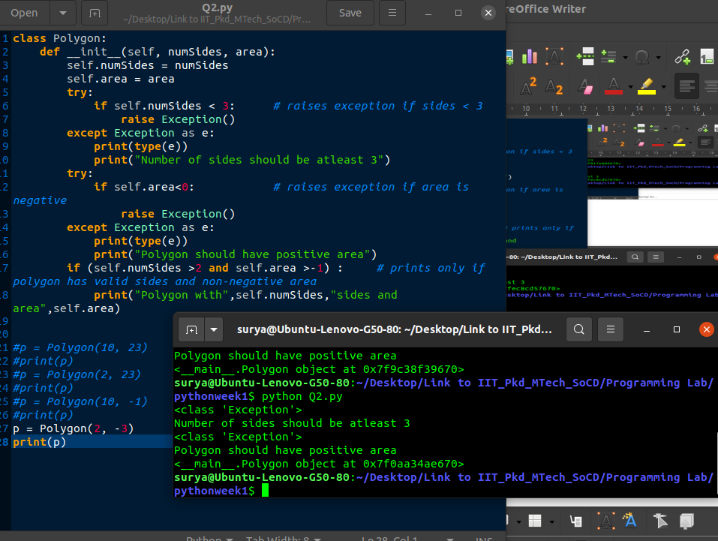
Fig 4

2. Q3
Created Triangle class inherited from the polygon class, the atributes for the triangle class are passed using *args where unpacking the items in container are done and then checked the necessary conditions for the triangle like sum of two sides is larger than third side and only positive side lengths can be created.

Test cases for Q3

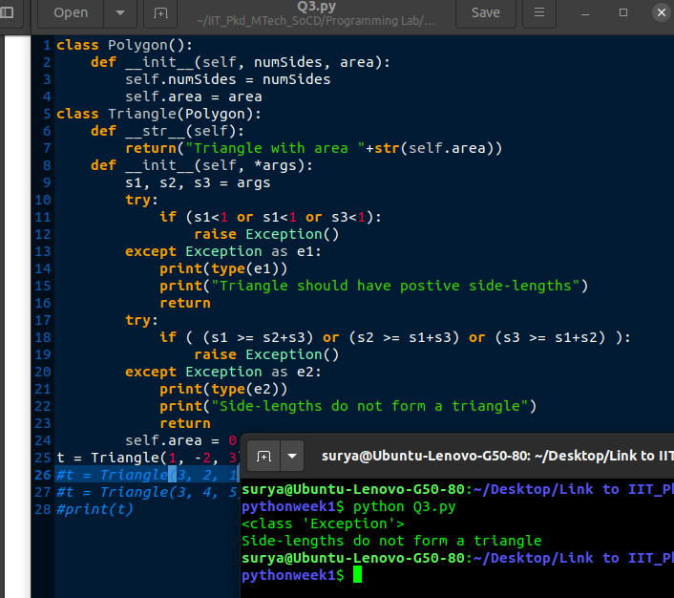
Fig 1

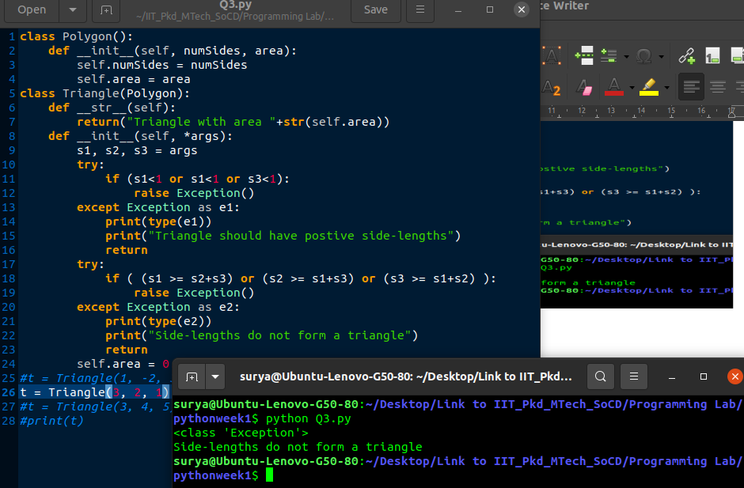
Fig 2

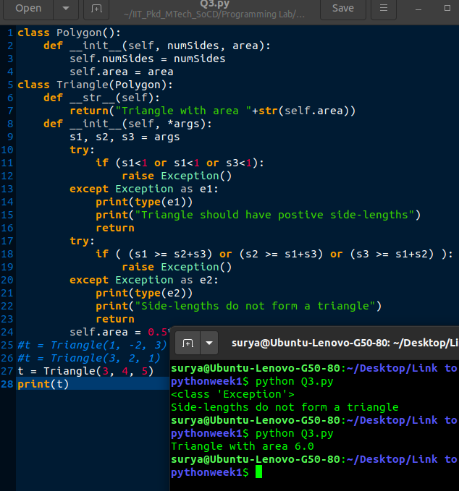
Fig 3

3. Q4

Created Paper class with the methods __init__, __str__, __add__, status, merge, erase functions. Where the __init__ generator initializes the area to the paper object and checks whether its positive or not.
__str__ prints the value of the free area available on paper and also total area of the paper.
__add__ overloads the plus operator so that the polygons with different number of sides, areas and triangles fill the paper area, return the paper object type and also it raises the exception when the available free area on the paper is less than zero.
Status functions fetches all the information from all the remaning objects i.e when new objects like polygons or the triangles added to paper object that addded information is stored into the paper status function.
Merge function merges the area of the same side polyons, it first ceates trigger named dictonary with sides as key and area as the value and adds up all the areas of same side polygons
Erase function clears entire area of the paper by reseting paper area and info variables.
Polygon class in __init__ function treats the polygon with 3 sides as the triangle.
Triangle class checks the necessary conditions to be the valid triangle in __init__ constructor, calculates the area and sends the information to the paper’s status function.

Test Cases for Q4

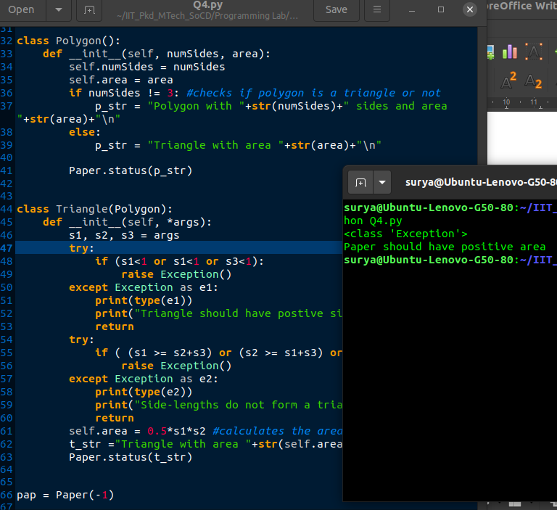

Fig 1

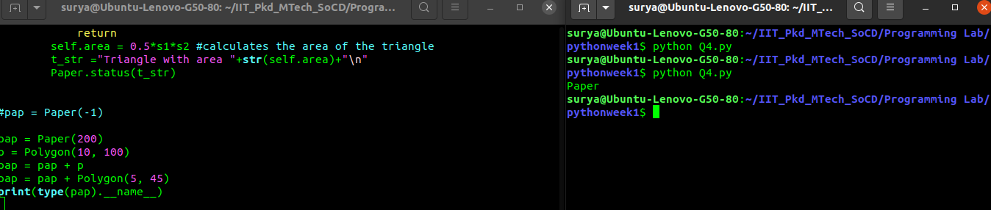

Fig 2

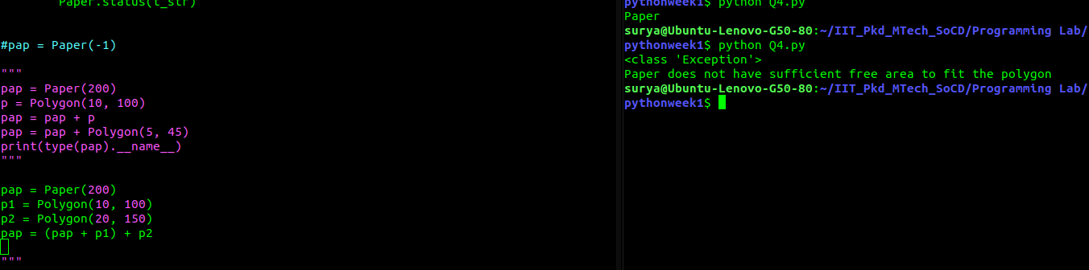
Fig 3

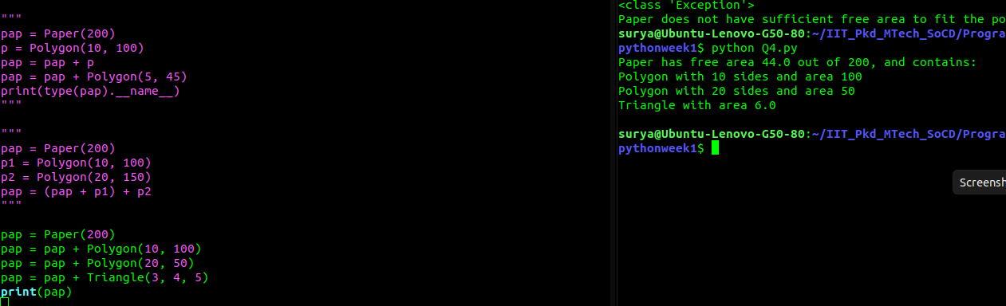
Fig 4

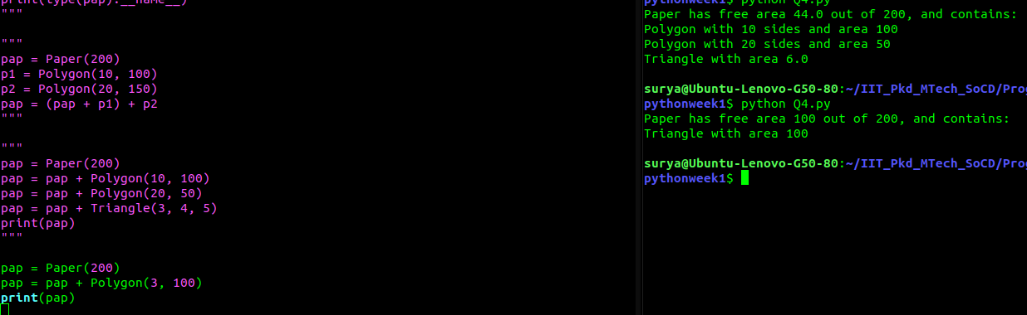
Fig 5

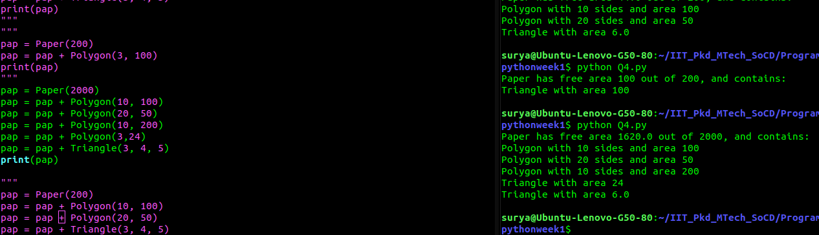
Fig 6

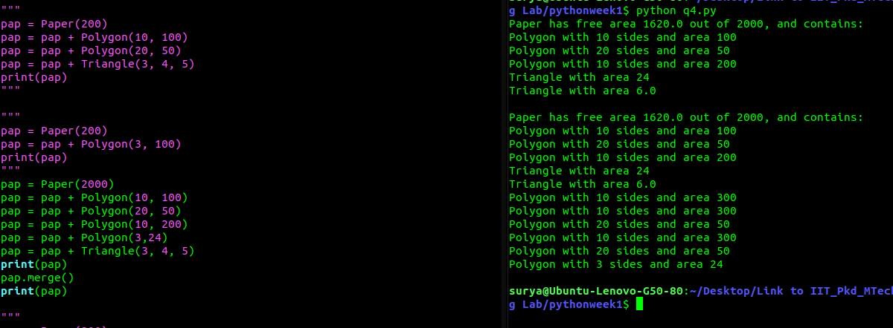
Fig 7

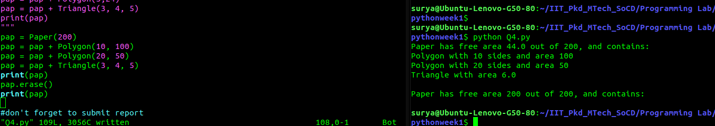
Fig 8

