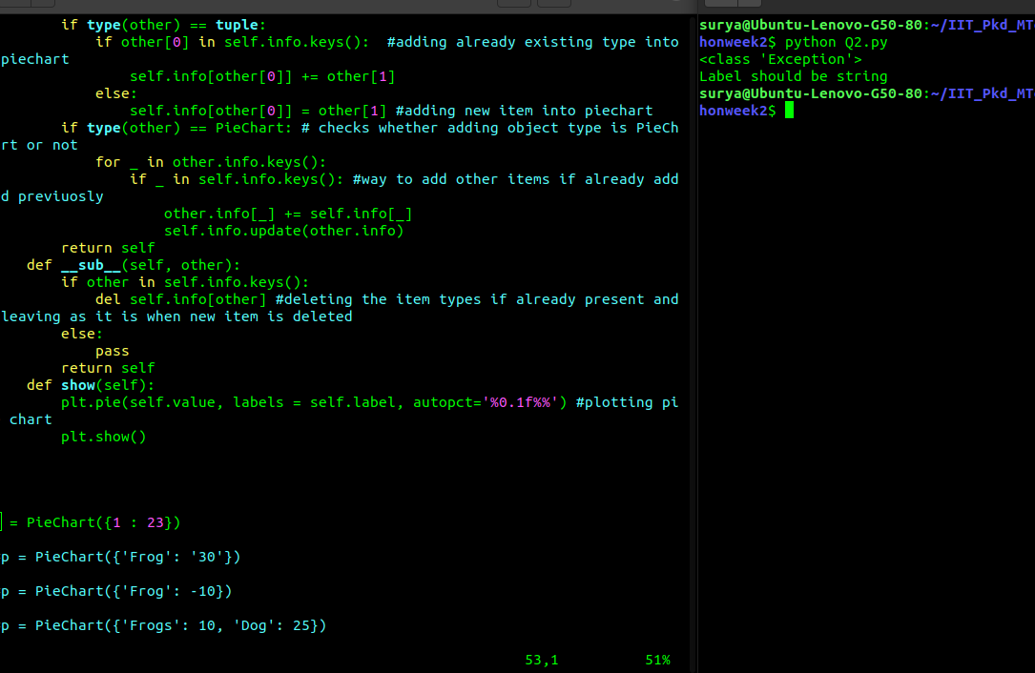
Q2: Created a class PieChart: Following are some of the test cases
1: raises exception when theres no string type in the label.

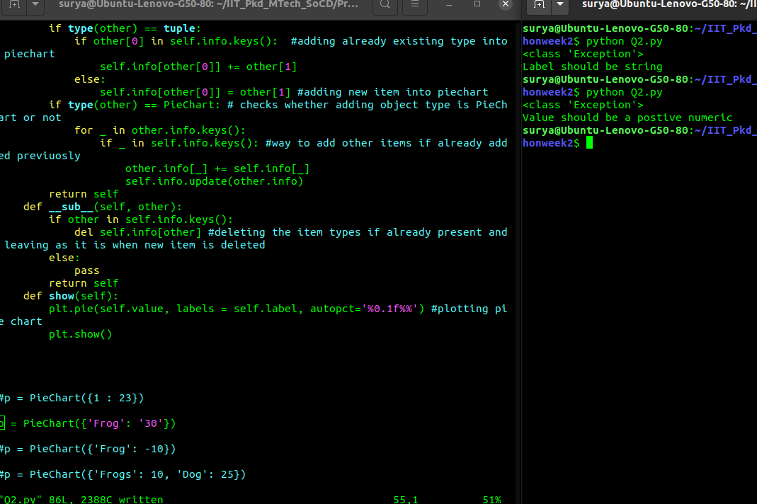
2. raises exeption when key value is not numeric
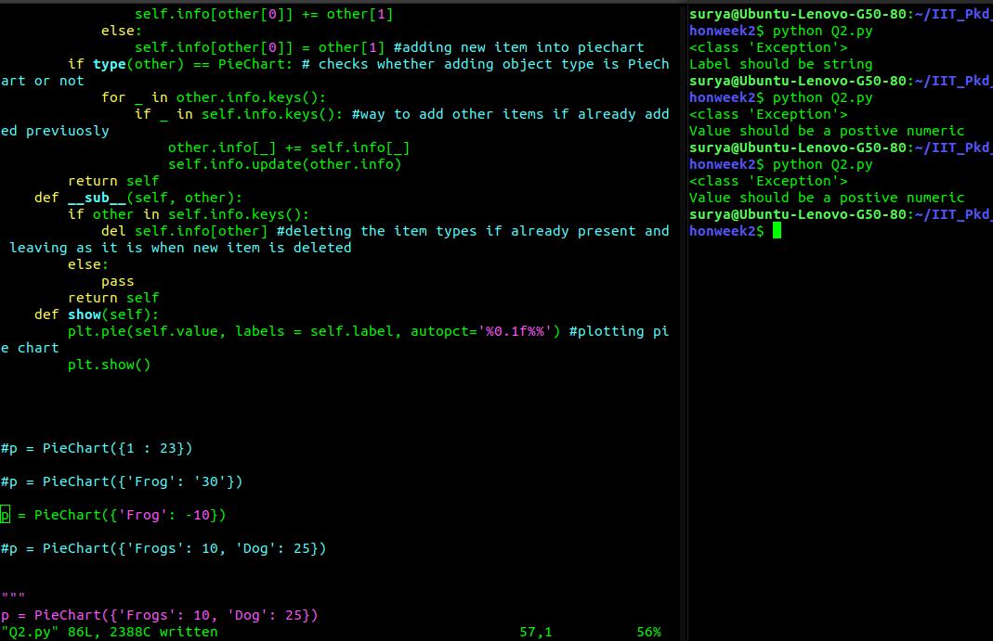
3. raises the exception when the key values are the non positive.

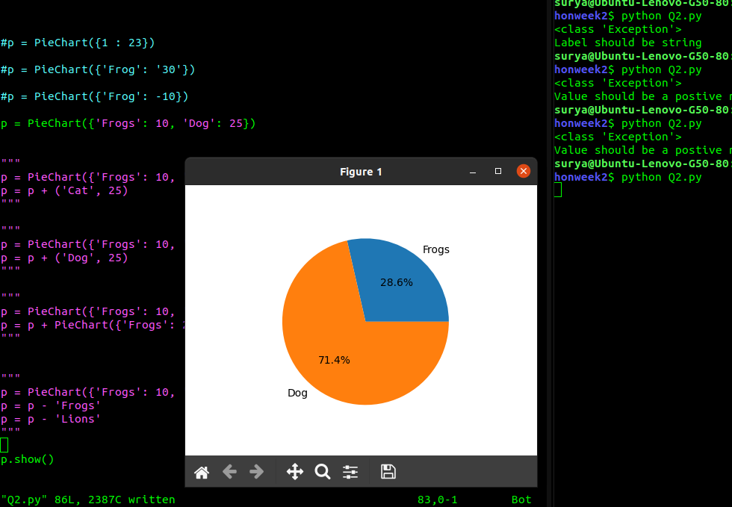
4. Draws an pie chart when appropriate dictonary values are given.

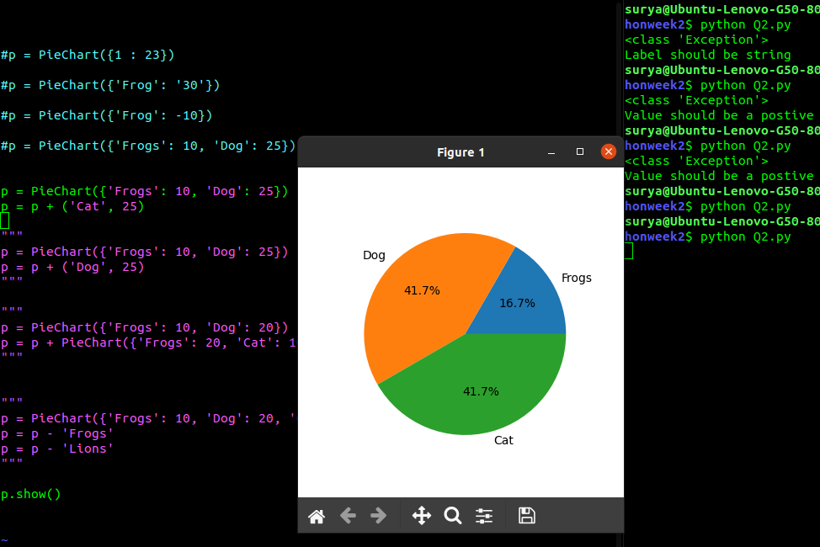
5. Implemented + operator overloading using __add__ method in the PieChart class.

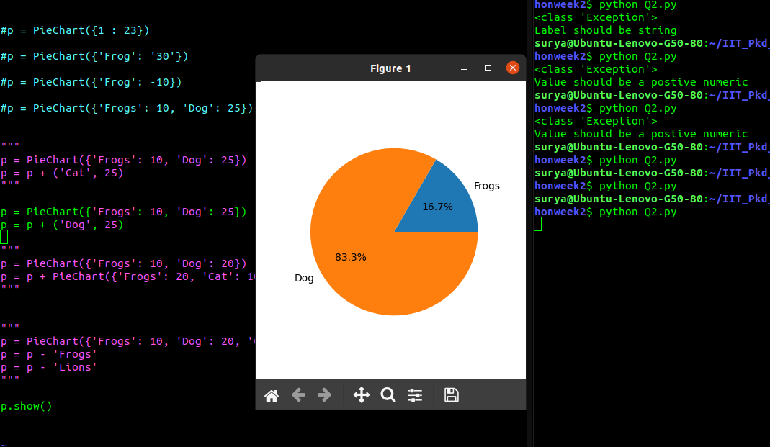
6. Merging is done when the adding of same type object happened.

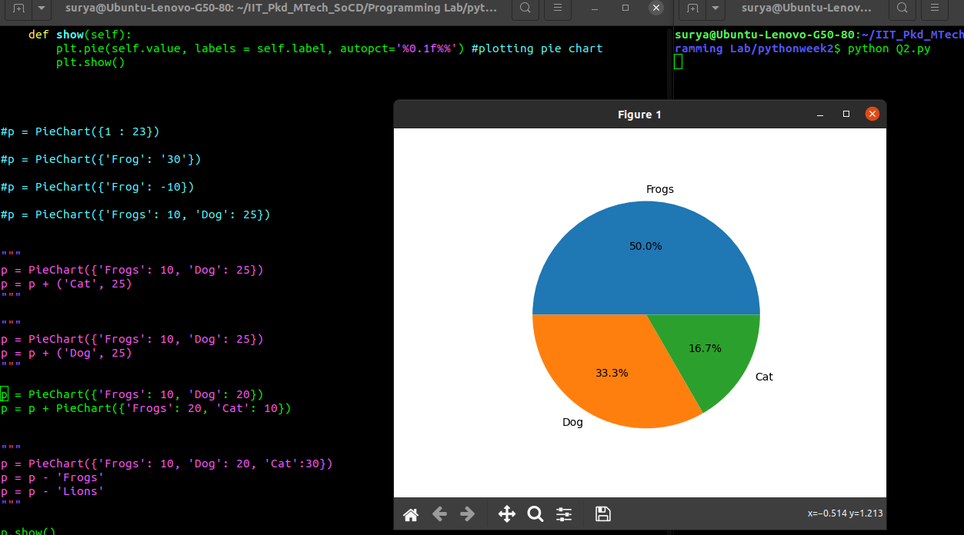
7

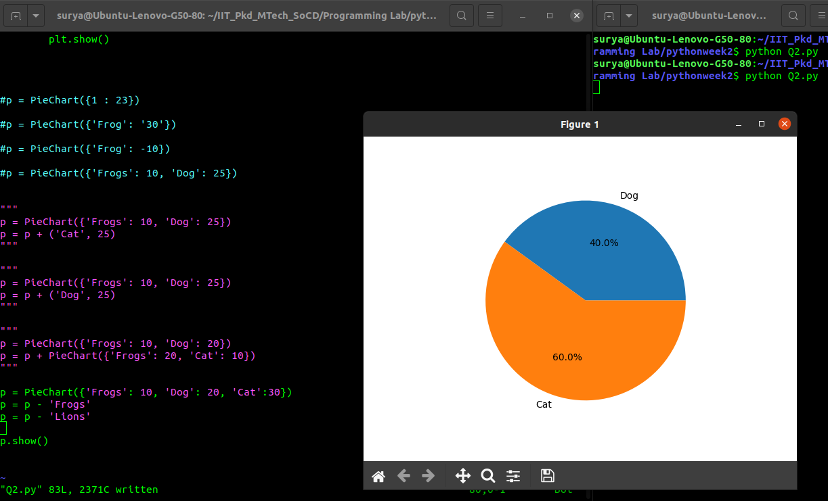
8. Removes the types from pie graph, which are not present previously, implement using __sub__ function.

Q3
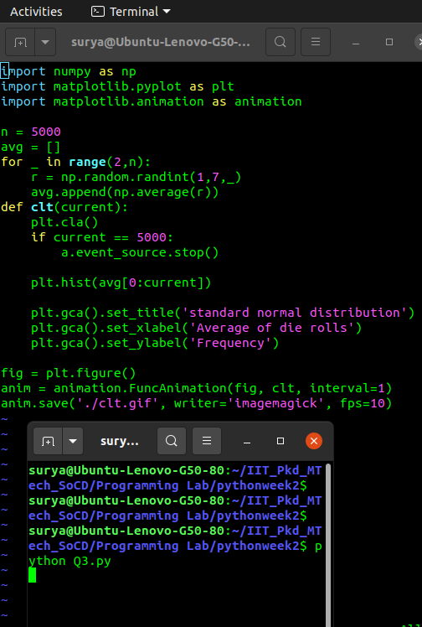

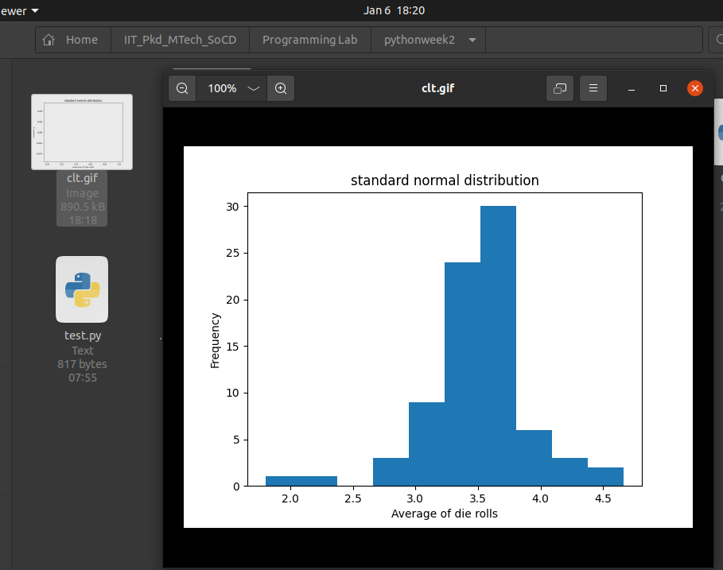
First created random experiment of unbiased dice, generates random variable where average number of occurences are used. Funcanimation is used to generated the animation in 10 fps, When the n is taken the large value, it resembles the standard normal distribution.

Q4 Created the Sines class, which has methods addSine, shiftRight, shiftLeft.
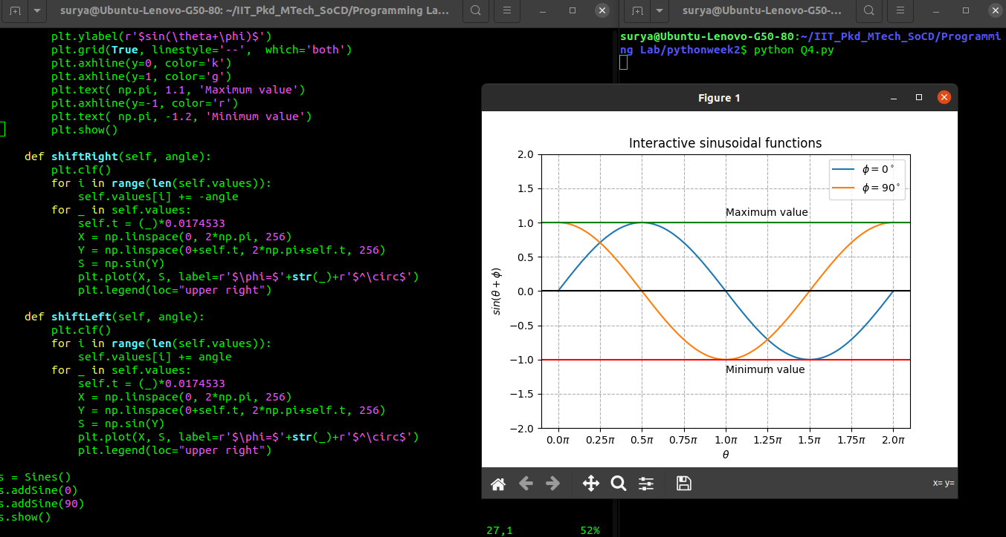
1. adds the angles with degress into the plot using the addSine method.

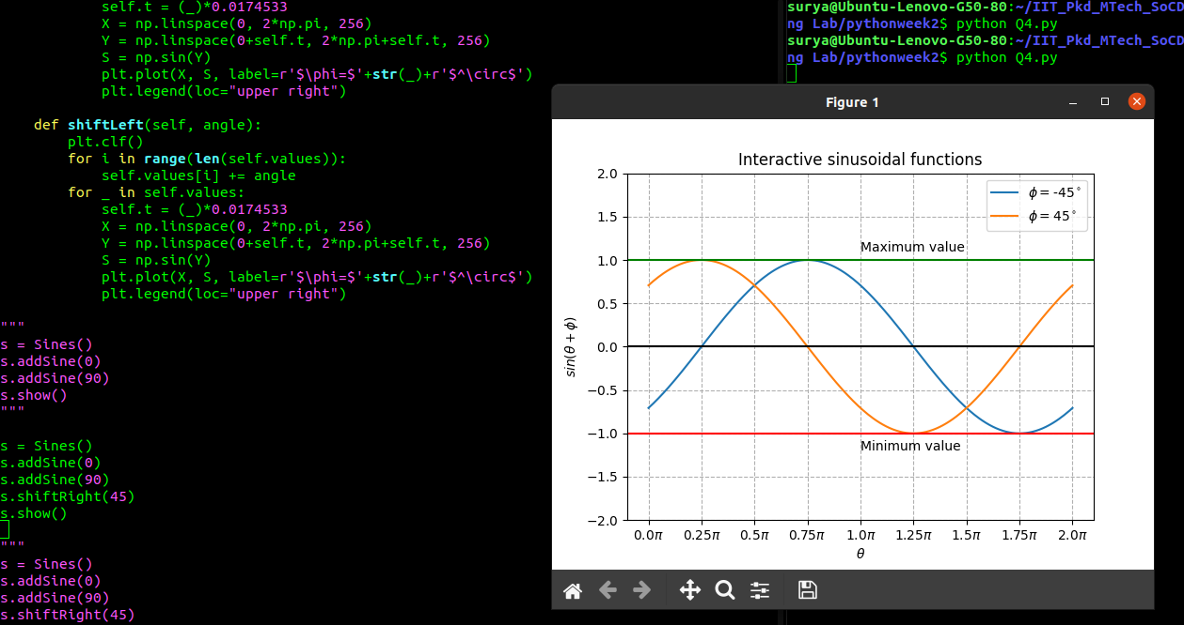
2. Shifts the existing curves to right in angle degrees with the shiftRight() method.

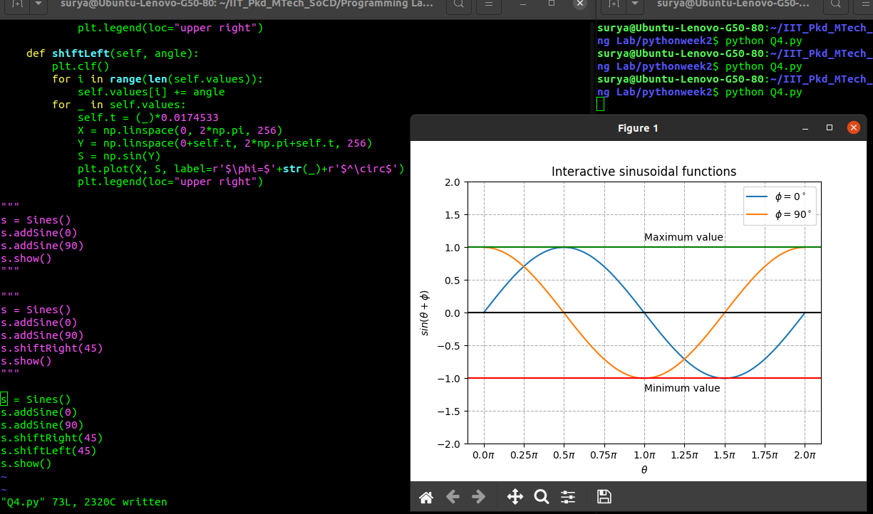
3. Shifts the existing curves to left in angle degrees with the shiftLeft() method.
Mathematical symbols are implemented using the TeX as its by default it supports TeX notation.
Axes of x and y are drawn using the ticks. Numpy is used to generate the number from 0 to 2pi and also corresponding the sine curve values. Drawing legend, ploting graph all are implemented using matplotlib library.

