ADVANCED ENCRYPTION STANDARDS (AES)

1. Introduction
2. Terms used
3. Description of the Algorithm
4. Implementations
5. Driver
6. Security
7. References

**By:**

Siddhartha Valluri

Sri Vivek Immadisetty

1. **Introduction**

**AES** is a secure block cipher. **AES** is a symmetric-key algorithm which means that same key can be used both for encryption and decryption. **Advanced Encryption Standard** is an US government standard that has been implemented to overcome the standard DES. **AES** uses a different structure than **DES**.

It is available in different encryption packages and is a publicly accessible cipher approved by National Secret Agency (NSA) to transmit most secure information.

1. **Terms Used:**
   1. Plain text- a message which has to be encrypted
   2. Ciphertext- the encrypted message
   3. Cipher key- a secret key used to generate round keys
   4. Round keys- derived key from the key-expansion algorithm.
   5. RCON- It is a matrix having ten round constants. Every value is an element of AES-GF256 field.
   6. S-box: A lookup table used to grab the elements from, to substitute in the SubBytes() and InvSubBytes() functions.
2. **Description of the Algorithm:**

AES is a Symmetric-Key encryption algorithm implemented by Federal Information Processing Standards(FIPS). It is widely believed that it is secure, efficient and reliable.

It is a Rijndael algorithm specification, which uses cipher keys of lengths 128, 192 and 256 bits to process data blocks of size 128 bits. This encrypts 128-bit block (plaintext) to produce a 128-bit block (cipher text), or decrypts the 128-bit block (cipher text) into a 128-bit (plaintext).

AES uses keys of sizes 128,192 and 256 bits, so the encryption/decryption using cipher keys are denoted as AES-128, AES-192 and AES-256 respectively.

AES-128, AES-192 and AES-256 processes data blocks using 10, 12 and 14 iterations or rounds. These iterations are pre-defined sequences of transformations.

For the encryption/decryption process we need to generate the round keys which can be done using "Key Expansion" algorithm.

In encryption process, there are a series of steps/transformations involved to get the ciphertext.

* 1. SubBytes
  2. ShiftRows
  3. MixColumns
  4. AddRoundKey

Of all the rounds/transformations, the last round has no MixColumn()/Inv MixColumns() to the final round in both the encryption and decryption processes.

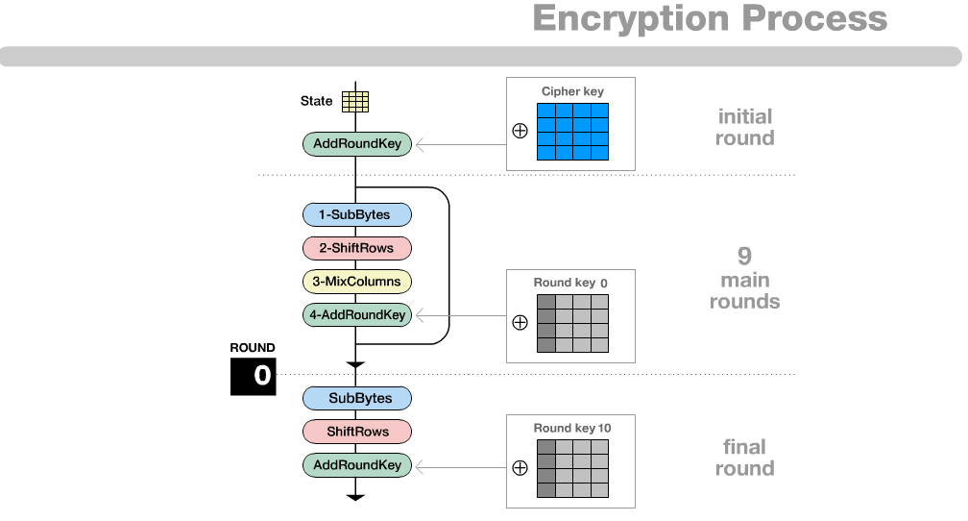

**3a. SubBytes() transformation:**

In this step, we use a lookup table of 16 * 16 size to get a replacement byte for a given byte in the input state array.

The lookup table is created by Galois Field(28). We replace all the 16 bytes of state array using each byte as an index to the lookup table and replace that value from that table. We can restore the original elements of the state array by using inverse SubBytes transformation.

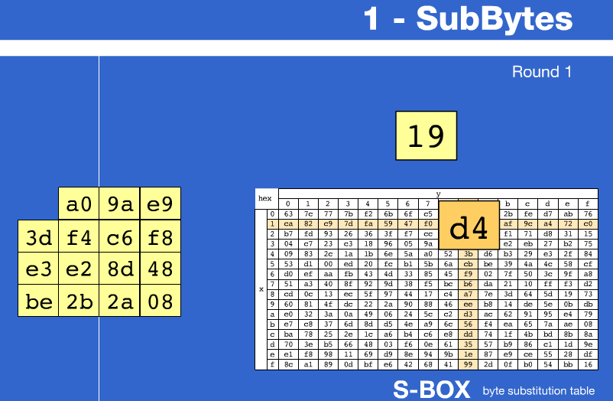

**3b. ShiftRows() transformation:**

As the name suggests, in this transformation we shift the elements in the rows according to the value of the row they are present in. We consider a 4*4 matrix for this step.

First row will be unchanged, the second row shifts to the left by one byte, the third row shifts by two bytes, the fourth row shifts to the left by three bytes.

* 1st row: no change
* 2nd row: left shift by 1 byte
* 3rd row: left shift by 2 bytes
* 4th row: left shift by 3 bytes

**3c. MixColumns() transformations:**

It is a 16-byte to 16-byte transformation which operates on 4*4 matrix input. The state arrays each column is processed to produce a new column by matrix multiplication.

This operation takes each column of state array and replaces it with a new column generated by matrix multiplication.

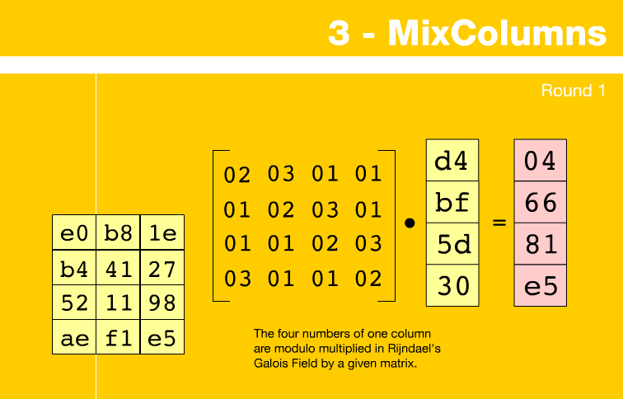

**3d. AddRoundKeys() transformations:**

In this transformation, we just XOR the values of the state array with corresponding round key bytes.

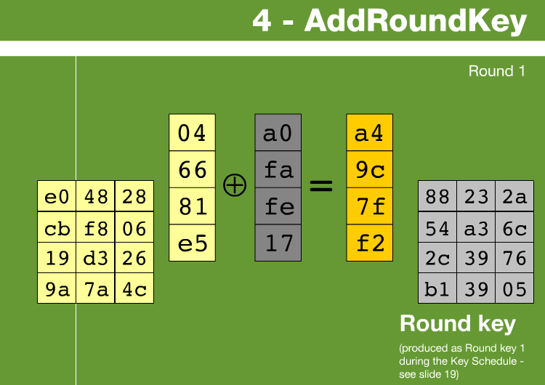

**4. Key Expansion:**

AES uses a cipher key whose length is 128,192 and 256 bits. This expands the cipher key into 10, 12, 14 round keys using “Key Expansion” algorithm.

It uses a key schedule to expand a key into a number of different keys.

It can be executed prior to encryption/decryption phase.

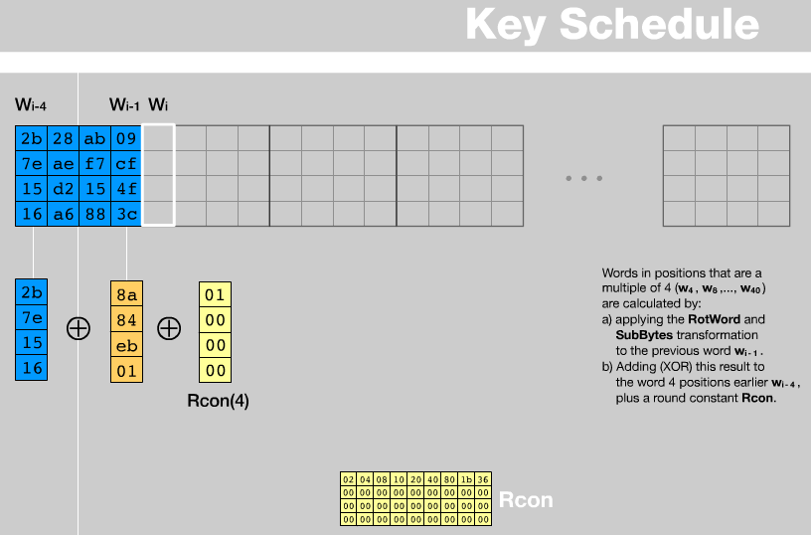

**AES Decryption:**

This process involves the steps inverse of the encryption process.

1. InvAddRoundKey()

2. InvSubBytes()

3. InvMixColumns()

4. InvShiftRows()

**1. Inverse ShiftRows():**

**InvShiftRows()** is the inverse of the ShiftRows() transformation. Bytes in the last rows except the first row(r=0) shift to the right circularly.

1st row: No row shift

2nd row: right shift by 1 byte

3rd row: right shift by 2 bytes

4th row: right shit by 3 bytes

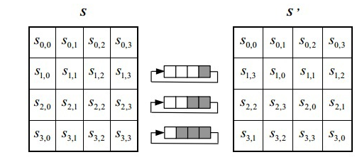

**2. Inverse MixColumns:**

**InvMixColumns()** is the inverse of the MixColumns() transformation.

The S-box is designed to be resistant to many cryptanalyst attacks.

The elements are in hexadecimal and are of Galois Field(GF). The multiplication of a fixed polynomial over GF(28) called modulo multiplication, calculated using shifts and XOR operations.

**3. Inverse SubBytes():**

InvSubBytes() is inverse of the SubBytes() transformation in the encryption process. Inverse affine transformation is applied first prior to computing the multiplicative inverse.

Steps involved are:

Inverse affine transformation Multiplicative inverse in GF(28).

**4. AddRoundKey()**

This is the easier step in which the AddRoundKey() elements are applied in reverse order because it is just an XOR operation.

**Driver:**

Driver takes the input plaintext from the user and encrypts it depending on the type of encryption being used 128/192/256-bit.

As we know AES processes the data in blocks of 32 bytes, so in order to process the data the input plaintext should be a multiple of the block size. If the size of the input plaintext is not a exact multiple then we need to do ‘**Padding**’ before encrypting by adding a padding string and reverse in decrypting i.e., remove the padded string before decrypting.

‘Padding’ means adding some extra bits to make it 32-bytes long so that it can be processed.

**Security:**

AES was designed to face any kind of attack. Some of the attacks that have been tested:

1. AES is more secure because of its larger key size.
2. Of all attacks till date, known attacks were on 7/8/9 rounds for 128/192/256-bit keys respectively.
3. The key sizes in decimal terms are:

a. 3.4 x 1038 possible 128-bit keys,

b. 6.2 x 1057 possible 192-bit keys,

c. 1.1 x 1077 possible 256-bit keys,

And it is said that it takes 149 trillion years to break the 128-bit AES key.

**References:**

1. Federal Information Processing Standards:

<http://csrc.nist.gov/publications/fips/fips197/fips-197.pdf>

2. Advanced Encryption Standards

<https://en.wikipedia.org/wiki/Advanced_Encryption_Standard>