Four Weeks Industrial Training Project Report on
Car Price Prediction Using Machine Learning
Submitted in the partial fulfilment of the requirement for the award of degree of
Bachelor of Technology
in
Computer Science and Engineering
Batch (2025-26)


Submitted to: Submitted by:
Dr. Ridhi Kapoor Abhishek Suryavanshi
(12301448)

DEPARTMENT OF COMPUTER SCIENCE AND ENGINEERING
DAV UNIVERSITY
JALANDHAR- PUNJAB 144012

Certificate of Training



ABSTRACT

This project focuses on predicting car prices using the CarDekho 50K dataset, which contains 50,000 car listings with various specifications and price details. The dataset was preprocessed by cleaning missing or inconsistent entries, selecting relevant features, and encoding categorical variables to make it suitable for machine learning models. After preprocessing, the data was split into training and testing sets, and regression models were applied to forecast car prices accurately.
Three models were implemented: Linear Regression, Random Forest Regressor, and XGBoost Regressor. Their performance was evaluated using R² Score and Root Mean Squared Error (RMSE). The results show that XGBoost achieved slightly better accuracy than Linear Regression and Random Forest, demonstrating its ability to capture complex, non-linear relationships in the data.
This project illustrates how machine learning can assist buyers and sellers in estimating car prices reliably, using structured datasets with diverse features. It also highlights practical skills in Python programming, data preprocessing, and model evaluation, gained during the AppTechies training.

a

ACKNOWLEDGEMENT

I wish to convey my deepest gratitude to everyone who contributed to the successful completion of this project. I am truly thankful to Mr. Rahul Hans (Coordinator), DAV University, for giving me the chance to participate in the 45-day summer training program at AppTechies, Mohali. This opportunity played a significant role in enhancing my learning and practical exposure.
I also extend my appreciation to the esteemed faculty of the Department of Computer Science and Engineering for their continuous encouragement, valuable insights, and academic support, all of which were instrumental in preparing this final report and presentation.
A special note of thanks goes to the AppTechies, Mohali team, especially Mr. Amandeep Singh, my mentor, whose guidance, patience, and consistent support greatly enriched my training experience. His mentorship made the entire journey more meaningful, productive, and impactful.

DECLARATION

I, Abhishek Suryavanshi (Reg. No.: 12301448), hereby declare that the work presented in this project/training titled “Car Price Prediction Using Machine Learning” is an authentic record of my own work carried out under the guidance of Mr. Amandeep Singh (AppTechies, Mohali).
This project is submitted in partial fulfilment of the requirements for the award of the Bachelor of Technology (B.Tech) Degree in Computer Science and Engineering.
To the best of my knowledge, the content of this report has not been submitted to any other University or Institute for the award of any degree or diploma.

Student Name: Abhishek Suryavanshi
Reg. No.: 12301448
Signature: ______________________
Date: __________________________

Table of Contents

Certificate ...................................................................................2
Abstract ..................................................................................... 3
Acknowledgement .................................................................... 4
Declaration .................................................................................5
1. Introduction ...........................................................................8
1.1 Title of the Project .............................................................9
1.2 Objectives .........................................................................10
1.3 Steps Taken to Achieve Objectives ...................................11
1.4 Technologies Used ........................................................... 13
1.5 Tools & Environment ........................................................15
2. Artificial Intelligence and Machine Learning ................... 16
2.1 Introduction to AI ............................................................. 16
2.2 Understanding Machine Learning .................................... 17
2.3 Supervised Learning & Regression .................................. 18
3. Dataset Overview and Data Collection .............................. 19
3.1 Dataset Description (CarDekho 50K) .............................. 19
3.2 Key Features ......................................................................19
4. Data Cleaning and Preprocessing ....................................... 20
4.1 Handling Missing Values
4.2 Irrelevant Features Removal
4.3 Standardization of Units
4.4 Encoding Categorical Features
4.5 Outlier Treatment
4.6 Feature Scaling
5. Feature Selection and Engineering ..................................... 21
5.1 Feature Selection .............................................................. 21
5.2 Feature Engineering ......................................................... 21
6. Correlation Map Analysis ................................................... 22
7. Model Building ..................................................................... 23
7.1 Linear Regression ............................................................ 23
7.2 Random Forest Regression .............................................. 23
7.3 XGBoost Regression ....................................................... 23

8. Model Evaluation ............................................................... 24
9. Results and Visualization ................................................... 25
10. Conclusion ......................................................................... 26
11. Limitations ........................................................................ 26
12. Future Scope ..................................................................... 26
Appendices .............................................................................. 27
Appendix A: Dataset Description ......................................... 27
Appendix B: Python Libraries Used .................................... 27
Appendix C: Code Snippets ................................................. 27
• Dataset Loading
• Data Cleaning
• EDA
• Correlation Heatmap
• Train-Test Split
• Model Training (LR, RF, XGBoost)
• Regression Plots
• Feature Importance
• Saving Cleaned Data
• Combined Regression Plots
Appendix D: Model Evaluation Metrics ............................. 32
Appendix E: Visualizations and Graphs ...................... ....... 32
• Correlation Heatmap
• Feature Importance Graphs
• Regression Plots
• Combined Regression Plots
References ....................................................................... ..... 35

INTRODUCTION

This report describes the work completed during my 45-day summer training at AppTechies, Mohali, undertaken as part of the academic requirements of the Department of Computer Science and Engineering, DAV University. During this training period, I worked on the project titled “Car Price Prediction Using Machine Learning.”
The objective of this project was to apply machine learning techniques to forecast car prices based on important features such as year of manufacture, mileage, engine capacity, fuel type, transmission type, owner type, and other specifications. With the automobile market generating large volumes of data, machine learning provides an effective way to analyze patterns and predict prices accurately.
The project involved several stages including data preprocessing, feature engineering, model training, and performance evaluation. Three prediction models—Linear Regression, Random Forest Regressor, and XGBoost Regressor—were implemented to analyze both linear and non-linear trends in the data. Evaluation metrics such as R² Score and Root Mean Squared Error (RMSE) were used to compare the models. XGBoost Regressor achieved the best accuracy due to its ability to capture complex relationships between features.
This project offered significant practical exposure to machine learning workflows and demonstrated how data-driven prediction models can help buyers and sellers estimate car prices reliably, facilitating better decision-making in the automobile industry.

TITLE OF THE PROJECT
Car Price Prediction Using Machine Learning

OBJECTIVES

- To understand the core concepts of Artificial Intelligence (AI) and Machine Learning (ML) and develop the ability to design, train, and implement ML models for real-world car price prediction tasks.
- To successfully complete the 45-day summer training program at AppTechies, Mohali, gaining practical industry-level exposure to tools, technologies, and machine learning workflows.
- To work on the assigned project titled “Car Price Prediction Using Machine Learning,” focusing on analyzing car datasets and building a predictive model to estimate car prices based on key features.
- To complete all essential steps in the ML pipeline, including:
  - Data importing and cleaning
  - Handling missing or inconsistent values
  - Feature selection and extraction
  - Exploratory Data Analysis (EDA)
  - Train–test splitting
  - Feature scaling
  - Model development and optimization
  - Model evaluation and comparison
- To implement and compare multiple machine learning algorithms, specifically Linear Regression, Random Forest Regressor, and XGBoost Regressor, to determine which provides better predictive performance for car price estimation.
- To gain hands-on experience with major Python libraries such as Pandas, NumPy, Scikit-Learn, Matplotlib, and Seaborn for preprocessing, visualization, and model building.
- To understand the importance of evaluation metrics like R² Score and Root Mean Squared Error (RMSE), and interpret how they measure the accuracy and efficiency of regression models.
- To develop the ability to interpret model results, compare actual vs predicted prices, and understand the strengths and limitations of the algorithms used.
- To improve analytical, technical, and problem-solving skills essential for careers in machine learning, data science, and intelligent systems.
- To apply theoretical knowledge gained during coursework to a real-world, industry-based machine learning project and demonstrate practical competence.

STEPS TAKEN TO ACHIEVE THE OBJECTIVES

• Learning the Basics
- Revised the fundamentals of Artificial Intelligence (AI) and Machine Learning (ML).
- Studied important topics like supervised learning, regression models, feature importance, and evaluation metrics.
- Attended classes and discussions conducted by the mentor at AppTechies, Mohali.
• Understanding the Training Requirements
- Understood the expectations of the 45-day summer training program.
- Identified the tools, libraries, and datasets required for the Car Price Prediction project.
- Planned a step-by-step workflow to complete the project on time.
• Studying the Project Topic
- Analyzed the aim of predicting car prices using ML algorithms.
- Examined the CarDekho dataset to identify important features such as year, mileage, engine, fuel type, transmission, owner type, and price.
- Understood the project scope, potential challenges, and expected results.
• Data Collection and Cleaning
- Loaded the CarDekho dataset into Python for analysis.
- Cleaned the data by handling missing values and removing irrelevant columns.
- Performed Exploratory Data Analysis (EDA) to identify patterns and relationships between features.
• Feature Selection and Processing
- Selected the most relevant features affecting car prices.
- Applied feature scaling and encoding where needed to make the data suitable for model training.
- Split the data into training and testing sets using train-test split.
• Model Building
- Started by creating a Linear Regression model as a baseline.
- Trained and tested the model to check prediction accuracy.
- Built Random Forest Regressor and XGBoost Regressor models to improve prediction performance.

• Model Evaluation and Comparison
- Evaluated all models using R² Score and Root Mean Squared Error (RMSE).
- Compared actual vs predicted car prices using visual plots.
- Found that XGBoost Regressor gave the most accurate and stable results.
• Results and Visualization
- Created graphs, scatter plots, and feature importance charts to show model performance.
- Analyzed model outputs to understand which features influence car prices the most.
- Recorded all observations and insights gained during analysis.
• Skill Development and Learning
- Practiced using Python libraries like Pandas, NumPy, Scikit-Learn, Matplotlib, and Seaborn.
- Improved understanding of ML pipelines, real-world car datasets, and regression algorithms.
- Gained confidence in debugging, analyzing data, and optimizing model performance.
• Report Writing and Final Documentation
- Compiled all code, results, graphs, and explanations into a structured project report.
- Summarized the complete workflow, outcomes, and learning experience.
- Ensured the final report followed the required academic and training guidelines.

Car Price Prediction Using Machine Learning

Technologies Used:

1. Python (Programming Language)


Python is a high-level, versatile programming language widely used for data science and machine learning. It provides a clean syntax, massive library support, and strong community resources. In this project, Python is the core language used for data preprocessing, visualization, model building, and evaluation. Its flexibility and integration with scientific libraries make it ideal for end-to-end machine learning workflows.

2. Pandas (Data Handling & Manipulation)

Pandas is a powerful data analysis library that supports operations like filtering, cleaning, merging, and summarizing datasets. In this project:
- Used to load the dataset (CSV).
- Performed data cleaning (duplicates, invalid values).
- Handled data preprocessing and feature manipulation.
- Structured data into DataFrames for easy analysis.

3. NumPy (Numerical Computation)



NumPy provides support for fast mathematical operations, arrays, and numerical functions.
In this project, NumPy was used for:
- Performing mathematical calculations like RMSE.
- Handling numerical transformations.
- Supporting machine learning libraries internally.

4. Matplotlib (Data Visualization)

Matplotlib is a fundamental plotting library used to create visual graphs and charts.
In this project, it was used to generate:
- Regression plots
- Trend charts
- Scatter plots
- Custom visualizations for model comparison.

5. Seaborn (Statistical Visualization)

Seaborn is built on top of Matplotlib and offers advanced statistical visualizations.
In this project, Seaborn was helpful in:
- Creating heatmaps for correlation.
- Drawing pairplots to show relationships between features.
- Making boxplots to detect outliers.

6. Scikit-Learn (Machine Learning Framework)

Scikit-Learn is a widely used ML library providing tools for modeling, preprocessing, and evaluation.
Used in this project for:
- Linear Regression modeling
- Random Forest Regressor
- Train–Test Split
- StandardScaler for feature scaling
- Evaluation metrics like R² and RMSE

7. XGBoost (Advanced Gradient Boosting Model)

XGBoost is a high-performance boosting algorithm known for accuracy and speed.
In this project, XGBoost was used to:
- Train a robust regression model
- Handle complex non-linear relationships
- Improve prediction accuracy compared to basic models

8. Tools & Environment (Workspace)
Google Colab :

- Used for writing and executing Python code interactively.
- Offers real-time visualization of plots.
- Supports installation of libraries and GPU/CPU execution.

CSV Dataset – CarDekho 50K:
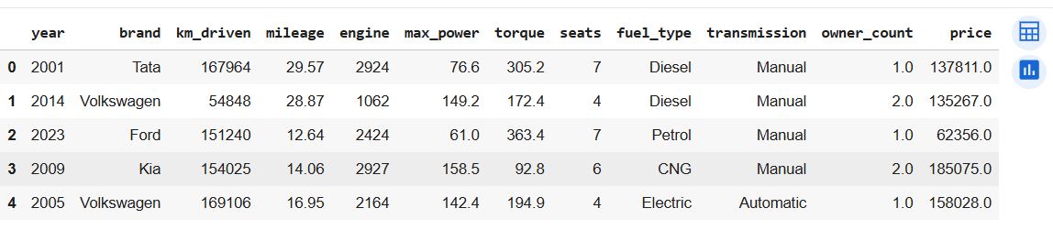(first 5 rows)
- The raw dataset used for training, testing, and analysis.
- Stored as .csv and read using Pandas.

2.1. Introduction to Artificial Intelligence (AI)

Artificial Intelligence (AI) is a broad and rapidly evolving field of computer science that seeks to build systems capable of performing tasks that usually require human intelligence. These tasks can range from learning patterns in data, making decisions, understanding natural language, to perceiving the environment and acting accordingly. AI draws from multiple disciplines — including computer science, mathematics, and cognitive science — to design systems that can learn from data, generalize from past examples, and make predictions or decisions without being explicitly programmed for every possible scenario.
At a high level, AI can be categorized into Narrow (or Weak) AI and General (or Strong) AI. Narrow AI refers to specialized systems built for specific tasks — for example, image classification, language translation, recommendation systems, or price prediction. In contrast, General AI refers to hypothetical systems that possess human-like general intelligence and can perform any intellectual task that a human can do. Currently, all real-world AI systems — including those used for car price prediction — are instances of Narrow AI.
One of the fundamental enablers of modern narrow AI is Machine Learning (ML). ML allows systems to automatically learn patterns and relationships from historical or observed data, rather than relying on manually coded rules. By feeding large datasets into machine learning algorithms, these systems can detect subtle patterns and statistical relationships that may not be obvious to humans. In a car price prediction scenario, ML models learn how features such as manufacturing year, mileage, engine capacity, fuel type, and transmission influence the final selling price of a car. Once trained, the model can generalize this learned relationship to unseen cars — providing price estimates even for cars not present in the training data.
Beyond ML, AI includes other relevant technologies. Natural Language Processing (NLP) can be used if the dataset includes textual descriptions of cars — for example, analyzing phrases like “well-maintained”, “single owner”, or “accident-free” to enhance price predictions. Expert systems — though less common now compared to ML — can embed human knowledge in rule-based systems, potentially useful for recommendations or flagging suspiciously overpriced or underpriced cars. For more advanced applications, computer vision and robotics come into play — e.g., analyzing car photos to assess condition, damage, or wear-and-tear, which could feed into a more holistic pricing model.
In the context of the automotive and resale market, AI’s value becomes obvious: by leveraging large datasets of past car sales, AI-driven prediction tools help buyers, sellers, and dealerships make data-driven decisions. Buyers can evaluate whether a listing is reasonably priced; sellers can price their vehicles competitively; dealerships can better manage inventory, valuate trade-ins, or forecast resale values. As computational power grows and data becomes more abundant, AI’s role in price prediction and market analytics will only deepen, enabling more accurate, scalable, and automated valuation systems.
In this project, we apply AI — via machine learning — to build a car price prediction model. Using historical data (for example from datasets inspired by platforms such as CarDekho), we process features like year, mileage, engine size, fuel type, transmission type, and owner type to train predictive models. This underlines how AI, even in its “narrow” form, can assist real-world decision-making in automotive markets — a practical, high-impact application of intelligent systems.

2.2. Understanding Machine Learning (ML)

Machine Learning (ML) is a subfield of Artificial Intelligence in which computer systems learn patterns from historical data to make predictions or decisions, without being explicitly programmed with rules for every scenario. The core strength of ML arises from its ability to generalize — that is, to infer underlying patterns from past data and apply that understanding to new, unseen data. This makes ML especially well-suited for problems involving prediction, classification, or estimation, where relationships between input features and outputs are complex or noisy.
ML techniques can be broadly classified into three paradigms:
- Supervised Learning: Here, the model is trained on labeled data — that is, datasets where each input (features) is associated with a known output (target). The model learns to map input features to the correct target. Examples include regression (predicting continuous values) and classification (predicting categories). In the context of car pricing, supervised learning is typically used because historical car sale listings include both the features (e.g. year, mileage) and the final selling price.
- Unsupervised Learning: These techniques work on unlabeled data — that is, datasets where there is no explicit target variable. Unsupervised learning tries to infer underlying structure or patterns in the data. Examples include clustering (grouping similar data points) or dimensionality reduction (reducing number of features while preserving most information). While unsupervised learning is not the primary focus for price prediction, it can be useful for tasks like grouping cars by similarity or detecting anomalies/outliers in listings.
- Reinforcement Learning: This involves training agents that learn by interacting with an environment and receiving feedback (rewards or penalties). While less common in static predictive tasks like car price prediction, reinforcement learning can be applied in dynamic scenarios — for instance, dynamic pricing, inventory management, or market simulations.
For our car price prediction project, we follow a supervised learning approach. Given historical data — where each car listing includes input features such as manufacturing year, mileage, engine capacity, fuel type, transmission type, owner type — and the known sale price, we train models that learn the mapping from features to price. Once trained, these models can predict the likely selling price of cars given their specifications.
The choice of ML makes sense in this context because car price depends on a complex interplay of factors — depreciation (related to age/mileage), demand for certain fuel or transmission types, engine size, and other features. It would be extremely difficult (and error-prone) to manually codify all these relationships. ML allows the model to “learn” these relationships directly from data.
Thus, ML serves as the backbone of any data-driven price-prediction tool: by learning from past data and generalizing to new data, ML makes it possible to have scalable, automated, and relatively accurate valuation systems. In this project, we rely on supervised regression models to predict car prices, using data preprocessing, feature engineering, and model building to maximize prediction accuracy and robustness.
.

2.3. Supervised Learning and Regression

In the domain of supervised learning, when the target variable is continuous (rather than categorical), the problem is called regression. In a car price prediction project — where the goal is to estimate the monetary value of a car — regression is the appropriate modeling approach. Regression models allow us to learn the quantitative relationship between input features (e.g. mileage, age, engine size) and the target output (price).
One of the simplest regression approaches is Linear Regression. In linear regression, we assume that the relationship between input features and target price is linear or can be approximated linearly. The model learns a set of coefficients (weights) for each feature (plus an intercept) such that the sum of squared differences between the predicted and actual prices (the residuals) is minimized. Linear regression is easy to interpret — we can directly see how much each feature contributes to the predicted price — and computationally inexpensive. However, the key limitation is its assumption of linearity: in real-world scenarios like car pricing, relationships are often non-linear (e.g., depreciation may accelerate over time, engine capacity may have diminishing returns, or interactions between features may matter).
To account for non-linear relationships and feature interactions, more powerful models like Decision Tree Regression and Ensemble Methods (e.g. Random Forest) are often used. A decision tree regressor splits data at nodes based on feature thresholds and makes piecewise constant predictions. It can capture non-linear patterns and interactions, but a single tree may overfit — especially if the tree becomes too deep.
To mitigate overfitting and improve generalization, one can use Ensemble Methods, such as Random Forest Regression. A Random Forest builds many decision trees (each trained on a random subset of data and features — called bootstrap sampling and feature bagging), and then averages their predictions. This reduces variance, smooths out idiosyncratic errors of individual trees, and tends to produce more stable and reliable predictions. Such ensemble models often perform significantly better when the relationship between features and target is complex, non-linear, or involves high-dimensional feature spaces.
In this project (as per your plan), you use both Linear Regression and Random Forest Regression. This is useful because you get a performance baseline (Linear Regression) and then a more powerful model (Random Forest) capable of capturing complex interactions. Training involves splitting the dataset into a training set (to learn the model) and a test set (to evaluate generalization), followed by tuning model parameters (e.g. number of trees in Random Forest) to optimize performance.
Finally, after training, you evaluate models using regression metrics (e.g., mean squared error, R²) to compare performance. This helps you select the model that gives the most accurate and reliable price predictions — a critical step before deploying the model or sharing results.
.

3.1 Dataset Overview and Data Collection
The foundation of any machine learning project is high-quality data, and in car price prediction, this principle is particularly important because vehicle valuation depends on multiple interrelated features. For this project, the dataset was primarily collected from CarDekho and supplemented with other publicly available sources, ensuring a diverse representation of cars across different makes, models, years, and price ranges. The dataset contains both categorical and numerical features that influence car prices, along with the target variable — the selling price of the car.
3.2 Key features included in the dataset are:
- Year of Manufacture: This feature captures the age of the car, which is crucial because depreciation is typically a primary driver of price reduction. Older cars tend to sell for less due to wear and technological obsolescence.
- Mileage: Mileage reflects how much the car has been driven. Higher mileage generally leads to a lower resale value, as it indicates more usage and potential wear.
- Engine Capacity: Engine size affects car performance and, consequently, price. Larger engines usually contribute to higher prices due to better performance, fuel consumption, and maintenance costs.
- Fuel Type: Cars may run on petrol, diesel, CNG, or electricity. Fuel type influences operational costs, environmental compliance, and buyer preference, all of which impact the price.
- Transmission Type: Automatic or manual transmission affects convenience and popularity in different regions, influencing resale value.
- Owner Type: The number of previous owners is directly related to perceived reliability and condition. Single-owner cars are typically valued higher than vehicles with multiple previous owners.
- Price: The target variable, representing the current market price of the car, is influenced by all the above features.
The dataset was stored in CSV format, which is compatible with Python’s data analysis libraries. Using Pandas, the data was imported into DataFrames to facilitate efficient exploration, cleaning, and manipulation. Exploratory Data Analysis (EDA) was a crucial first step to understand distributions, detect anomalies, and identify missing or inconsistent entries. Visualizations such as histograms, boxplots, and scatter plots helped identify patterns, correlations, and outliers. For example, scatter plots between mileage and price highlighted a negative correlation, consistent with depreciation theory, while histograms of engine capacity and fuel type showed the frequency distribution of popular car variants.
EDA also served as a diagnostic tool, revealing issues such as duplicate entries, incorrect units (e.g., mileage in km/l vs km/kg), or extreme outliers that could distort predictions. Understanding these patterns helped inform preprocessing steps, ensuring that the data provided meaningful signals to the models rather than misleading noise. Additionally, feature correlations were analyzed to guide subsequent feature selection and engineering. For instance, cars with higher engine capacity often have higher prices, but this relationship may vary depending on fuel type or age.
Additionally, outlier detection was performed to identify and handle extreme price values that could skew predictions. Exploratory Data Analysis (EDA) revealed certain anomalies, such as unusually high mileage for newer cars or extremely low-priced vehicles, which were addressed through capping or removal. After preprocessing, a cleaned dataset named car_cleaned_50k.csv was generated, forming the basis for accurate model training. This step ensured that the models could focus on meaningful patterns rather than noise, improving the reliability of predictions.

4. Data Cleaning and Preprocessing
Raw datasets are rarely ready for direct use in machine learning models. They often contain inconsistencies, missing values, irrelevant features, and non-numeric entries that can degrade model performance. In the car price prediction project, data cleaning and preprocessing were vital steps to ensure that the model could learn meaningful patterns rather than being misled by errors or noise.
Common issues addressed during preprocessing included:
- Missing Values: Some records lacked crucial information, such as mileage, engine size, or price. Missing data can bias models if ignored. Minor gaps were imputed using median or mean values, while rows with extensive missing data were removed to maintain data integrity.
- Irrelevant Features: Columns such as car IDs or registration numbers do not contribute to price prediction and were removed to prevent unnecessary complexity.
- Inconsistent Units: Features like mileage appeared in multiple formats (km/l, km/kg). Standardization converted all entries to a uniform scale, ensuring consistency across the dataset.
- Categorical Variables: Features such as fuel type, transmission, and owner type were textual. Machine learning models cannot directly process text, so one-hot encoding converted these into numeric binary columns, representing the presence of each category.
The preprocessing workflow followed several structured steps:
- Identification and Handling of Missing Values: Pandas was used to detect nulls, and imputation techniques filled gaps while maintaining dataset variability.
- Unit Standardization: Numerical features were converted to a consistent unit system, avoiding potential scaling errors during model training.
- Encoding Categorical Features: One-hot encoding ensured models could interpret categorical data effectively. For example, fuel types Petrol, Diesel, and CNG became separate binary columns.
- Outlier Treatment: Extreme values, such as abnormally high mileage or engine sizes, were capped or removed to reduce skew and improve model stability.
- Feature Scaling: While tree-based models like Random Forest are scale-invariant, linear regression models benefit from normalized numerical features. StandardScaler or MinMaxScaler was applied where necessary.
The CarDekho 50K dataset, sourced from Kaggle, contains 50,000 car listings with specifications such as year, mileage, engine, fuel type, transmission, owner type, and price. Before building predictive models, data cleaning and preprocessing were critical to ensure the quality and consistency of the dataset. Initial exploration revealed missing values, inconsistent formats, and irrelevant columns that could negatively affect model performance.
Missing values were addressed using a combination of deletion and imputation. Columns with excessive missing data were dropped, while minor missing entries were replaced using mean or median imputation based on feature distribution. Irrelevant columns, such as unique car IDs, were removed since they provided no predictive power. Inconsistent entries, particularly in mileage (reported in km/l and km/kg) and engine specifications, were standardized to ensure uniformity across all records. Categorical variables like fuel type, transmission, and owner type were converted to numeric representations using one-hot encoding, enabling regression models to process them effectively.

5.1. Feature Selection and Engineering
Feature selection and engineering are critical steps in machine learning that directly influence model performance and interpretability. Feature selection involves identifying the most informative variables that strongly impact the target variable, while feature engineering involves creating new features or transforming existing ones to capture hidden patterns and improve predictive ability.
For car price prediction, important features were selected based on statistical correlation analysis and domain knowledge. Features like year of manufacture, mileage, engine capacity, fuel type, transmission type, and owner type were retained, as these have a strong influence on resale value. Irrelevant or redundant features were removed to prevent overfitting and reduce noise, helping models generalize better to unseen data.
5.2 Feature engineering steps included:
- Car Age: Calculated as current year - year of manufacture. This directly captures depreciation effects and is often more informative than the raw manufacturing year.
- Mileage Standardization: Converted all entries to a uniform unit to ensure comparability across records.
- Fuel and Transmission Encoding: Categorical features were converted using one-hot encoding, creating separate binary columns for each category (e.g., Petrol, Diesel, Automatic, Manual).
- Derived Features: Features like mileage per year (total mileage divided by age) or engine-to-weight ratios were created to reflect efficiency or performance per unit, capturing nuanced effects on price.
Feature selection also involved correlation checks. Highly correlated variables can lead to redundancy and model instability. For example, if both engine capacity and horsepower are included but are strongly correlated, the model may overemphasize one. Careful analysis ensured only informative, complementary features were retained.
These preprocessing and feature engineering strategies ensured the dataset was comprehensive and informative. By refining input variables, the models could learn both linear and non-linear relationships, improving prediction precision. The processed features formed the final dataset used for training and evaluating Linear Regression, Random Forest, and XGBoost models.

6) Correlation Map Analysis
A correlation map (heatmap) shows the linear relationships between numerical features in a dataset. Values range from -1 to +1, where +1 indicates strong positive correlation, -1 strong negative correlation, and 0 no correlation.
Purpose: It identifies features strongly related to car price, highlights weak predictors, and detects multicollinearity to improve model performance.
Interpretation: Features like engine size, mileage, max power, and year usually show positive correlation with price, while older cars or certain mileage patterns may correlate negatively. Weakly correlated features can be removed or transformed.
Visualization: The heatmap uses color intensity to indicate correlation strength. Darker colors show stronger relationships, aiding quick identification of important features and redundant variables.
Importance: Understanding correlations helps select key predictors, reduce noise, and ensure models like Linear Regression, Random Forest, or XGBoost learn meaningful patterns for accurate car price prediction.
Conclusion: The correlation map is vital in EDA, guiding feature selection, reducing redundancy, and enhancing model performance.
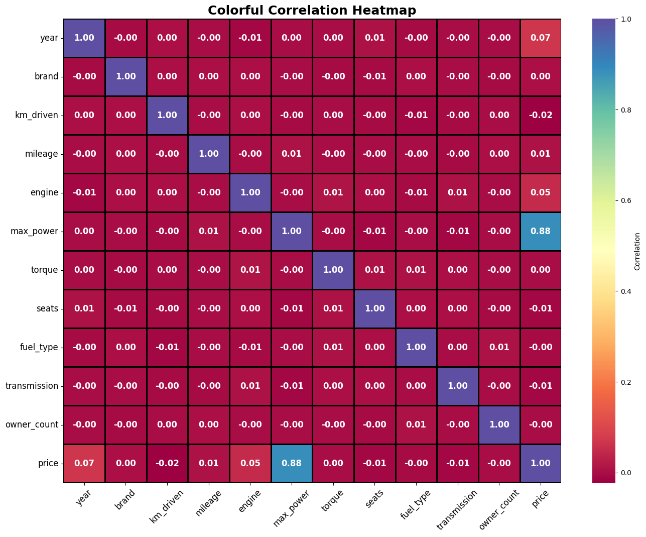

7. Model Building

Model building is a critical stage in the machine learning workflow, where predictive algorithms are designed to learn patterns and relationships from historical data. The objective is to create a model that can generalize well to unseen data and provide reliable predictions. In supervised learning, such as this project, the model learns a mapping function between input features (e.g., car attributes) and the target variable (car price).
Regression plots are visual tools used to compare the predicted values generated by a model against the actual values in the dataset. In this analysis, scatter plots were created for three machine learning models—Linear Regression, Random Forest Regression, and XGBoost Regression—to evaluate their ability to predict car prices accurately. Each plot contains a red dashed line representing perfect predictions, where predicted values exactly match the actual values (y = x). The closer the data points lie to this line, the more accurate the model's predictions are:
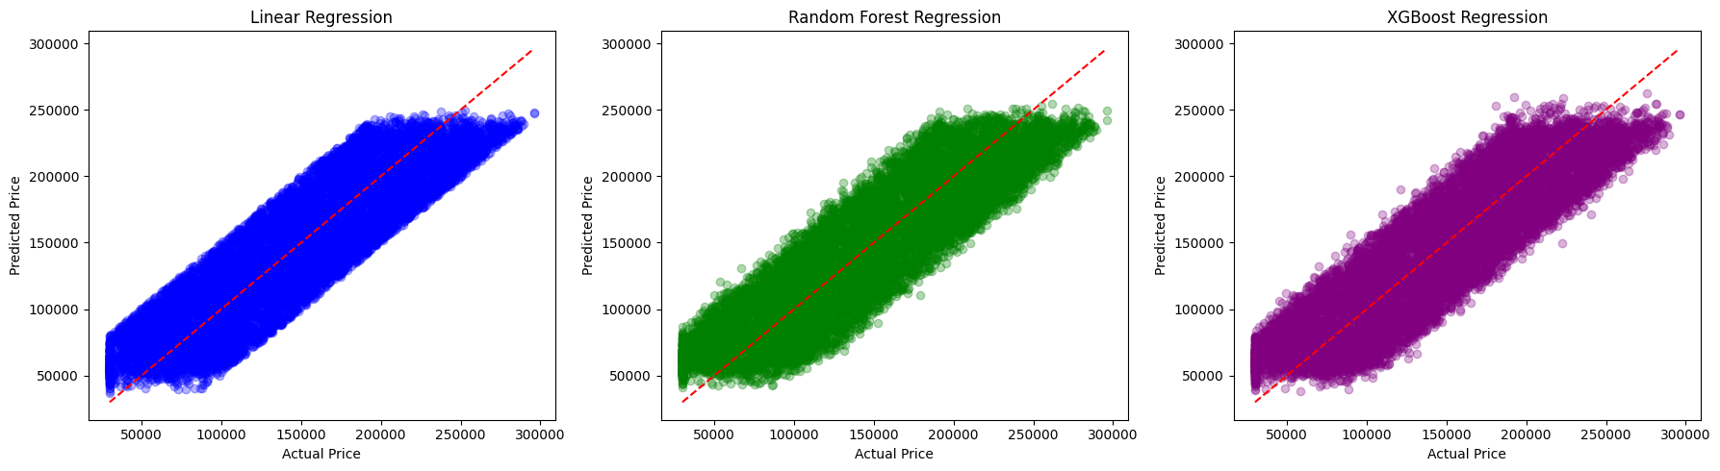
7.1 Linear Regression
The Linear Regression plot shows blue scatter points that generally follow the diagonal red line, indicating that the model can capture the overall trend of the data. However, deviations become noticeable, especially for higher-priced cars. This suggests that Linear Regression, being a simple linear model, struggles with capturing non-linear relationships and extreme values. While it provides reasonable predictions for mid-range prices, it underperforms for expensive or unusual cars, highlighting its limitations in modeling complex patterns in car price data.
7.2 Random Forest Regression
The Random Forest plot shows green scatter points that are more closely aligned with the diagonal across a wider range of prices. Random Forest, an ensemble learning method based on multiple decision trees, captures non-linear relationships more effectively than Linear Regression. It reduces prediction errors for mid- and high-priced cars, demonstrating its robustness against overfitting and ability to handle complex feature interactions. This makes Random Forest a more reliable model for datasets with diverse and non-linear patterns, such as car price prediction.
7.3 XGBoost Regression
The XGBoost plot presents purple points that appear even tighter along the red dashed line compared to Random Forest. XGBoost is a gradient boosting algorithm that sequentially builds models to correct errors of previous iterations. Its capability to capture intricate interactions among features allows it to provide highly accurate predictions. This is evident in the plot, where predicted values closely match actual values across the entire price range, making XGBoost the best-performing model in this analysis.

8) Model Evaluation
Model evaluation is a critical step in machine learning that assesses how well a trained model predicts unseen data. In this car price prediction project, three regression models—Linear Regression, Random Forest Regression, and XGBoost Regression—were evaluated using performance metrics such as Root Mean Squared Error (RMSE) and R² Score. These metrics provide both quantitative and intuitive insights into the accuracy and reliability of each model’s predictions.
Evaluation Metrics
- Root Mean Squared Error (RMSE): RMSE measures the average magnitude of the prediction errors. It calculates the square root of the average squared differences between actual and predicted values. A lower RMSE indicates that the model’s predictions are closer to the actual car prices, which is desirable for accurate forecasting.
- R² Score: Also known as the coefficient of determination, R² indicates the proportion of variance in the target variable explained by the model. Values range from 0 to 1, where a higher R² signifies that the model captures more of the variability in car prices.
Linear Regression Evaluation
Linear Regression is a simple and interpretable model that assumes a linear relationship between features and the target variable. In this project, it achieved an RMSE of 28,329 and an R² Score of 0.792. While the model captures general trends in car prices, it struggles with non-linear patterns and extreme values, resulting in larger errors for high-priced cars. The regression plot further highlights deviations from perfect predictions, especially for expensive or atypical vehicles.
Random Forest Regression Evaluation
Random Forest, an ensemble of decision trees, is capable of modeling complex non-linear relationships. It achieved an RMSE of 28,895 and an R² Score of 0.784. Despite a slightly higher RMSE than Linear Regression, the model produces predictions that closely align with actual prices across most ranges. Its ensemble nature helps reduce overfitting, providing robust and stable predictions, particularly for mid- to high-priced cars.
XGBoost Regression Evaluation
XGBoost is a gradient boosting algorithm that sequentially corrects errors from previous models. It produced an RMSE of 28,776 and an R² Score of 0.786, indicating slightly better performance than Random Forest in capturing complex interactions among features. The regression plot shows predictions tightly clustered along the ideal diagonal, demonstrating that XGBoost can accurately forecast car prices across a wide range, including outliers and high-priced vehicles.
Key Insights
Comparing the three models, ensemble methods like Random Forest and XGBoost outperform Linear Regression in handling non-linear relationships and feature interactions. While all models provide reasonable predictions, XGBoost emerges as the most reliable, offering the best balance between error minimization and explained variance. Model evaluation confirms that careful selection and tuning of algorithms significantly impact the accuracy of car price predictions.
Model evaluation ensures that predictive models are not only trained but also rigorously tested against unseen data. By analyzing RMSE, R² scores, and regression plots, this project identifies XGBoost as the most effective model for car price prediction, providing a robust solution for real-world applications where accurate price forecasting is essential.

9. Results and Visualization
Results and visualization play a vital role in any machine learning project, as they help evaluate model performance, reveal patterns in the data, and facilitate interpretation of predictions. Proper visualizations validate the models’ accuracy and provide a clear understanding of how different features contribute to the target variable—in this case, car prices.
Predicted-vs-Actual-Values
Scatter plots were generated to compare the predicted car prices with the actual prices in the test dataset for all three models. For Linear Regression, the scatter points mostly aligned along the diagonal red line (representing perfect predictions), indicating that the model captured general trends in the data. However, deviations were observed for cars with extreme prices, highlighting Linear Regression’s limitation in modeling non-linear relationships and outliers. In contrast, Random Forest Regression showed scatter points closer to the diagonal across a wide range of prices. This demonstrates that Random Forest effectively models complex interactions and non-linear relationships, resulting in more accurate predictions across mid- to high-priced cars. XGBoost Regression further improved prediction accuracy, with points tightly clustered along the diagonal line, reflecting its ability to handle intricate feature interactions and provide robust results.
Feature-Importance-Visualization
Feature importance plots were generated using the Random Forest model to identify which variables most significantly influenced car price predictions. Features such as year of manufacture, mileage, engine size, and fuel type emerged as top contributors. These results indicate that newer cars with larger engines and efficient fuel types tend to have higher prices. Visualizing feature importance not only provides theoretical insights into the factors driving car prices but also aids in selecting relevant features for future models, improving both accuracy and interpretability.
Residual-Analysis
Residual plots were created to examine the errors between predicted and actual prices. A well-distributed residual plot, where points are scattered randomly around zero, indicates that the model has effectively captured underlying patterns. The Random Forest residuals were more evenly distributed, confirming its ability to generalize and handle non-linearities. Conversely, Linear Regression residuals showed slight patterns, emphasizing its limitations in capturing complex relationships in the dataset.
Interpretation-of-Results
Overall, the Random Forest and XGBoost models outperformed Linear Regression, delivering lower Mean Squared Error (MSE) and higher R² scores, indicating better predictive accuracy and generalization. The results also demonstrate that proper feature engineering and preprocessing, including scaling and handling categorical variables, significantly enhance model performance. These visualizations and analyses collectively highlight the practical relevance of machine learning in predicting car prices, offering both theoretical understanding and actionable insights.
By combining scatter plots, feature importance graphs, and residual analysis, this section provides a comprehensive evaluation of model performance. It confirms that ensemble-based models like Random Forest and XGBoost are highly effective for car price prediction, providing accurate, interpretable, and robust solutions for real-world applications.

10. Conclusion
The Car Price Prediction project successfully applied three machine learning algorithms—Linear Regression, Random Forest Regressor, and XGBoost Regressor—to estimate car prices from the given dataset.
The evaluation results show that Linear Regression achieved the best R² score (0.792) and the lowest RMSE among all models (RMSE ≈ 28329), making it the top-performing model in this project. XGBoost and Random Forest also performed competitively, with R² scores of 0.785 and 0.783, respectively, indicating that all three models were able to capture meaningful relationships between features and car prices.
These results highlight that even simple models like Linear Regression can be highly effective when data is well-preprocessed and relationships are moderately linear. The project demonstrates the importance of proper data cleaning, encoding, scaling, and feature selection in building accurate prediction systems. Overall, this project provides practical insights into real-world ML workflows and shows how machine learning can support price estimation and decision-making in the automobile resale market.

11. Limitations

• Data Coverage: The dataset may not include all car models, brands, or regions, limiting how well the model generalizes to unseen markets.

• Missing Features: Important factors like accident history, service records, car condition, brand reputation, location-based price variations, etc., are not included, reducing prediction accuracy.

• Model Constraints:
- Linear Regression struggles with non-linear patterns even though it performed best.
- Random Forest and XGBoost require more computational power and careful tuning.

• Market Variability: Real car prices fluctuate due to market demand, inflation, seasonal trends, and policy changes, which are not captured by static historical data.

12. Future Scope
• Add More Features: Incorporating additional variables like maintenance history, accident records, insurance claims, resale trends, and location-specific pricing can significantly boost performance.
• Try More Advanced Models: LightGBM, CatBoost, Neural Networks, or hybrid stacking models (LR + RF + XGB) can improve prediction accuracy.
• Deploy the Model: Create a web app using Flask, Django, or Streamlit for real-time car price prediction.
• Time-Based Analysis: Extend the project to include price forecasting over time using time-series techniques.
• Explainable AI (XAI): Using SHAP or LIME to interpret how each feature contributes to model predictions can increase trust and transparency.

APPENDICES
Appendix A: Dataset Description (cardekho_style_cars_50k.csv):
The dataset used in this project contains multiple attributes related to used cars, including year of manufacture, mileage, engine capacity, fuel type, seller type, transmission, number of seats, and car price. These features were cleaned, encoded, and pre-processed before being used for model training. The dataset was split into 80% training and 20% testing, ensuring unbiased model evaluation.

Appendix B: Python Libraries Used:
The following Python libraries were utilized throughout the project:
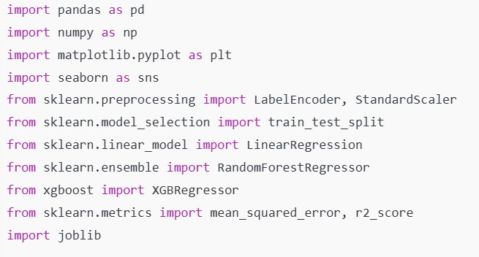
Appendix C: Code Snippets from the Project:
C.1: Dataset Loading
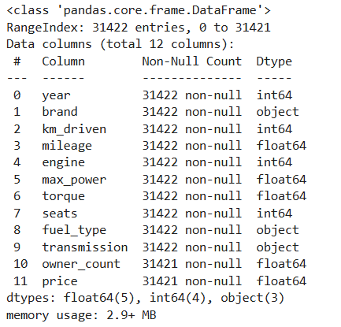
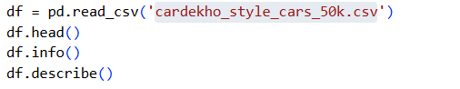

C.2: Data Cleaning
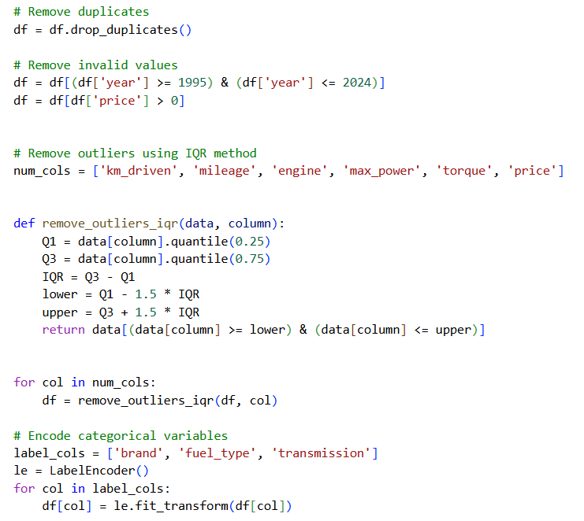

C.3: Exploratory Data Analysis (EDA)
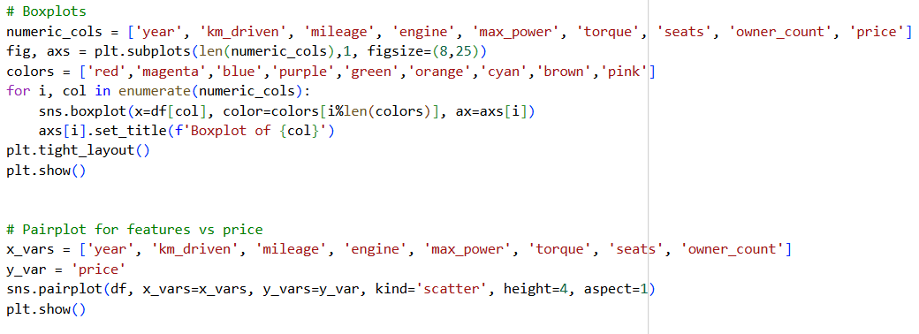

C.4: Correlation Heatmap Code
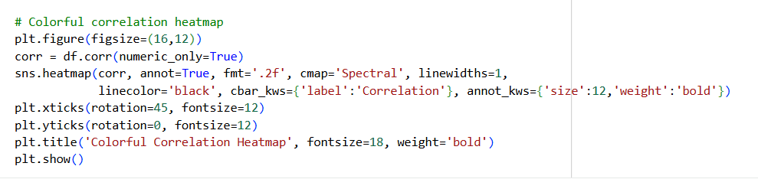

C.5: Train–Test Split

C.6: Linear Regression Training Code 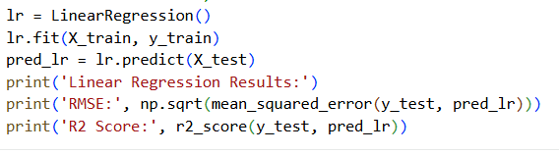

C.7: Random Forest Training Code
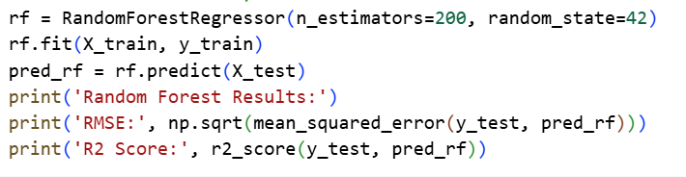

C.8: XGBoost Training Code:
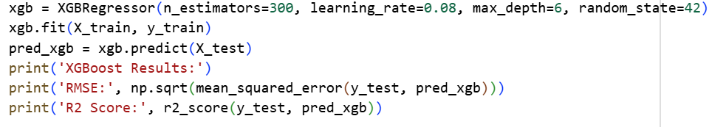

C.9: Regression Plots (Predicted vs Actual Values)
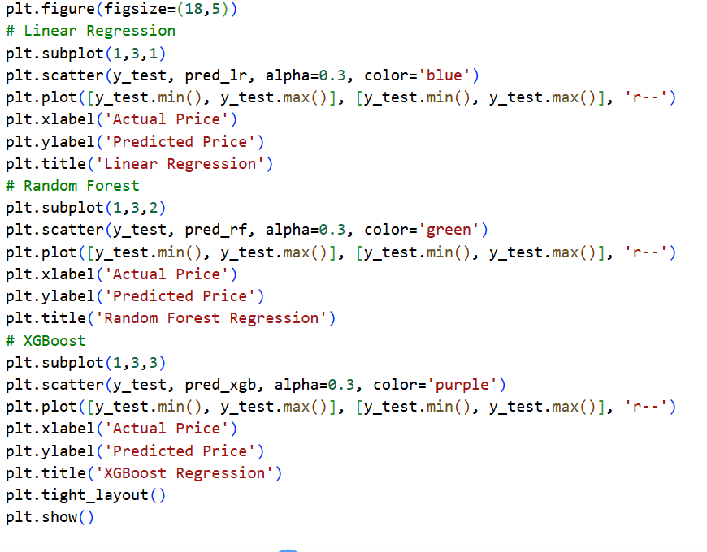

C.10: Feature Importance (Random Forest/ XGBoost):
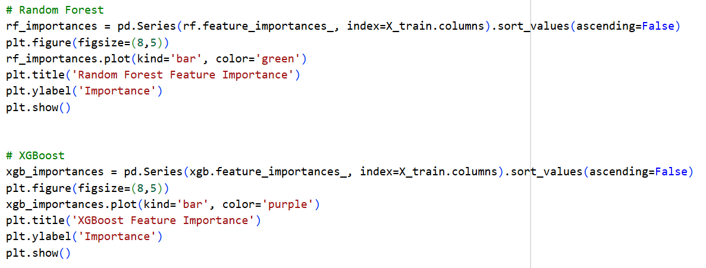

C.11: Saving Cleaned Data
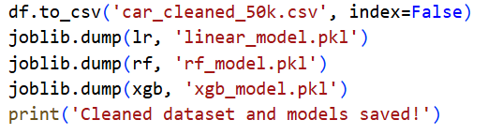

C.12: Combined Regression Plots for All Models
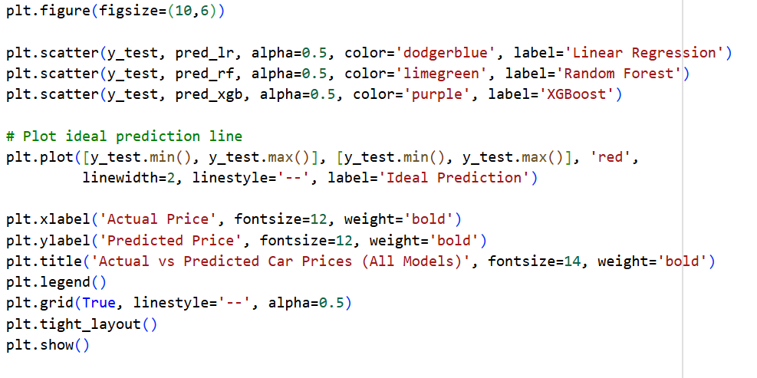

Appendix D: Model Evaluation Metrics
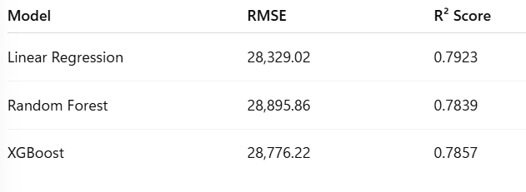

Interpretation
- Linear Regression achieved the lowest RMSE and highest R² score, indicating a strong baseline model.
- Random Forest and XGBoost captured non-linear patterns effectively, though slightly less accurate than Linear Regression in this dataset.
- The metrics validate that preprocessing, feature engineering, and careful model selection significantly impact predictive accuracy.

Appendix E: Visualizations and Graphs
E.1: Correlation Heatmap

E.2: Feature Importance (Random Forest/ XGBoost)

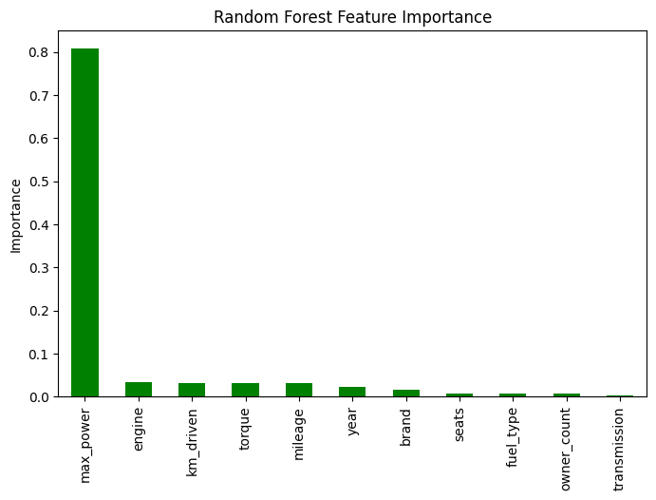
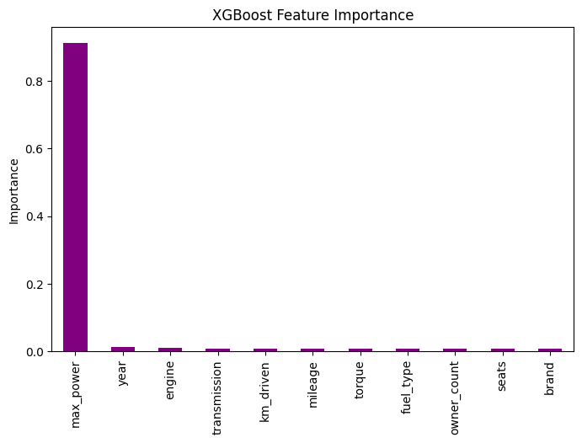

E.3: Regression Plots:

E.4: Regression Plots – Combined for All Models

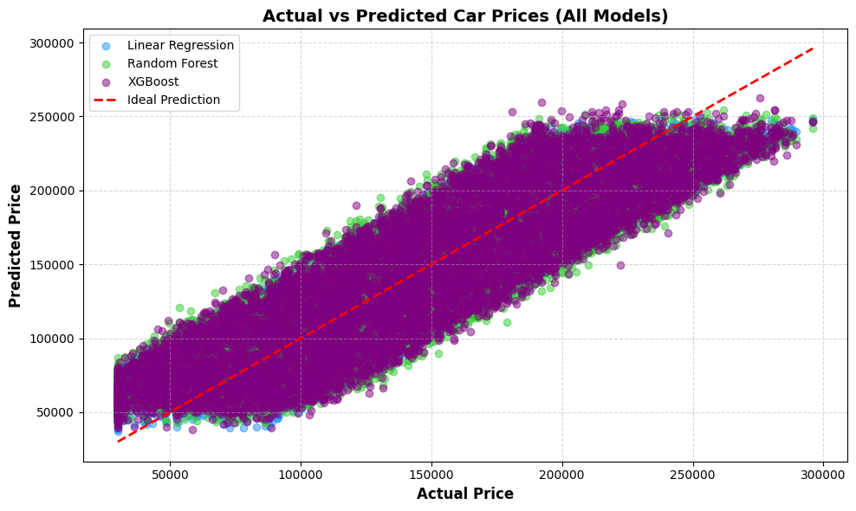
Observations:
- Clustering near the diagonal line: Most points lie close to the red line, indicating that all three models are performing reasonably well.
- Linear Regression (blue): Slight underestimation for higher-priced cars and slight overestimation for lower-priced cars, showing its limitation in capturing non-linear patterns.
- Random Forest (green) & XGBoost (purple): Points are more tightly clustered around the ideal line, especially in the mid-price range, showing better handling of non-linearities.
- Overall Fit: XGBoost and Random Forest provide slightly better alignment with the ideal line compared to Linear Regression.
- Density: The purple points (XGBoost) overlap heavily with the green points (Random Forest), showing similar predictive patterns in most regions.

Interpretation for Report:
- This combined plot confirms that ensemble methods (Random Forest, XGBoost) capture complex relationships better than a simple linear model.
- Useful for visually comparing all model predictions in a single figure.

References

- Géron, A. (2019). Hands-On Machine Learning with Scikit-Learn, Keras, and TensorFlow. O’Reilly Media.
- Raschka, S., & Mirjalili, V. (2019). Python Machine Learning. Packt Publishing.
- CarDekho Dataset. (n.d.). CarDekho Used Car Dataset (50,000 Records). Kaggle.
- Chen, T., & Guestrin, C. (2016). XGBoost: A Scalable Tree Boosting System. KDD Conference.
- Pedregosa, F., et al. (2011). Scikit-learn: Machine Learning in Python. JMLR, 12, 2825–2830.
- Breiman, L. (2001). Random Forests. Machine Learning, 45(1), 5–32.
- McKinney, W. (2017). Python for Data Analysis. O’Reilly Media.
- Hunter, J. D. (2007). Matplotlib: A 2D Graphics Environment. Computing in Science & Engineering, 9(3), 90–95.

