**Abstract-** Air pollution affects our day to day activities and quality of life. It poses a threat to the ecosystem and the quality of life on the planet. The dire need to monitor air quality is very glaring, owing to increased industrial activities over the past years.

People need to know the extent to which their activities affect air quality. This project proposes an air pollution monitoring system. The system was developed using the ESP8266 Arduino Wi-Fi Shield. The air pollution monitoring system was designed to monitor and analyse air quality of Varanasi in real-time and log data to a remote server, keeping the data updated over the internet. The air quality measurements taken by the designed system was accurate. The result was o Serial Monitor.

An RTC module is used to synchronise time even system is in OFF state.

**Keywords-** Temperature, Humidity, Wind speed, Wind Direction, AQI, PM2.5, Primary Pollutant, NO2 O3, API, Weather Station.

**Contents**

Introduction …………..

Structure ……………

Hardware …………….

Weather API ……………

Weather API ……………

Programming ……………..

GPIO ……………..

Introduction:

This project monitor air quality and weather data of Ardhali Bazar, vranasi. All data received via API <https://airpollutionapi.com/> and display on LED board.

Hardware requirement:

1. ESP8266 wi-fi Shield
2. RTC 3231
3. Red LED, Yellow LED, Green LED
4. 3 resistors 300 ohms
5. Connecting Wires

Structure:

Weather API :

Generation of API Key –

1. Go to the link <https://airpollutionapi.com/api> .

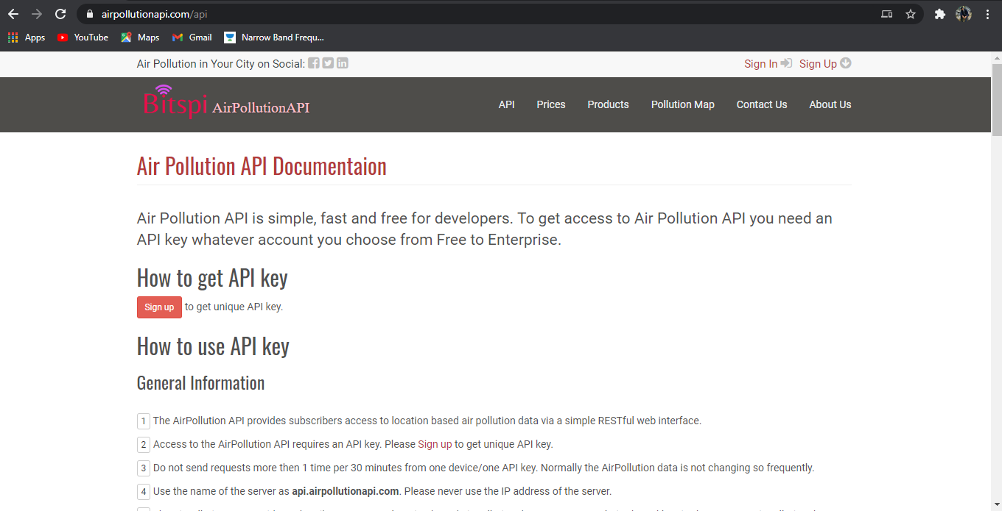

1. Go to the sign-up page and create account.

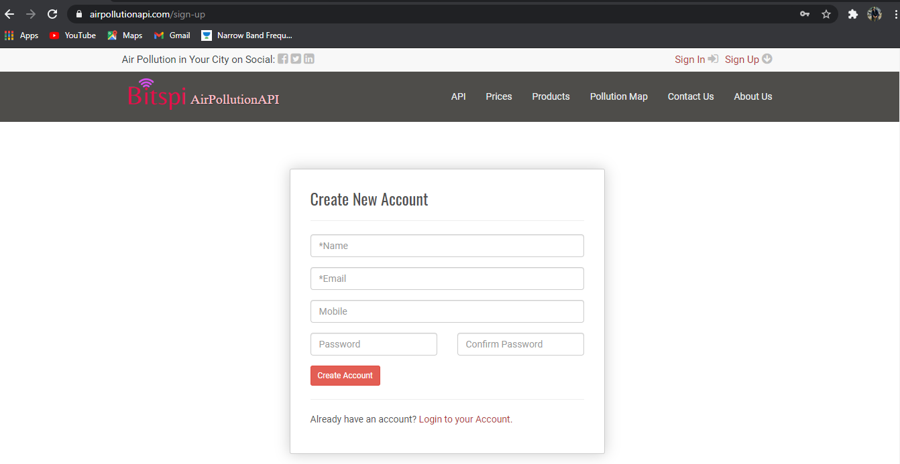

1. After creating account go to login page and login to account. After login into account in *Dashboard* section, go to *API Keys and Usage* section.

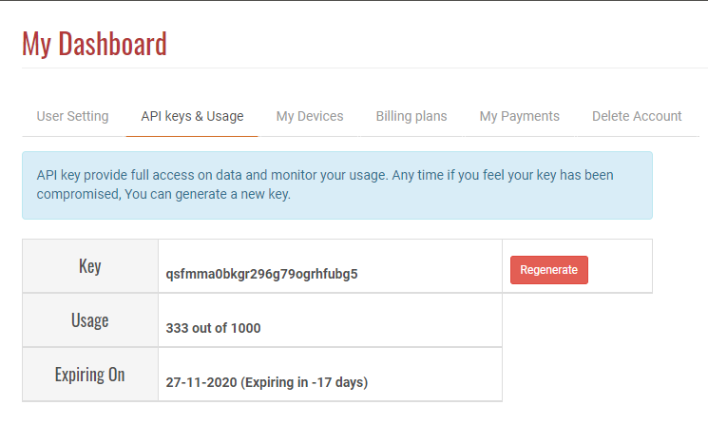

Process of using API Key:

Go to the given link for all details of the process of using API key.

<https://airpollutionapi.com/api>

Example of calling API: <http://api.airpollutionapi.com/1.0/aqi?lat=28.7040590&lon=77.10249&APPID=1111111111>

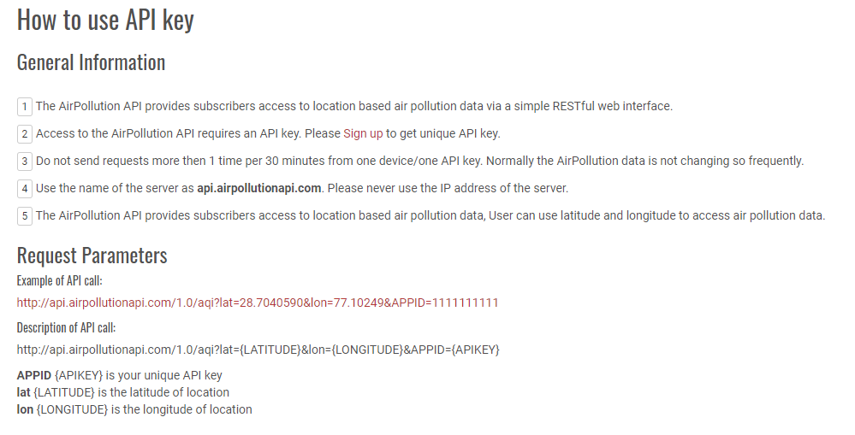

Location:

Using [Google maps](https://www.google.com/maps) find the Latitude and Longitude.

API response:

Using “POSTMAN” software-

Response of API in raw text :

{"status":"success","msg":null,"data":{"text":"Poor","alert":"Poor air quality index in this location. It may cause breathing discomfort to people on prolonged exposure, and discomfort to people with heart disease.","color":"#FF9A00;","value":300,"index":4,"updated":"Tue Nov 10 04:45:00 +0000 2020","temp":"21","content":null,"country":"India","clouds":"description = mist, image = https://airpollutionapi.com/images/icons/50d.png","coordinates":{"latitude":25.302547,"longitude":82.98322},"source":{"name":"CPCB, Ardhali Bazar, Varanasi UPPCB","coordinates":{"latitude":25.3505986,"longitude":82.9083074}},"accuracy":"9.23 Km","dominating":"PM2.5","aqiParams":[{"name":"NO2","value":"30.08 µg/m³, AQI 37","aqi":37,"color":"#79bc6a;","text":"Good","updated":"Tue Nov 10 04:45:00 +0000 2020"},{"name":"O3","value":"13.13 µg/m³, AQI 13","aqi":13,"color":"#79bc6a;","text":"Good","updated":"Tue Nov 10 04:45:00 +0000 2020"},{"name":"PM2.5","value":"144.0 µg/m³, AQI 300","aqi":300,"color":"#A52A2A;","text":"Severe","updated":"Tue Nov 10 04:45:00 +0000 2020"},{"name":"Humidity","value":"68.0 %","aqi":null,"color":null,"text":null,"updated":null},{"name":"Barometric Pressure","value":"1017.0 hPa","aqi":null,"color":null,"text":null,"updated":null},{"name":"Wind Speed","value":" 3.36 m/s","aqi":null,"color":null,"text":null,"updated":null},{"name":"Wind Direction","value":"30.0 degrees","aqi":null,"color":null,"text":null,"updated":null}]}}

Query Parameters:

**Key Value**

Latitude 25.302547

Longitude 82.983220

APPID qsfmma0bkgr296g79ogrhfubg5

Data Used:

1. AQI
2. NO2
3. O3
4. PM2.5
5. Temperature
6. Humidity
7. Wind Speed
8. Wind Direction

Time API:

Host : https://www.timezonedb.com/

<http://api.timezonedb.com/v2.1/get-time-zone?key=OL4S2K3JTIWD&format=json&by=zone&zone=Asia/Kolkata>

Time API response:

{"status":"OK","message":"","countryCode":"IN","countryName":"India","zoneName":"Asia\/Kolkata","abbreviation":"IST","gmtOffset":19800,"dst":"0","zoneStart":-764145000,"zoneEnd":null,"nextAbbreviation":null,"timestamp":1605173662,"formatted":"2020-11-12 09:34:22"}

Programming:

Arduino –

Functions-

1. void ResetSettings() – This function is used to reset esp8266 on hotspot mode. In this mode user can change/save SSID, Password, IP Address and Subnet mask in EEPROM of RTC 3231 Module.
2. String aqi_weather_api () – This function is used to receive data from weather API in json format and returned json data to void json_parse (String input) function.
3. void json_parse (String input) – This function is used extract usable data from json file and display on Serial Monitor.
4. String time_api ()– This function is used to receive data from Time API in json format and returned it to void json_parse (String input) function.
5. void json_parse (String input) – This function is used to extract Date & Time data from json file and returned it to void rtc_time(String date_time).
6. void rtc_time(String date_time) – This function is used to save Date and Time in RTC 3231 module.
7. void show() – This function is used to show saved date and time on Serial monitor from RTC 3231.

GPIO:

Raspberry Pi GPIO pins are used for display Power, Wi-Fi Status, Internet Status.

Pin Configuration:

17 – Wi-Fi – Yellow LED, Flash delay 1 sec.

18 – Internet – Green LED, Flash delay 1 sec.

27 – Power – Red LED