**AIR POLLUTION FORECASTING USING LSTM**

**Steps followed:**

1. Data preparation
2. Data visualization
3. LSTM data preparation
4. Fit model along with regularization term
5. Evaluate model

**Data preparation:**

* Replace NA values
* Parse date-time into pandas dataframe index
* Specified clear names for each columns

**Data visualization**

* Used matplotlib to plot

[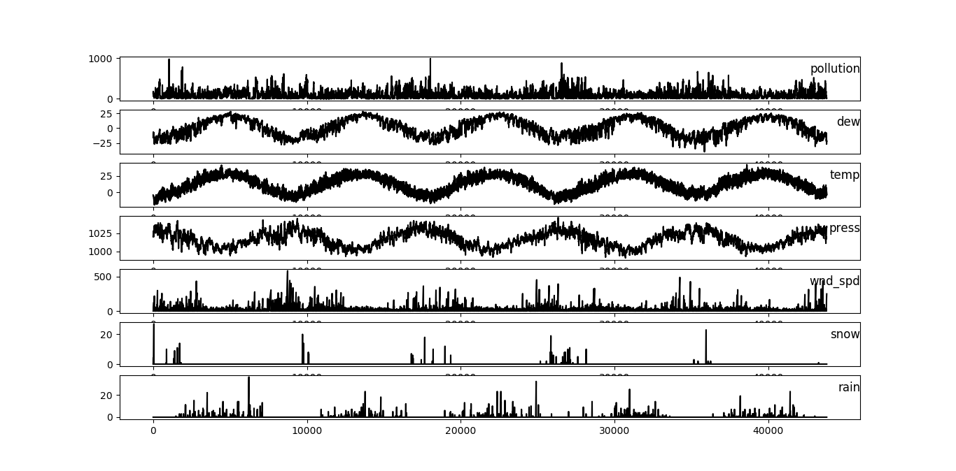](https://raw.githubusercontent.com/sagarmk/Air-pollution-forecasting-with-RNN/master/images/img1.png)

**LSTM data preparation**

* Normalized data
* Transformed dataset into supervised learning problem

**Model Fitting**

* Split data into train and test
* Split into i/p and o/p
* Reshape into 3D
* Define a 50 neuron followed by 1 nueron LSTM
* Add dropout at 30%
* Plot history of training and testing loss

[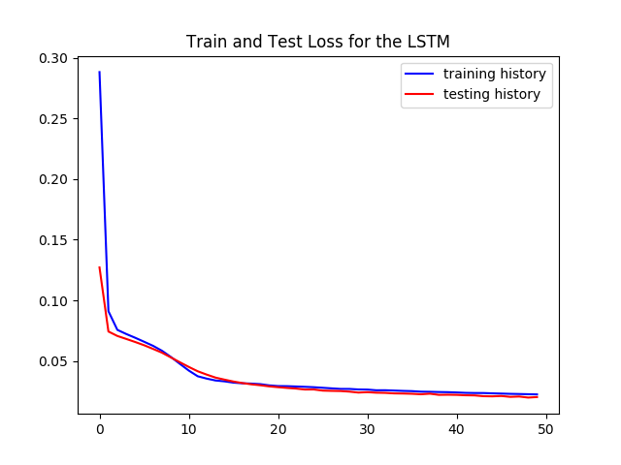](https://raw.githubusercontent.com/sagarmk/Air-pollution-forecasting-with-RNN/master/images/img2.png)

**Evaluate model**

* Make prediction
* Invert scalings
* Calculate RMSE