**RDS**

1. **Create Database** and **select Engine MySQL :**

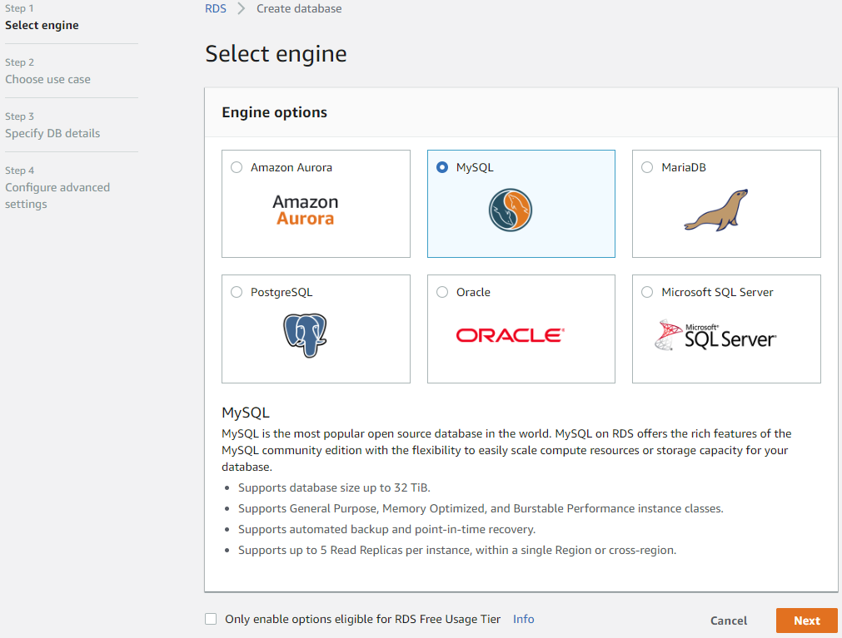

1. **Next choose use case like Production/Dev/Test-Mysql :**

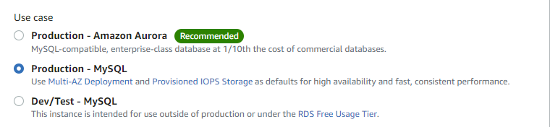

1. **Next specify database details :**

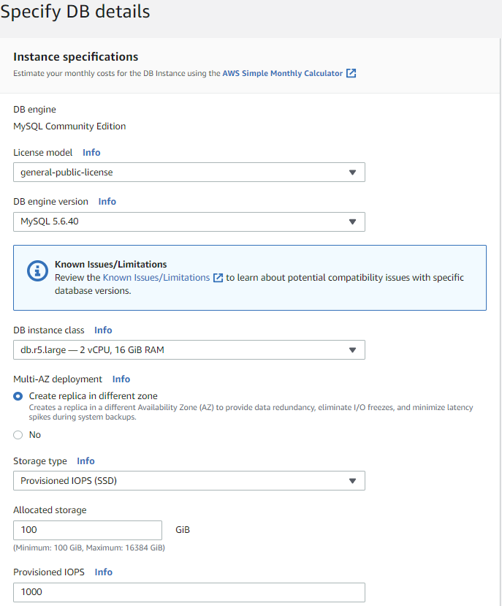

**In this above one :-**

**Licence model : general-public-license (default)**

**DB engine version : As your wish**

**DB Instance class : As your requirement (db.t2.micro,t2.large,…..)**

**Multi-AZ deployment : Create replica in different zone (Production) / No (Test)**

**Storage Type : provisioned IOPS (SSD)**

**General Purpose (SSD)**

**3.1) Next Settings: Enter DB Identifier (Not DB name), user & password**

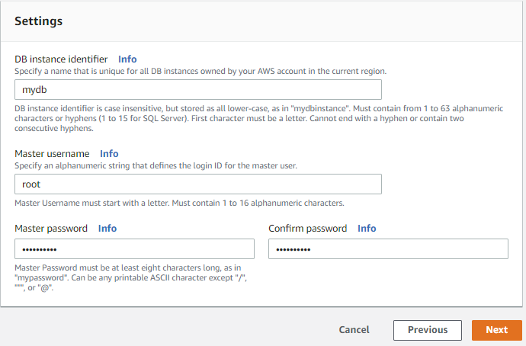

1. **Go to Configure advanced settings : Network & Security**

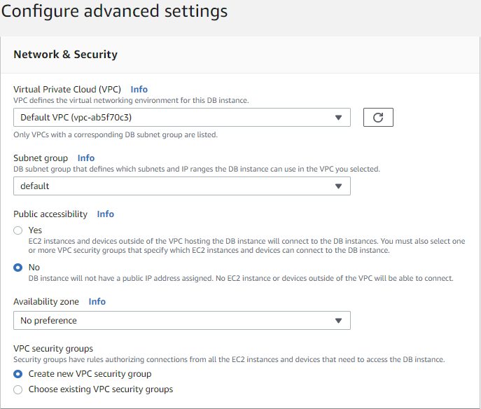

**4.1) Database Options :**

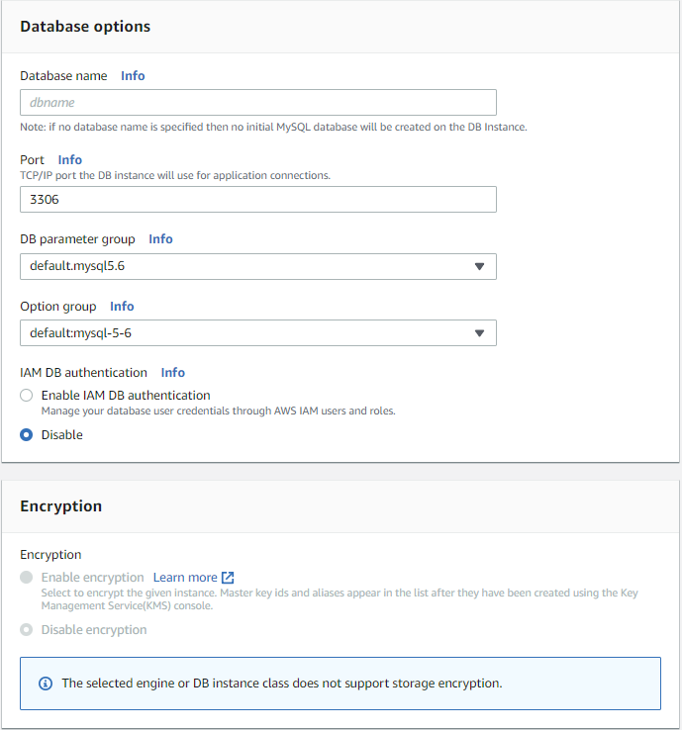

**4.2) Backup & Monitoring :**

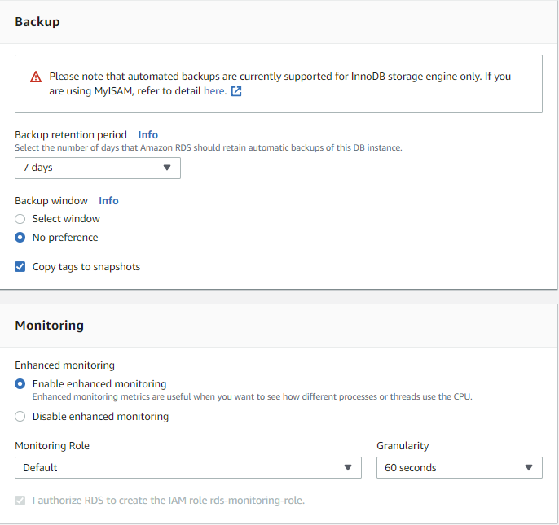

**4.3) Log exports, Maintenance & Delete Protection :**

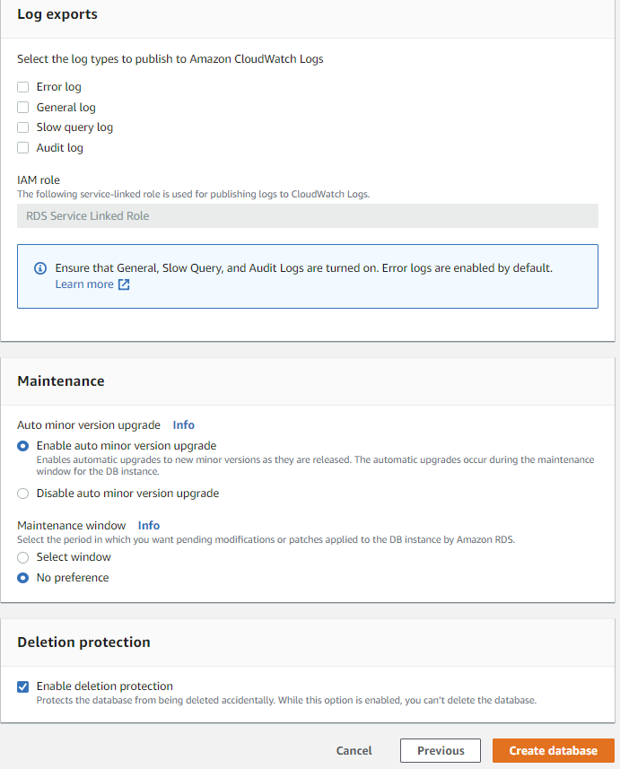

1. **After Creating Database :**

