**Weblogic Servers and Clusters Installation in Windows:**

**Step1:**

Go to the site and download the weblogic 14c usnig below link

Firat you have create oracle account

https://www.oracle.com/middleware/technologies/weblogic-server-installers-downloads.html

**Step2:**

After that extract the Zip file with selected directires you have created.

**Step3:**

Run the command prompt ( CMD ) as administration mode give the path of the directries EX: d:,c:,e: etc

provide the exact file locations and commands :

cd D:\oracleweblogic\fmw_14.1.1.0.0_wls_lite_quick_Disk1_1of1 (1)

provide the jar file locaion:

command : java -jar Jar file path.jar

java -jar fmw_14.1.1.0.0_wls_lite_quick_generic.jar

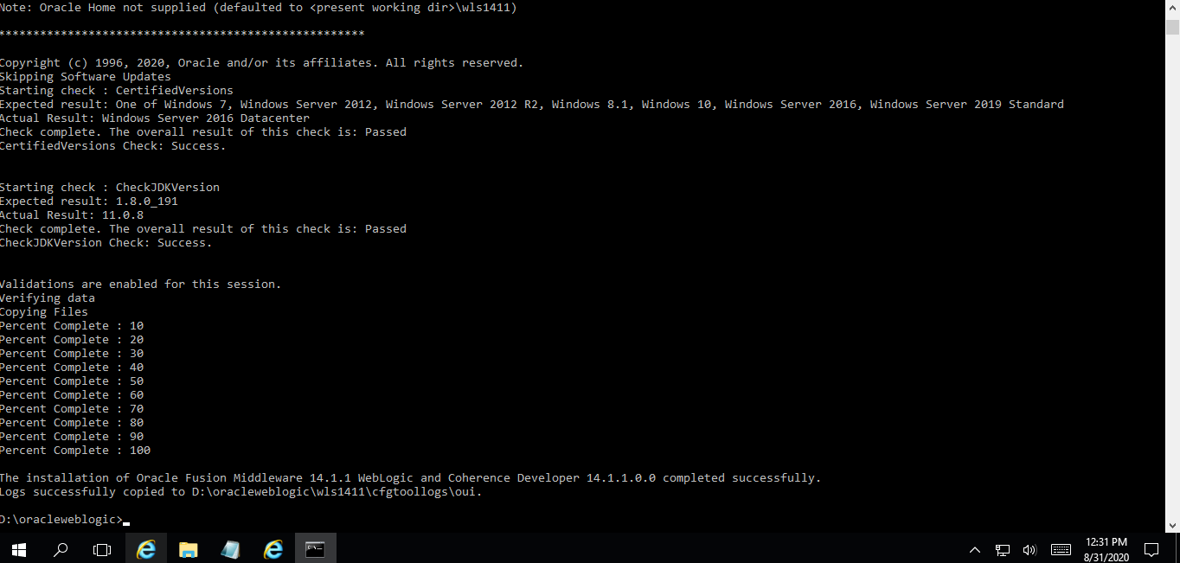

after successfull execution wls1411 will be creted in the directorie open that and go to oracle_commn

cd D:\Weblogic\wls1411\oracle_common\common\bin

using the command to start the console

.\config.cmd

Step 4: Once the configuration starts console will be open.

Step 5: create a new domain.

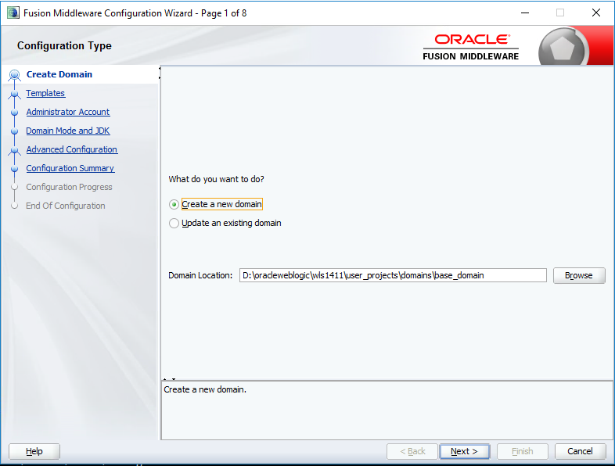

Step 6: Click next, select the template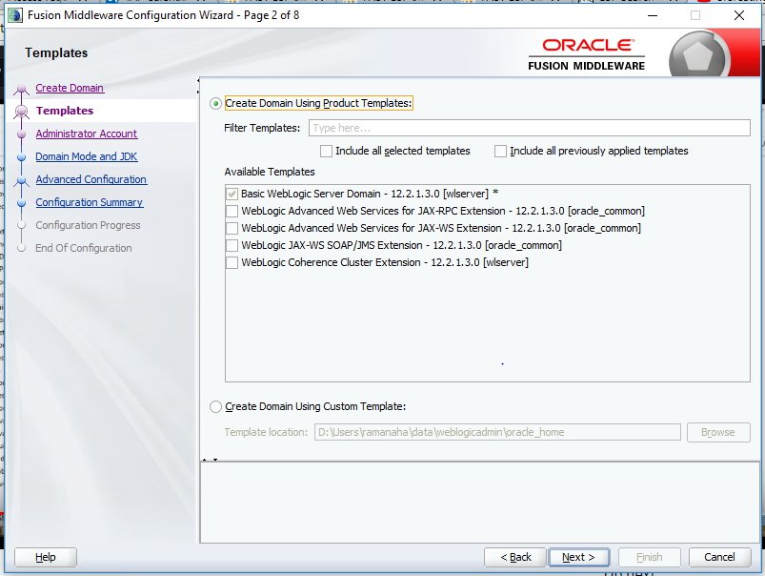

Step 7: Once you done to select all template, click next

Step 8: Enter the credentials in administration account

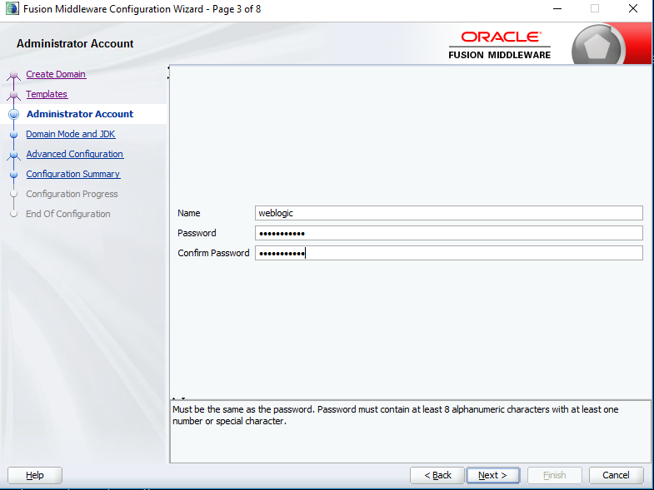

Step 9: Click next , Select the Domain mode and JDK.

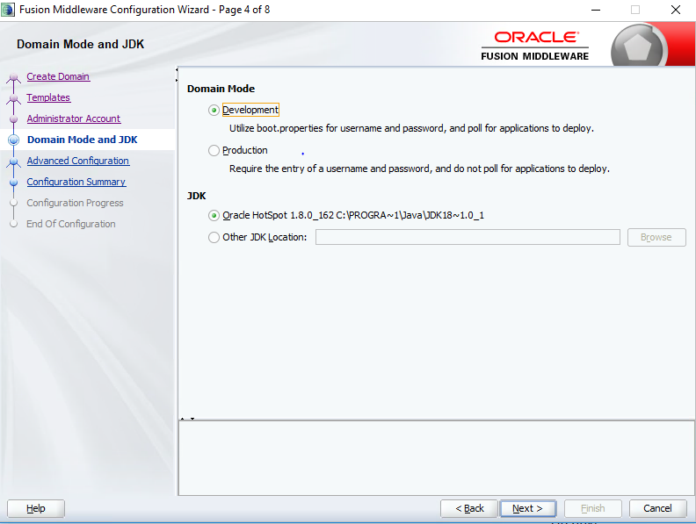

Step 10: once the process is done click next, Select the advance configuration.

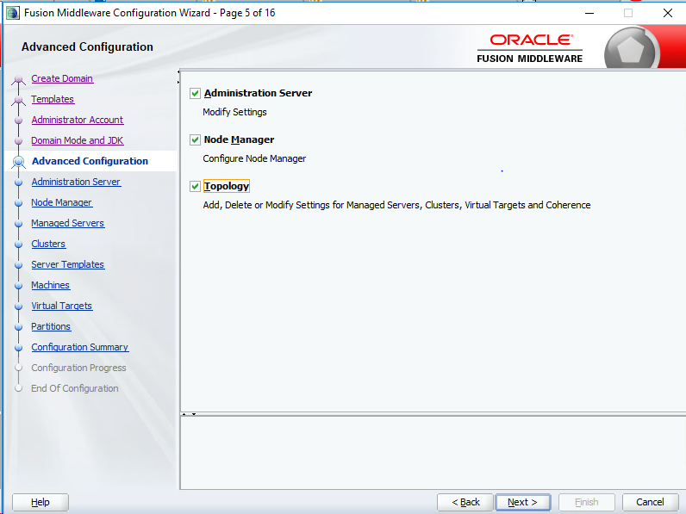

Step 11: Click next, Select the Administration server to enter the server name, address and ports

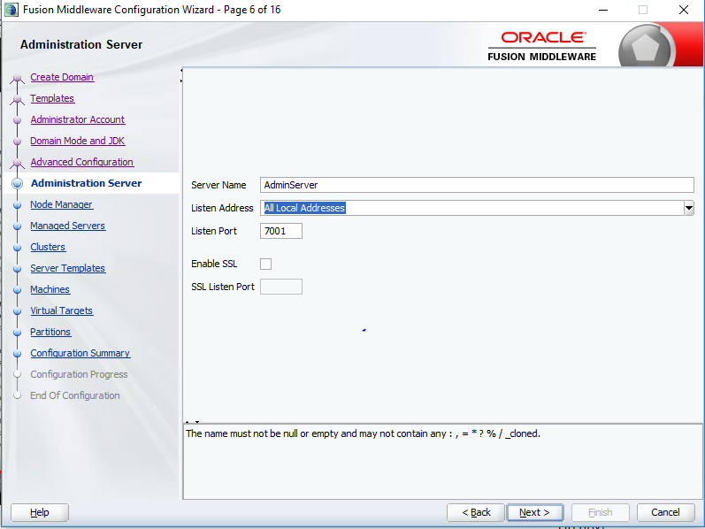

Step 12: click next, Select the node manager enter the node manager credentials.

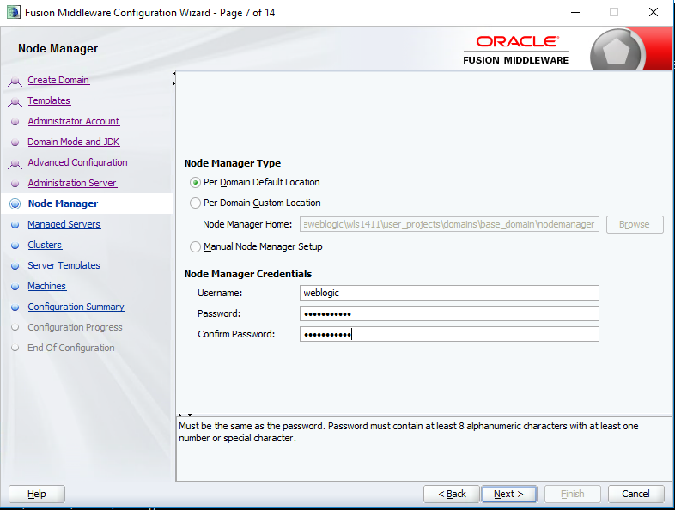

Step 13: Click next create Managed servers.

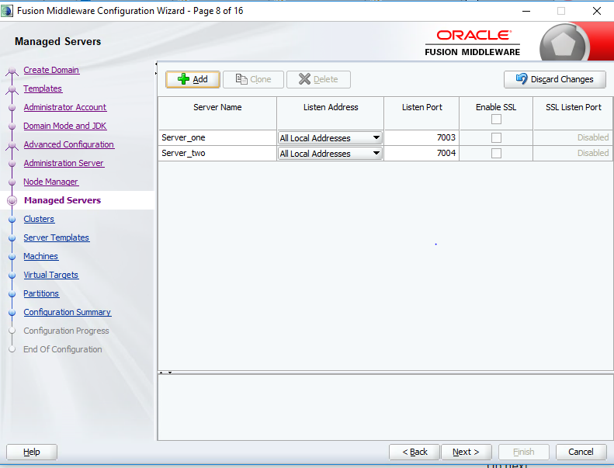

Step 14: Click next , if you want cluster you can create the clusters.

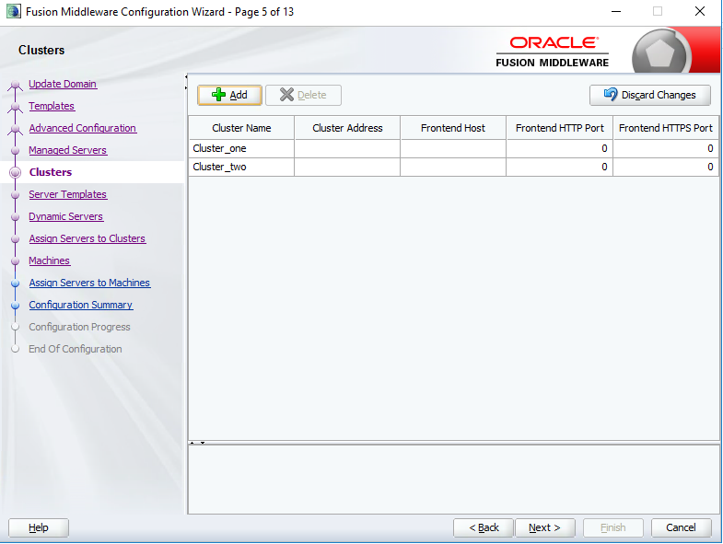

Otherwise move to next step to add a machines.

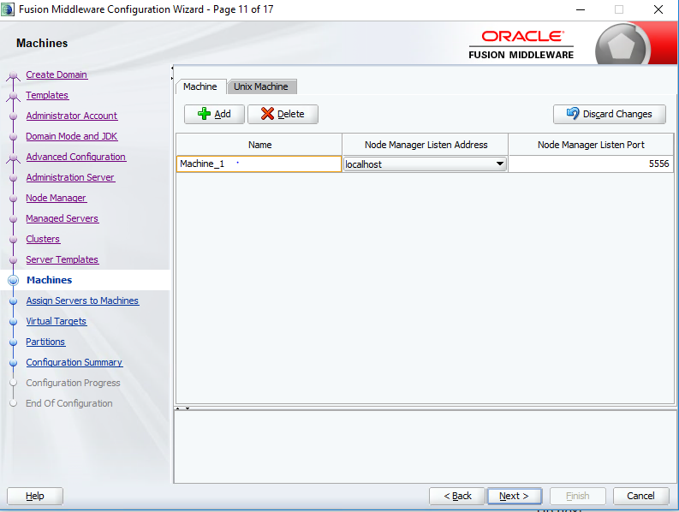

Step 15: Click next assign the servers to machine

**Note: Select one or more servers in the left pane and one machine in the right pane. Then use the right arrow button (>) to assign the server or servers to the machine.**

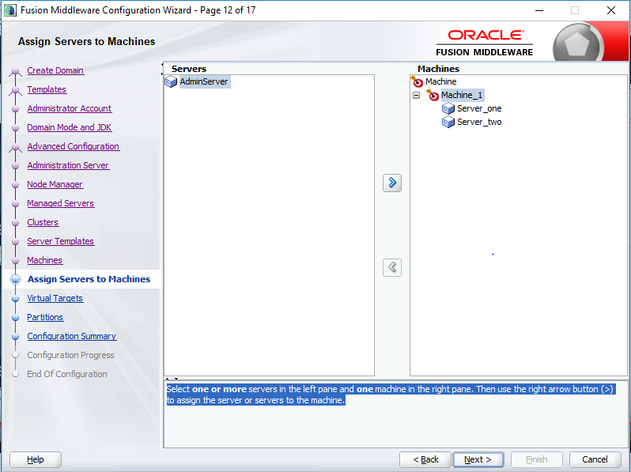

Step 16: Once check it all step was done click the create button to create a new domain.

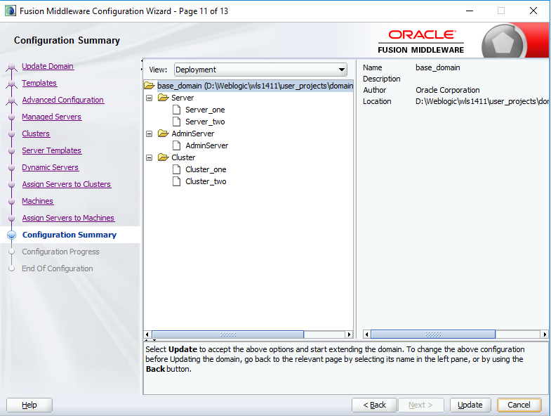

Step 17: Once the WebLogic server configuration succeed click finish.

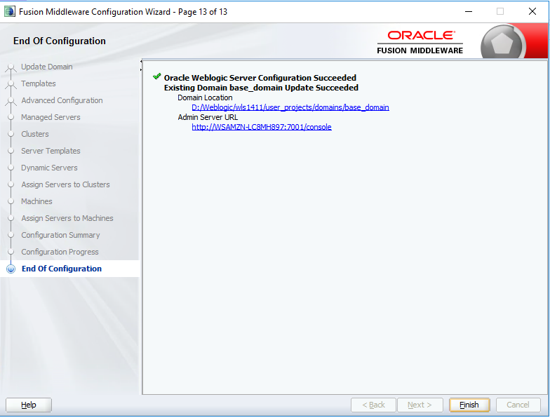

Reference Please check the link <https://www.youtube.com/watch?v=ZbcbxMh2eiU>

**Starting the welogic server:**

cd D:\Weblogic\wls1411\user_projects\domains\base_domain

command : startWebLogic.cmd

Go to the CMD and run as administration mode

After completing the setups go to the Chrome and search the path

# [http://localhost:7001/console](https://community.oracle.com/message/2994573#2994573)

s

we will get the login page and provide the username and Password to login .

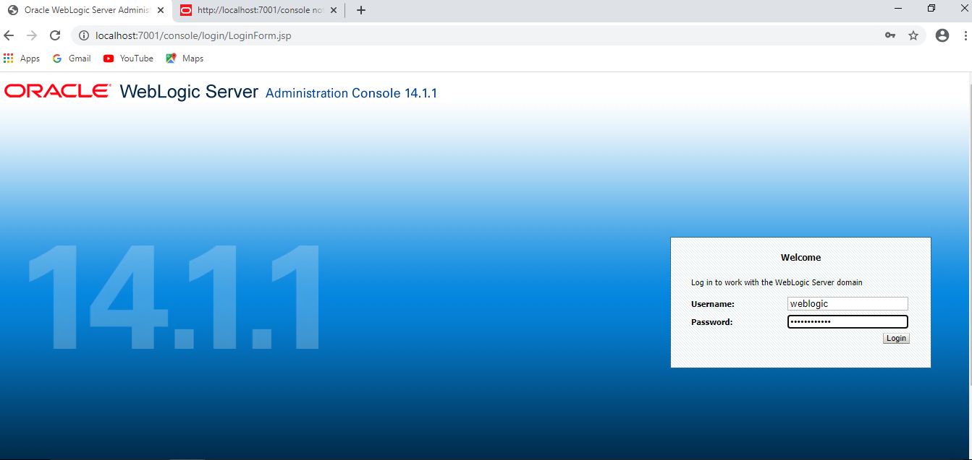

After login we will get main page

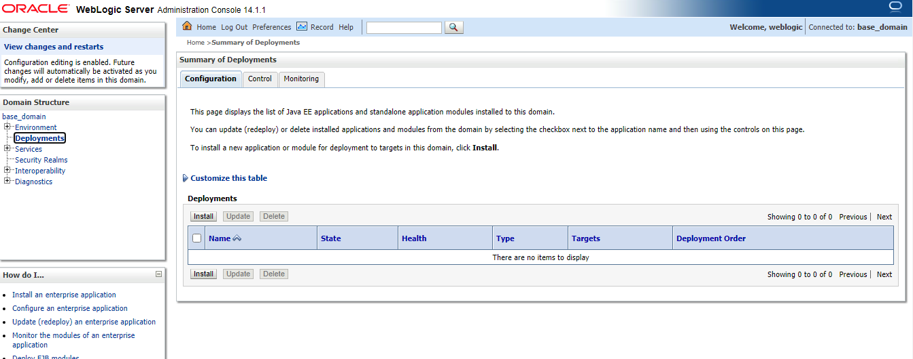

# Kerberos Setup

1. Create keytab file in DDE. As keytab storages service account encrypted keys, it can be reused in ITG/PRO once it is created.

* How to create a keytab file

1. Run ktutil with root privilege

pbrun su

1. run command, need to enter password for service account

addent -password -p $rmuseritg220@AMERICAS.CPQCORP.NET -k 1 -e rc4-hmac

wkt keytab

quit

1. keytab will be saved in current directory

* How to verify keytab

1. Run command klist. If principal is the service account, that will be ok.

klist –ke keytab



1. Copy keytab from DDE to ITG/PRO, /../../../Kerberos

***Note:*** */../../../ - is your kerberos path*

Backup original keytab if it exists



1. Change krb5.conf. Make sure default_realm is pointing to “AMERICAS.CPQCORP.NET” if your database is from americas.

Comment out following attributes if exists

#forwardable = true

#proxiable = true

1. Make sure sqljdbc4.jar lib in the directory /../../../domain/RMS_FQM_domain/lib/, if not exists, copy it there.
2. Add argument in weblogic console – server start

-Dsun.security.krb5.debug=true -Djava.security.auth.login.config=/../../../kerberos/JDBCDriverLogin.conf -Djava.security.krb5.conf=/../../../kerberos/krb5.conf

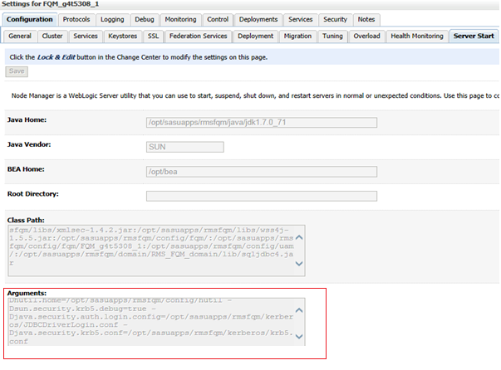

**Note**: argument “-Dsun.security.krb5.debug=true” will be in DDE only. DO NOT add it to PRO.

1. Change data source connection URL

jdbc:sqlserver://GVS91643.americas.hpqcorp.net:2048;integratedSecurity=true;authenticationScheme=JavaKerberos

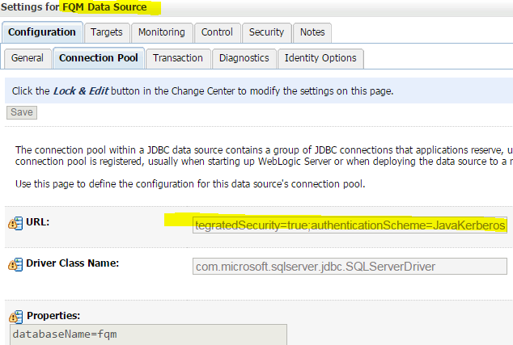

# Service Account Switch

1. Create a new keytab file for service account ($rmuseritg221), refer to “Kerberos Setup” step 1
2. Copy keytab to/../../../Kerberos directory on each server.
3. Start all servers