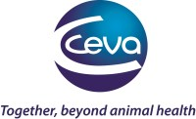

Eprecis®, the first injectable endectocide in the market
Ceva Animal Health has launched a new eprinomectin product, Eprecis®, indicated for use against internal and external parasites in cattle, including gut and lungworms, sucking and chewing lice and mange mites. Eprecis extends Ceva’s portfolio for ruminants.
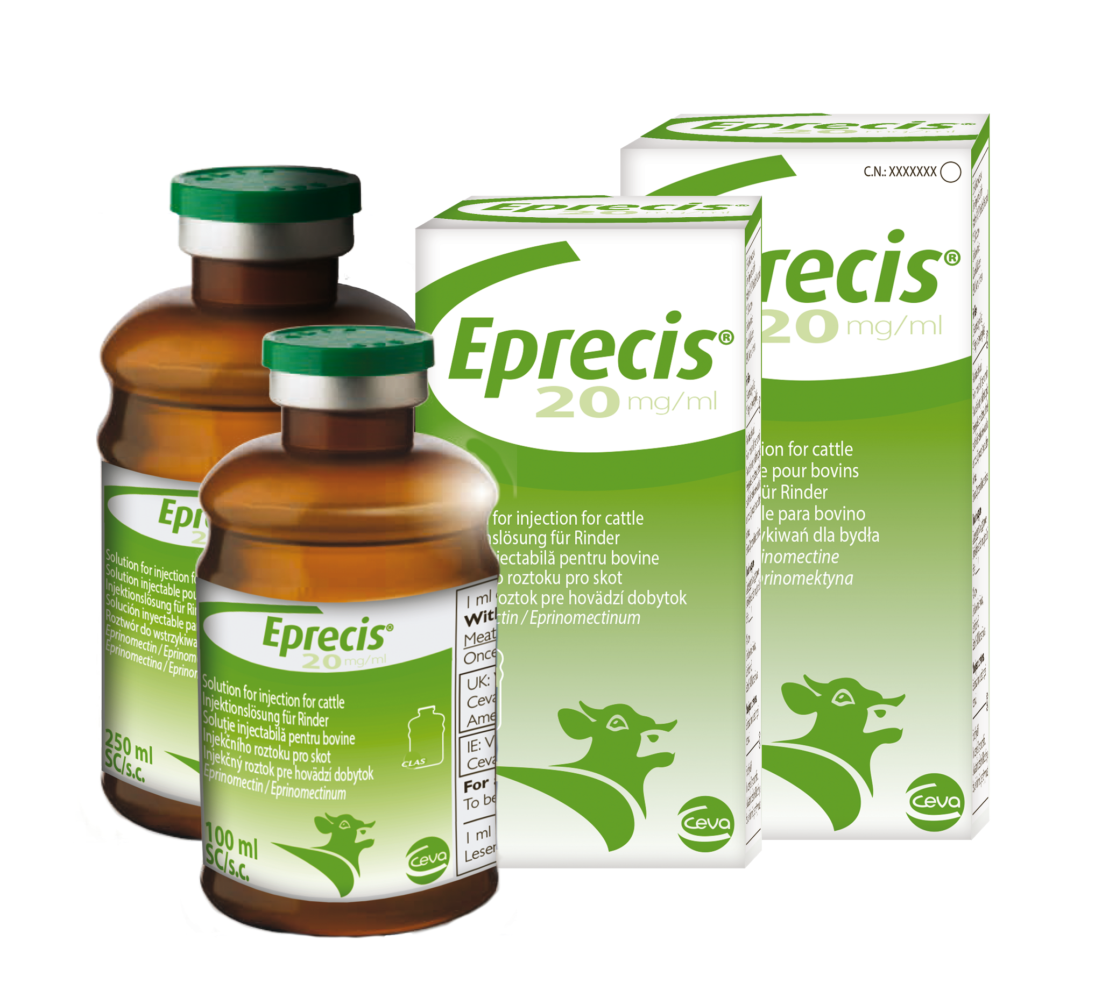
Eprecis is available as a pour-on but also as an injectable formulation and each formulation has a zero-day withdrawal period in milk. This is the first injectable eprinomectin to the UK and Irish market and is administered via a subcutaneous injection.
Carol Atkinson, product manager for Eprecis said ‘it is exciting to have an injectable formulation of this tried and trusted molecule, as it provides an alternative for farmers who may be concerned with the effect the weather in the UK and Ireland can have when using a pour-on product, as well as cows licking each other after treatment.’ The increased bioavailability and the concentration of the product means that smaller volumes are needed compared to the volume used as a pour-on. Carol added, ‘the great advantage of using an injectable eprinomectin is accurate dosing. This results in reduced parasite resistance and lower environmental impact.’’
The Preciback carrier is designed to provide user comfort whilst using the pour-on formulation and has pockets to fit the 2L or 5L bottles. The injectable formulation meanwhile is available in 100ml and 250ml in the Ceva unique shock resistant CLAS vials. High quality Preciguns are available for both Eprecis injectable and Eprecis pour on.

